AWS Lambda & AWS API Gateway & AWS KMS

Topic 1: Amazon Web Services Lambda
1. Objective
To gain an understanding of AWS Lambda, its architecture and practical applications, and complete a hands-on exercise covering function creation, testing, and monitoring.

2. Introduction to AWS Lambda
AWS Lambda is a serverless compute service from Amazon Web Services (AWS) that lets developers execute code without having to provision or maintain servers.
After uploading the code and configuring an event trigger, AWS automatically runs the function whenever the specified event takes place.
Definition
AWS Lambda is a managed serverless compute service that executes application code in response to events while AWS takes care of the underlying infrastructure.

3. Understanding Serverless Computing
Serverless does not imply that physical servers are absent; rather, AWS manages the server infrastructure on the developer's behalf.
AWS takes care of the following operational responsibilities:
- Server provisioning
- Operating system management
- Security patching
- Auto Scaling
- High Availability
Developers can focus primarily on developing and deploying their application code.
Example
Traditional Model (EC2):
- Launch an EC2 instance
- Install operating system
- Install required software
- Configure security
- Monitor server health
- Scale servers manually
Serverless Model (Lambda):
- Develop the required code
- Deploy the code
- Set up the required event trigger
- AWS manages the remaining infrastructure tasks

4. Key Features of AWS Lambda
- Serverless architecture
- Automatic scaling
- Event-driven execution
- Pay only for execution time
- Supports multiple programming languages
- Easy integration with AWS services
- High availability
- Built-in monitoring with Amazon CloudWatch

5. Supported Programming Languages
AWS Lambda provides support for multiple programming languages, including:
- Python
- Java
- Node.js
- .NET
- Go
- Ruby
- Custom Runtime

6. Common Use Cases
Typical applications of AWS Lambda include:
Image Processing
Automatically resize images whenever they are uploaded to an Amazon S3 bucket.

REST APIs
Build backend APIs by integrating Amazon API Gateway with Lambda.

File Processing
Process CSV, JSON, or XML files that are uploaded to Amazon S3.

Scheduled Tasks
Execute scheduled or automated tasks through Amazon EventBridge.

Log Processing
Process and analyze application or server logs in near real time.

IoT Applications
Process incoming data generated by IoT devices.

7. AWS Lambda Architecture
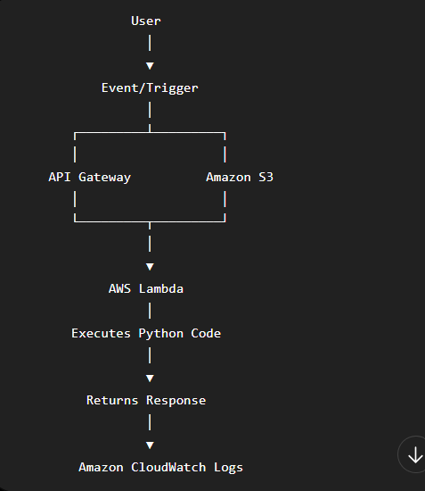

8. Lambda Event Triggers
A trigger is an event or action that initiates the execution of a Lambda function.
Examples:
- API Gateway
- Amazon S3
- CloudWatch Events/EventBridge
- DynamoDB Streams
- SNS
- SQS

9. Benefits
- No server management
- Automatic scaling
- Cost-effective
- Fast deployment
- High availability
- Supports event-driven applications

10. Limitations
- Maximum execution time: 15 minutes
- Cold start latency may occur
- Memory allocation has limits
- Temporary storage (/tmp) is limited

11. Pricing Model
Lambda charges are primarily determined by:
- Number of requests
- Compute duration (execution time)
- Memory allocated
You are charged for the resources used while your function executes.
12. Practical Implementation
Step 1: Access the AWS Console
- Sign in to the AWS Management Console.
- Search for the Lambda service.
- Open Amazon Lambda.
Screenshot: AWS Lambda Dashboard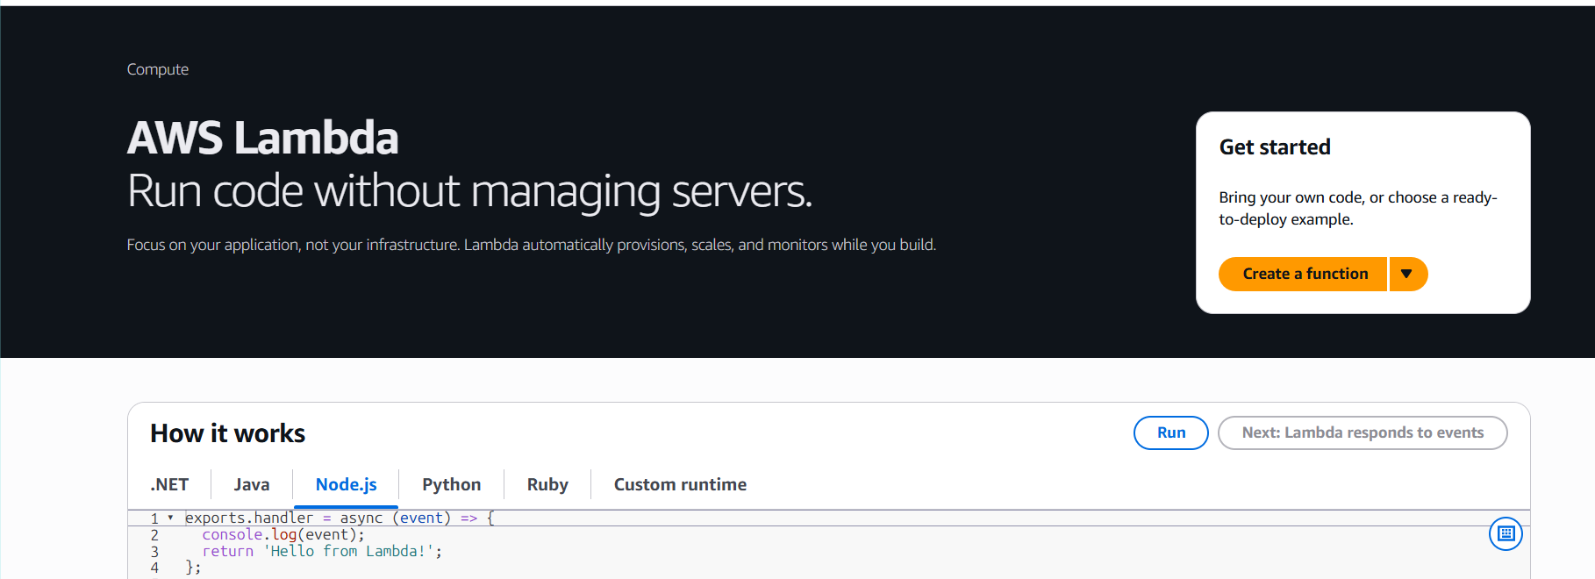
Step 2: Create the Lambda Function
Select Create function.
Choose the following option:
- Author from scratch
Enter the following configuration values:
Field | Value
Function Name | HelloLambda
Runtime | Python 3.13 (or latest available)
Architecture | x86_64
Permissions | Create a new role with basic Lambda permissions
Select Create function.
Screenshot: Create Function Page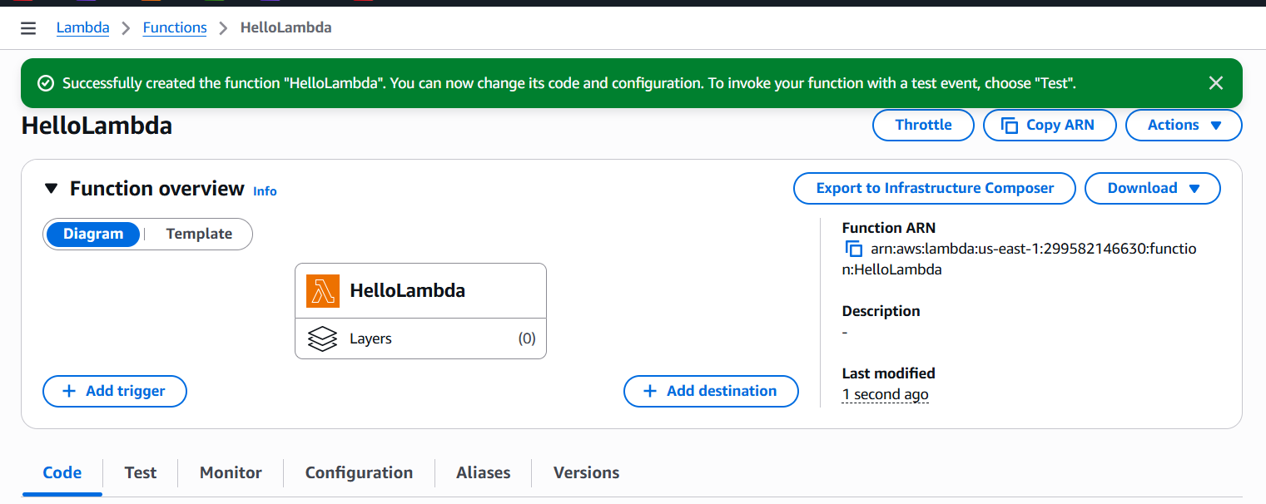

Step 3: Add the Function Code
Replace the sample code with the following handler:
def lambda_handler(event, context):
return {
"statusCode": 200,
"body": "Hello from AWS Lambda!"
}
Select Deploy to publish the updated code.
Screenshot: Lambda Function Code 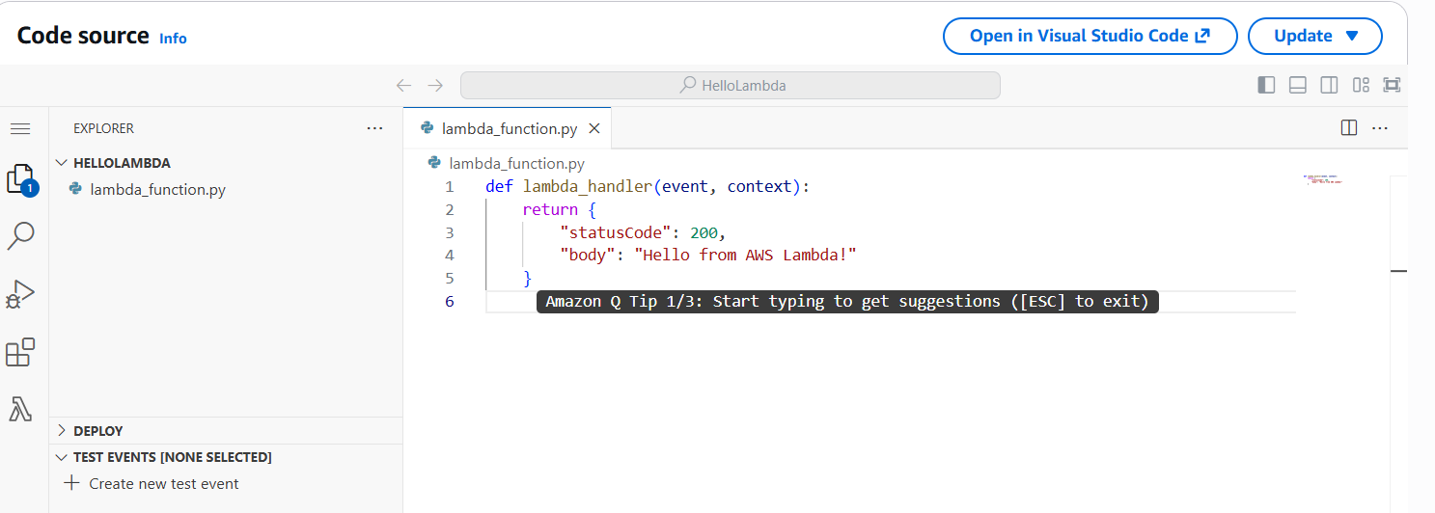 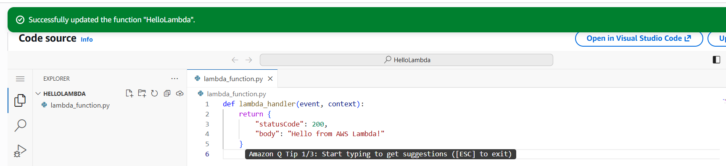

Step 4: Test the Lambda Function
Click Test.
Select Create new event.
Enter the event name:
TestEvent
Use the default JSON payload:
{}
Save the test event.
Run the test again.
Expected result:
{
"statusCode": 200,
"body": "Hello from AWS Lambda!"
}
Screenshot: Successful Test Output
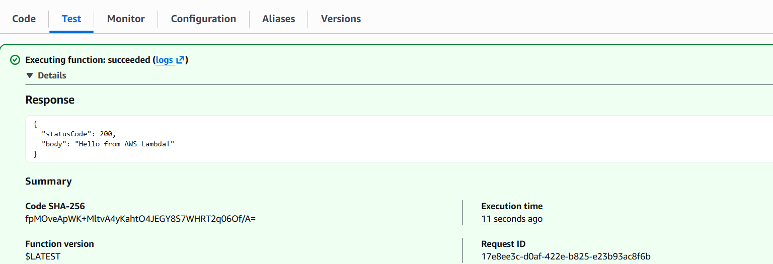

Step 5: Review Execution Logs
- Open the Monitor tab.
- Select View CloudWatch Logs.
- Review the execution records.
The logs contain information such as:
- Request ID
- Duration
- Memory Used
- Status
Screenshot: CloudWatch Logs
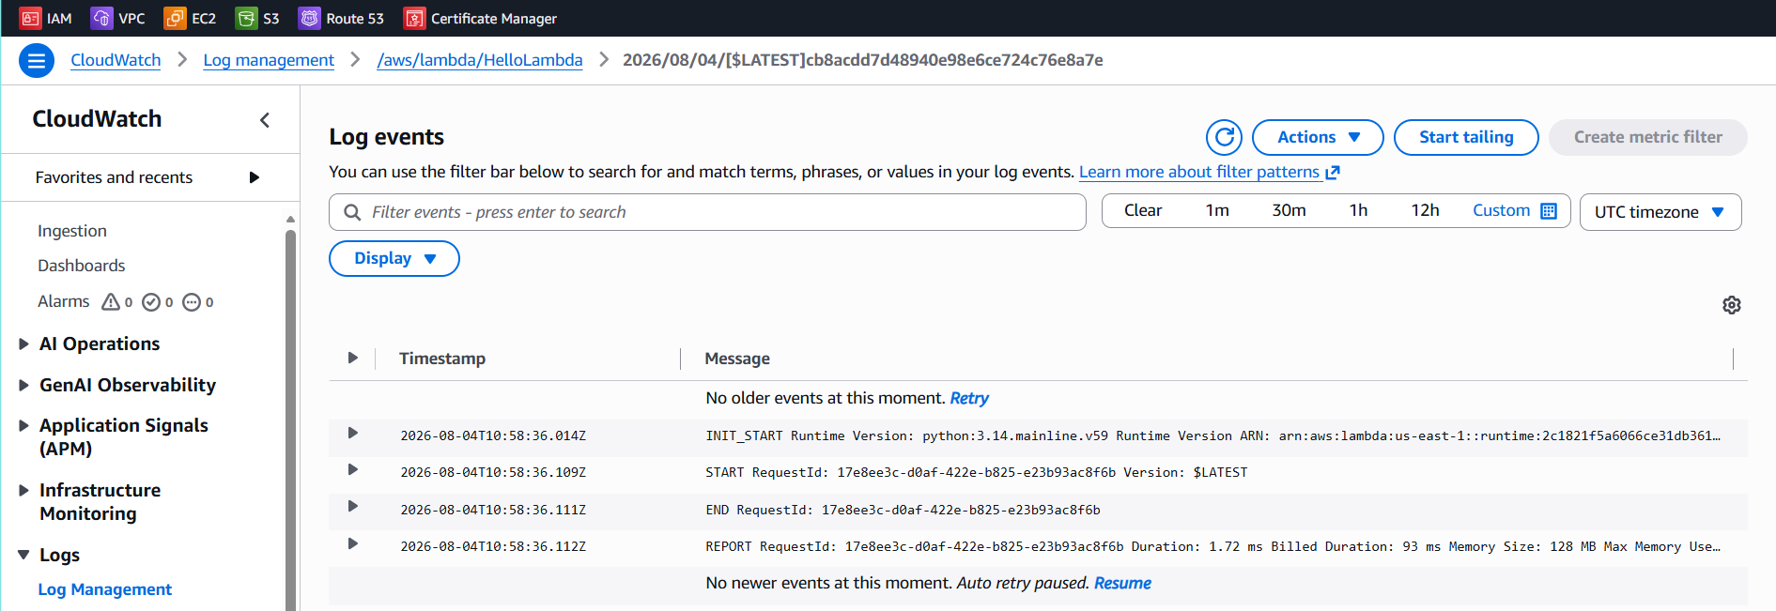

AWS API GATEWAY
Objective
Build an HTTP API with Amazon API Gateway and connect it to the existing HelloLambda function.

Step 1: Access API Gateway
- Log in to the AWS Management Console.
- Search for Amazon API Gateway.
- Open the API Gateway service.
Screenshot: API Gateway Dashboard
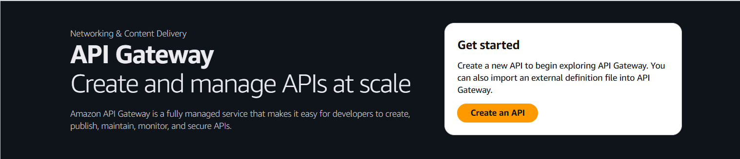

Step 2: Create the API
Select Create API.
The console provides several API options:
- HTTP API (recommended)
- REST API
- WebSocket API
Select HTTP API.
Select Build.
Screenshot: Create HTTP API
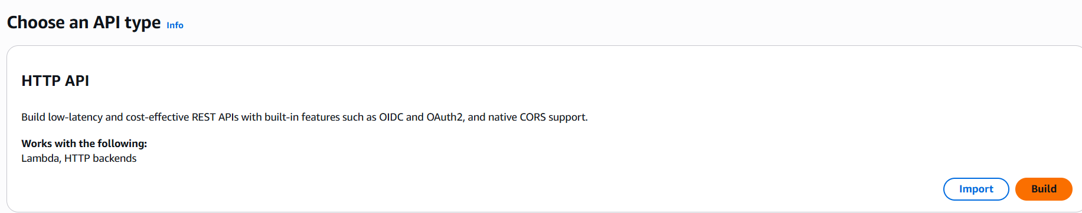

Step 3: Configure the Integration
Under Integrations, configure the following:
- Integration type: Lambda
- Region: Current AWS Region
- Lambda function: HelloLambda
Select Next.
Screenshot: Lambda Integration
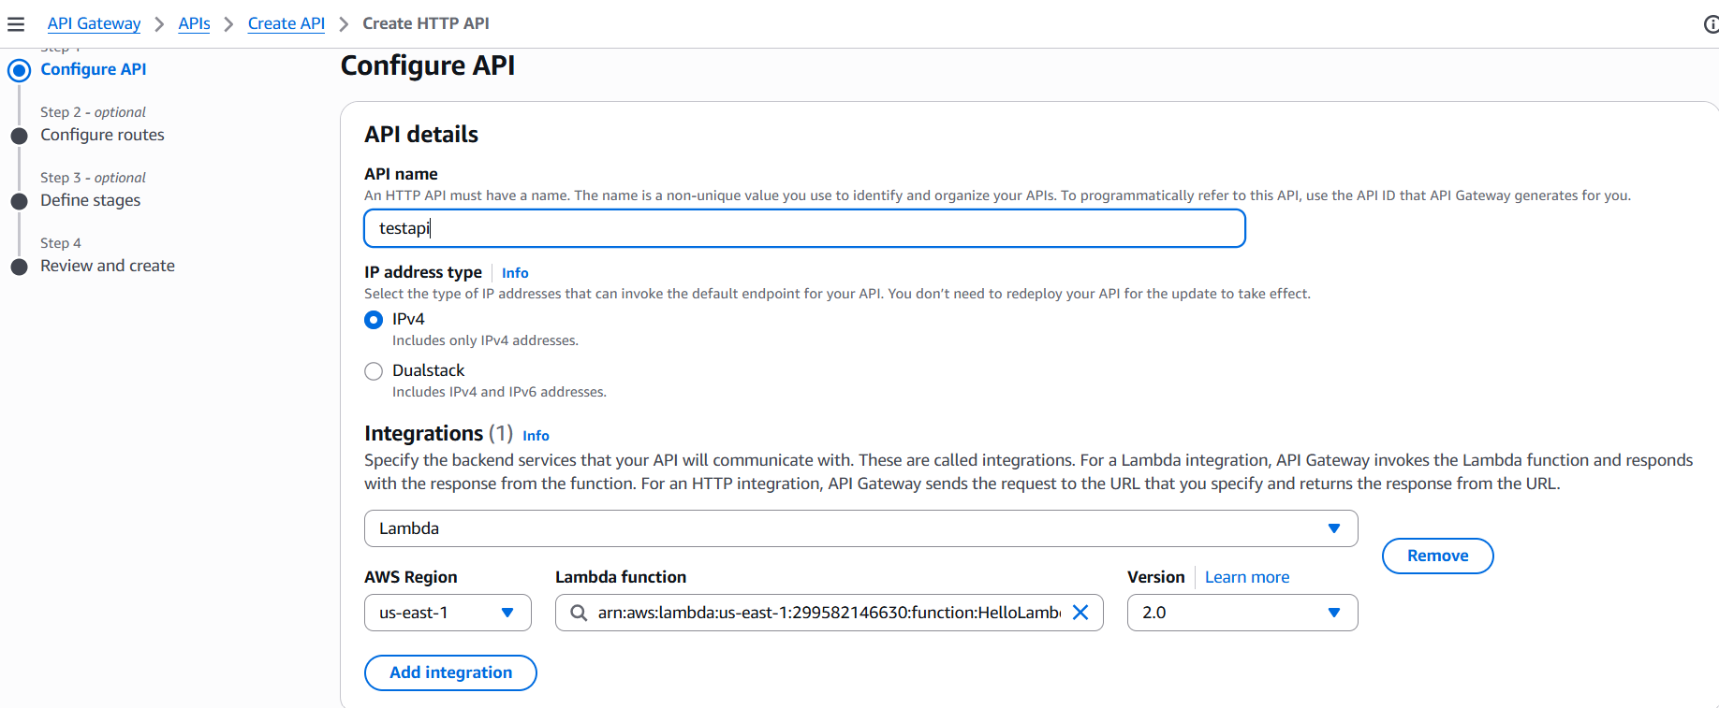

Step 4: Define the Route
Create the following route:
Setting | Value
Method | GET
Resource path | /hello
Select Next.
Screenshot: Route Configuration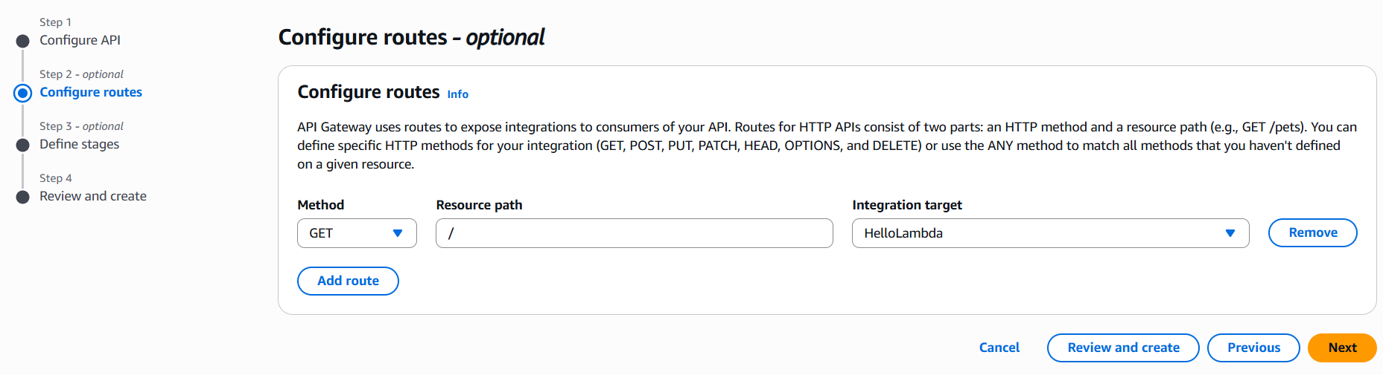

Step 5: Configure the Stage
Stage name:
$default
(Leave the default value unchanged.)
Select Next and then Create.

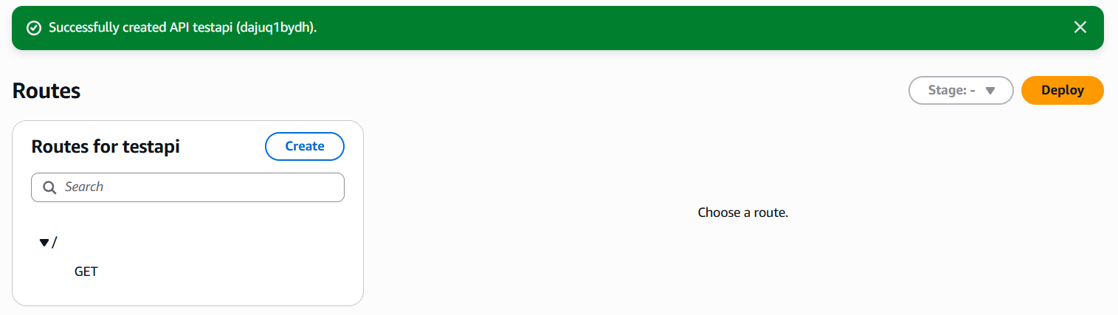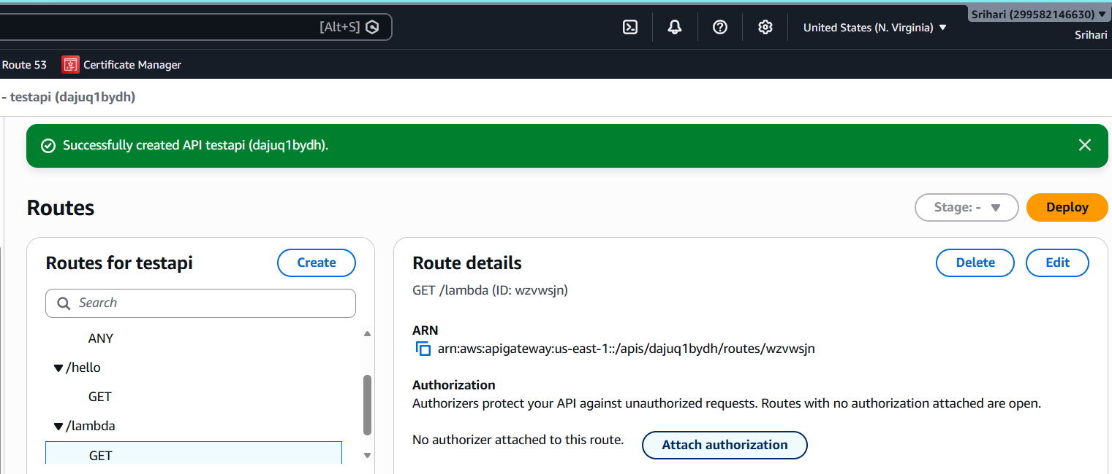

Step 6: Obtain the Invoke URL
Once the API has been created, the console displays an Invoke URL. For example:
https://abc123.execute-api.eu-north-1.amazonaws.com
To call the configured route, append the route path:
https://abc123.execute-api.eu-north-1.amazonaws.com/hello
Open the URL in a browser or test it with Postman.
Screenshot: API Response
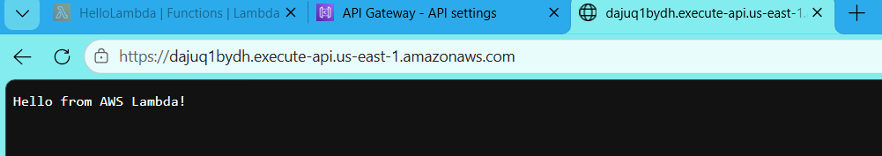
Architecture:
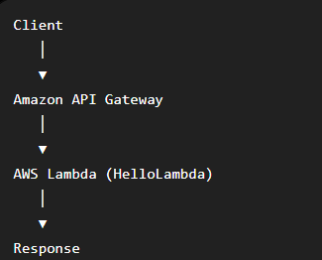

AWS KMS (Key Management Service)
1. Objective
To understand AWS Key Management Service (KMS), create a Customer Managed Key (CMK), and learn how the key can be used to protect AWS resources through encryption.

2. Introduction to AWS KMS
AWS Key Management Service (KMS) is a fully managed service for creating, managing, and controlling cryptographic keys used to encrypt and decrypt data.
Rather than maintaining encryption keys independently, you can use AWS KMS to securely manage them.
Definition
AWS KMS is a managed service that enables you to create, store, administer, and control encryption keys used to protect data across AWS services.

3. Key Features of AWS KMS
- Create and manage encryption keys
- Centralized key management
- Automatic key rotation
- Access control using IAM
- Audit logs through AWS CloudTrail
- Integration with AWS services (S3, EBS, RDS, Lambda, Secrets Manager, etc.)

4. Common Use Cases
- Encrypt Amazon S3 buckets
- Encrypt EBS volumes
- Encrypt RDS databases
- Protect application secrets
- Encrypt Lambda environment variables
- Secure backups and sensitive files

5. AWS KMS Architecture
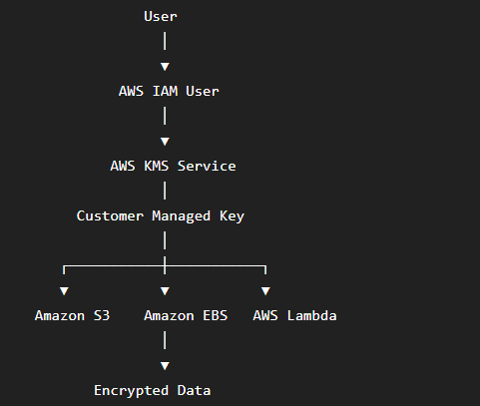
6. KMS Key Categories
AWS Owned Keys
- Fully managed by AWS.
- Used internally by AWS services.
AWS Managed Keys
- Created automatically for AWS services.
- Example: aws/s3, aws/ebs.
Customer Managed Keys (CMK)
- Created and managed by you.
- Full control over permissions, rotation, and deletion.

7. Practical Implementation
Step 1: Access AWS KMS
- Log in to the AWS Management Console.
- Search for KMS.
- Open the Key Management Service.

Screenshot: AWS KMS Dashboard
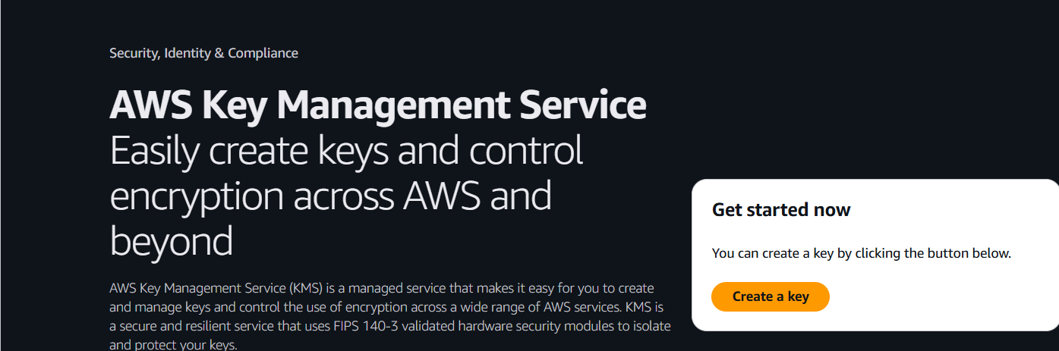

Step 2: Create a KMS Key
- Select Create key.
Choose the following option:
Setting | Value
Key type | Symmetric
Key usage | Encrypt and Decrypt

Step 3: Configure the Key
Enter the following values:
Setting | Value
Alias | DemoKey
Description | Key for AWS KMS Hands-on
Select Next.
Screenshot: Key Alias
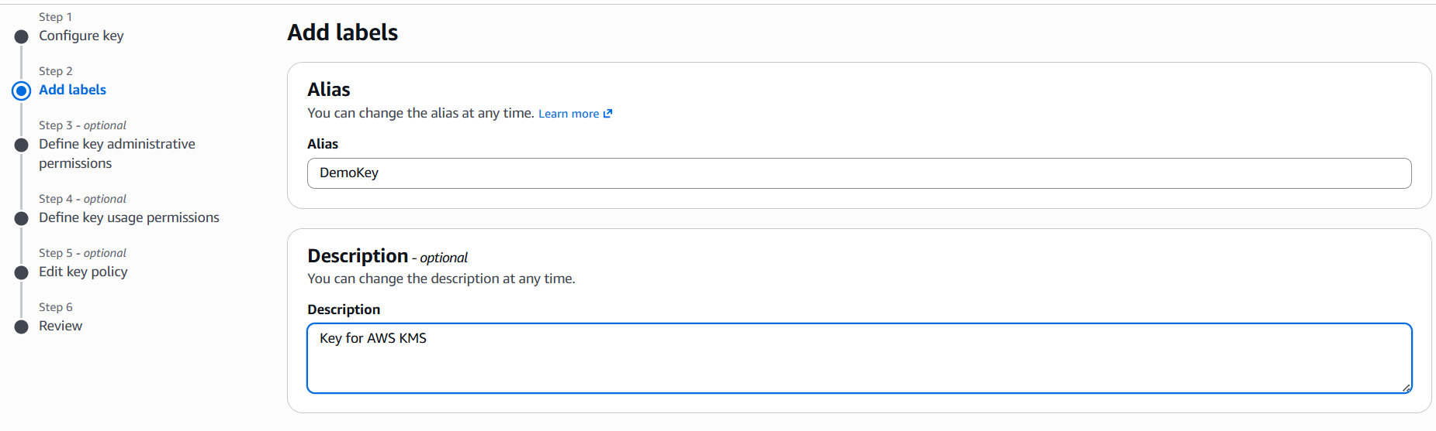

Step 4: Assign Key Administrators
Select the appropriate IAM user as the Key Administrator.
Select Next.
Screenshot: Key Administrators
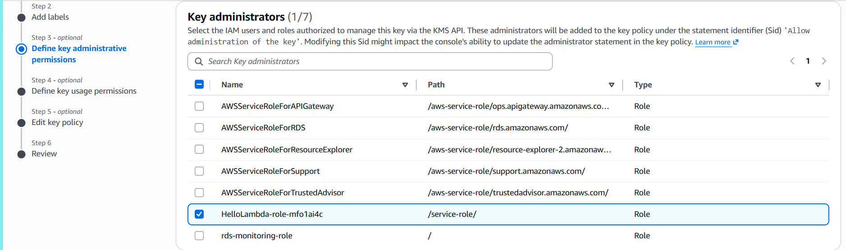

Step 5: Assign Key Users
Select the appropriate IAM user as the Key User.
Select Next.
Screenshot: Key Users
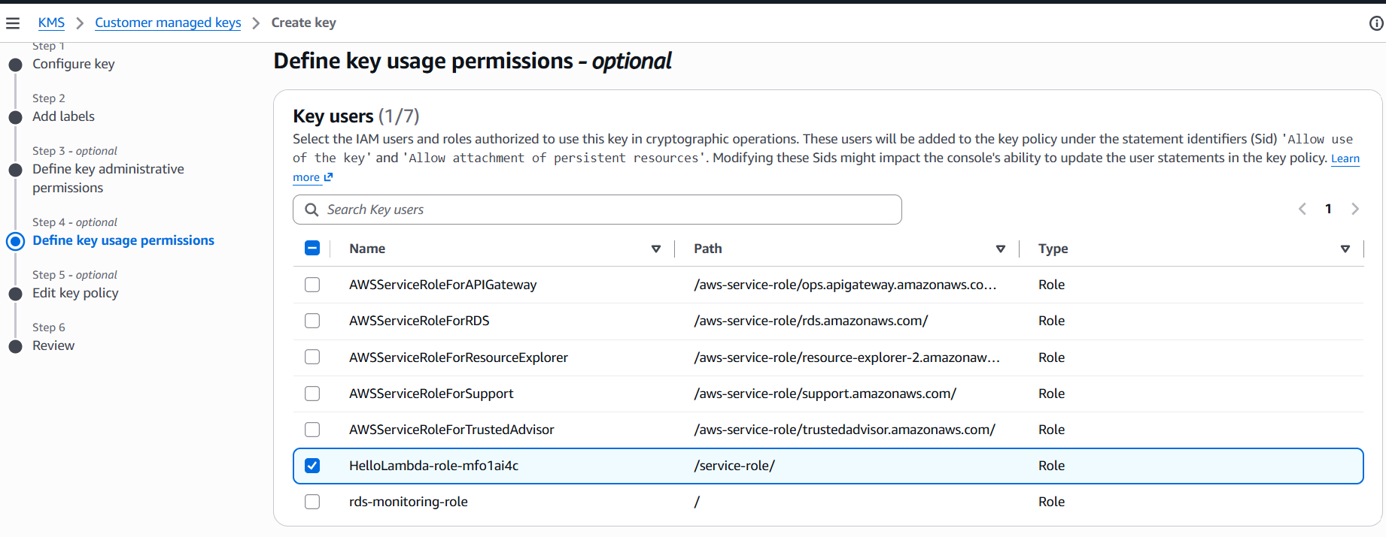

Step 6: Review and Create the Key
Review the selected configuration.
Select Create key.

Step 7: Verify the Created Key
After the key is created, open its details.
Confirm the following details:
- Key ID
- Alias
- ARN
- Status: Enabled
- Key Type: Symmetric
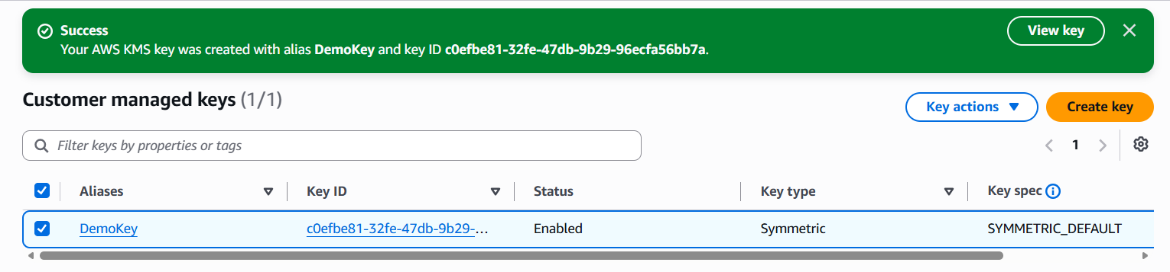

8. Key Configuration
Setting | Value
Key Type | Symmetric
Key Usage | Encrypt and Decrypt
Alias | DemoKey
Key Rotation | Disabled (Enable if required)
Key State | Enabled

9. Observations
- A Customer Managed Key was created successfully.
- IAM permissions were assigned for key administration and usage.
- The key is currently in the Enabled state.
- The key can be integrated with AWS services such as Amazon S3, EBS, RDS, and Lambda for encryption.
- AWS securely manages the encryption key.

10. Benefits
- Secure key storage
- Centralized key management
- Fine-grained access control
- Automatic integration with AWS services
- Audit logging through CloudTrail

11. Limitations
- Deleting a key requires a waiting period (7–30 days).
- If a key is deleted, data encrypted with that key cannot be decrypted.
- KMS usage beyond the free tier may incur charges.

Why Use a KMS Key?
By default, S3 data is not necessarily protected with a customer-managed encryption key.
When AWS KMS is used:
- Only authorized users can decrypt the data.
- You control who can use the key.
- Every key usage is logged in AWS CloudTrail.
- Many AWS services (S3, EBS, RDS, Lambda, Secrets Manager) can use the same key.

Example Task
Step 1: Create an Amazon S3 Bucket
- Open the Amazon S3 service.
- Select Create bucket.
Example:
Setting | Value
Bucket Name | kms-demo-bucket-098
Region | Same as KMS key
Block Public Access | Keep enabled
Select Create bucket.
Screenshot: Create Bucket
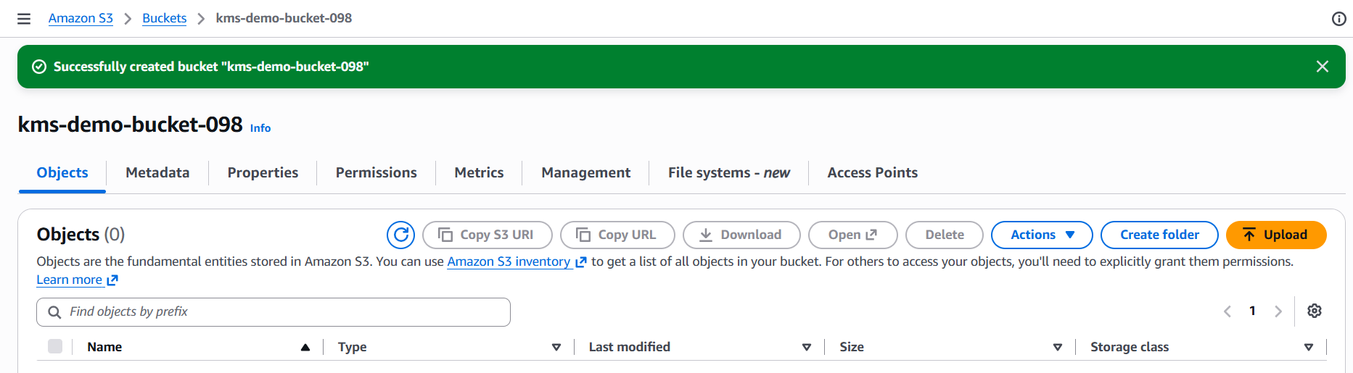

Step 2: Open the Bucket Properties
Open the newly created bucket.
Navigate to:
Properties
Scroll to:
Default encryption
Click Edit.
Screenshot: Bucket Properties
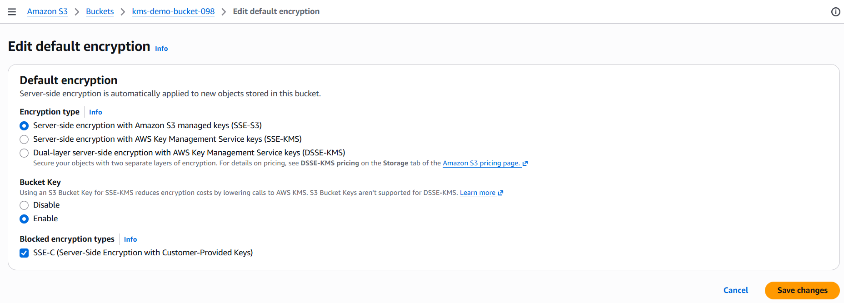

Step 3: Configure KMS Encryption
Select the following options:
- Server-side encryption
- AWS Key Management Service (AWS KMS)
Then select:
Customer managed key
Choose the following option:
DemoKey
Select Save changes.

Screenshot: Enable KMS Encryption
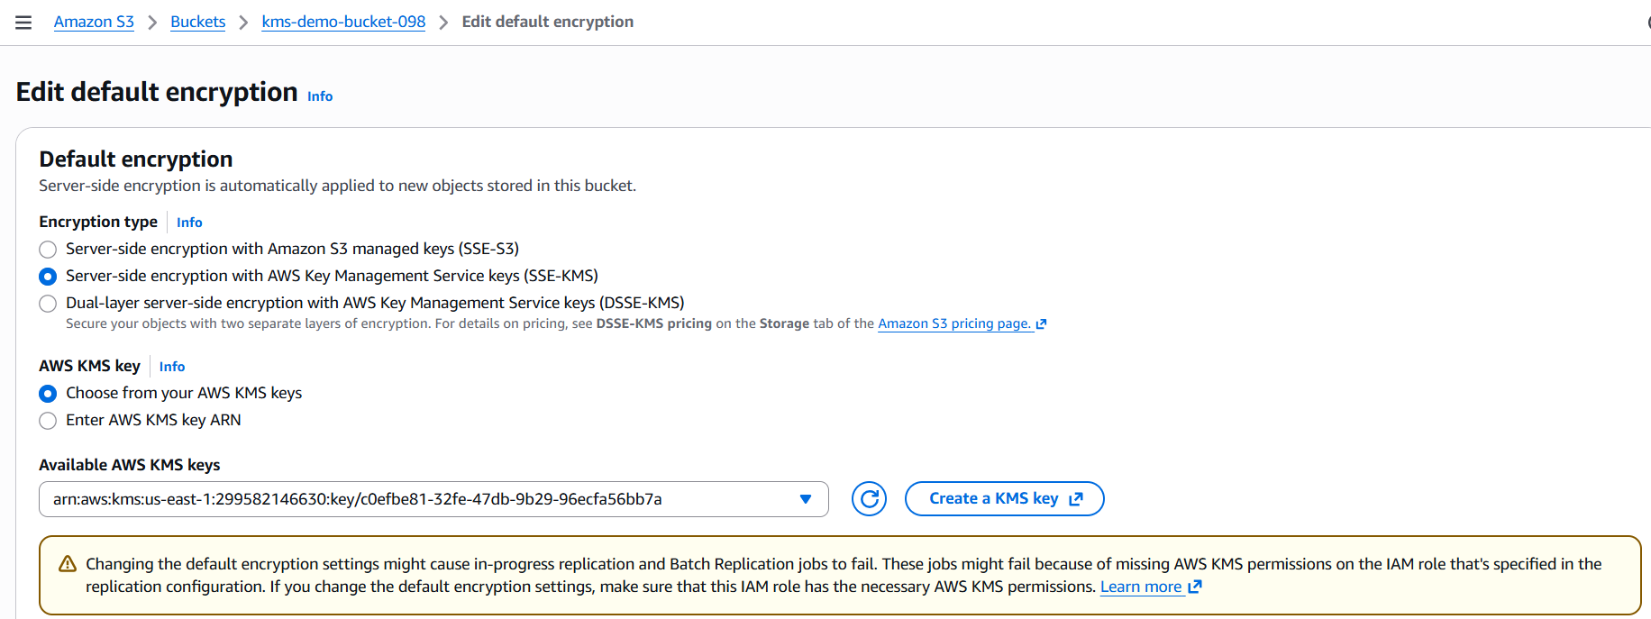

Step 4: Upload a Test File
Select:
Upload
Upload a sample file, for example:
sample.txt
Select Upload.
Screenshot 4: Upload File
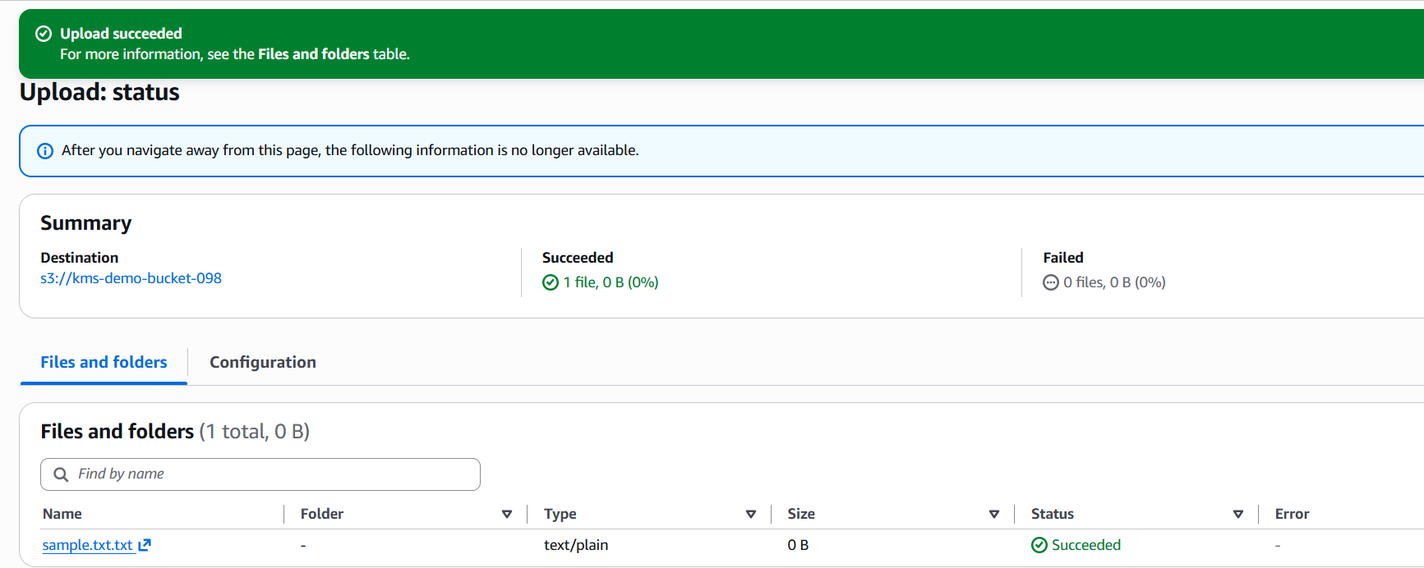

Step 5: Confirm Encryption
Open the uploaded object.
Navigate to:
Properties
Under the properties, you should find:
Server-side encryption
Depending on the AWS Console version, it may display:
- AWS KMS (SSE-KMS)
- Your KMS Key ARN (like in your screenshot), or
- Your key alias (e.g., DemoKey) depending on the AWS Console version.
Displaying the KMS Key ARN is normal in newer versions of the AWS Console.
Screenshot: Encryption Details
