Objective
Complete S3 tasks including bucket creation, static website hosting, cross-region replication, bucket policy, lifecycle policy, AWS CLI operations, Bash scripting, and uploading a 1 GB file.

Task 1: Create an S3 Bucket and Upload Objects
- Open AWS Console → S3 → Create bucket.
- Enter a globally unique bucket name.
- Select the required AWS Region (Mumbai).
- Create the bucket.
- Open the bucket → Upload → Add files → Upload.
- Take Screenshot: Bucket created and uploaded objects.
- 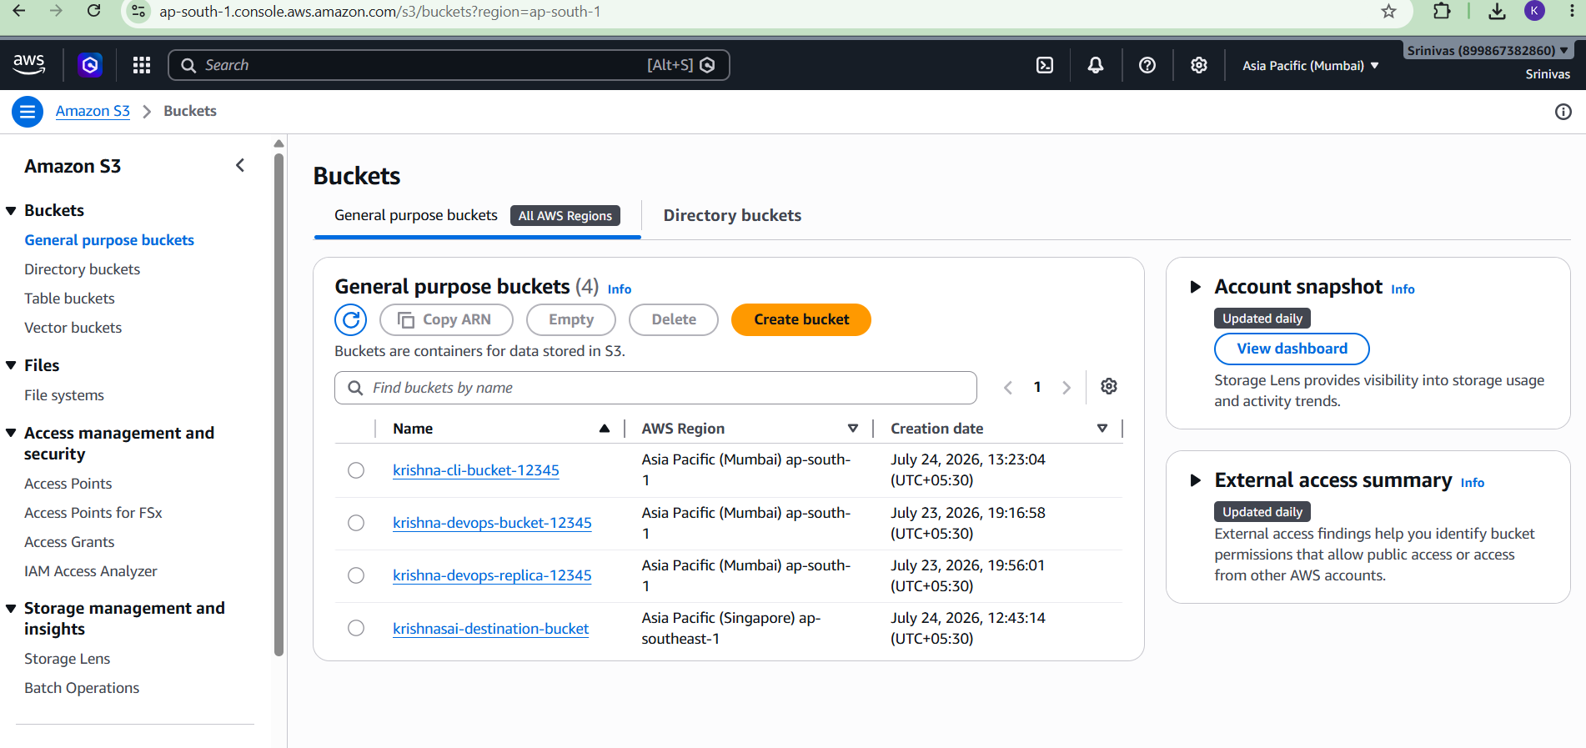

Task 2: Deploy a Static Website
- Open the bucket → Properties.
- Enable Static website hosting.
- Choose 'Host a static website'.
- Set index document as index.html.
- Upload index.html.
- Configure bucket policy for public read (only for website hosting).
- Open the website endpoint and verify it loads.
- Take Screenshot: Website endpoint and web page.
- 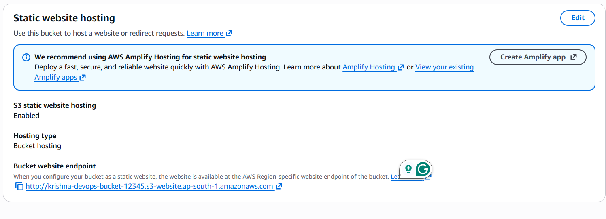
- 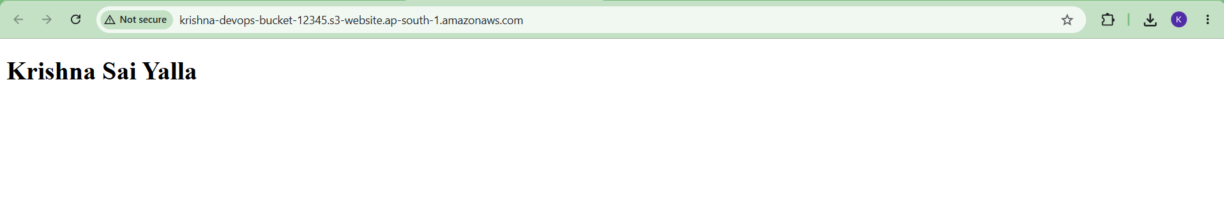

Task 3: Enable Cross-Region Replication
- Create a destination bucket in a different region (Singapore).
- Enable Versioning on both source and destination buckets.
- Open Source Bucket → Management → Replication rules → Create replication rule.
- Apply to all objects.
- Choose destination bucket (Singapore).
- Create a new IAM role automatically.
- Save the rule.
- Upload a new file to the source bucket and verify it appears in the destination bucket.
- Take Screenshot: Replication rule and replicated object.
- 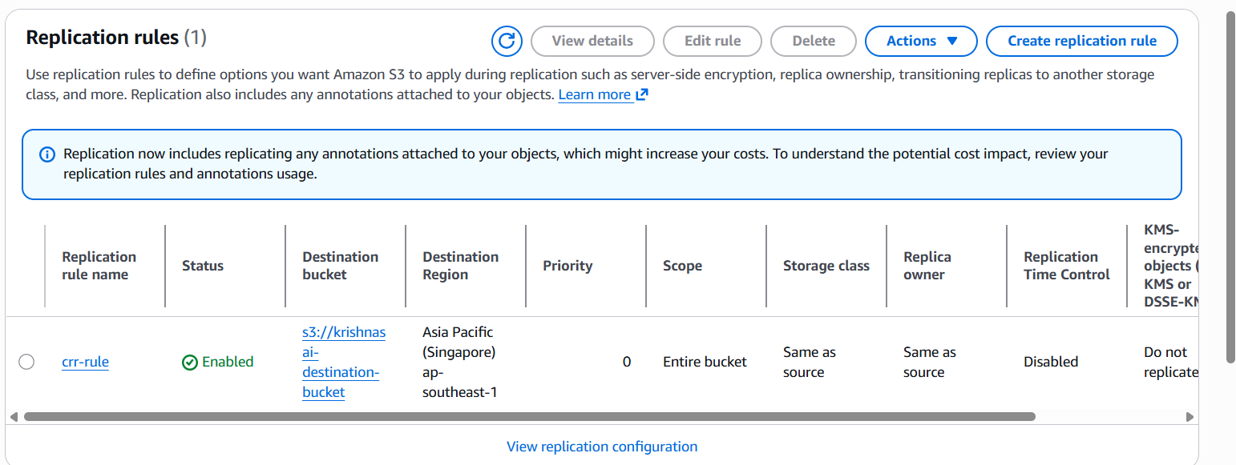
- 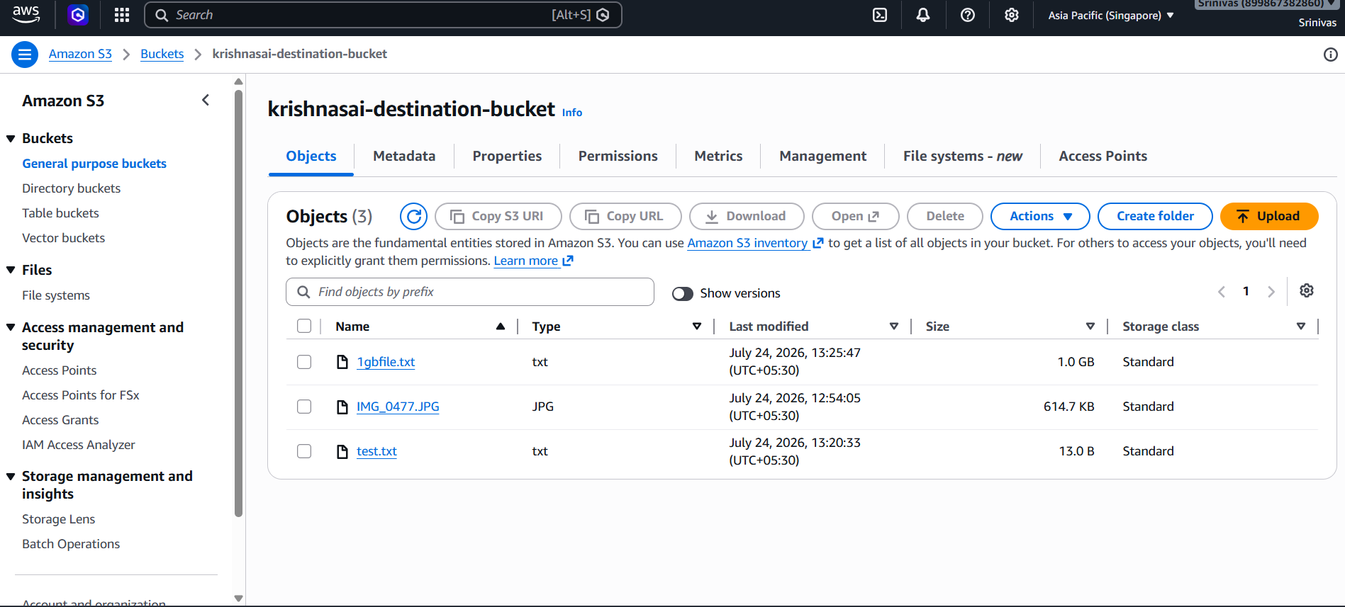

Task 4: Configure Bucket Policy for Admin User
- Create an IAM user named Admin.
- Attach AdministratorAccess policy.
- Copy the Admin user's ARN.
- Open S3 Bucket → Permissions → Bucket Policy.
- Replace the public policy with a policy allowing only the Admin IAM user.
- Save the policy.
- Take Screenshot: Bucket policy and Admin IAM user.
- 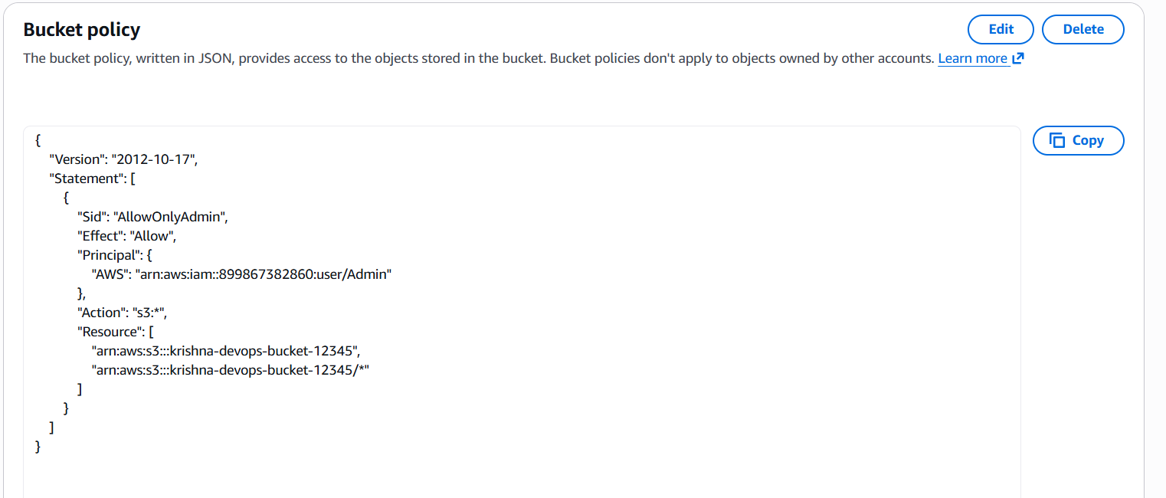
- 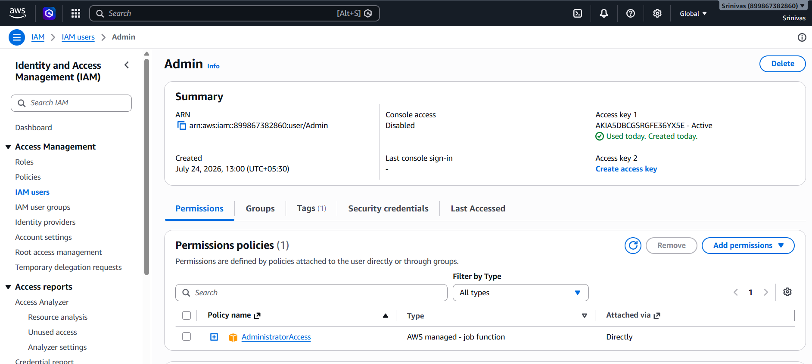

Task 5: Lifecycle Policy
- Open Bucket → Management → Create lifecycle rule.
- Name the rule.
- Apply to all objects.
- Transition objects to Standard-IA after 30 days.
- Expire objects after 365 days.
- Create the rule.
- Take Screenshot: Lifecycle rule.
- 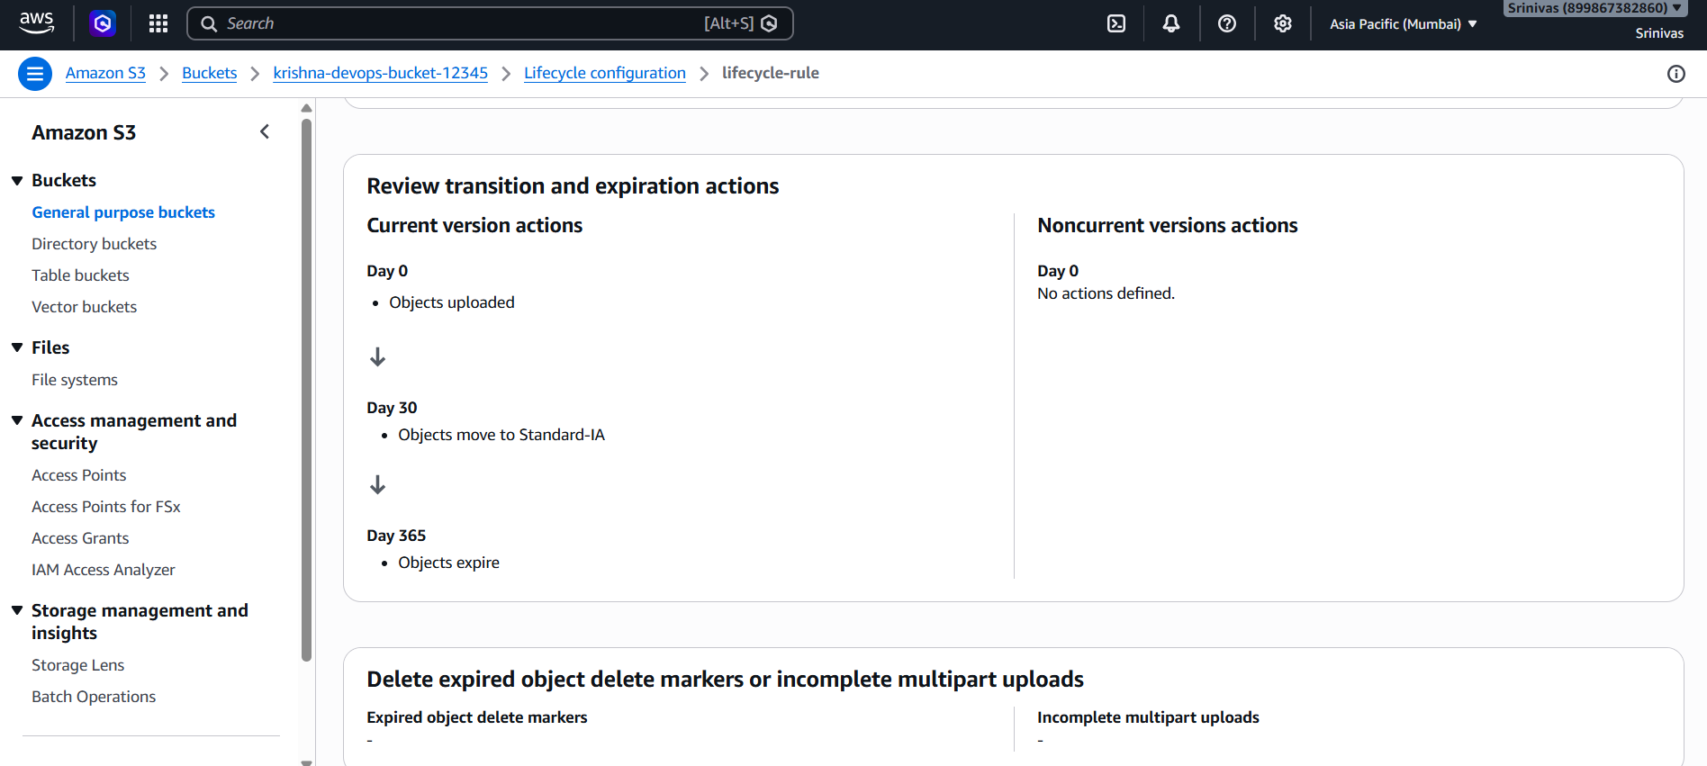

Task 6: Upload Objects Using AWS CLI
- Install AWS CLI.
- Run aws configure and enter Access Key, Secret Key, Region and Output format.
- Create a test file.
- Upload using: aws s3 cp test.txt s3://<bucket-name>/
- Verify the object in S3.
- Take Screenshot: CLI upload and S3 bucket.
- 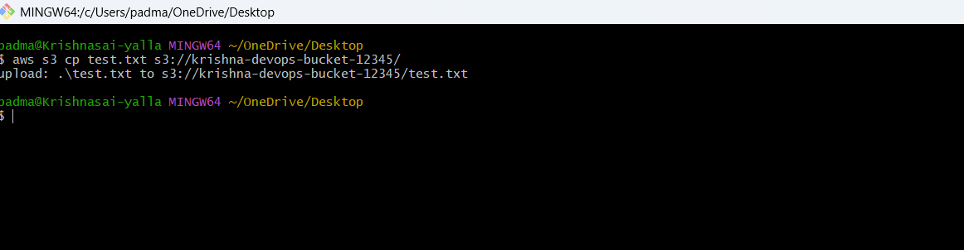
- 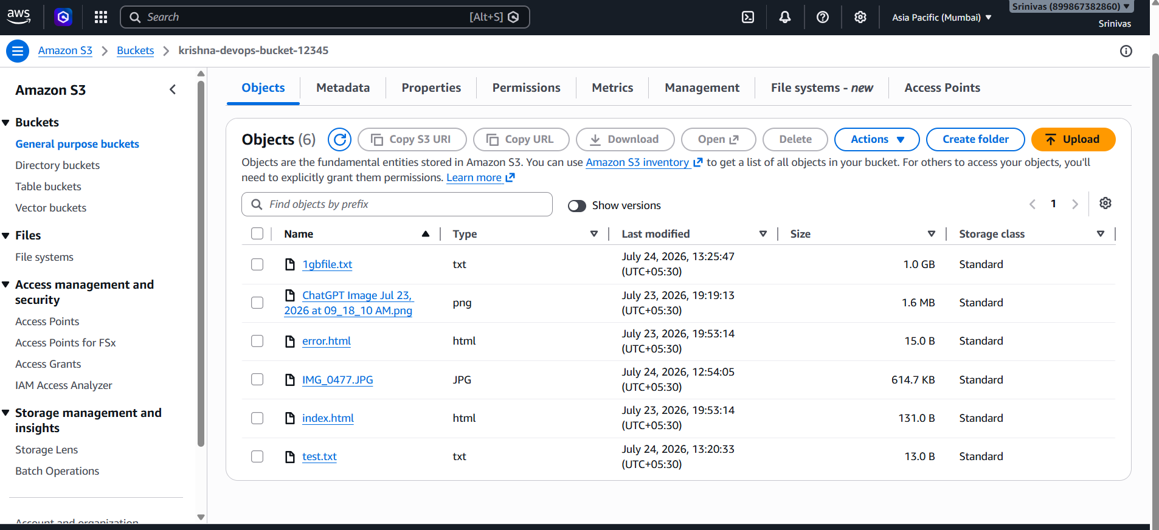

Task 7: Bash Script to Create S3 Bucket
- Create create_bucket.sh.
- Script:
- #!/bin/bash
BUCKET_NAME="your-unique-bucket-name"
REGION="ap-south-1"
aws s3api create-bucket --bucket $BUCKET_NAME --region $REGION --create-bucket-configuration LocationConstraint=$REGION
echo "Bucket created successfully."
- Run chmod +x create_bucket.sh
- Execute ./create_bucket.sh
- Take Screenshot: Script and created bucket.
- 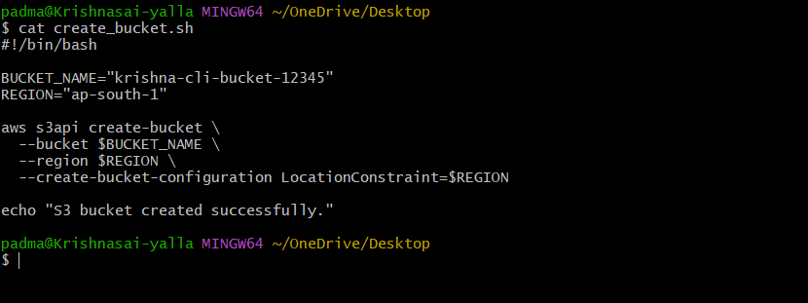
- 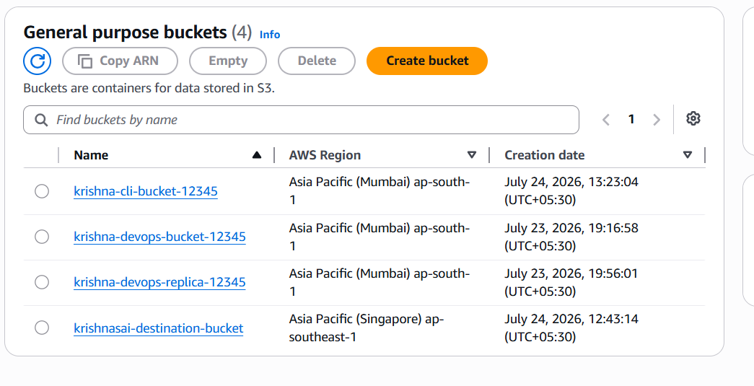

Task 8: Upload 1 GB File
- Create a 1 GB file:
fsutil file createnew 1gbfile.txt 1073741824
- Upload:
aws s3 cp 1gbfile.txt s3://<bucket-name>/
- Verify the upload in S3.
- Take Screenshot: CLI upload progress and bucket objects.
- 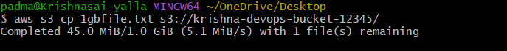

Commands Used
aws --version
aws configure
aws s3 cp test.txt s3://<bucket-name>/
chmod +x create_bucket.sh
./create_bucket.sh
fsutil file createnew 1gbfile.txt 1073741824
aws s3 cp 1gbfile.txt s3://<bucket-name>/

