JENKINS-01 ASSIGNMENT
Jenkins Installation, Security, Users, Labels, Sample Jobs & Private GitHub Job

TASK 1 — Install Jenkins and Run on Port 8081
Objective: Install Jenkins on the Ubuntu EC2 server and make Jenkins accessible on port 8081.

Step 1.1 — Connect to the Ubuntu EC2 server
Connect to the Ubuntu server using SSH from Git Bash/terminal.
ssh -i <key-file.pem> ubuntu@<EC2-PUBLIC-IP>
Replace <key-file.pem> and <EC2-PUBLIC-IP> with the values for your server.

Step 1.2 — Install Java
sudo apt update
sudo apt install -y fontconfig openjdk-21-jre
Java is required for Jenkins to run.

Step 1.3 — Install Jenkins
Add the Jenkins repository/key and install Jenkins. After installation, verify the service.
sudo systemctl enable jenkins
sudo systemctl start jenkins
sudo systemctl status jenkins

Step 1.4 — Configure Jenkins to use port 8081
The Jenkins service configuration was changed so Jenkins listens on port 8081 instead of the default 8080.
sudo systemctl restart jenkins
Jenkins was then accessed in the browser using:
http://<EC2-PUBLIC-IP>:8081
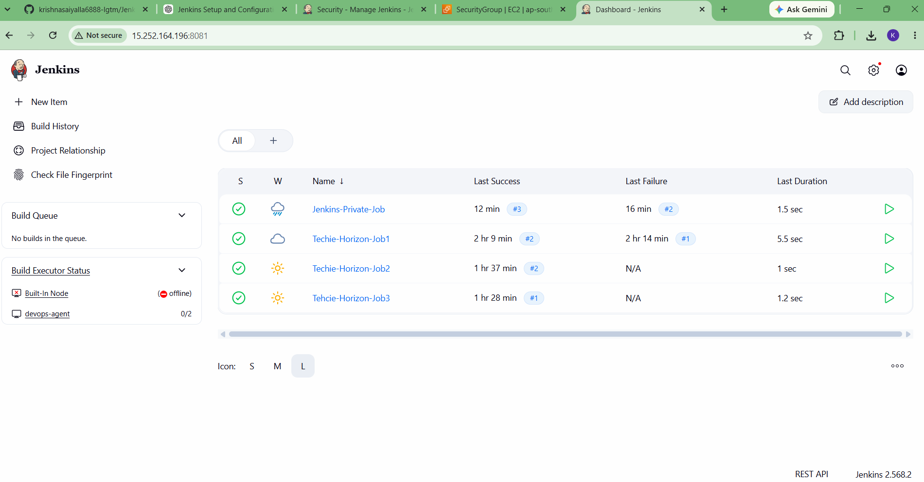

Step 1.5 — Verify port 8081
sudo ss -lntp | grep 8081
The Jenkins Java process was listening on port 8081.
Task 1 Screenshot — Jenkins running on port 8081:
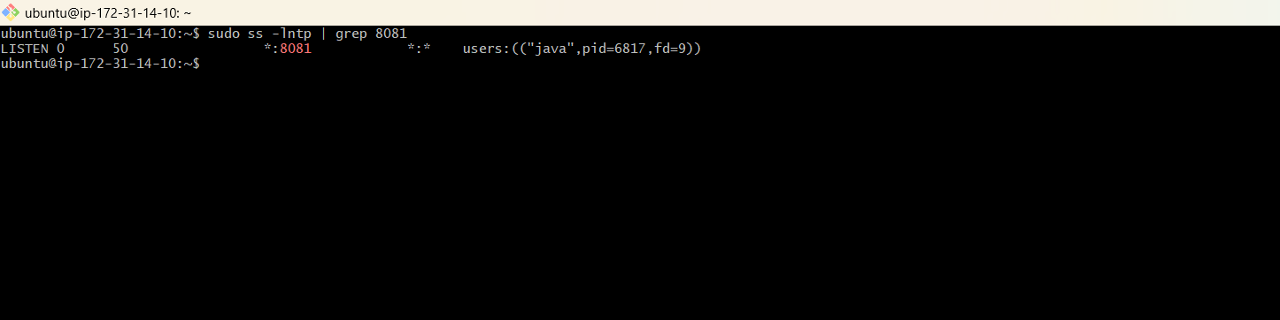

TASK 2 — Secure Jenkins Server
Objective: Enable Jenkins authentication and authorization so unauthenticated users cannot access Jenkins.

Step 2.1 — Open Jenkins Security
Go to: Manage Jenkins → Security.

Step 2.2 — Configure authentication
Jenkins' own user database was used for managing Jenkins users.

Step 2.3 — Configure authorization
Matrix-based security was selected. This allows permissions to be assigned individually to users.
Authorization: Matrix-based security

Step 2.4 — Secure anonymous access
Anonymous users were left with no permissions, preventing unauthenticated access.

Step 2.5 — Keep administrator access
The administrator account was retained with Overall → Administer permission so the Jenkins server remains manageable.
Result: Jenkins security is enabled and access is controlled through the Jenkins permission matrix.
Task 2 Screenshot — Security / Matrix-based authorization:
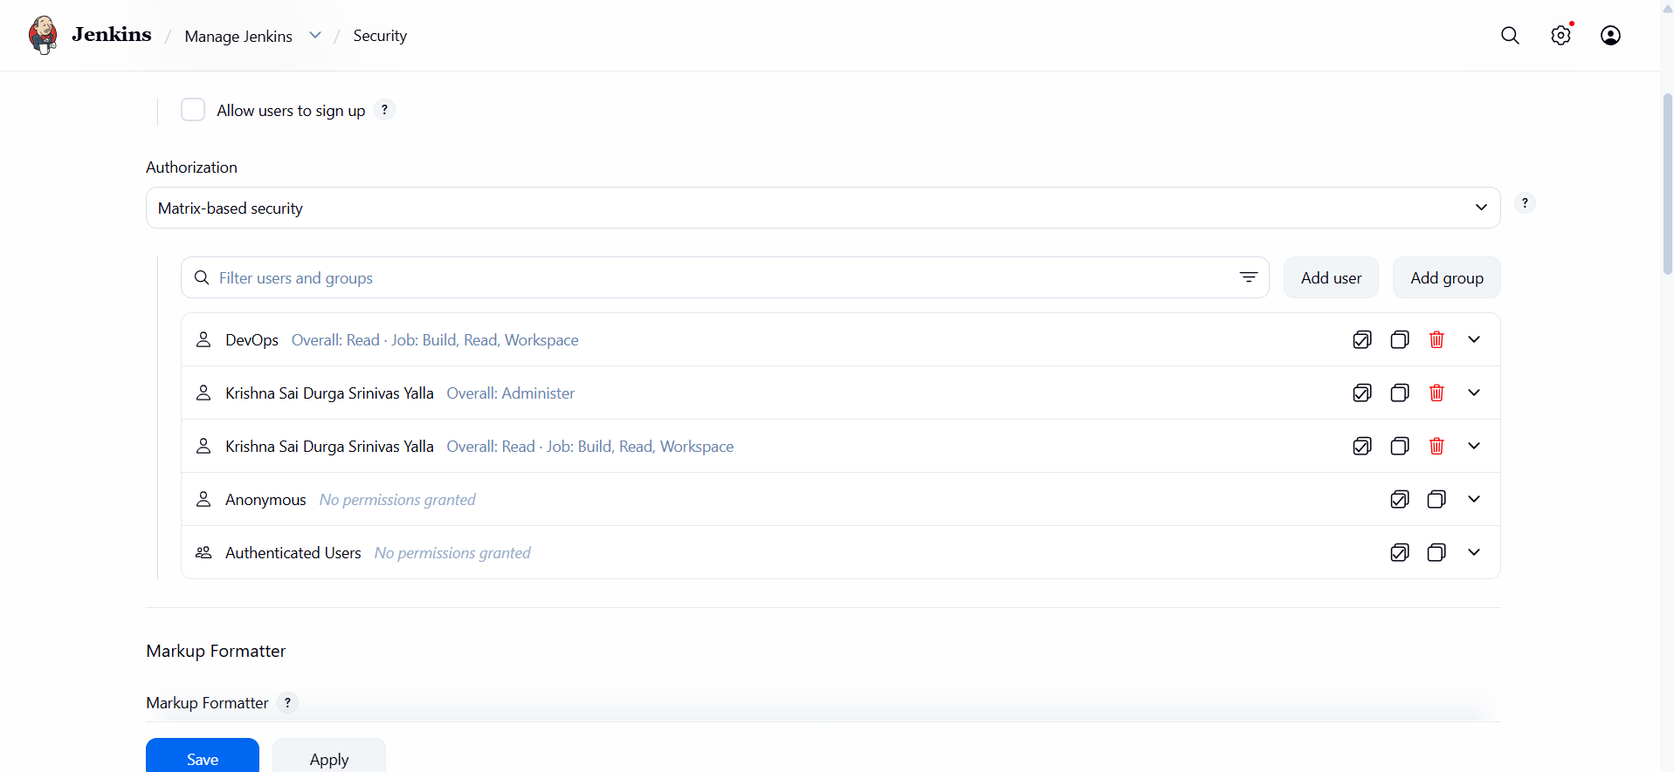

TASK 3 — Create DevOps and Testing Users with Limited Access
Objective: Create two Jenkins users and give them limited permissions.

Step 3.1 — Open Jenkins User Management
Go to: Manage Jenkins → Users.

Step 3.2 — Create DevOps user
A Jenkins user named DevOps was created.

Step 3.3 — Create Testing user
A Jenkins user named Testing was created.

Step 3.4 — Configure limited permissions
Under Matrix-based security, both users were given limited permissions:
Overall: Read
Job: Read
Job: Build
Job: Workspace
Neither DevOps nor Testing received Overall → Administer permission.

Step 3.5 — Verify users
The Jenkins user list showed DevOps, Testing, and the administrator account.
Task 3 Screenshot — Users list:
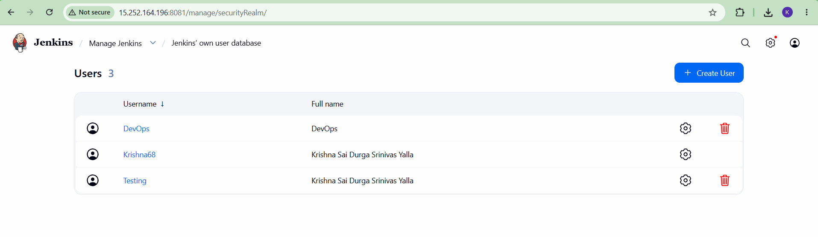
Task 3 Screenshot — Matrix permissions for DevOps/Testing:
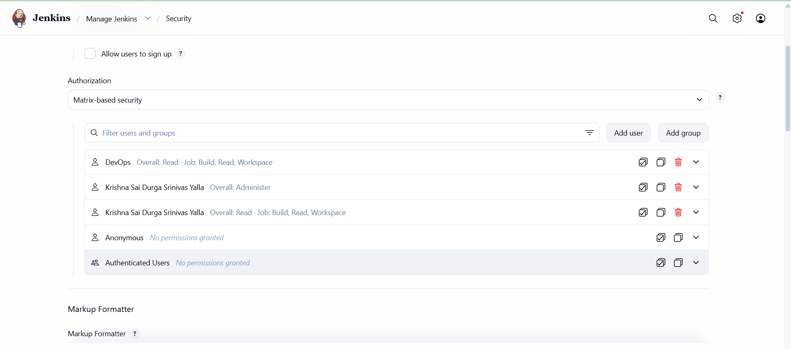

TASK 4 — Configure Labels and Restrict Jobs to the Label
Objective: Configure a Jenkins agent label and ensure jobs execute only on that labeled agent.

Step 4.1 — Configure Jenkins agent
A Jenkins agent named devops-agent was configured and connected to the controller.

Step 4.2 — Configure the label
The agent was assigned the label:
devops

Step 4.3 — Connect the agent
The agent was connected using the Jenkins agent command line/WebSocket method. The agent page showed:
Agent is connected.
Task 4 Screenshot — devops-agent connected with label devops:
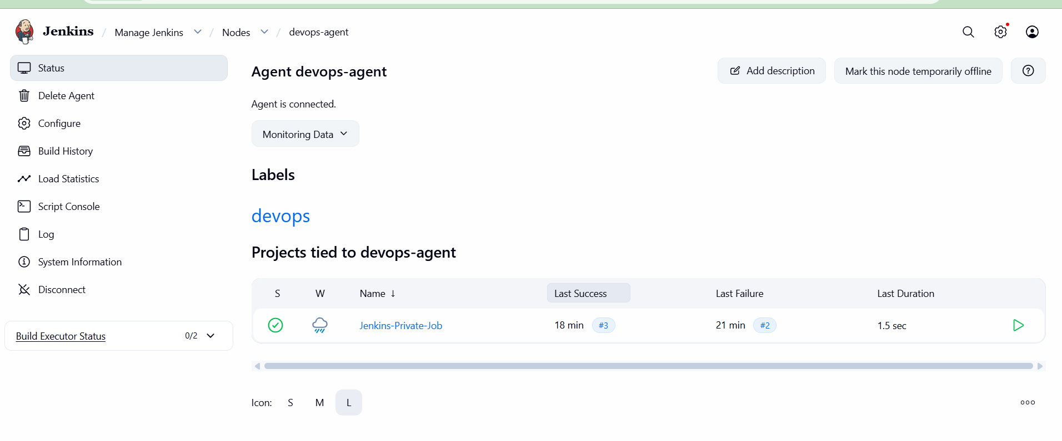

Step 4.4 — Restrict a job to the label
For each relevant job, General → Restrict where this project can be run was enabled.
Label Expression: devops
Jenkins therefore schedules the job on a node matching the devops label.
Task 4 Screenshot — Restrict where this project can be run / Label Expression: devops:
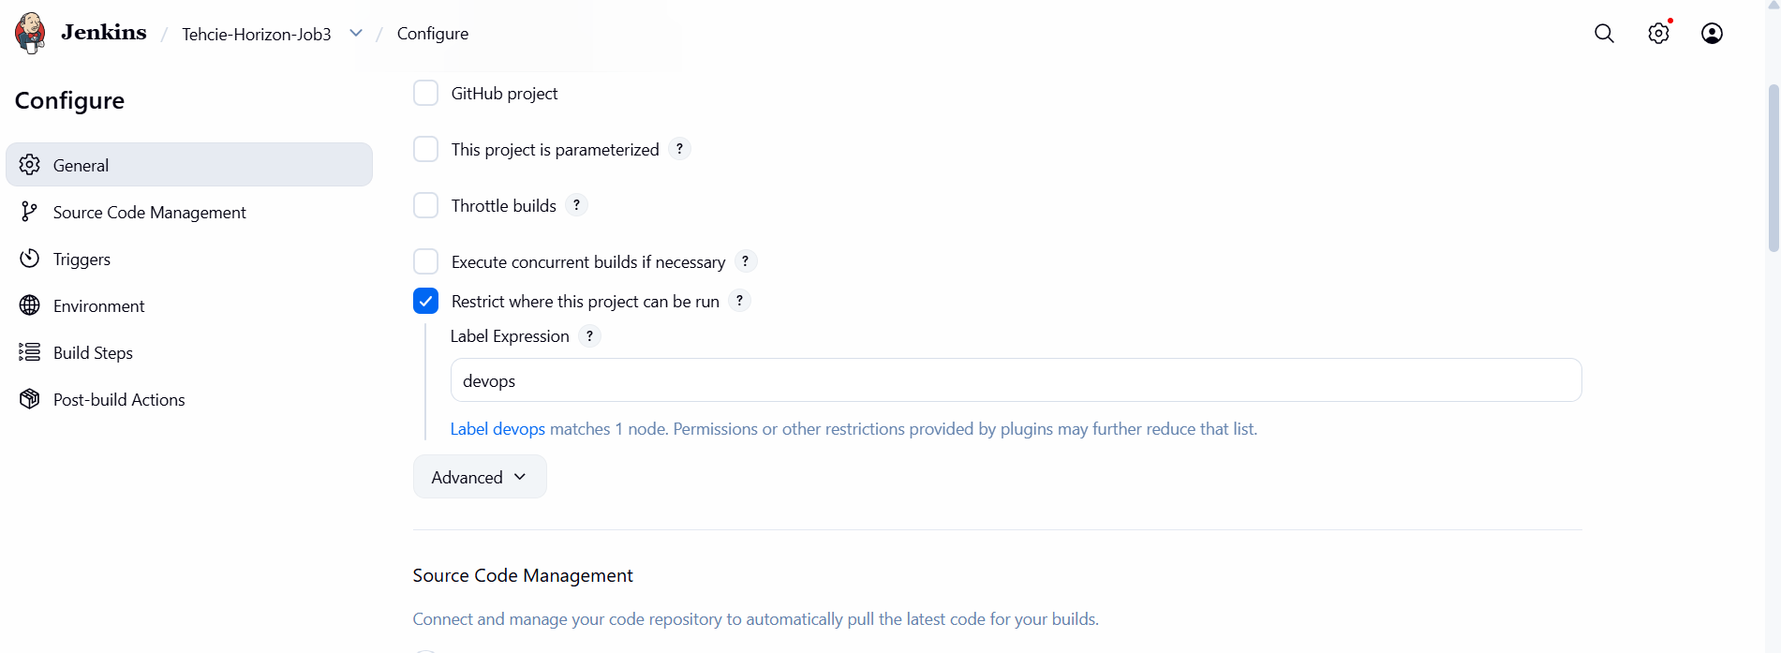

TASK 5 — Create Three Sample Jobs
Objective: Create three Jenkins jobs using the supplied public GitHub source repository.
Source repository:
https://github.com/betawins/Techie_horizon_Login_app.git

Step 5.1 — Create Sample Job 1
Created the job:
Techie-Horizon-Job1
Configured Git source code management and the required branch. The job was restricted to the devops label and a shell build step was used to print system/job information.
Task 5 Screenshot — Techie-Horizon-Job1 successful build:
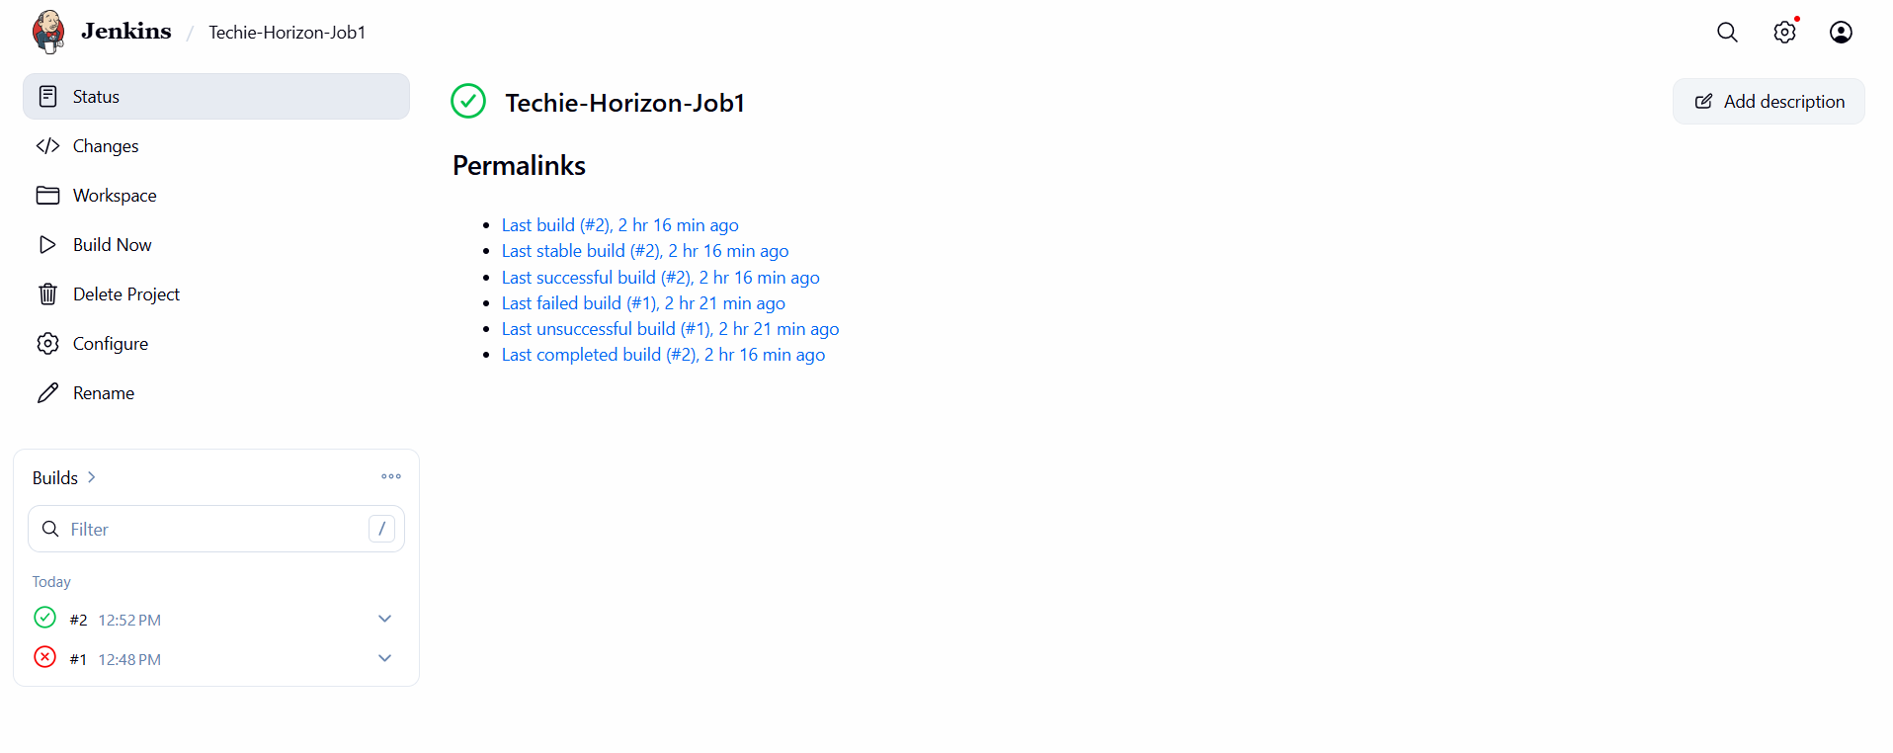

Step 5.2 — Create Sample Job 2
Created the job:
Techie-Horizon-Job2
The job checked out the repository and executed the configured shell script on devops-agent.
The console output included system health information such as disk and memory usage.
Task 5 Screenshot — Techie-Horizon-Job2 successful build:
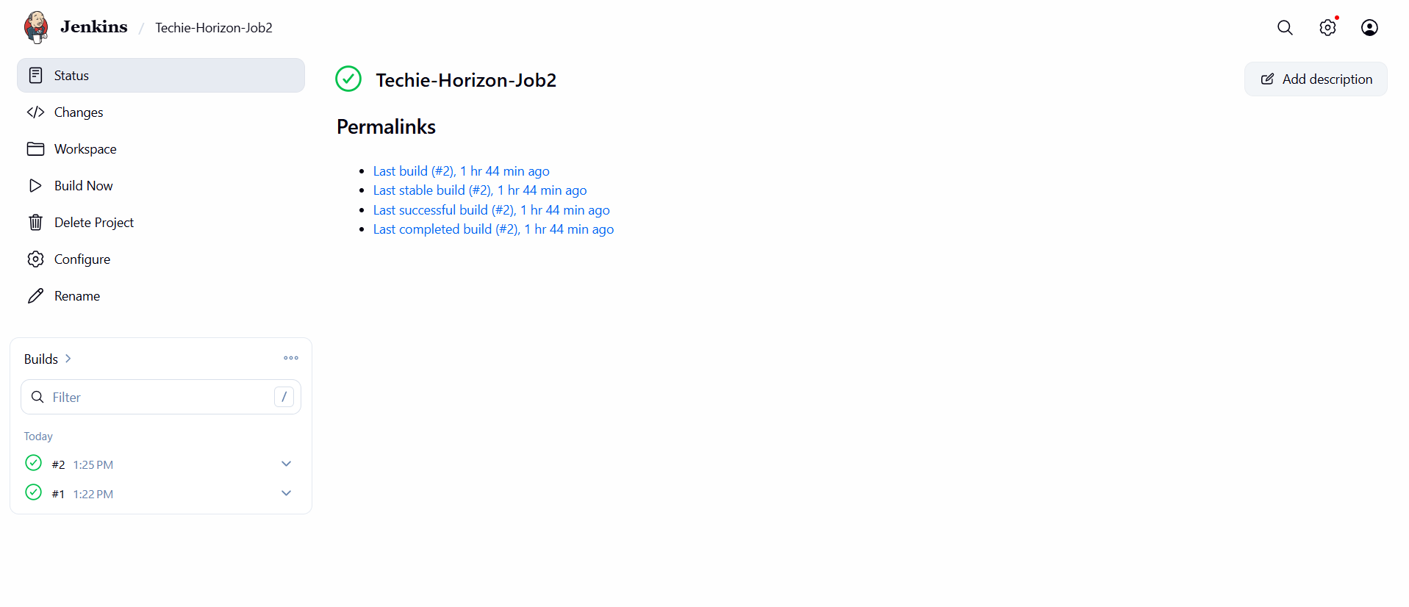

Step 5.3 — Create Sample Job 3
Created the job:
Techie-Horizon-Job3
The job printed sample build information including build number, job name, workspace and node.
Task 5 Screenshot — Techie-Horizon-Job3 successful build:
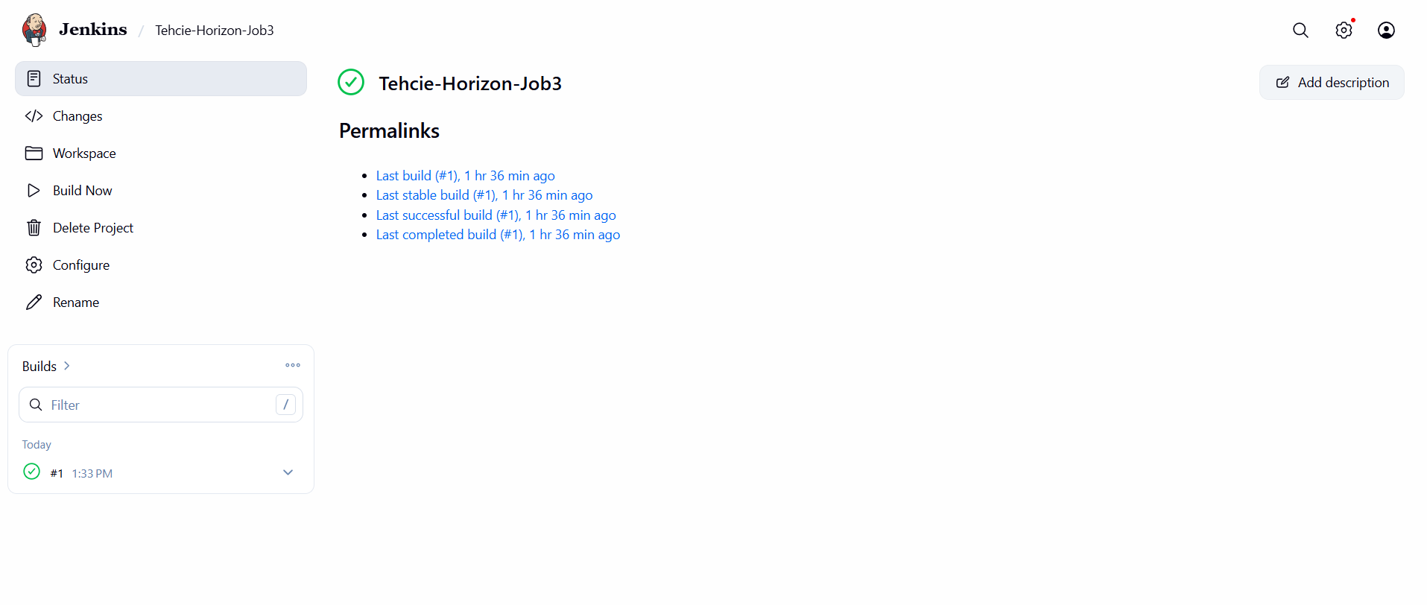

Task 5 Result
All three sample jobs were executed successfully on the labeled devops-agent.
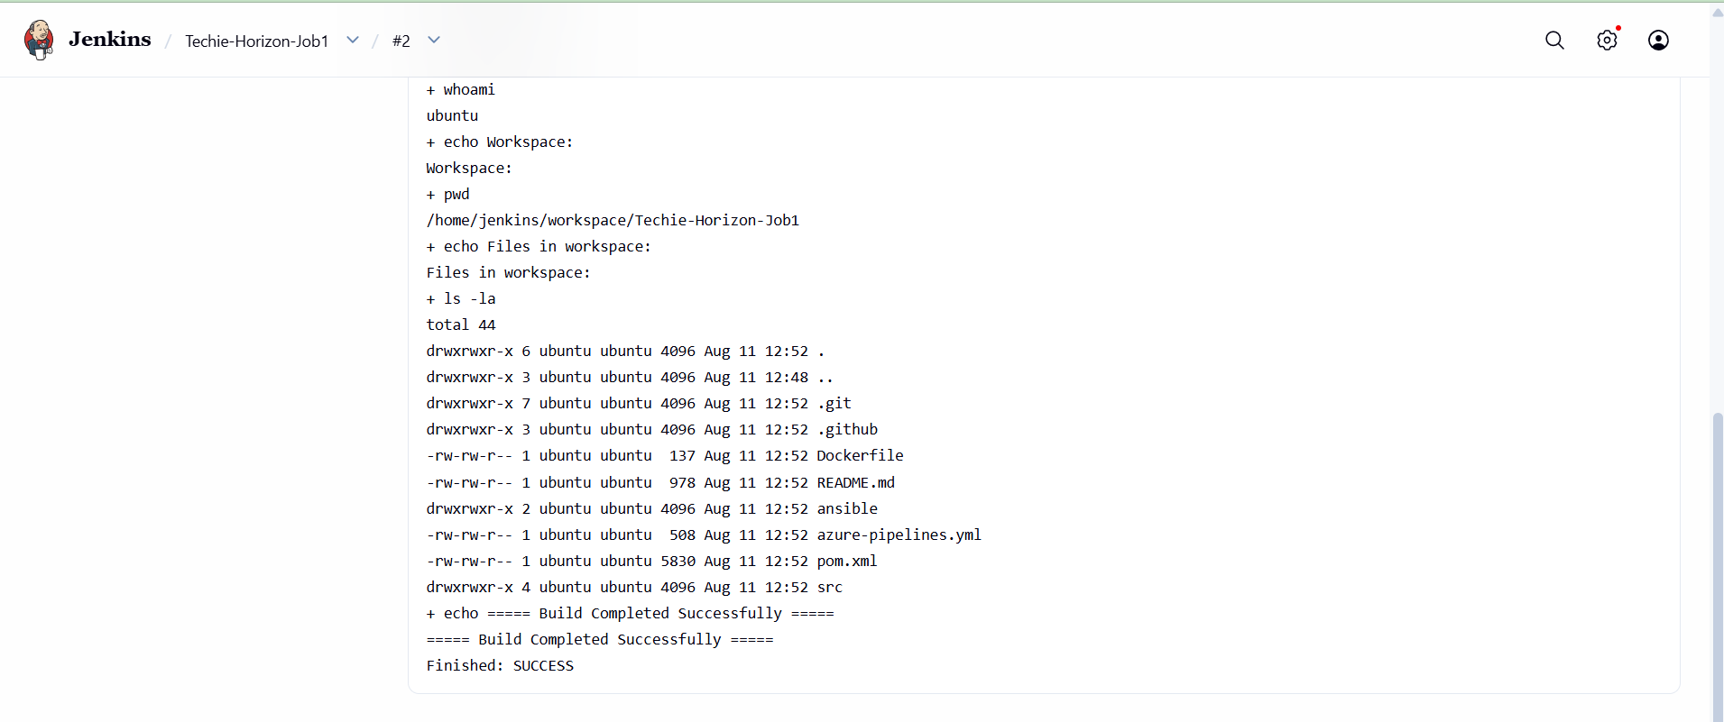
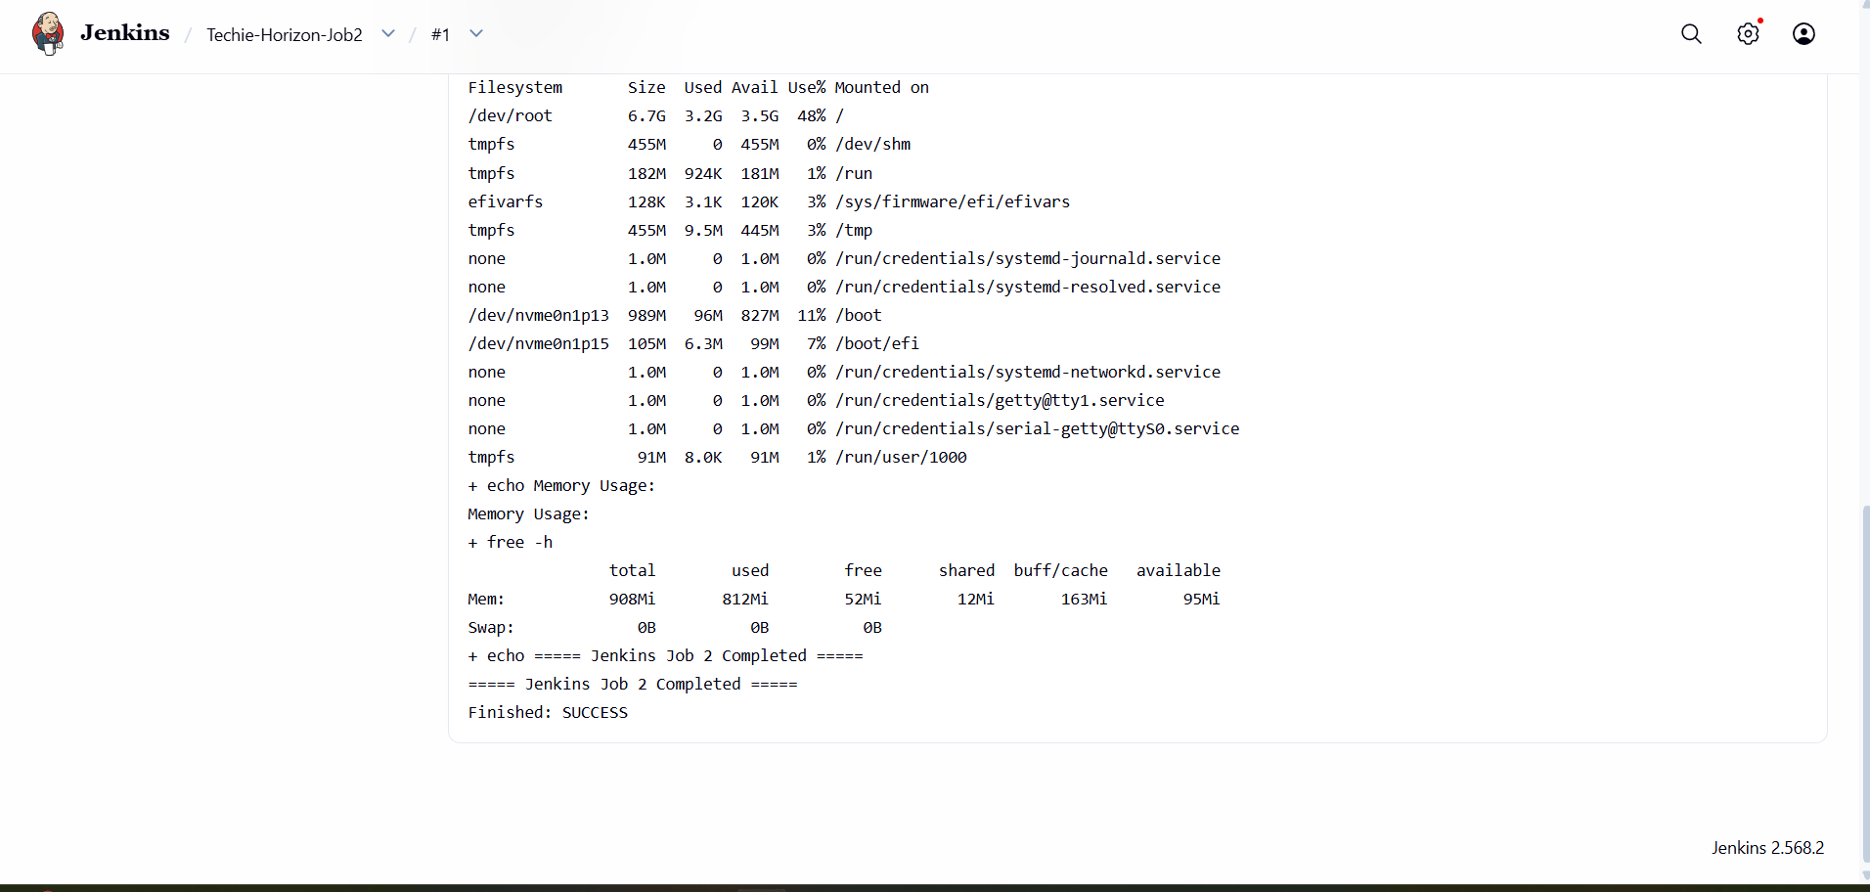
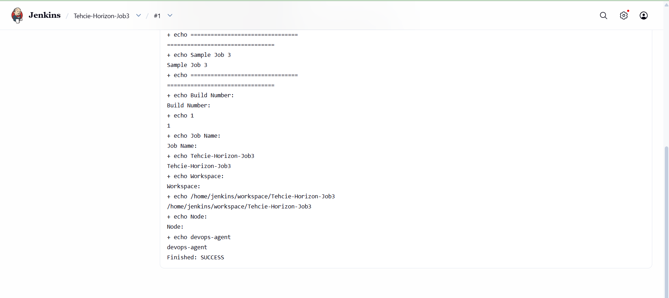

TASK 6 — Create a Jenkins Job Using a GitHub Private Repository
Objective: Create a private GitHub repository, authenticate Jenkins using a GitHub token, and successfully build the private repository.

Step 6.1 — Create the private GitHub repository
A private repository was created:
Jenkins-Private-Repo
The repository was initialized with a README and uses the main branch.
Task 6 Screenshot — Private GitHub repository:
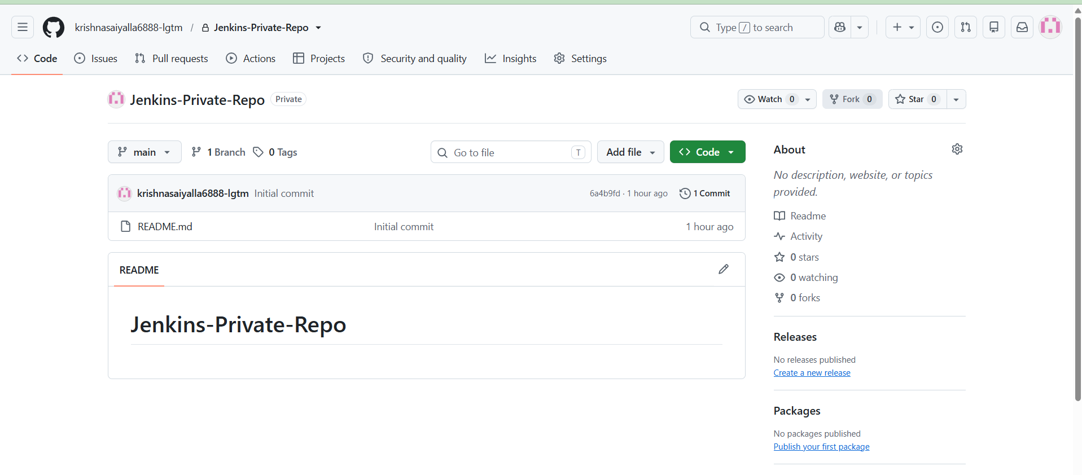

Step 6.2 — Generate a GitHub Personal Access Token
A GitHub Personal Access Token was generated for Jenkins authentication. The token itself should never be pasted into this document or exposed in screenshots.

Step 6.3 — Add the token to Jenkins Credentials
The GitHub token was added to Jenkins as a credential with the ID:
github-private-token
The token is stored securely in Jenkins and is referenced by the job instead of being written directly into the repository URL or build script.
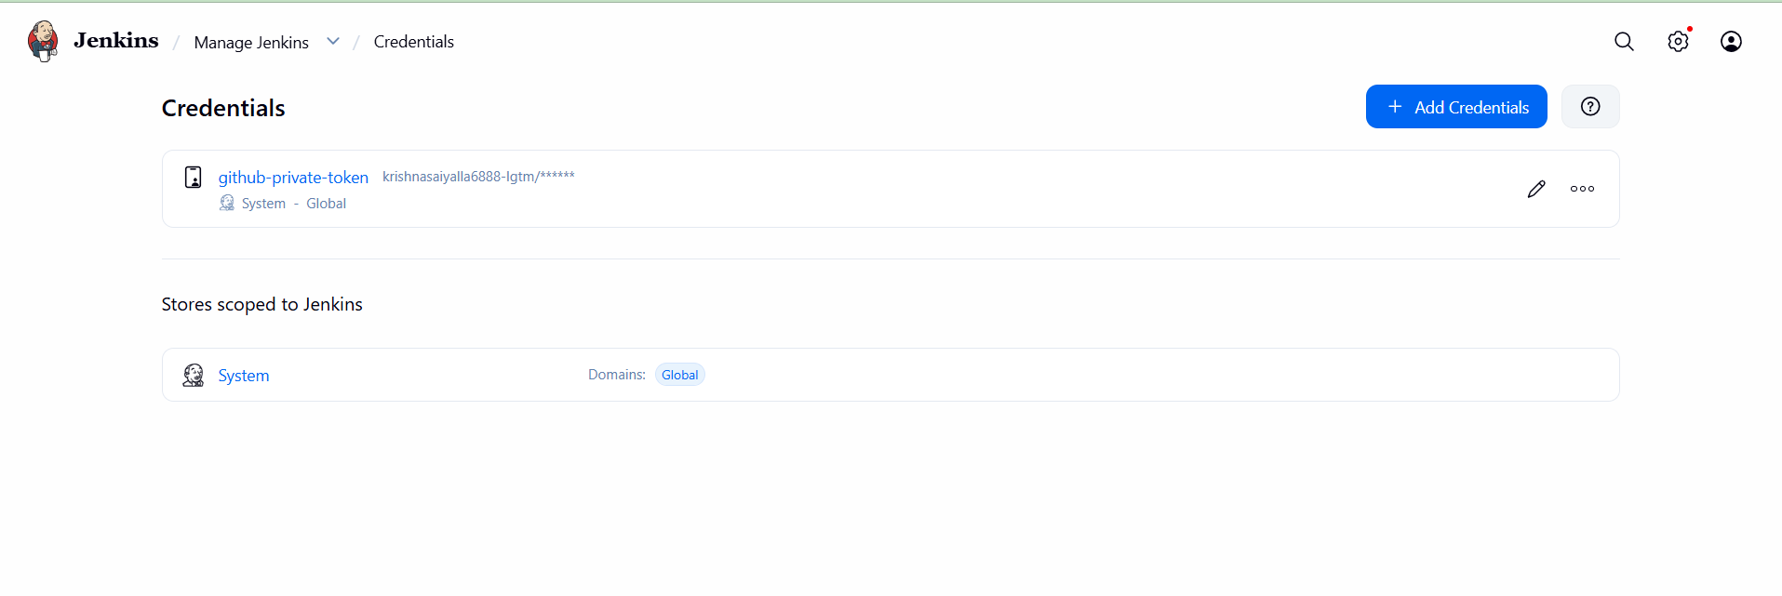

Step 6.4 — Create the private repository Jenkins job
A Jenkins job named Jenkins-Private-Job was configured with:
Repository URL: https://github.com/krishnasaiyalla6888-lgtm/Jenkins-Private-Repo.git
Credentials: github-private-token
Branch: */main
The first attempt used master and failed because the private repository uses main. The branch was corrected to main.

Step 6.5 — Build and verify
The successful console output showed that Jenkins authenticated with the configured credential and checked out the main branch:
using credential github-private-token
Checking out Revision ... (refs/remotes/origin/main)
Finished: SUCCESS
