Jenkins Administration Assignment

Task 1 — Configure 2 Agent Machines in Jenkins Master
Objective: Configure two Jenkins agent/slave machines and make them available for Jenkins jobs.

Step 1.1 — Prepare agents
Java was installed on the agent machines because Jenkins agents require Java.
java -version
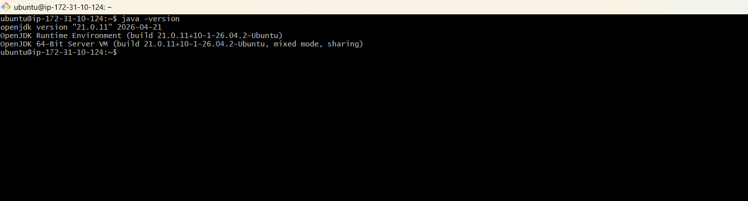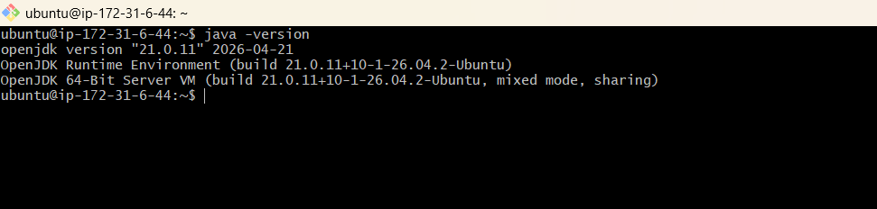

Step 1.2 — Create first agent
- Jenkins → Manage Jenkins → Nodes → New Node.
- Create permanent node: devops-agent.
- Remote directory: /home/jenkins.
- Label: devops.
- Use the launch method/command generated by Jenkins.
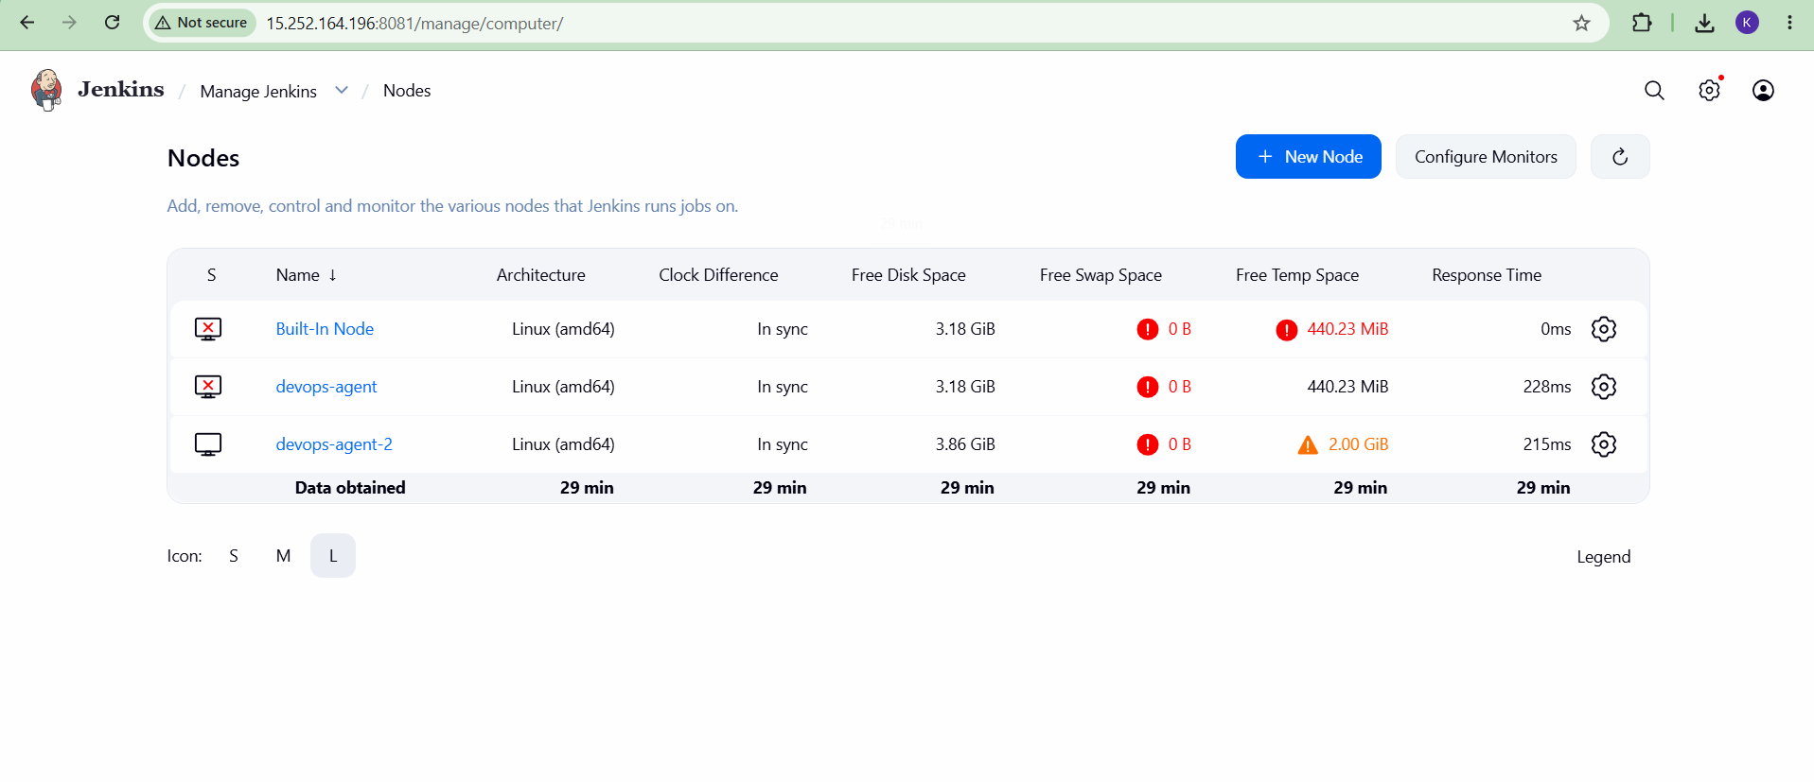

Step 1.3 — Connect first agent
curl -sO http://<JENKINS-IP>:8081/jnlpJars/agent.jar
java -jar agent.jar -url http://<JENKINS-IP>:8081/ -secret <AGENT-SECRET> -name "devops-agent" -webSocket -workDir "/home/jenkins"
Run the exact command displayed by Jenkins. Verify “Agent is connected.”
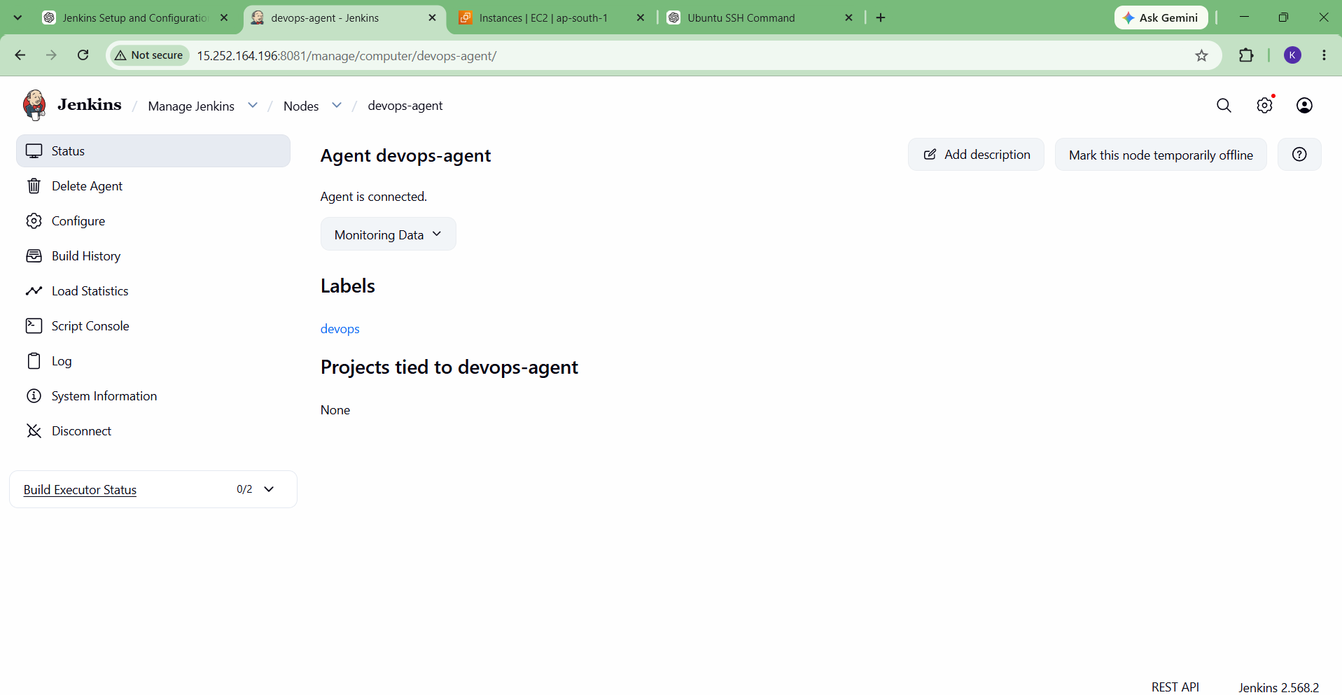

Step 1.4 — Create second agent
- Create permanent node: devops-agent-2.
- Configure its remote directory and required label.
- Connect it using the Jenkins-generated agent command.
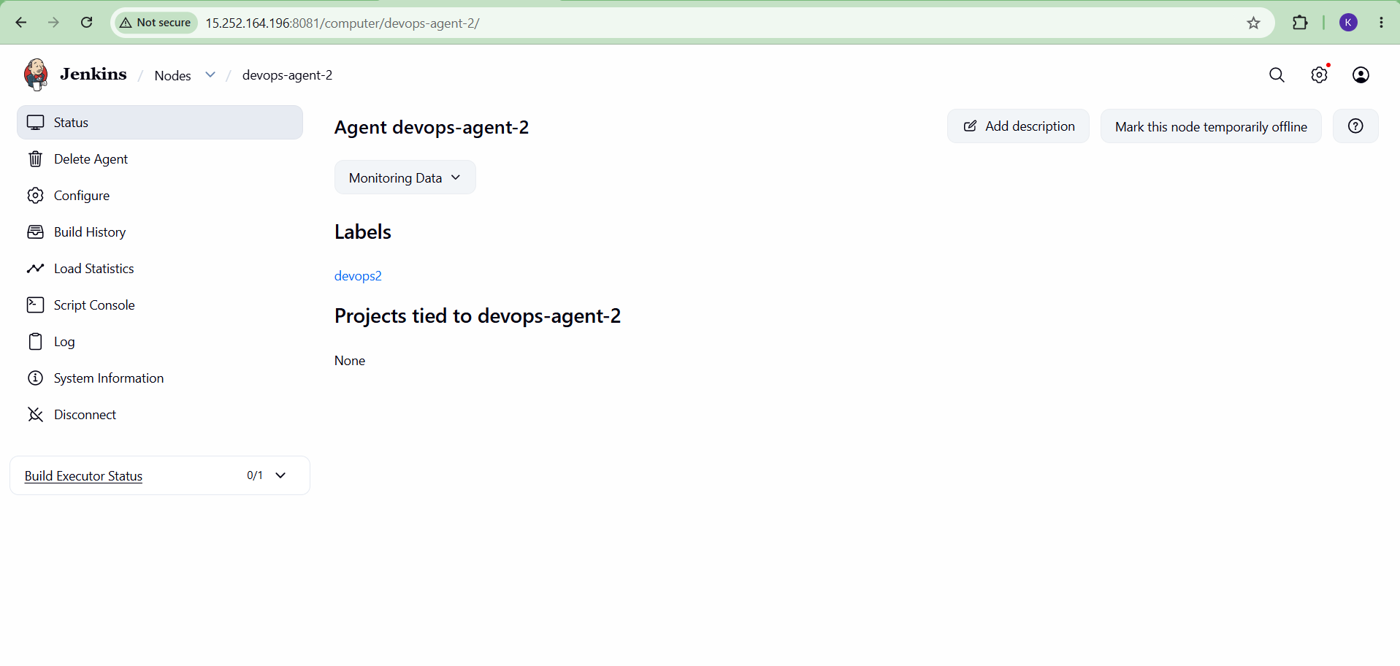

Step 1.5 — Verify
Manage Jenkins → Nodes. Confirm both agents are listed.
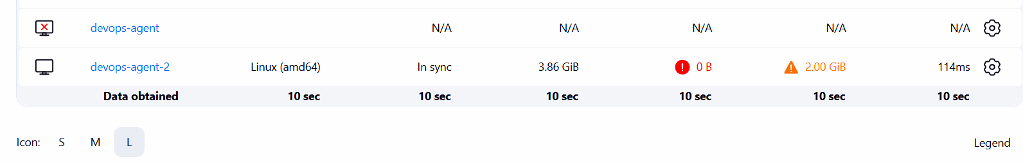

Task 2 — Configure GitHub Webhook to Jenkins Job
Objective: Configure GitHub so repository pushes send webhook requests to Jenkins.

Step 2.1 — Configure Jenkins job
- Open the job → Configure.
- Under Build Triggers, enable “GitHub hook trigger for GITScm polling”.
- Save.
- 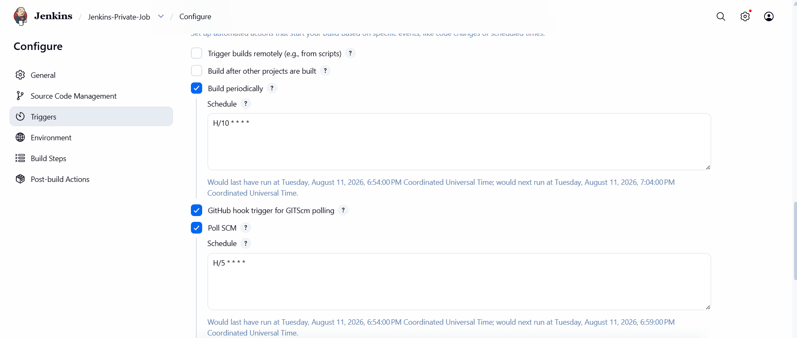

Step 2.2 — Add GitHub webhook
- Open GitHub repository → Settings → Webhooks.
- Click Add webhook.
- Enter the Jenkins webhook endpoint used for the job.
- Select the Push event.
- Save the webhook.
The completed webhook showed a green check and “Last delivery was successful.”
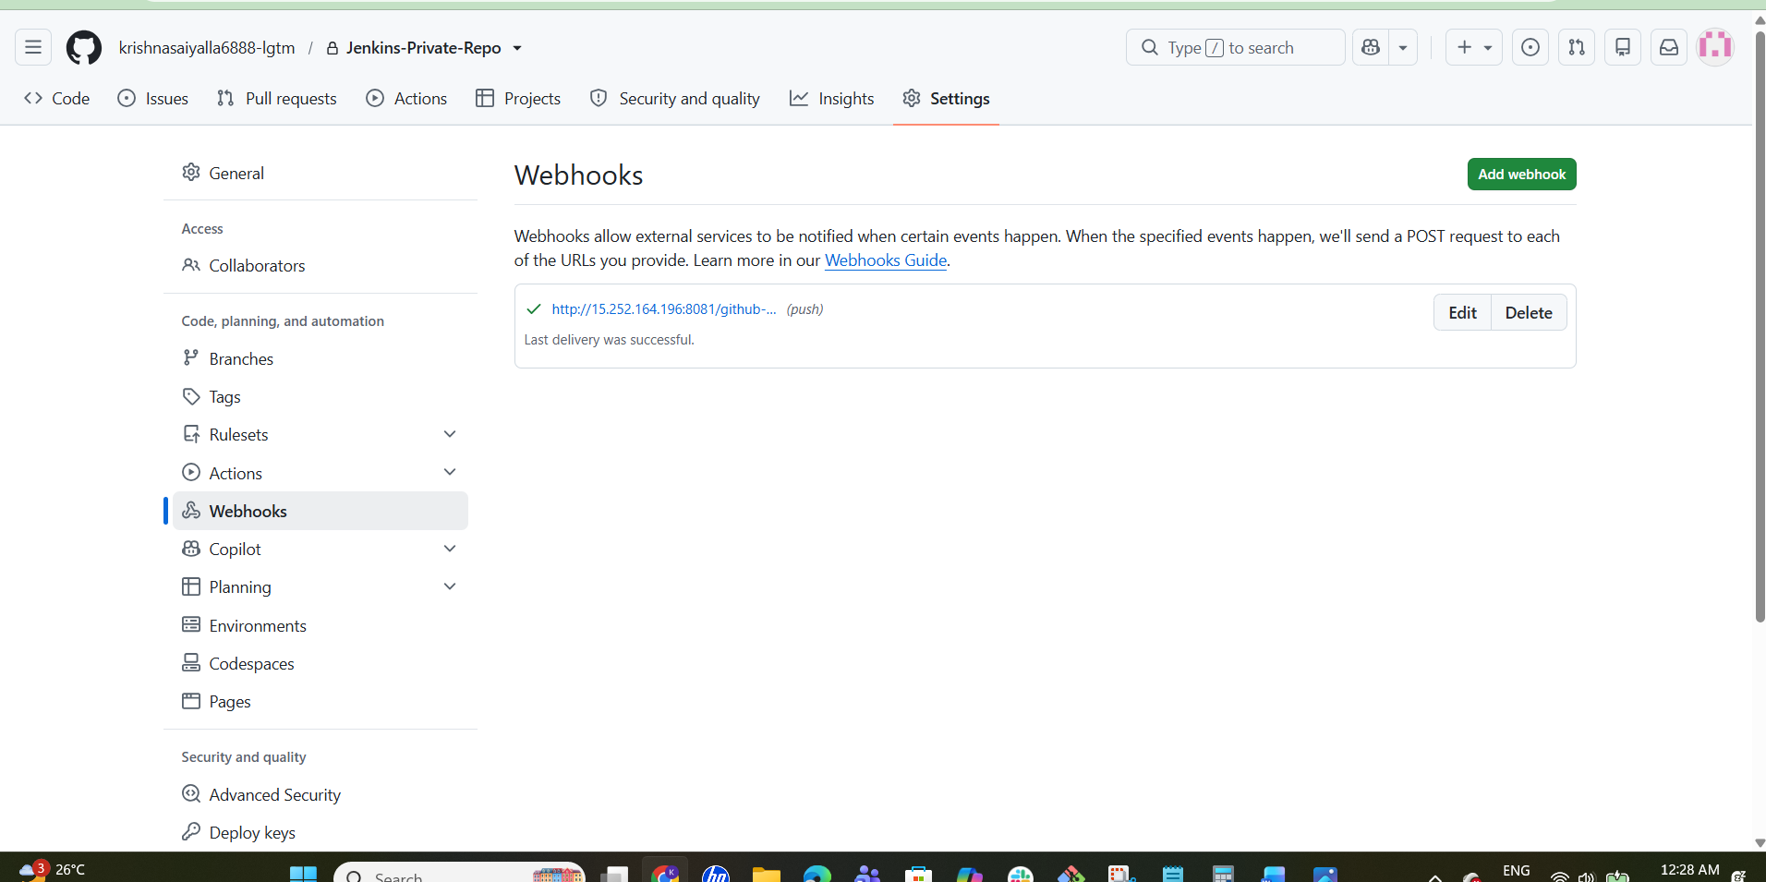

Step 2.3 — Verify
- Push a repository change.
- Check webhook delivery history.
- Confirm Jenkins receives the event and the job build is triggered.
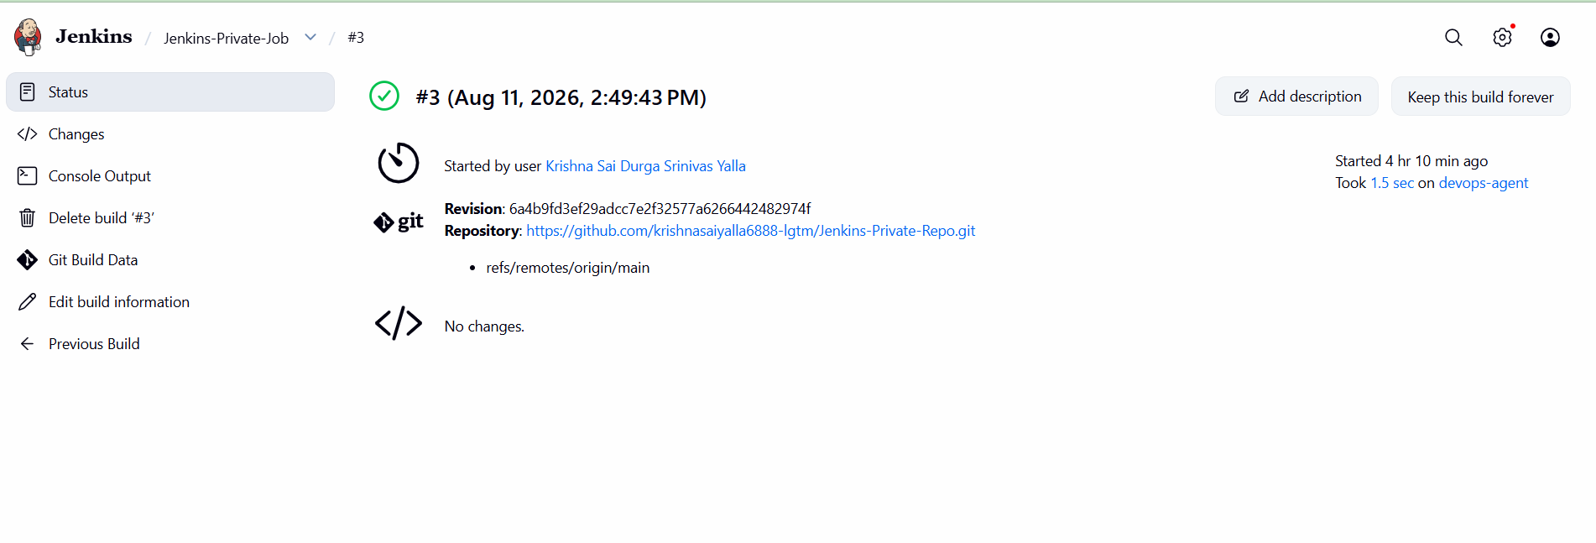

Task 3 — Configure Poll SCM and Build Periodically
Objective: Configure Jenkins to poll the repository and run the job on a schedule.

Step 3.1 — Build Periodically
- Open job → Configure → Build Triggers.
- Enable Build periodically.
- Completed configuration used:
H/10 * * * *
This schedules a build approximately every 10 minutes.
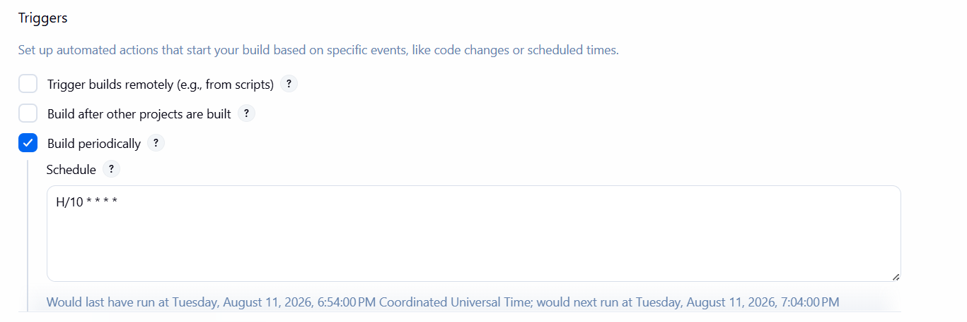

Step 3.2 — Poll SCM
- Enable Poll SCM.
- Completed configuration used:
H/5 * * * *
This polls approximately every 5 minutes and builds when Jenkins detects relevant SCM changes.
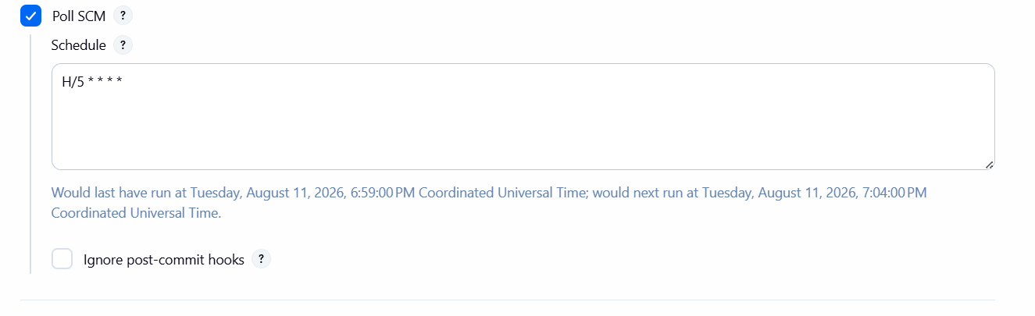

Step 3.3 — Save and verify
- Click Save.
- Return to the job.
- Verify build history.
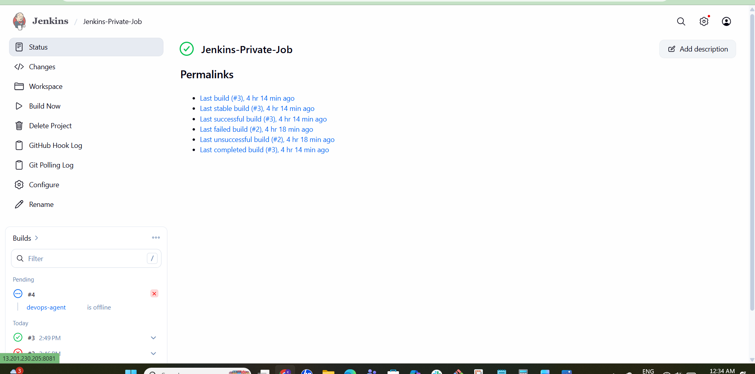

Task 4 — Jenkins Backup Using Bash Script
Objective: Create a compressed backup of Jenkins using a Bash script.

Step 4.1 — Check Jenkins home and disk
hostname
sudo ls -ld /var/lib/jenkins
df -h
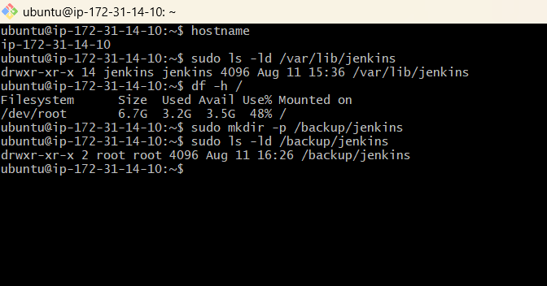

Step 4.2 — Create backup directory
sudo mkdir -p /backup/jenkins
sudo ls -ld /backup/jenkins
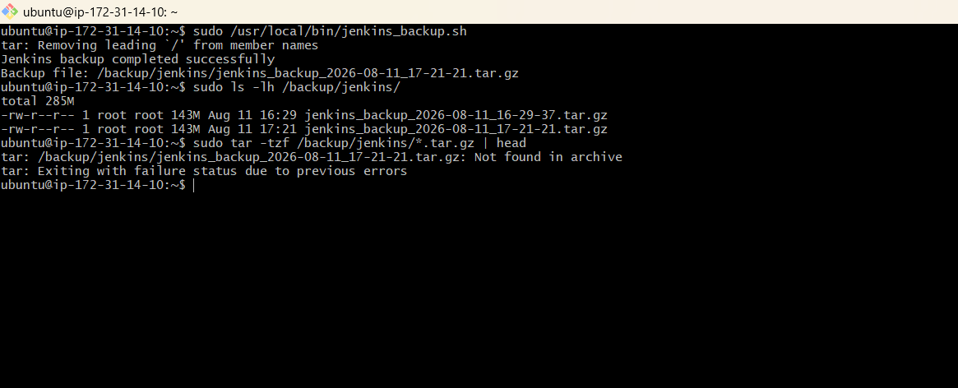

Step 4.3 — Create backup script
sudo nano /usr/local/bin/jenkins_backup.sh
#!/bin/bash
DATE=$(date +%Y-%m-%d_%H-%M-%S)
BACKUP_DIR="/backup/jenkins"
JENKINS_DIR="/var/lib/jenkins"
BACKUP_FILE="$BACKUP_DIR/jenkins_backup_$DATE.tar.gz"
tar -czf "$BACKUP_FILE" "$JENKINS_DIR"
echo "Jenkins backup completed successfully"
echo "Backup file: $BACKUP_FILE"
Save and exit nano. Make it executable if required:
sudo chmod +x /usr/local/bin/jenkins_backup.sh
[ SCREENSHOT 4.3 ]
Paste script/terminal screenshot.

Step 4.4 — Run script
sudo /usr/local/bin/jenkins_backup.sh
The completed backup produced a dated archive, for example:
/backup/jenkins/jenkins_backup_2026-08-11_17-21-21.tar.gz
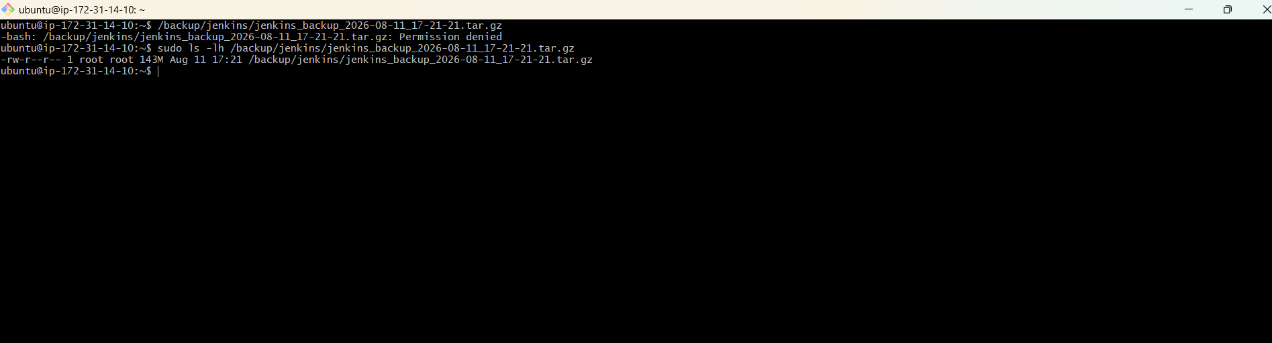

Step 4.5 — Verify
sudo ls -lh /backup/jenkins/
The completed backup was approximately 143 MB on the Jenkins server.
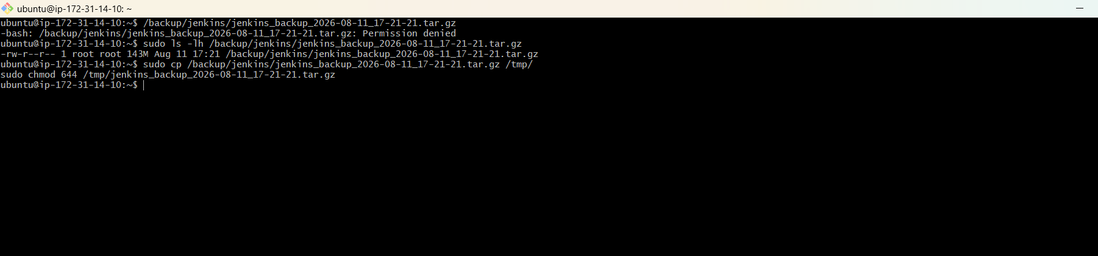

Task 5 — Jenkins Backup Using ThinBackup
Objective: Install ThinBackup and create a Jenkins backup using the plugin.

Step 5.1 — Install plugin
- Manage Jenkins → Plugins.
- Search for ThinBackup.
- Install the plugin and wait for Success.
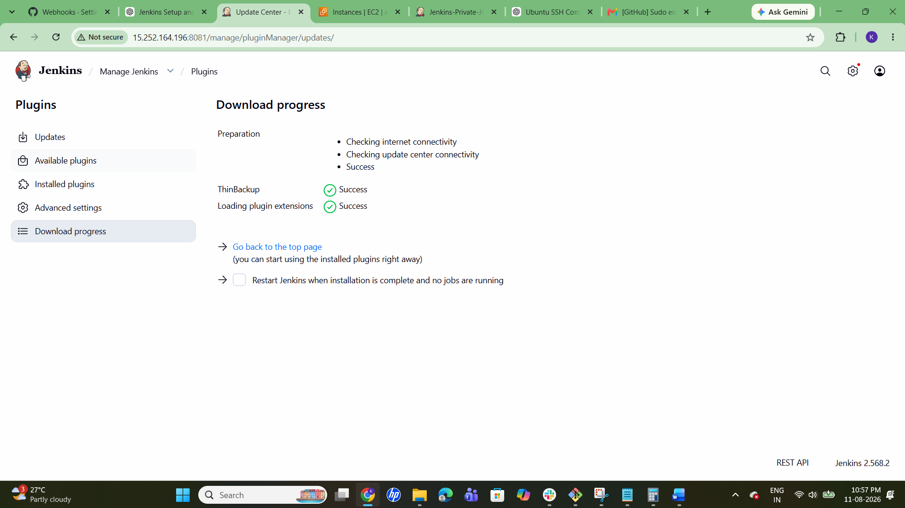

Step 5.2 — Prepare backup directory
sudo mkdir -p /backup/jenkins/thinbackup
sudo chown -R jenkins:jenkins /backup/jenkins/thinbackup
sudo ls -lh /backup/jenkins/thinbackup/
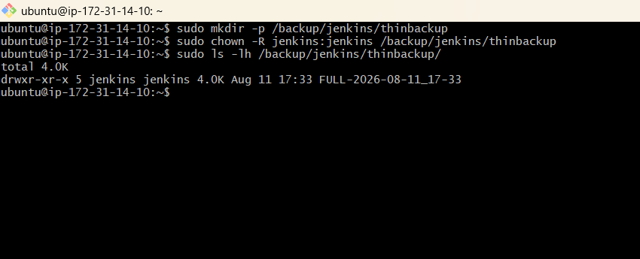

Step 5.3 — Open ThinBackup
- Manage Jenkins → ThinBackup.
- Verify Backup now and Restore options are available.
- 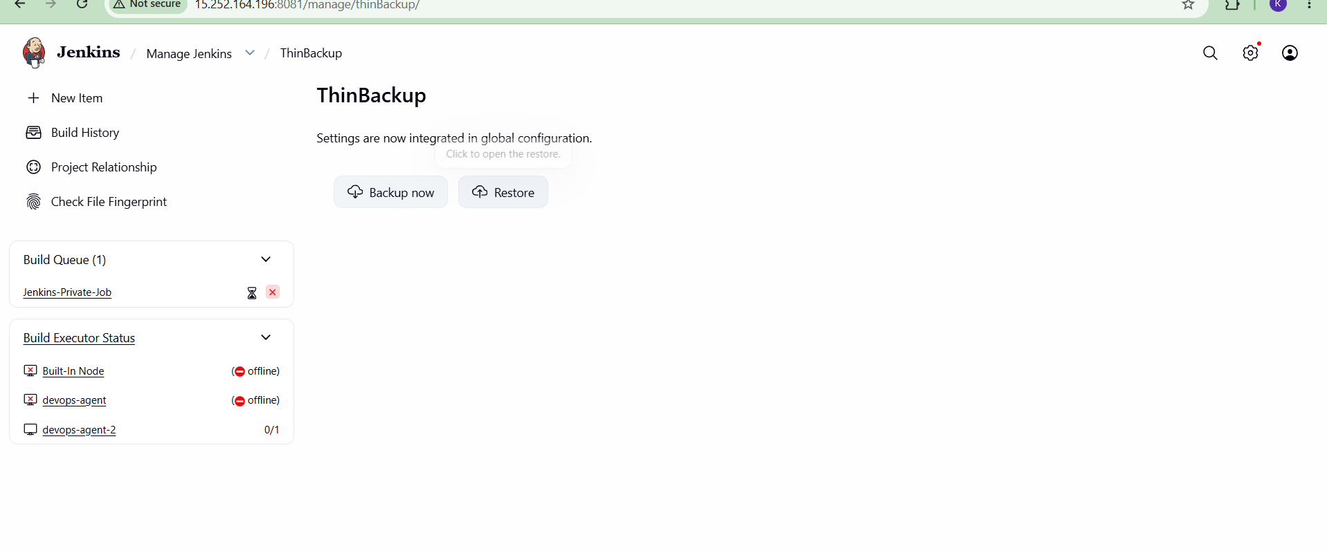

Step 5.4 — Run Backup now
- Click Backup now.
- Wait for completion.
- Verify a dated backup directory is created in the configured location.

Task 6 — New Jenkins Server and Restore Task 4 Backup
Objective: Set up the new Jenkins server and restore the Bash-script backup from Task 4.

Step 6.1 — New EC2 instance
- Launch/use the new Ubuntu EC2 instance.
- Completed server public IP: 13.201.230.205.
- Allow SSH port 22 and Jenkins port 8081 in the security group.
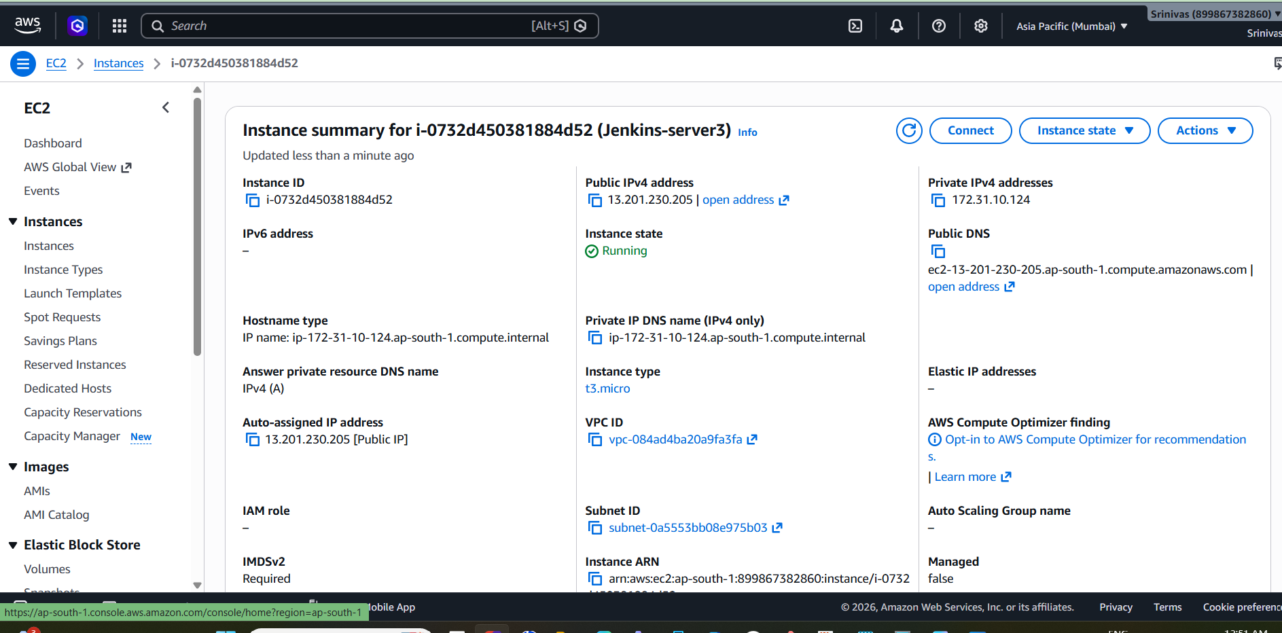

Step 6.2 — Verify Java and Jenkins
java -version
sudo systemctl status jenkins --no-pager
Java was already installed and Jenkins was running on the new server.
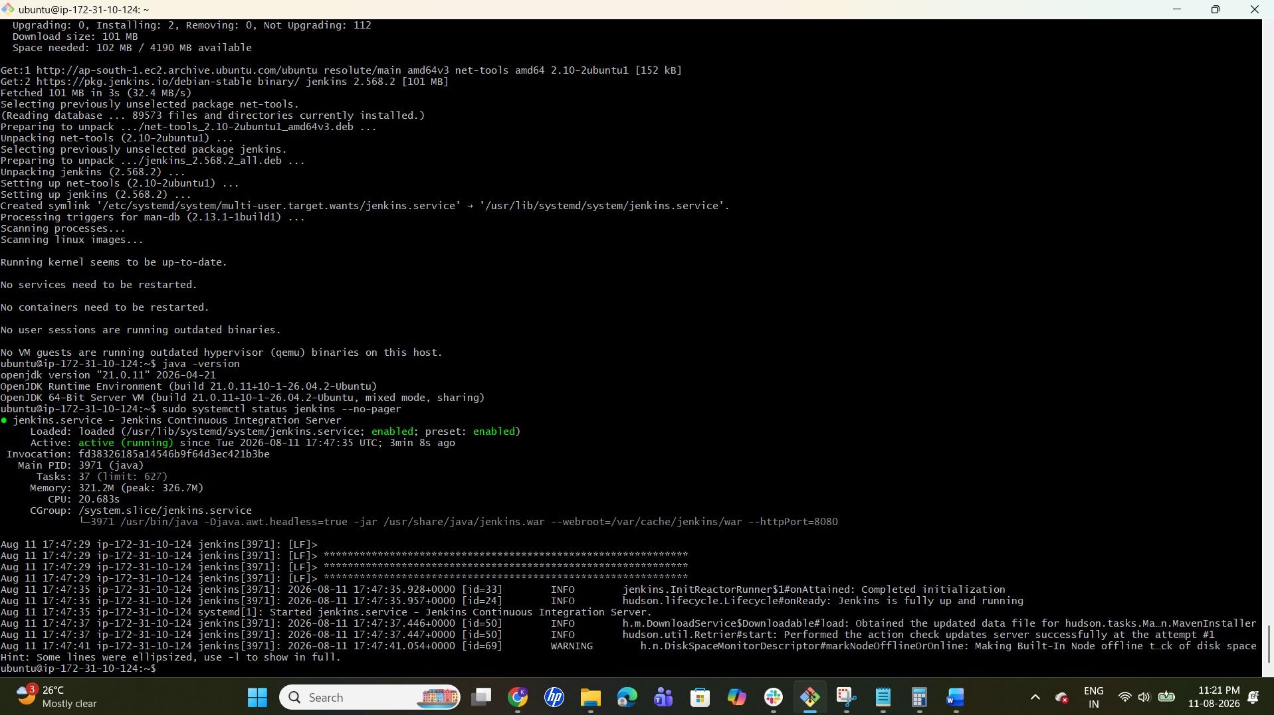

Step 6.3 — Copy backup from old server to Windows
scp -i "krishna6.pem" ubuntu@15.252.164.196:/tmp/jenkins_backup_2026-08-11_17-21-21.tar.gz .
The completed transfer reached 100% and was approximately 142 MB.
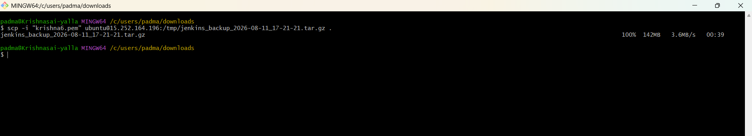

Step 6.4 — Copy backup to new server
scp -i "krishna6.pem" jenkins_backup_2026-08-11_17-21-21.tar.gz ubuntu@13.201.230.205:/tmp/
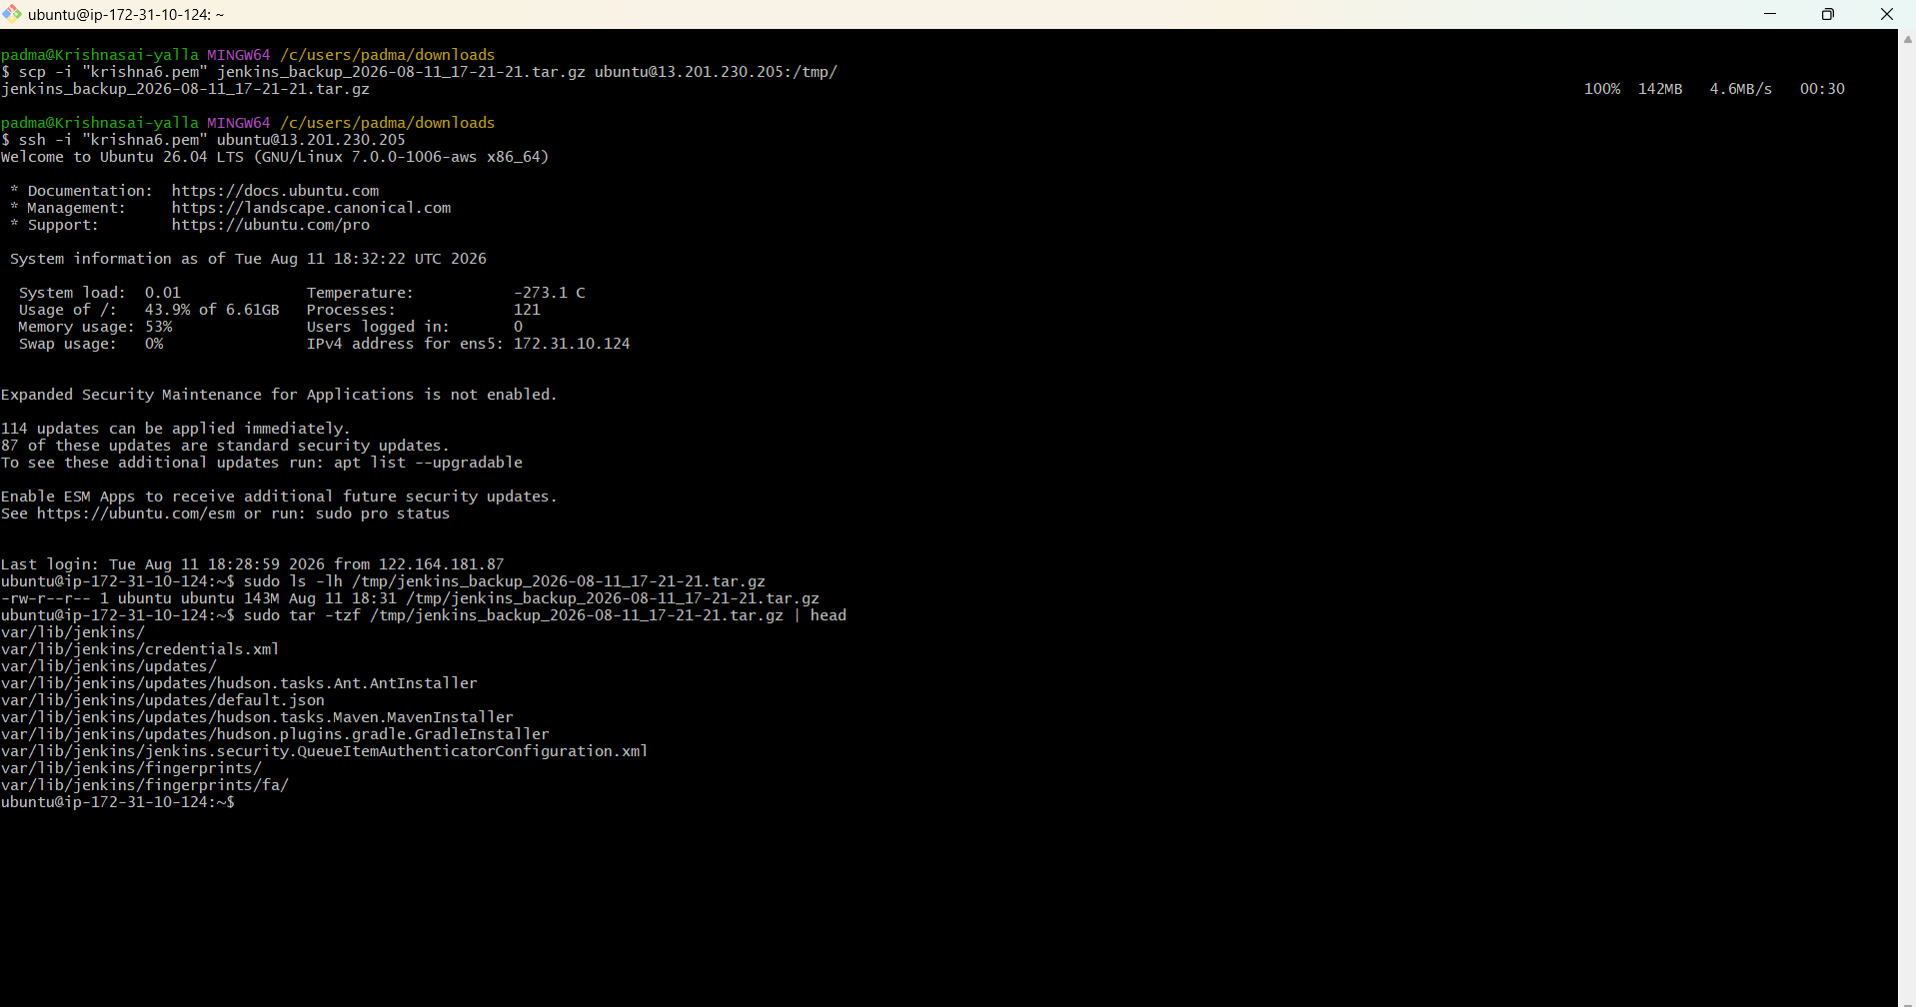

Step 6.5 — Verify archive
sudo ls -lh /tmp/jenkins_backup_2026-08-11_17-21-21.tar.gz
sudo tar -tzf /tmp/jenkins_backup_2026-08-11_17-21-21.tar.gz | head
The archive contained var/lib/jenkins and Jenkins configuration/data such as credentials.xml, updates and fingerprints.

Step 6.6 — Stop Jenkins
sudo systemctl stop jenkins
sudo systemctl status jenkins --no-pager
Expected state: Active: inactive (dead).
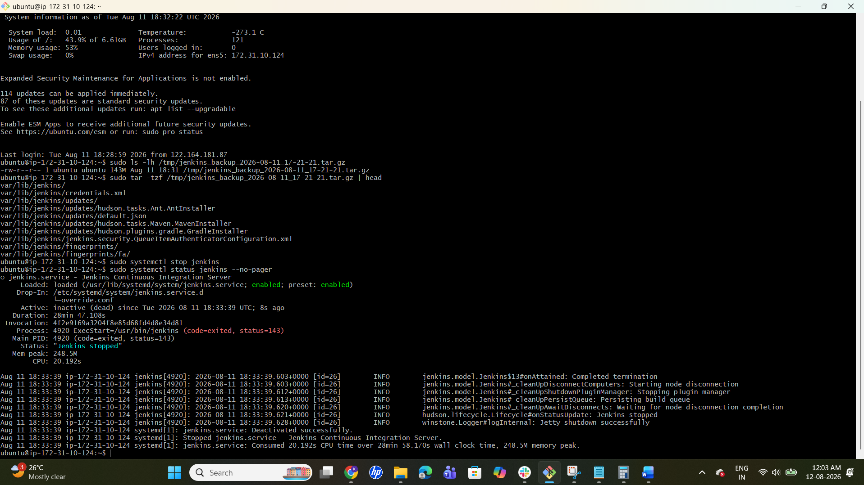

Step 6.7 — Preserve existing new-server data
sudo mv /var/lib/jenkins /var/lib/jenkins_before_restore
This keeps a safety copy of the original Jenkins data on the new server.
[ SCREENSHOT 6.7 ]
Paste terminal screenshot.

Step 6.8 — Extract backup
sudo tar -xzf /tmp/jenkins_backup_2026-08-11_17-21-21.tar.gz -C /

Step 6.9 — Fix ownership and start Jenkins
sudo chown -R jenkins:jenkins /var/lib/jenkins
sudo systemctl start jenkins
sudo systemctl status jenkins --no-pager
The completed setup showed Jenkins as Active: active (running).
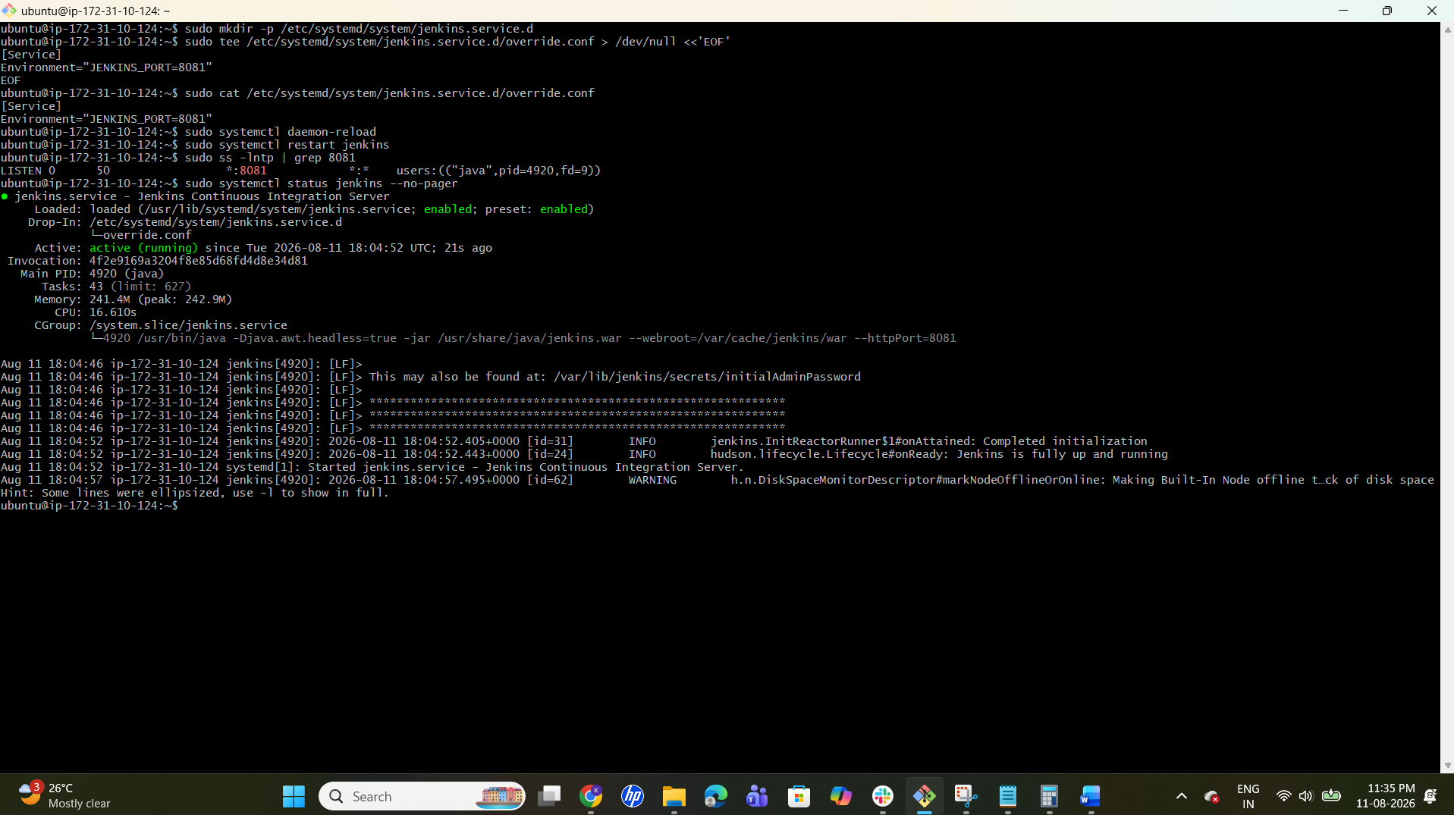

Step 6.10 — Verify restored Jenkins
http://13.201.230.205:8081
The restored dashboard showed these previous jobs:
- Jenkins-Private-Job
- Techie-Horizon-Job1
- Techie-Horizon-Job2
- Techie-Horizon-Job3
The restored Nodes page also showed the previously configured agents, confirming successful restoration.
