CloudFront with Custom Domain Setup (AWS + Route 53 + GoDaddy)
Objective: Host a static website from Amazon S3 using CloudFront, HTTPS (ACM), Route 53 and a GoDaddy domain.

Step 1: Create an S3 Bucket
Open AWS Console → S3 → Create bucket.
Enter a unique bucket name.
Disable Block Public Access (if using website hosting).
Create the bucket.
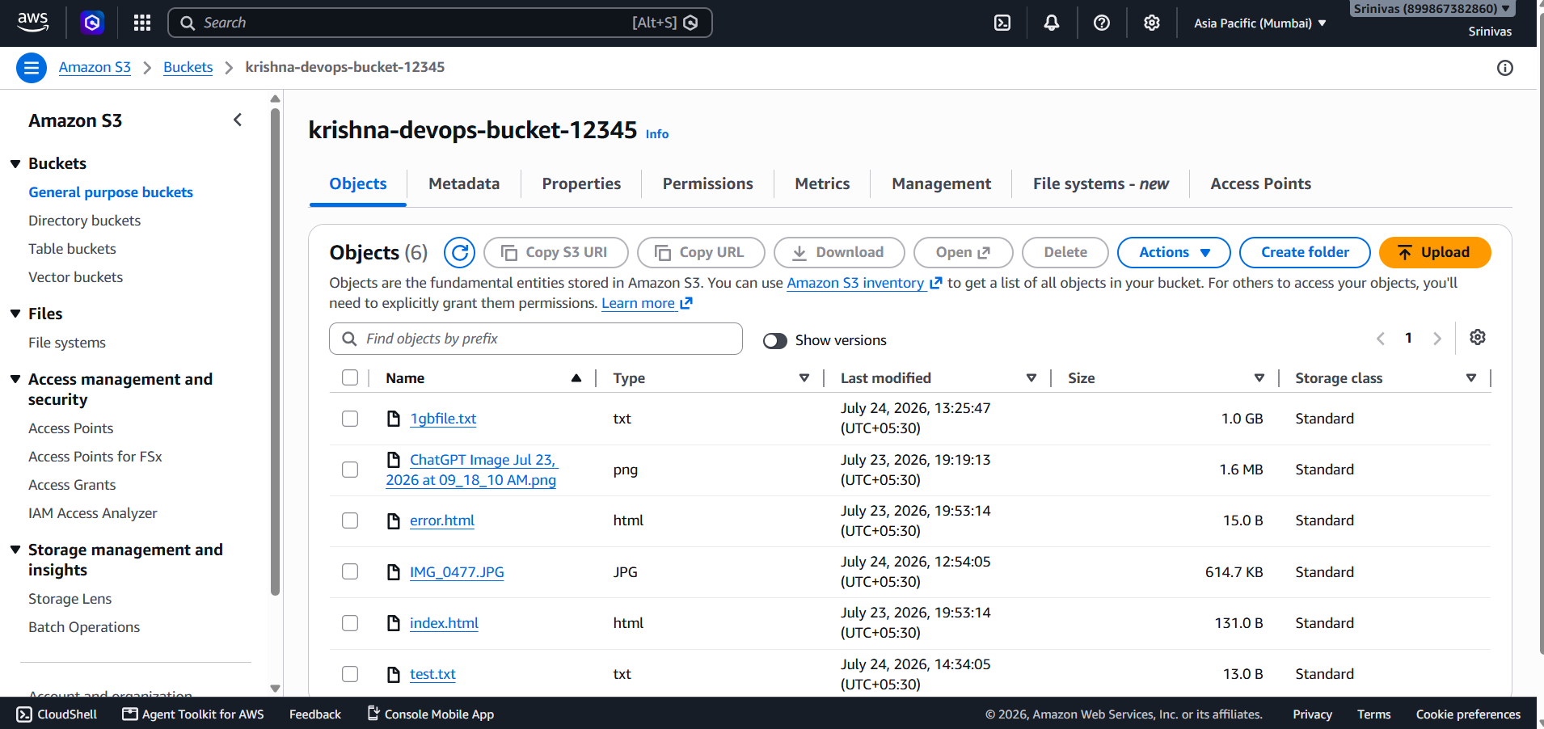

Step 2: Upload Website Files
Upload index.html and any CSS/images to the bucket.
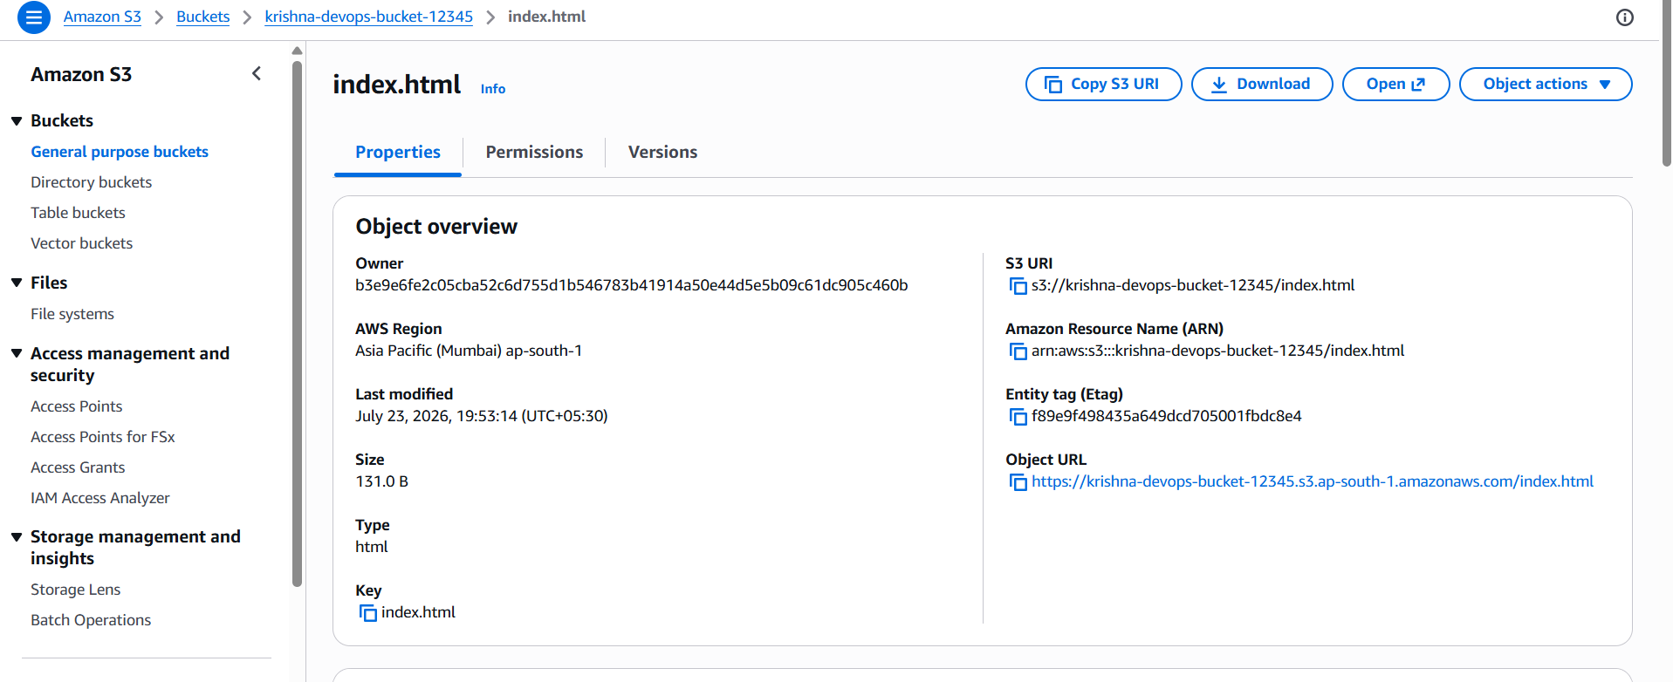

Step 3: Enable Static Website Hosting
S3 Bucket → Properties → Static website hosting → Enable.
Index document: index.html.
Save and note the website endpoint.
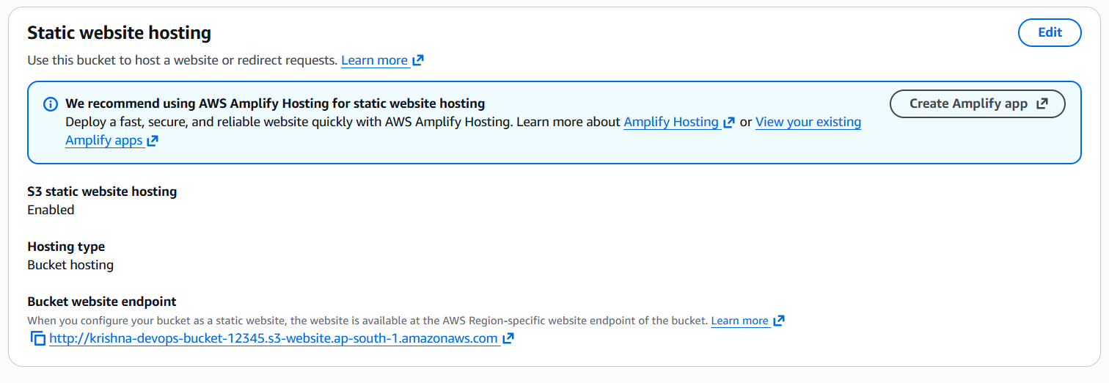

Step 4: Create Route 53 Hosted Zone
Open Route 53 → Hosted Zones → Create Hosted Zone.
Domain: sriveeraqua.in
Type: Public Hosted Zone.
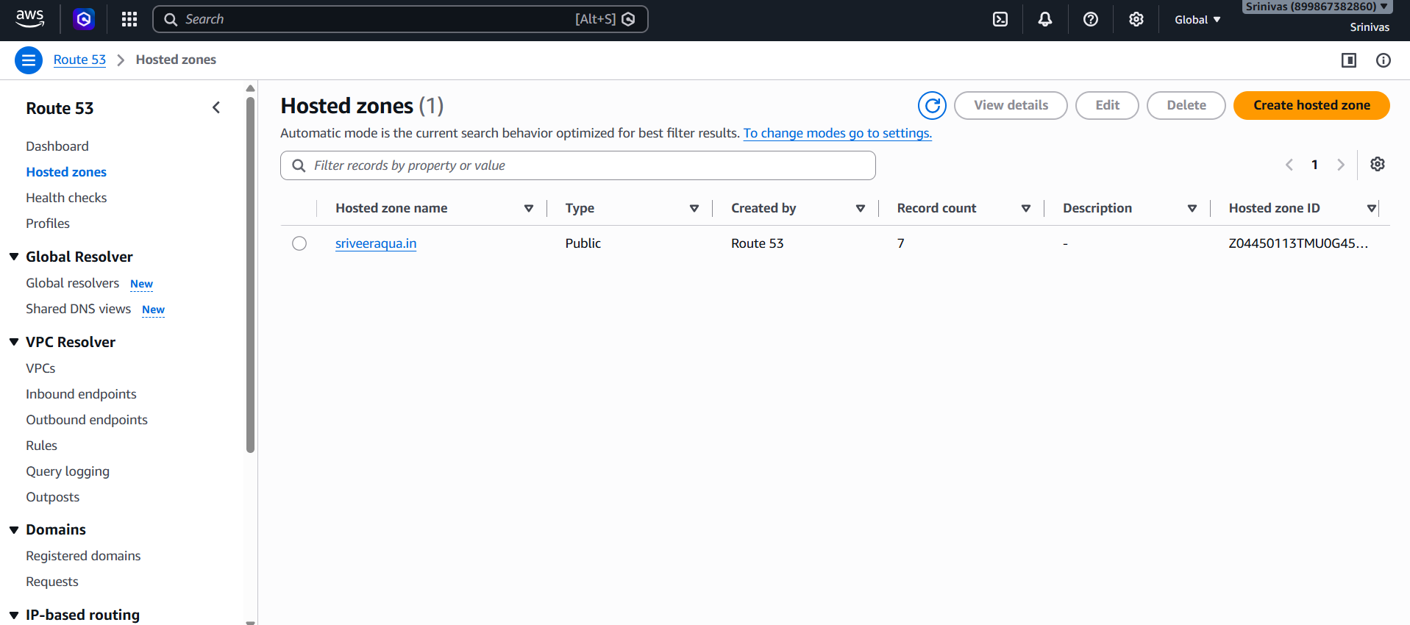

Step 5: Update GoDaddy Nameservers
GoDaddy → Domain → Nameservers → Use custom nameservers.
Copy the four Route 53 NS records into GoDaddy and save.
Wait for propagation.
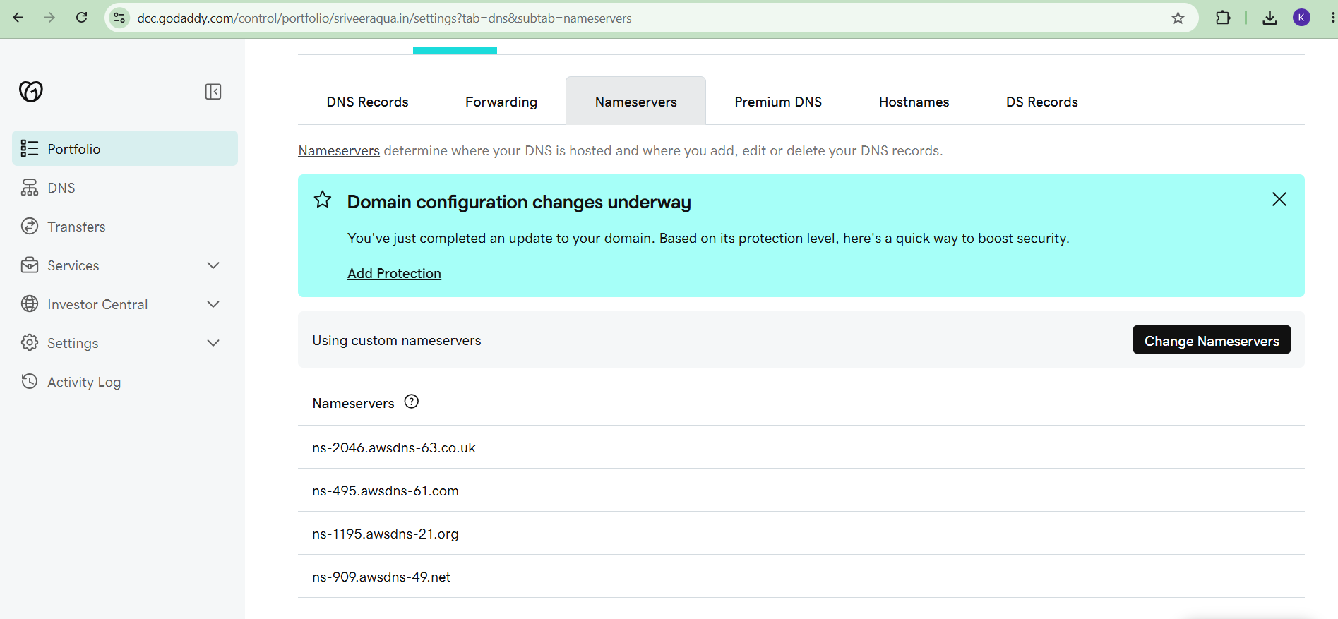

Step 6: Request ACM Certificate
Switch to US East (N. Virginia).
Open ACM → Request public certificate.
Add sriveeraqua.in and *.sriveeraqua.in.
Choose DNS validation.
Create records in Route 53 and wait until status becomes Issued.
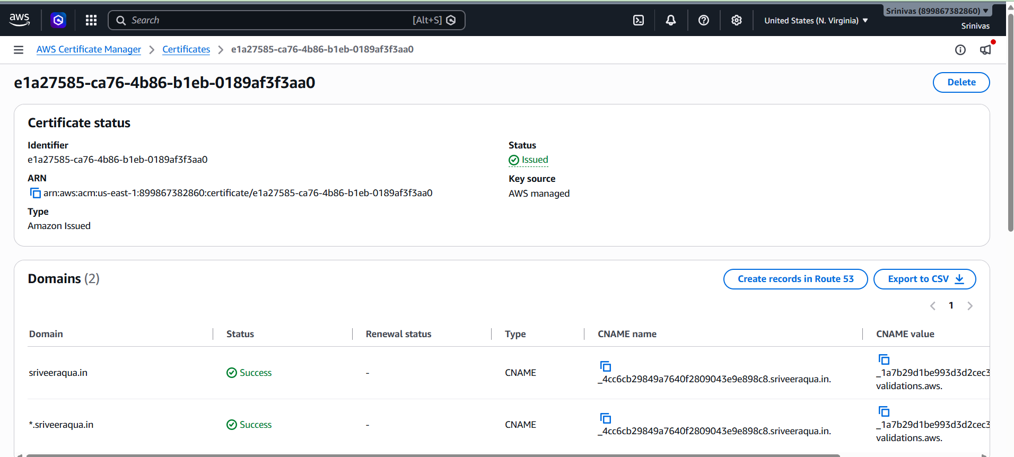

Step 7: Create CloudFront Distribution
CloudFront → Create Distribution.
Origin: S3 bucket.
Grant CloudFront access to the bucket.
Disable WAF (optional for lab).
Create distribution.
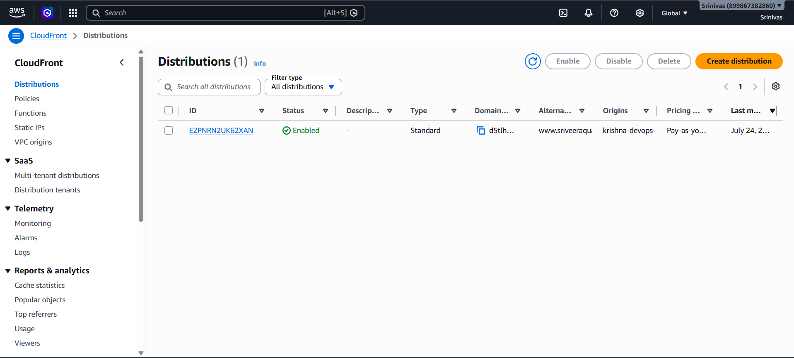

Step 8: Configure CloudFront
Edit distribution.
Default root object: index.html.
Alternate domain names:
- sriveeraqua.in
- www.sriveeraqua.in
Select the ACM certificate.
Security Policy: TLSv1.2_2021 (recommended).
Save changes.
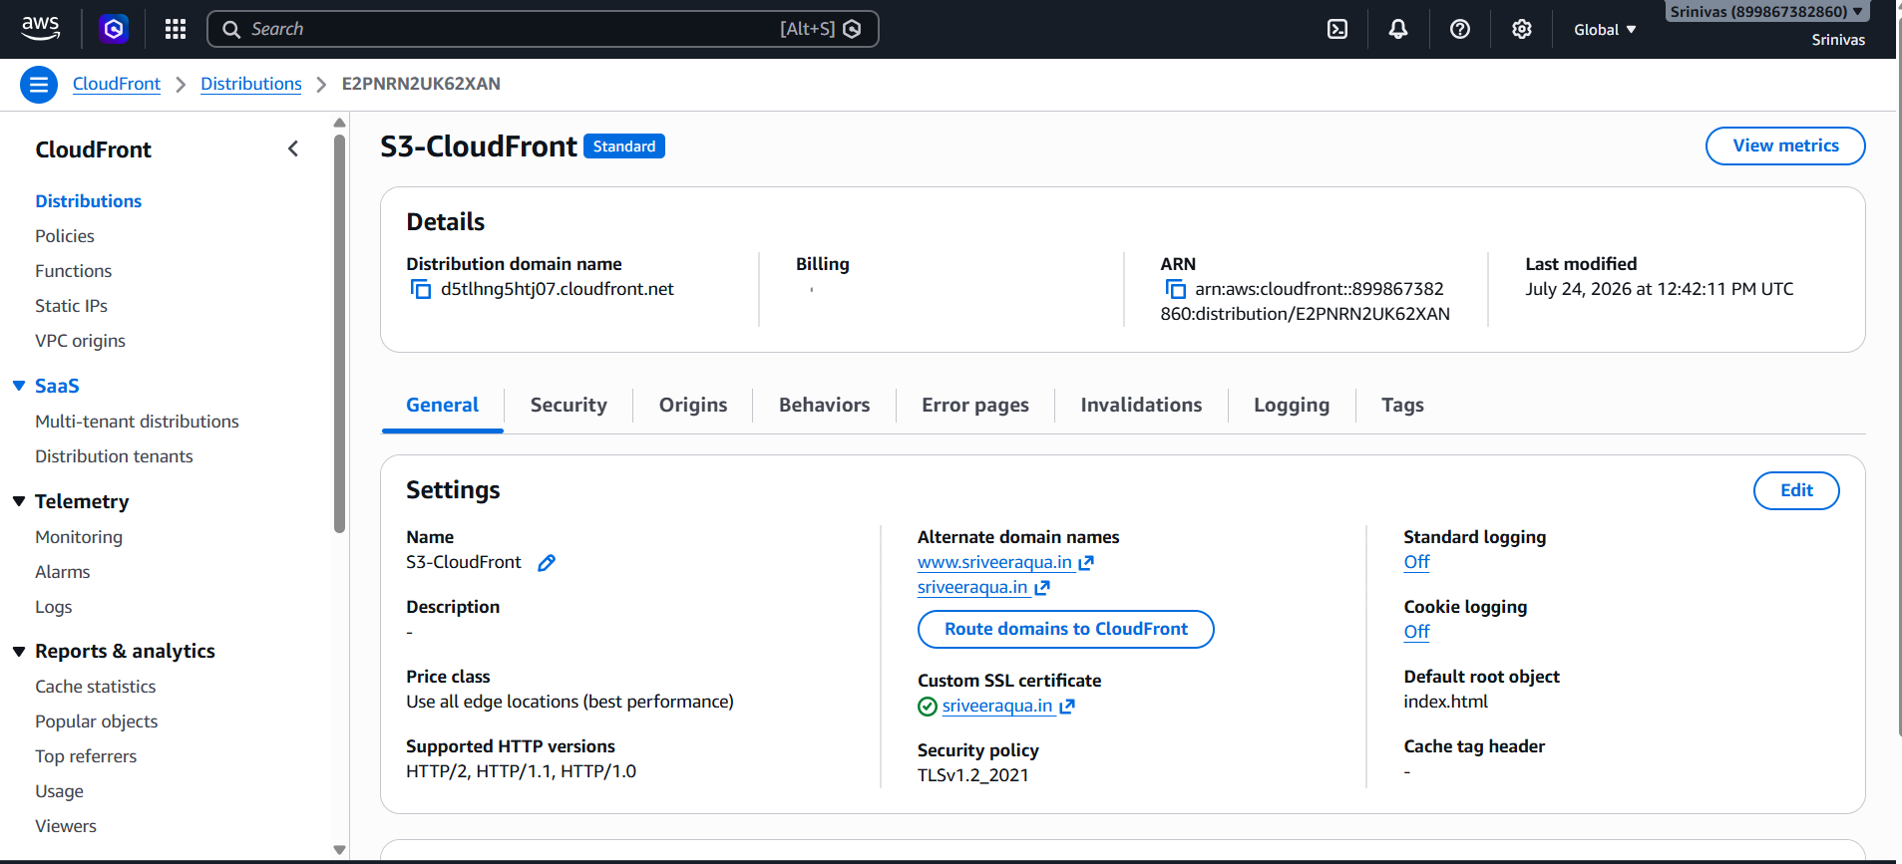

Step 9: Route Domain
Click 'Route domains to CloudFront'.
Allow AWS to create Route 53 Alias records automatically.
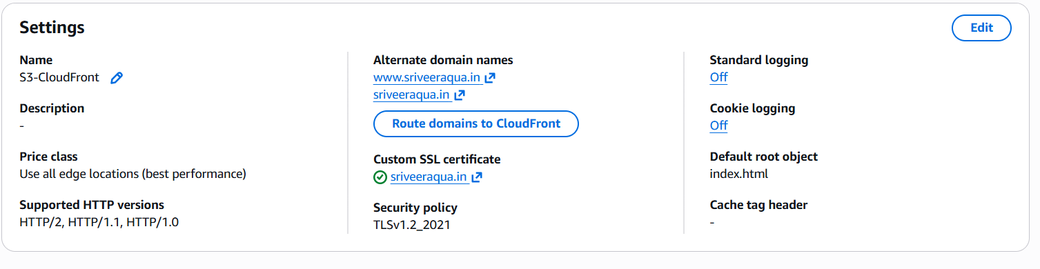

Step 10: Verify
Wait for CloudFront status to become Deployed.
Open:
https://sriveeraqua.in
https://www.sriveeraqua.in
Confirm the website loads over HTTPS.
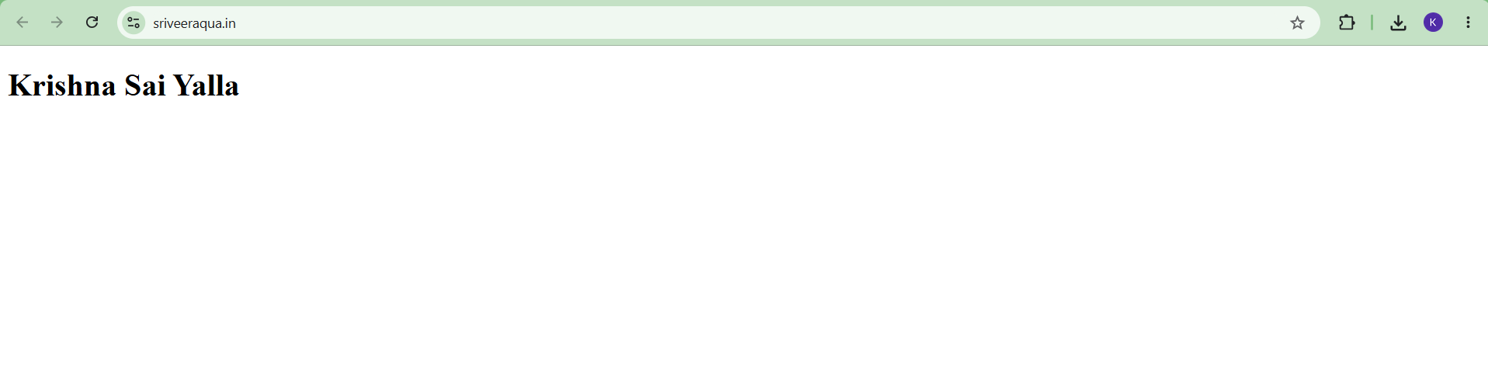


Evidence to Capture
- S3 bucket and uploaded files
- Static website hosting enabled
- Route 53 hosted zone
- ACM certificate (Issued)
- CloudFront distribution
- Route 53 alias records
- Website using custom domain (HTTPS)

