AWS EC2 Assignment Documentation

Task 1: Launch Amazon Linux 2 with Apache
1. Go to EC2 → Launch Instance.
2. Choose Amazon Linux 2 AMI.
3. Select t3.micro (or t2.micro if available).
4. Select your key pair.
5. Allow SSH (22) and HTTP (80).
6. Paste the Apache User Data script.
7. Launch the instance.
8. Verify Apache using the Public IP.
Screenshots: EC2 Running, User Data, Apache webpage.
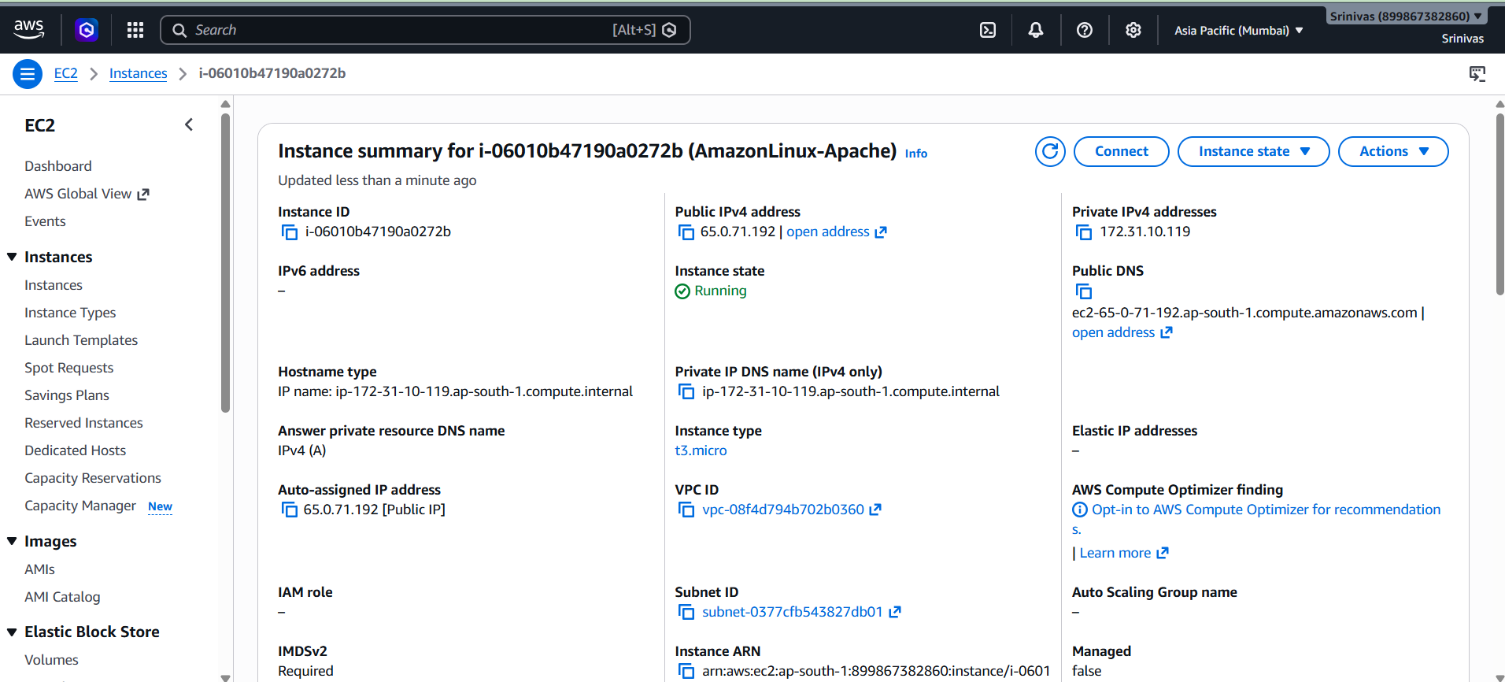
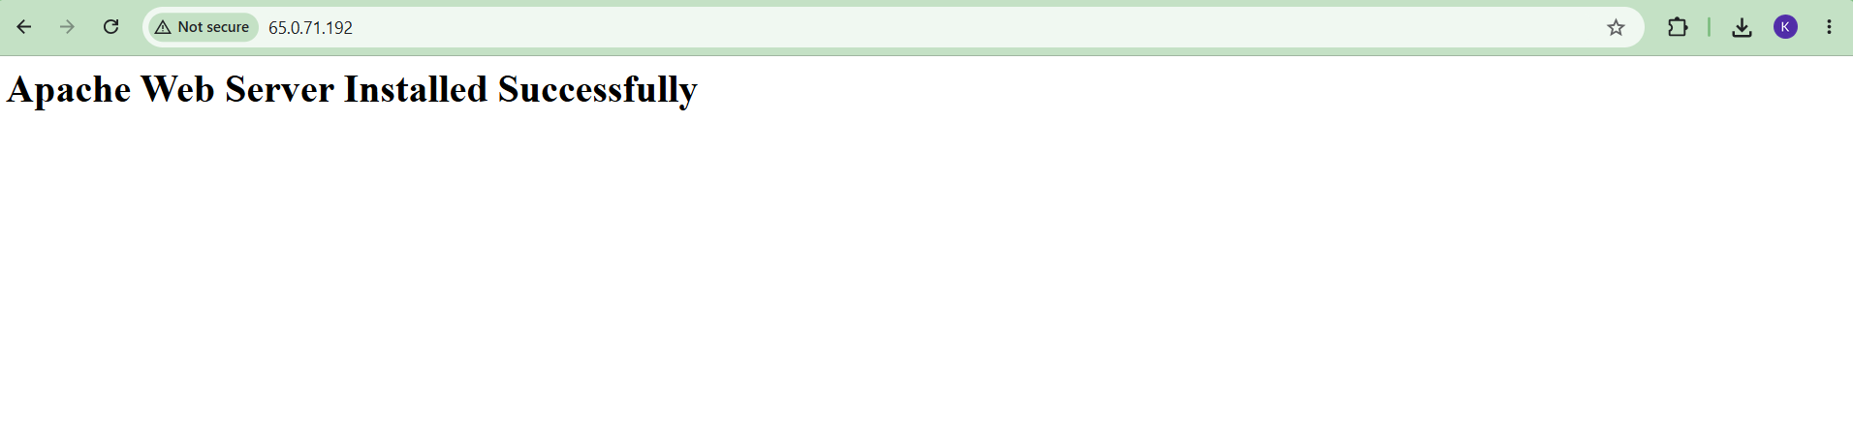

Task 2: Launch Ubuntu with Nginx
1. Launch a new EC2 instance.
2. Choose Ubuntu Server AMI.
3. Select t3.micro.
4. Allow SSH and HTTP.
5. Paste the Nginx User Data script.
6. Launch and verify Nginx.
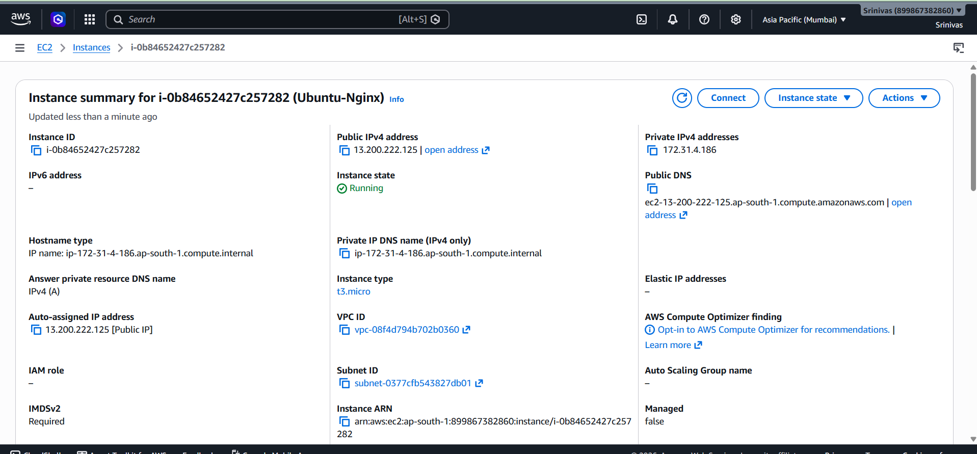
Screenshots: EC2 Running, Nginx webpage.

Task 3: Windows EC2 and Tomcat
1. Launch Windows Server EC2.
2. Allow RDP (3389).
3. Retrieve Administrator password.
4. Connect using Remote Desktop.
5. Install Java.
6. Download and start Apache Tomcat.
7. Allow port 8080.
8. Verify Tomcat.
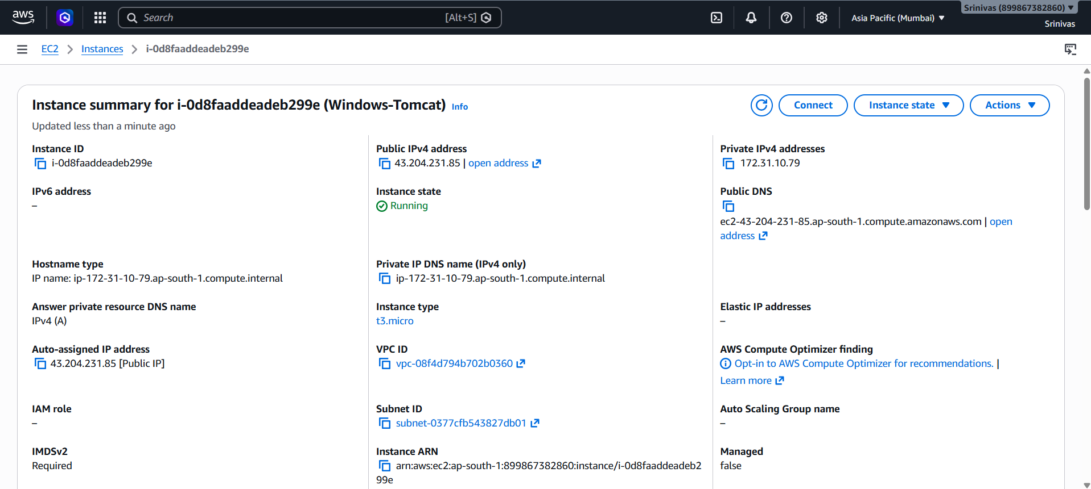
Screenshots: Windows EC2, Tomcat page.

Task 4: EBS Snapshot
1. Select the Amazon Linux instance.
2. Open Storage and select the EBS volume.
3. Create Snapshot.
4. Wait until Completed.
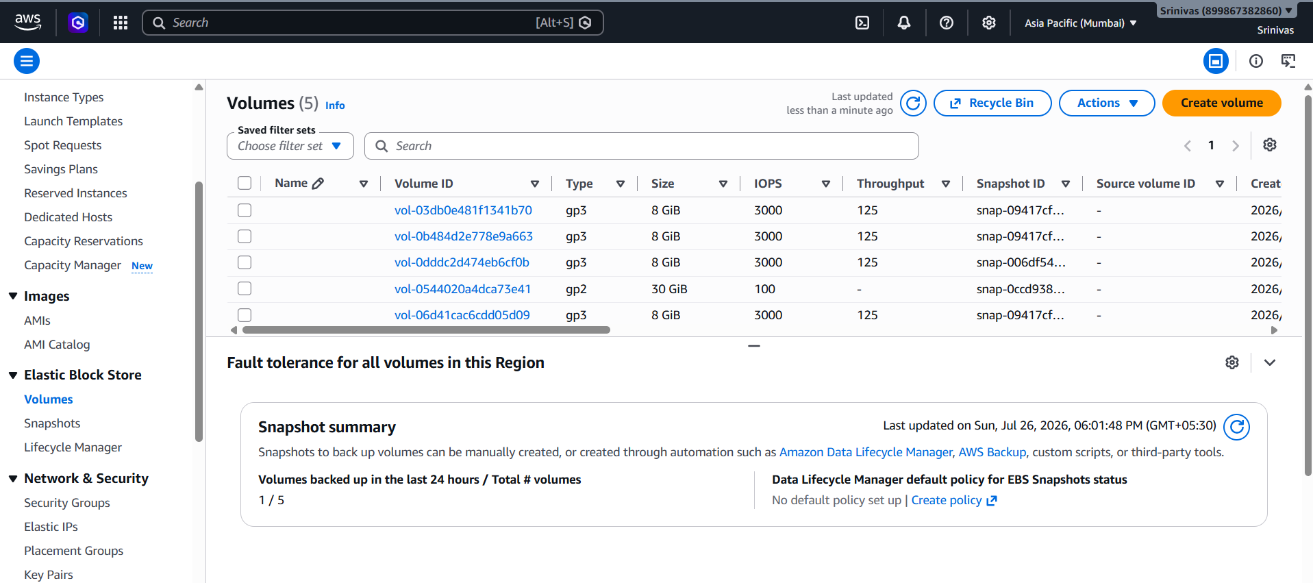
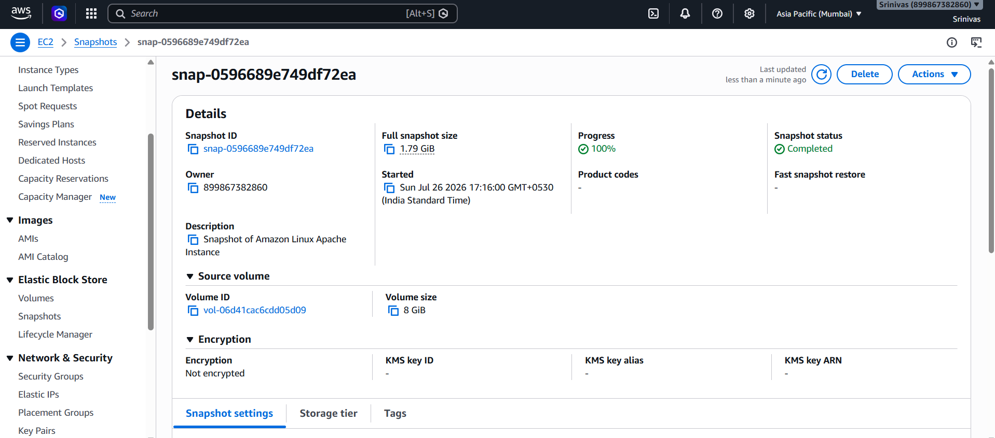
Screenshot: Snapshot Completed.

Task 5: Passwordless Authentication
- Connect using: ssh -i Krishna6.pem ubuntu@<Public-IP>.
- 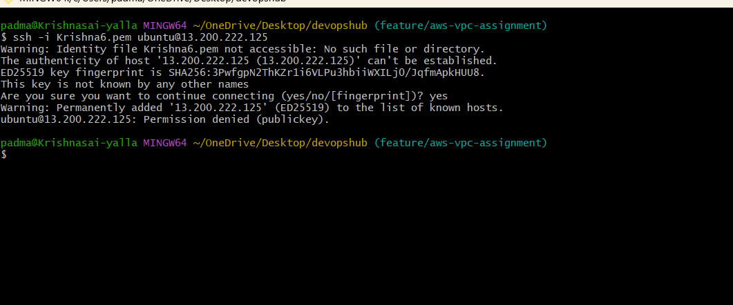
Screenshot: Successful SSH login.

Task 6: Spot Instance
1. Launch a new EC2.
2. Enable Request Spot Instances.
3. Launch and verify Running.
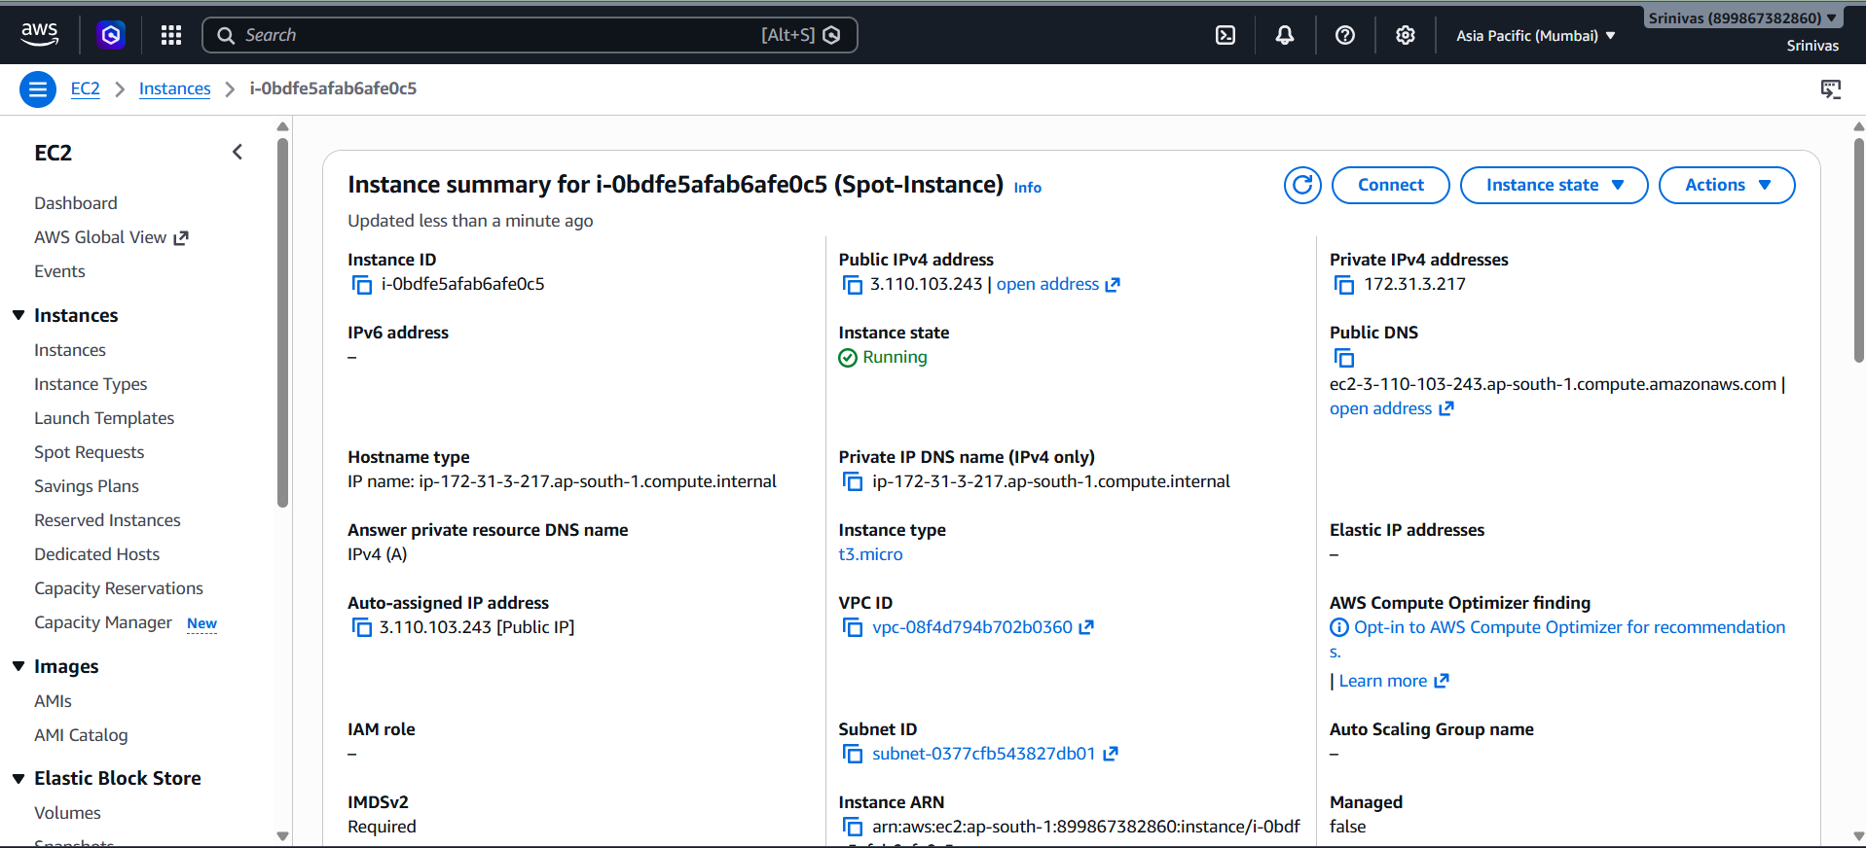
Screenshot: Spot Instance Running.

Task 7: Termination Protection
1. Select Ubuntu instance.
2. Actions → Instance settings → Change termination protection.
3. Enable and save.
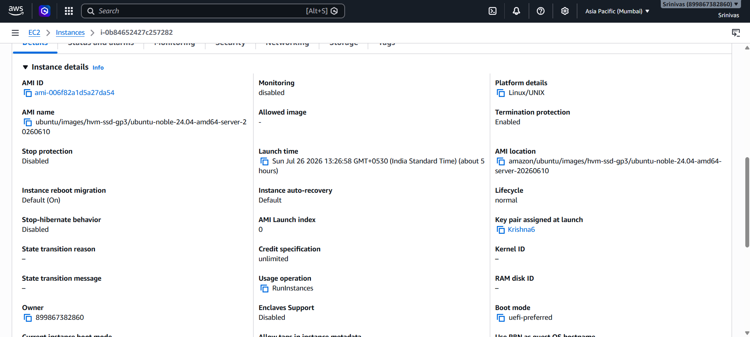
Screenshot: Termination Protection Enabled.

Task 8: Launch EC2 using AWS CLI
1. Run aws ec2 run-instances with AMI ID, key pair, security group and subnet.
2. Verify the CLI output or EC2 instance.
Screenshot: CLI output or CLI-EC2 instance.
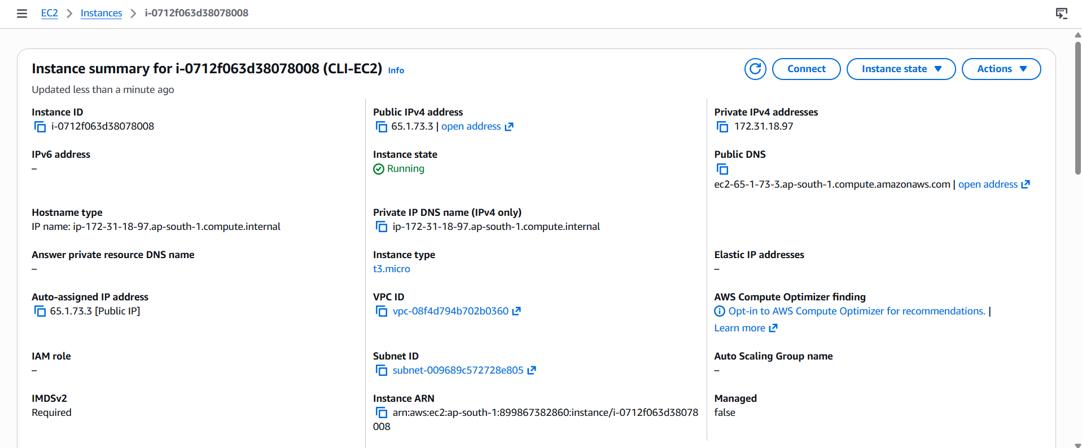

Conclusion
The EC2 assignment was completed using the AWS Console and AWS CLI.

