DOCKER-03 ASSIGNMENT
Step-by-Step Practical Implementation Guide

1. Environment: An existing Ubuntu Docker server is used. Docker is already installed. Existing Docker-02 containers should not be deleted or modified unnecessarily.

2. Prerequisites / Initial Verification
docker --version
docker ps
docker images
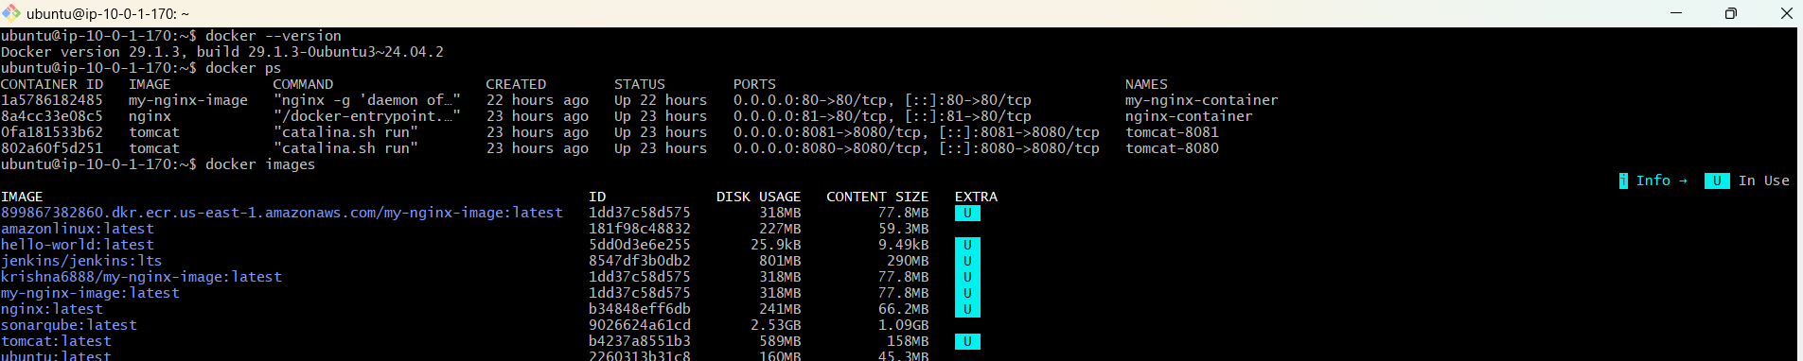
Expected: Docker should be installed and the existing Docker-02 containers should remain running. For this assignment, use separate names and ports such as docker03-container and 8085/8086 so that existing ports are not disturbed.

3. Task 1 — Create an Image from a Running Container
Objective: Create a container from Nginx, modify the running container, and use docker commit to create a new image from that container.

Step 1 — Create a new container
docker run -d --name docker03-container -p 8085:80 nginx
docker ps
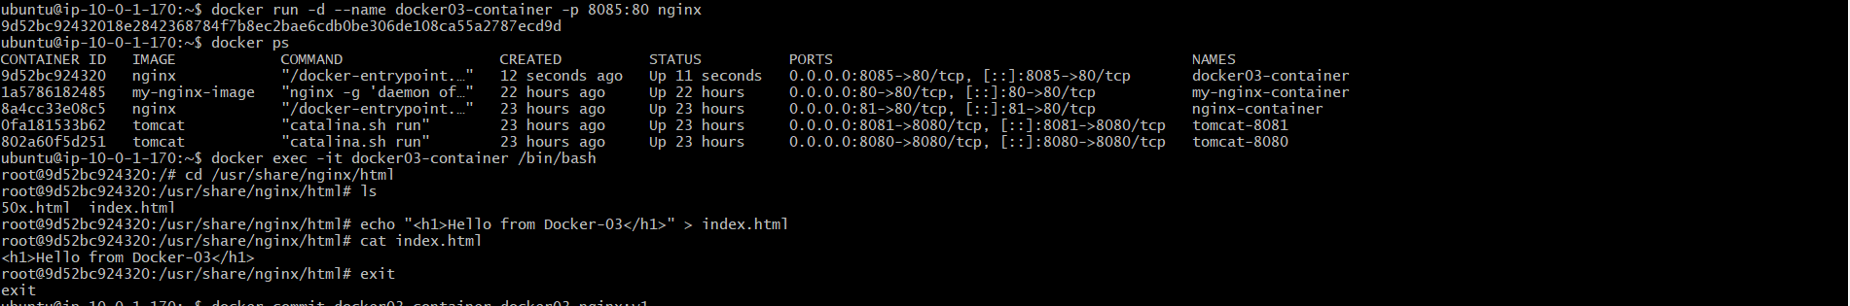
Why: Host port 8085 is mapped to container port 80 because ports 80, 81, 8080 and 8081 are already used by the Docker-02 work.

Step 2 — Enter the container
docker exec -it docker03-container /bin/bash
cd /usr/share/nginx/html
ls

Step 3 — Modify the running container
echo "<h1>Hello from Docker-03</h1>" > index.html
cat index.html
exit

Step 4 — Create an image from the running container
docker commit docker03-container docker03-nginx:v1
docker images
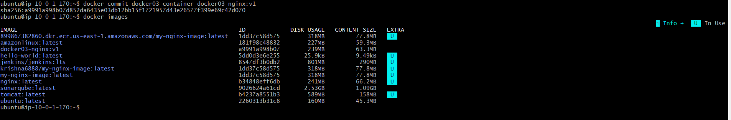
Important: The docker commit command creates a new image containing the current filesystem state of the container.

Task 2 — Copy Image from Local Machine to Docker Server and Load It
Objective: Export a Docker image as a tar archive on the local computer, transfer it to the Docker server, and load it into the server's Docker image store.

Step 1 — On the local Windows machine, verify the image
docker images
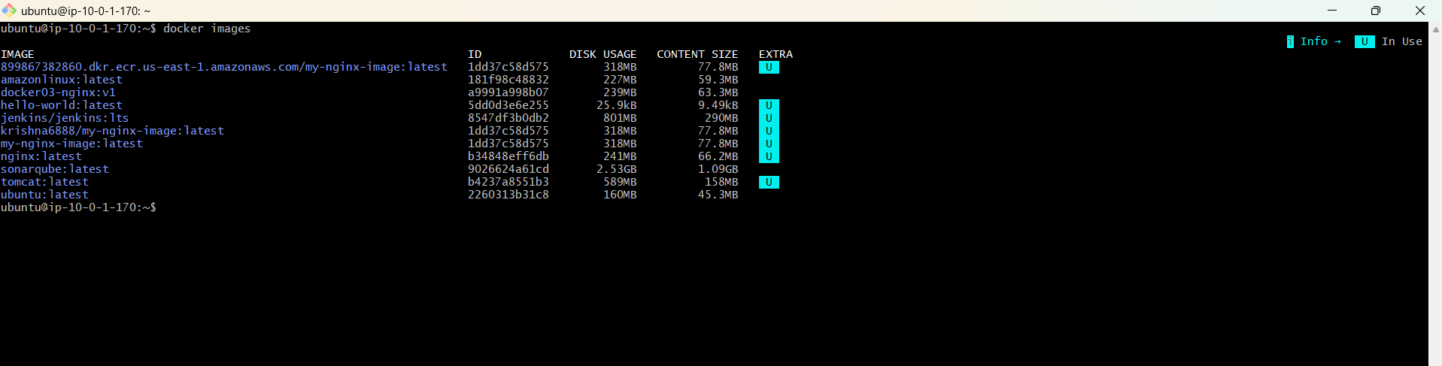

Step 2 — Save the image to a TAR file
docker save -o docker03-nginx-v1.tar docker03-nginx:v1
Result: A file named docker03-nginx-v1.tar is created on the local machine.

Step 3 — Copy the TAR file to the Docker server
Run this command from PowerShell on the local Windows machine.:
scp -i "C:\path\to\your-key.pem" docker03-nginx-v1.tar ubuntu@<DOCKER-SERVER-PUBLIC-IP>:/home/ubuntu/
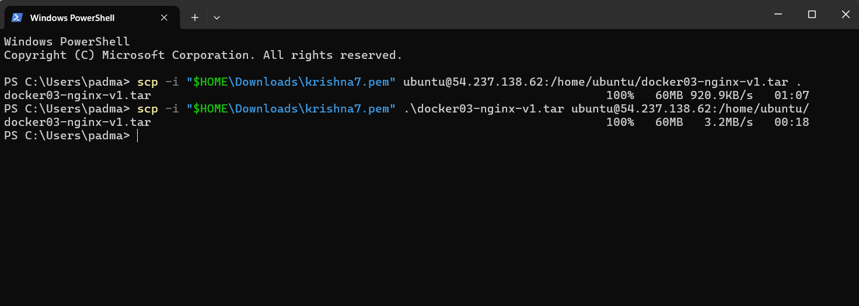
If your SSH key/path is different: Replace the PEM path, username, and public IP with the values used to SSH into your Docker server.

Step 4 — On the Docker server, verify the file
ls -lh /home/ubuntu/docker03-nginx-v1.tar

Step 5 — Load the image into Docker
docker load -i /home/ubuntu/docker03-nginx-v1.tar

Step 6 — Verify
docker images | grep docker03-nginx
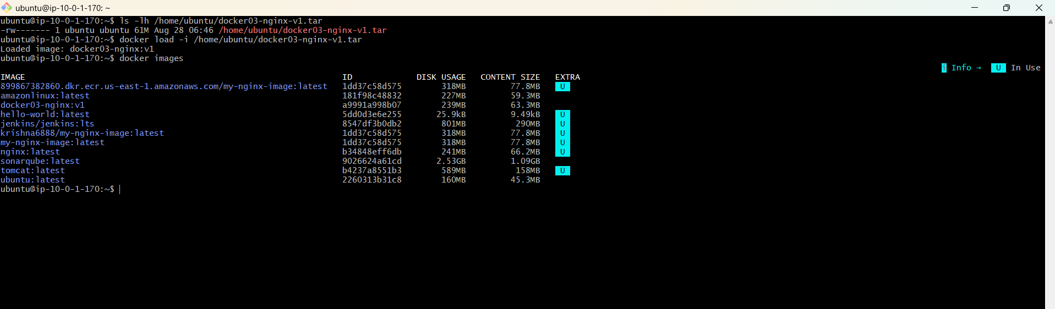

5. Task 3 — Create an Alpine-Based Image Customized with Tomcat
Objective: Use Alpine Linux as the base image, install Java, download Apache Tomcat, configure it, and run Tomcat inside the custom image.

Step 1 — Create a working directory
mkdir -p ~/docker03/task3-alpine-tomcat
cd ~/docker03/task3-alpine-tomcat

Step 2 — Create Dockerfile
cat > Dockerfile <<'EOF'
FROM alpine:3.20
RUN apk add --no-cache openjdk17-jre curl tar
ENV CATALINA_HOME=/opt/tomcat
ENV TOMCAT_VERSION=10.1.48
RUN mkdir -p ${CATALINA_HOME} && curl -fL https://archive.apache.org/dist/tomcat/tomcat-10/v${TOMCAT_VERSION}/bin/apache-tomcat-${TOMCAT_VERSION}.tar.gz -o /tmp/tomcat.tar.gz && tar -xzf /tmp/tomcat.tar.gz --strip-components=1 -C ${CATALINA_HOME} && rm /tmp/tomcat.tar.gz
EXPOSE 8080
CMD ["/opt/tomcat/bin/catalina.sh", "run"]
EOF
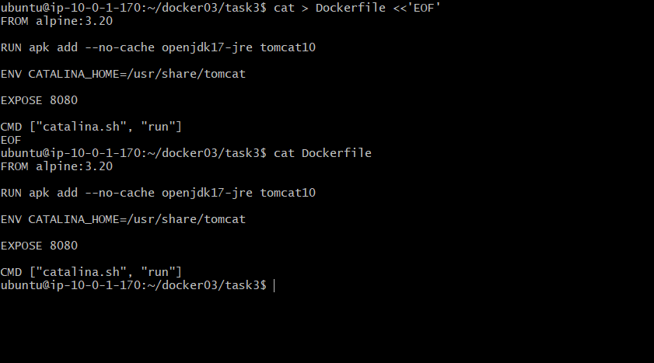
Version note: If the specified Tomcat archive version is no longer available, replace TOMCAT_VERSION and its archive URL with an available Tomcat 10.1.x version from Apache Tomcat.

Step 3 — Build the image
docker build -t alpine-tomcat:v1 .

Step 4 — Run the container
docker run -d --name alpine-tomcat -p 8089:8080 alpine-tomcat:v1
docker ps
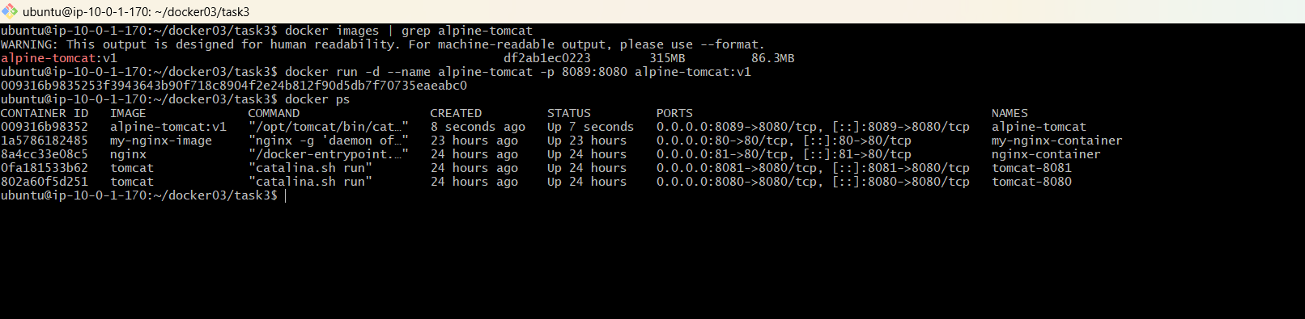

Step 5 — Check Tomcat
docker logs alpine-tomcat
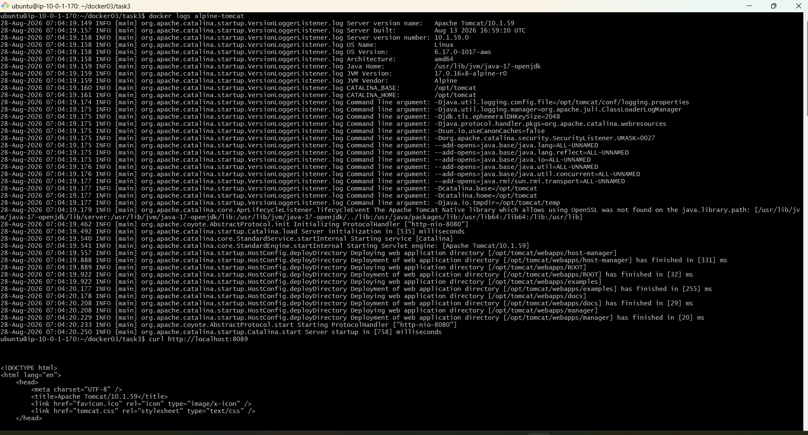
docker exec -it alpine-tomcat java -version

6. Task 4 — Single-Stage and Multi-Stage Dockerfiles
Source repository: https://github.com/betawins/multi-stage-example
Repository structure: The repository is a Spring Boot/Maven application. Its Dockerfile uses an OpenJDK 8 Alpine builder stage, runs ./mvnw clean package, then copies the generated JAR into a final stage and exposes port 8080.

Step 1 — Clone the repository
cd ~/docker03
git clone https://github.com/betawins/multi-stage-example.git
cd multi-stage-example
ls
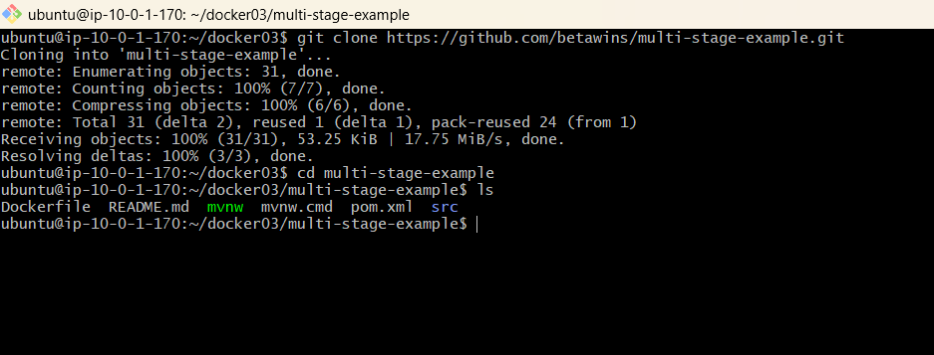

Part A — Multi-stage Dockerfile
Create Dockerfile.multi: This follows the repository's existing multi-stage pattern.
cat > Dockerfile.multi <<'EOF'
FROM openjdk:8-jdk-alpine AS builder
RUN mkdir -p /app/source
COPY . /app/source
WORKDIR /app/source
RUN ./mvnw clean package
FROM builder
COPY --from=builder /app/source/target/*.jar /app/app.jar
EXPOSE 8080
ENTRYPOINT ["java","-Djava.security.egd=file:/dev/./urandom","-jar","/app/app.jar"]
EOF
docker build -f Dockerfile.multi -t multi-stage-example:v1 .
docker run -d --name multi-stage-app -p 8090:8080 multi-stage-example:v1
docker ps
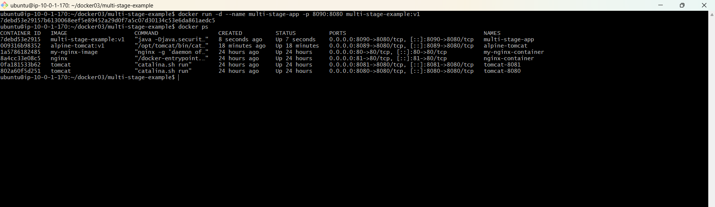

Part B — Single-stage Dockerfile
Create Dockerfile.single: All build and runtime work is kept in one image stage.
cat > Dockerfile.single <<'EOF'
FROM openjdk:8-jdk-alpine
RUN mkdir -p /app/source
COPY . /app/source
WORKDIR /app/source
RUN ./mvnw clean package && cp target/*.jar /app/app.jar
EXPOSE 8080
ENTRYPOINT ["java","-Djava.security.egd=file:/dev/./urandom","-jar","/app/app.jar"]
EOF
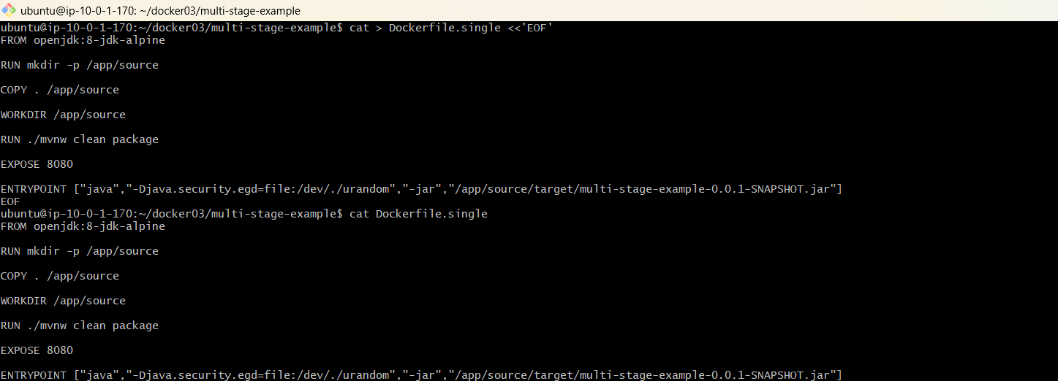

docker build -f Dockerfile.single -t single-stage-example:v1 .
docker run -d --name single-stage-app -p 8091:8080 single-stage-example:v1
docker ps
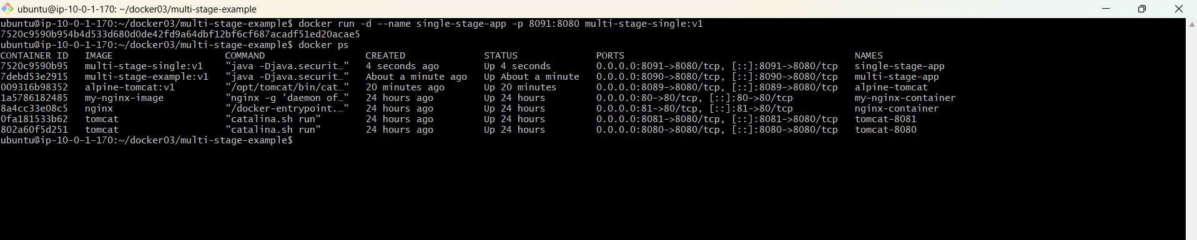
Comparison: Single-stage keeps the build environment in the final image. Multi-stage separates the build stage from the final runtime stage, which can reduce unnecessary build tooling in the runtime image.

Optional — Build only the builder stage
docker build -f Dockerfile.multi -t multi-stage-builder:v1 --target=builder .

7. Task 5 — Install Docker Compose and Execute a Sample Application
Objective: Install the Docker Compose plugin on the existing Linux Docker server and run a sample multi-container application.

Step 1 — Install Docker Compose plugin
sudo apt-get update
sudo apt-get install -y docker-compose-plugin

Step 2 — Verify
docker compose version
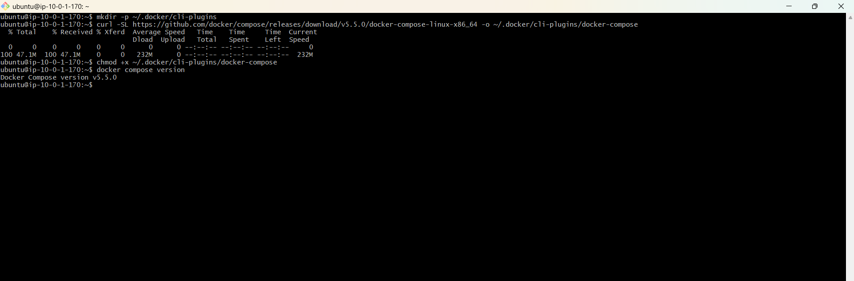

Step 3 — Create a sample Compose application
mkdir -p ~/docker03/compose-demo
cd ~/docker03/compose-demo
cat > compose.yaml <<'EOF'
services:
web:
image: nginx:latest
ports:
- "8095:80"
restart: unless-stopped
redis:
image: redis:7-alpine
restart: unless-stopped
EOF
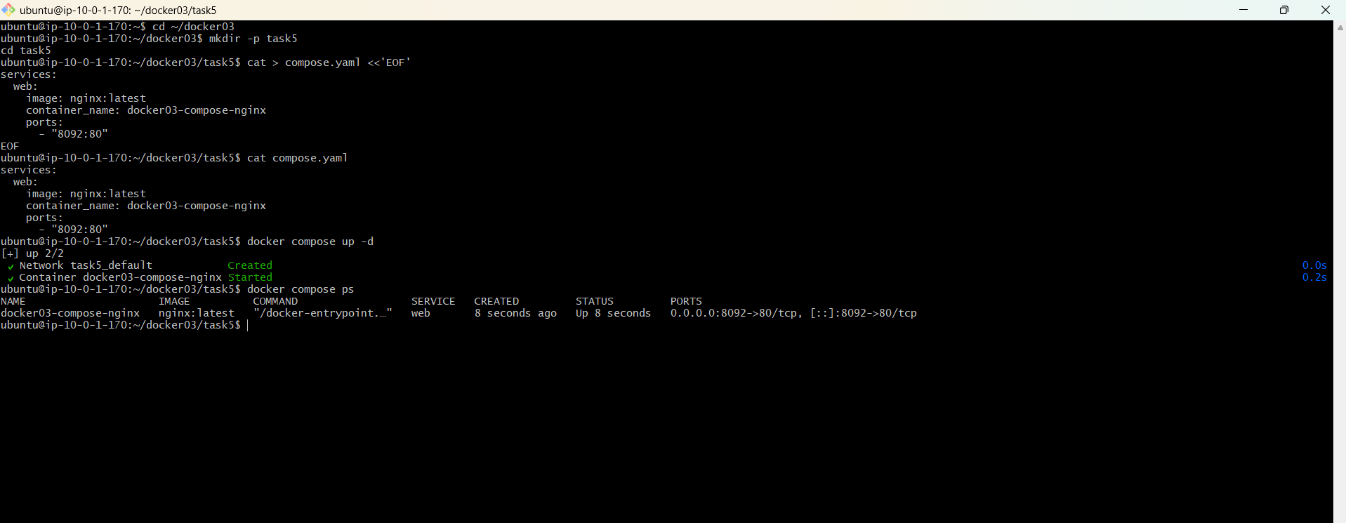

Step 4 — Start the application
docker compose up -d
docker compose ps

Step 5 — Verify containers
docker ps

Step 6 — Test the web service
curl http://localhost:8095
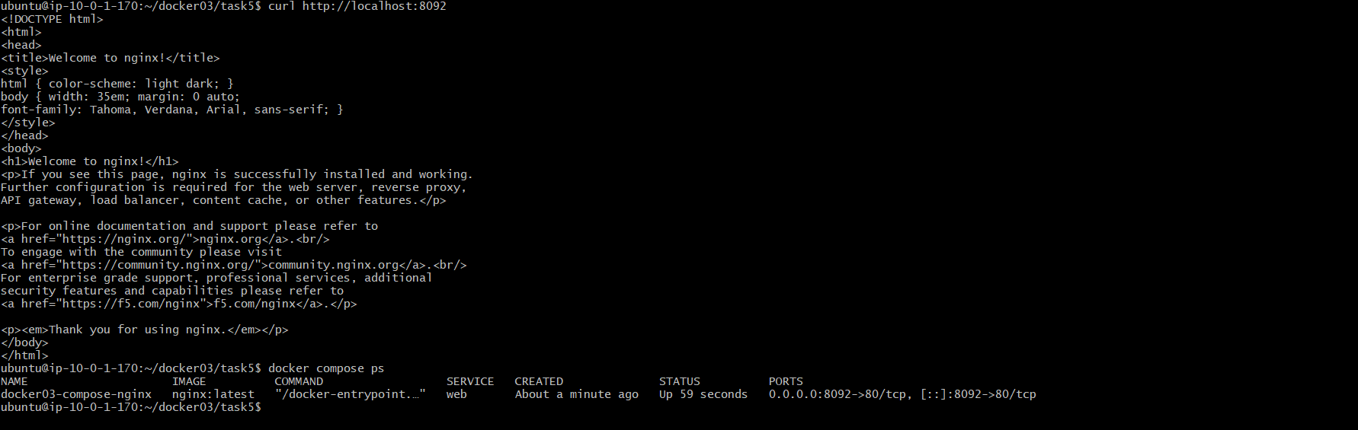

Step 7 — Stop and remove the Compose application
docker compose down

8. Task 6 — Scan Images When Pushed to Docker Hub
Recommended solution: Use Docker Scout image analysis on the Docker Hub repository. Once image analysis is activated for a repository, new images pushed to that repository are automatically analyzed for vulnerabilities.

Step 1 — Sign in to Docker Hub
docker login
Security: Use a Docker Hub Personal Access Token when prompted instead of storing your Docker Hub password in scripts.
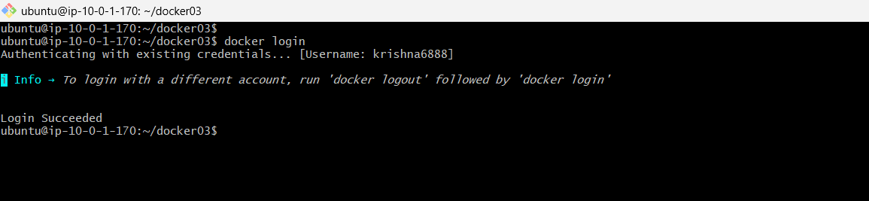
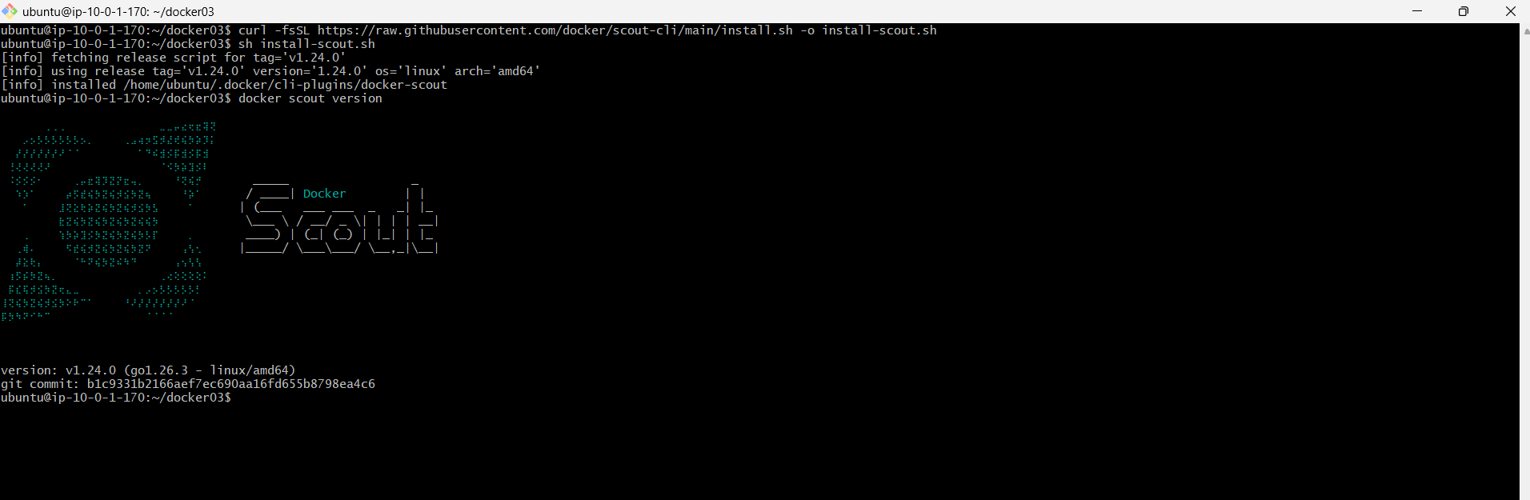
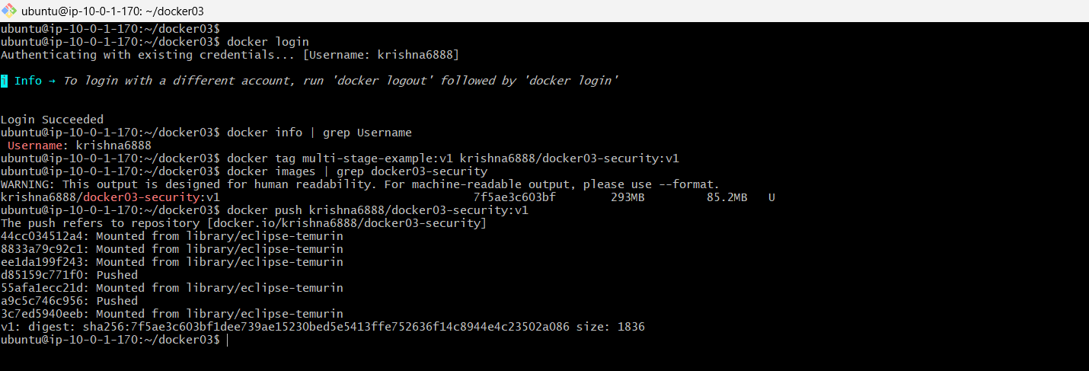

Step 2 — Enroll Docker Scout for the organization
docker scout enroll <DOCKERHUB_USERNAME_OR_ORG>
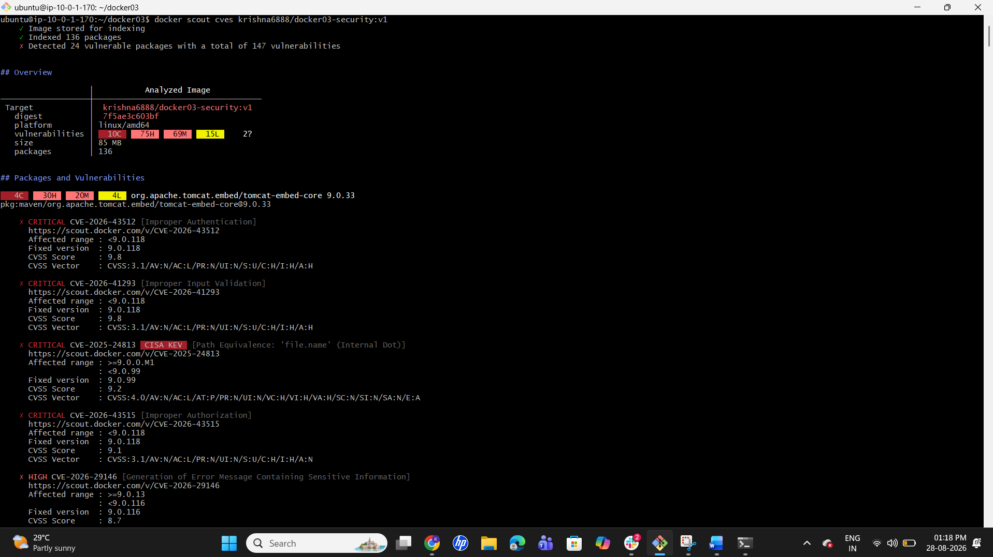
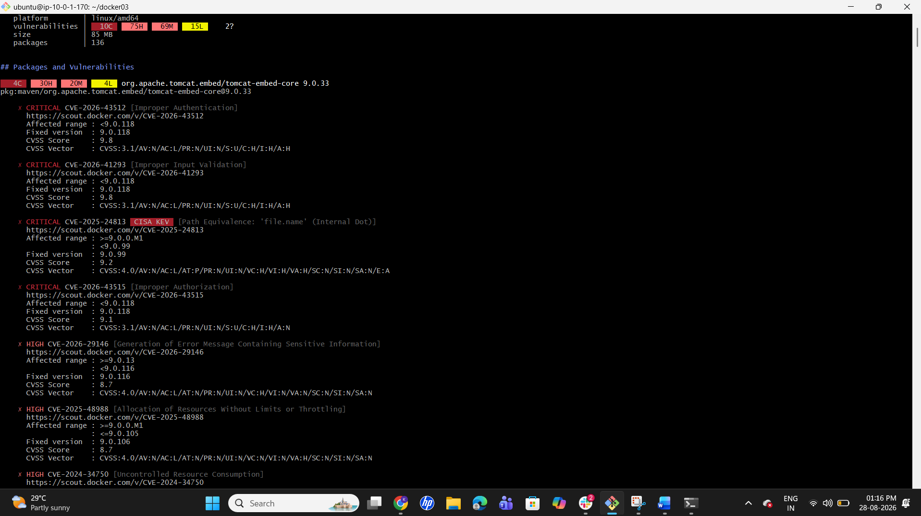

Step 3 — Enable Scout image analysis for the repository
docker scout repo enable --org <DOCKERHUB_USERNAME_OR_ORG> <DOCKERHUB_USERNAME_OR_ORG>/docker03-scan-demo
Repository: Create the Docker Hub repository docker03-scan-demo first if it does not already exist.
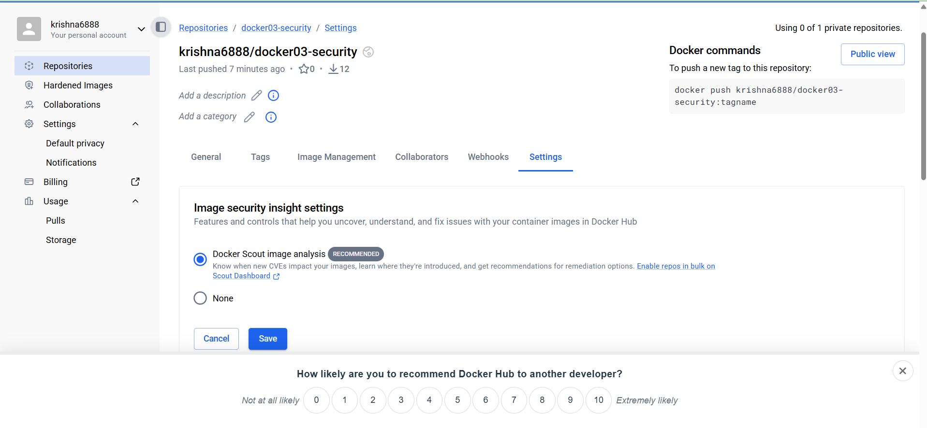

Step 4 — Build and push an image
docker build --provenance=true --sbom=true -t <DOCKERHUB_USERNAME>/docker03-scan-demo:v1 .
docker push <DOCKERHUB_USERNAME>/docker03-scan-demo:v1

Step 5 — Check vulnerabilities from the CLI
docker scout cves <DOCKERHUB_USERNAME>/docker03-scan-demo:v1

Step 6 — Verify in Docker Scout
Verification: Open Docker Scout Dashboard → Images → select the repository/image and review vulnerability findings, SBOM/package inventory, and severity levels.
Important: Automatic analysis occurs because image analysis is enabled for the Docker Hub repository; the CLI cves command is useful for verification.

9. Task 7 — Scan Images When Pushed to AWS ECR
Basic scan-on-push solution: Configure the ECR repository to scan images automatically after they are pushed. AWS also supports enhanced scanning through Amazon Inspector for OS and programming-language package vulnerabilities.

Step 1 — Verify AWS CLI
aws --version
aws sts get-caller-identity

Step 2 — Set the AWS region
export AWS_REGION=us-east-1
Region: Use the region where your ECR repository is located. Change this if your repository is in another region.

Step 3 — Create an ECR repository with scan-on-push
aws ecr create-repository --repository-name docker03-scan-demo --image-scanning-configuration scanOnPush=true --region $AWS_REGION
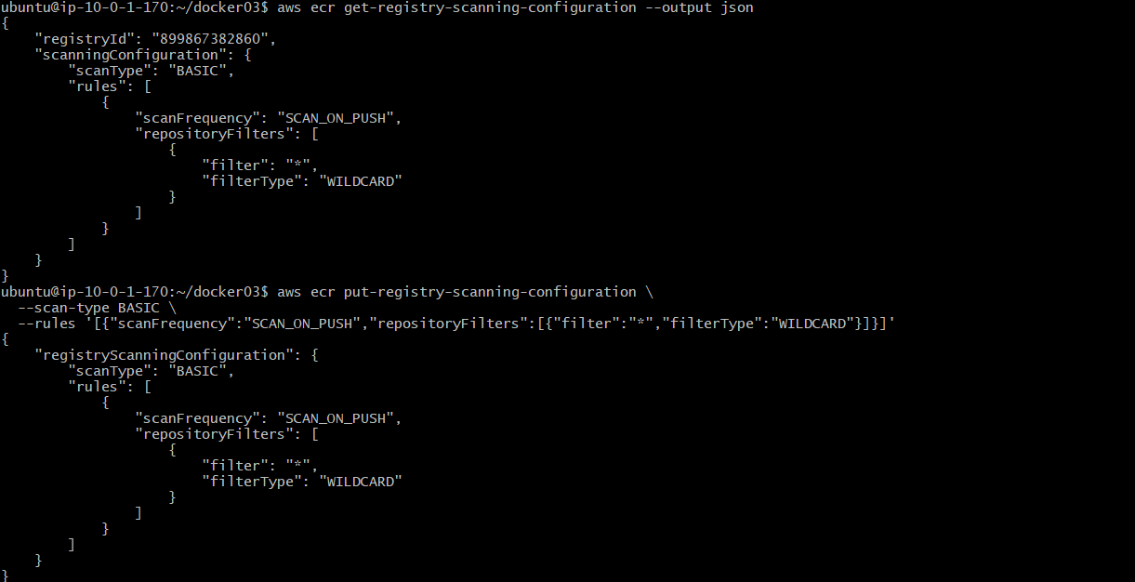

Step 4 — Authenticate Docker to ECR
aws ecr get-login-password --region $AWS_REGION | docker login --username AWS --password-stdin <ACCOUNT_ID>.dkr.ecr.$AWS_REGION.amazonaws.com

Step 5 — Tag the image for ECR
docker tag docker03-nginx:v1 <ACCOUNT_ID>.dkr.ecr.$AWS_REGION.amazonaws.com/docker03-scan-demo:v1

Step 6 — Push the image
docker push <ACCOUNT_ID>.dkr.ecr.$AWS_REGION.amazonaws.com/docker03-scan-demo:v1
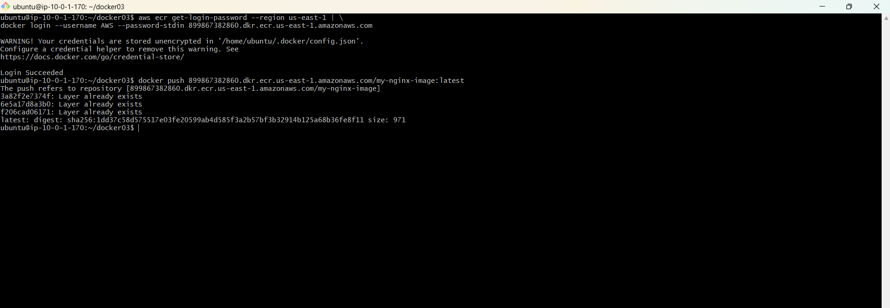

Step 7 — Check the scan result
aws ecr describe-image-scan-findings --repository-name docker03-scan-demo --image-id imageTag=v1 --region $AWS_REGION
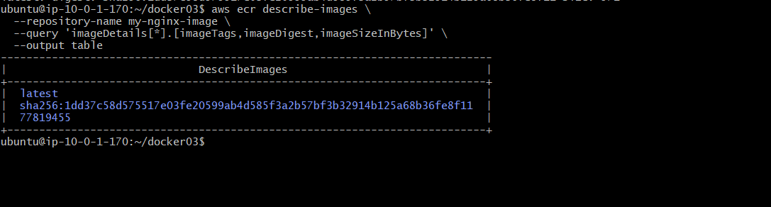

10. Task 8 — Jenkins Pipeline to Build and Push to Docker Hub
Objective: Create a Jenkins declarative pipeline that checks out source code, builds a Docker image, logs in securely using Jenkins credentials, and pushes the image to Docker Hub.

Step 1 — Jenkins prerequisites
- Jenkins server/agent must have Docker CLI available.
- The Jenkins user must be allowed to access the Docker daemon (for example, through the docker group where appropriate).
- Install/enable the Pipeline and Docker Pipeline plugins if using Docker Pipeline steps.
- The Jenkins job must have access to the source repository.

Step 2 — Add Docker Hub credentials in Jenkins
Jenkins: Manage Jenkins → Credentials → add a Username with password credential.
Username: <DOCKERHUB_USERNAME>
Password: Docker Hub Personal Access Token (PAT), not the account password.
Credential ID: dockerhub-creds (example). Use the exact ID configured in your Jenkins instance.

Step 3 — Create Jenkinsfile
pipeline {
agent any

environment {
DOCKER_IMAGE = 'krishna6888/docker03-jenkins:v1'
DOCKER_CREDENTIALS = 'dockerhub-credentials'
}

stages {

stage('Checkout Code') {
steps {
git branch: 'master',
url: 'https://github.com/betawins/multi-stage-example.git'
}
}

stage('Fix Dockerfile') {
steps {
sh '''
cat > Dockerfile <<'EOF'
FROM maven:3.9-eclipse-temurin-8 AS builder

WORKDIR /app/source

COPY . .

RUN mvn clean package -DskipTests

FROM eclipse-temurin:8-jre-alpine

COPY --from=builder /app/source/target/*.jar /app/app.jar

EXPOSE 8080

ENTRYPOINT ["java","-Djava.security.egd=file:/dev/./urandom","-jar","/app/app.jar"]
EOF

echo "======================================"
echo "Final Dockerfile:"
echo "======================================"
cat Dockerfile
echo "======================================"
'''
}
}

stage('Build Docker Image') {
steps {
sh '''
echo "Building Docker image..."
docker build -t ${DOCKER_IMAGE} .
'''
}
}

stage('Docker Login') {
steps {
withCredentials([
usernamePassword(
credentialsId: "${DOCKER_CREDENTIALS}",
usernameVariable: 'DOCKER_USERNAME',
passwordVariable: 'DOCKER_PASSWORD'
)
]) {
sh '''
echo "$DOCKER_PASSWORD" | docker login \
-u "$DOCKER_USERNAME" \
--password-stdin
'''
}
}
}

stage('Push to Docker Hub') {
steps {
sh '''
echo "Pushing image to Docker Hub..."
docker push ${DOCKER_IMAGE}
'''
}
}
}

post {
success {
echo "======================================"
echo "Docker image successfully pushed!"
echo "Image: ${DOCKER_IMAGE}"
echo "======================================"
}

failure {
echo "Pipeline failed. Check the console output."
}

always {
sh 'docker logout || true'
}
}
}If your source repository is private: Configure the Jenkins job's SCM credentials or use a Pipeline checkout configuration appropriate for your Git provider.

Step 4 — Create the Jenkins Pipeline job
- Jenkins Dashboard → New Item.
- Choose Pipeline.
- Configure the source repository or paste the Jenkinsfile into the Pipeline definition.
- Save the job.
- Click Build Now.
- 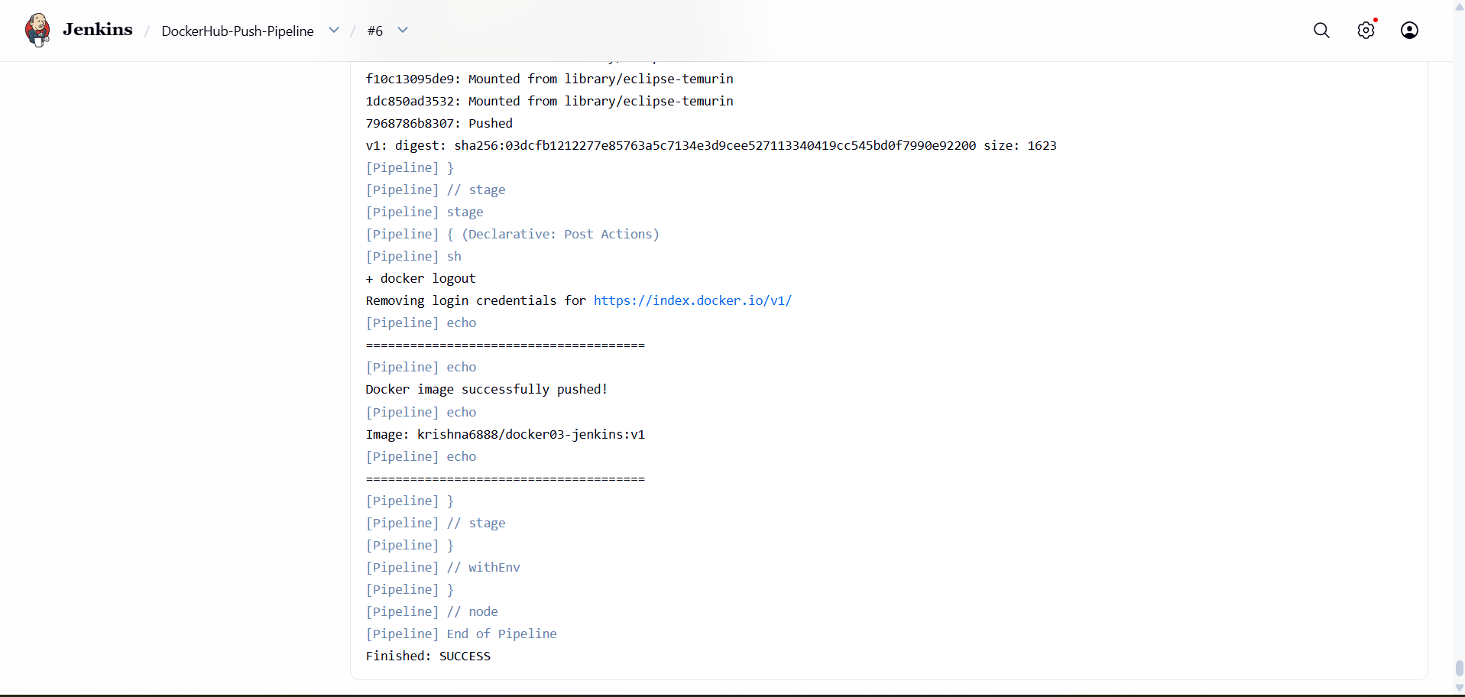

Step 5 — Verify the pipeline
docker images
docker ps
Docker Hub verification: Open Docker Hub → the docker03-jenkins-demo repository → Tags. Verify that the build-number tag and latest tag were pushed.
Pipeline flow: Checkout → Build Docker Image → Docker Login and Push → Docker Hub.
- 