Docker, Jenkins & SonarQube EC2 Lab
Objective: Create an Ubuntu EC2 server, install Docker, pull five required Docker images, run Nginx on port 81, remove the Tomcat image, inspect Jenkins and SonarQube images, run Jenkins, and execute a sample Jenkins job.

Environment
- AWS EC2
- Ubuntu Server 24.04 LTS, 64-bit (x86)
- Instance type: m7i.large
- 2 vCPUs, 8 GiB RAM
- 30 GB gp3 EBS storage

Task 1 — Setup a Virtual Machine Using Ubuntu Image

Step 1: Launch EC2
AWS Console → EC2 → Instances → Launch instance.
Screenshot — EC2 launch page:

Step 2: Instance Name
docker-jenkins-server

Step 3: Select Ubuntu Image
Ubuntu Server 24.04 LTS, 64-bit (x86).

Step 4: Select Instance Type
m7i.large — 2 vCPUs and 8 GiB RAM.

Step 5: Select Key Pair
Selected the SSH key pair used for EC2 access.

Step 6: Configure Security Group
Allowed TCP 22 (SSH), TCP 80 (HTTP), TCP 81 (Nginx), and TCP 8080 (Jenkins).

Step 7: Configure Storage
30 GB gp3 root EBS volume.

Step 8: Launch Instance
Launched the Ubuntu EC2 instance and waited for 2/2 status checks.

Step 9: Connect Using SSH
ssh -i "your-key.pem" ubuntu@<EC2-PUBLIC-IP>

Step 10: Verify Ubuntu
cat /etc/os-release

Step 11: Verify Memory
free -h

Step 12: Verify Storage
df -h /
Result: Ubuntu EC2 virtual machine was created, configured, and accessed successfully.
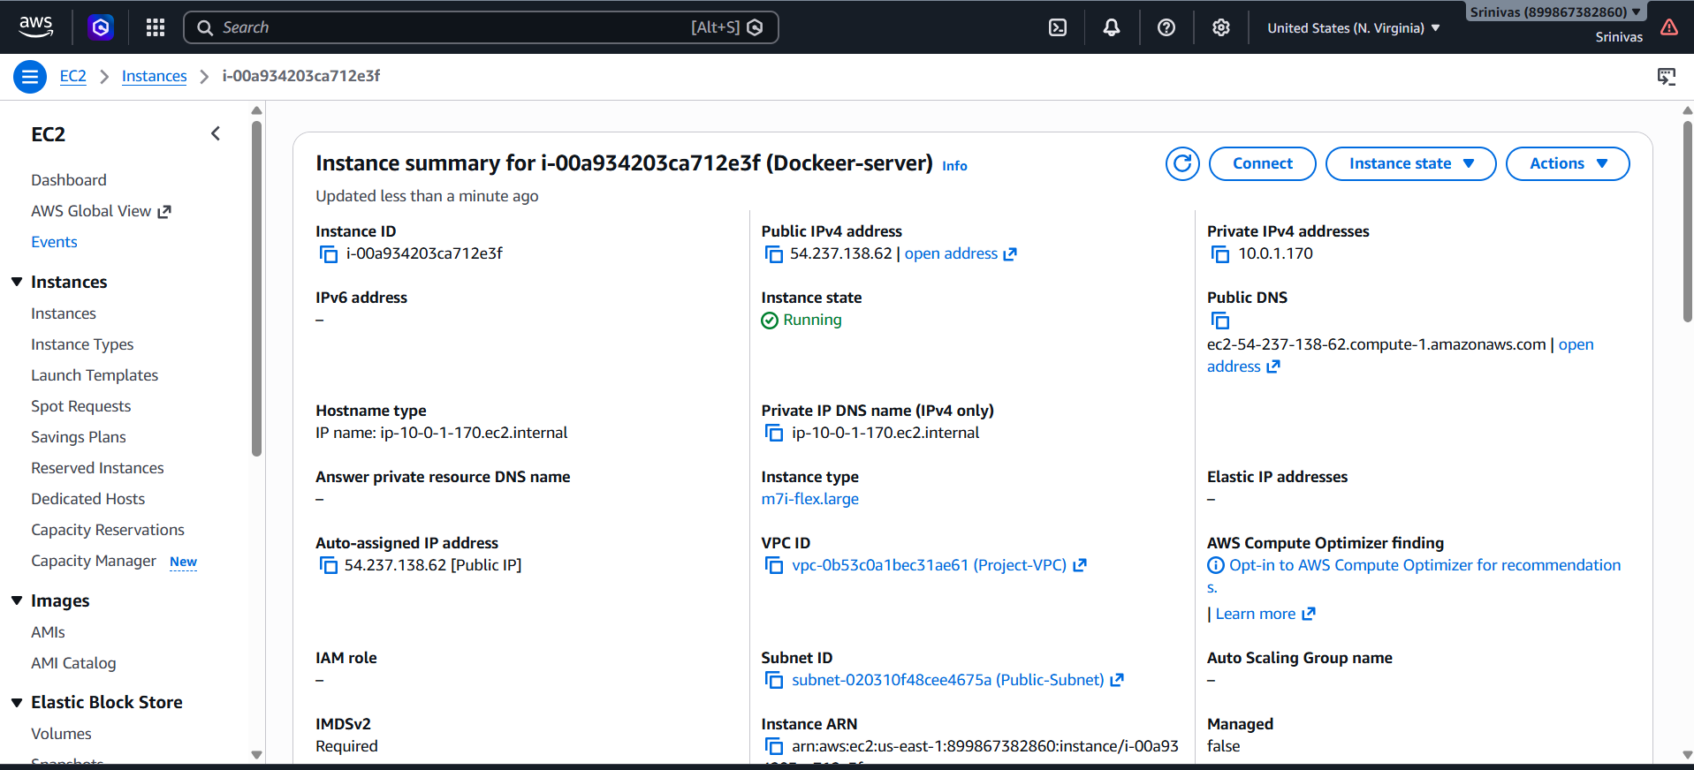

Task 2 — Install Docker on EC2

Step 1: Update Packages
sudo apt update

Step 2: Install Docker
sudo apt install docker.io -y

Step 3: Check Docker Version
docker --version

Step 4: Start Docker
sudo systemctl start docker

Step 5: Enable Docker
sudo systemctl enable docker

Step 6: Check Docker Service
sudo systemctl status docker

Step 7: Add Ubuntu User to Docker Group
sudo usermod -aG docker $USER

Step 8: Refresh Group Membership
newgrp docker

Step 9: Test Docker
docker run hello-world
Result: Docker was installed, started, enabled, and verified with the hello-world container.
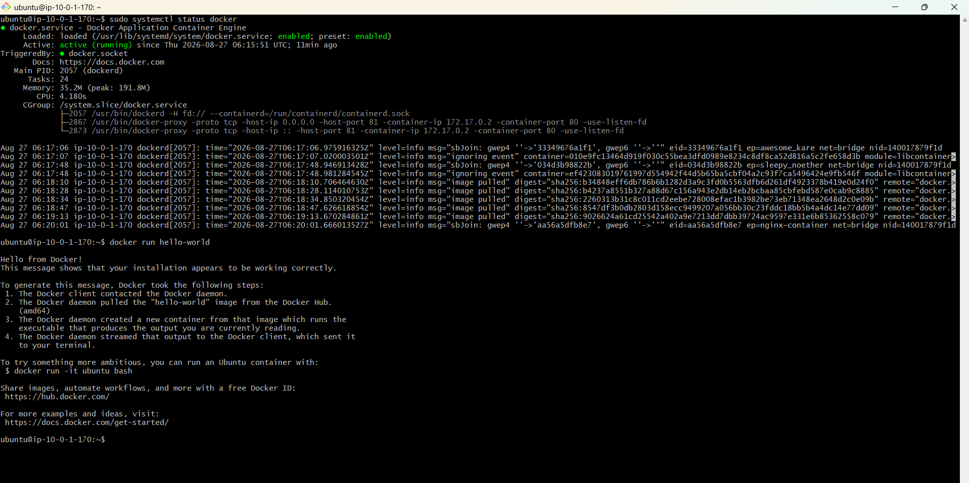

Task 3 — Pull 5 Docker Images

Step: Pull Nginx
docker pull nginx

Step: Pull Apache Tomcat
docker pull tomcat

Step: Pull Ubuntu
docker pull ubuntu

Step: Pull Jenkins LTS
docker pull jenkins/jenkins:lts

Step: Pull SonarQube
docker pull sonarqube

Verify All Five Images
docker images
Expected repositories: nginx, tomcat, ubuntu, jenkins/jenkins, sonarqube.
Result: All five required images were downloaded to the local EC2 Docker host.
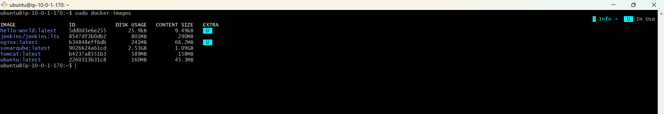

Task 4 — Run Nginx Container and Expose on Port 81

Step 1: Run Nginx
docker run -d --name nginx-container -p 81:80 nginx
Port mapping: EC2 port 81 → container port 80.

Step 2: Verify Container
docker ps
Expected mapping: 0.0.0.0:81->80/tcp.

Step 3: Test Nginx From EC2
curl http://localhost:81
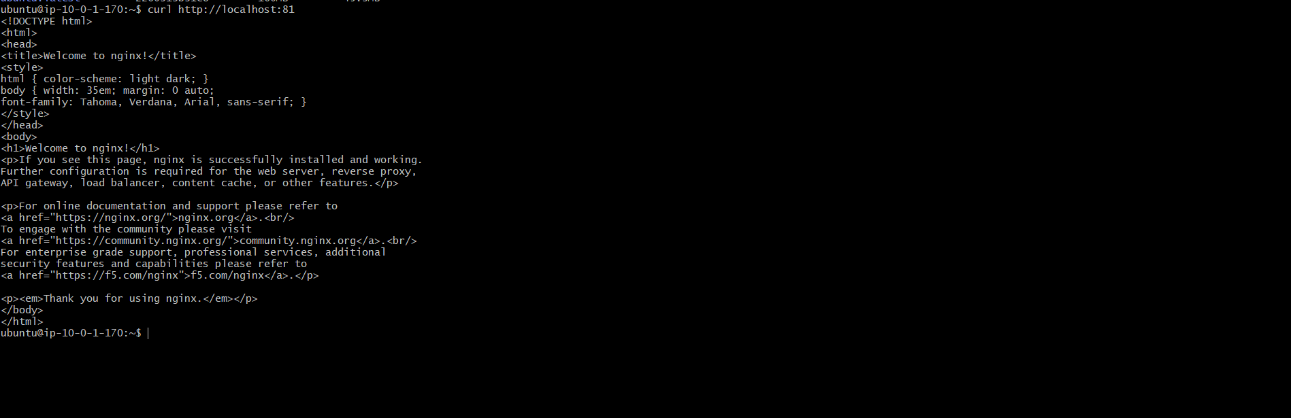

Step 4: Test Nginx From Browser
http://<EC2-PUBLIC-IP>:81
Expected result: Welcome to nginx! page.
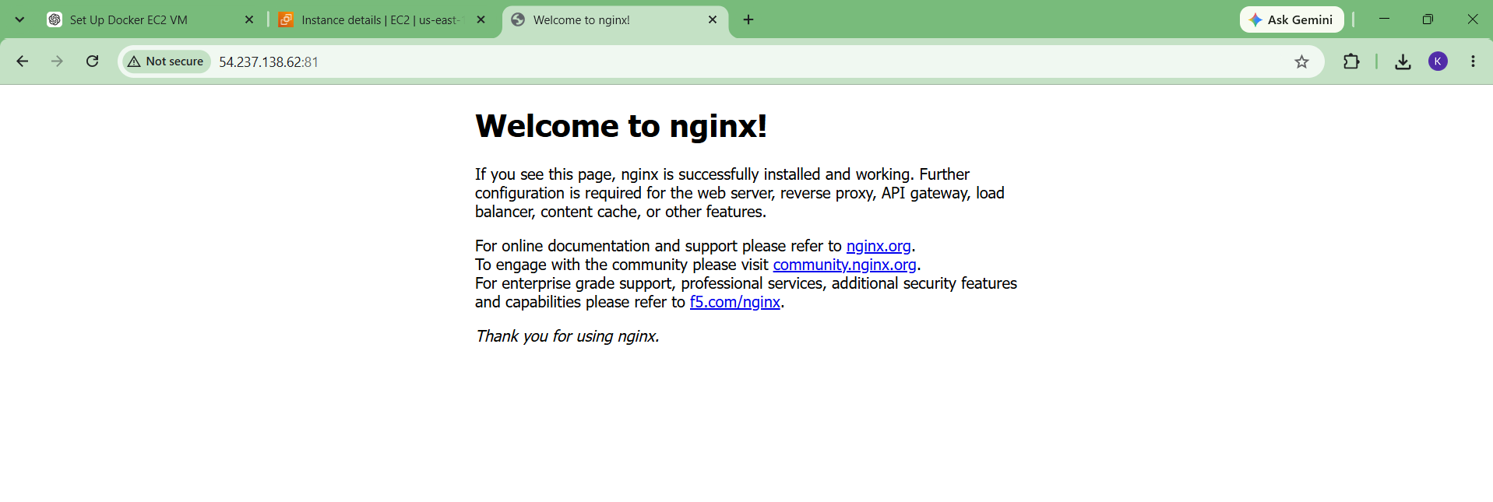
Result: Nginx was successfully started and exposed on EC2 port 81.

Task 5 — Delete Apache Tomcat Image From Local
Important: Take the Task 3 docker images screenshot BEFORE performing this task.

Step 1: Confirm Tomcat Exists
docker images
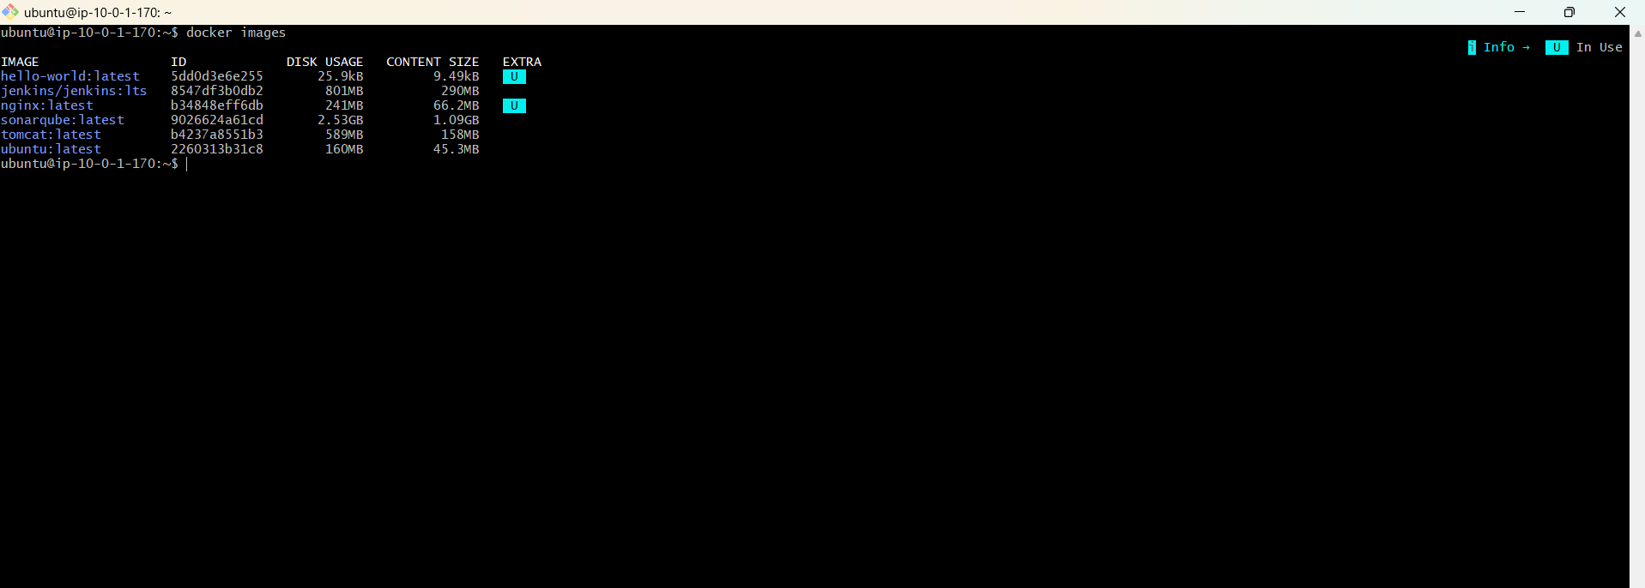

Step 2: Remove Tomcat Image
docker rmi tomcat

Step 3: Verify Tomcat Was Deleted
docker images
Tomcat should no longer appear in the image list.
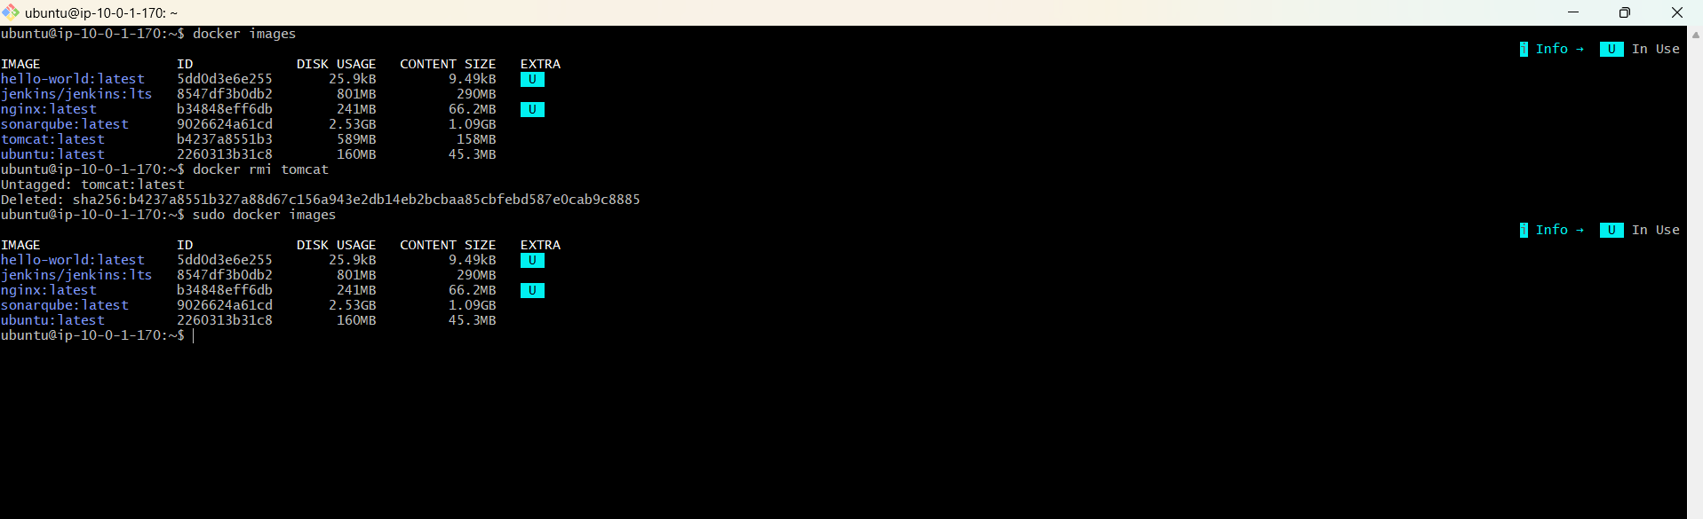

Task 6 — Inspect Jenkins and SonarQube Images

Step 1: Inspect Jenkins Image
docker inspect jenkins/jenkins:lts
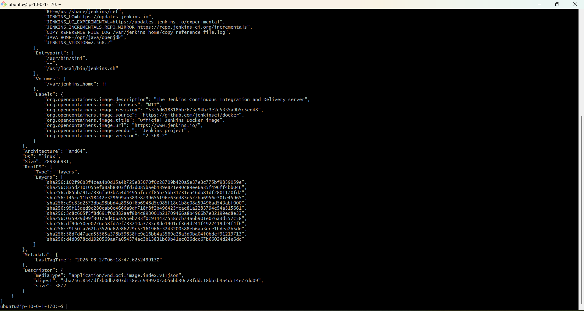
The inspection output can be reviewed for image configuration such as image ID, environment variables, exposed ports, volumes, entrypoint, working directory, and user.

Optional: Inspect Jenkins Exposed Ports
docker inspect jenkins/jenkins:lts --format='{{json .Config.ExposedPorts}}'
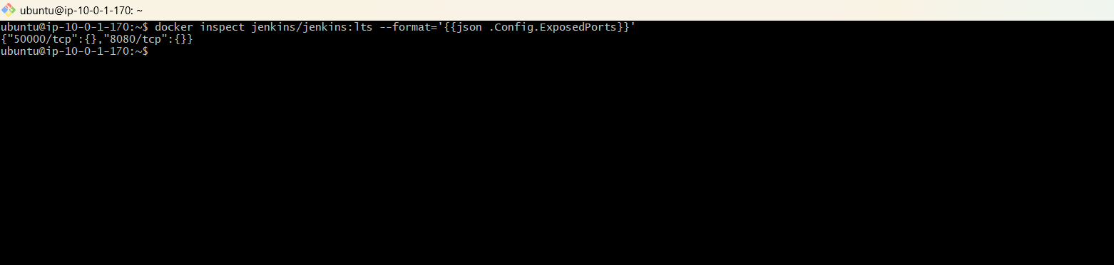

Step 2: Inspect SonarQube Image
docker inspect sonarqube
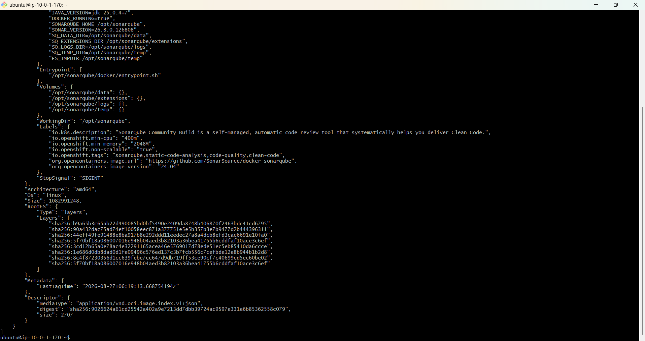

Optional: Inspect SonarQube Exposed Ports
docker inspect sonarqube --format='{{json .Config.ExposedPorts}}'
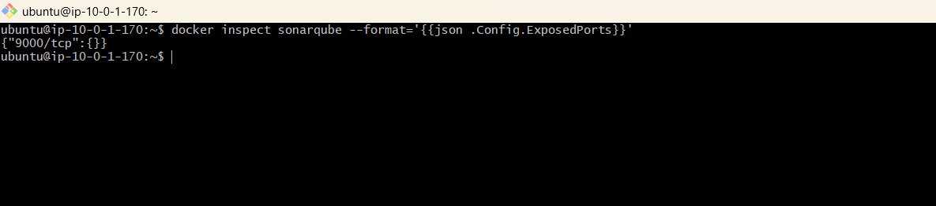
Result: Jenkins and SonarQube image configurations were inspected successfully.

Task 7 — Run Jenkins Container and Execute a Sample Job

Step 1: Run Jenkins Container
docker run -d \
--name jenkins \
-p 8080:8080 \
-p 50000:50000 \
jenkins/jenkins:lts
Port 8080 is used for the Jenkins web interface. Port 50000 is used for Jenkins inbound agent communication.

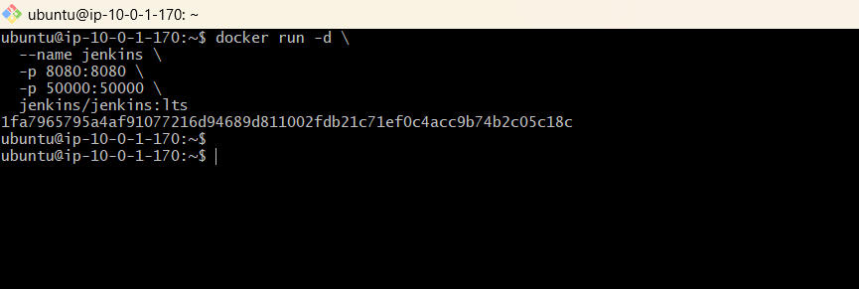Step 2: Verify Jenkins Container
docker ps

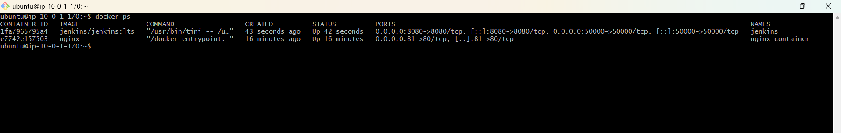Step 3: Get Jenkins Initial Admin Password
docker exec jenkins cat /var/jenkins_home/secrets/initialAdminPassword

Step 4: Open Jenkins Dashboard
http://<EC2-PUBLIC-IP>:8080
Enter the initial administrator password, choose Install suggested plugins, and create the Jenkins administrator account.
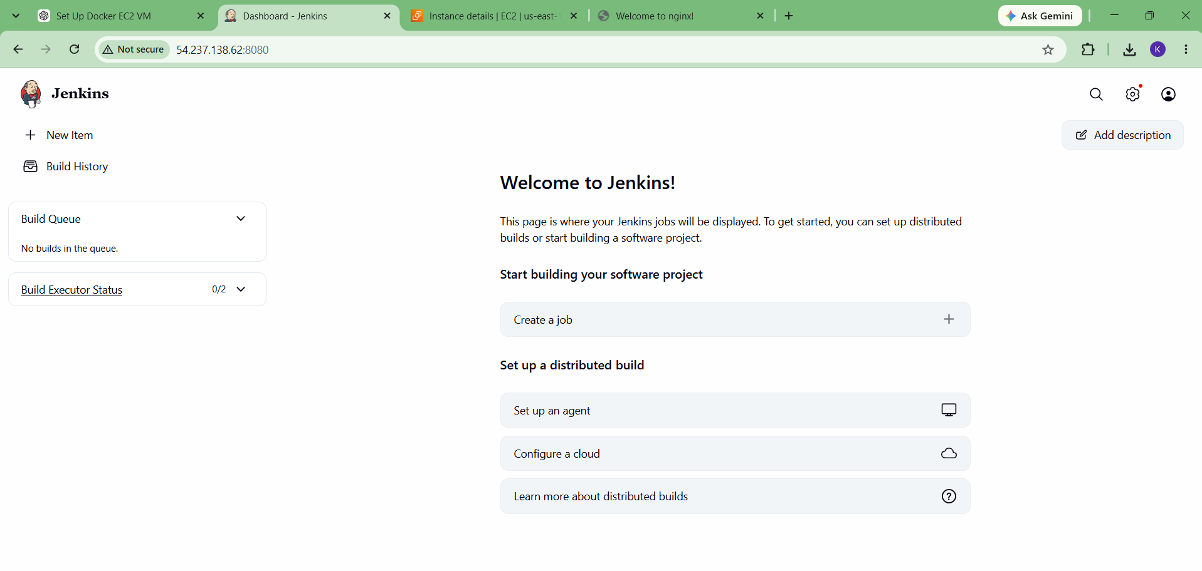

Step 5: Create Sample Freestyle Job
Click New Item → enter sample-job → select Freestyle project → click OK.
Screenshot — New Item / sample-job:

Step 6: Add Build Step
Under Build Steps, select Execute shell and enter:
echo "Hello from Jenkins"
echo "Docker Jenkins sample job is working"

Step 7: Save and Build
Click Save → Build Now.
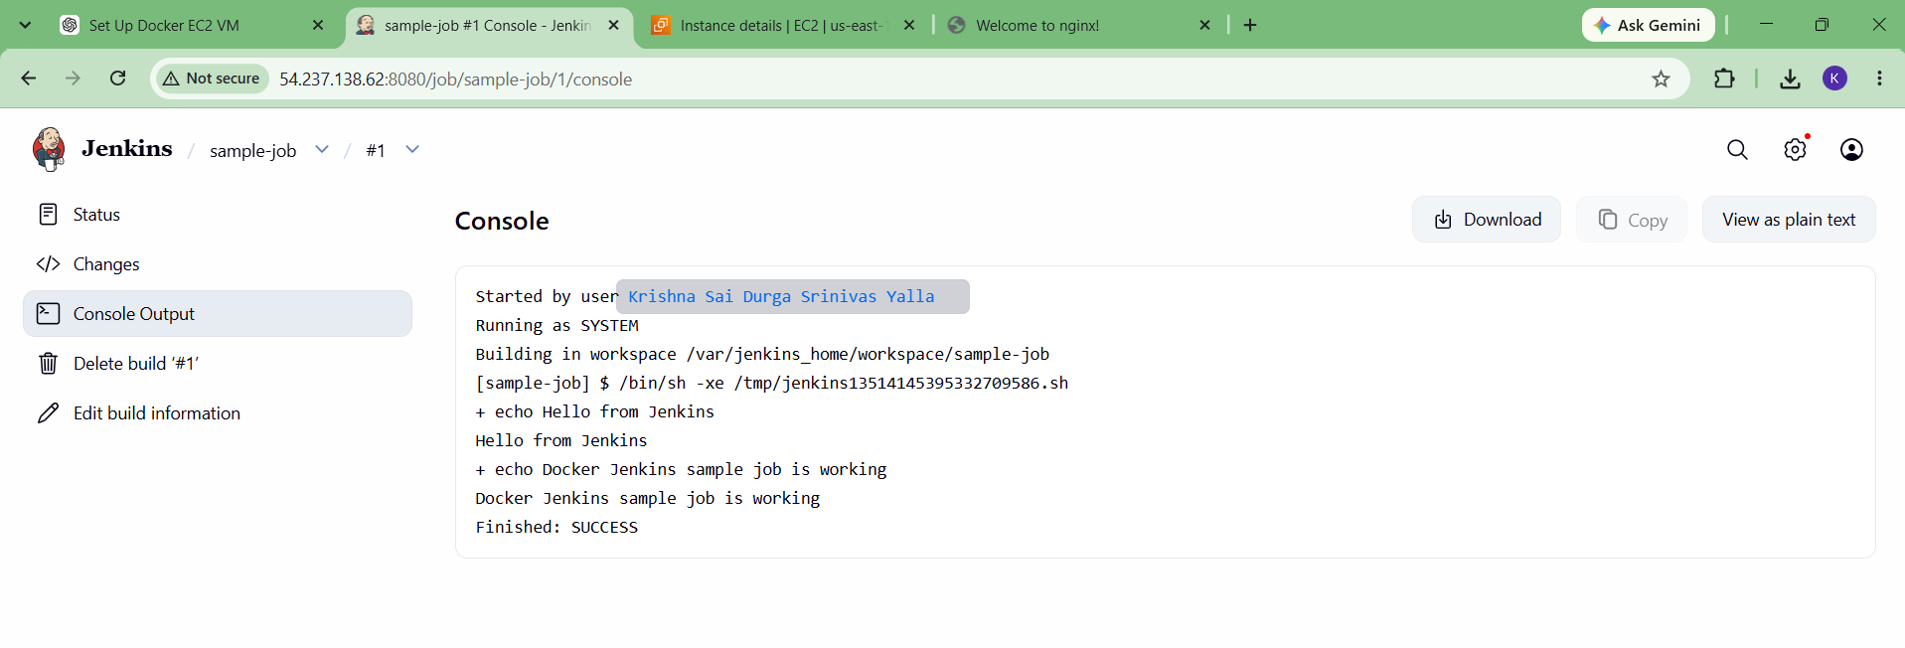

Step 8: Verify Console Output
Open Build #1 → Console Output. Expected output includes the two echo messages and Finished: SUCCESS.

Final Verification
Run the following commands after completing the lab:
docker ps
docker images
Expected running containers: nginx-container and jenkins.
