DOCKER CHALLENGE

Task 1 — Create a Customised Docker Image
Goal: create a Dockerfile, build a customised image, run it, and verify it.

Step 1 — Verify Docker
Exact command:
docker --version
Expected output:
Docker version <version>, build <build>
What to check:
Docker is installed and the command works.

Step 2 — Clone the source repository
Exact command:
git clone https://github.com/betawins/docker-tasks.git
cd docker-tasks
ls
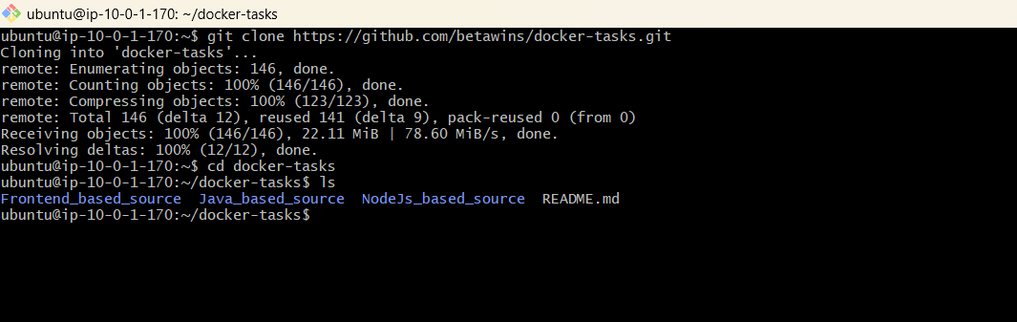
Expected output:
The repository is cloned and its files/directories are listed.
What to check:
You are inside the docker-tasks directory.

Step 3 — Inspect the source
Exact command:
find . -maxdepth 3 -type f | sort
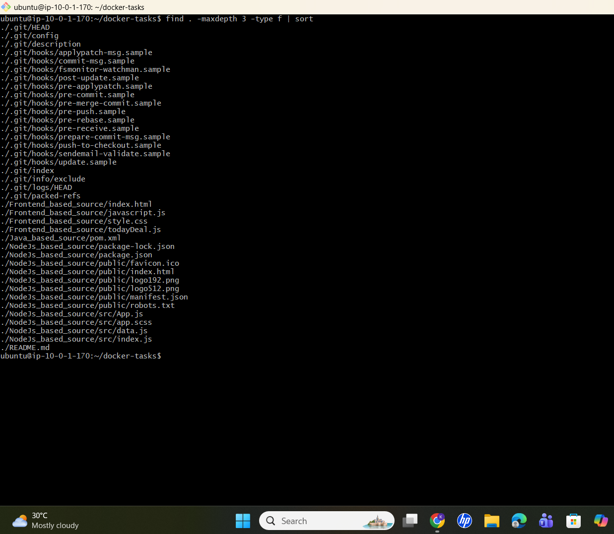
Expected output:
A list of source files is displayed.
What to check:
Identify the source directory required for the first customized-image task.

Step 4 — Enter the required application directory
Exact command:
cd <APPLICATION_DIRECTORY>
ls
Expected output:
The application files are displayed.
What to check:
Confirm that the required source files are present.

Step 5 — Create Dockerfile
Exact command:
vi Dockerfile
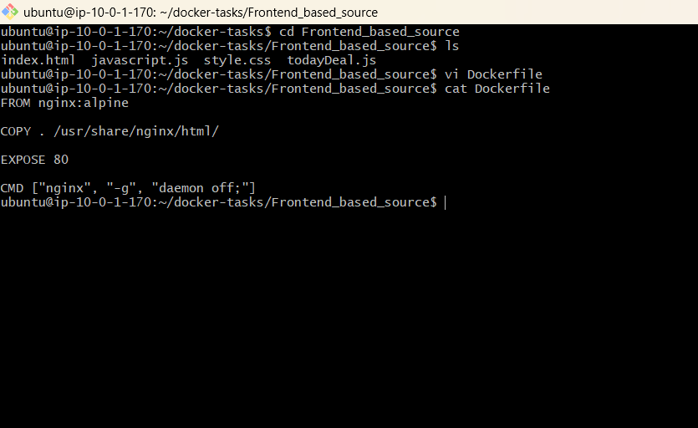
The exact Dockerfile depends on the source directory identified in Step 3; do not use a guessed Dockerfile.
What to check:
Create a file named exactly Dockerfile. Use the application's runtime, copy required files, install dependencies, expose the application port, and define the startup command.

Step 6 — Build the image
Exact command:
docker build -t <DOCKERHUB_USERNAME>/custom-app:v1 .
Expected output:
The build completes successfully and the image is tagged.
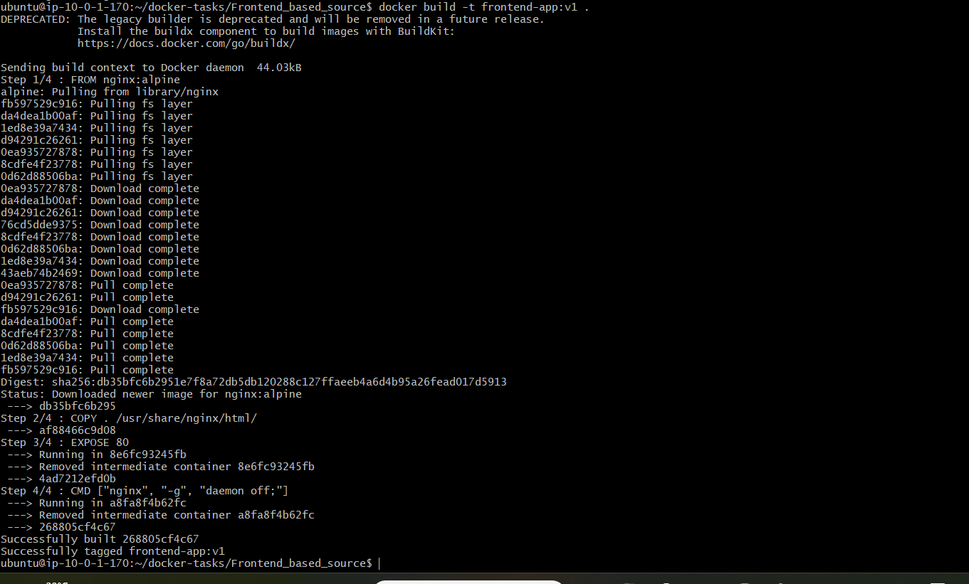
What to check:
No build errors are present and the tag is correct.

Step 7 — Verify image
Exact command:
docker images
Expected output:
The custom-app image with tag v1 appears.
What to check:
Repository and tag match the intended image.

Step 8 — Run container
Exact command:
docker run -d --name custom-app -p 8080:<CONTAINER_PORT> <DOCKERHUB_USERNAME>/custom-app:v1
Expected output:
A container ID is returned.
What to check:
Use the port on which the application actually listens.

Step 9 — Verify container
Exact command:
docker ps
docker logs custom-app
Expected output:
The container is Up/Running and logs do not show a fatal startup error.
What to check:
Confirm the application started successfully.

Step 10 — Test application
Exact command:
curl http://localhost:8080
Expected output:
The application responds with its expected page/response.

What to check:
The application is reachable through the mapped port.

Task 2 — Push the Image to Docker Hub

Step 1 — Log in to Docker Hub
Exact command:
docker login
Expected output:
Login Succeeded
What to check:
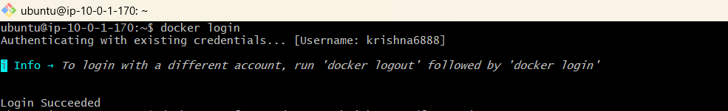
Do not expose your password/token in the terminal screenshot or document.

Step 2 — Tag the image
Exact command:
docker tag <DOCKERHUB_USERNAME>/custom-app:v1 <DOCKERHUB_USERNAME>/custom-app:v1
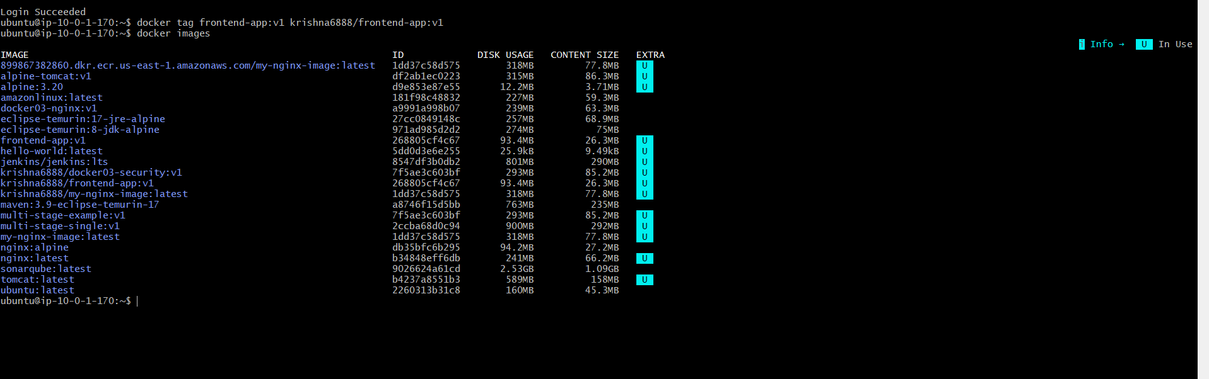
Expected output:
No output is normally produced.
What to check:
The image has the correct Docker Hub repository/tag.

Step 3 — Push the image
Exact command:
docker push <DOCKERHUB_USERNAME>/custom-app:v1
Expected output:
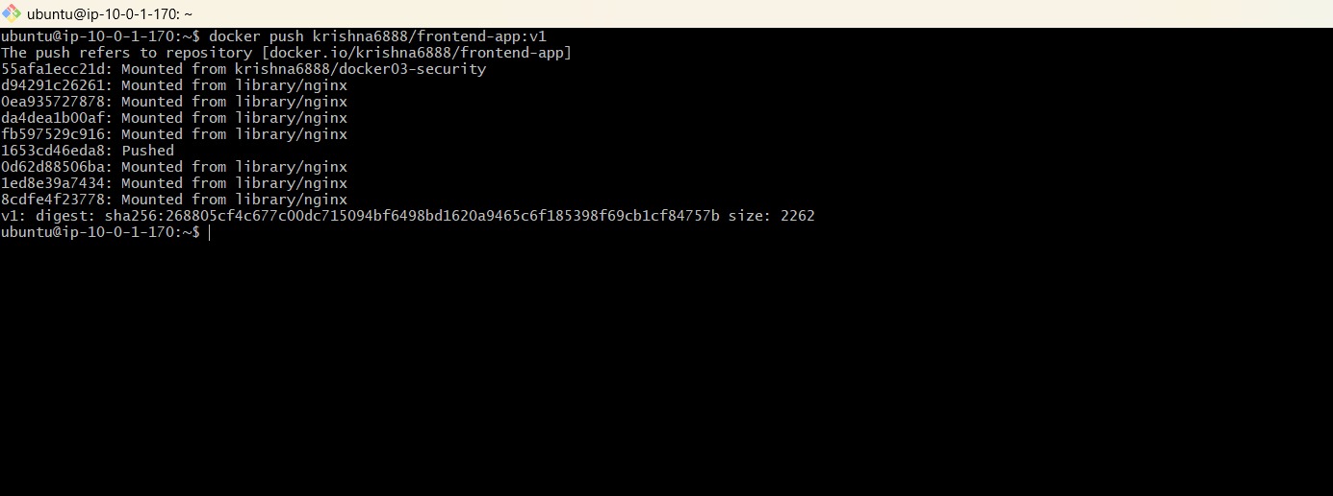
Layers are pushed and the command ends successfully.
What to check:
The push completed without denied/authentication errors.

Step 4 — Verify locally
Exact command:
docker images | grep custom-app
Expected output:
The custom-app:v1 image is listed.
What to check:
Repository and tag are correct.

Step 5 — Verify in Docker Hub
Exact command:
Open your Docker Hub repository in a browser.
Expected output:
The custom-app repository contains tag v1.
What to check:
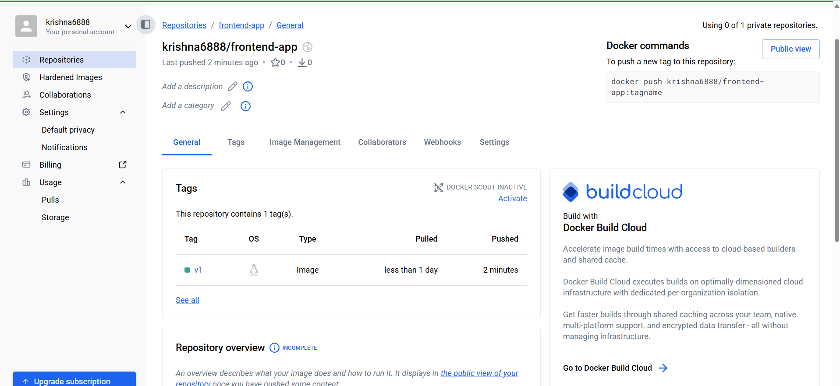
Confirm the image is visible in the registry.

Task 3 — Push the Same Image to Amazon ECR

Step 1 — Configure/check AWS CLI
Exact command:
aws sts get-caller-identity
aws configure get region
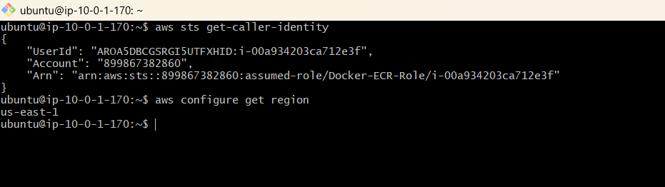
Expected output:
AWS account identity and configured region are displayed.
What to check:
Confirm the correct AWS account and region.

Step 2 — Set variables
Exact command:
export AWS_REGION=<AWS_REGION>
export ACCOUNT_ID=$(aws sts get-caller-identity --query Account --output text)
export ECR_REPO=custom-app
Expected output:
Variables are set.
What to check:
Confirm ACCOUNT_ID, AWS_REGION and ECR_REPO.

Step 3 — Create ECR repository
Exact command:
aws ecr describe-repositories --repository-names $ECR_REPO --region $AWS_REGION || aws ecr create-repository --repository-name $ECR_REPO --region $AWS_REGION
Expected output:
The repository is found or created successfully.
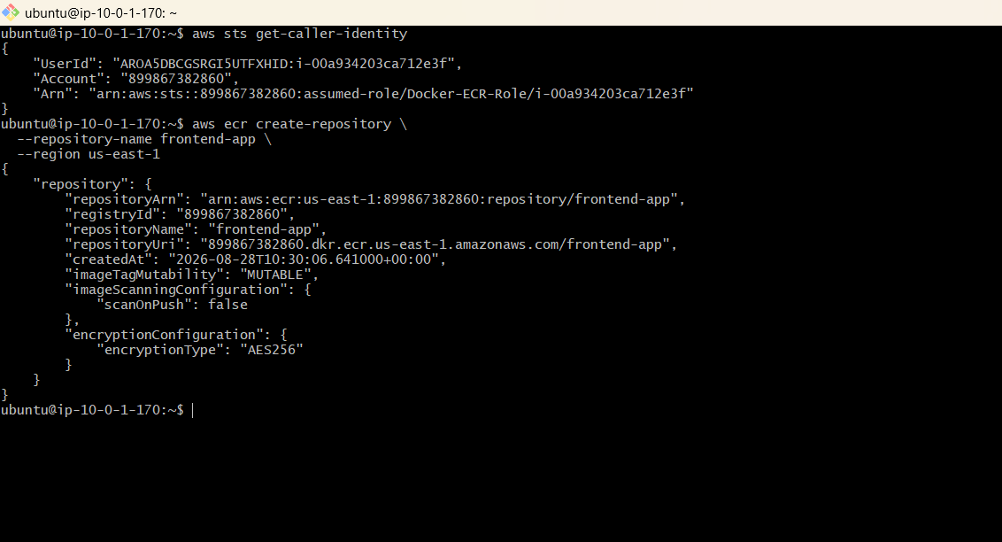
What to check:
Repository name and region are correct.

Step 4 — Authenticate Docker to ECR
Exact command:
aws ecr get-login-password --region $AWS_REGION | docker login --username AWS --password-stdin $ACCOUNT_ID.dkr.ecr.$AWS_REGION.amazonaws.com
Expected output:
Login Succeeded
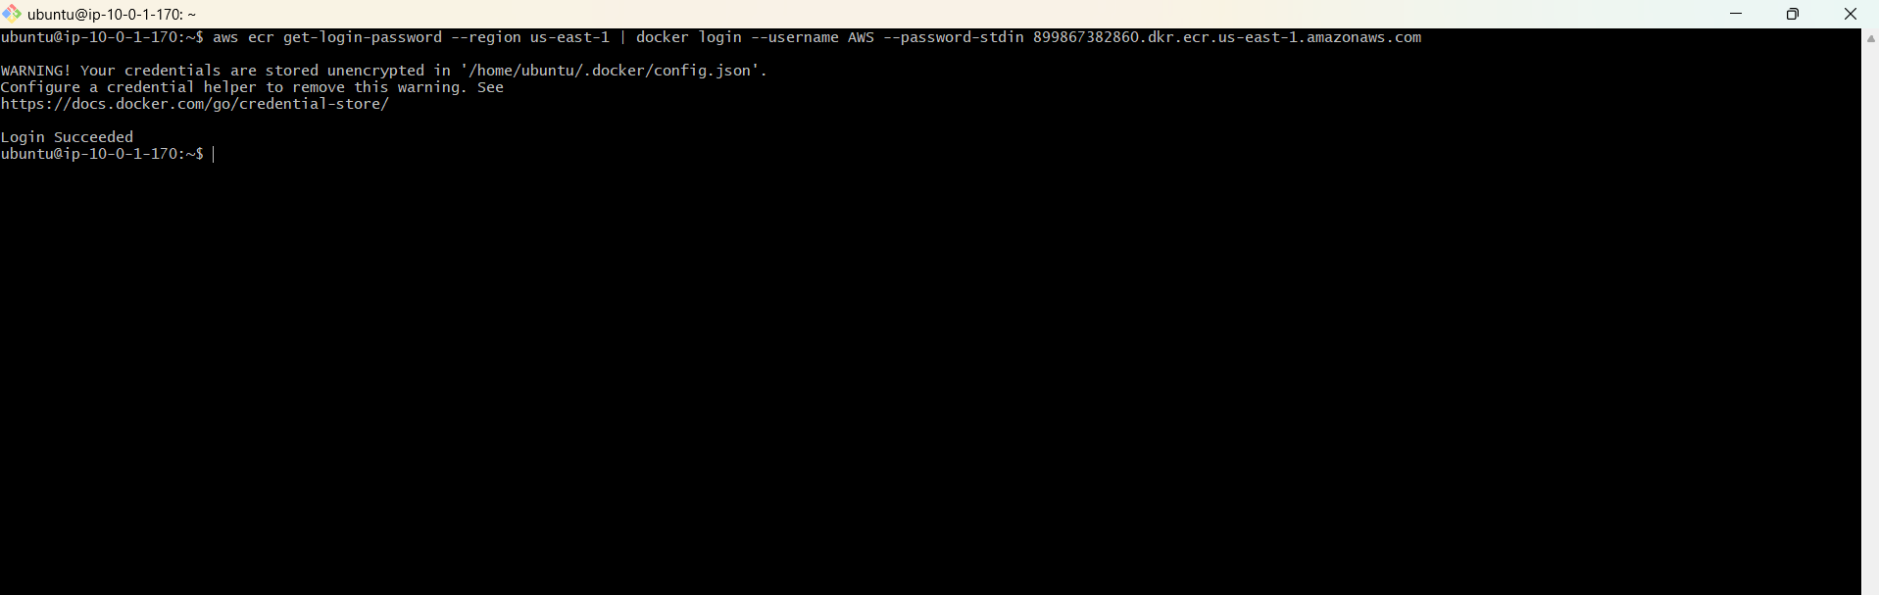
What to check:
Do not expose credentials.

Step 5 — Tag the same image
Exact command:
docker tag <DOCKERHUB_USERNAME>/custom-app:v1 $ACCOUNT_ID.dkr.ecr.$AWS_REGION.amazonaws.com/$ECR_REPO:v1
Expected output:
No output is normally produced.
What to check:
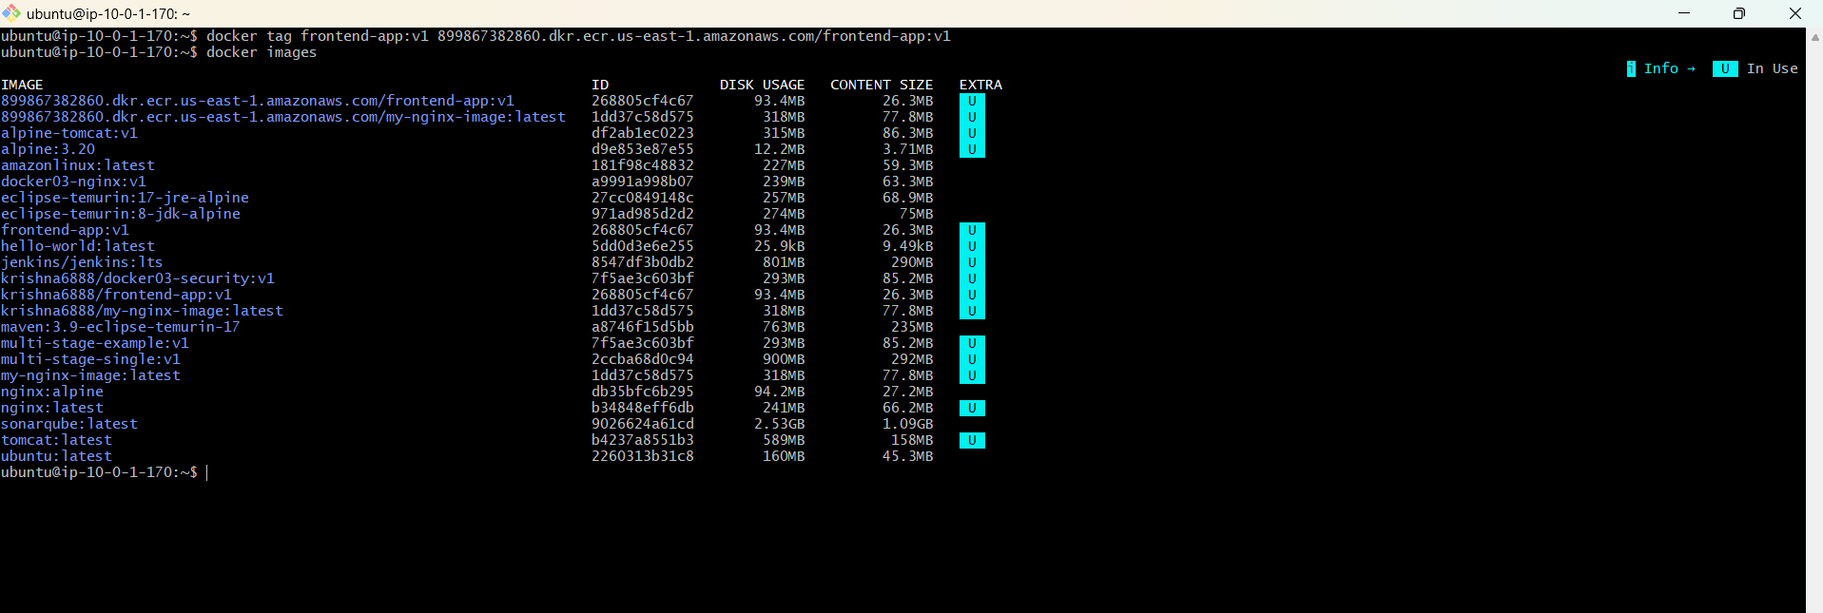
The ECR tag points to the same local image.

Step 6 — Push to ECR
Exact command:
docker push $ACCOUNT_ID.dkr.ecr.$AWS_REGION.amazonaws.com/$ECR_REPO:v1
Expected output:
Layers are pushed successfully.
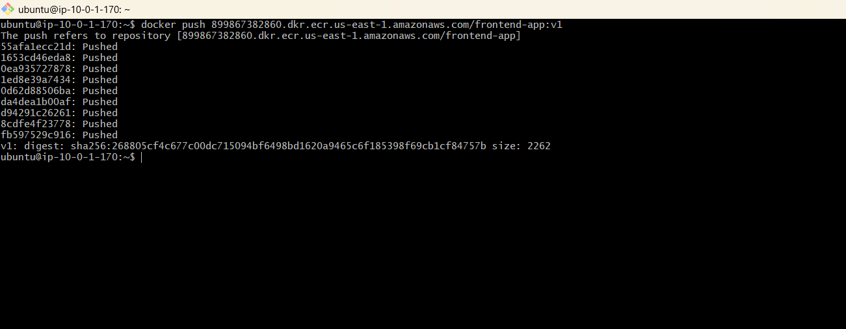
What to check:
No authentication or repository errors.

Step 7 — Verify ECR
Exact command:
aws ecr describe-images --repository-name $ECR_REPO --region $AWS_REGION
Expected output:
The v1 image is listed.

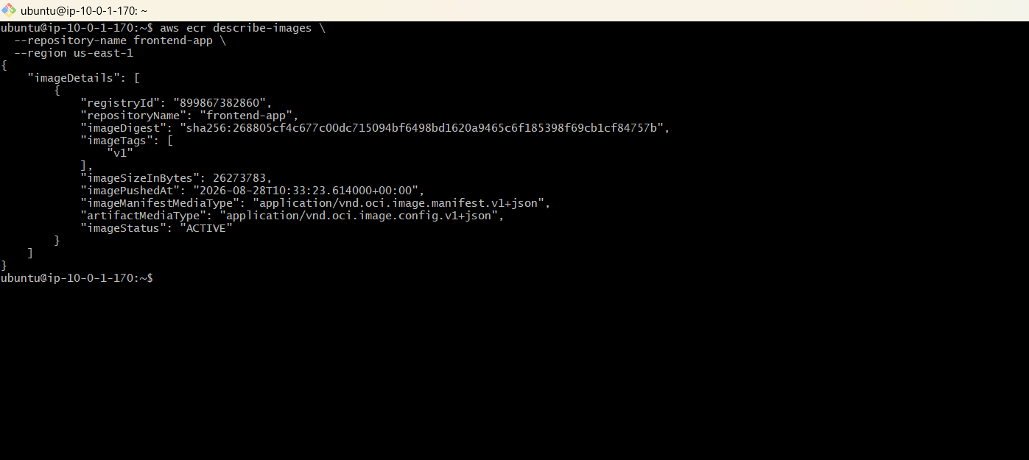
What to check:
Confirm the ECR repository contains the expected tag.

Task 4 — Terraform EC2 + Jenkins
Goal: provision exactly one EC2 instance with Terraform, install Jenkins, and access Jenkins.
Install Terraform - 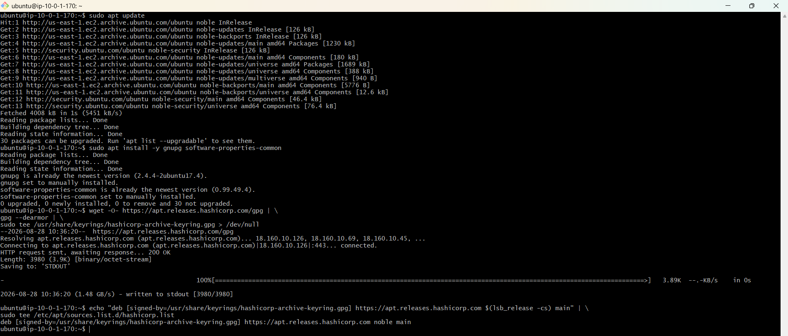

Step 1 — Create Terraform directory
Exact command:
mkdir -p ~/docker-challenge/terraform
cd ~/docker-challenge/terraform
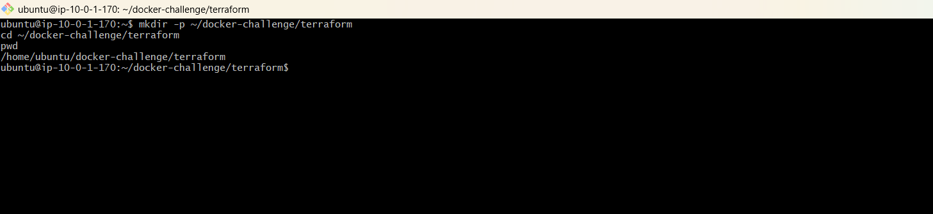
Expected output:
Directory is created and current directory changes.
What to check:
Confirm pwd points to the Terraform directory.

Step 2 — Create Terraform files
Exact command:
touch main.tf variables.tf outputs.tf
ls
Expected output:
main.tf, variables.tf and outputs.tf are listed.
What to check:
All required files exist.

Step 3 — Write Terraform configuration
Exact command:
vi main.tf
terraform {
required_providers {
aws = {
source = "hashicorp/aws"
version = "~> 6.0"
}
}

required_version = ">= 1.5.0"
}

provider "aws" {
region = "us-east-1"
}

resource "aws_security_group" "jenkins_sg" {
name = "jenkins-server-sg"
description = "Security group for Jenkins server"
vpc_id = "vpc-0b53c0a1bec31ae61"

ingress {
description = "SSH"
from_port = 22
to_port = 22
protocol = "tcp"
cidr_blocks = ["0.0.0.0/0"]
}

ingress {
description = "Jenkins"
from_port = 8080
to_port = 8080
protocol = "tcp"
cidr_blocks = ["0.0.0.0/0"]
}

egress {
from_port = 0
to_port = 0
protocol = "-1"
cidr_blocks = ["0.0.0.0/0"]
}

tags = {
Name = "jenkins-server-sg"
}
}

data "aws_ssm_parameter" "ubuntu_ami" {
name = "/aws/service/canonical/ubuntu/server/24.04/stable/current/amd64/hvm/ebs-gp3/ami-id"
}

resource "aws_instance" "jenkins_server" {
ami = data.aws_ssm_parameter.ubuntu_ami.value
instance_type = "t3.medium"

subnet_id = "subnet-0a0ca1b6afe69679f"
vpc_security_group_ids = [aws_security_group.jenkins_sg.id]
key_name = "krishna7"
associate_public_ip_address = true

user_data = <<-EOF
#!/bin/bash
set -e

apt-get update
apt-get install -y fontconfig openjdk-21-jre docker.io wget

systemctl enable docker
systemctl start docker

mkdir -p /etc/apt/keyrings

wget -O /etc/apt/keyrings/jenkins-keyring.asc \
https://pkg.jenkins.io/debian-stable/jenkins.io-2026.key

echo "deb [signed-by=/etc/apt/keyrings/jenkins-keyring.asc]" \
https://pkg.jenkins.io/debian-stable binary/ \
> /etc/apt/sources.list.d/jenkins.list

apt-get update
apt-get install -y jenkins

usermod -aG docker jenkins

systemctl enable jenkins
systemctl start jenkins
EOF

tags = {
Name = "Jenkins-Server-Terraform"
}
}

output "jenkins_instance_id" {
value = aws_instance.jenkins_server.id
}

output "jenkins_public_ip" {
value = aws_instance.jenkins_server.public_ip
}

output "jenkins_url" {
value = "http://${aws_instance.jenkins_server.public_ip}:8080"
}
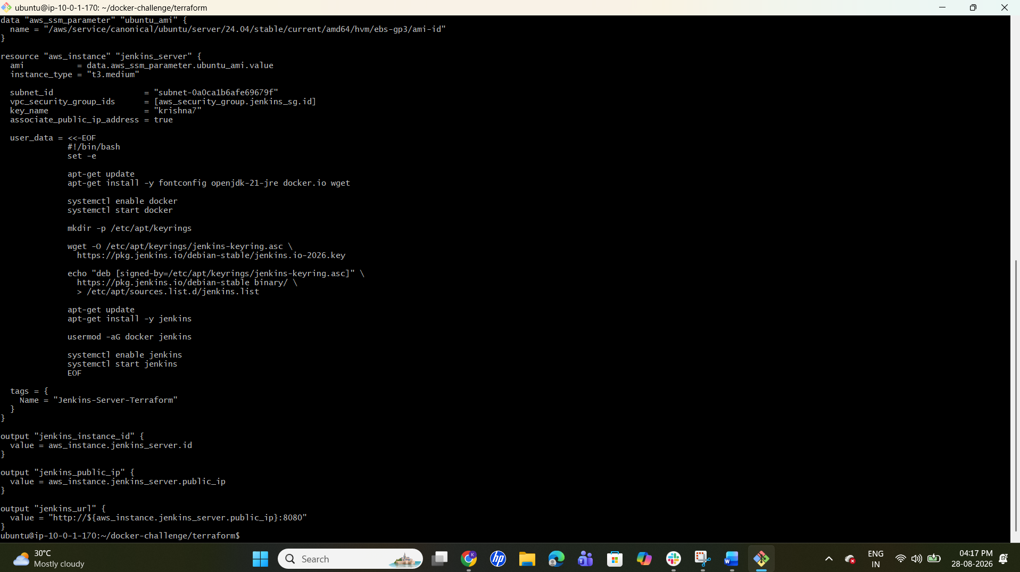
Use an Ubuntu AMI valid for your chosen AWS region.
What to check:
Configure AWS provider, one EC2 instance, security group, key pair, and outputs. Allow SSH port 22 and Jenkins port 8080 from an appropriate source.

Step 4 — Initialize Terraform
Exact command:
terraform init
Expected output:
Terraform initialization succeeds.
What to check:
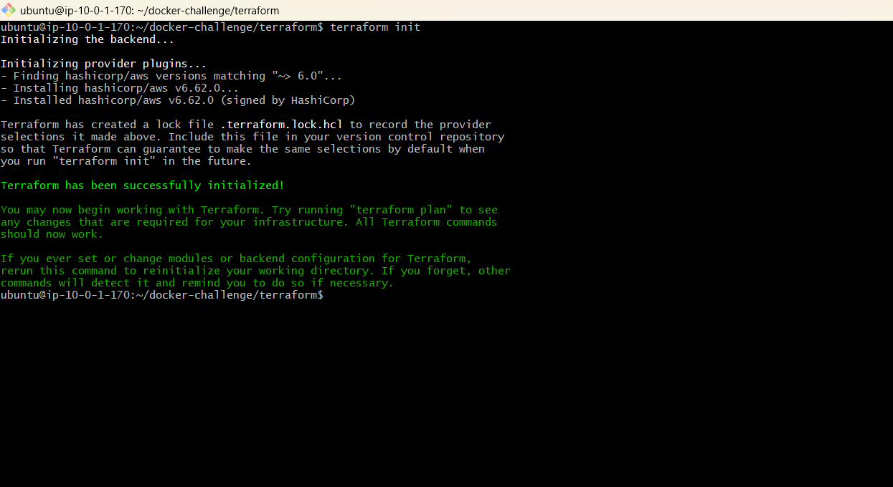
No provider initialization errors.

Step 5 — Format and validate
Exact command:
terraform fmt
terraform validate
Expected output:
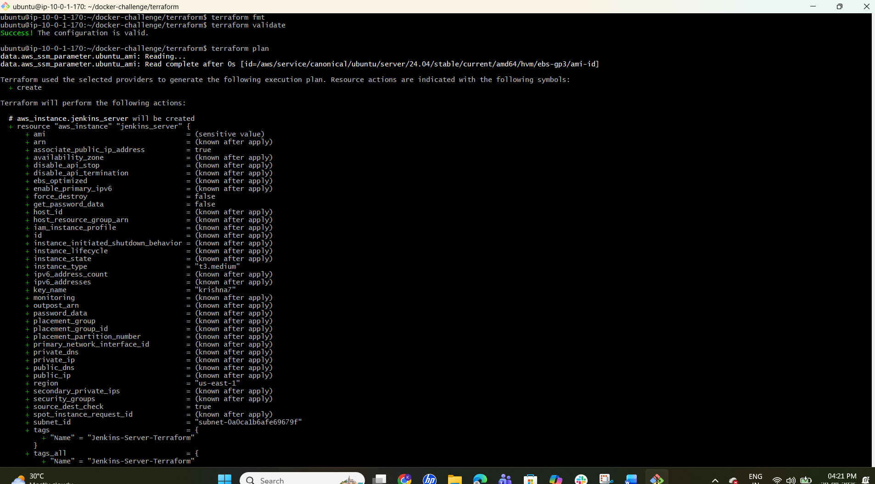
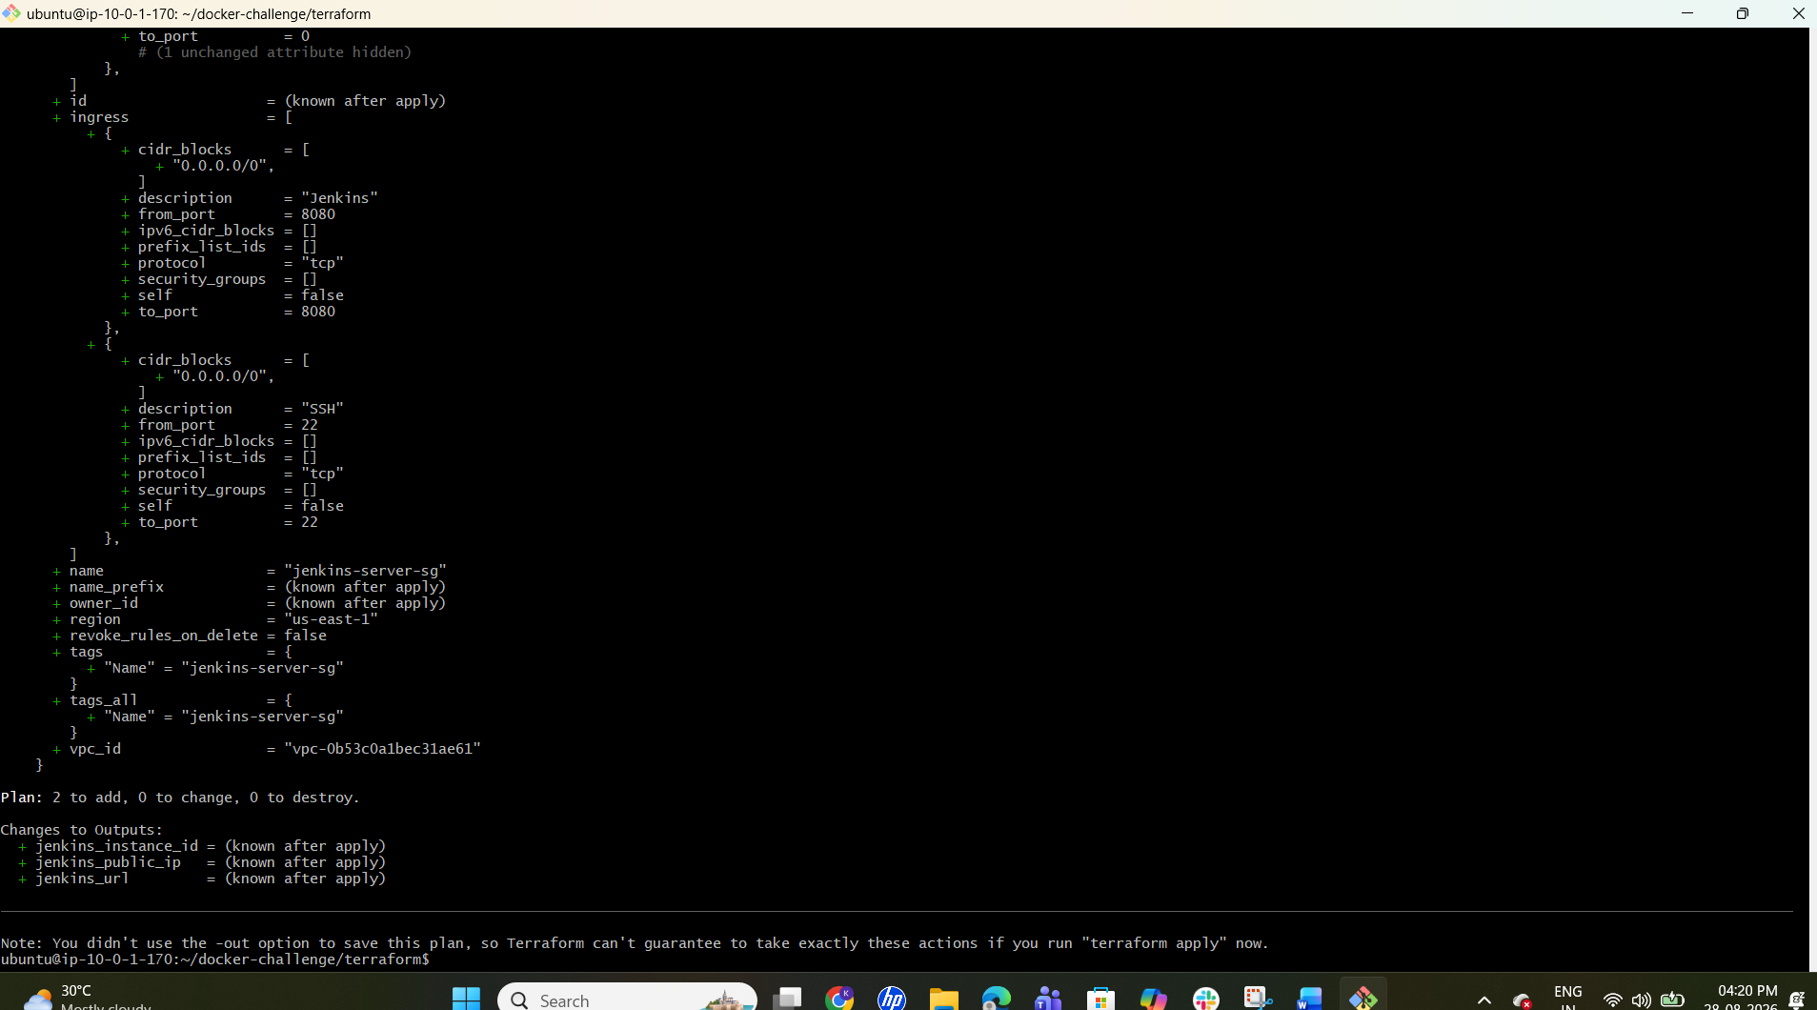
Success! The configuration is valid.
What to check:
Terraform reports valid configuration.

Step 6 — Review plan
Exact command:
terraform plan
Expected output:
Terraform shows one EC2 instance and required networking/security resources to be created.
What to check:
Check that you are not accidentally creating additional EC2 instances.

Step 7 — Apply configuration
Exact command:
terraform apply
Expected output:
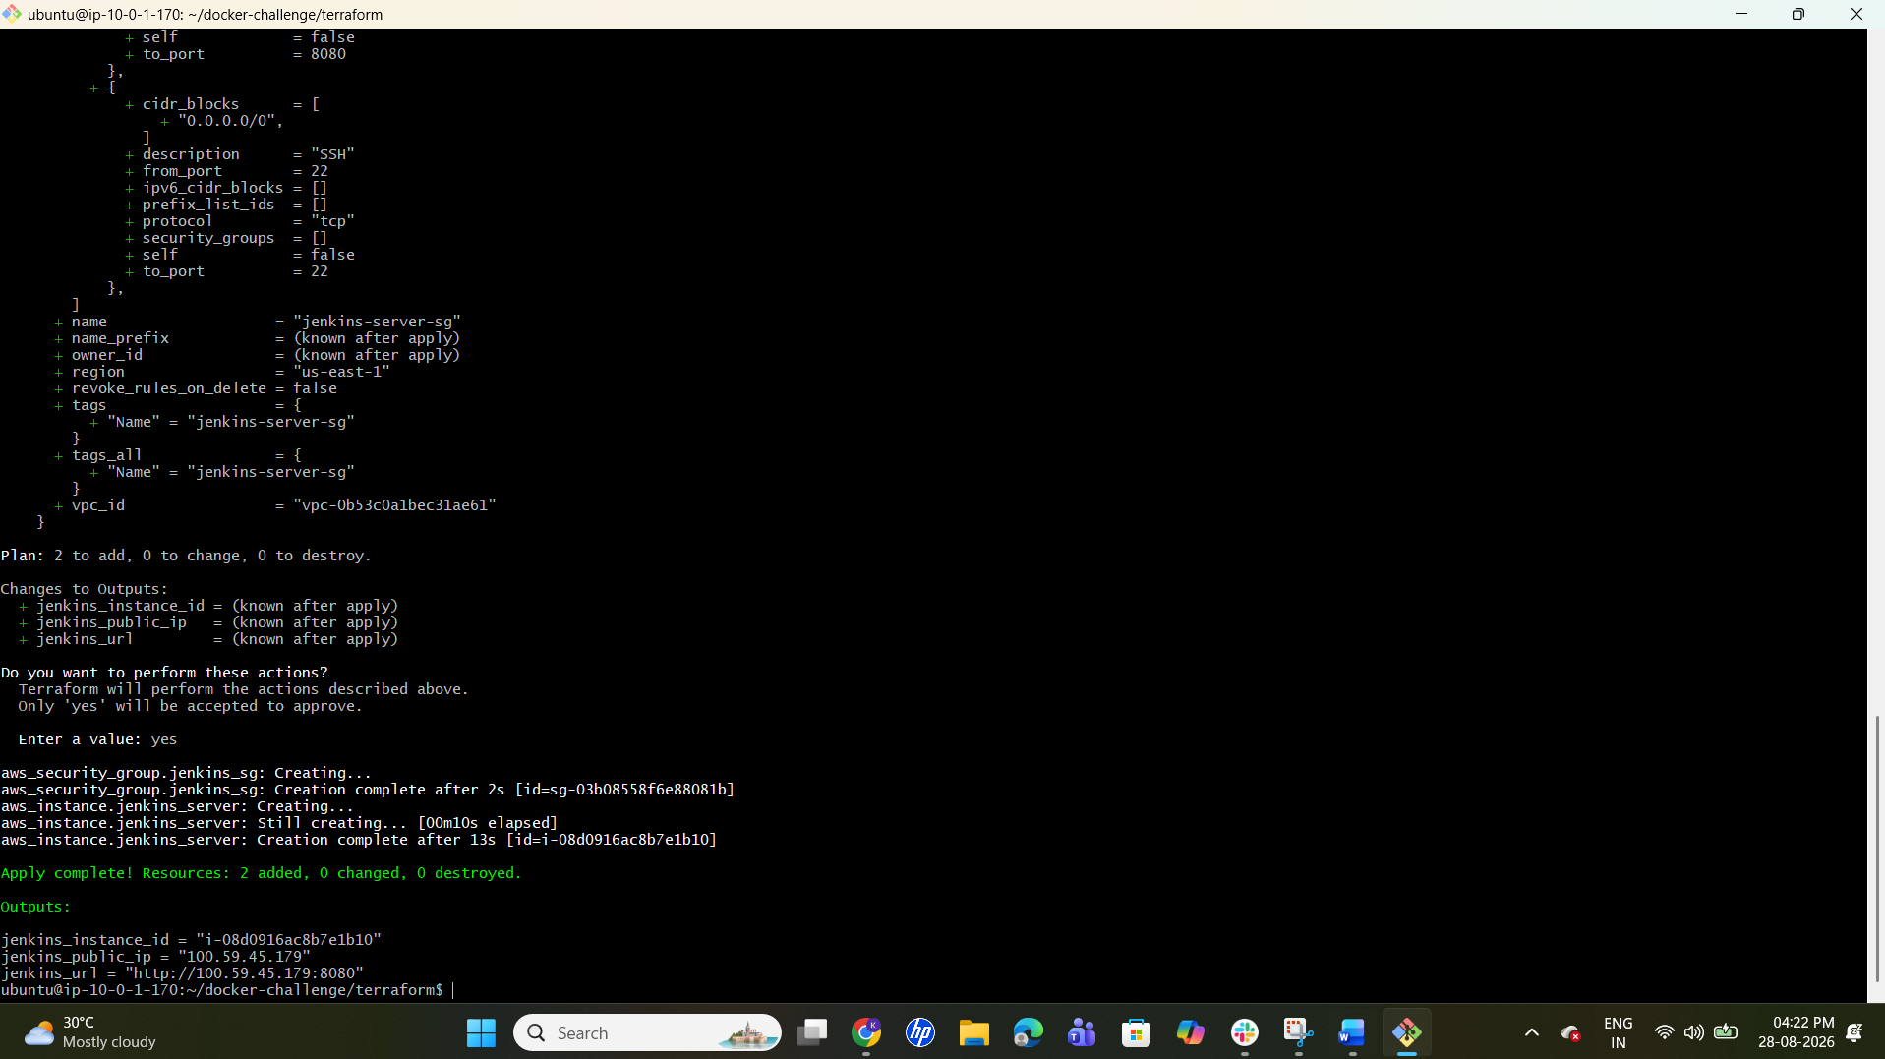
Apply complete! Resources are created.
What to check:
Confirm the EC2 instance was created successfully.

Step 8 — Get output
Exact command:
terraform output
Expected output:
The configured outputs, such as public IP, are displayed.
What to check:
Record the EC2 public IP.

Step 9 — Connect to EC2
Exact command:
ssh -i <KEY_FILE.pem> ubuntu@<EC2_PUBLIC_IP>
Expected output:
You get a shell on the Ubuntu EC2 instance.
What to check:
Confirm you are on the newly created server.

Step 10 — Update packages
Exact command:
sudo apt update && sudo apt upgrade -y
Expected output:
Packages update successfully.
What to check:
No package-manager errors.

Step 11 — Install Java
Exact command:
sudo apt install -y fontconfig openjdk-21-jre
java -version
Expected output:
Java 21 version information is displayed.
What to check:
Confirm Java is installed.

Step 12 — Install Jenkins repository/key
Exact command:
sudo wget -O /usr/share/keyrings/jenkins-keyring.asc https://pkg.jenkins.io/debian-stable/jenkins.io-2026.key
echo 'deb [signed-by=/usr/share/keyrings/jenkins-keyring.asc] https://pkg.jenkins.io/debian-stable binary/' | sudo tee /etc/apt/sources.list.d/jenkins.list > /dev/null
sudo apt update
Expected output:
Repository/key setup and apt update complete successfully.
What to check:
If the current Jenkins installation instructions use a different repository key, follow the current official Jenkins instructions.

Step 13 — Install and start Jenkins
Exact command:
sudo apt install -y jenkins
sudo systemctl enable --now jenkins
sudo systemctl status jenkins --no-pager
Expected output:
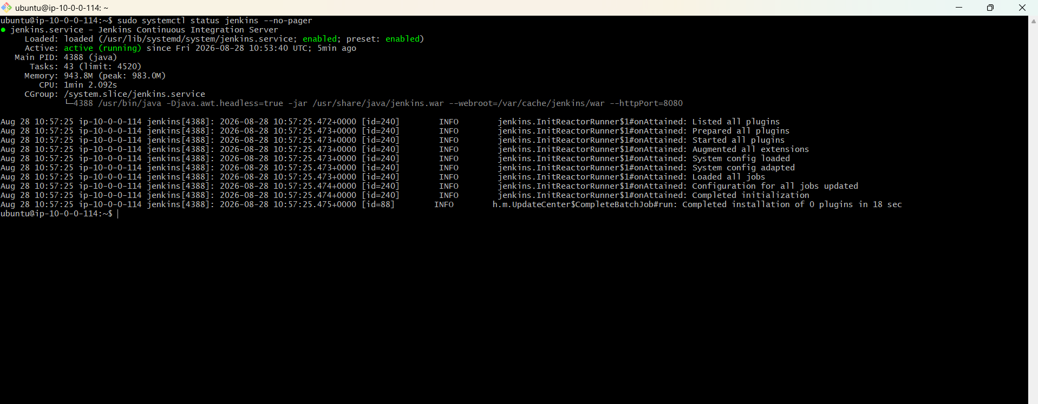
Jenkins is active/running.
What to check:
Confirm Jenkins service is running.

Step 14 — Get initial admin password
Exact command:
sudo cat /var/lib/jenkins/secrets/initialAdminPassword
Expected output:
A password string is displayed.
What to check:
Use it only for Jenkins setup; do not publish it.

Step 15 — Open Jenkins
Exact command:
Open http://<EC2_PUBLIC_IP>:8080 in your browser.
Expected output:
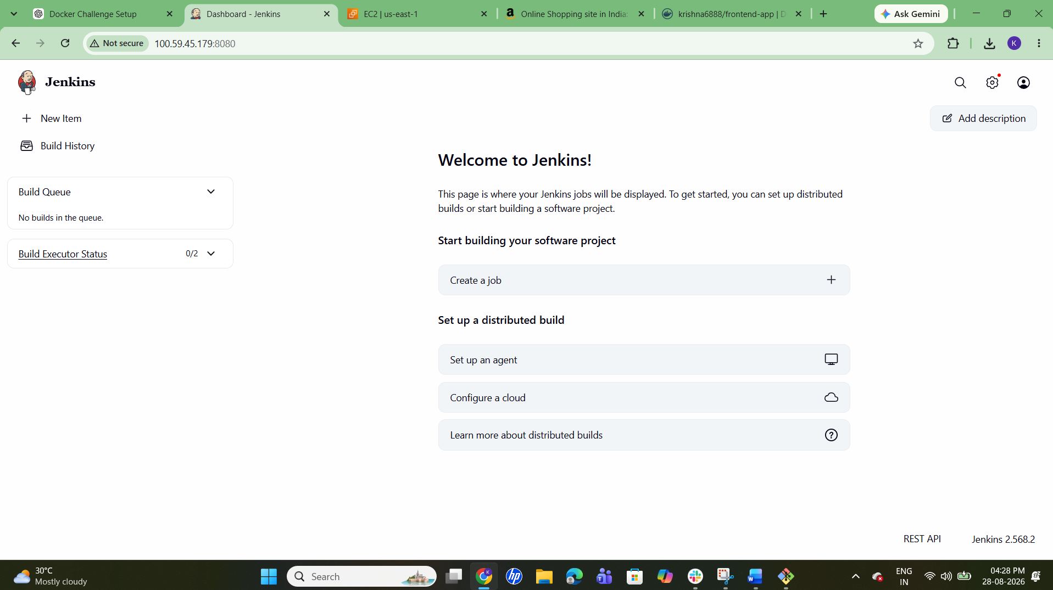
Jenkins Unlock/Setup page appears.
What to check:
Complete setup and create the Jenkins admin user.

Task 5 — Jenkins Job to Build and Push Python Image

Step 1 — Install Docker on Jenkins EC2
Exact command:
sudo apt update
sudo apt install -y docker.io
sudo systemctl enable --now docker
Expected output:
Docker is installed and running.
What to check:
Confirm docker --version works.

Step 2 — Allow Jenkins to use Docker
Exact command:
sudo usermod -aG docker jenkins
sudo systemctl restart jenkins
Expected output:
Jenkins restarts successfully.
What to check:
A new Jenkins session may be required for group membership changes.

Step 3 — Verify Docker access
Exact command:
sudo -u jenkins docker version
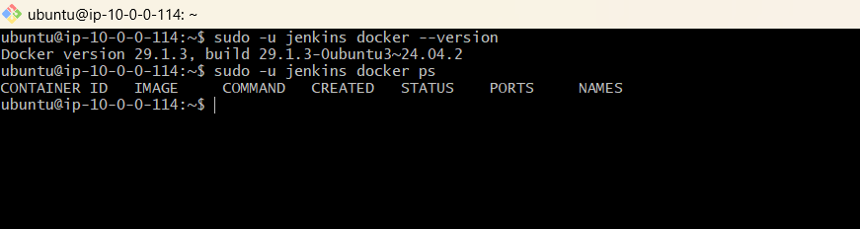
Expected output:
Docker client/server information is displayed without permission denied.
What to check:
Jenkins can execute Docker.

Step 4 — Add Docker Hub credentials in Jenkins
Exact command:
In Jenkins: Manage Jenkins → Credentials → add a username/password or appropriate Docker Hub credential.
Expected output:
Credential is saved.
What to check:
Never put the password/token directly in the Jenkinsfile.

Step 5 — Create Pipeline job
Exact command:
In Jenkins: New Item → Pipeline → enter a job name → OK.
Expected output:
The Pipeline job is created.
What to check:
Confirm the job is a Pipeline.

Step 6 — Configure source
Exact command:
Repository: https://github.com/betawins/Python-app.git
Expected output:
Jenkins is configured to retrieve the repository.
What to check:
Confirm the correct repository/branch.

Step 7 — Create Jenkinsfile
Exact command:
Create a Jenkinsfile in the repository or use Pipeline script as required.
Do not hard-code credentials.
What to check:
Stages should include Checkout, Docker Build, Docker Login and Docker Push. Use Jenkins credentials binding for Docker Hub authentication.

Step 8 — Build the job
Exact command:
Click Build Now.
Expected output:
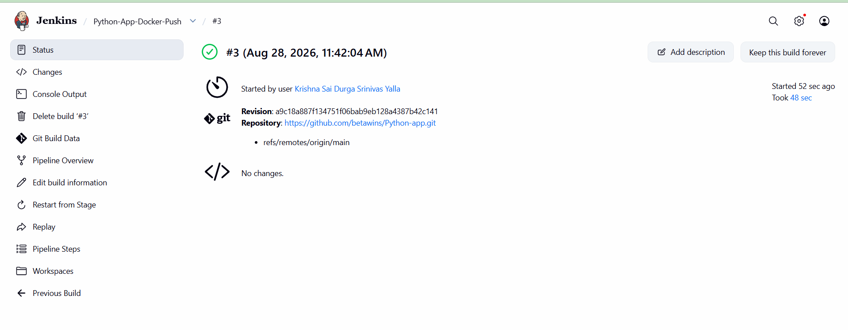
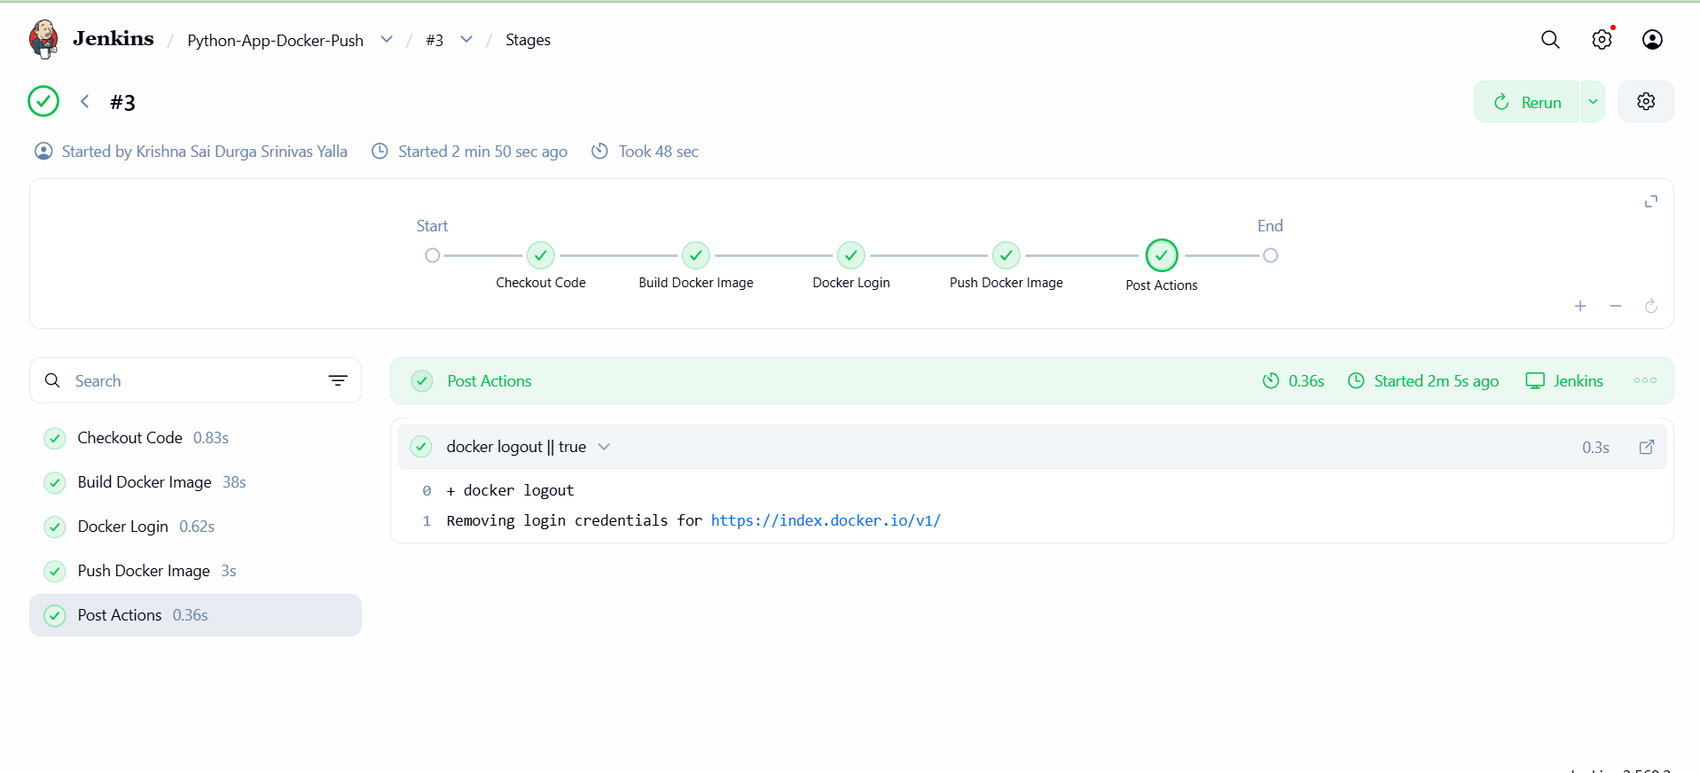
Build #1 (or the current build) completes successfully.
What to check:
All pipeline stages are green/successful.

Step 9 — Review console
Exact command:
Open Console Output.
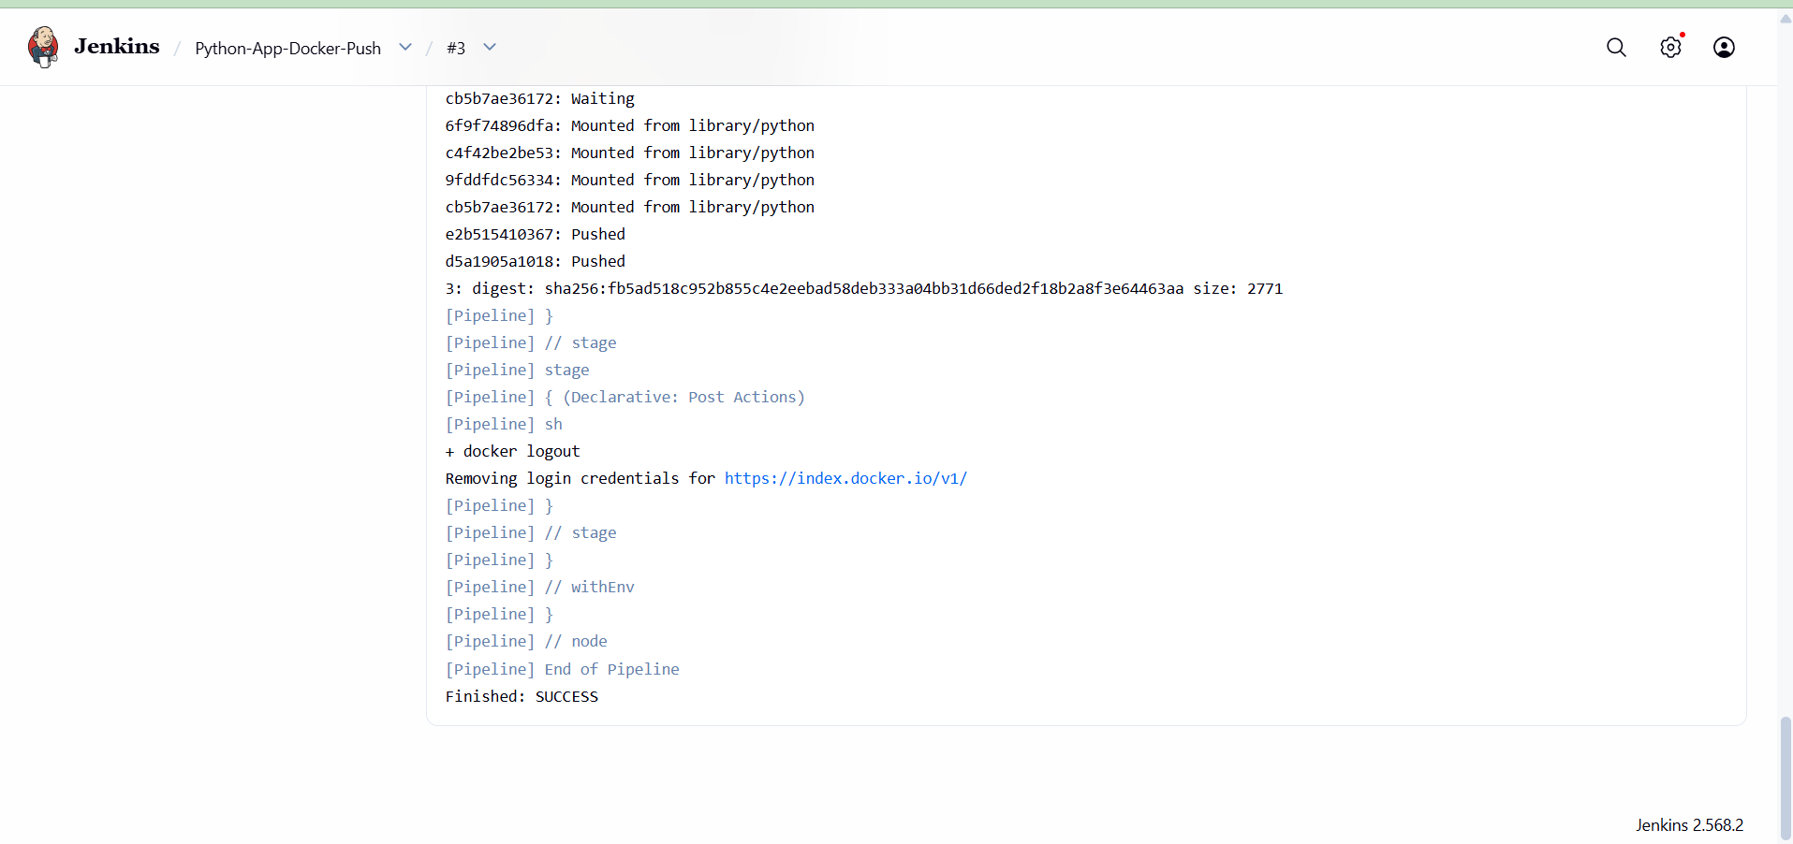
Expected output:
The log shows checkout, image build, authentication and push completing successfully.
What to check:
No Docker Hub authentication/push errors.

Step 10 — Verify Docker Hub
Exact command:
Open the Docker Hub repository used by Jenkins.
Expected output:
The pushed image/tag is visible.
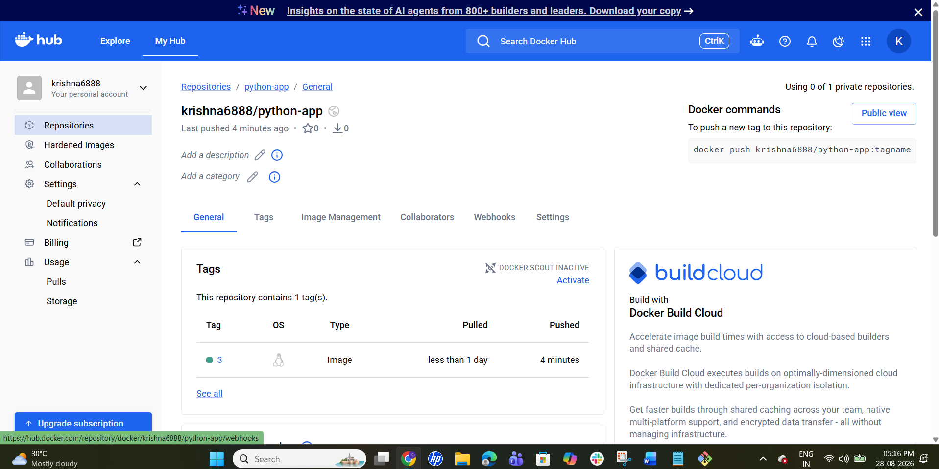
What to check:
Confirm the image was pushed by the Jenkins pipeline.

Task 6 — Frontend Source Code

Step 1 — Update repository
Exact command:
cd ~/docker-tasks
git pull
find . -maxdepth 3 -type f | sort
Expected output:
Source files are listed.
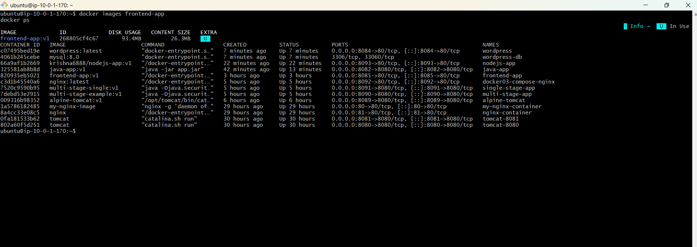
What to check:
Identify the frontend directory.

Step 2 — Enter frontend directory
Exact command:
cd <FRONTEND_DIRECTORY>
ls
Expected output:
Frontend files are displayed.
What to check:
Look for package.json, build configuration, or static assets.

Step 3 — Inspect package configuration
Exact command:
cat package.json
Expected output:
Scripts, dependencies and start/build commands are displayed.
What to check:
Identify the correct build/start command and port.

Step 4 — Create Dockerfile
Exact command:
vi Dockerfile
Do not assume the framework until package.json is checked.
What to check:
Create a Dockerfile matching the frontend technology. For a static production build, a multi-stage Node build plus Nginx runtime is commonly appropriate. For a server-rendered frontend, use its required Node runtime.

Step 5 — Build frontend image
Exact command:
docker build -t <DOCKERHUB_USERNAME>/frontend:v1 .
Expected output:
Build completes and image is tagged.
What to check:
No dependency/build errors.

Step 6 — Run frontend
Exact command:
docker run -d --name frontend -p 8081:<CONTAINER_PORT> <DOCKERHUB_USERNAME>/frontend:v1
Expected output:
Container ID is returned.
What to check:
Use the application's actual container port.

Step 7 — Verify
Exact command:
docker ps
docker logs frontend
Expected output:
Container is running and logs show successful startup.
What to check:
Confirm the app is listening.

Step 8 — Test
Exact command:
curl http://localhost:8081
Expected output:
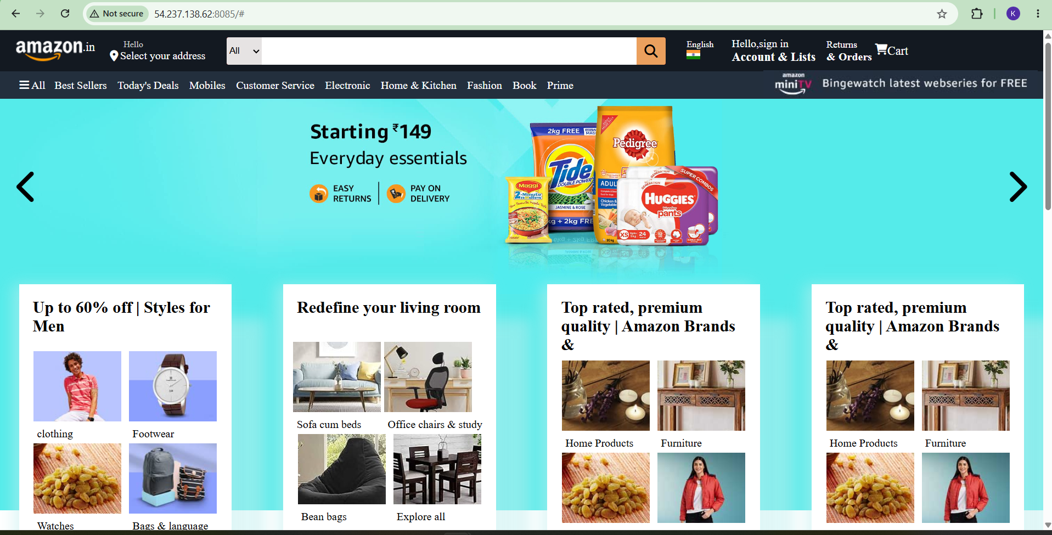
Frontend response is returned.
What to check:
Confirm the frontend loads successfully.

Step 9 — Push
Exact command:
docker push <DOCKERHUB_USERNAME>/frontend:v1
Expected output:
Image layers push successfully.
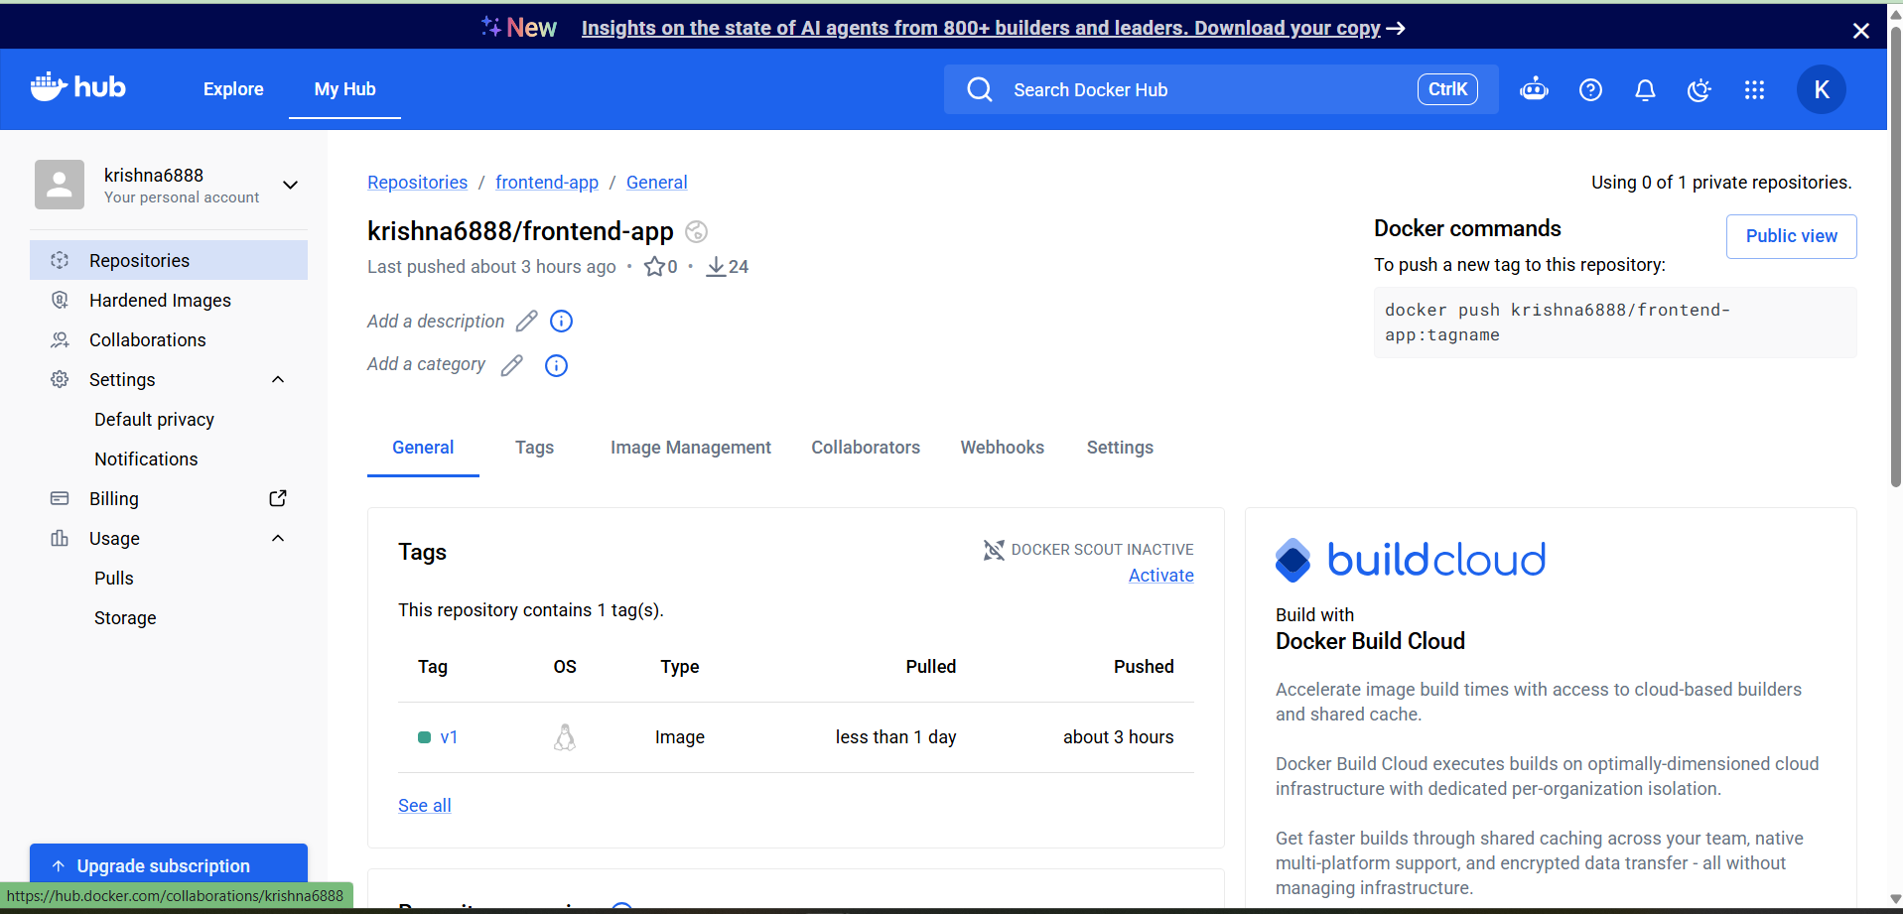
What to check:
Verify repository/tag in Docker Hub.

Task 7 — Java-Based Source Code

Step 1 — Identify Java directory
Exact command:
cd ~/docker-tasks
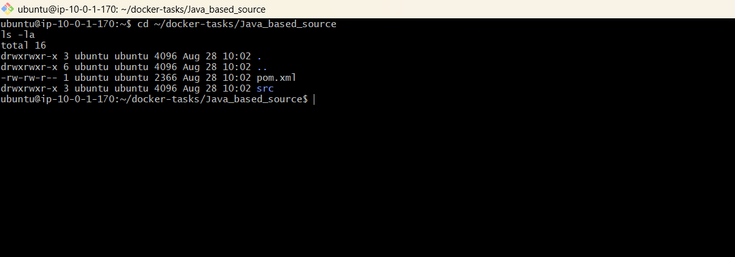
find . -maxdepth 3 \( -name pom.xml -o -name build.gradle -o -name build.gradle.kts \) -print
Expected output:
Java build files are listed.
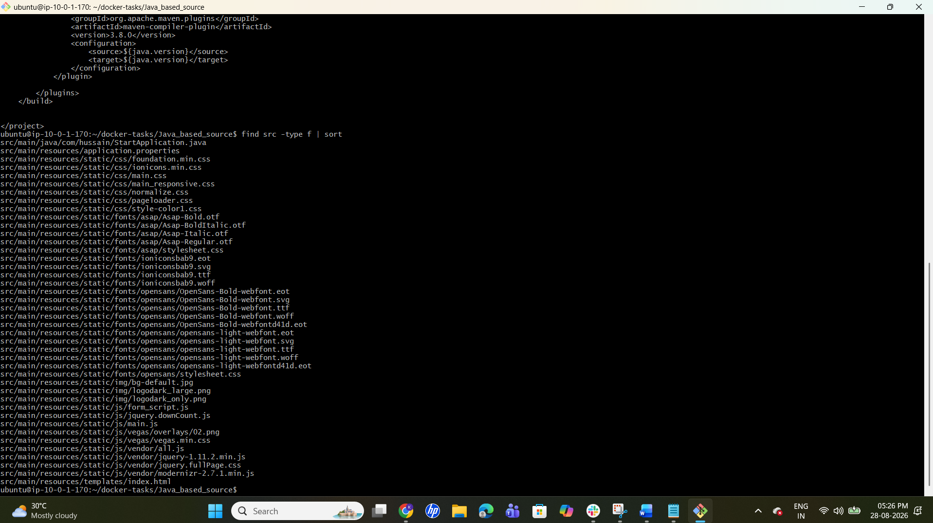
What to check:
Identify the Java application directory.

Step 2 — Inspect build file
Exact command:
cd <JAVA_DIRECTORY>
ls
cat pom.xml
Expected output:
The Java project/build configuration is displayed.
What to check:
If the project uses Gradle, inspect build.gradle instead.

Step 3 — Determine artifact/port
Exact command:
Review the build file and application configuration.
Expected output:
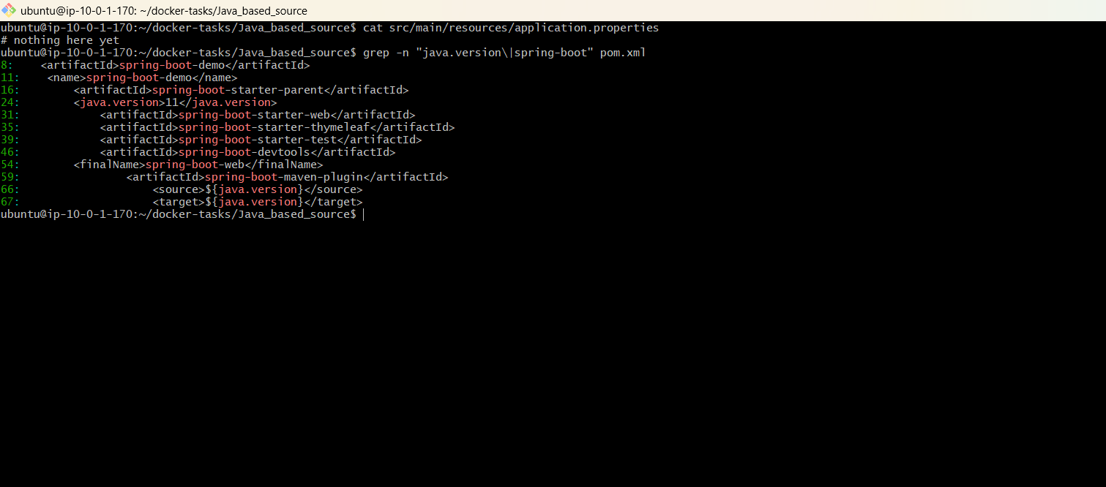
The Java version, artifact and listening port are identified.
What to check:
Use the actual application port.

Step 4 — Create Dockerfile
Exact command:
vi Dockerfile
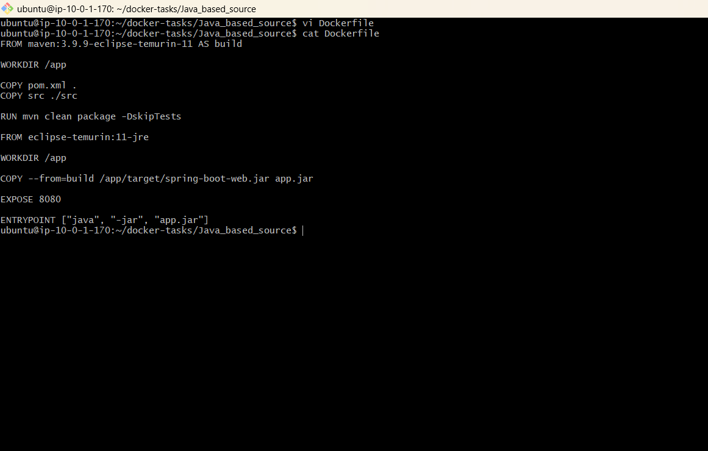
Use the project's actual build tool and artifact.
What to check:
Create a Dockerfile suitable for the Java application. A multi-stage build can compile the application and a smaller JRE image can run it.

Step 5 — Build image
Exact command:
docker build -t <DOCKERHUB_USERNAME>/java-app:v1 .
Expected output:
Image builds successfully.
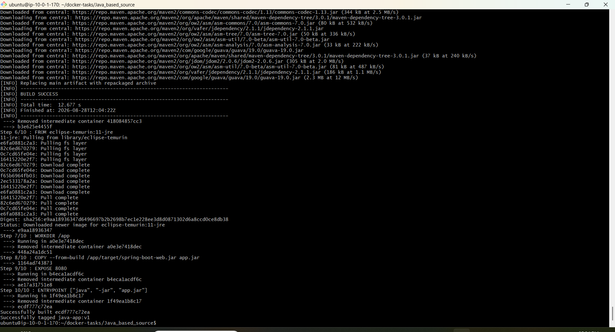
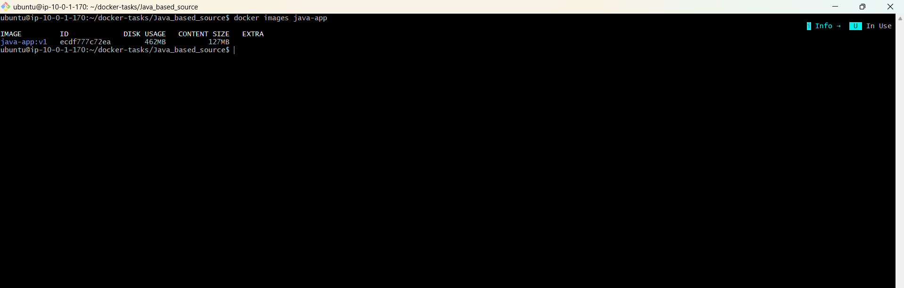
What to check:
No compilation or runtime dependency errors.

Step 6 — Run container
Exact command:
docker run -d --name java-app -p 8082:<CONTAINER_PORT> <DOCKERHUB_USERNAME>/java-app:v1
Expected output:
Container ID is returned.
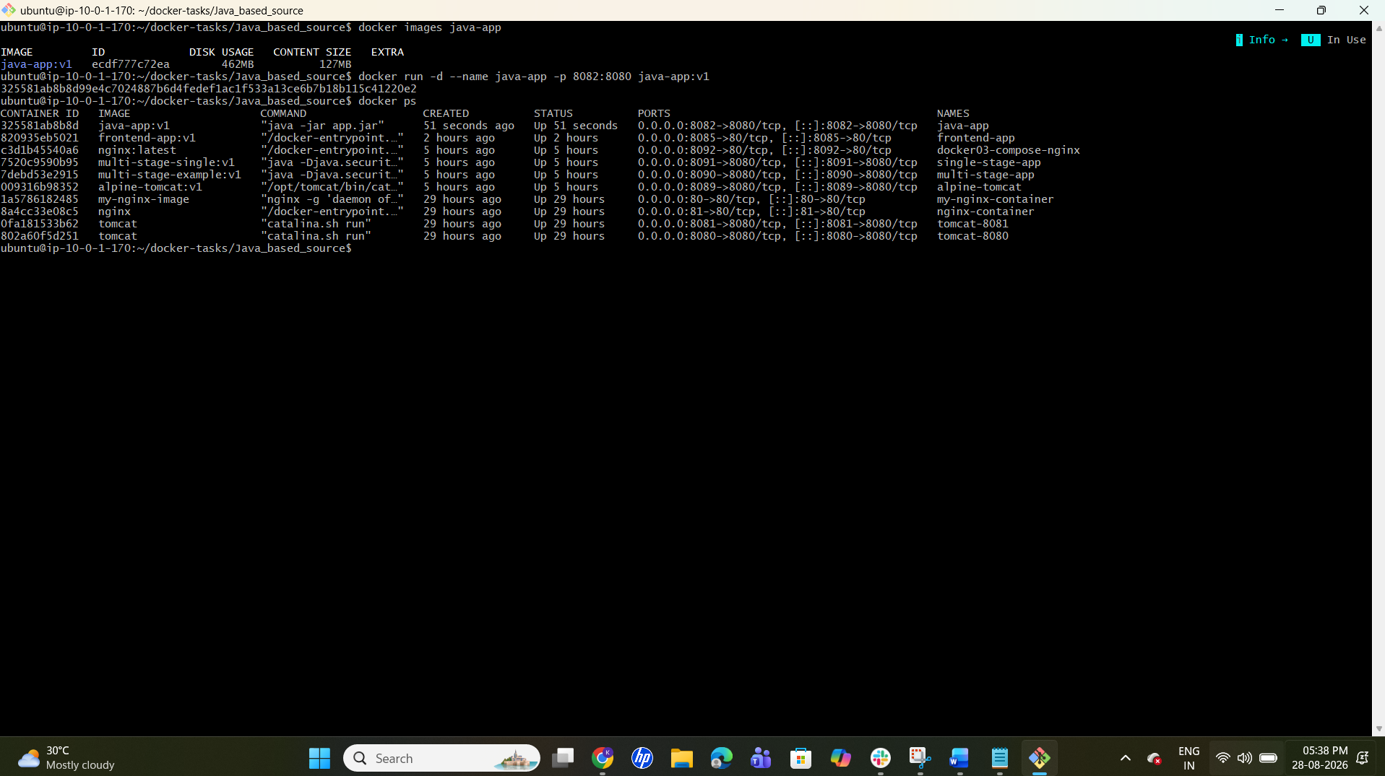
What to check:
Use the correct Java application port.

Step 7 — Check container/logs
Exact command:
docker ps
docker logs java-app
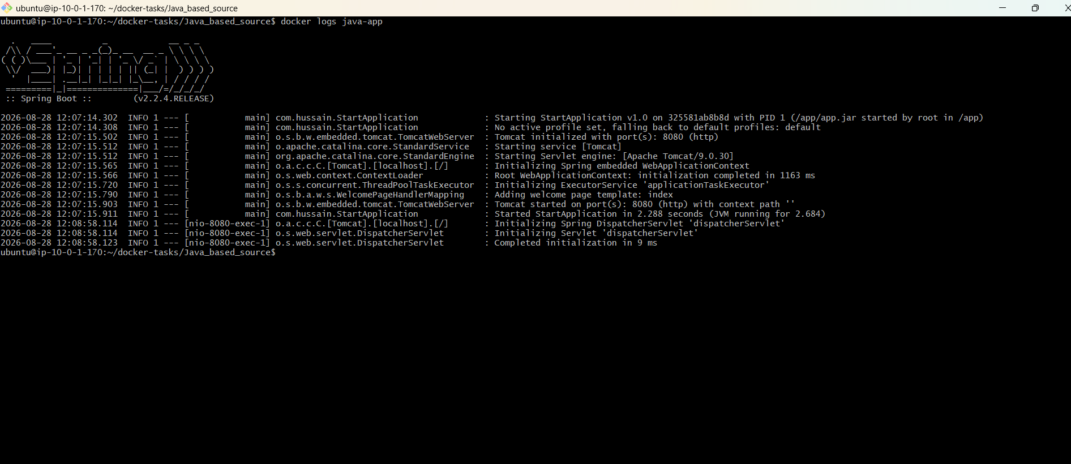
Expected output:
Container is running and application starts.
What to check:
No fatal startup exception.

Step 8 — Test application
Exact command:
curl http://localhost:8082
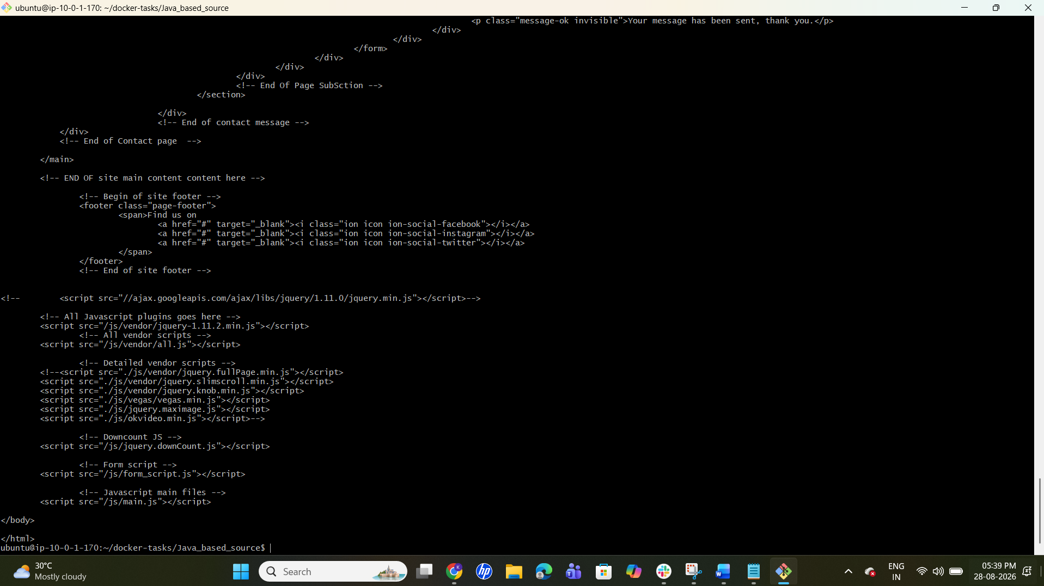
Expected output:
Application responds.
What to check:
Confirm endpoint works.

Step 9 — Push image
Exact command:
docker push <DOCKERHUB_USERNAME>/java-app:v1
Expected output:
Push completes successfully.
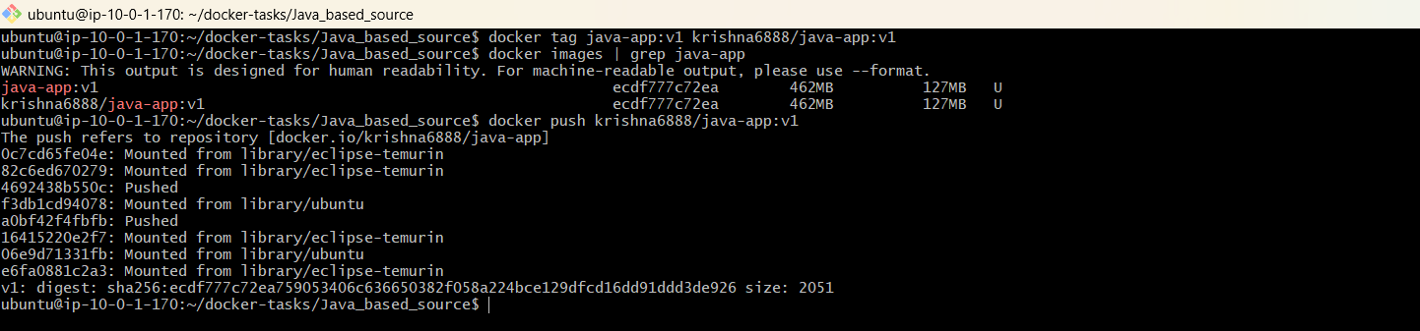
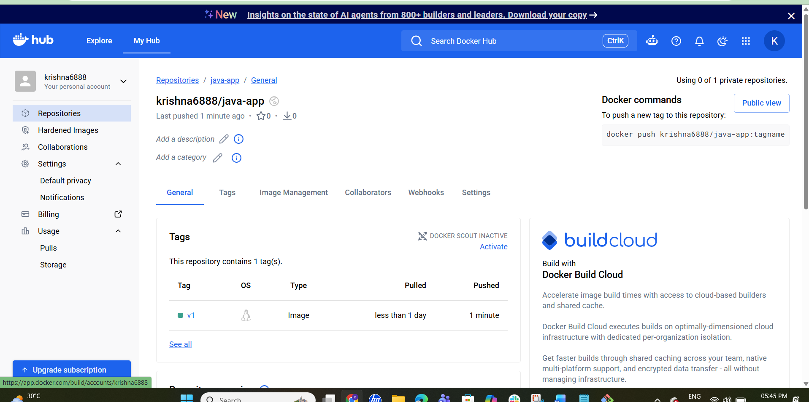
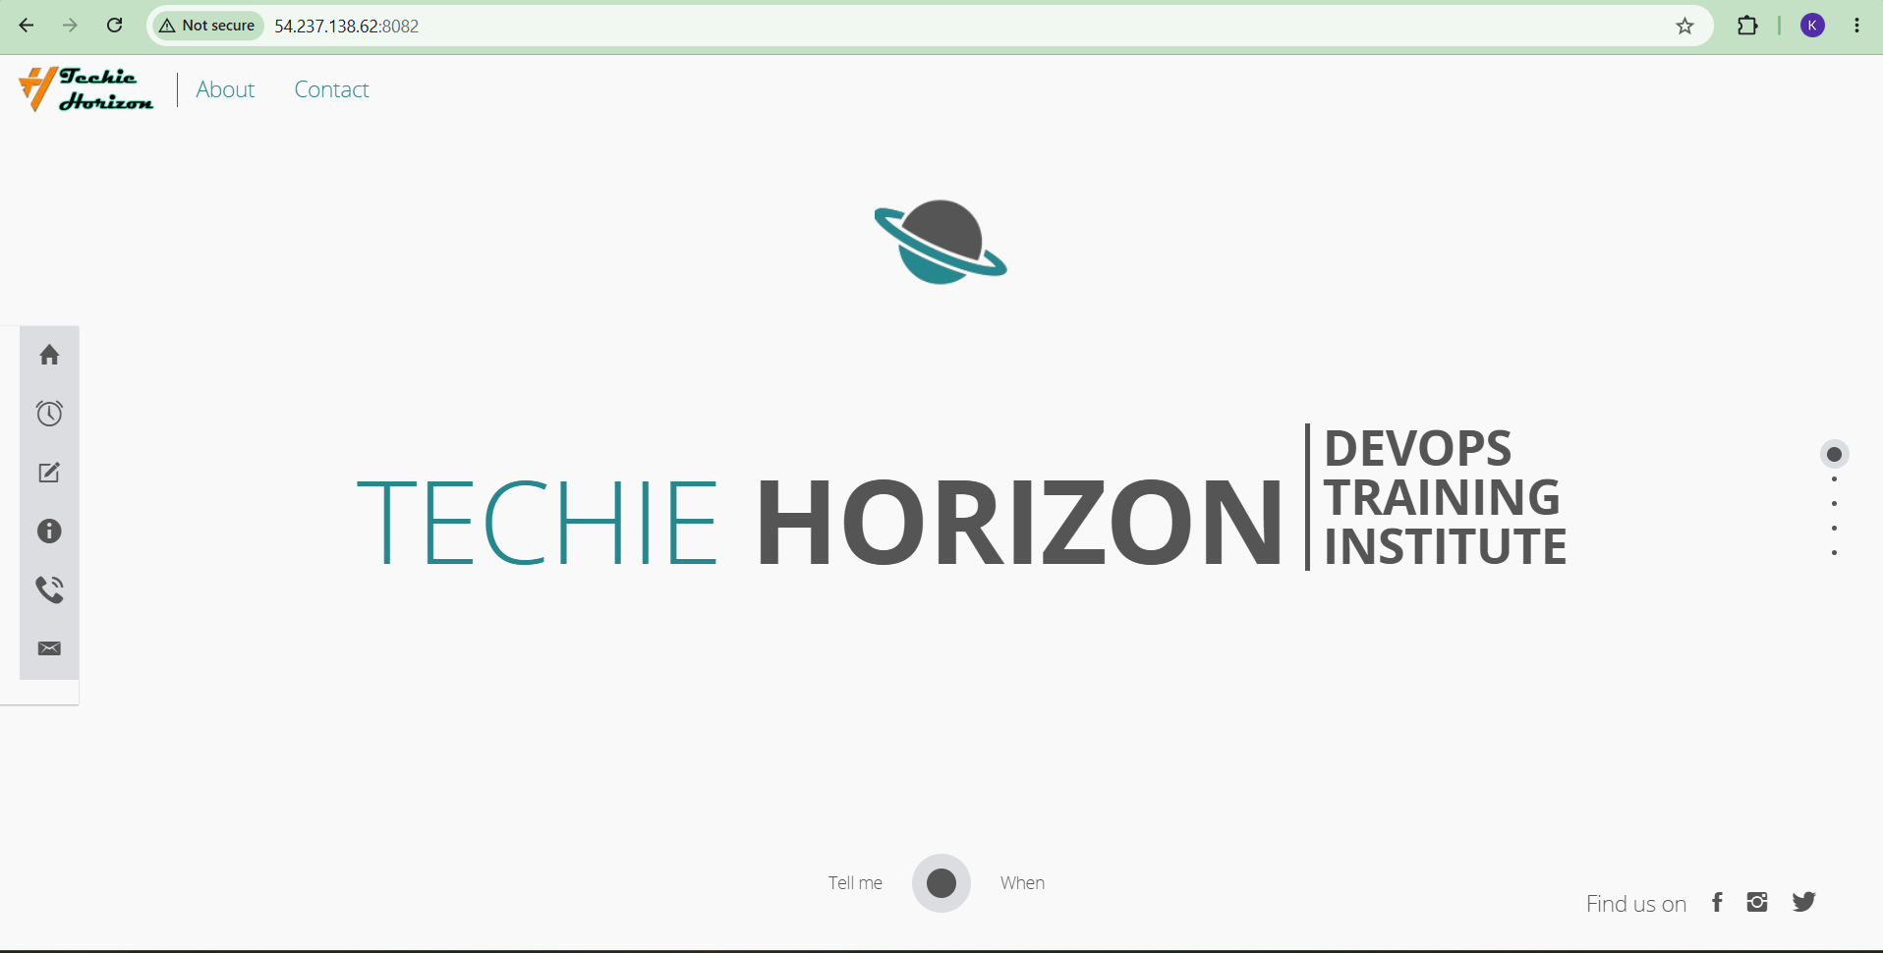
What to check:
Verify image/tag in Docker Hub.

Task 8 — Node.js Source Code (Tag v1)

Step 1 — Identify Node.js directory
Exact command:
cd ~/docker-tasks
find . -maxdepth 3 -name package.json -print
Expected output:
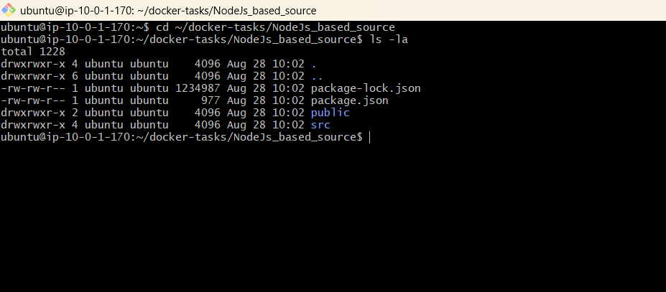
Node.js package.json files are listed.
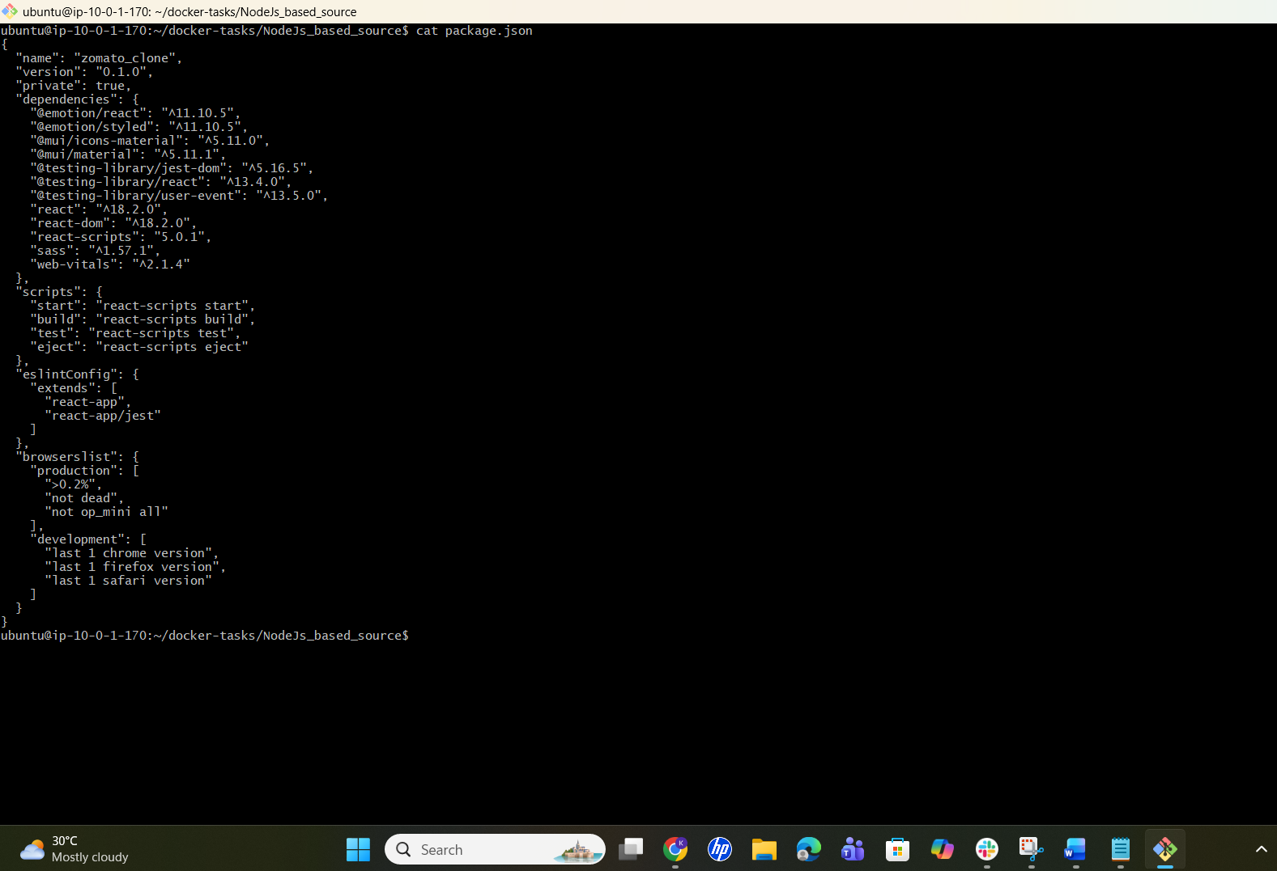
What to check:
Identify the Node.js application directory.

Step 2 — Inspect package.json
Exact command:
cd <NODE_DIRECTORY>
cat package.json
Expected output:
Scripts and dependencies are displayed.
What to check:
Identify start command and port.

Step 3 — Create Dockerfile
Exact command:
vi Dockerfile
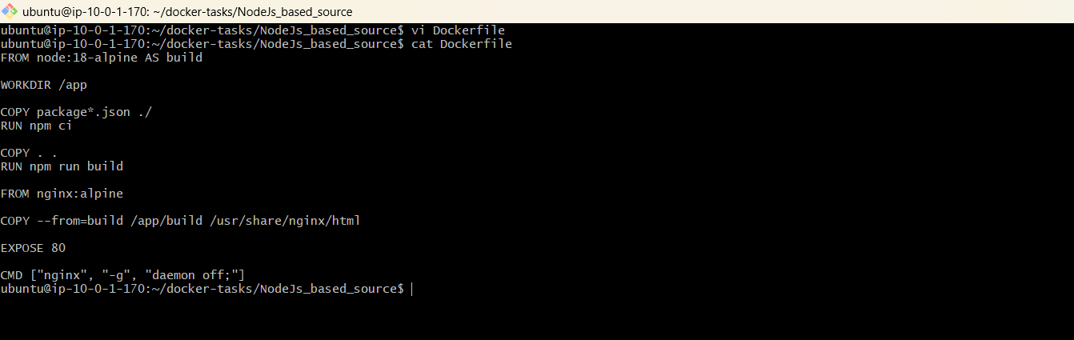
Use npm ci when package-lock.json is present.
What to check:
Use an appropriate Node.js base image, set WORKDIR, copy package files, install dependencies, copy source, expose the correct port, and define the start command.

Step 4 — Build with required v1 tag
Exact command:
docker build -t <DOCKERHUB_USERNAME>/node-app:v1 .
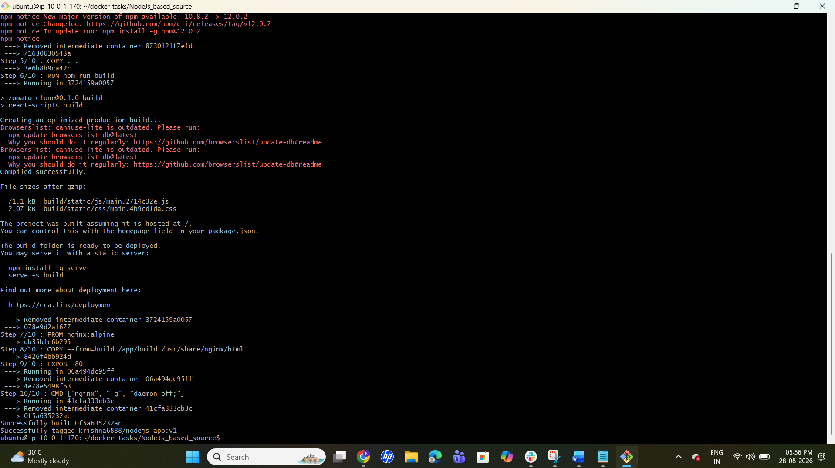
Expected output:
Build completes successfully with the v1 tag.
What to check:
Confirm the tag is exactly v1.

Step 5 — Verify image
Exact command:
docker images | grep node-app
Expected output:
node-app:v1 is listed.
What to check:
Repository/tag are correct.

Step 6 — Run
Exact command:
docker run -d --name node-app -p 8083:<CONTAINER_PORT> <DOCKERHUB_USERNAME>/node-app:v1
Expected output:
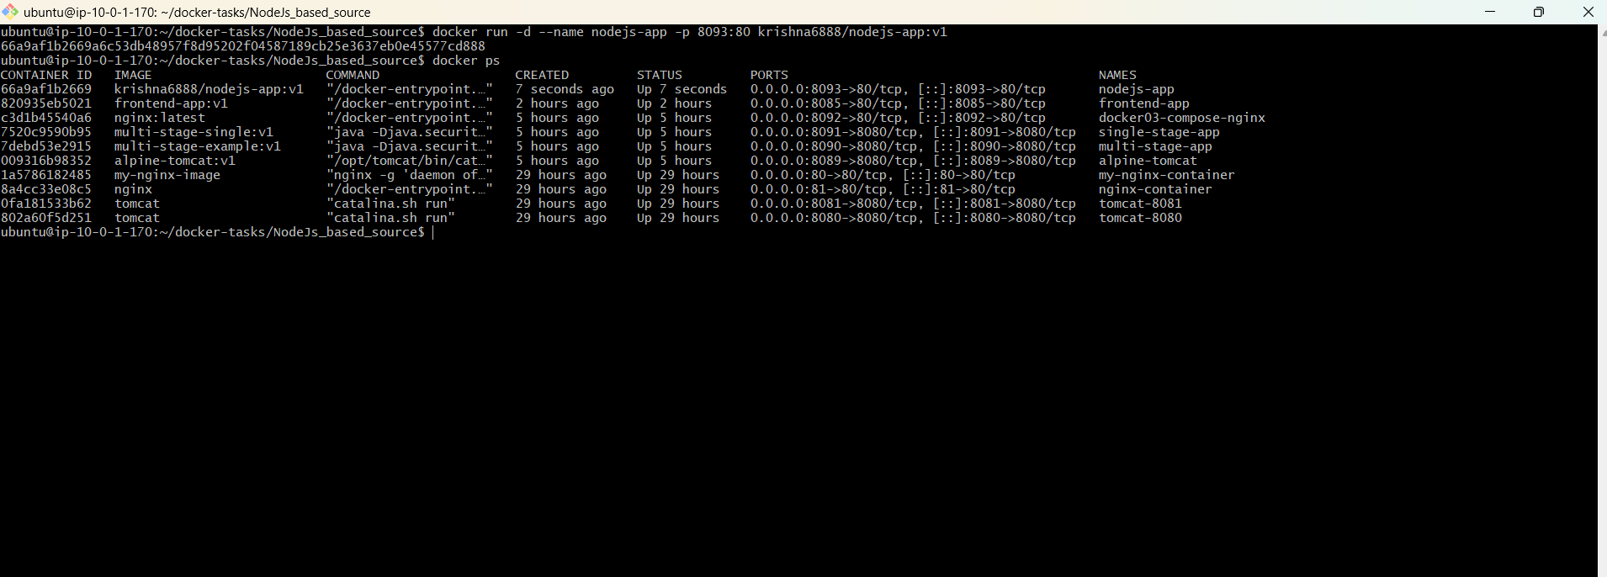
Container ID is returned.
What to check:
Use the actual Node.js port.

Step 7 — Verify
Exact command:
docker ps
docker logs node-app
Expected output:
Container is running and application starts.
What to check:
No fatal errors.

Step 8 — Test
Exact command:
curl http://localhost:8083
Expected output:
Application responds.
What to check:
Confirm the Node.js application works.

Step 9 — Push v1
Exact command:
docker push <DOCKERHUB_USERNAME>/node-app:v1
Expected output:
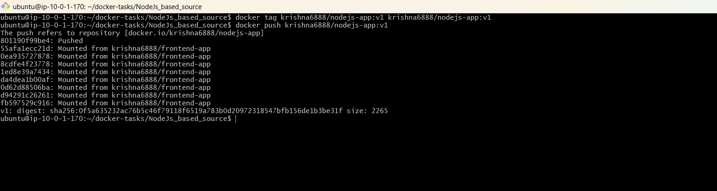
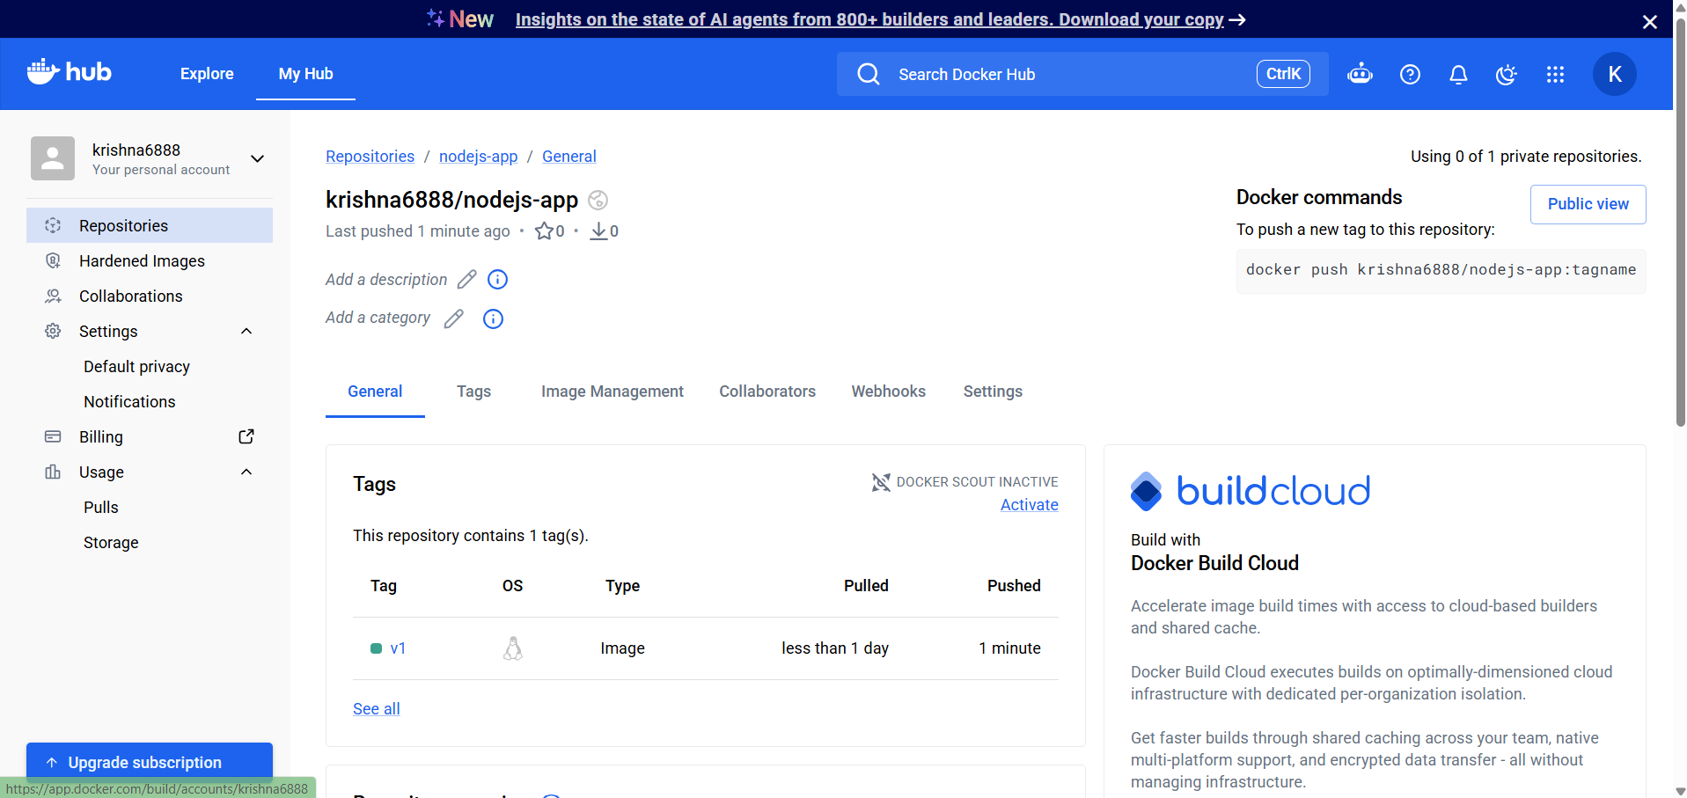

Push completes successfully.
What to check:
Verify node-app:v1 in Docker Hub.

Task 9 — Docker Compose: WordPress + MySQL

Step 1 — Create project directory
Exact command:
mkdir -p ~/docker-challenge/wordpress
cd ~/docker-challenge/wordpress
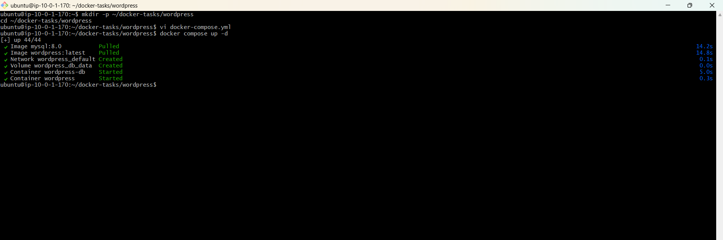
Expected output:
Directory is created.
What to check:
Confirm you are in the Compose project directory.

Step 2 — Create Compose file
Exact command:
vi docker-compose.yml
Use strong passwords and do not publish them.
What to check:
Define two services: db (MySQL) and wordpress. Add persistent MySQL storage, required database environment variables, WordPress database connection variables, a dependency on db, and a WordPress port mapping.

Step 3 — Validate Compose
Exact command:
docker compose config
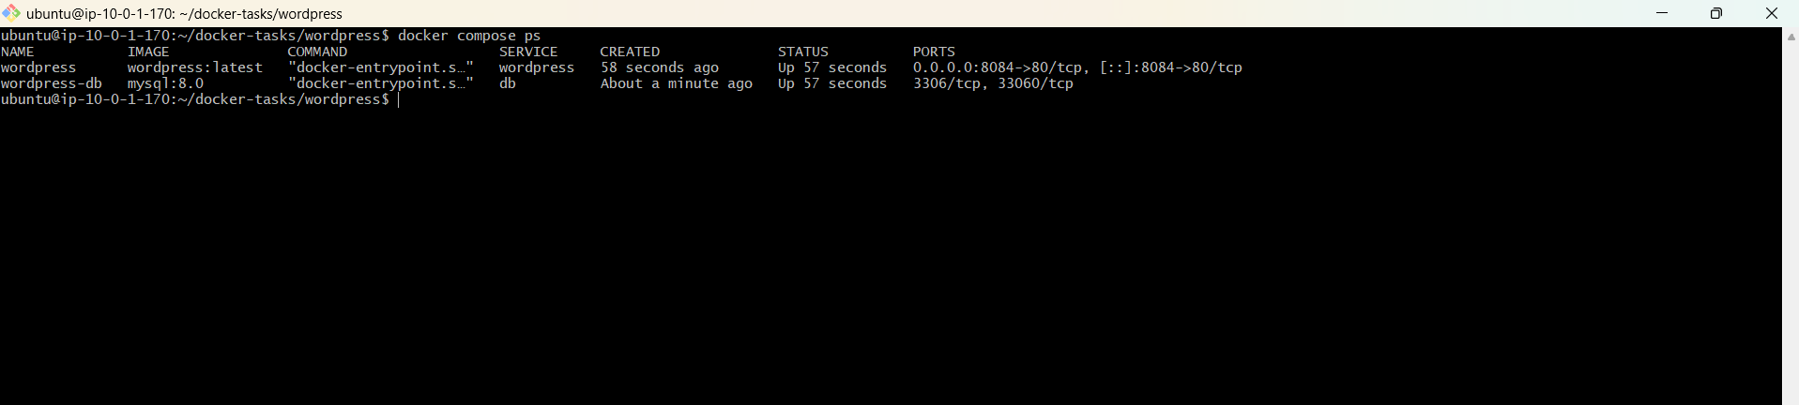
Expected output:
The normalized Compose configuration is displayed without errors.
What to check:
Confirm both services and volumes are present.

Step 4 — Start stack
Exact command:
docker compose up -d
Expected output:
MySQL and WordPress containers are created/started.
What to check:
No image, network, or environment-variable errors.

Step 5 — Check services
Exact command:
docker compose ps
Expected output:
Both services show Running/Up.
What to check:
Confirm WordPress and MySQL are running.

Step 6 — Check logs if needed
Exact command:
docker compose logs --tail=100
Expected output:
Startup logs are displayed.
What to check:
Look for database connection or WordPress startup errors.

Step 7 — Open WordPress
Exact command:
Open http://<EC2_PUBLIC_IP>:8084 in a browser.
Expected output:
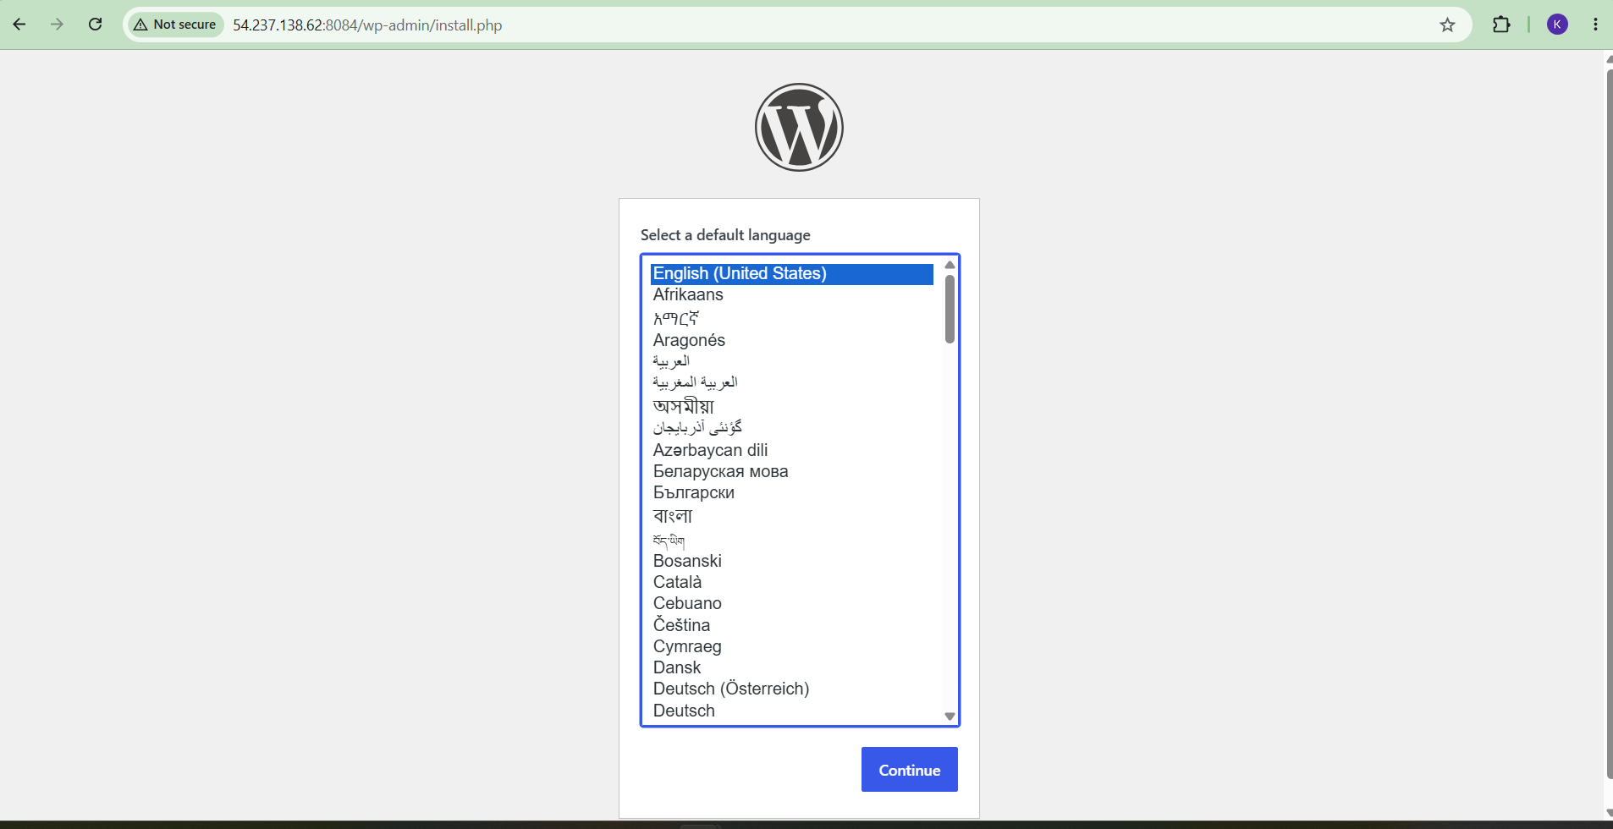
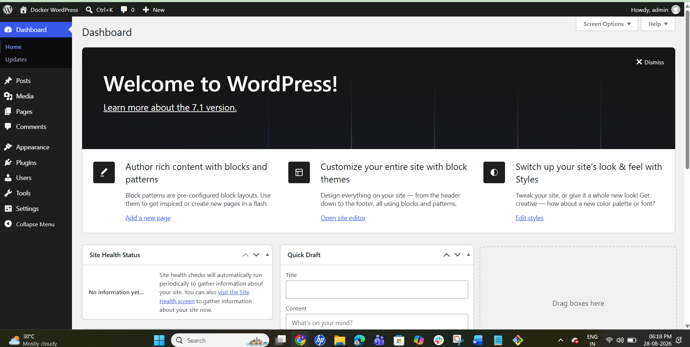
WordPress setup page appears.
What to check:
Complete WordPress installation.

