JENKINS-04

Task 1 – Setup Jenkins CI/CD Pipeline Using Freestyle Job
Source Code: https://github.com/betawins/hiring-app.git
Step 1: Open Jenkins
Log in to Jenkins and open the Jenkins Dashboard.
Step 2: Create Freestyle Job
Click New Item, enter a suitable job name, select Freestyle project, and click OK.
Step 3: Configure Git Clone
In Source Code Management, select Git. Enter the hiring-app repository URL and configure the required Git credentials/branch.
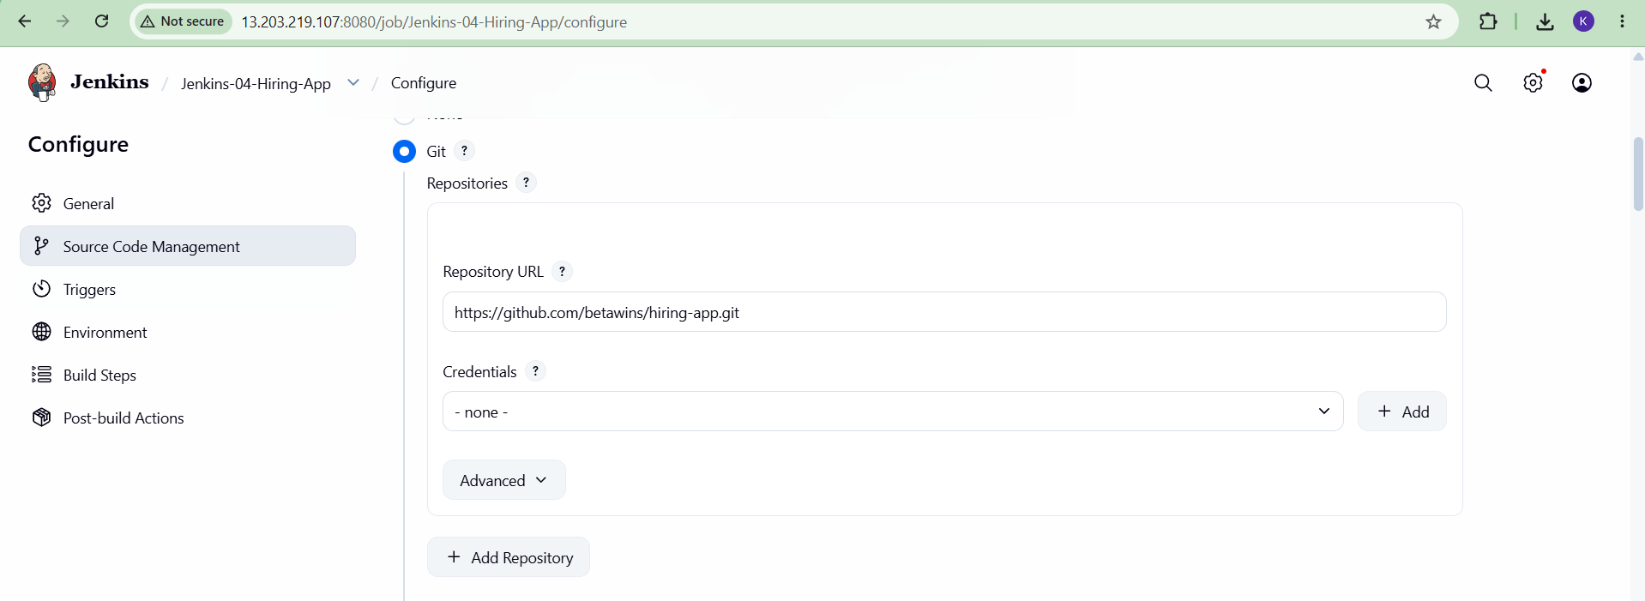
Step 4: Configure Build Environment
Configure the required Docker/container environment and Jenkins tools needed for the build.
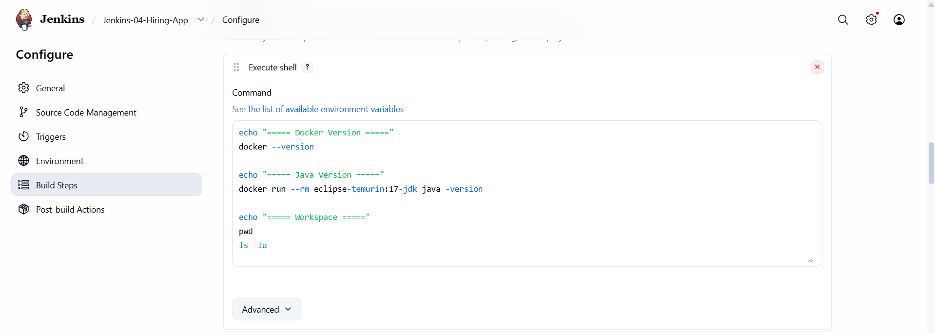
Step 5: Add SonarQube Integration
Add the SonarQube analysis step and configure the Jenkins SonarQube server/tool settings.
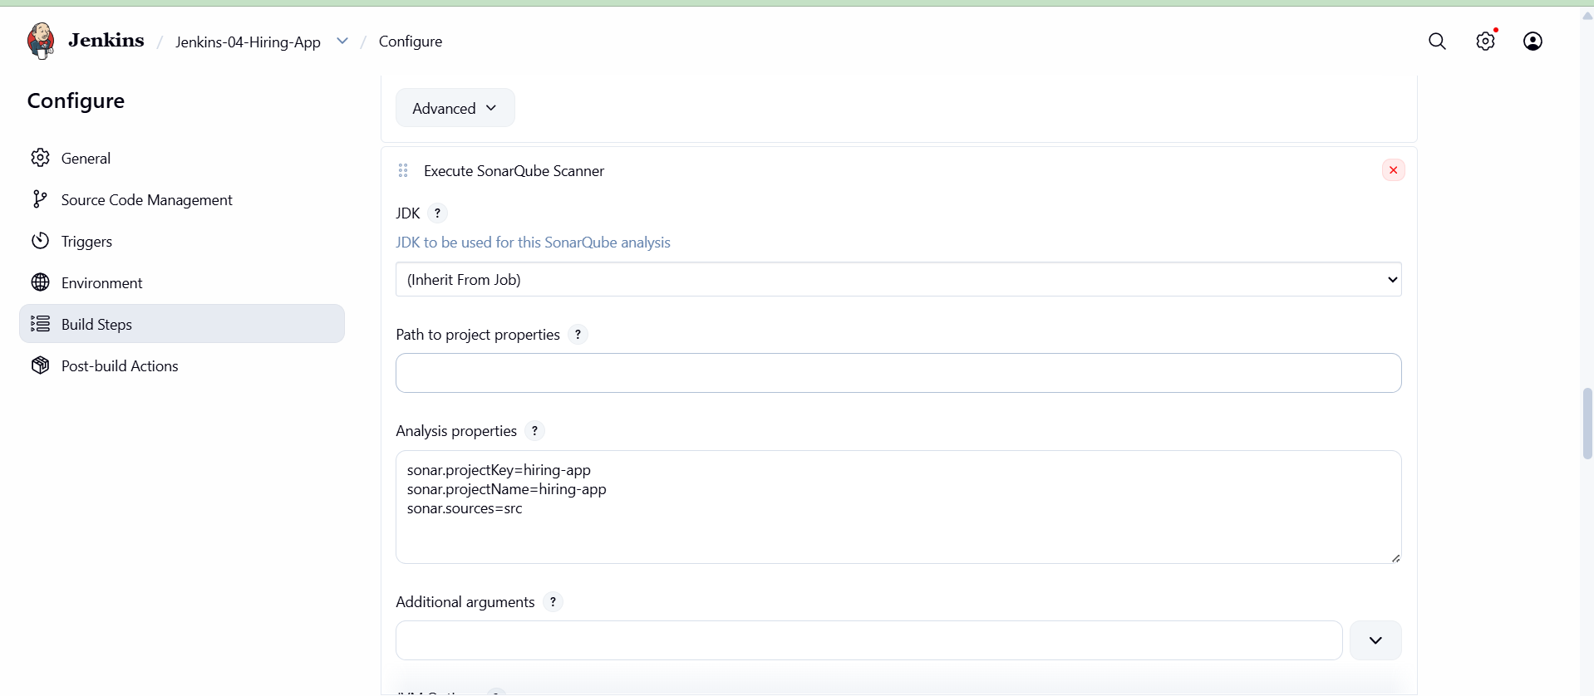
Step 6: Add Maven Compilation
Add the Maven build step and configure the required Maven goals, such as clean package, according to the application.
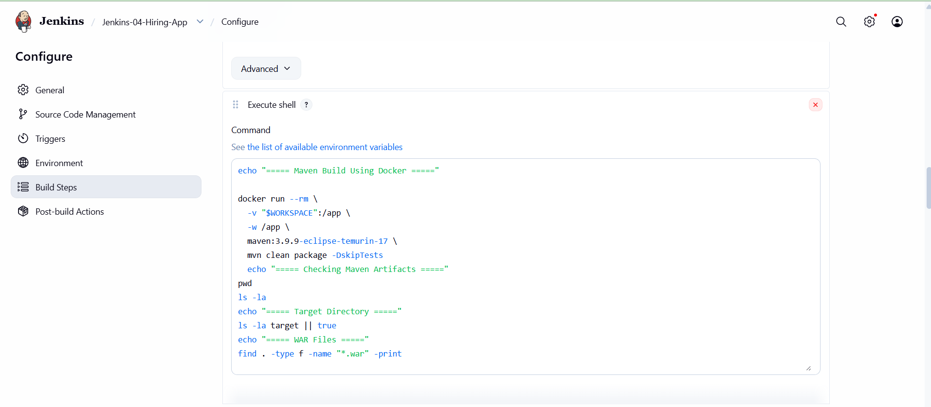
Step 7: Configure Nexus Artifactory
Configure the Nexus repository details and the build/artifact upload step so the generated artifact can be stored in Nexus.
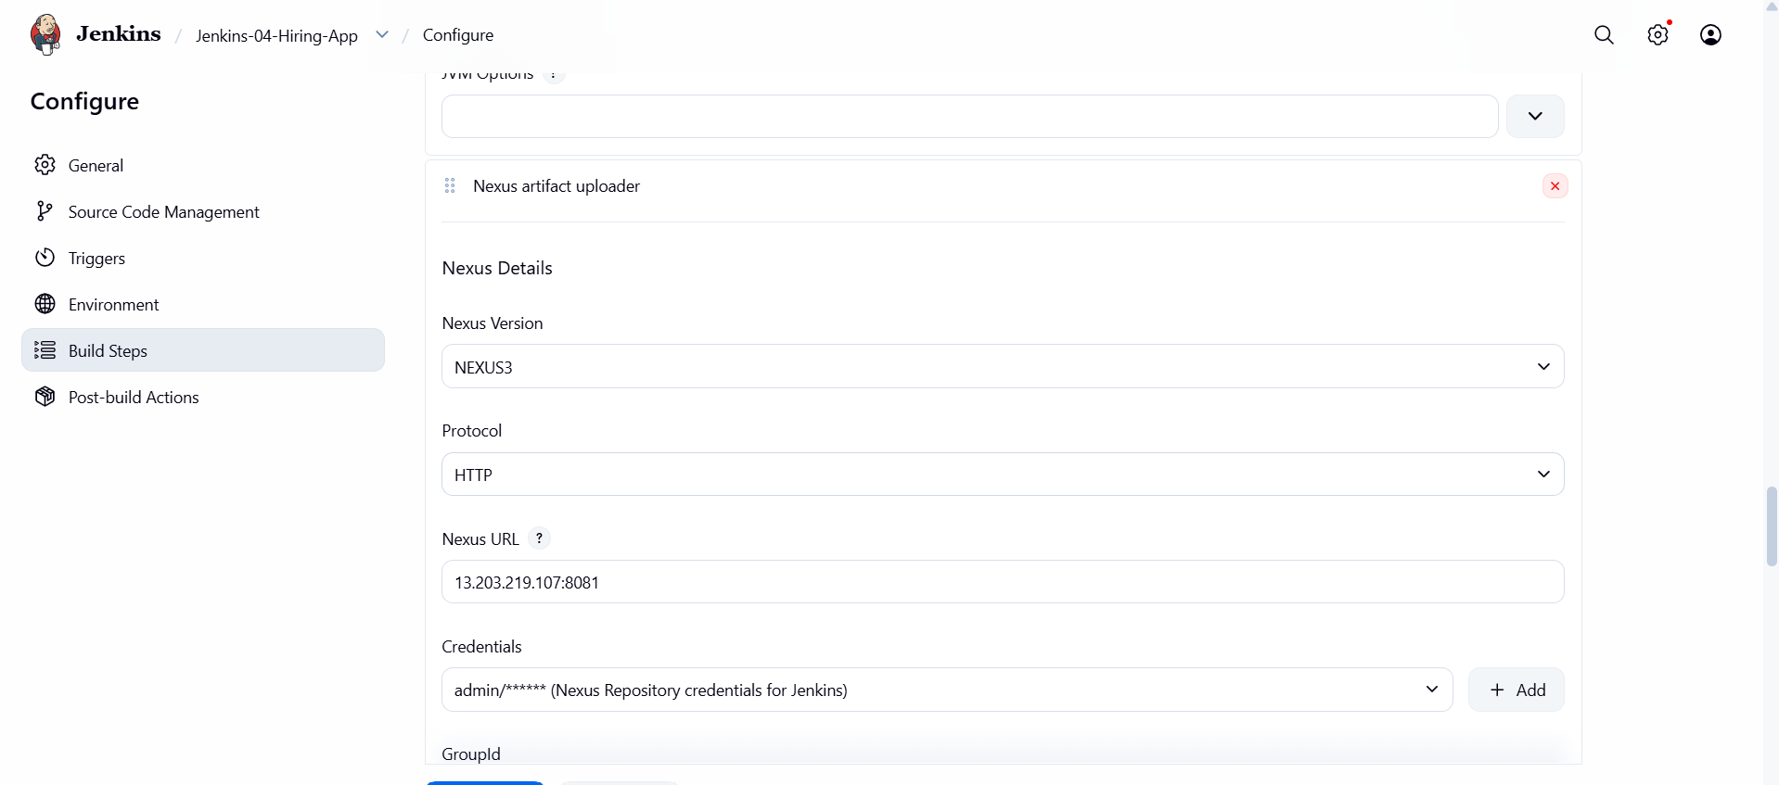
Step 8: Configure Slack Notification
Add the Slack notification/post-build action and select the required Slack notification conditions.
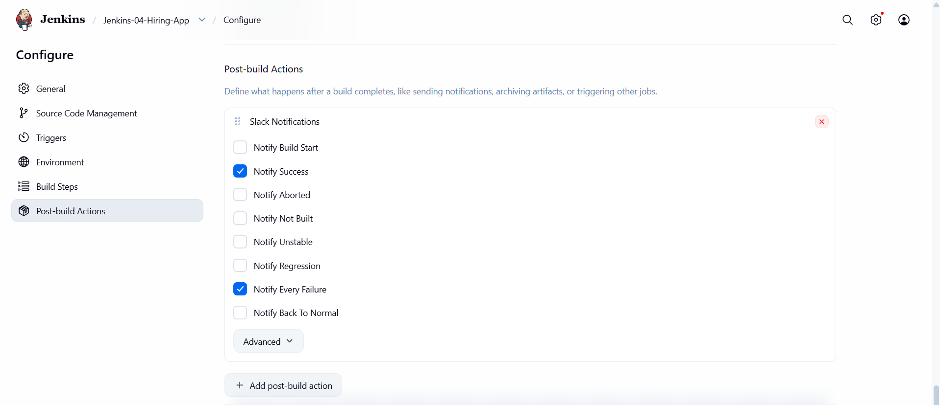
Step 9: Configure Tomcat Deployment
Configure the Tomcat server details and deployment step so the generated application can be deployed to Tomcat.
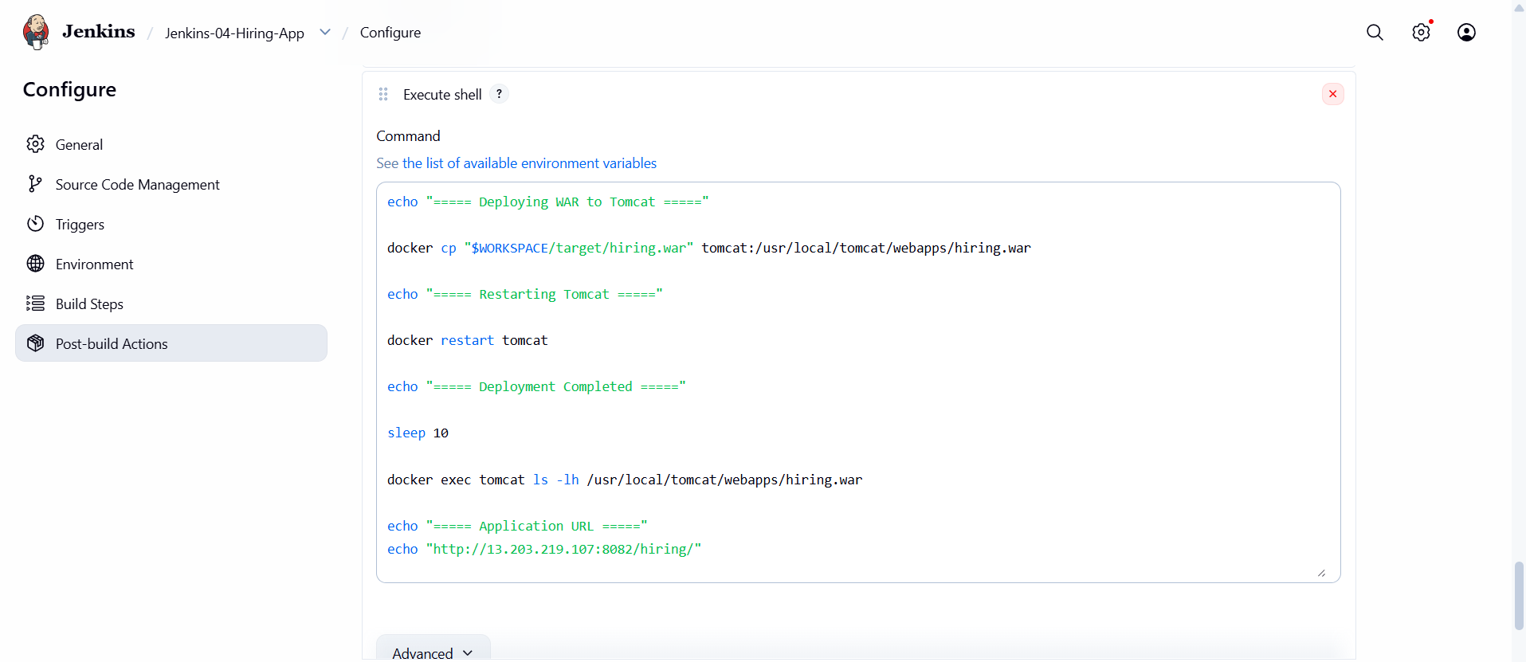
Step 10: Save and Build
Save the Freestyle job and run Build Now. Open Console Output and verify that Git clone, SonarQube, Maven, Nexus, Slack and Tomcat stages complete successfully.
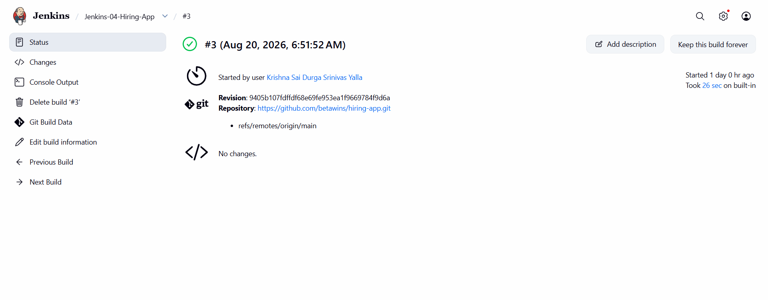
[ PASTE SCREENSHOT(S) FOR THIS TASK HERE ]

Task 2 – Setup Jenkins CI/CD Pipeline Using Declarative Pipeline
Source Code: https://github.com/betawins/sabear_simplecutomerapp/tree/feature-1.1 — Branch: feature-1.1
Step 1: Open Jenkins
Open the Jenkins Dashboard and click New Item.
Step 2: Create Pipeline Job
Enter a job name, select Pipeline, and click OK.
Step 3: Configure Pipeline Definition
In the Pipeline section, select Pipeline script or the appropriate SCM-based Jenkinsfile option.
Step 4: Configure Git Checkout
Use the sabear_simplecutomerapp repository and specify the feature-1.1 branch.
Step 5: Create Declarative Structure
Create a pipeline block with an agent and stages. Define the required stages inside the stages block.
Step 6: Add Git Clone Stage
Create a stage for checking out the feature-1.1 source code from Git.
Step 7: Add SonarQube Stage
Create a stage that runs the configured SonarQube analysis using the Jenkins SonarQube environment/tool.
Step 8: Add Maven Compilation Stage
Create a Maven stage and run the required Maven command to compile/package the application.
Step 9: Add Nexus Artifactory Stage
Create a stage to publish/store the generated artifact in the configured Nexus repository.
Step 10: Add Slack Notification Stage
Create a stage/post action to send the build status notification to Slack.
Step 11: Add Tomcat Deployment Stage
Create a deployment stage that transfers/deploys the application artifact to the configured Tomcat server.
pipeline {
agent any

stages {

stage('Git Clone') {
steps {
echo '===== Git Clone - feature-1.1 ====='

git branch: 'feature-1.1',
url: 'https://github.com/betawins/sabear_simplecutomerapp.git'
}
}

stage('Maven Build') {
steps {
echo '===== Maven Build ====='

sh '''
mvn clean package -DskipTests
'''
}
}

stage('SonarQube Analysis') {
steps {
echo '===== SonarQube Analysis ====='

withCredentials([
string(
credentialsId: 'sonar-token',
variable: 'SONAR_TOKEN'
)
]) {
sh '''
mvn org.sonarsource.scanner.maven:sonar-maven-plugin:sonar \
-Dsonar.host.url=http://13.203.219.107:9000 \
-Dsonar.token=$SONAR_TOKEN \
-Dsonar.projectKey=simplecustomerapp \
-Dsonar.projectName=simplecustomerapp
'''
}
}
}

stage('Nexus Upload') {
steps {
echo '===== Nexus Upload ====='

withCredentials([
usernamePassword(
credentialsId: 'nexus-credentials',
usernameVariable: 'NEXUS_USER',
passwordVariable: 'NEXUS_PASSWORD'
)
]) {
sh '''
curl -u "$NEXUS_USER:$NEXUS_PASSWORD" \
--upload-file target/*.war \
"http://13.203.219.107:8081/repository/maven-releases/in/javahome/simplecustomerapp/0.1/simplecustomerapp-0.1.war"
'''
}
}
}

stage('Deploy to Tomcat') {
steps {
echo '===== Deploy WAR to Tomcat ====='

sh '''
docker cp target/*.war tomcat:/usr/local/tomcat/webapps/simplecustomerapp.war
'''
}
}

stage('Slack Notification') {
steps {
echo '===== Slack Notification ====='

slackSend(
channel: '#new-channel',
color: 'good',
message: "SUCCESS: Jenkins-04 Pipeline completed successfully. Build #${BUILD_NUMBER}"
)
}
}
}

post {
success {
echo '===== PIPELINE SUCCESS ====='
}

failure {
echo '===== PIPELINE FAILED ====='

slackSend(
channel: '#new-channel',
color: 'danger',
message: "FAILED: Jenkins-04 Pipeline failed. Build #${BUILD_NUMBER}"
)
}

always {
echo '===== Pipeline Completed ====='
}
}
}
Step 12: Save and Run
Save the Pipeline and click Build Now. Open the build details and verify the Declarative Pipeline stages complete successfully.
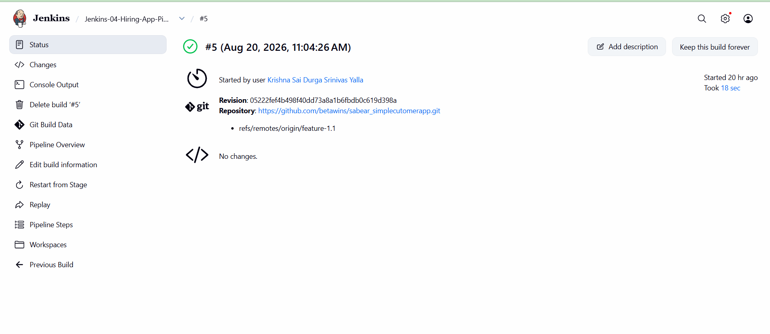

Task 3 – Setup Jenkins CI/CD Pipeline Using Scripted Pipeline
Source Code: https://github.com/betawins/sabear_simplecutomerapp/tree/feature-1.1 — Branch: feature-1.1
Step 1: Open Jenkins
Open the Jenkins Dashboard and create a new Pipeline project.
Step 2: Configure Pipeline Script
Open the Pipeline configuration and select the option to enter a Pipeline script.
Step 3: Create Scripted Structure
Create a node block and define the CI/CD stages using Scripted Pipeline syntax.
Step 4: Add Git Clone Stage
Create a stage for checking out the feature-1.1 branch from the Git repository.
Step 5: Add SonarQube Stage
Create a stage that performs SonarQube code-quality analysis using the configured Jenkins SonarQube settings.
Step 6: Add Maven Compilation Stage
Create a stage that runs the required Maven build/compilation command.
Step 7: Add Nexus Artifactory Stage
Create a stage that publishes the generated artifact to the configured Nexus repository.
Step 8: Add Slack Notification Stage
Create a stage or post-build notification step to send the build status to Slack.
Step 9: Add Tomcat Deployment Stage
Create a stage that deploys the generated application to the configured Tomcat server.
node {

try {

stage('Git Clone') {
echo '===== Git Clone - feature-1.1 ====='

git(
branch: 'feature-1.1',
url: 'https://github.com/betawins/sabear_simplecutomerapp.git'
)
}

stage('Maven Compilation') {
echo '===== Maven Compilation ====='

sh '''
mvn clean package -DskipTests
'''
}

stage('SonarQube Integration') {
echo '===== SonarQube Analysis ====='

withCredentials([
string(
credentialsId: 'sonar-token',
variable: 'SONAR_TOKEN'
)
]) {

sh '''
mvn org.sonarsource.scanner.maven:sonar-maven-plugin:sonar \
-Dsonar.host.url=http://13.203.219.107:9000 \
-Dsonar.token=$SONAR_TOKEN \
-Dsonar.projectKey=simplecustomerapp \
-Dsonar.projectName=simplecustomerapp
'''
}
}

stage('Nexus Artifactory') {
echo '===== Nexus Upload ====='

withCredentials([
usernamePassword(
credentialsId: 'nexus-credentials',
usernameVariable: 'NEXUS_USER',
passwordVariable: 'NEXUS_PASSWORD'
)
]) {

sh '''
WAR_FILE=$(find target -name "*.war" | head -1)

echo "WAR file found:"
echo "$WAR_FILE"

curl -v \
-u "$NEXUS_USER:$NEXUS_PASSWORD" \
--upload-file "$WAR_FILE" \
"http://13.203.219.107:8081/repository/maven-snapshots/com/javatpoint/SimpleCustomerApp/${BUILD_NUMBER}-SNAPSHOT/SimpleCustomerApp-${BUILD_NUMBER}-SNAPSHOT.war"
'''
}
}

stage('Deploy On Tomcat') {
echo '===== Deploy On Tomcat ====='

sh '''
WAR_FILE=$(find target -name "*.war" | head -1)

echo "WAR file found:"
echo "$WAR_FILE"

docker cp "$WAR_FILE" \
tomcat:/usr/local/tomcat/webapps/simplecustomerapp.war

echo "===== WAR deployed to Tomcat successfully ====="

docker exec tomcat \
ls -lh /usr/local/tomcat/webapps/
'''
}

stage('Slack Notification') {
echo '===== Slack Notification ====='

slackSend(
channel: '#new-channel',
color: 'good',
message: "SUCCESS: Jenkins-04 Scripted Pipeline completed successfully - Build #${BUILD_NUMBER}"
)
}

echo '===== PIPELINE SUCCESS ====='

}

catch (err) {

echo '===== PIPELINE FAILED ====='

slackSend(
channel: '#new-channel',
color: 'danger',
message: "FAILED: Jenkins-04 Scripted Pipeline - Build #${BUILD_NUMBER}"
)

throw err
}

finally {

echo '===== Pipeline Completed ====='
}
}
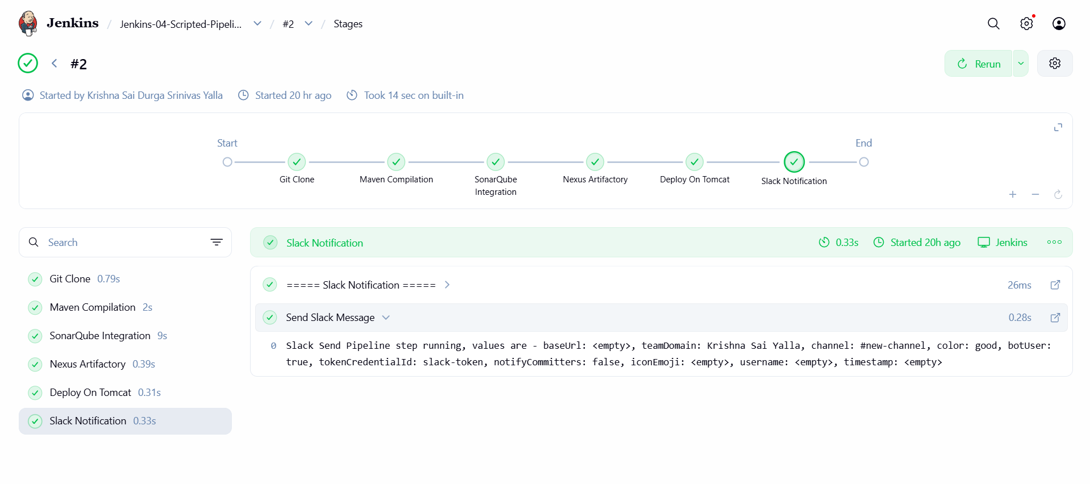
Step 10: Save and Run
Save the Scripted Pipeline, run a build, open Console Output, and verify that all required stages complete successfully.
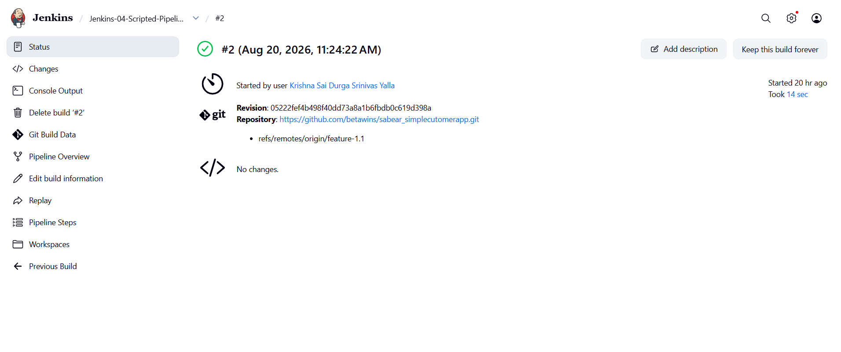
[ PASTE SCREENSHOT(S) FOR THIS TASK HERE ]

Task 4 – Write Sample Skeleton of Pipelines
Step 1: Open Jenkins
Open the Jenkins Dashboard and create/open a Pipeline project or use the Pipeline script editor.
Step 2: Write Declarative Skeleton
Create a basic Declarative Pipeline containing pipeline, agent, stages and stage blocks. Keep the stage bodies as simple sample commands.
pipeline {
agent any

stages {
stage('Git Clone') {
steps {
// sample
}
}

stage('SonarQube Integration') {
steps {
// sample
}
}

stage('Maven Compilation') {
steps {
// sample
}
}
}
}
Step 3: Add Required CI/CD Stage Names
Use the assignment stage names as sample stages: Git Clone, SonarQube Integration, Maven Compilation, Nexus Artifactory, Slack Notification and Deploy on Tomcat.
Step 4: Write Scripted Skeleton
Create a basic Scripted Pipeline using node and stage blocks, with sample commands inside each stage.
node {
stage('Git Clone') {
// sample
}

stage('SonarQube Integration') {
// sample
}

stage('Maven Compilation') {
// sample
}

stage('Nexus Artifactory') {
// sample
}

stage('Slack Notification') {
// sample
}

stage('Deploy On Tomcat') {
// sample
}
}
Step 5: Save the Skeletons
Save the sample pipeline structures so they can be reused as templates for future Jenkins pipelines.
[ PASTE SCREENSHOT(S) FOR THIS TASK HERE ]

Task 5 – Create a Parameterized Job
Source Code: https://github.com/betawins/spring3-mvc-maven-xml-hello-world-1.git
Step 1: Open Jenkins
Open the Jenkins Dashboard and click New Item.
Step 2: Create the Job
Enter a suitable job name, select the appropriate project type, and click OK.
Step 3: Configure Git Repository
Under Source Code Management, select Git and enter the spring3-mvc-maven-xml-hello-world-1 repository URL.
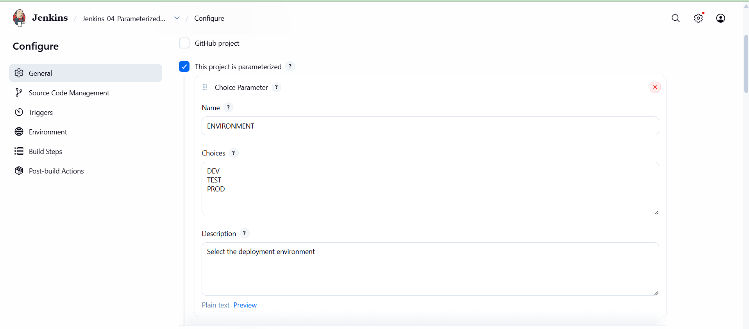
Step 4: Enable Parameterization
Enable This project is parameterized in the job configuration.
Step 5: Add a Parameter
Click Add Parameter and create the parameter required by the assignment, giving it a name, type and default value where appropriate.
Step 6: Use the Parameter
Reference the parameter in the relevant build configuration so the value supplied at build time is available to the job.
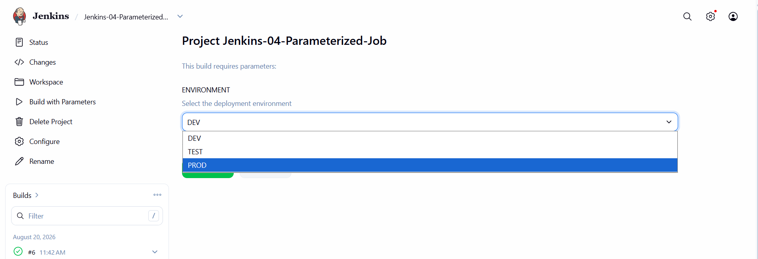
Step 7: Configure Maven Build
Configure the Maven build step/goals required to build the Spring MVC Maven application.
Step 8: Save the Job
Click Save to store the parameterized job configuration.
echo "========================================"
echo "Parameterized Jenkins Job"
echo "========================================"

echo "Environment: $ENVIRONMENT"

echo "Java Version:"
java -version

echo "Maven Version:"
mvn -version

echo "========================================"
echo "Starting Maven Build"
echo "========================================"

mvn clean package -DskipTests -Djdk.version=1.8

echo "========================================"
echo "Maven Build Completed"
echo "========================================"

echo "Environment selected: $ENVIRONMENT"

echo "========================================"
echo "Parameterized Job Completed"
echo "========================================"
Step 9: Run with Parameters
Click Build with Parameters, enter/select the required parameter value, and start the build.
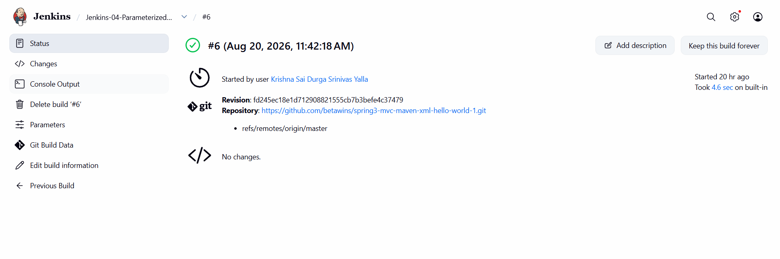
Step 10: Verify Build
Open Console Output and verify that Jenkins received the parameter and the build completed successfully.
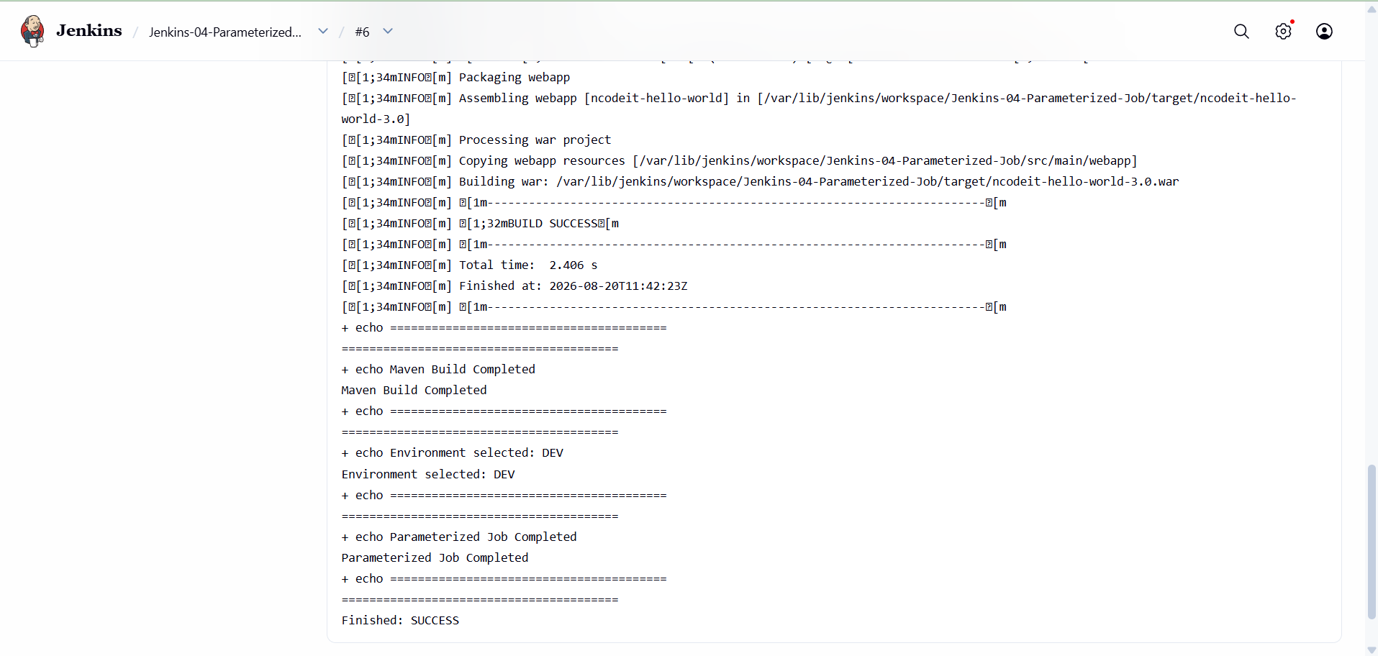
[ PASTE SCREENSHOT(S) FOR THIS TASK HERE ]

Task 6 – Setup One Slave Machine for Jenkins
Source Code: Jenkins Controller + separate Ubuntu EC2 Jenkins Agent
Step 1: Launch/Prepare Agent EC2
Use a separate Ubuntu EC2 instance for the Jenkins slave/agent. Confirm that SSH access to the instance is available.
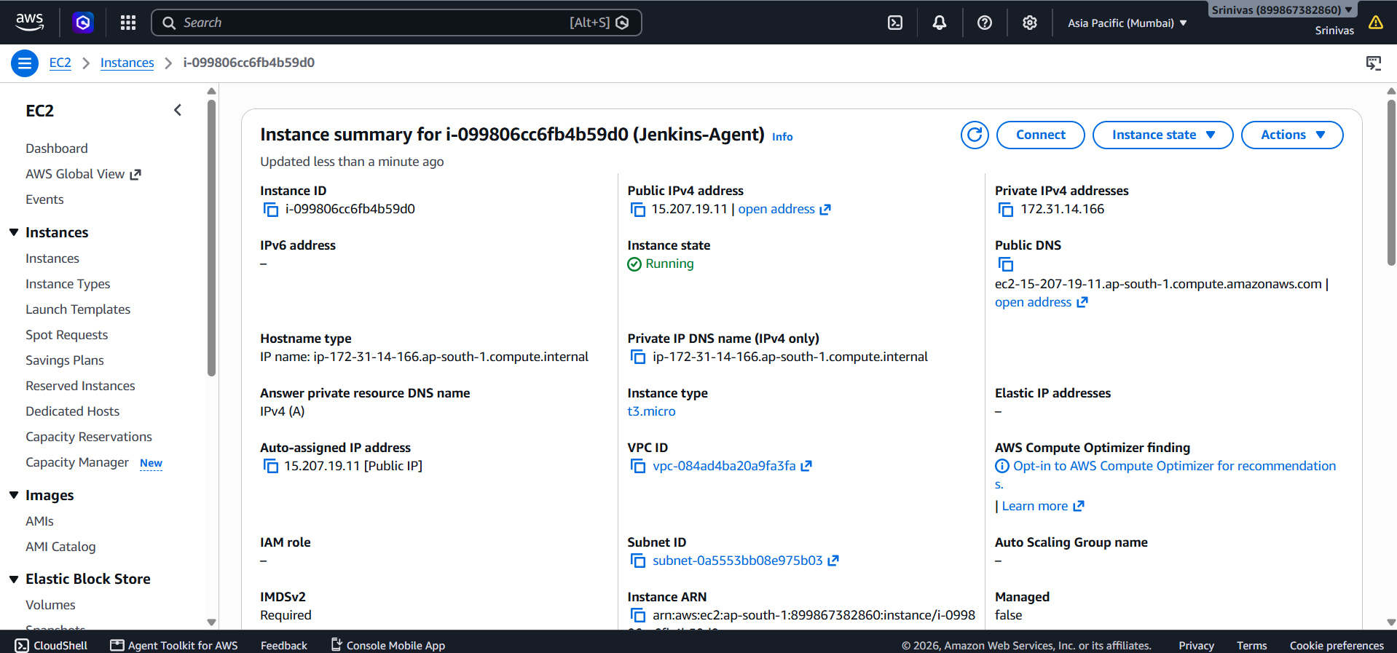
Step 2: Connect to the Agent
Open AWS EC2 Instance Connect for the Agent machine and log in as the ubuntu user.
Step 3: Verify Agent Host
Run hostname and verify the Agent host. The completed setup used hostname ip-172-31-14-166.
Step 4: Prepare Jenkins SSH Key
On the Jenkins Controller, create the Jenkins user's SSH directory and generate an ED25519 key pair for Jenkins Agent authentication.
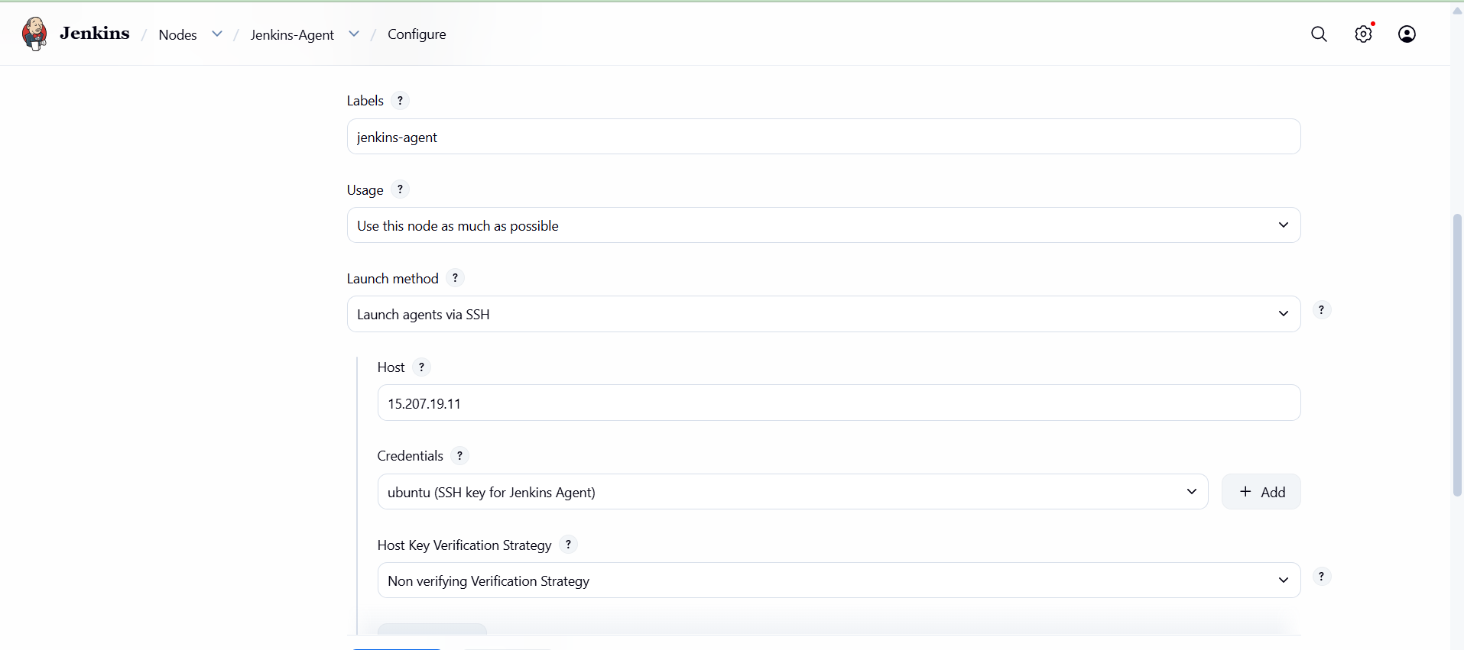
Step 5: Verify Public Key
Display the generated public key and copy the complete ssh-ed25519 public-key line.
Step 6: Configure Authorized Keys
On the Agent machine, create ~/.ssh/authorized_keys and add the Jenkins public key to it.
Step 7: Set SSH Permissions
Set ~/.ssh to 700 and authorized_keys to 600, and ensure the files are owned by the ubuntu user.
Step 8: Restart SSH
Restart the SSH service after configuring authorized_keys.
Step 9: Create Jenkins Credential
In Jenkins, create/update the SSH credential with ID jenkins-agent-key, username ubuntu, and the corresponding private key.
Step 10: Create Agent Node
In Jenkins, open Manage Jenkins > Nodes and create the Jenkins-Agent node.
Step 11: Configure Agent Connection
Configure the Agent to use SSH, enter the Agent public IP 15.207.19.11, port 22, and select the jenkins-agent-key credential.
Step 12: Configure Agent Label
Set the node label to jenkins-agent and save the node configuration.
Step 13: Verify Agent Connection
Open the Jenkins-Agent status/log page and verify that the SSH connection succeeds and the node becomes online.
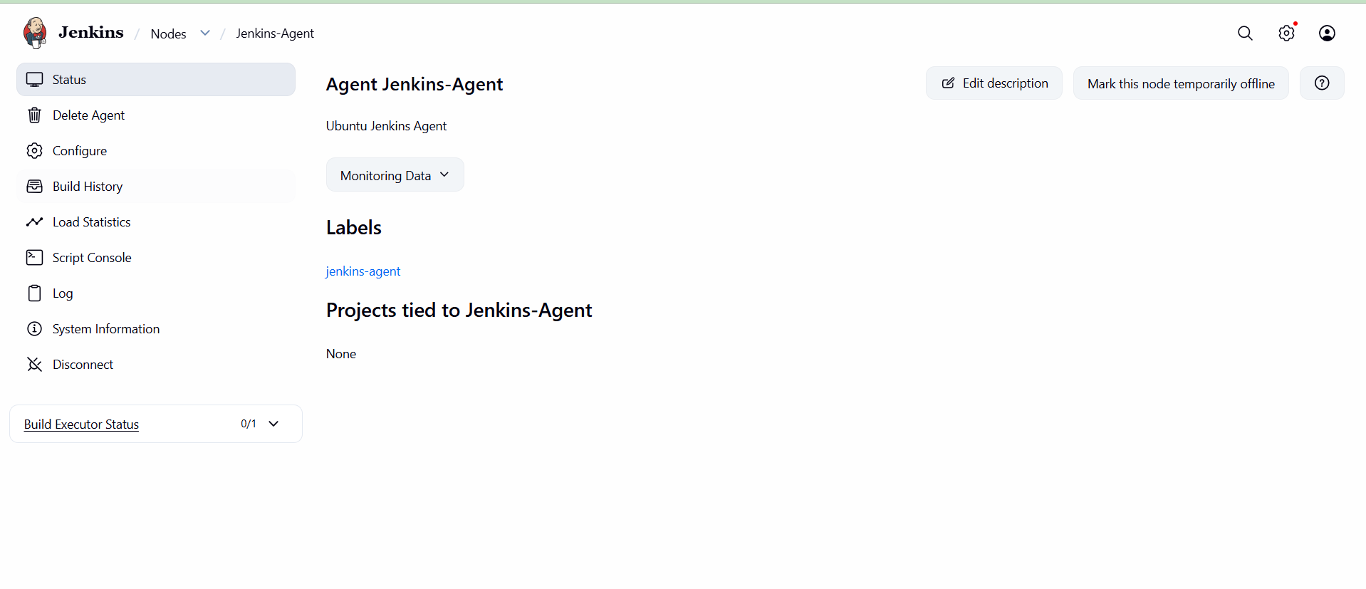
Step 14: Verify Monitoring Data
Confirm the Agent page displays Linux amd64 architecture, clock status, disk space and other monitoring information.
