AWS VPC Assignment Documentation
Objective: Create and configure AWS VPC networking components including VPC, subnets, cross-region peering, cross-account peering, Transit Gateway, and VPC Endpoint.

Task 1: Create a VPC with Public and Private Subnets
- Open AWS Console → VPC → Create VPC.
- Create VPC named 'Krishna-VPC' with CIDR 10.0.0.0/16.
- Create Public Subnet (10.0.1.0/24).
- Create Private Subnet (10.0.2.0/24).
- Create and attach an Internet Gateway.
- Create a Public Route Table.
- Add route 0.0.0.0/0 to the Internet Gateway.
- Associate the Public Subnet with the Public Route Table.
- Verify the VPC, subnets, Internet Gateway, and route table.
Screenshots:
• VPC
• Public Subnet
• Private Subnet
• Internet Gateway
• Route Table
• Subnet Association
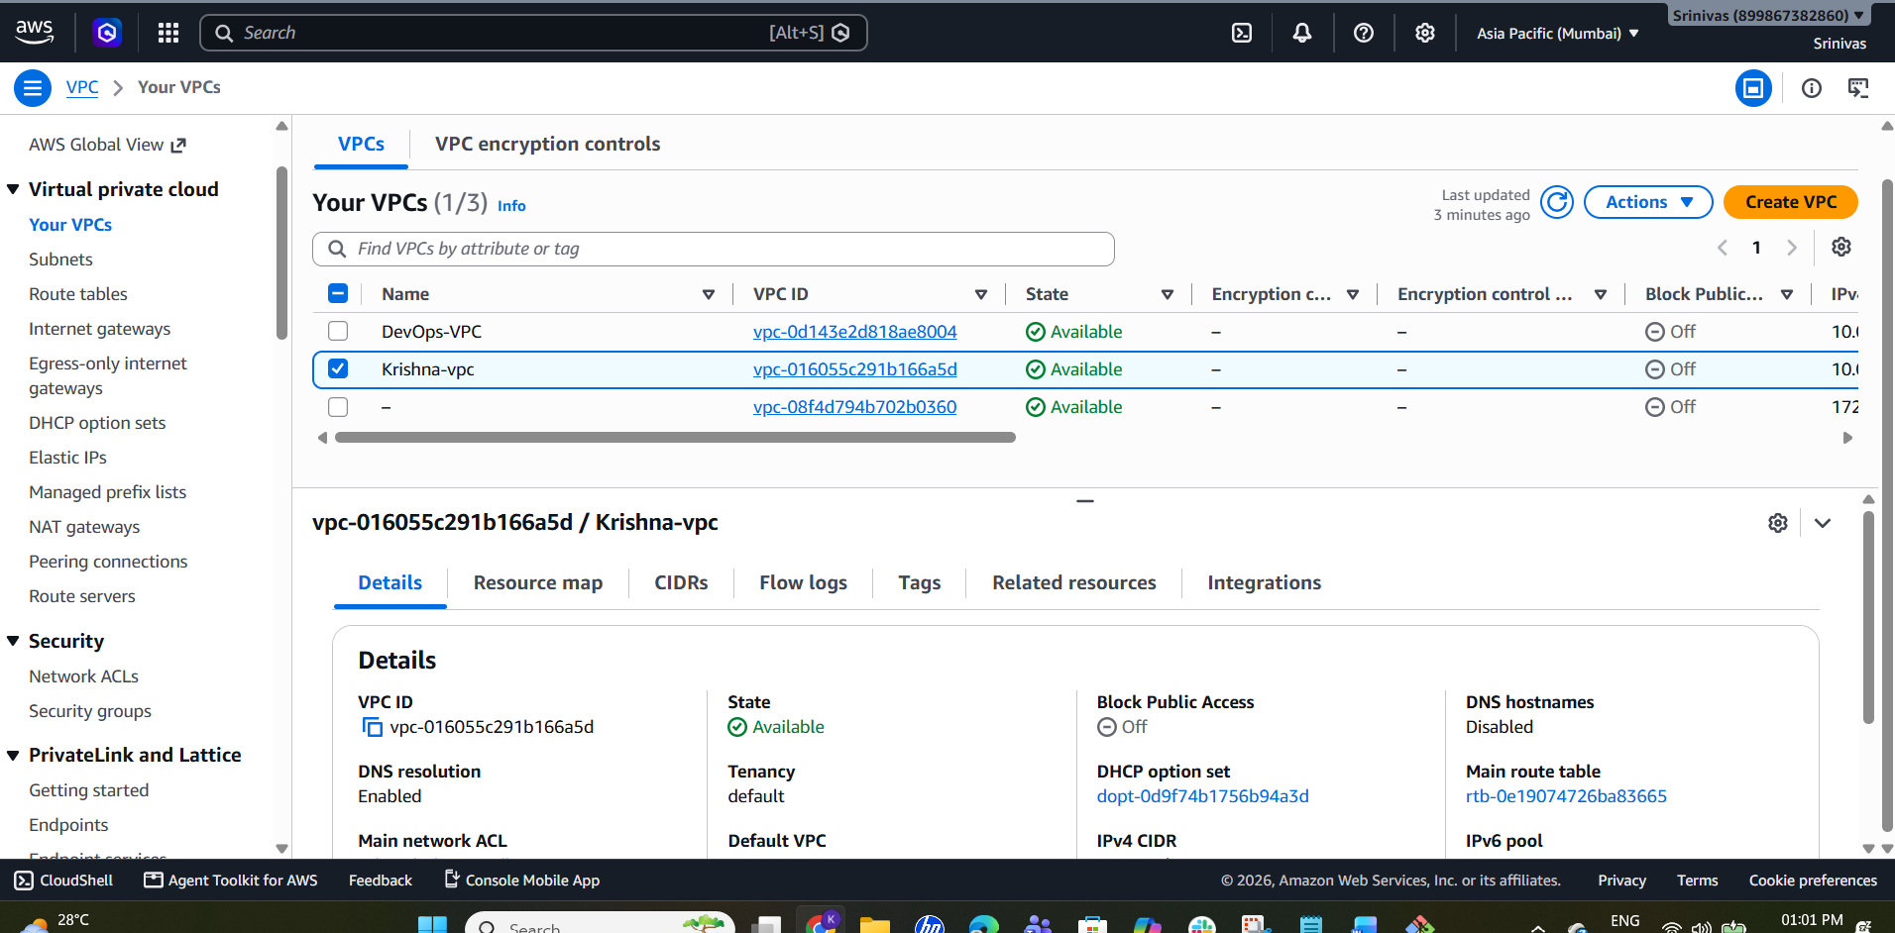
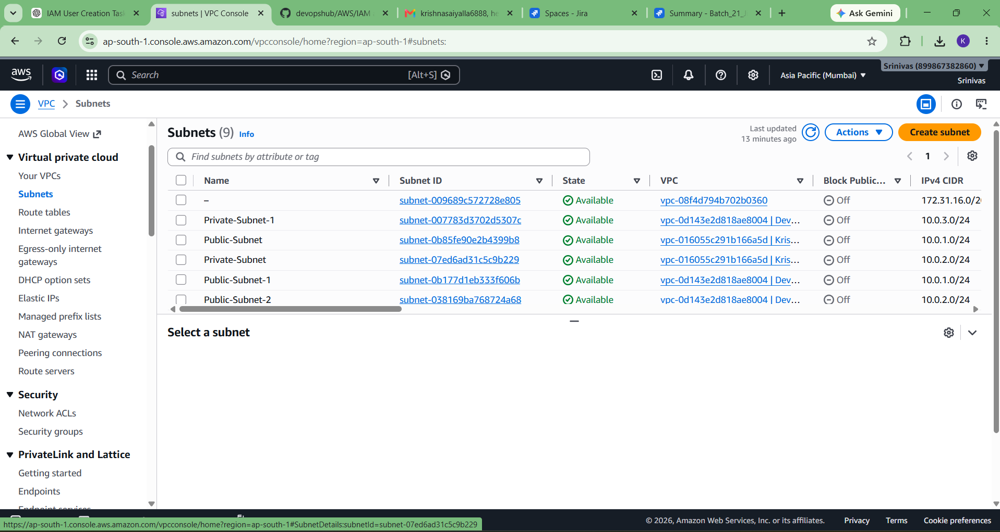
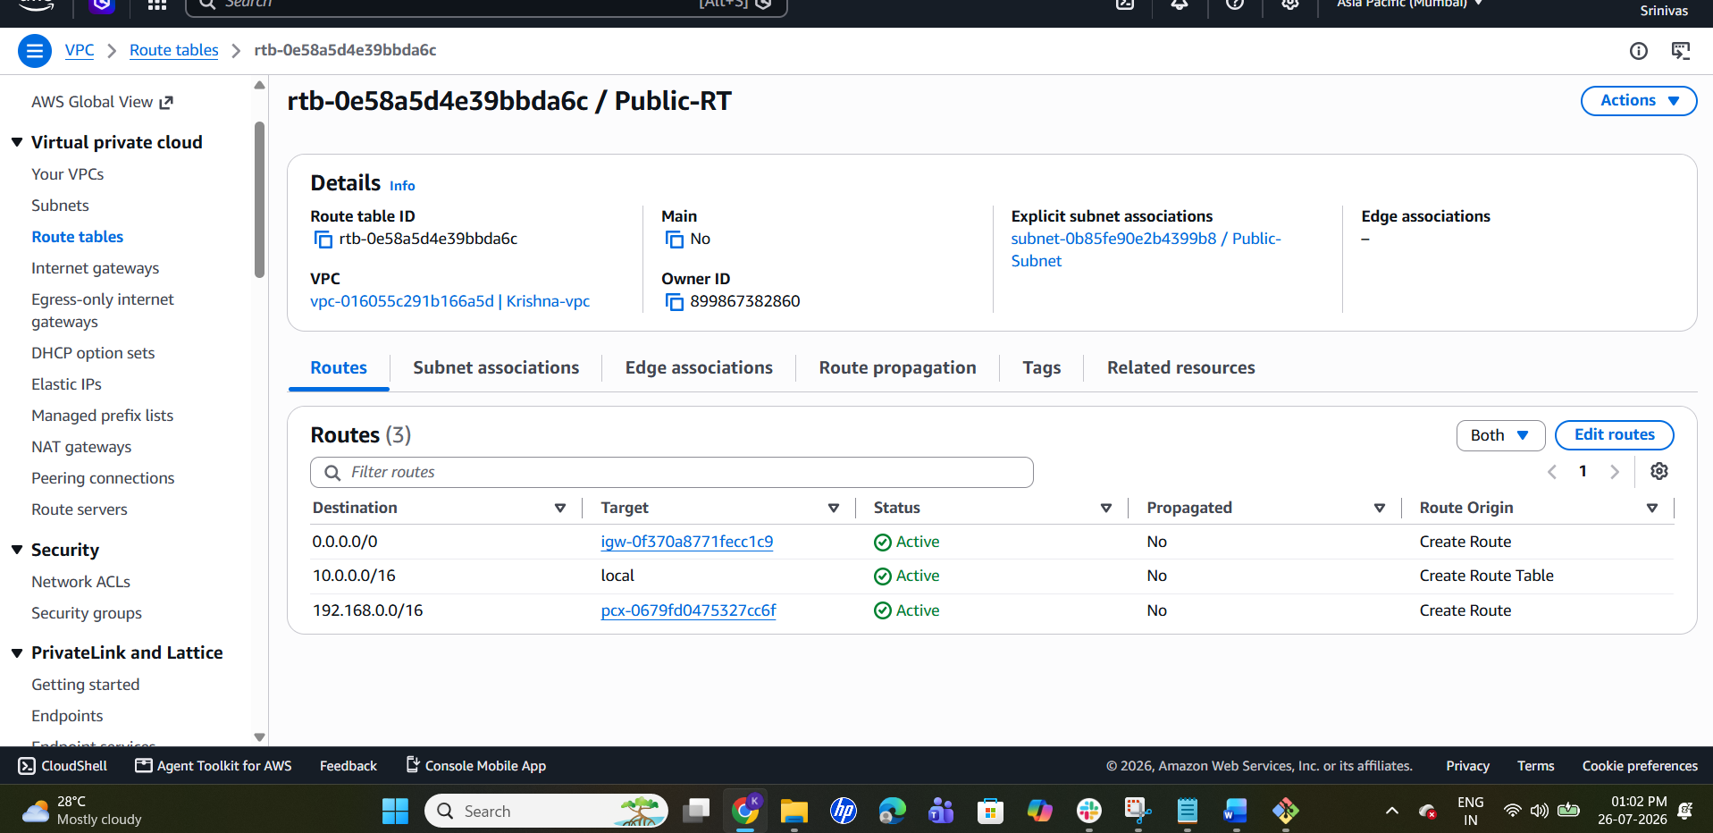

Task 2: Cross-Region VPC Peering
- Switch to another AWS Region (e.g., N. Virginia).
- Create a second VPC with CIDR 192.168.0.0/16.
- Return to Mumbai region and create a VPC Peering Connection.
- Select your VPC as the requester and the second VPC as the accepter.
- Accept the peering request in the second region.
- Update route tables in both VPCs to point to the peering connection.
- Verify the peering status is 'Active'.
Screenshots:
• Second VPC
• Peering Request
• Active Status
• Route Tables
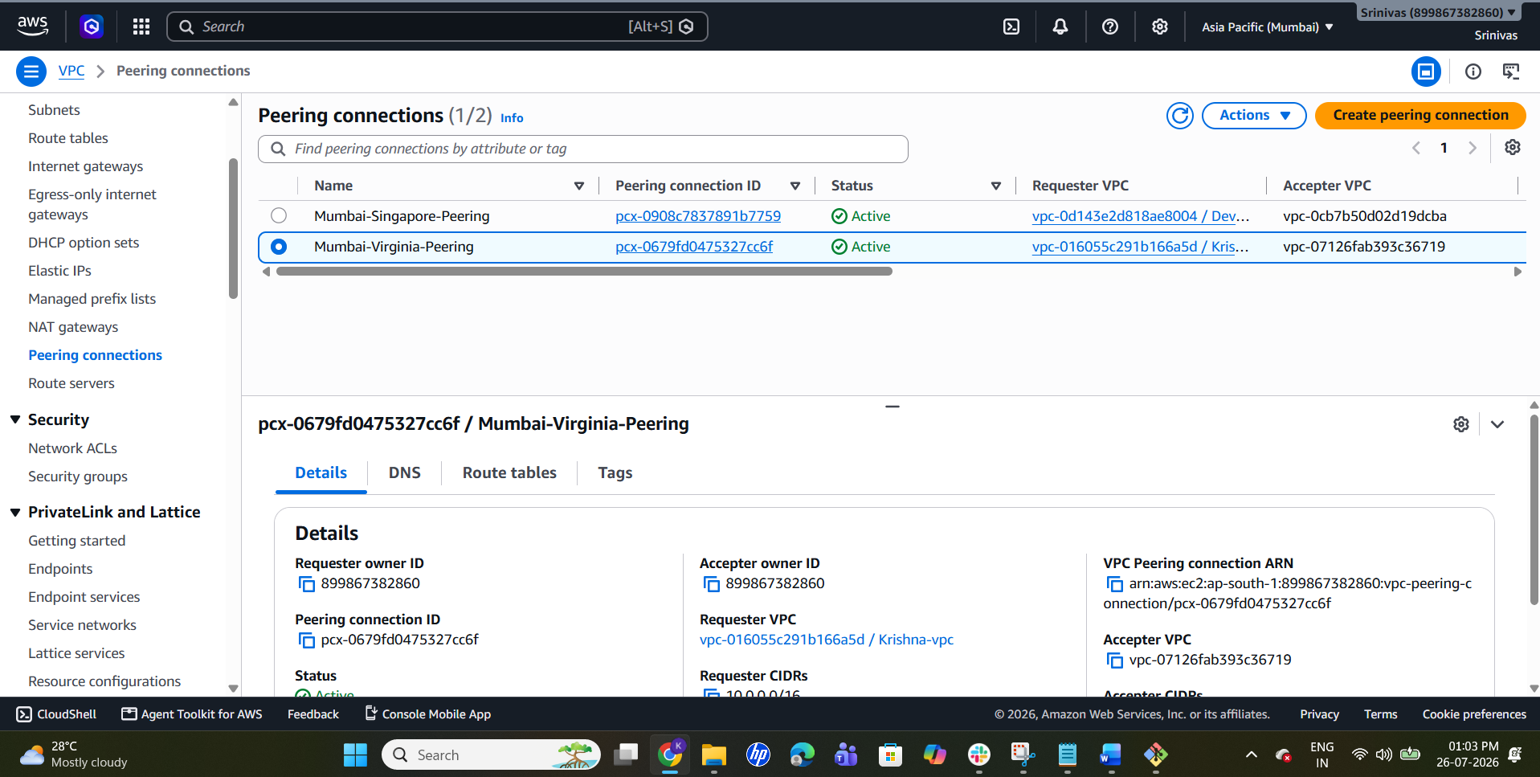
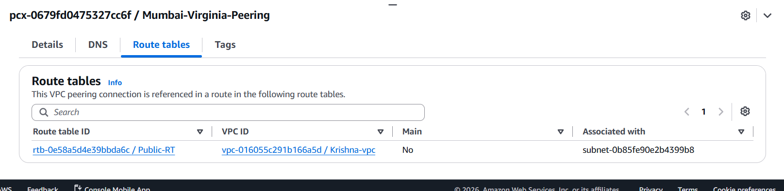

Task 3: Cross-Account VPC Peering
- Create or use a VPC in another AWS account.
- Create a cross-account VPC peering request.
- Accept the request from the second AWS account.
- Update route tables in both accounts.
- Verify the peering status is 'Active'.
Screenshots:
• Cross-Account Request
• Accepted Status
• Route Tables
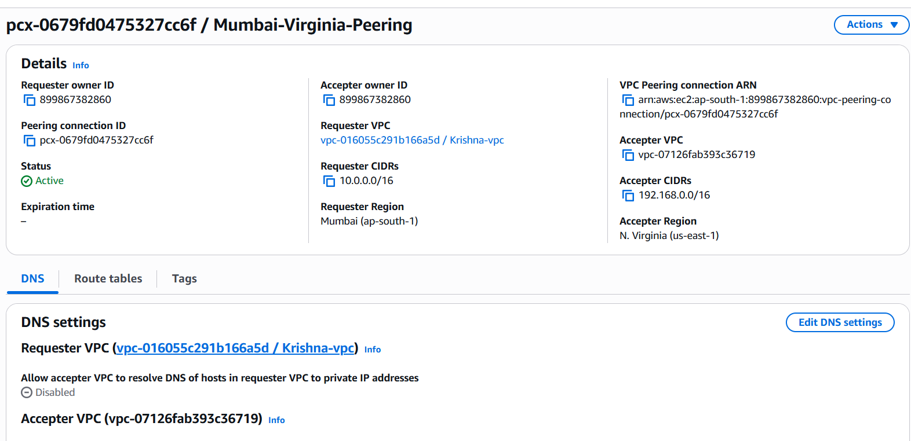

Task 4: Transit Gateway
- Create a Transit Gateway named 'Krishna-TGW'.
- Wait until the state becomes 'Available'.
- Create a Transit Gateway Attachment.
- Select the Transit Gateway, your VPC, and a subnet.
- Wait until the attachment state becomes 'Available'.
Screenshots:
• Transit Gateway
• Transit Gateway Attachment
• Available Status
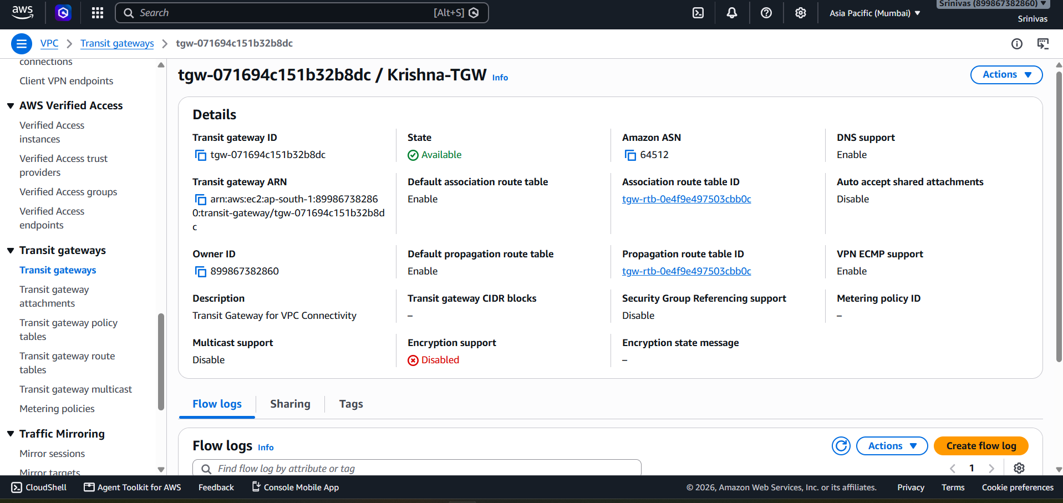
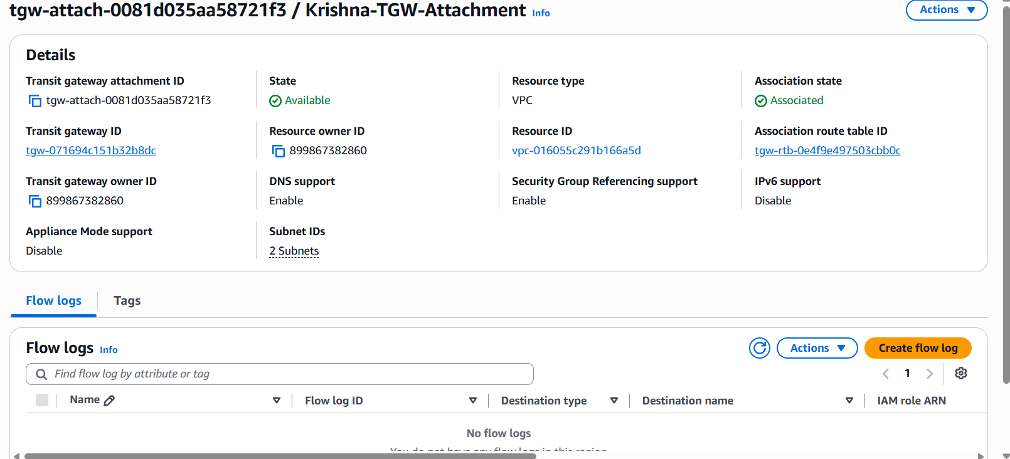

Task 5: VPC Endpoint
- Go to VPC → Endpoints → Create Endpoint.
- Search and select com.amazonaws.ap-south-1.s3 (Gateway).
- Select your VPC.
- Choose the required route table(s).
- Leave the default Full Access policy.
- Create the endpoint and verify its state is 'Available'.
Screenshots:
• Endpoint Configuration
• Endpoint Details
• Available Status
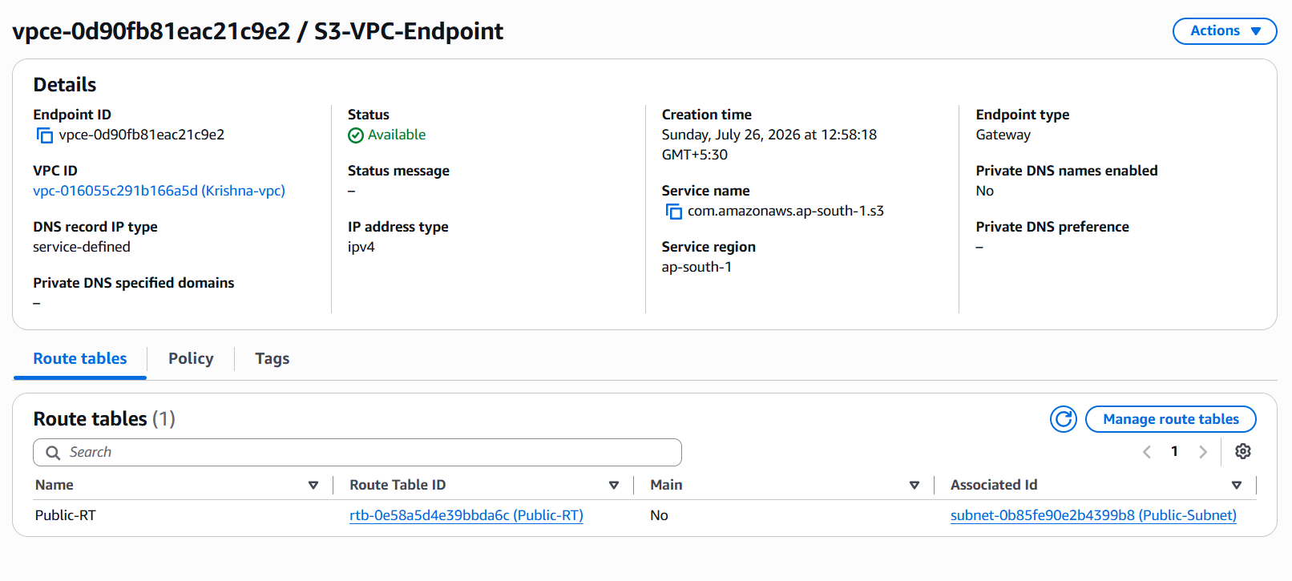

Conclusion
Successfully created and configured a VPC with public and private subnets, configured cross-region and cross-account VPC peering, created a Transit Gateway and attachment, and configured an Amazon S3 Gateway VPC Endpoint.

