**Shared lock**

* Before I begin let me first say that there are 5 types of table locks - row shared, row exclusive, shared, shared row exclusive and exclusive. And shared lock is one among these. Also, please note that there are row locks, which are different than table locks. Follow the link I have provided in end to read about all this.
* A shared lock is acquired on the table specified in following statement – LOCK TABLE table IN SHARE MODE;
* This lock prevents other transactions from getting “row exclusive” (this lock is used by INSERT, UPDATE and DELETE statement), “shared row exclusive” and “exclusive” table locks, otherwise everything is permitted.
* So, this means that a shared lock will block other transactions from executing INSERT, UPDATE and DELETE statements on that table but will allow other transactions to update the rows using “SELECT … FOR UPDATE” statement because for this statement a “row shared” lock is required, and it is permitted when a “shared” lock is required.

Below table is a good summary of locks and what's permitted.

[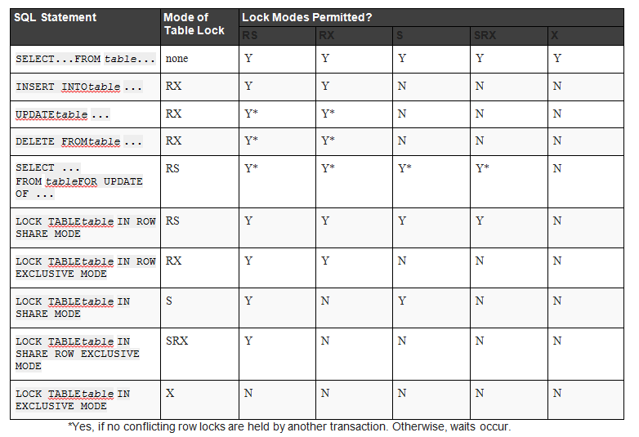](https://i.sstatic.net/fvzQ6.png)

*Since many users will follow this question so I decided to go one more step further and put my learning notes, I hope folks will be benefited from it:*

[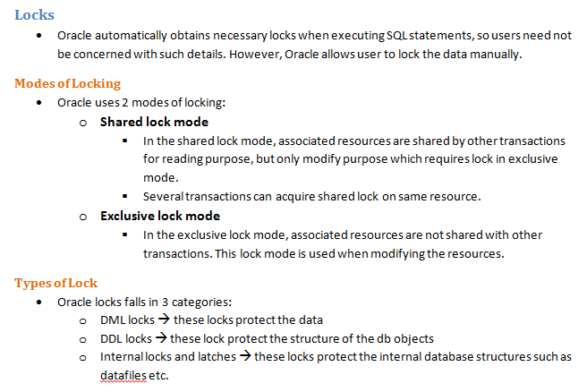](https://i.sstatic.net/K6rgk.png) [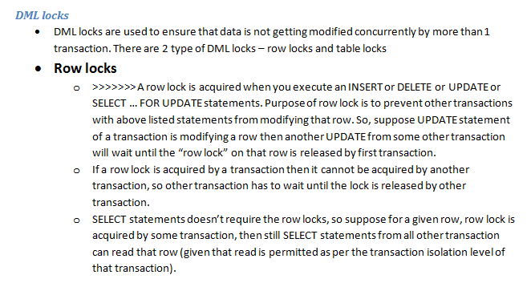](https://i.sstatic.net/L7gOj.png) [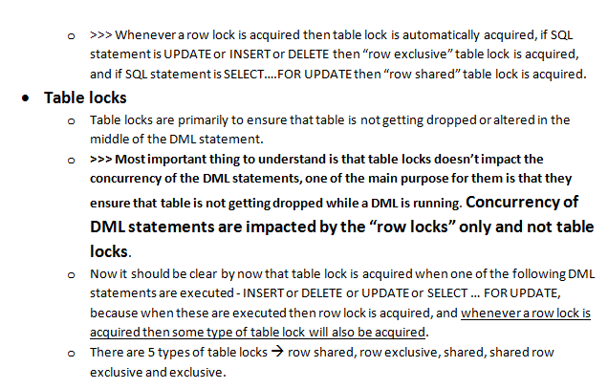](https://i.sstatic.net/dVt60.png) [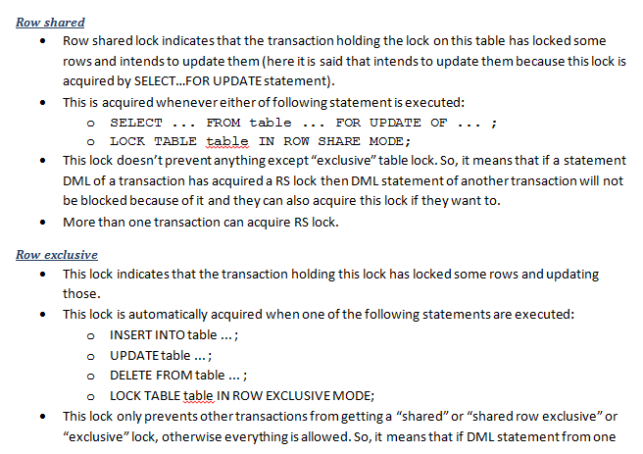](https://i.sstatic.net/cxKP1.png) [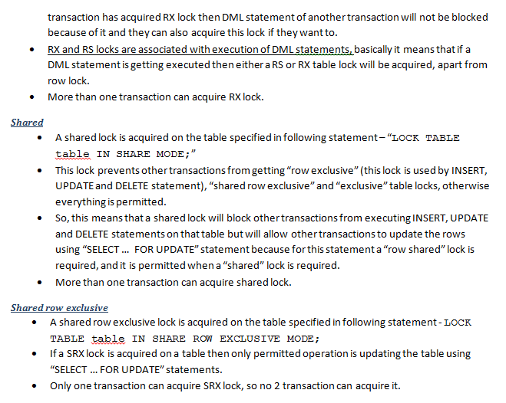](https://i.sstatic.net/dzEQn.png) [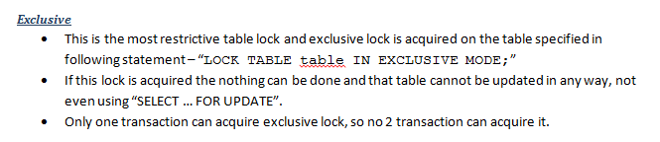](https://i.sstatic.net/qwHi3.png)