Design Document (DD)
Project Name: Loan Application Form – LoanApp
Version: 1.0
Prepared By: Krishna N
Approved By: [Stakeholder]

1. Introduction
1.1 Purpose
This Design Document describes the UI design, architecture, field-level design, validation rules, and system flow for the Loan Application Form (LoanAppBuild1).
It explains how the system will be implemented based on the BRS, SRS, and FRS.
1.2 Scope
The design covers:
- Frontend UI structure
- Field-level properties
- Validation rules
- Page layout design
- User interactions
- Error-handling workflow
Since the system is a standalone HTML/CSS/JS app, no backend architecture is included.

2. System Architecture
2.1 Architecture Type
Client-Side Architecture:
- HTML → Structure
- CSS → Styling
- JavaScript → Validation Logic & Event Handling
- Hosted on GitHub Pages (Static Hosting)
2.2 High-Level Architecture Diagram
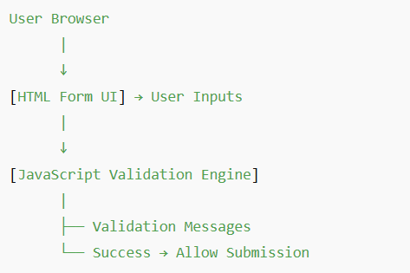
3. User Interface Design
3.1 UI Layout Structure
Page Title
Loan Application
Sections
- Header
- Mandatory Field Note
- Input Field Group
- Submit Button
Layout Overview
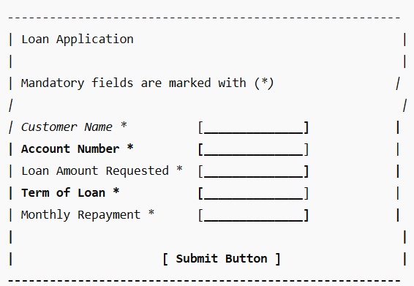
4. Field Design Details
4.1 Customer Name Field
Property | Description
Label | Customer Name *
Type | Text
Placeholder | Customer Name
Allowed Characters | A–Z, a–z, space
Min Length | 2
Max Length | 64
Error Message | “Customer Name is required”, “Only alphabets allowed”

4.2 Account Number Field
Property | Description
Label | Account Number *
Type | Numeric Textbox
Allowed | Digits only
Length | Exactly 6 digits
Special Rule | First digit ≠ 0
Error Message | “Enter valid 6-digit account number”

4.3 Loan Amount Requested Field
Property | Description
Label | Loan Amount Requested *
Type | Numeric Textbox
Allowed Range | 500–9000
Max Digits | 4
Error Message | “Loan amount must be between $500 and $9000”

4.4 Term of Loan Field
Property | Description
Label | Term of Loan *
Type | Numeric Textbox
Range | 1–30 years
Max Digits | 2
Error Message | “Term must be between 1 and 30 years”

4.5 Monthly Repayment Field
Property | Description
Label | Monthly Repayment *
Type | Numeric Text
Min Value | 10
Max Digits | 4
Error Message | “Monthly repayment must be at least $10”

5. JavaScript Validation Design
5.1 Validation Trigger
- When user clicks Submit
- Optional: Real-time validation on each field
5.2 Validation Flow
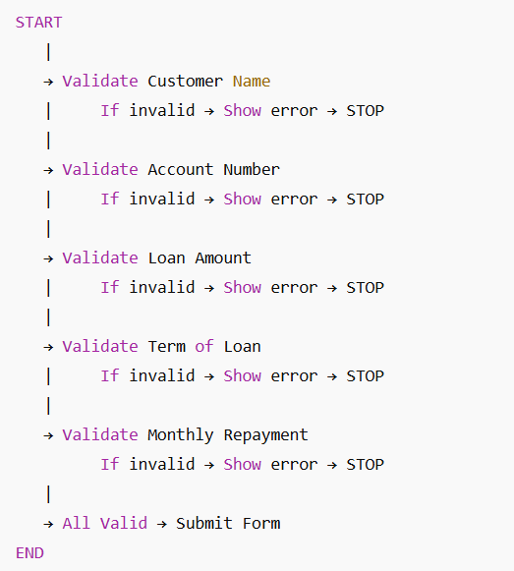
6. Error Handling Design
6.1 Error Display Rules
- Color: Red
- Font-size: Small but readable
- Location: Directly under each field
6.2 Types of Errors
- Empty field errors
- Format errors (non-numeric, invalid characters)
- Range errors (below or above limits)

7. Styling (CSS) Design
Fonts
- Header: Bold, 24px
- Field labels: 18px
- Error text: 14px red
Buttons
- Background: Blue (#4a5cff)
- Text: White
- Hover: Darker shade
Spacing
- 20px between fields
- 40px top margin for header
Responsiveness
- Full-width input fields on mobile
- Center-aligned content on desktop

8. Constraints & Limitations
- No database storage
- No API calls
- All logic is client-side
- Application resets on page refresh

9. Future Enhancements (Design Perspective)
- Add EMI formula with interest rate
- Auto-calculate Monthly Repayment instead of manual entry
- Client-side charts for repayment visualization
- Backend for storing loan applications
- Authentication module

10. Document Revision History
Version | Date | Description | Author
1.0 | [Date] | Initial Design Document Created | [Your Name]

