Question 1

void main() {

  var a = 0;

  var b = 1;

  var c;

  print(a);

  print(b);

  for (int i = 0; i < 10; i++) {

    c = a + b;

    print(c);

    a = b;

    b = c;

  }

}

o/p:

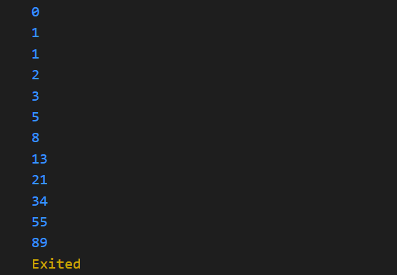

Question 2

double ftoc(int f)

{

  return (f-32) * 5/9 ;

}

double ctof(int c)

{

  return (c+9/5) + 32 ;

}

void main() {

  print("Enter temp:");

  var name = int.parse(stdin.readLineSync()!);

  print("enter 1 for celisustof and 2 for fharenheittoc");

  var c = int.parse(stdin.readLineSync()!);

  switch (c)

  {

    case 1:

        print(ctof(name));

      case 2:

          print(ftoc(name));

  }

}

o/p:

Question 3

void main() {

  for (int i = 1; i <= 5; i++) {

    for (int k = 4; k >= i; k--) {

      stdout.write(' ');

    }

    for (int j = 0; j < (2 * i) - 1; j++) {

      stdout.write('*');

    }

    print("");

  }

  for (int i = 5; i >= 1; i--) {

    for (int k = 5; k >i; k--) {

      stdout.write(' ');

    }

    for (int j = 0; j < (2 * i) - 1; j++) {

      stdout.write('*');

    }

    print("");

  }

}

o/p:

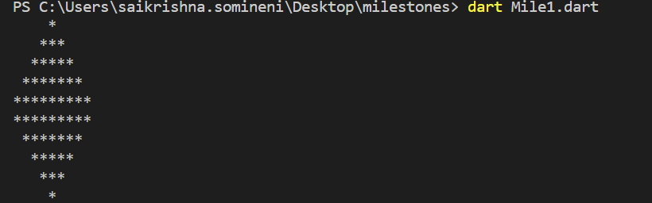

Question 4

void main() {

String? sentence = stdin.readLineSync();

var s = sentence?.split(" ");

var dict = {};

for (var i = 0; i < s!.length; i++) {

  if (dict.containsKey(s[i])) {

    dict[s[i]] += 1;

  } else {

    dict[s[i]] = 1;

  }

}

print(dict);

o/p:

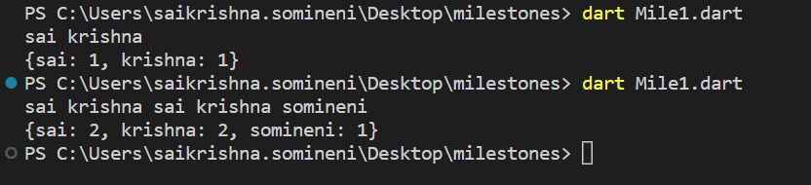

Question 5

void main() {

  var word1 = stdin.readLineSync();

  var word2 = stdin.readLineSync();

  var dict = {};

  for (var i = 0; i < word1!.length; i++) {

    if (dict.containsKey(word1[i])) {

      dict[word1[i]] += 1;

    } else {

      dict[word1[i]] = 1;

    }

  }

  var dict2 = {};

  for (var i = 0; i < word2!.length; i++) {

    if (dict2.containsKey(word2[i])) {

      dict2[word2[i]] += 1;

    } else {

      dict2[word2[i]] = 1;

    }

  }

  var sortedKeys1 = dict.keys.toList()..sort();

  var sortedKeys2 = dict.keys.toList()..sort();

  if (word1.length != word2.length) {

    print("false");

  } else {

    var flag = true;

    for (var i = 0; i < word1.length; i++) {

      if (dict[sortedKeys1[i]] != dict2[sortedKeys2[i]]) {

        print("false");

        flag = false;

        break;

      }

    }

    if (flag == true) {

      print("true");

    }

  }

o/p:

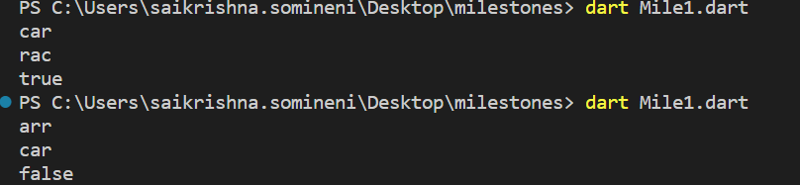

Question 6

void main(){

var dp = [

  [0, 0, 0, 0, 0, 0],

  [0, 0, 0, 0, 0, 0],

  [0, 0, 0, 0, 0, 0],

  [0, 0, 0, 0, 0, 0],

  [0, 0, 0, 0, 0, 0],

  [0, 0, 0, 0, 0, 0]

];

var X = "sadbfd";

var Y = "adbfgs";

var result = 0;

for (var i = 0; i <= 5; i++) {

  for (var j = 0; j <= 5; j++) {

    if (i == 0 || j == 0) {

      dp[i][j] = 0;

    } else if (X[i - 1] == Y[j - 1]) {

      dp[i][j] = dp[i - 1][j - 1] + 1;

      result = max(result, dp[i][j]);

    } else {

      dp[i][j] = 0;

    }

  }

}

print(result);

}

o/p:

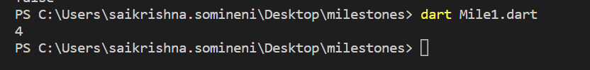

Question 7

Void main(){

  var obj = Circle();

  print(obj.getArea());

  print(obj.getCircumference());

}

class Circle {

  var radius = 5.14;

  double getArea() {

    return 3.14 * 5.14 * 5.14;

  }

   double getCircumference () {

    return 2*3.14 * 5.14 ;

  }

}}

o/p:

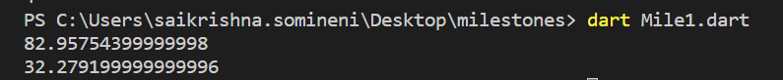

/// Question 8

class Vehicle {

  String make = "xyx";

  String model = "xxxxx";

  int year = 4440;

  void displayDetails() {

    print(make);

    print(model);

    print(year);

  }

}

class Car extends Vehicle {

  var numDoors=15;

  void displayDetails() {

    print(make);

    print(model);

    print(year);

    print(numDoors);

  }

}

class Motorcycle extends Vehicle {

  late bool hasSidecar=true;

  void displayDetails() {

    print(make);

    print(model);

    print(year);

    print(hasSidecar);

  }

}

void main() {

  var obj = Car();

  obj.displayDetails();

   var obj1 = Motorcycle();

  obj1.displayDetails();

}

o/p:

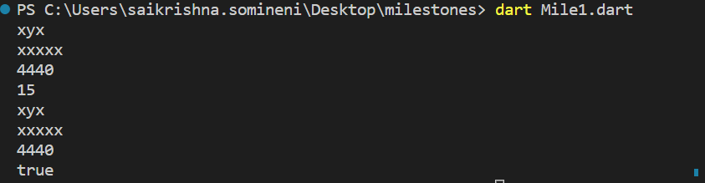

Question 9

abstract class Shape {

  double calculateArea();

}

class Circle extends Shape {

  double radius = 2.2;

  double calculateArea() {

    return 3.14 * radius * radius;

  }

}

class Rectangle extends Shape {

  double length = 2.2;

  double width = 2.2;

  double calculateArea() {

    return length * width;

  }

}

class Triangle extends Shape {

  double basee = 2.2;

  double height = 2.2;

  double calculateArea() {

    return (basee * height) / 2;

  }

}

void main() {

  var obj = Rectangle();

 print( obj.calculateArea());

  var obj1 = Circle();

 print( obj1.calculateArea());

  var obj2 = Triangle();

 print( obj2.calculateArea());

}

o/p:

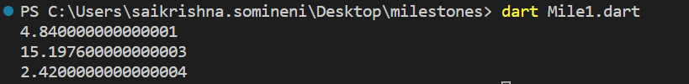

//Question 10

class AudioPlayer{

double volume=0;

 bool isplaying=false;

 AudioPlayer(this.volume,this.isplaying);

  void play(){

 print('music is played');

 }

void stop(){

 print('music is stopped');

}

void pause(){

 print('music is paused');

 }

}

class Visualizer{

 void visualizeAudio(){

 }

}

class Equalizer{

 adjustEqualizer(){

 }

}

class MusicPlayer extends AudioPlayer implements Visualizer,Equalizer{

 MusicPlayer(super.volume, super.isplaying);

void playMusic(){

play();

}

 void stopMusic(){

stop();

 }

 void adujustAudio(){

 adjustEqualizer();

}

 void showVisualization(){

visualizeAudio();

}

@override

adjustEqualizer() {

print('adjusting Audio Equalizer settings ');

}

 @override

 void visualizeAudio() {

print('Audio is being visualized');

 }

}

Question 11

void main() {

  var bdy = stdin.readLineSync();

  var split = bdy?.split("-");

  var bdyMonth = int.parse(split![1]);

  var bdyDat = int.parse(split[0]);

  final birthday = DateTime(2023, bdyMonth , bdyDat);

  final date2 = DateTime.now();

  final difference = date2.difference(birthday).inDays.abs();

  print(difference);

}

o/p:

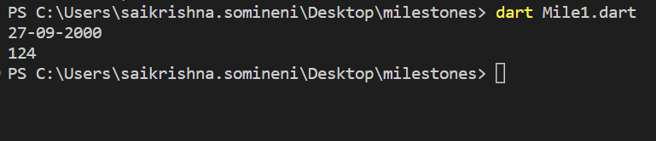

///////Question 12

import 'dart:io';

main() async {

  final request = await HttpClient().getUrl(Uri.parse('https://en.wikipedia.org/wiki/Constitution_of_India'));

  final response = await request.close();

  response.pipe(File('content.txt').openWrite());

}