Sir,

We are a part of the internship team from LBSITW, Trivandrum.Our project topic is Household Water Monitoring System.

We are trying to develop a water monitoring system which checks both quality as well as quantity of water of a house.So for checking the quality,we are using a coagulation sensor using IR transreceiver.We are attaching the circuit diagram of the mentioned sensor.So for this circuit,we think we can make a pcb using fablab facility.
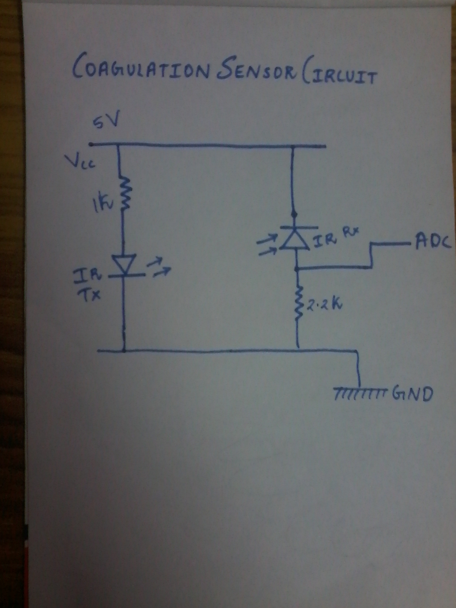

Yours sincerely
Team members
Karthi.G,Krishnapriya.S,Sowmya.K

