Warehouse Slotting Optimizer
Project Report submitted for the partial fulfilment of grade for the course

Data Structures and Algorithms -3 (25CS2103E)
in

A.Y. 2026-2027

Submitted by
Ramya-2520090213
Krishnasree-2520080009

Team Number: 32
Section: 12

Under the guidance of

Ms.K.Chandusha

Asst.Prof., CS&IT

Hyderabad-500090, Telangana, India.

K L (Deemed to be) University
DEPARTMENT OF COMPUTER SCIENCE ENGINEERING / COMPUTER SCIENCE AND INFORMATION TECHNOLOGY/ARTIFICIAL INTELLIGENCE & DATA SCIENCE



DECLARATION

The Mini Project Report entitled Warehouse Slotting Optimizer is a record of Bonafide work of Ramya-2520090213,KrishnaSree-2520080009 submitted in partial fulfillment for the award of B. Tech in Computer Science and Engineering/Computer Science and Information Technology/ Artifical Intelligence & data Science to the K L University. The results embodied in this report have not been copied from any other departments/University/Institute.
Ramya-2520090213
KrishnaSree-2520080009

K L (Deemed to be) University
DEPARTMENT OF COMPUTER SCIENCE ENGINEERING / COMPUTER SCIENCE AND INFORMATION TECHNOLOGY
CERTIFICATE

This is to certify that the mini project based report entitled Warehouse Slotting Optimizer is a bonafide work done and submitted by Ramya-2520090213,KrishnaSree-2520080009 in partial fulfillment of the requirements for the award of the degree of BACHELOR OF TECHNOLOGY in Department of Computer Science Engineering/ Computer Science and Information Technology/Artificial Intelligence & Data Science, K L (Deemed to be University), during the academic year 2026-2027.

Signature of the Supervisor

Signature of the HOD Signature of the External Examiner

ACKNOWLEDGEMENT

The success in this project would not have been possible but for the timely help and guidance rendered by many people. Our wish to express my sincere thanks to all those who has assisted us in one way or the other for the completion of my project.

Our greatest appreciation to my guide, Ms.K.Chandusha, Asst.Prof, CSIT which cannot be expressed in words for his/her tremendous support, encouragement and guidance for this project.

We express our gratitude to Dr. P.Venkateshwar Rao (CSE)/Dr. Khaja Shareef (CSIT)/ Dr. Sreenath Itikela (AI&DS), Head of the Department for Computer Science Engineering/ Department for Computer Science and Information Technology/Department of Artificial Intelligence and Data Science for providing us with adequate facilities, ways and means by which we are able to complete this project-based Lab.

We thank all the members of teaching and non-teaching staff members, and also who have assisted me directly or indirectly for successful completion of this project. Finally, I sincerely thank my parents, friends and classmates for their kind help and cooperation during my work.

Ramya-2520090213
KrishnaSree-2520080009

TABLE OF CONTENTS

S.No. | Contents | Page no.
1. | Abstract | 6
2. | Introduction | 7
3. | Literature survey | 8
4. | Problem Statement and Objectives | 10
5. | Hardware and Software requirements | 11
6. | Implementation | 12
7. | Results & Discussion | 14
8. | Conclusion & Future Scope | 18
9. | References | 19

1.ABSTRACT

The Warehouse Slotting Optimizer is a project designed to improve the efficiency of product placement inside a warehouse. In traditional warehouse systems, products may be stored without considering their demand frequency, size, weight, or distance from the dispatch area. This can increase picking time, worker movement, and operational costs.
The proposed system aims to assign suitable storage locations to products based on their characteristics and picking frequency. Frequently picked products can be placed closer to the dispatch area, while less frequently picked products can be stored in comparatively distant locations. Data Structures and Algorithms (DSA) are used to organize product information, manage storage slots, and support efficient slot assignment.
The system considers factors such as product demand, storage capacity, and slot availability to improve warehouse space utilization. Suitable algorithms can be used to rank products and recommend storage locations. The main objective is to reduce unnecessary movement, minimize product retrieval time, and improve the overall efficiency of warehouse operations.
This project demonstrates how computational techniques and optimization strategies can solve practical warehouse management problems. The proposed system can serve as a foundation for more advanced warehouse management solutions that incorporate real-time inventory tracking, automated slot assignment, and demand forecasting.

Team Members:
- [Ramya,2520090213]
- [KrishnaSree,2520080009]

- INTRODUCTION

Warehousing plays an important role in supply chain management by storing products and making them available for dispatch when required. The arrangement of products inside a warehouse directly affects order-picking time, worker movement, and space utilization.
Warehouse slotting is the process of assigning products to appropriate storage locations. Inefficient slotting can lead to longer picking routes, increased labor effort, and poor utilization of available storage space.
The Warehouse Slotting Optimizer aims to improve product placement by considering demand frequency, product size, weight, storage requirements, and slot availability. Frequently picked products are prioritized for locations closer to the dispatch area, helping reduce unnecessary movement.
Data Structures and Algorithms are used to manage product records, organize storage slots, rank products by priority, and recommend suitable locations. The project focuses on developing an efficient and systematic approach to warehouse slot assignment, with the goal of reducing retrieval time and improving overall warehouse productivity.

- LITERATURE SURVEY

3.1 Warehouse Management Optimization Using a Sorting-Based Slotting Approach
This research proposes a method for assigning products to warehouse storage locations based on product characteristics and demand. It uses optimization techniques to determine efficient storage arrangements. The study considers warehouse layout and product priorities while evaluating picking time. It is closely related to our project because it demonstrates how sorting and slot assignment can improve warehouse efficiency.
URL: https://www.jiem.org/index.php/jiem/article/view/5661/0
3.2 Warehouse Slotting Optimization Software – Lucas Systems
Lucas Systems provides dynamic slotting software that helps warehouses improve product placement and picking productivity. Its approach considers changing warehouse conditions and product movement. It aims to reduce manual slotting effort and improve space utilization. Our project follows a similar objective by recommending suitable storage locations based on product demand.
URL: https://www.lucasware.com/slotting/
3.3 Slot3D Warehouse Slotting Optimization
Slot3D is a warehouse slotting optimization platform that focuses on product placement, warehouse visualization, and operational efficiency. It helps warehouse operators evaluate slotting plans and reduce unnecessary travel. The platform demonstrates the importance of choosing appropriate storage locations. Our project applies the same general principle through a DSA-based slot assignment approach.
URL: https://www.slot3d.com/
3.4 The Deterministic Product Location Problem Under a Pick-by-Order Policy
This research studies how products can be assigned to warehouse locations to reduce picking effort. It analyzes storage assignment decisions and their effect on order retrieval. The study also discusses the computational difficulty of finding optimal assignments. It provides a theoretical foundation for developing efficient product placement algorithms.
URL: https://doi.org/10.1016/j.dam.2013.07.002
3.5 A Faster Optimal Model Slotting in Rack Positions with Mono SKU Pallet
This research presents a mathematical model for assigning products to warehouse rack positions. It considers product turnover, storage levels, and product weight. Frequently moving products are placed closer to dispatch, while heavy products are assigned to suitable lower positions. These ideas are relevant to our project because product demand and physical characteristics influence slot assignment.
URL: https://doi.org/10.1016/j.procs.2022.07.084
3.6 Integrating Storage Location and Order Picking Problems in Warehouse Planning
This study combines storage location assignment with order-picking decisions. It explains how product placement and picking routes influence one another. Optimization algorithms are used to improve warehouse operations. Our project similarly aims to assign products to suitable locations to reduce retrieval effort.
URL: https://doi.org/10.1016/j.tre.2020.102003
3.7 Optimization of Storage Allocation in Order Picking Operations Through a Genetic Algorithm
This research uses a genetic algorithm to optimize product allocation in warehouses. It considers customer orders and product storage positions to reduce picking travel distance. The study illustrates how optimization algorithms can improve warehouse productivity. Our project shares the objective of finding better product locations using computational methods.
URL: https://doi.org/10.1080/13675567.2012.694860
3.8 Design and Control of Warehouse Order Picking: A Literature Review
This review examines warehouse order-picking methods, storage assignment, routing, and warehouse layout. It explains how these decisions affect labor requirements and operating efficiency. The study identifies several opportunities for improving warehouse operations through better planning. It provides useful background for understanding the need for warehouse slotting optimization.
URL: https://doi.org/10.1016/j.ejor.2006.07.009

- Problem Statement and Objectives

Problem Statement:
Inefficient product placement in warehouses increases order-picking time, worker movement, and storage management effort.

Problem Description:
Products stored without considering demand frequency, size, weight, and distance from the dispatch area can cause unnecessary movement and delays. An efficient slotting system is required to recommend suitable storage locations and improve warehouse productivity.

Objectives:
- To develop an efficient system for assigning products to suitable warehouse storage slots.
- To prioritize frequently picked products for locations closer to the dispatch area.
- To consider product demand, size, weight, storage requirements, and slot availability.
- To apply Data Structures and Algorithms for efficient product management and slot assignment.
- To reduce unnecessary worker movement and product retrieval time.
- To improve the utilization of available warehouse storage space.
.

- HARDWARE AND SOFTWARE REQUIREMENTS

Hardware Requirements:
- Processor: Intel Core i3 or equivalent and above.
- RAM: Minimum 4 GB; 8 GB recommended.
- Storage: Minimum 500 MB of free space for project files and data.
- Input/Output Devices: Keyboard, mouse, and monitor.

Software Requirements:
- Operating System: Windows 10/11 or Linux.
- Programming Language: Python.
- Code Editor: Visual Studio Code.
- Libraries: Python standard libraries; additional libraries if required by the implementation.
- Data Storage: CSV files or SQLite database, depending on the implementation.
- Browser: Google Chrome or Microsoft Edge, if a web interface is developed.

- IMPLEMENTATION
<!DOCTYPE html>
<html lang="en">
<head>
<meta charset="UTF-8">
<meta name="viewport" content="width=device-width, initial-scale=1.0">
<title>SlotMind â€” Warehouse Slotting Optimizer</title>
<style>
@import url('https://fonts.googleapis.com/css2?family=DM+Mono:wght@400;500&family=Manrope:wght@400;500;600;700;800&display=swap');
:root{
--bg:#080b10; --panel:#10151d; --panel2:#141b24; --line:#26303d;
--text:#eef3f8; --muted:#8793a3; --cyan:#55e6c1; --blue:#70a7ff;
--amber:#ffcb70; --red:#ff7272; --shadow:0 20px 60px rgba(0,0,0,.28);
}
*{box-sizing:border-box} body{margin:0;background:radial-gradient(circle at 80% -10%,#17302c 0,transparent 32%),var(--bg);color:var(--text);font-family:Manrope,Arial,sans-serif}
button,input,select{font:inherit}.app{display:flex;min-height:100vh}
.sidebar{width:250px;border-right:1px solid var(--line);padding:25px 18px;position:fixed;height:100vh;background:rgba(8,11,16,.92);backdrop-filter:blur(18px);z-index:5}
.brand{display:flex;gap:11px;align-items:center;margin-bottom:42px}.logo{width:40px;height:40px;border:1px solid #36584f;border-radius:12px;display:grid;place-items:center;background:#10211d;font-weight:800;color:var(--cyan)}
.brand b{font-size:17px}.brand small{display:block;color:var(--muted);font-size:10px;letter-spacing:1.5px}
.nav{display:grid;gap:7px}.nav button{border:0;background:transparent;color:#9ba7b7;text-align:left;padding:12px 13px;border-radius:10px;cursor:pointer;display:flex;gap:11px;align-items:center}.nav button.active,.nav button:hover{background:#151e27;color:#fff}.nav i{font-style:normal;width:20px}
.side-bottom{position:absolute;bottom:24px;left:18px;right:18px;border-top:1px solid var(--line);padding-top:18px;color:var(--muted);font-size:11px;line-height:1.6}
main{margin-left:250px;width:calc(100% - 250px);padding:30px 34px 60px}
.top{display:flex;justify-content:space-between;align-items:center;margin-bottom:28px}.eyebrow{font-family:"DM Mono";font-size:11px;color:var(--cyan);letter-spacing:2px}.top h1{font-size:30px;margin:5px 0}.top p{margin:0;color:var(--muted);font-size:13px}.status{border:1px solid #315448;background:#0d1d19;color:var(--cyan);padding:8px 12px;border-radius:30px;font-size:11px}
.hero{display:grid;grid-template-columns:1.55fr .8fr;gap:18px;margin-bottom:18px}
.card{background:linear-gradient(145deg,rgba(19,26,35,.94),rgba(12,17,23,.94));border:1px solid var(--line);border-radius:18px;box-shadow:var(--shadow)}
.hero-card{padding:27px;min-height:260px;position:relative;overflow:hidden}.hero-card:after{content:"";position:absolute;width:260px;height:260px;border-radius:50%;right:-80px;bottom:-120px;border:1px solid #254a43;box-shadow:0 0 0 35px rgba(85,230,193,.025),0 0 0 70px rgba(85,230,193,.018)}
.hero-card h2{font-size:34px;line-height:1.1;margin:10px 0 13px;max-width:600px}.hero-card p{color:var(--muted);max-width:620px;line-height:1.7;font-size:13px}.actions{display:flex;gap:10px;margin-top:22px}.btn{border:1px solid var(--line);background:#171f28;color:#fff;border-radius:10px;padding:11px 16px;cursor:pointer;font-weight:700;font-size:12px}.btn.primary{background:var(--cyan);color:#06110e;border-color:var(--cyan)}.btn:hover{transform:translateY(-1px)}
.score{padding:25px;display:flex;flex-direction:column;justify-content:space-between}.score-head{display:flex;justify-content:space-between;color:var(--muted);font-size:12px}.ring{width:150px;height:150px;border-radius:50%;margin:8px auto 0;background:conic-gradient(var(--cyan) 0 74%,#24302d 74% 100%);display:grid;place-items:center}.ring:before{content:"";width:112px;height:112px;border-radius:50%;background:#0e141b;position:absolute}.ring span{position:relative;font-size:31px;font-weight:800}.score small{color:var(--muted);text-align:center}
.metrics{display:grid;grid-template-columns:repeat(4,1fr);gap:14px;margin-bottom:18px}.metric{padding:18px}.metric .label{font-size:11px;color:var(--muted);text-transform:uppercase;letter-spacing:1px}.metric strong{font-size:25px;display:block;margin:9px 0 3px}.good{color:var(--cyan)}.warn{color:var(--amber)}.metric small{color:#6f7b89;font-size:11px}
.grid{display:grid;grid-template-columns:1.15fr .85fr;gap:18px}.panel{padding:20px}.panel-head{display:flex;justify-content:space-between;align-items:center;margin-bottom:17px}.panel-head h3{margin:0;font-size:15px}.panel-head span{font-size:11px;color:var(--muted)}

7.RESULTS & DISCUSSION

1. Overview Page
This page displays the overall warehouse performance, current and projected picking distance, and travel distance saved through optimization. It also shows the warehouse map and the top products frequently picked together.
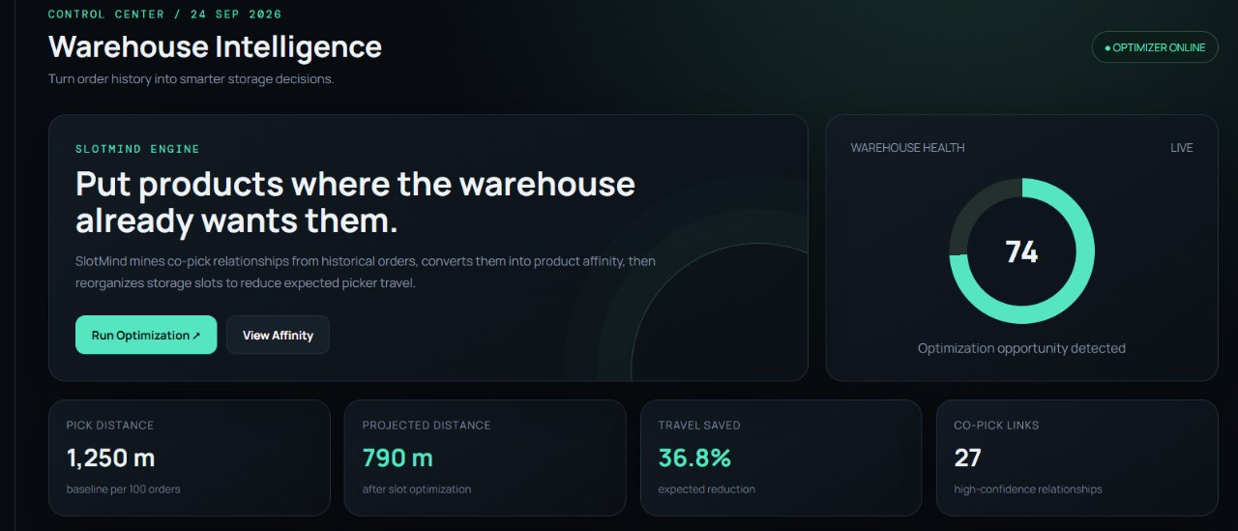
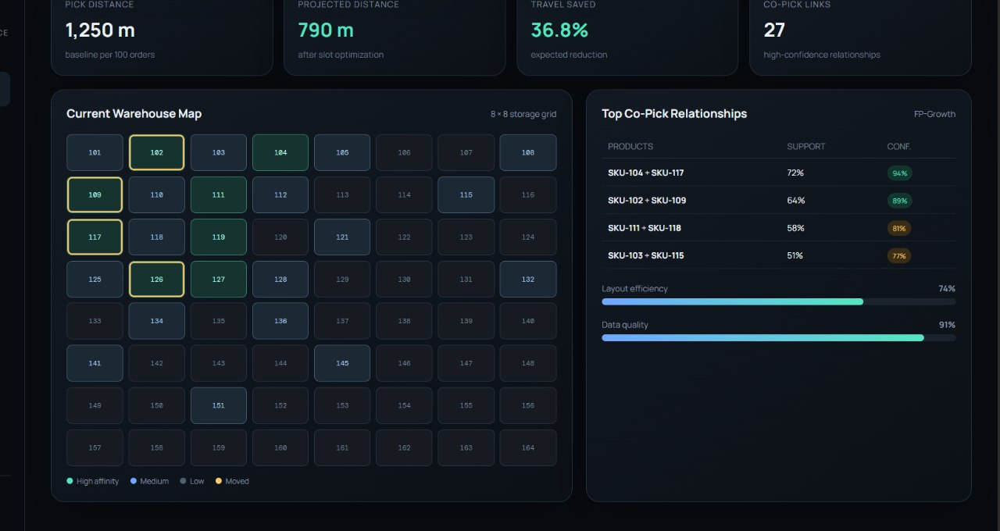

2. Slot Layout Page
This page displays an interactive warehouse grid containing different product storage slots. By clicking a slot, we can view the product ID, demand, and affinity score to understand its placement.

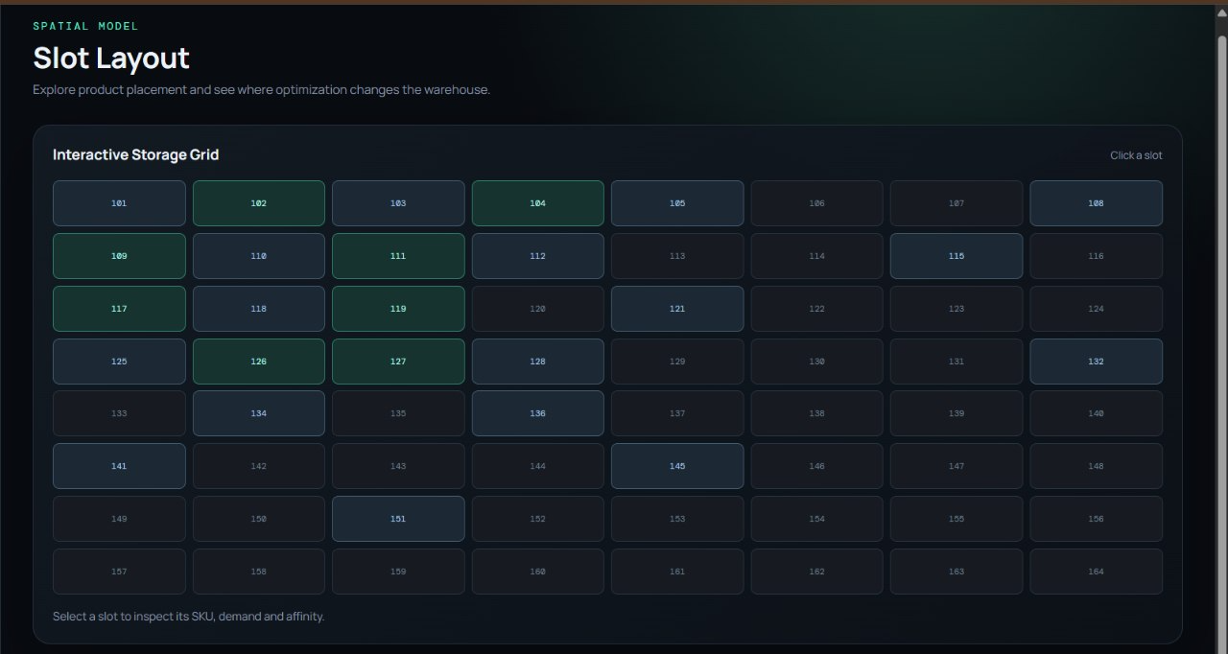
3. Affinity Engine Page
This page shows the relationships between products based on how frequently they are picked together. It uses frequent itemset mining techniques such as FP-Growth or Apriori to identify related products and help place them closer to each other.

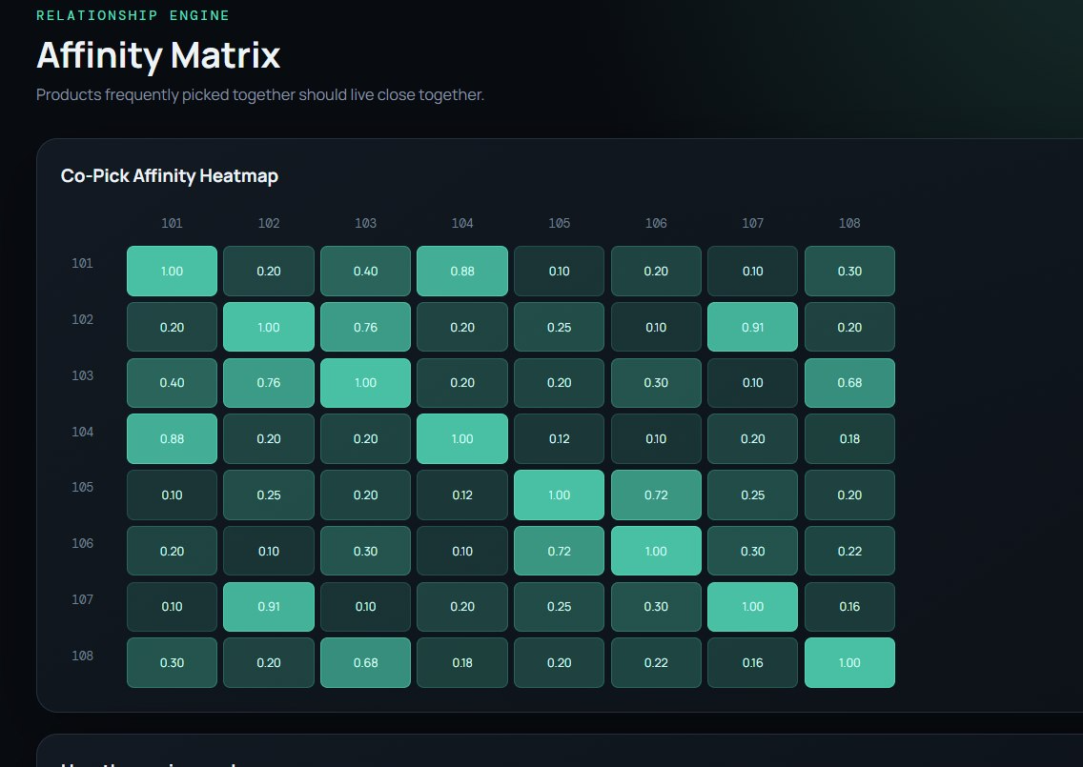

4. Optimization Simulator Page
This page allows users to change the order volume and optimization strength to estimate the impact on warehouse performance. It displays the calculated results and optimization events to demonstrate how product rearrangement can reduce picking distance.

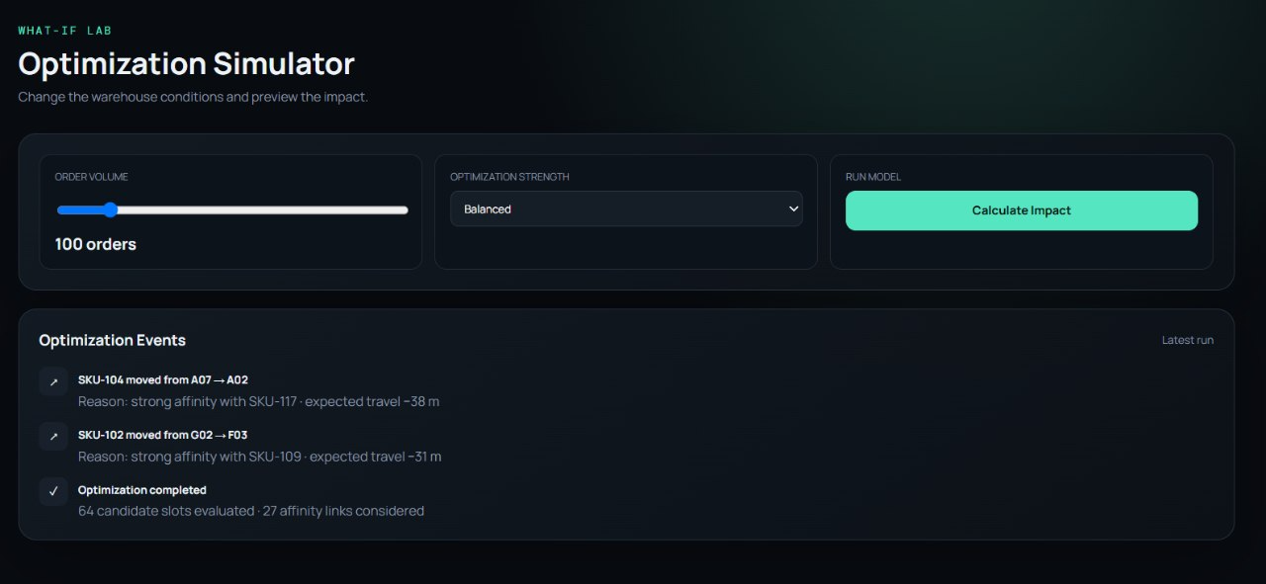

- CONCLUSION & FUTURE SCOPE
Conclusion
The Warehouse Slotting Optimizer aims to improve warehouse efficiency by assigning products to suitable storage locations. It considers factors such as product demand, size, weight, and slot availability to support systematic product placement. Data Structures and Algorithms help organize product information and perform product prioritization and slot assignment. The project focuses on reducing unnecessary worker movement, improving product retrieval efficiency, and utilizing warehouse space effectively. It demonstrates the practical application of DSA concepts to a real-world warehouse management problem.
Future Scope
In the future, the Warehouse Slotting Optimizer can be enhanced by integrating real-time inventory tracking using barcode scanners or RFID technology. Advanced optimization algorithms can be implemented to improve product placement and minimize picking distance. Machine learning techniques can be used to predict product demand based on historical data and dynamically update storage locations. A graphical warehouse layout can be developed to visualize product positions and available storage slots. The system can also support dynamic slot reassignment based on changes in demand, product availability, and warehouse conditions. These enhancements can help improve warehouse space utilization, reduce retrieval time, and increase overall operational efficiency.

- REFERENCES
1Duque-Jaramillo et al., Warehouse Management Optimization Using a Sorting-Based Slotting Approach. https://www.jiem.org/index.php/jiem/article/view/5661/0
2.Lucas Systems, Warehouse Slotting Optimization Software. https://www.lucasware.com/slotting/
3.Slot3D, Warehouse Slotting Optimization Software. https://www.slot3d.com/
4.Boysen and Stephan, The Deterministic Product Location Problem Under a Pick-by-Order Policy. https://doi.org/10.1016/j.dam.2013.07.002
5.A Faster Optimal Model Slotting in Rack Positions with Mono SKU Pallet. https://doi.org/10.1016/j.procs.2022.07.084
6.Silva et al., Integrating Storage Location and Order Picking Problems in Warehouse Planning. https://doi.org/10.1016/j.tre.2020.102003
7.Bottani et al., Optimisation of Storage Allocation in Order Picking Operations Through a Genetic Algorithm. https://doi.org/10.1080/13675567.2012.694860
8’de Koster et al., Design and Control of Warehouse Order Picking: A Literature Review. https://doi.org/10.1016/j.ejor.2006.07.009
9.Solving Location Assignment and Order Picker-Routing Problems in Warehouse Management. https://www.mdpi.com/2075-1680/12/7/711
10.Mantel et al., Order Oriented Slotting: A New Assignment Strategy for Warehouses. https://www.researchgate.net/publication/5171307_Order_oriented_slotting_A_new_assignment_strategy_for_warehouses

