**EXPERIMENT 1**

**Aim:** Write HTML code to display the following table with some data.

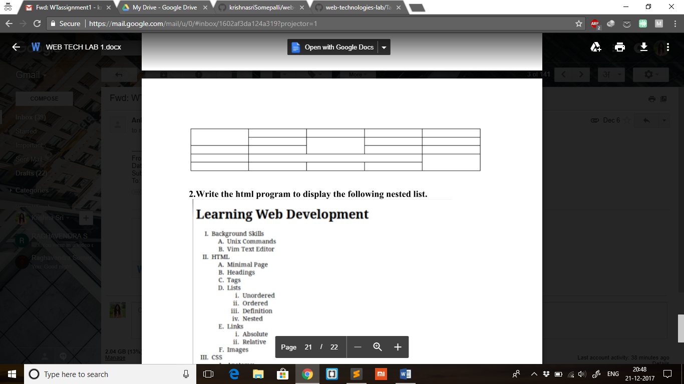

**Description:** A table is one of the most useful HTML constructs. Tables can be found over several web applications. The main use of a table is that they are used to structure pieces of information and even the whole web page. A table is defined as follows:

<table align=”center” | “left” | “right” border=”n” width=”n%” cellpadding=”n” cellspacing=”n”>…</table>

Everything that we write between these two tags will be within a table. The attributes of the table control the formatting of the table. Cell padding determines the space between the contents of a cell and its border. Cell spacing sets the amount of white space between cells. Width attribute sets the horizontal amount of screen that the table will use.

<tr> is used to define a row with a table and including a <td> tag (or a <th> tag for table headers) in the <tr> tag will give you a cell inside this row.

**Program:**

|  |
| --- |
|  |
|  | <html> |
|  | <head> |
|  | <title>Tables</title> |
|  | </head> |
|  | <body> |
|  | <table border='1' cellspacing='0' width=50%> |
|  | <tr border='2' align='center' valign='middle'> |
|  | <td rowspan='2'>Foo</td> |
|  | <td>Foo</td> |
|  | <td>Foo</td> |
|  | <td>Foo</td> |
|  | <td>Foo</td> |
|  | </tr> |
|  | <tr border='2' align='center' valign='middle'> |
|  | <td>Foo</td> |
|  | <td rowspan='2'>Foo</td> |
|  | <td>Foo</td> |
|  | <td>Foo</td> |
|  | </tr> |
|  | <tr border='2' align='center'> |
|  | <td>Foo</td> |
|  | <td>Foo</td> |
|  | <td>Foo</td> |
|  | <td>Foo</td> |
|  | </tr> |
|  | <tr border='2' align='center' valign='middle'> |
|  | <td>Foo</td> |
|  | <td colspan='3'>Foo</td> |
|  | <td rowspan='2'>Foo</td> |
|  | </tr> |
|  | <tr border='2' align='center'> |
|  | <td>Foo</td> |
|  | <td>Foo</td> |
|  | <td>Foo</td> |
|  | <td>Foo</td> |
|  | </tr> |
|  | </table> |
|  | </body> |
|  | </html> |

**Output:**

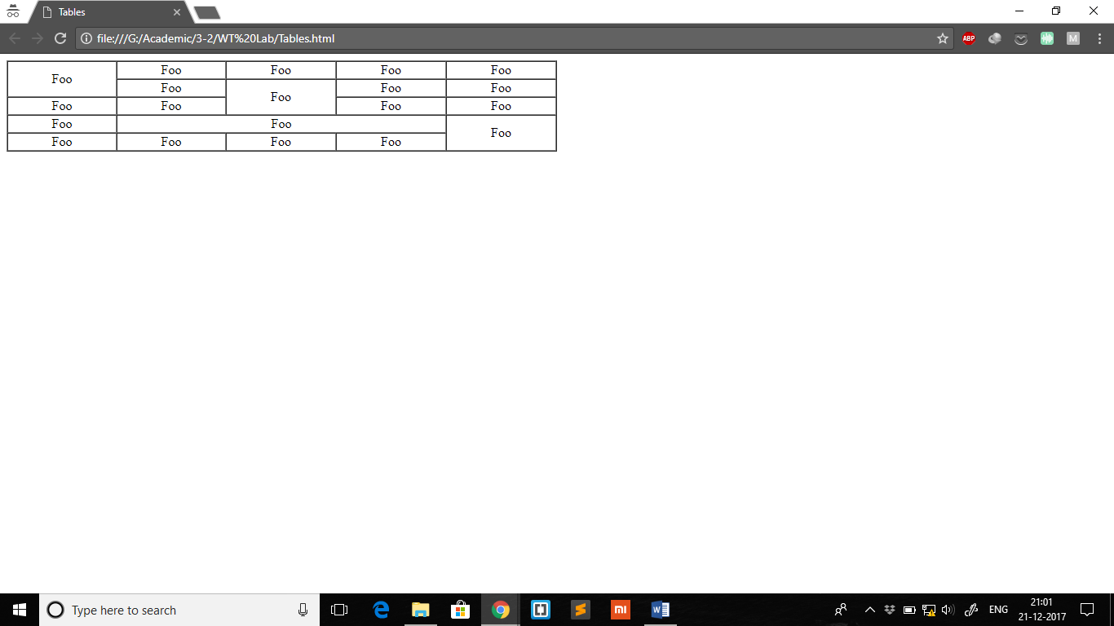

**EXPERIMENT 2**

**Aim:** Write HTML code to display the following nested list.

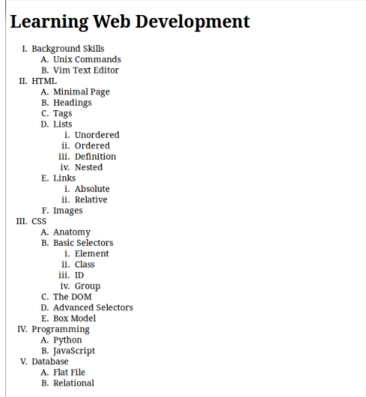

**Description:** One of the most effective ways of structuring a web site is to use lists. Lists provide straight forward index in the web site. HTML provides three types of lists:

1. Ordered List (Numbered List)
2. Unordered List (Bulleted List)
3. Definition List (dl)

Lists can be easily embedded easily in another list to provide complex but readable structures. The different tags used in lists are:

<ol> to define an ordered list.

<ul> to define an unordered list.

<li> to define a list item in any kind of list.

The content in an <li> tag can be a piece of text or even HTML code.

**Program:**

|  |
| --- |
|  |
|  | <html> |
|  | <head> |
|  | <title>Nested List</title> |
|  | </head> |
|  | <body> |
|  | <h2>Learning Web Development</h2> |
|  | <ol type='I'> |
|  | <li>Background Skills |
|  | <ol type='A'> |
|  | <li>Unix Commands</li> |
|  | <li>Vim Text Editor</li> |
|  | </ol> |
|  | </li> |
|  | <li>HTML |
|  | <ol type='A'> |
|  | <li>Minimal Page</li> |
|  | <li>Headings</li> |
|  | <li>Tags</li> |
|  | <li>Lists |
|  | <ol type='i'> |
|  | <li>Unordered</li> |
|  | <li>Ordered</li> |
|  | <li>Definition</li> |
|  | <li>Nested</li> |
|  | </ol> |
|  | </li> |
|  | <li>Links |
|  | <ol type='i'> |
|  | <li>Absolute</li> |
|  | <li>Relative</li> |
|  | </ol> |
|  | </li> |
|  | <li>Images</li> |
|  | </ol></li> |
|  | <li>CSS |
|  | <ol type='A'> |
|  | <li>Anatomy</li> |
|  | <li>Basic Selectors |
|  | <ol type='i'> |
|  | <li>Element</li> |
|  | <li>Class</li> |
|  | <li>ID</li> |
|  | <li>Group</li> |
|  | </ol> |
|  | </li> |
|  | <li>The DOM</li> |
|  | <li>Advanced Selectors</li> |
|  | <li>Box Model</li> |
|  | </ol> |
|  | </li> |
|  | <li>Programming |
|  | <ol type='A'> |
|  | <li>Python</li> |
|  | <li>JavaScript</li> |
|  | </ol> |
|  | </li> |
|  | <li>Database |
|  | <ol type='A'> |
|  | <li>Flat File</li> |
|  | <li>Relational</li> |
|  | </ol></li> |
|  | </ol> |
|  | </body> |
|  | </html> |

**Output:**

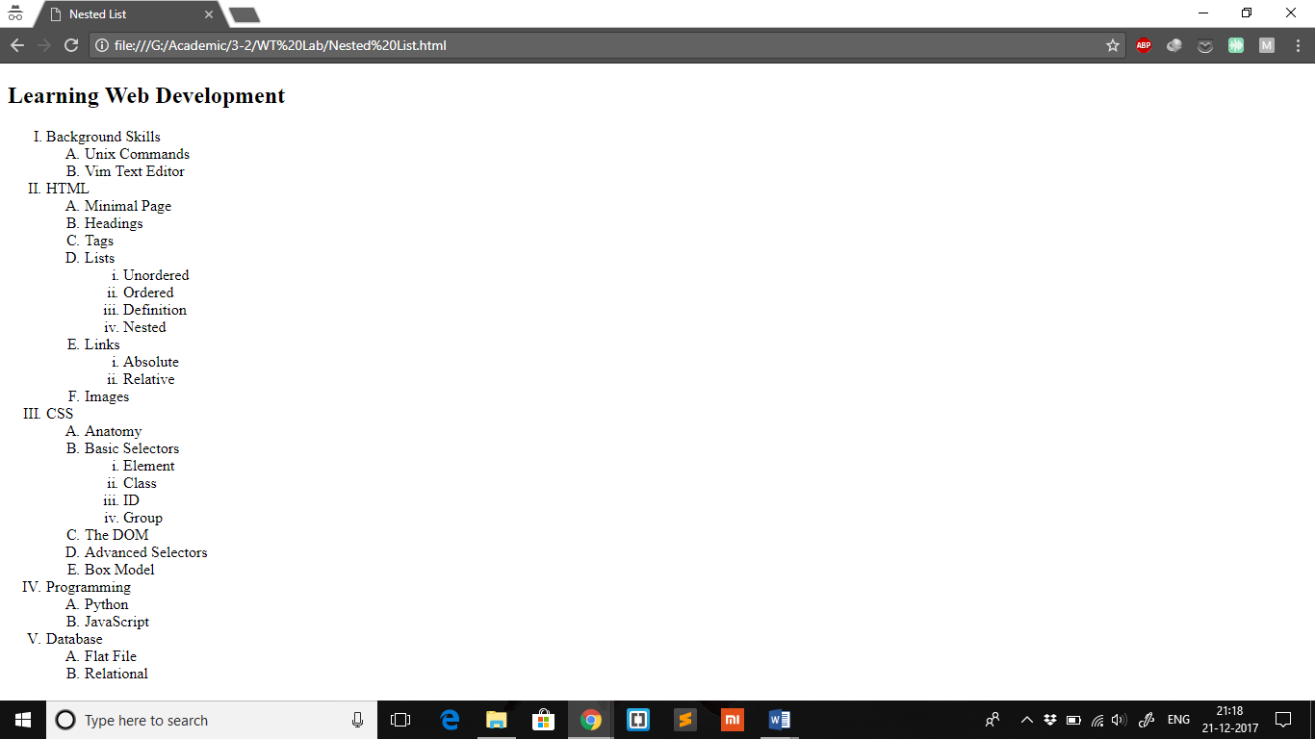

**EXPERIMENT 3**

**Aim:** Write HTML code to prepare your Curriculum Vitae.

**Description:** The CV has been prepared by implementing a HTML table with two columns. This has been done to achieve responsiveness and also to make structuring the page easy.

**Program:**

|  |
| --- |
| <html> |
|  | <head> |
|  | <title>Curriculum Vitae</title> |
|  | </head> |
|  | <body bgcolor=#EEEEEE> |
|  | <table cellspacing='0' cellpadding='40' width=75%> |
|  | <tr valign='top'> |
|  | <td width='20%'></td> |
|  | <td bgcolor=#243346> |
|  | <br/><br/><br/> |
|  | <font face='verdana' size='5' color=#D0A14F>KRISHNA SRI SOMEPALLI<br/></font> |
|  | <br/><br/><br/> |
|  | <font face='verdana' size='4' color=#D0A14F>CONTACT<br/></font> |
|  | <font face='verdana' size='2' color=#FFFFFF>9876543210<br/></font> |
|  | <font face='verdana' size='2' color=#FFFFFF>foo.bar@gmail.com<br/></font> |
|  | </td> |
|  | <td bgcolor=#FFFFFF> |
|  | <font face='verdana' size='4' color=#D0A14F>EDUCATION<br/></font> |
|  | <font face='verdana' size='2'><strong>Bachelor of Engineering, Computer Science and Engineering</strong><br/></font> |
|  | <font face='verdana' size='2'>Chaitanya Bharathi Institute of Technology | 2015-19<br/></font> |
|  | <font face='verdana' size='2'><strong>Senior Secondary</strong><br/></font> |
|  | <font face='verdana' size='2'>Narayana Junior College | 2013-15<br/></font> |
|  | <font face='verdana' size='2'><strong>Secondary</strong><br/></font> |
|  | <font face='verdana' size='2'>Johnson Grammar School | 2013<br/></font> |
|  | <br/> |
|  | <font face='verdana' size='4' color=#D0A14F>EXPERIENCE<br/></font> |
|  | <font face='verdana' size='2'><strong>Software Engineering Intern</strong><br/></font> |
|  | <font face='verdana' size='2'>Microsoft India Development Center, Gachibowli | 2017<br/></font> |
|  | <br/> |
|  | <font face='verdana' size='4' color=#D0A14F>ACTIVITIES<br/></font> |
|  | <font face='verdana' size='2'>Organized Kodecrypt, a coding event held during SUDHEE, the annual technical fest of our college<br/></font> |
|  | <font face='verdana' size='2'>Volunteered during SUDHEE<br/></font> |
|  | <font face='verdana' size='2'>Content Development for CodeByExamples, an online startup<br/></font> |
|  | <font face='verdana' size='2'>Content writing internship (virtual) with The Under18, an NPO<br/></font> |
|  | <font face='verdana' size='2'>Contributed articles to Binary and Celeritas, respectively the technical and literary magazines of our college<br/></font> |
|  | <br/> |
|  | <font face='verdana' size='4' color=#D0A14F>PROJECTS<br/></font> |
|  | <font face='verdana' size='2'>Worked in a team of 4, on a ReactJS based open source project, to develop the UI for a tool on the web portal for the Kaizala app as part of the internship at Microsoft.<br/></font> |
|  | <font face='verdana' size='2'>Developed an online file encryption tool using HTML5, CSS3 and JavaScript(AES algorithm)<br/></font> |
|  | <font face='verdana' size='2'>Built the classic 6x6 and 9x9 Sudoku from scratch using C<br/></font> |
|  | <br/> |
|  | <font face='verdana' size='4' color=#D0A14F>SKILLS<br/></font> |
|  | <font face='verdana' size='2'>Programming Languages: C, C++, Java, Python<br/></font> |
|  | <font face='verdana' size='2'>Web Development: HTML, CSS, Bootstrap, JavaScript(Vanilla, jQuery, ReactJS), Flask<br/></font> |
|  | <font face='verdana' size='2'>Others: Data Structures, OracleSQL<br/></font> |
|  | </td> |
|  | </tr> |
|  | </table> |
|  | </body> |
|  | </html> |

**Output:**

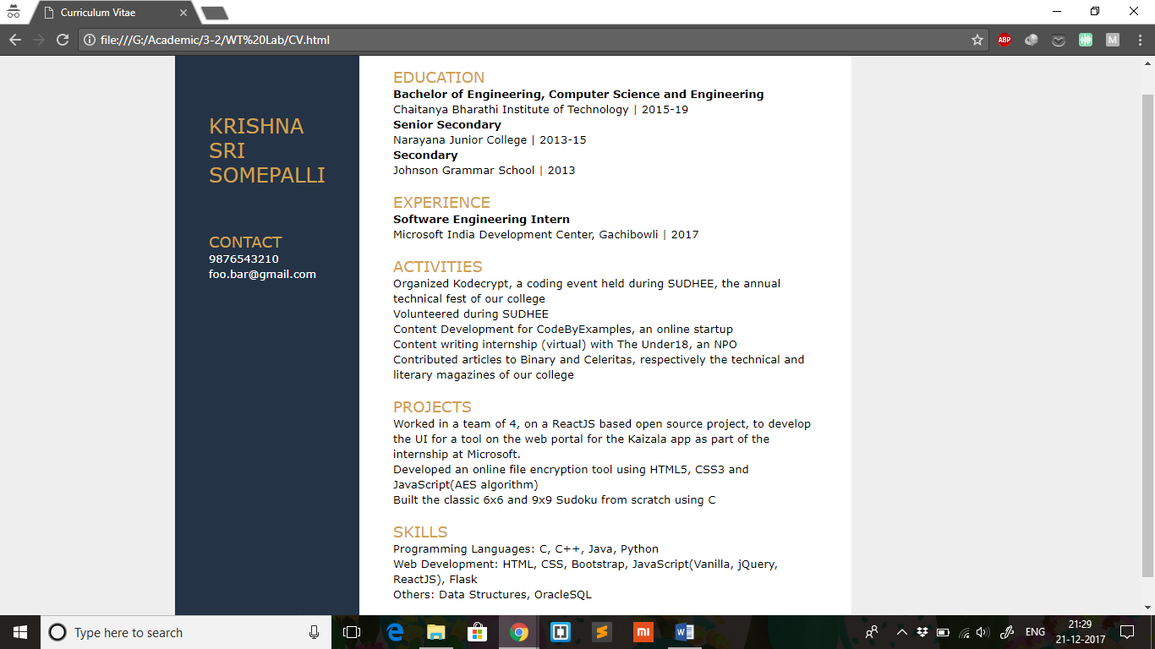

**EXPERIMENT 4**

**Aim:** Write HTML code to create two web pages in the given format, using frames.

a.b.

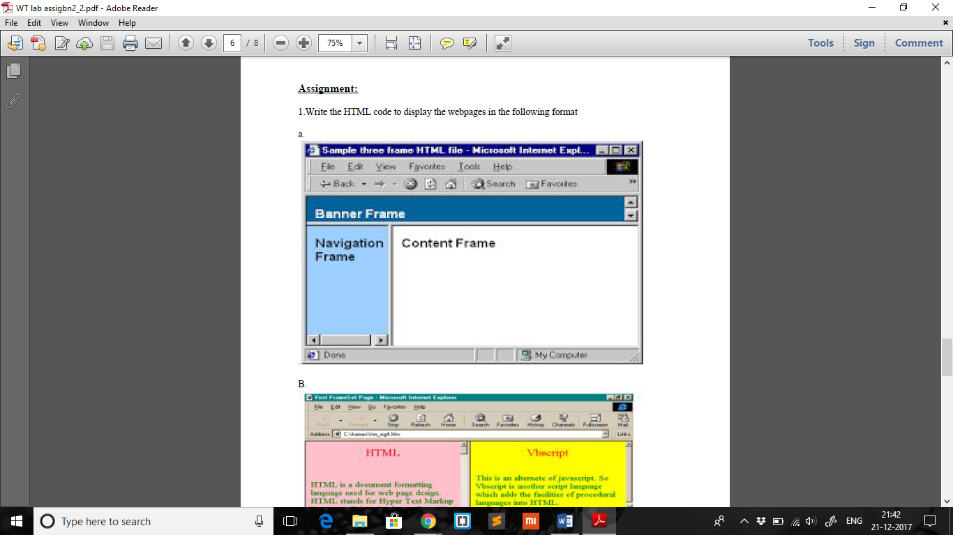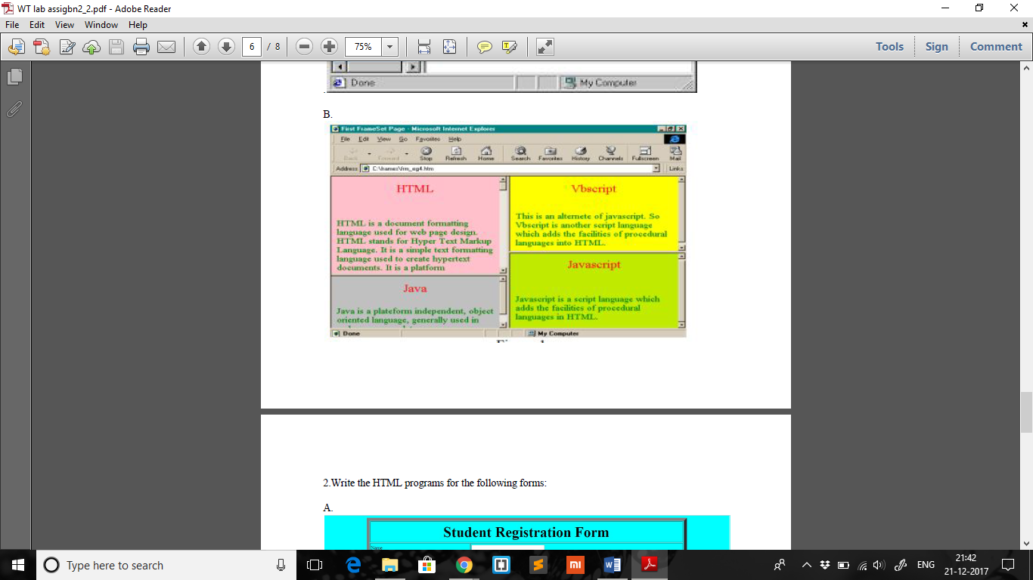

**Description:** The browser screen can be divided into a number of parts, each of which are completely independent. Each part of the screen is called a frame and each such rectangle can hold a different document. To implement frames, more than one document is needed. The MASTER document contains theframe layout that determines what the users see when they access the page. There is nocontent within the master document; instead, it contains one or more <frameset> elements thatdefine the frame layout. The <frame> element specifies which document is supposed tobe loaded into which frame. The actual documents are separate individual pages.

**a. Program:**

**1A.html:**

|  |
| --- |
| <html> |
|  | <head> |
|  | <title>Frames A</title> |
|  | </head> |
|  | <frameset rows="10%, 90%"> |
|  | <frame src="frame1Aa.html" scrolling="yes"/> |
|  | <frameset cols="30%, 70%"> |
|  | <frame src="frame1Ab.html" scrolling="yes"/> |
|  | <frame src="frame1Ac.html" /> |
|  | </frameset> |
|  | </frameset> |
|  | <body></body> |
|  | </html> |

**frame1Aa.html:**

|  |
| --- |
|  |
|  | <html> |
|  | <head> |
|  | <title>frame1Aa</title> |
|  | </head> |
|  | <body bgcolor="#4169EF"> |
|  | <font color="white" size='5'><strong>Banner Frame</strong></font> |
|  | </body> |
|  | </html> |

**frame1Ab.html:**

|  |
| --- |
| <html> |
|  | <head> |
|  | <title>frame1Ab</title> |
|  | </head> |
|  | <body bgcolor="#87CEFA"> |
|  | <font size='5'><strong>Navigation Frame</strong></font> |
|  | </body> |
|  | </html> |

**frame1Ac.html:**

|  |
| --- |
| <html> |
|  | <head> |
|  | <title>frame1Aa</title> |
|  | </head> |
|  | <body> |
|  | <font size='5'><strong>Content Frame</strong></font> |
|  | </body> |
|  | </html> |

**a. Output:**

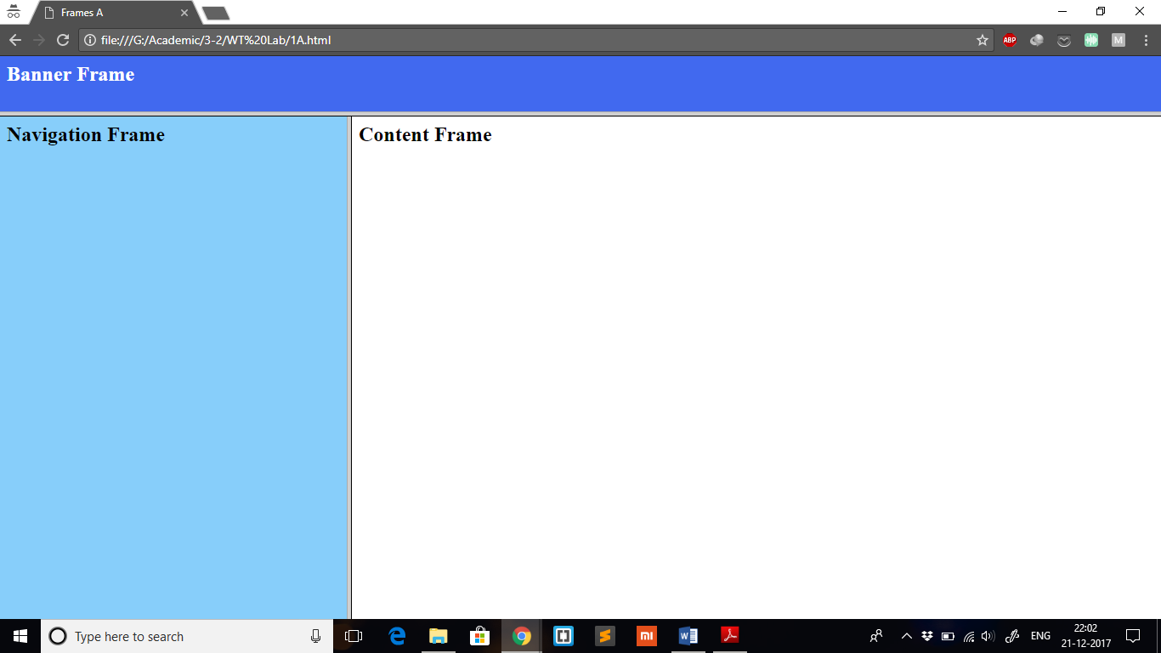

**b. Program:**

**1B.html:**

|  |
| --- |
| <html> |
|  | <head> |
|  | <title>Frames B</title> |
|  | </head> |
|  | <frameset cols="50%, 50%"> |
|  | <frameset rows="60%, 40%"> |
|  | <frame src="frame1Ba.html" scrolling="yes"/> |
|  | <frame src="frame1Bb.html" scrolling="yes"/> |
|  | </frameset> |
|  | <frameset rows="40%, 60%"> |
|  | <frame src="frame1Bc.html" scrolling="yes"/> |
|  | <frame src="frame1Bd.html" scrolling="yes"/> |
|  | </frameset> |
|  | </frameset> |
|  | <body></body> |
|  | </html> |

**frame1Ba.html:**

|  |
| --- |
| <html> |
|  | <head> |
|  | <title>frame1Ba</title> |
|  | </head> |
|  | <body bgcolor="#FA8072"> |
|  | <h1 style="text-align: center; color: #CCCCCC;">HTML</h1> |
|  | <br/> |
|  | <font color="#FFFFFF" size='2'>Hypertext Markup Language (HTML) is the standard markup language for creating web pages and web applications. With Cascading Style Sheets (CSS) and JavaScript it forms a triad of cornerstone technologies for the World Wide Web. Web browsers receive HTML documents from a web server or from local storage and render them into multimedia web pages. HTML describes the structure of a web page semantically and originally included cues for the appearance of the document.<br/><br/> |
|  | HTML elements are the building blocks of HTML pages. With HTML constructs, images and other objects, such as interactive forms, may be embedded into the rendered page. It provides a means to create structured documents by denoting structural semantics for text such as headings, paragraphs, lists, links, quotes and other items. HTML elements are delineated by tags, written using angle brackets. Tags such as &lt;img /&gt; and &lt;input /&gt; introduce content into the page directly. Others such as &lt;p&gt;...&lt;/p&gt; surround and provide information about document text and may include other tags as sub-elements. Browsers do not display the HTML tags, but use them to interpret the content of the page.<br/><br/> |
|  | HTML can embed programs written in a scripting language such as JavaScript which affect the behavior and content of web pages. Inclusion of CSS defines the look and layout of content. The World Wide Web Consortium (W3C), maintainer of both the HTML and the CSS standards, has encouraged the use of CSS over explicit presentational HTML since 1997.</font> |
|  | </body> |
|  | </html> |

**frame1Bb.html:**

|  |
| --- |
| <html> |
|  | <head> |
|  | <title>frame1Bb</title> |
|  | </head> |
|  | <body bgcolor="#2E8B57"> |
|  | <h1 style="text-align: center; color: #CCCCCC;">CSS</h1> |
|  | <br/> |
|  | <font color="#FFFFFF" size='2'>Cascading Style Sheets (CSS) is a style sheet language used for describing the presentation of a document written in a markup language. Although most often used to set the visual style of web pages and user interfaces written in HTML and XHTML, the language can be applied to any XML document, including plain XML, SVG and XUL, and is applicable to rendering in speech, or on other media. Along with HTML and JavaScript, CSS is a cornerstone technology used by most websites to create visually engaging webpages, user interfaces for web applications, and user interfaces for many mobile applications. |
|  |  |
|  | CSS is designed primarily to enable the separation of presentation and content, including aspects such as the layout, colors, and fonts. This separation can improve content accessibility, provide more flexibility and control in the specification of presentation characteristics, enable multiple HTML pages to share formatting by specifying the relevant CSS in a separate .css file, and reduce complexity and repetition in the structural content. |
|  |  |
|  | Separation of formatting and content makes it possible to present the same markup page in different styles for different rendering methods, such as on-screen, in print, by voice (via speech-based browser or screen reader), and on Braille-based tactile devices. It can also display the web page differently depending on the screen size or viewing device. Readers can also specify a different style sheet, such as a CSS file stored on their own computer, to override the one the author specified. |
|  |  |
|  | Changes to the graphic design of a document (or hundreds of documents) can be applied quickly and easily, by editing a few lines in the CSS file they use, rather than by changing markup in the documents. |
|  |  |
|  | The CSS specification describes a priority scheme to determine which style rules apply if more than one rule matches against a particular element. In this so-called cascade, priorities (or weights) are calculated and assigned to rules, so that the results are predictable. |
|  |  |
|  | The CSS specifications are maintained by the World Wide Web Consortium (W3C). Internet media type (MIME type) text/css is registered for use with CSS by RFC 2318 (March 1998). The W3C operates a free CSS validation service for CSS documents.</font> |
|  | </body> |
|  | </html> |

**frame1Bc.html:**

|  |
| --- |
| <html> |
|  | <head> |
|  | <title>frame1Bc</title> |
|  | </head> |
|  | <body bgcolor="#6A5ACD"> |
|  | <h1 style="text-align: center; color: #CCCCCC;">VBScript</h1> |
|  | <br/> |
|  | <font color="#FFFFFF" size='2'>VBScript ("Microsoft Visual Basic Scripting Edition") is an Active Scripting language developed by Microsoft that is modeled on Visual Basic. It allows Microsoft Windows system administrators to generate powerful tools for managing computers with error handling, subroutines, and other advanced programming constructs. It can give the user complete control over many aspects of their computing environment. |
|  |  |
|  | VBScript uses the Component Object Model to access elements of the environment within which it is running; for example, the FileSystemObject (FSO) is used to create, read, update and delete files. VBScript has been installed by default in every desktop release of Microsoft Windows since Windows 98; in Windows Server since Windows NT 4.0 Option Pack; and optionally with Windows CE (depending on the device it is installed on). |
|  |  |
|  | A VBScript script must be executed within a host environment, of which there are several provided with Microsoft Windows, including: Windows Script Host (WSH), Internet Explorer (IE), and Internet Information Services (IIS). Additionally, the VBScript hosting environment is embeddable in other programs, through technologies such as the Microsoft Script Control (msscript.ocx).</font> |
|  | </body> |
|  | </html> |

**frame1Bd.html:**

|  |
| --- |
| <html> |
|  | <head> |
|  | <title>frame1Bd</title> |
|  | </head> |
|  | <body bgcolor="#CD853F"> |
|  | <h1 style="text-align: center; color: #CCCCCC;">JavaScript</h1> |
|  | <br/> |
|  | <font color="#FFFFFF" size='2'>JavaScript, often abbreviated as JS, is a high-level, dynamic, weakly typed, prototype-based, multi-paradigm, and interpreted programming language. Alongside HTML and CSS, JavaScript is one of the three core technologies of World Wide Web content production. It is used to make webpages interactive and provide online programs, including video games. The majority of websites employ it, and all modern web browsers support it without the need for plug-ins by means of a built-in JavaScript engine. Each of the many JavaScript engines represent a different implementation of JavaScript, all based on the ECMAScript specification, with some engines not supporting the spec fully, and with many engines supporting additional features beyond ECMA. |
|  |  |
|  | As a multi-paradigm language, JavaScript supports event-driven, functional, and imperative (including object-oriented and prototype-based) programming styles. It has an API for working with text, arrays, dates, regular expressions, and basic manipulation of the DOM, but the language itself does not include any I/O, such as networking, storage, or graphics facilities, relying for these upon the host environment in which it is embedded. |
|  |  |
|  | Initially only implemented client-side in web browsers, JavaScript engines are now embedded in many other types of host software, including server-side in web servers and databases, and in non-web programs such as word processors and PDF software, and in runtime environments that make JavaScript available for writing mobile and desktop applications, including desktop widgets. |
|  |  |
|  | Although there are strong outward similarities between JavaScript and Java, including language name, syntax, and respective standard libraries, the two languages are distinct and differ greatly in design; JavaScript was influenced by programming languages such as Self and Scheme.</font> |
|  | </body> |
|  | </html> |

**b. Output:**

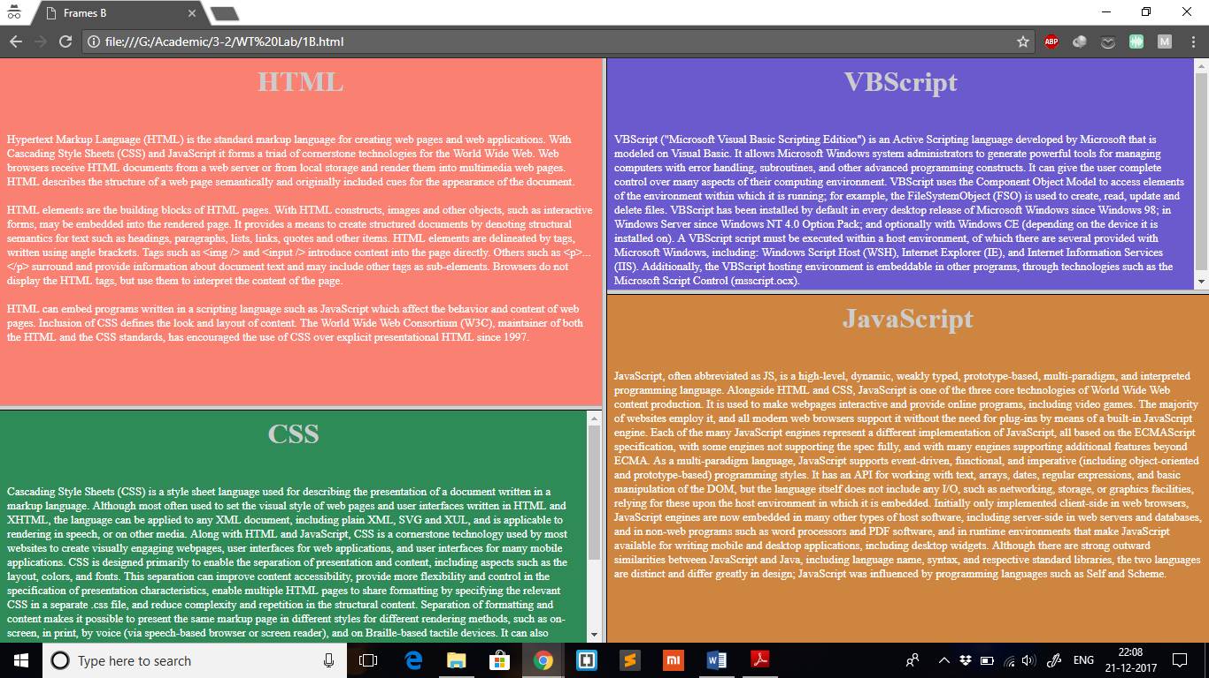

**EXPERIMENT 5**

**Aim:** Write HTML code to create the given two forms.

a.b.

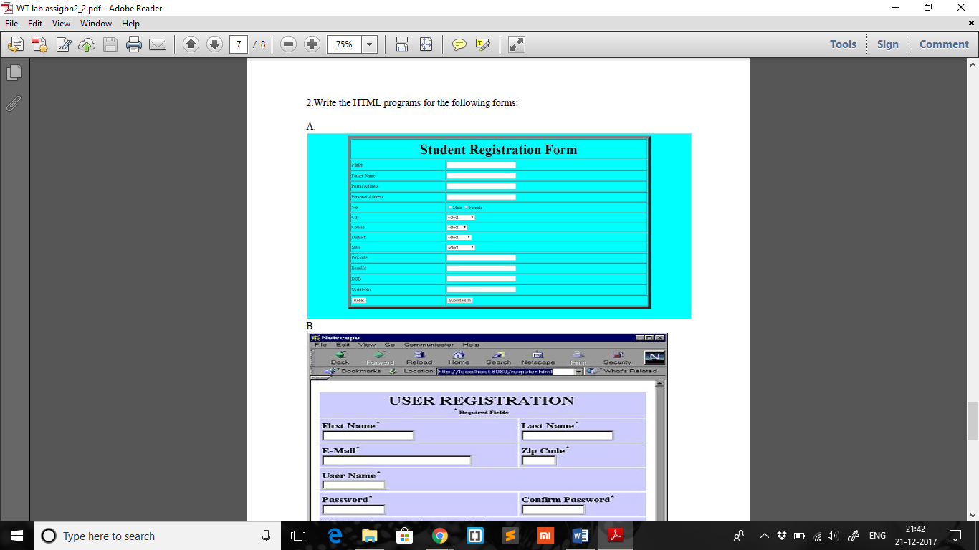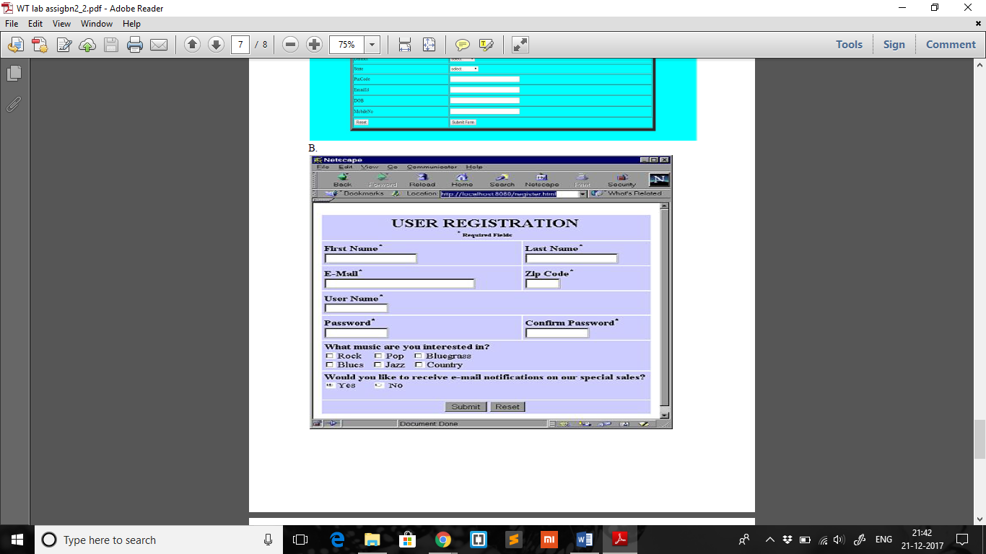

**Description:** Forms are used in HTML for getting inputs from the user. It can be a registration form, feedback form, order form and so on. To help the user in data entry, a form has components: text fields, radio buttons, check boxes, list boxes and so on. When data entry is complete, the user submits the form by clicking the submit button on the page. On submit, the data send to server for processing.

After the user fills the form and click the submit button the data passes either through the method POST (used to pass large amounts of data) or GET (used to pass smaller amounts of data; passed along with the URL) to the server-side script that then handles the data and performs the appropriate action.

**a. Program:**

|  |
| --- |
|  |
|  | <html> |
|  | <head> |
|  | <title>Forms A</title> |
|  | <style> |
|  | body{ |
|  | font-size: 13px; |
|  | } |
|  | td{ |
|  | padding-left: 2%; |
|  | padding-top: 0.5%; |
|  | padding-bottom: 0.5%; |
|  | } |
|  | </style> |
|  | </head> |
|  | <body style="background-color: #B0E0E6;"> |
|  | <table border='1' cellspacing='0' width=100%> |
|  | <tr> |
|  | <td colspan='2'> |
|  | <h1 style="text-align: center;">Student Registration Form</h1> |
|  | </td> |
|  | </tr> |
|  | <tr> |
|  | <td>Name</td> |
|  | <td> |
|  | <input type="text" size="20"/> |
|  | </td> |
|  | </tr> |
|  | <tr> |
|  | <td>Father's Name</td> |
|  | <td> |
|  | <input type="text" size="20"/> |
|  | </td> |
|  | </tr> |
|  | <tr> |
|  | <td>Postal Address</td> |
|  | <td> |
|  | <input type="text" size="20"/> |
|  | </td> |
|  | </tr> |
|  | <tr> |
|  | <td>Personal Address</td> |
|  | <td> |
|  | <input type="text" size="20"/> |
|  | </td> |
|  | </tr> |
|  | <tr> |
|  | <td>Sex</td> |
|  | <td> |
|  | <input type="radio" value="male" name="gender"/> Male |
|  | <input type="radio" value="female" name="gender"/> Female |
|  | </td> |
|  | </tr> |
|  | <tr> |
|  | <td>City</td> |
|  | <td> |
|  | <select> |
|  | <option diabled selected value style="display: none;">select</option> |
|  | <option value="hyderabad">Hyderabad</option> |
|  | <option value="bangalore">Bangalore</option> |
|  | <option value="cochin">Cochin</option> |
|  | <option value="chennai">Chennai</option> |
|  | </select> |
|  | </td> |
|  | </tr> |
|  | <tr> |
|  | <td>Course</td> |
|  | <td> |
|  | <select> |
|  | <option diabled selected value style="display: none;">select</option> |
|  | <option value="wt">Web Technologies</option> |
|  | <option value="ip">Image Processing</option> |
|  | <option value="cn">Computer Networks</option> |
|  | <option value="se">Software Engineering</option> |
|  | <option value="cc">Compiler Construction</option> |
|  | </select> |
|  | </td> |
|  | </tr> |
|  | <tr> |
|  | <td>District</td> |
|  | <td> |
|  | <select> |
|  | <option diabled selected value style="display: none;">select</option> |
|  | <option value="ad">Adilabad</option> |
|  | <option value="hy">Hyderabad</option> |
|  | <option value="kn">Karimnagar</option> |
|  | <option value="mk">Medak</option> |
|  | <option value="rr">Ranga Reddy</option> |
|  | </select> |
|  | </td> |
|  | </tr> |
|  | <tr> |
|  | <td>State</td> |
|  | <td> |
|  | <select> |
|  | <option diabled selected value style="display: none;">select</option> |
|  | <option value="ap">Andhra Pradesh</option> |
|  | <option value="bh">Bihar</option> |
|  | <option value="mp">Madhya Pradesh</option> |
|  | <option value="tg">Telangana</option> |
|  | <option value="up">Uttar Pradesh</option> |
|  | </select> |
|  | </td> |
|  | </tr> |
|  | <tr> |
|  | <td>Pin Code</td> |
|  | <td> |
|  | <input type="text" size="20"/> |
|  | </td> |
|  | </tr> |
|  | <tr> |
|  | <td>Email ID</td> |
|  | <td> |
|  | <input type="text" size="20"/> |
|  | </td> |
|  | </tr> |
|  | <tr> |
|  | <td>Date of Birth</td> |
|  | <td> |
|  | <input type="text" size="20"/> |
|  | </td> |
|  | </tr> |
|  | <tr> |
|  | <td>Mobile Number</td> |
|  | <td> |
|  | <input type="text" size="20"/> |
|  | </td> |
|  | </tr> |
|  | <tr> |
|  | <td> |
|  | <input type="reset" /> |
|  | </td> |
|  | <td> |
|  | <input type="submit"/> |
|  | </td> |
|  | </tr> |
|  | </table> |
|  | </body> |
|  | </html> |

**a. Output:**

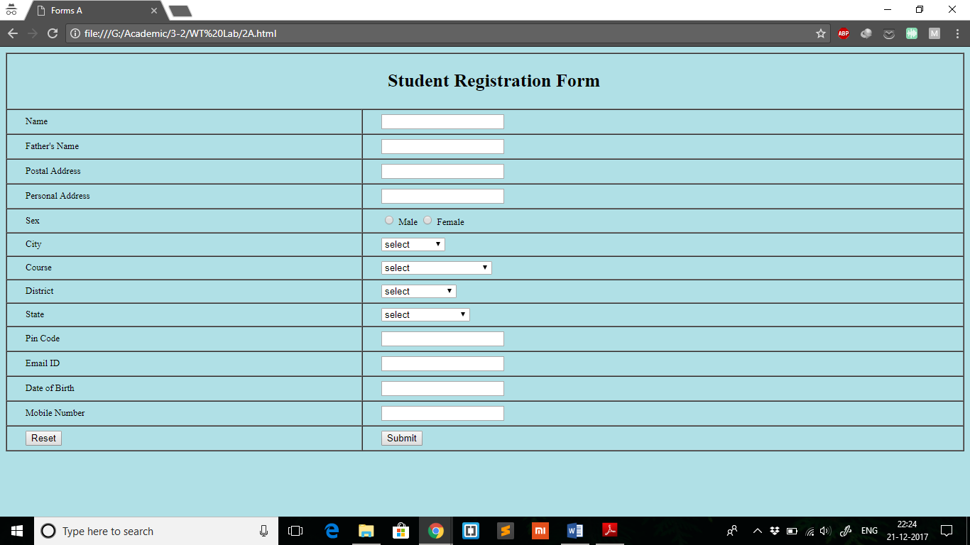

**b. Program:**

|  |
| --- |
|  |
|  | <html> |
|  | <head> |
|  | <title>Forms B</title> |
|  | <style> |
|  | body{ |
|  | font-size: 13px; |
|  | } |
|  | td{ |
|  | padding-left: 2%; |
|  | padding-top: 0.5%; |
|  | padding-bottom: 0.5%; |
|  | } |
|  | table{ |
|  | border: 1px solid white; |
|  | background-color: #778899; |
|  | } |
|  | </style> |
|  | </head> |
|  | <body> |
|  | <table cellspacing='0' border='1' width=100%> |
|  | <tr> |
|  | <td colspan='2'> |
|  | <h1 style="text-align: center;">USER REGISTRATION</h1> |
|  | <p style="text-align: center;">* Required Fields</p> |
|  | </td> |
|  | </tr> |
|  | <tr> |
|  | <td> |
|  | First Name* <br/> |
|  | <input type="text" size="20" /> |
|  | </td> |
|  | <td> |
|  | Last Name* <br/> |
|  | <input type="text" size="20" /> |
|  | </td> |
|  | </tr> |
|  | <tr> |
|  | <td> |
|  | E-mail* <br/> |
|  | <input type="text" size="30" /> |
|  | </td> |
|  | <td> |
|  | Zip Code* <br/> |
|  | <input type="text" size="10" /> |
|  | </td> |
|  | </tr> |
|  | <tr> |
|  | <td colspan='2'> |
|  | Username* <br/> |
|  | <input type="text" size="20" /> |
|  | </td> |
|  | </tr> |
|  | <tr> |
|  | <td> |
|  | Password* <br/> |
|  | <input type="text" size="20" /> |
|  | </td> |
|  | <td> |
|  | Confirm Password* <br/> |
|  | <input type="text" size="20" /> |
|  | </td> |
|  | </tr> |
|  | <tr> |
|  | <td colspan='2'> |
|  | What music are you interested in? <br/> |
|  | <input type="checkbox" name="music" /> Rock |
|  | <input type="checkbox" name="music" /> Pop |
|  | <input type="checkbox" name="music" /> Bluegrass<br/> |
|  | <input type="checkbox" name="music" /> Blues |
|  | <input type="checkbox" name="music" /> Jazz |
|  | <input type="checkbox" name="music" /> Country |
|  | </td> |
|  | </tr> |
|  | <tr> |
|  | <td colspan='2'> |
|  | Would you like to receive e-mail notifications on our special sales? <br/> |
|  | <input type="radio" name="sale" /> Yes |
|  | <input type="radio" name="sale" /> No |
|  | </td> |
|  | </tr> |
|  | <tr> |
|  | <td colspan='2'> |
|  | <input type="Submit" style="margin-left: 45%;"/> |
|  | <input type="Reset" /> |
|  | </td> |
|  | </tr> |
|  | </table> |
|  | </body> |
|  | </html> |

**b. Output:**

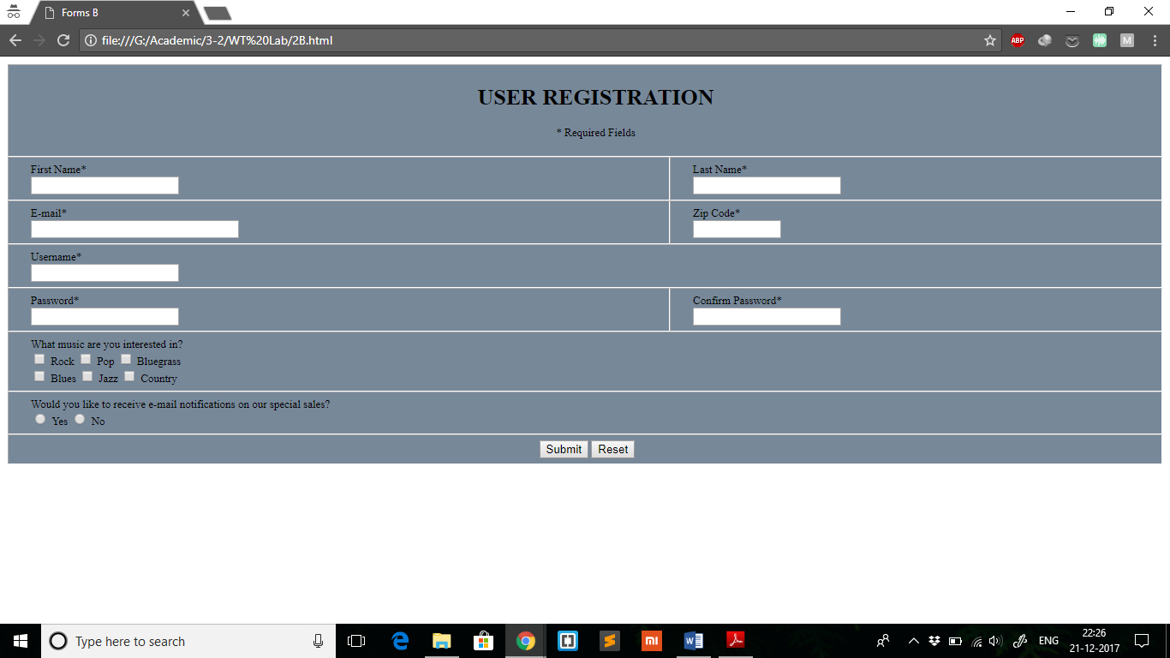

**EXPERIMENT 6**

**Aim:** To use frames to implement a restaurant webpage.

**Description:** Create a HTML webpage for a restaurant with three frames. The first frame will be horizontal on displaying the name and address of restaurant. Second frame which is vertical on left will list the available food items and when pressed on a

particular food item, an image and price of that food item should be displayed in the

third frame. The third frame will be to the right of second frame and will display

the introduction to the restaurant.

**Program:**

**3.html:**

|  |
| --- |
|  |
|  | <html> |
|  | <head> |
|  | <title>Restaurant</title> |
|  | </head> |
|  | <frameset rows="20%, 80%"> |
|  | <frame src="frameA.html" /> |
|  | <frameset cols="30%, 70%"> |
|  | <frame src="frameB.html" /> |
|  | <frame src="frameC.html" name="info" /> |
|  | </frameset> |
|  | </frameset> |
|  | </html> |

**frameA.html:**

|  |
| --- |
|  |
|  | <html> |
|  | <head> |
|  | <title>frame 3A</title> |
|  | </head> |
|  | <body> |
|  | <img src="http://c9e18afbb0c1b5131676-f9128945b4b12d53bc3e2950c2b3e837.r39.cf1.rackcdn.com/lps/assets/u/DSZE01.jpg" style="width: 6%;"/> |
|  | <h3 style="margin-top: 0;">Zega - Sheraton Hyderabad</h3> |
|  | <p>Address: 115/1, Financial District, Gachibowli, Hyderabad, Telangana 500032</p> |
|  | </body> |
|  | </html> |

**frameB.html:**

|  |
| --- |
|  |
|  | <html> |
|  | <head> |
|  | <title>frame 3B</title> |
|  | </head> |
|  | <body> |
|  | <h3>Menu</h3> |
|  | <ul> |
|  | <li><a href="soups.html" target="info">Soups</a> |
|  | <ul> |
|  | <li>Tom Yum</a></li> |
|  | <li> Sinchuan Hot &amp; Sour</li> |
|  | <li>Tom Kha</li> |
|  | <li>Steamed Boat</li> |
|  | </ul> |
|  | </li> |
|  | <li><a href="noodles_rice.html" target="info">Noodles &amp; Rice</a> |
|  | <ul> |
|  | <li>Steamed Jasmine/Basmati Rice</li> |
|  | <li>Fried Rice</li> |
|  | <li>XO Rice</li> |
|  | <li>Wok Tossed Soft Noodles</li> |
|  | <li>Yang Chow Fried Rice</li> |
|  | <li> Phad Thai, Flat Noodles, Tamarind Chilli Sauce</li> |
|  | </ul> |
|  | </li> |
|  | <li><a href="sushirolls.html" target="info">Sushi Rolls</a> |
|  | <ul> |
|  | <li>Uramaki</li> |
|  | <li>Maki</li> |
|  | <li>Nigiri</li> |
|  | <li>Sashimi</li> |
|  | </ul> |
|  | </li> |
|  | </ul> |
|  | </body> |
|  | </html> |

**frameC.html:**

|  |
| --- |
|  |
|  | <html> |
|  | <head> |
|  | <title>frame 3C</title> |
|  | </head> |
|  | <body> |
|  | <p>Preferred choice for Eat, Drink &amp; Socializing. An Asian inspired modern &amp; easy living social space known for multi sensory experiences through its ambience, asian comfort food &amp; distinct beverage selections.</p> |
|  | <br/> |
|  | <h3>General Information</h3> |
|  | <p>Lunch: 12:00 PM to 3:00 PM<br/>Dinner: 6:30 PM to 2:00 AM<br/>Cuisine: Asian<br/>Atmosphere: Modern &amp; Easy Living<br/>Dress Code: Smart Casual</p> |
|  | </body> |
|  | </html> |

**soups.html:**

|  |
| --- |
|  |
|  | <html> |
|  | <head> |
|  | <title>soups</title> |
|  | </head> |
|  | <body> |
|  | <h2>Soups</h2> |
|  | <img src="https://upload.wikimedia.org/wikipedia/commons/thumb/3/3d/Grzybowa.jpg/220px-Grzybowa.jpg" /> |
|  | <p>Soup is a primarily liquid food, generally served warm or hot (but may be cool or cold), that is made by combining ingredients such as meat and vegetables with stock, juice, water, or another liquid. Hot soups are additionally characterized by boiling solid ingredients in liquids in a pot until the flavors are extracted, forming a broth.</p> |
|  | <br /> |
|  | <p>In traditional French cuisine, soups are classified into two main groups: clear soups and thick soups. The established French classifications of clear soups are bouillon and consommé. Thick soups are classified depending upon the type of thickening agent used: purées are vegetable soups thickened with starch; bisques are made from puréed shellfish or vegetables thickened with cream; cream soups may be thickened with béchamel sauce; and veloutés are thickened with eggs, butter, and cream. Other ingredients commonly used to thicken soups and broths include egg, rice, lentils, flour, and grains; many popular soups also include pumpkin, carrots, and potatoes.</p> |
|  | <p>Soups are similar to stews, and in some cases there may not be a clear distinction between the two; however, soups generally have more liquid than stews.</p> |
|  | <p>Price: &#8377;229-&#8377;699</p> |
|  | </body> |
|  | </html> |

**noodles_rice.html:**

|  |
| --- |
|  |
|  | <html> |
|  | <head> |
|  | <title>noodles &amp; rice</title> |
|  | </head> |
|  | <body> |
|  | <h2>Noodles &amp; Rice</h2> |
|  | <img src="https://upload.wikimedia.org/wikipedia/commons/thumb/b/bd/Spicy_noodle_soup_with_beef%2C_Festival_des_P%C3%A2tes%2C_Paris_001.jpg/220px-Spicy_noodle_soup_with_beef%2C_Festival_des_P%C3%A2tes%2C_Paris_001.jpg" /> |
|  | <p>Noodles are a staple food in many cultures made from unleavened dough which is stretched, extruded, or rolled flat and cut into one of a variety of shapes. While long, thin strips may be the most common, many varieties of noodles are cut into waves, helices, tubes, strings, or shells, or folded over, or cut into other shapes. Noodles are usually cooked in boiling water, sometimes with cooking oil or salt added. They are often pan-fried or deep-fried. Noodles are often served with an accompanying sauce or in a soup. Noodles can be refrigerated for short-term storage, or dried and stored for future use. The material composition or geocultural origin must be specified when discussing noodles. The word derives from the German word Nudel.</p> |
|  | <img src="https://upload.wikimedia.org/wikipedia/commons/thumb/b/b5/Nasi_goreng_Solaria_Kuta.JPG/220px-Nasi_goreng_Solaria_Kuta.JPG" /> |
|  | <p>Rice is the seed of the monocot plants Oryza sativa (Asian rice) or Oryza glaberrima (African rice). As a cereal grain, it is the most widely consumed staple food for a large part of the world's human population, especially in Asia and the West Indies. It is the grain with the second-highest worldwide production, after maize (corn), according to data for 2010.</p> |
|  | <p>Price: &#8377;199-&#8377;450</p> |
|  | </body> |
|  | </html> |

**sushirolls.html:**

|  |
| --- |
|  |
|  | <html> |
|  | <head> |
|  | <title>sushi rolls</title> |
|  | </head> |
|  | <body> |
|  | <h2>Sushi Rolls</h2> |
|  | <img src="https://upload.wikimedia.org/wikipedia/commons/thumb/9/9c/2007feb-sushi-odaiba-manytypes.jpg/220px-2007feb-sushi-odaiba-manytypes.jpg" /> |
|  | <p>Sushi (すし, 寿司, 鮨) is the Japanese preparation and serving of specially prepared vinegared rice (鮨飯 sushi-meshi) combined with varied ingredients (ネタ neta) such as chiefly seafood (often uncooked), vegetables, and occasionally tropical fruits. Styles of sushi and its presentation vary widely, but the key ingredient is sushi rice, also referred to as shari (しゃり), or sumeshi (酢飯).</p> |
|  | <br /> |
|  | <p>Sushi can be prepared with either brown or white rice. It is often prepared with raw seafood, but some varieties of sushi use cooked ingredients, and many others are vegetarian. Sushi is often served with pickled ginger, wasabi, and soy sauce. Daikon radish is popular as a garnish.</p> |
|  | <br /> |
|  | <p>Sushi is often confused with sashimi, a related Japanese dish consisting of thinly sliced raw fish or occasionally meat, and an optional serving of rice.</p> |
|  | <p>Price: &#8377;375-&#8377;1400</p> |
|  | </body> |
|  | </html> |

**Output:**

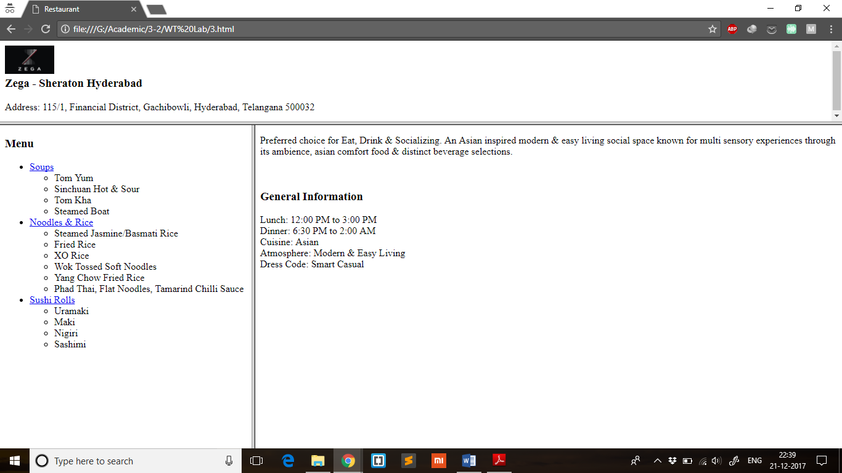

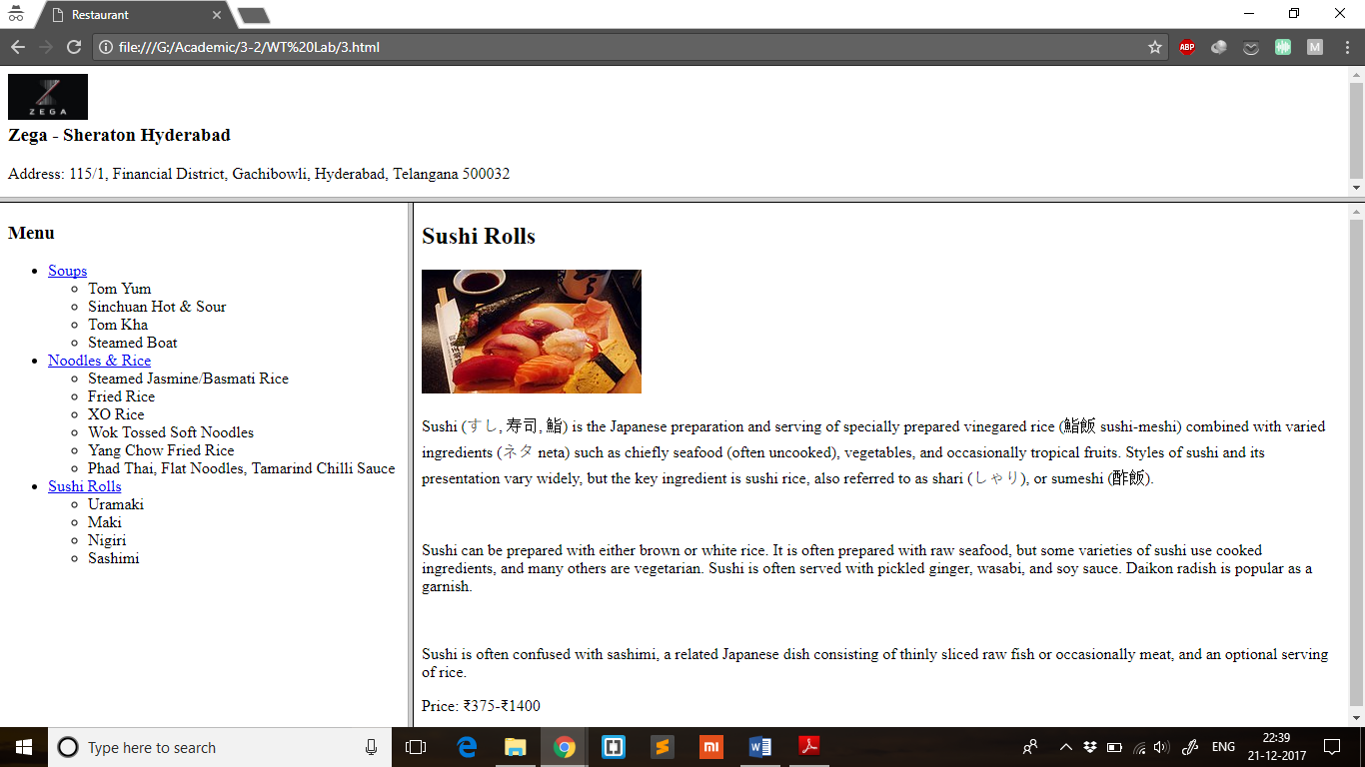

**EXPERIMENT 7**

**Aim:** To use frames to develop a company website.

**Description:** Create an HTML page having Four frames named:

a. Top

b. Center

c. Bottom

d. Left

The Top frame should contain the company logo and title. The Bottom frame should

contain copyright information. The Left frame should contain various links like

Home, Products, Services, Branches, About us, etc. When we click on those links,

the content should come in to the Center frame.

**Program:**

**4.html:**

|  |
| --- |
|  |
|  | <html> |
|  | <head> |
|  | <title>Ikea</title> |
|  | </head> |
|  | <frameset rows="10%, 80%, 10%"> |
|  | <frame src="frame4A.html" name="top"/> |
|  | <frameset cols="30%, 70%"> |
|  | <frame src="frame4B.html" name="left"/> |
|  | <frame src="frame4C.html" name="center"/> |
|  | </frameset> |
|  | <frame src="frame4D.html" name="bottom"/> |
|  | </frameset> |
|  | </html> |

**frame4A.html:**

|  |
| --- |
|  |
|  | <html> |
|  | <head> |
|  | <title>frame A</title> |
|  | </head> |
|  | <body> |
|  | <img src="https://upload.wikimedia.org/wikipedia/commons/thumb/c/c5/Ikea_logo.svg/220px-Ikea_logo.svg.png" style="width: 8%;"/> |
|  | </body> |
|  | </html> |

**frame4B.html:**

|  |
| --- |
|  |
|  | <html> |
|  | <head> |
|  | <title>frame B</title> |
|  | </head> |
|  | <body> |
|  | <ul> |
|  | <li><a href="http://www.ikea.com" target="center">About IKEA</a></li> |
|  | <li><a href="http://www.ikea.in/hejhome" target="center">Hej HOME</a></li> |
|  | <li><a href="http://www.ikea.in/ikeafamily" target="center">IKEA FAMILY</a></li> |
|  | <li><a href="http://www.ikea.in/jobs" target="center">Work at IKEA</a></li> |
|  | </ul> |
|  | </body> |
|  | </html> |

**frame4C.html:**

|  |
| --- |
|  |
|  | <html> |
|  | <head> |
|  | <title>frame C</title> |
|  | </head> |
|  | <body> |
|  | <p>Select an option</p> |
|  | </body> |
|  | </html> |

**frame4D.html:**

|  |
| --- |
|  |
|  | <html> |
|  | <head> |
|  | <title>frame C</title> |
|  | </head> |
|  | <body> |
|  | <p>One of our tasks, as the worldwide IKEA franchisor, is to protect the IKEA trademarks and other parts of the IKEA Concept.</p> |
|  | <p>Occasionally, the IKEA trademarks are used without permission. There have been cases of others using the IKEA trademarks or IKEA domain names for activities such as fake IKEA websites, fraudulent schemes and similar. Sometimes others use IKEA copyright pictures without our permission, sell fake IKEA products and even set up fake IKEA stores. We feel that it is very important that our consumers are not misled, but can trust that all products having the IKEA trademark are genuine products.</p> |
|  | <p>In the best of consumers interest, we therefore ask for your help to report wrongful use of the IKEA trademarks or similar marks. We cannot give you any reward or compensation other than a big thank you for helping us to protect the IKEA trademarks and to prevent fraud and misrepresentation.</p> |
|  | <p>Please send an email to this address to let us know what you have seen. If you are able to provide images or links that is very valuable!</p> |
|  | </body> |
|  | </html> |

**Output:**

