**Countries badly affected by COVID-19, their most affected age group and time taken to recover or to die.**

Submitted by:

Abhishek Singh Kushwaha (19BEC001)

Aman Kumar (19BEC003)

Shresth Bharadia (19BCS100)

Sourav Bhagat (19BCS103)

Sutrave Krishna Sambhaji (19BCS105)

Data files:

Question 1: (i) coronavirus q1.py (ii)covidcase.xlsx (iii)coviddeath.xlsx

Question 2: (i) coronavirus q2.py (ii) americanstates.xlsx

Question 3: (i) coronavirus q3.py (ii) deathduration.xlsx

Submitted to:

Dr. Uma Sheshadri

Professor, Computer Science and Engineering

IIIT Dharwad



**Problem Statement 1:**

**Identify the countries as “HIGH RISK” TRAVEL destination countries for Internship or Project work for the next two years.**

**Purpose of study:**

To study and get the information about COVID -19 outbreak in the countries, which are preferred by Indian students for internship or project work for the next two years, to avoid the travel of students in infected countries.

**Observation:**

We use the concept of Death Rate which signifies the number of deaths in a hundred infected people. If a country has a death rate greater then two we list that country as “HIGH RISK”.

We came to know that the US, China (PRC), and countries of Europe are at high risk. We are giving some data for example purpose.

|  |  |  |  |
| --- | --- | --- | --- |
| Countries | Total Cases | Deaths | Death Rate |
| US | 759086.0 | 40661.0 | 5.35657356346975 |
| Spain | 198674.0 | 20453.0 | 10.2947542204817 |
| Germany | 145184.0 | 4586.0 | 3.158750275512453 |
| United Kingdom | 120067.0 | 16060.0 | 13.375865141962404 |
| Germany | 145184.0 | 4586.0 | 3.158750275512453 |
| Italy | 178972.0 | 23660.0 | 13.219945019332632 |
| France | 152894.0 | 19718.0 | 12.896516540871453 |
| Turkey | 86306.0 | 2017.0 | 2.337033346464904 |
| Iran | 82211.0 | 5118.0 | 6.225444283611682 |
| Switzerland | 27740.0 | 1393.0 | 5.0216294160057675 |

Graph showing daily death:

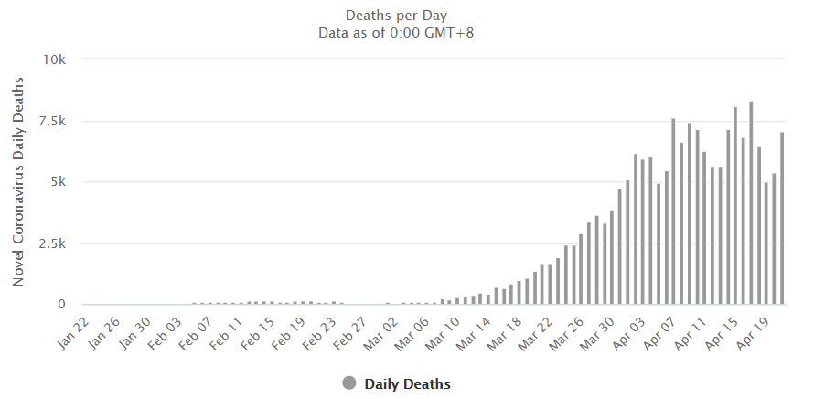

**References:**

We use two data files named “covidcase.xlsx” and “coviddeath.xlsx” and these are extracted from site “<https://data.humdata.org/dataset/novel-coronavirus-2019-ncov-cases>”, we mainly use this for research purposes and GeeksforGeeks for some problems related to code.

**Data Types:**

String:- The input given by the user is in the form of a string and we process this string according to our necessity in the program.

List:- We use a list of data structure very frequently in our program to store data and also strings.

**Result:**

In our research, we found that the countries having a death ratio greater than two are at high risk, and most of the countries of Europe, America, and Australia posses a death ratio greater than two. So, Indian students should avoid traveling to these countries for jobs, internships, and higher studies at least two years from now to avoid coronavirus infection chances.

**Problem Statement 2:**

**Identify the TOP FIFTEEN (15) countries as HIGHRISK Age Group Countries for Study.**

**Purpose to study this topic:**

Nowadays, the COVID-19 virus is spreading very fast all over the world. The number of cases is increasing day by day. To control the spreading of the virus, we have to study on it i.e.

* In which age group the number of cases is more?
* In which countries the number of cases is more?
* In which country the number of deaths is more?

**Observation:**

The observation table is given below:

Which includes countries and the number of COVID-19 cases age group-wise with an interval of ten-ten years.

|  |  |  |  |  |  |  |  |
| --- | --- | --- | --- | --- | --- | --- | --- |
| **American States** | **0-15**  **(Age)** | **15-25**  **(Age)** | **25-35**  **(Age)** | **35-45**  **(Age)** | **45-55**  **(Age)** | **55-65**  **(Age)** | **65+**  **(Age)** |
| NEW YORK | 16 | 1088 | 1057 | 1934 | 2644 | 4028 | 11475 |
| NEW JERSEY | 5 | 253 | 322 | 452 | 726 | 1035 | 2735 |
| MICHIGAN | 3 | 124 | 167 | 275 | 486 | 536 | 1437 |
| MASSACHUSETTS | 1 | 111 | 106 | 196 | 286 | 432 | 1176 |
| PENNSYLVANIA | 1 | 107 | 101 | 161 | 264 | 343 | 1032 |
| LLLINOIS | 1 | 93 | 89 | 154 | 246 | 324 | 945 |
| CONNECTICUT | 0 | 84 | 81 | 143 | 223 | 302 | 912 |
| LOUISIANA | 0 | 73 | 79 | 132 | 203 | 293 | 823 |
| CALICORNIA | 1 | 64 | 71 | 113 | 183 | 273 | 789 |
| FLORIDA | 0 | 42 | 54 | 76 | 123 | 187 | 534 |
| GEORGIA | 0 | 38 | 48 | 70 | 118 | 174 | 493 |
| WASHINGTON | 0 | 32 | 43 | 67 | 112 | 156 | 433 |
| MARYLAND | 0 | 31 | 38 | 61 | 105 | 143 | 398 |
| INDIANA | 1 | 28 | 34 | 56 | 96 | 134 | 378 |
| OHIO | 0 | 24 | 31 | 47 | 87 | 128 | 343 |
| TEXAS | 0 | 21 | 29 | 42 | 76 | 112 | 308 |
| COLORADO | 0 | 19 | 25 | 38 | 67 | 94 | 287 |
| VIRGINIA | 0 | 15 | 21 | 31 | 54 | 79 | 231 |
| WISCONSIA | 0 | 12 | 17 | 27 | 43 | 61 | 197 |
| NORTH CAROLINA | 0 | 12 | 17 | 21 | 35 | 59 | 181 |
| MISSOURI | 0 | 11 | 15 | 18 | 31 | 48 | 143 |
| ARIZONA | 0 | 11 | 13 | 17 | 35 | 41 | 125 |
| ALABAMA | 0 | 11 | 12 | 16 | 34 | 38 | 112 |
| MISSISSIPPI | 0 | 10 | 11 | 15 | 31 | 35 | 111 |
| RHODE ISLAND | 0 | 10 | 12 | 17 | 25 | 39 | 113 |
| KENTUCKY | 0 | 10 | 11 | 17 | 23 | 38 | 104 |
| OKLAHOMA | 0 | 10 | 11 | 15 | 20 | 31 | 93 |
| NEVADA | 0 | 9 | 11 | 13 | 19 | 30 | 91 |
| MINNESOTA | 0 | 9 | 10 | 11 | 17 | 30 | 89 |
| TENNESSEE | 0 | 8 | 9 | 10 | 17 | 28 | 81 |

**References:**

* In this problem, we used “americanstates.xlsx” file.
* <https://www.worldometers.info/coronavirus/?utm_campaign=homeAdvegas1?%22%20%5Cl%22countries>
* <https://www.aljazeera.com/news/2020/01/countries-confirmed-cases-coronavirus-200125070959786.html>

**Data structures used:**

* String
* Int
* List

**Final Result:**

The number of COVID-19 case patients is increasing rapidly. This report gives us information about which countries the COVID-19 cases are more active. To control it many countries are following a complete shutdown system. Because of it all companies, markets, universities are completely shut down since the month of MARCH.

The highest number of cases are found in NEW YORK and are increasing rapidly day by day.

From the above table, we will conclude that a more number of cases are found in old peoples ( above 80 years old ) because of low immunity.

SUSPECT CASE:

A patient with an acute respiratory illness and has been in contact with a confirmed or probable COVID-19 case in the last 14 days before the onset of symptoms.

**Problem Statement 3:**

**3.1) Find out the average number of days it took for a confirmed case to turn**

**to a death state in any country. Which country took the maximum number of days?**

**3.2) Find out the average number of days it took a confirmed case to turn to a**

**recovery state in any country. Which country took the maximum number of days?**

**Purpose to study this topic:**

This topic is important to study because, as we know the COVID-19 virus is spreading all over the world. It is a very dangerous disease. Many people are dying because of it. That’s why we have to study this topic such as:

* The average number of days took to get a confirmed COVID-19 active case?
* The number of deaths because of the COVID-19 virus?
* How long did it take to the number of confirmed death cases to double?
* And some more things which mentioned in the above question.

**Observation:**

The number of confirmed death cases to double for various countries is as follows:

|  |  |
| --- | --- |
| **Countries** | **The time it takes to number of confirmed death case to Double (In days)** |
| China | 59 |
| South Korea | 28 |
| Iraq | 23 |
| Iran | 22 |
| San Marino | 30 |
| Italy | 20 |
| Albania | 20 |
| Spain | 17 |
| Greece | 17 |
| Sri Lanka | 17 |
| Singapore | 16 |
| Thailand | 15 |
| Australia | 15 |
| Denmark | 15 |
| Switzerland | 14 |
| Netherlands | 14 |
| Austria | 13 |
| France | 13 |
| Myanmar | 12 |
| Germany | 11 |
| Japan | 10 |
| United Kingdom | 10 |
| United States | 9 |
| India | 9 |

From the above table, it is confirmed that China took more number of days. And India and the United States took 9 days which is a minimum.

Graph showing the observation:

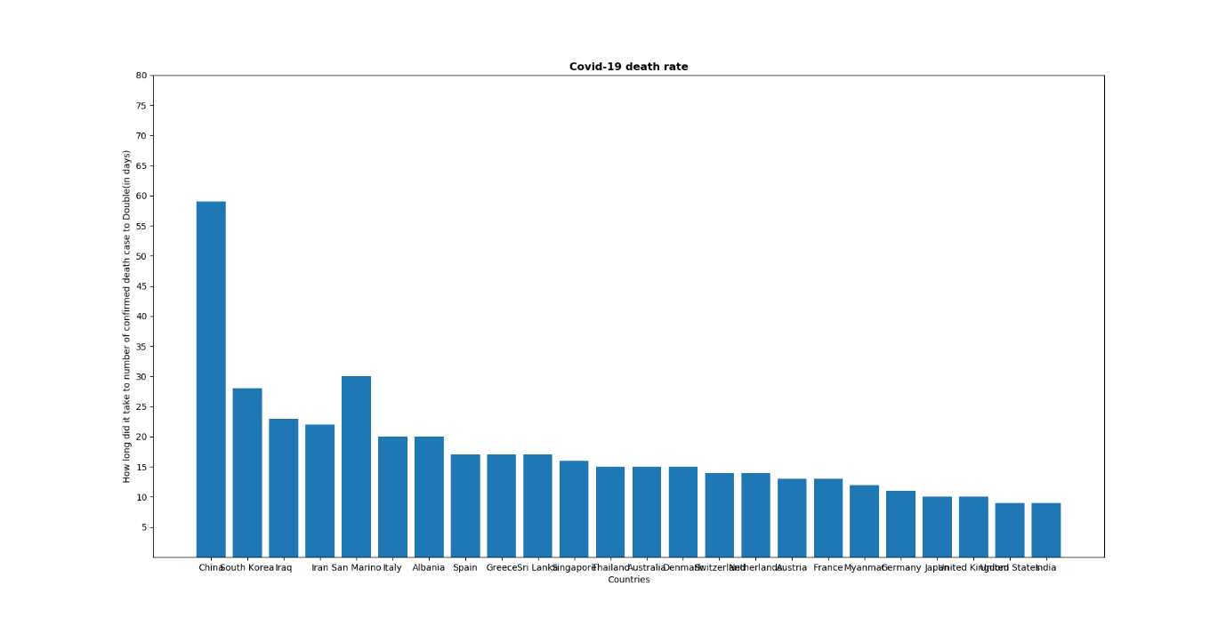

**Data types used:**

* List
* String

**References:**

* For this problem we used information from “deathduration.xlsx” file.

**Final Result:**

The number of COVID-19 cases is increasing rapidly. Also, the number of deaths is also increasing because of it. In a few days, the death troll is increased rapidly. So, that government applied a lockdown technique. Because it is a viral disease, it will spread through handshaking, meeting in groups, public crowd. So, we avoid that.