**PREREQUISITES**

Ensure an APP is registered within Azure Active Directory under the user who is going to deploy the below application. Also, the user should have at least contributor level permission within the subscription.

The App should have full permissions w.r.t Storage Account, App Services, Function Apps, Hosting Plan, App Service Plan, Logic App.

Follow the below references incase a user don’t have an APP registered under AAD or enough permission

<https://docs.microsoft.com/en-us/azure/azure-resource-manager/resource-group-create-service-principal-portal>

<https://docs.microsoft.com/en-us/azure/role-based-access-control/overview>

**Deploying the Azure Fault Injection Web Application using ARM template**

1. Open power shell console (Preferably with admin access)
2. Login to the azure portal using the subscription where the user wants to perform fault injection

> Login-AzureRmAccount -Subscription <“Subscription_Name” >

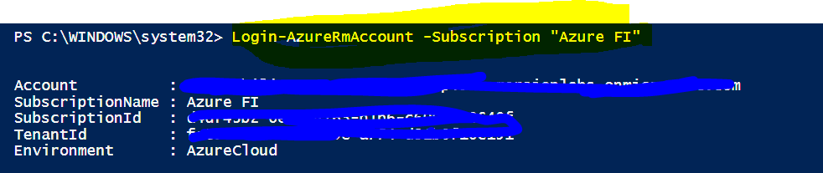

1. Create a new resource group by providing resource group name and location (This is optional. You can still use an existing one as well)

> New-AzureRmResourceGroup -Name ExampleResourceGroupARM -Location "South Central US"

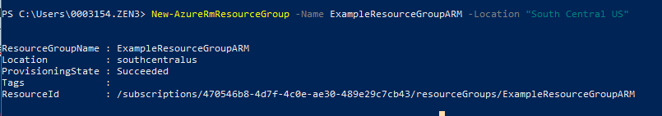

1. Create the storage account by providing the resource group, type and location (This is optional. You can still use an existing one as well)

New-AzureRmStorageAccount -ResourceGroupName ExampleResourceGroupARM -Name ExampleStorageAccountARM -Type Standard_LRS -Location "South Central US"

1. Run the below command from the where the shared folder located. **Before running the below command change the website name and the storage account name in the website.parameters.json file.**

Note: storage account name should be same as below & update the TemplateFile and TemplateParametersFile to their absolute paths.

.\Deploy-AzureResourceGroup.ps1 -StorageAccountName "ExampleStorageAccountARM" -ResourceGroupName "ExampleResourceGroupARM" -TemplateFile "C:\FIWebDeployment\website.json" -TemplateParametersFile " C:\FIWebDeployment\website.parameters.json" –UploadArtifacts

Ex:



Once the above command is succeeded then you will be able to see the website information as below in this screen shot.

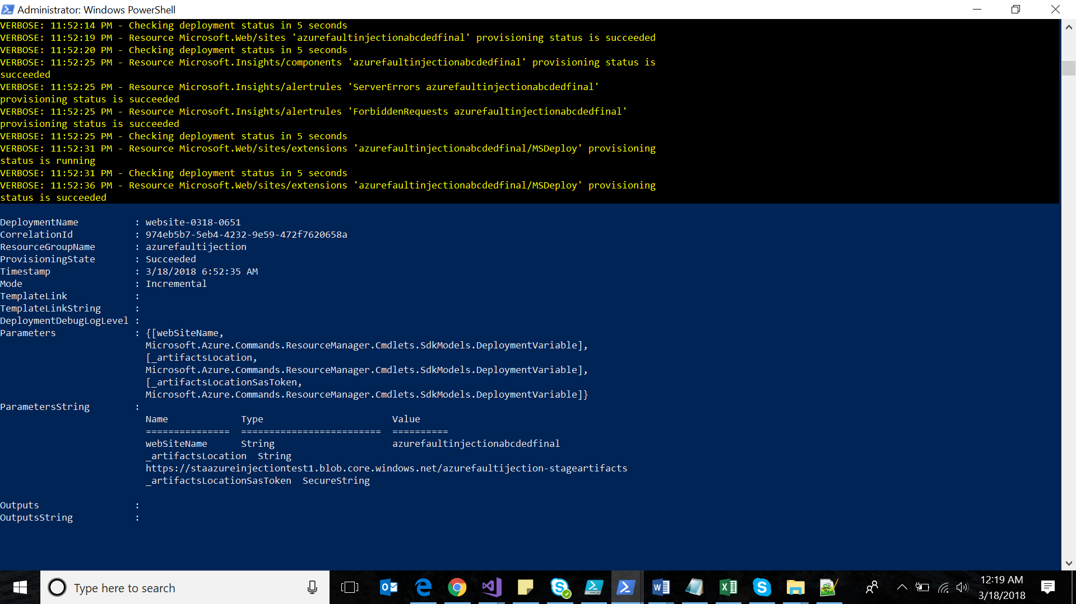

Updating the Configuration and Azure Function App deployment

1. Once the website succeeds launch the website
2. Enter the authenticate information

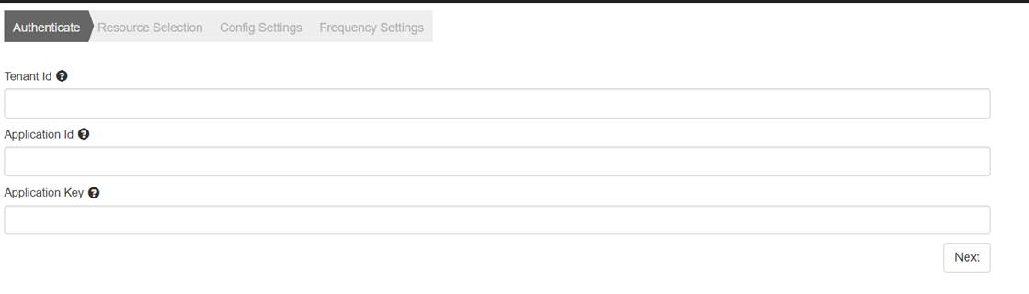

1. Select the subscription and the excluded & included resource groups.

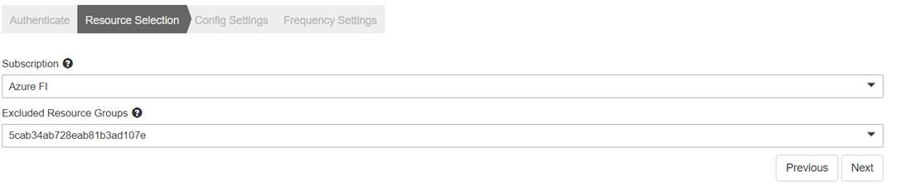

1. Update the config settings by choosing the VM % , enable/disable the options & the Fault Injection Actions – Power Cycle & Restart

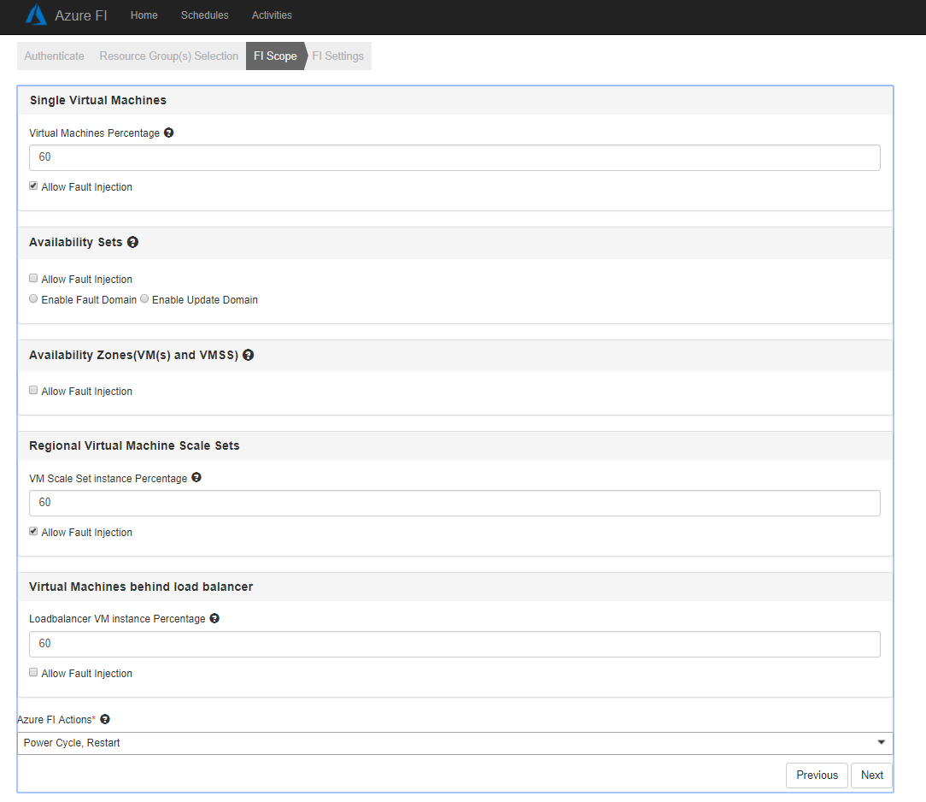

1. Provide the frequency details accordingly.

Note:

a) Scheduler Frequency should be at least twice the Power Cycle Schedule or Power Cycle Schedule should not be more than half the Scheduler Frequency

b) Scheduler Frequency should be less than the sum of Crawler Frequency and Meantime b/w FI on a VM.

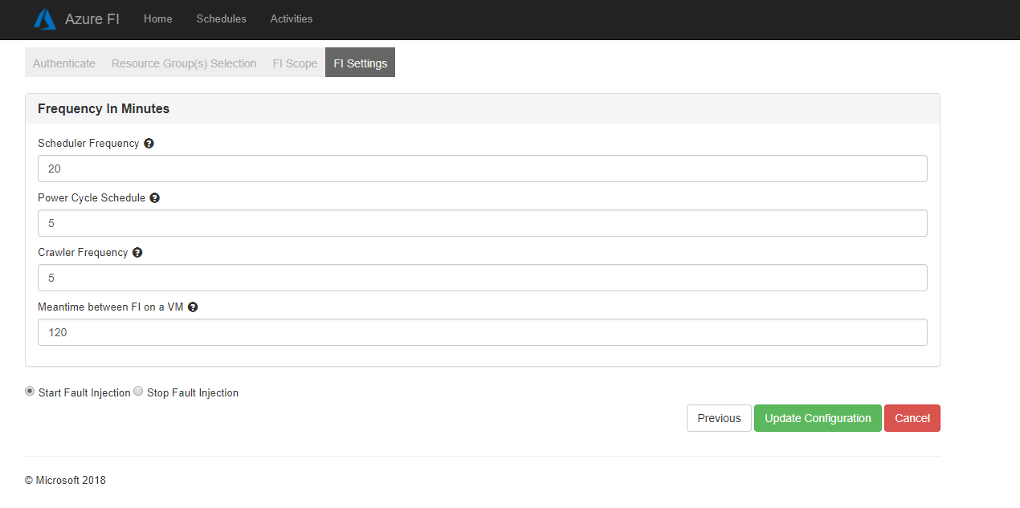

1. Submit : once you have entered all the data, click on the submit/UpdateConfiguration. Once the data is submitted, blob with above configuration is created in storage account and the corresponding azure functions are deployed. If you wish to edit the config start over the process from step -1. Edit wouldn’t redeploy the functions again. It would only update the blob & app settings.