Extension Concept

In propose work author has used traditional deep learning algorithm to remove noise and not applied any super-resolution algorithms to regenerate new clear image by enhancing all weaker pixels with super resolution pixels to make image clearer and noise free.

In below screen showing image output with extension super resolution enhancement.

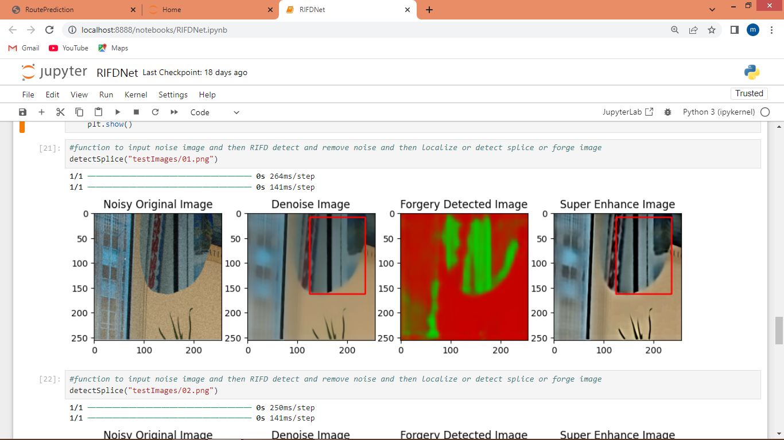

In above screen first image is the original noise image, second image is the propose de-noise image and 3rd image is the forgery detected image and 4th image is the super-resolution image which is more clear than other image output

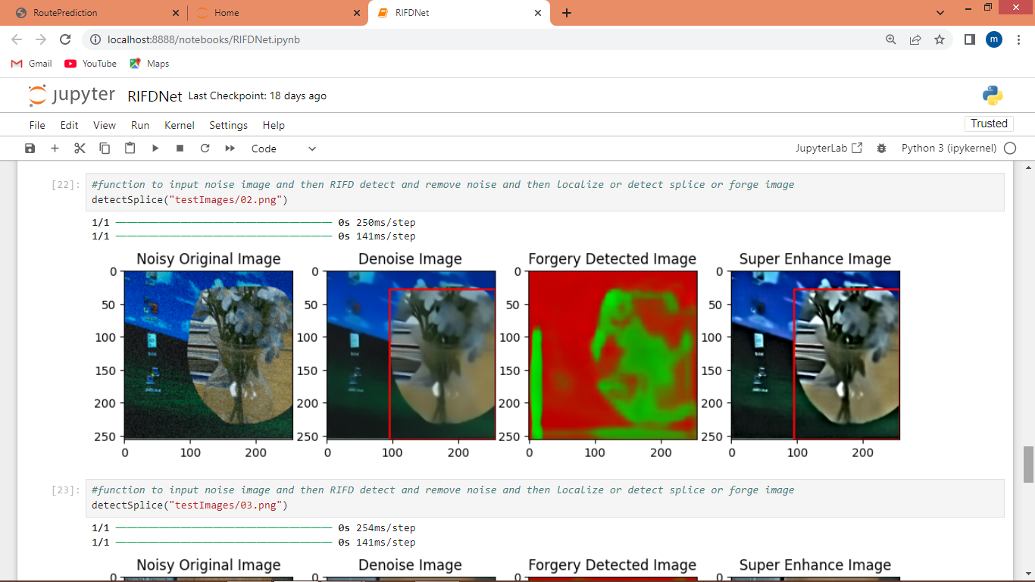

In above example also can see 4th image is more clear than other images

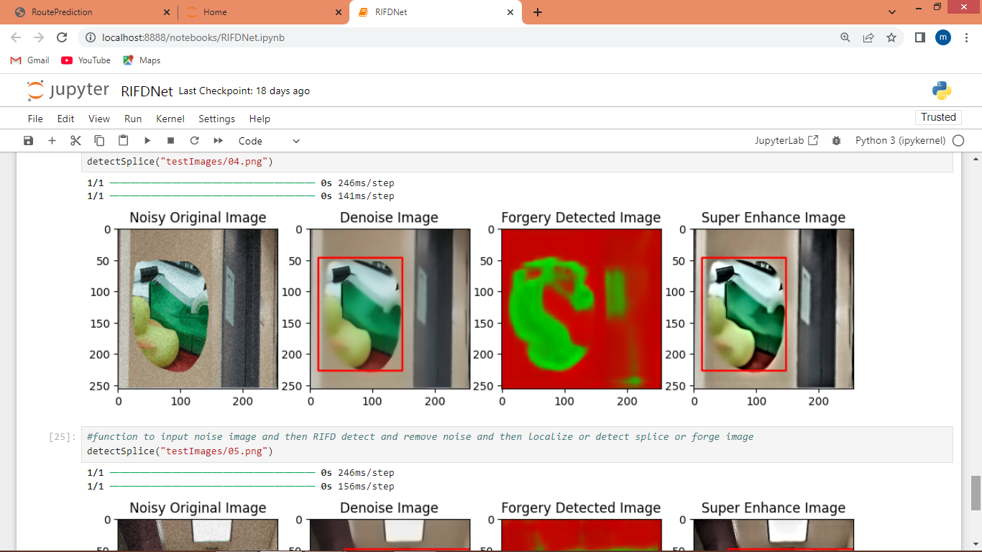

Above output also showing more clear image generated with extension algorithm

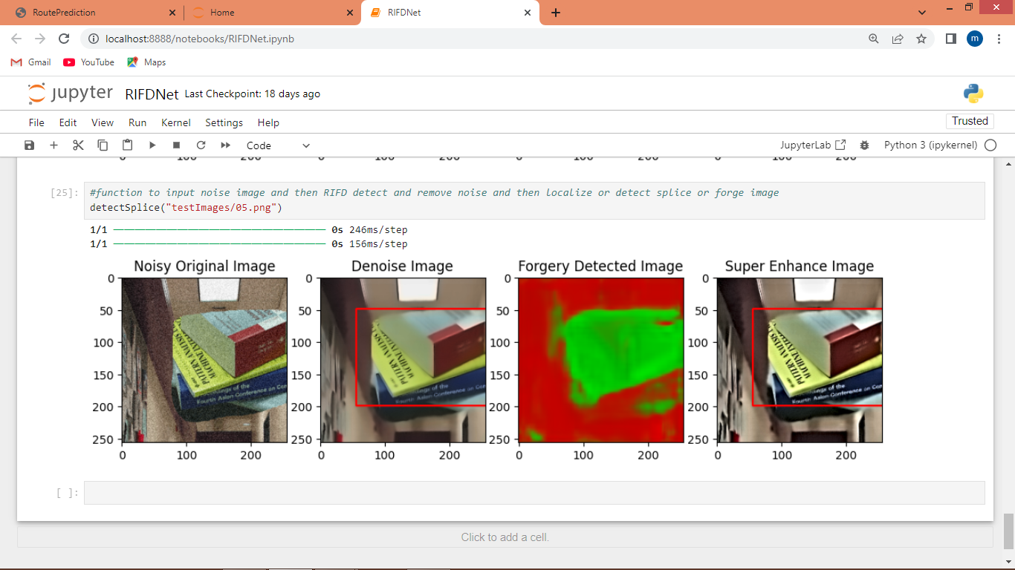

In above output also can see 4th image having super resolution clear pixels