RIFD-Net: A Robust Image Forgery Detection Network

Image splicing technique refers to remove and add object to images to form a new images and Splicing Forensic technique will be utilized to detect such Forgery. Image splicing also known image forgery and in the past many existing algorithms were invented to detect forgery but those algorithm detection accuracy will be highly degraded when splice images contains noise. To overcome from this issue and to enhance forgery detection from noisy images, author this paper employing novel technique called RIFD-Net.

Propose RIFD model consists of multiple classifiers such as Noise Detection, De-noise (remove noise with ADNET) and forgery detection. Noise detection layer help algorithm to predict noise and then employ ADNET de-noise model to clean noisy image and then apply Siamese layer will be applied to calculate similarity between model and test images to detect forgery images.

In propose paper author has trained model to detect various noises such as Pepper & Salt, Gaussian noise and many more. To train above algorithms author has used multiple dataset such as LIVE1 for noise detection and Columbia dataset for image forgery detection and then calculate model performance in terms of MAP (mean absolute precision). MAP refers to number of correct forgery region detection from test images.

SCREEN SHOTS

We have coded this project using JUPYTER notebook and below are the code and output screens with blue colour comments

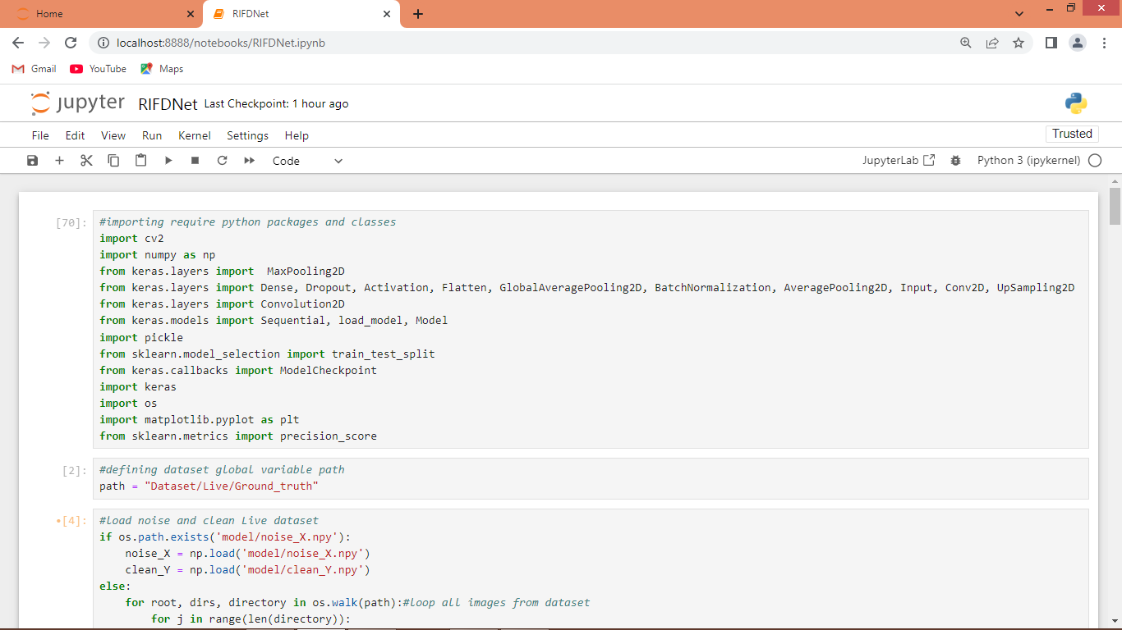

In above screen importing required python classes and packages

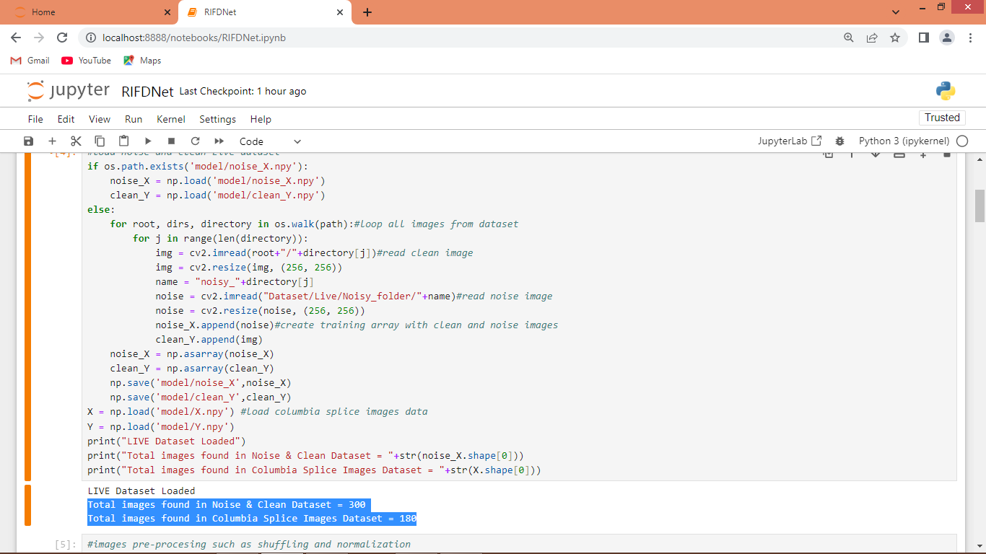

In above screen looping and reading all clean, noise and Columbia splice images from dataset and then creating X and Y training array and then in blue text can see size of noise and Columbia images dataset

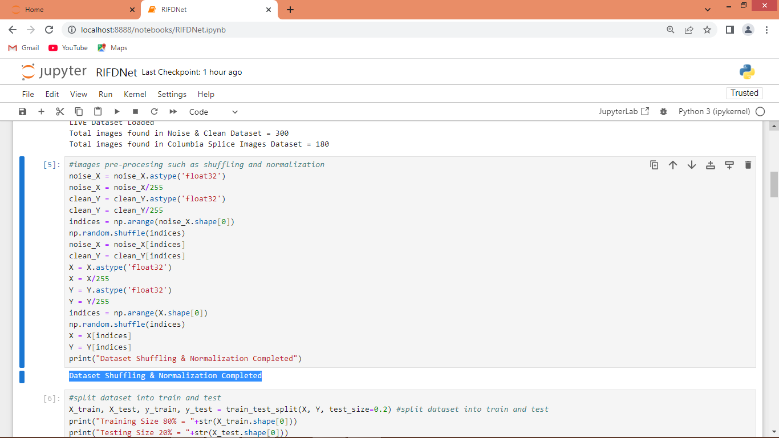

In above screen applying image processing techniques such as shuffling and normalization on all dataset images

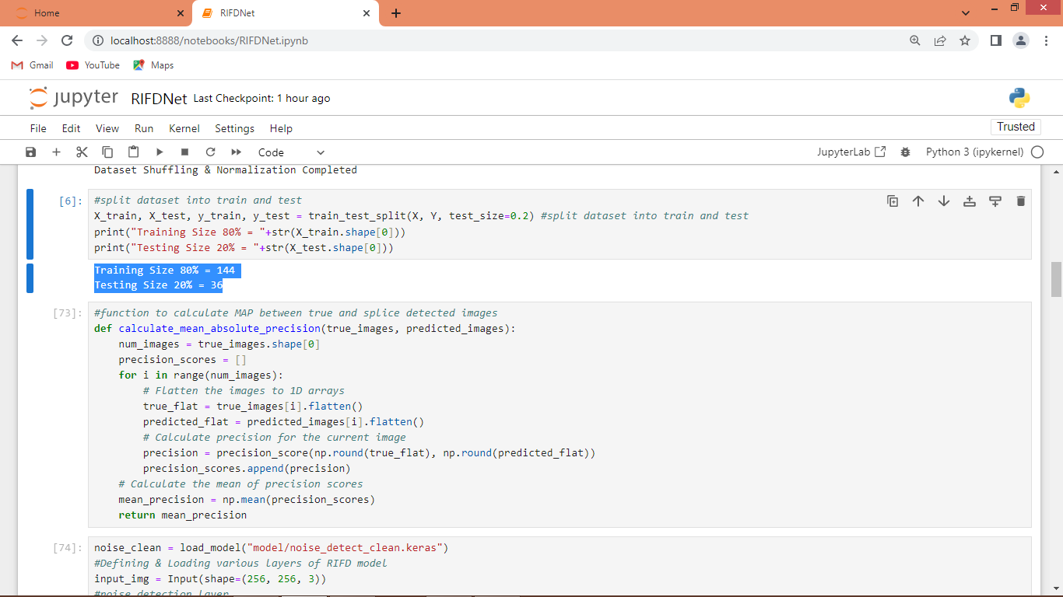

In above screen splitting dataset into train and test where application using 80% dataset for training and 20% for testing. In next block defining function to calculate MAP from True and predicted images

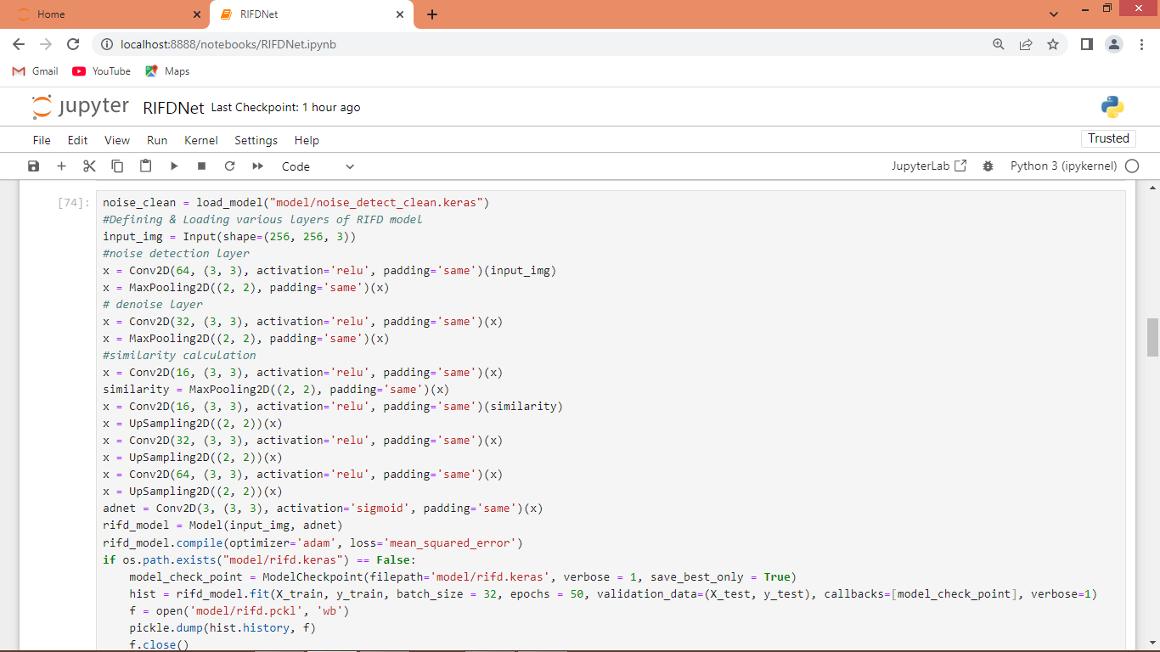

In above screen defining RIFD algorithm layers and after executing above block will get below output

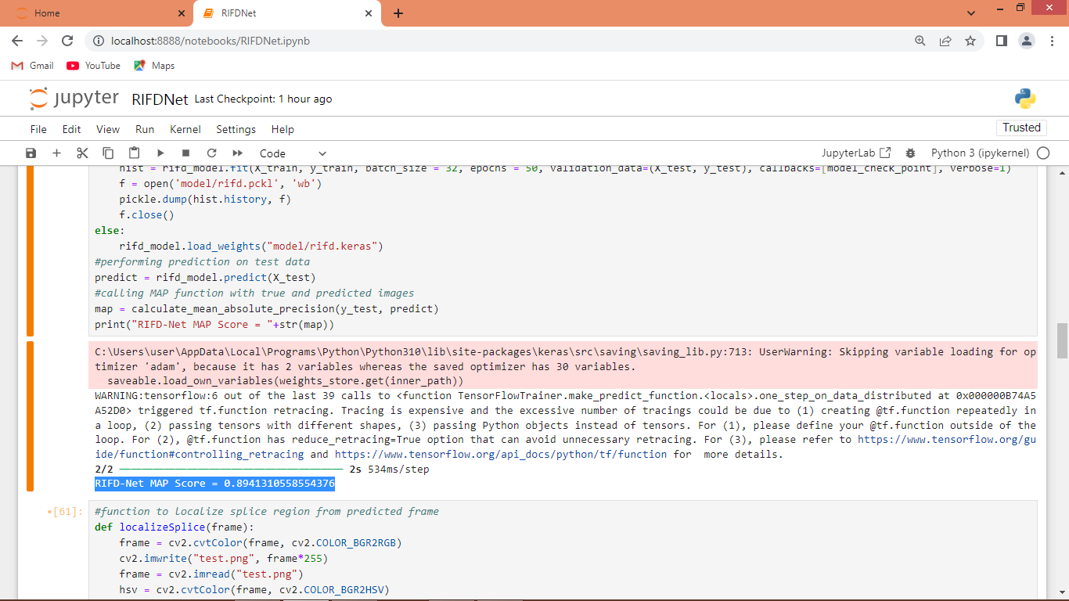

In above screen in blue text can see propose RIFD algorithm got 89% MAP on test images for splice detection

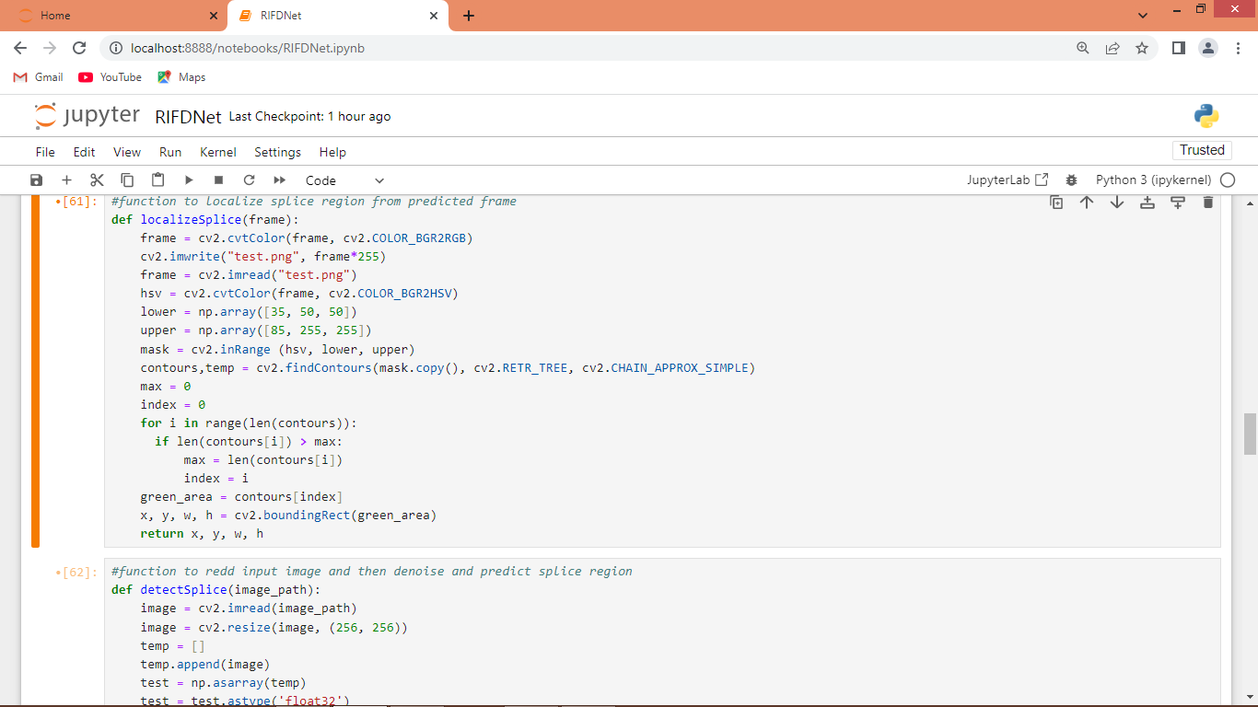

In above screen defining function to localize SPLICE region from predicted frame

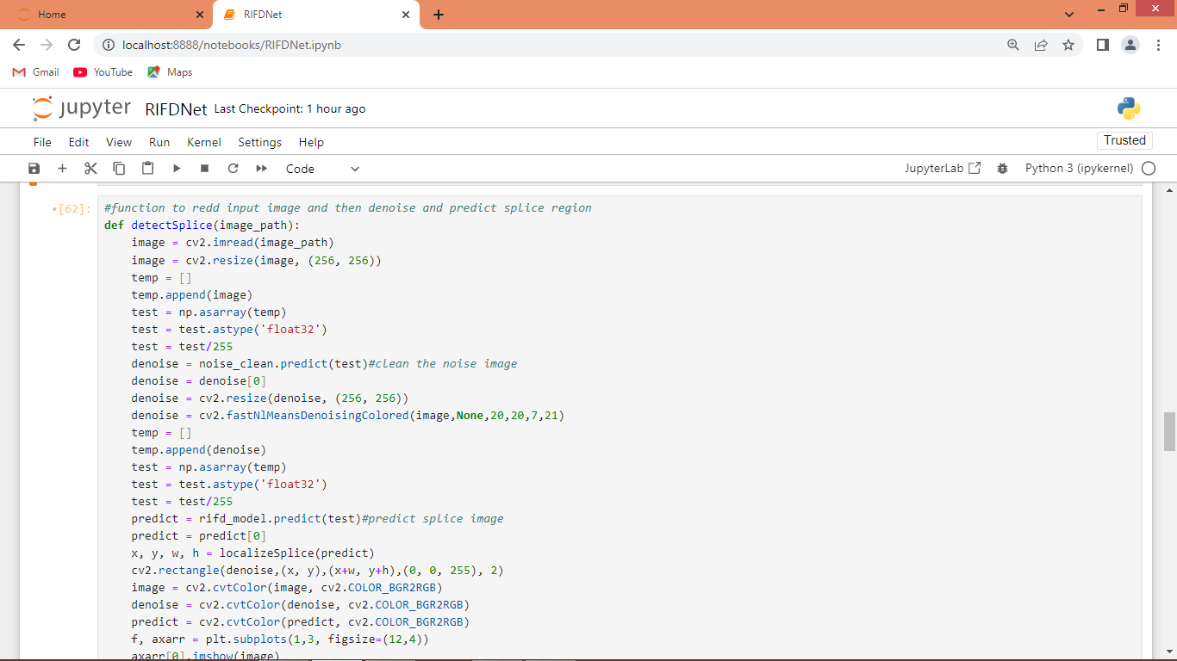

Above function will read test image and then apply model to clean noise and the apply model to predict splice image and then call ‘LocalizeSplice’ function to identify region which contains forgery or splice

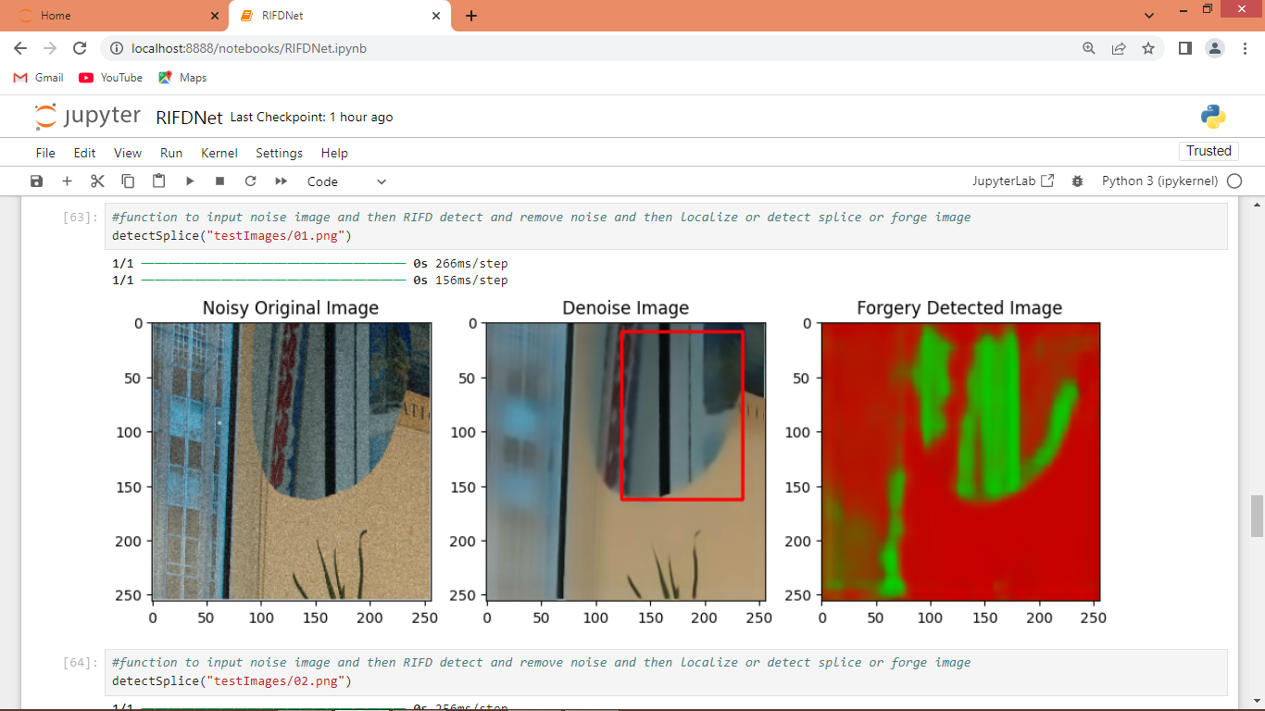

In above screen calling ‘detect Splice’ function with test image path and after executing function will get 3 images as output where first image is the noise image and second image is the de-noise image and 3rd image is the splice detection image and this detected part we are showing in de-noise image with red colour bounding box. So in above screen we de-noise image and then detect forgery or splice part

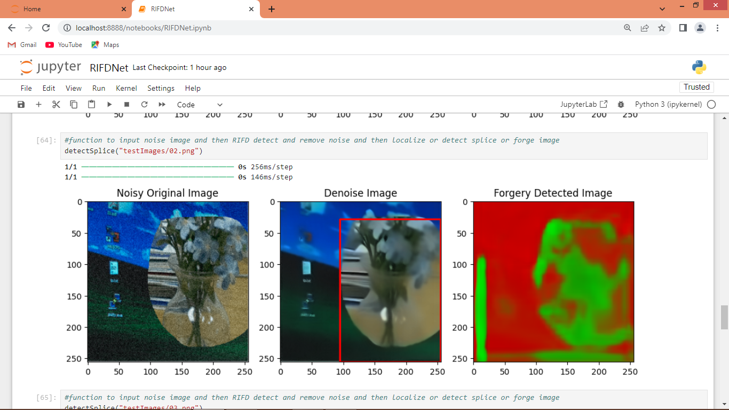

In above screen we are testing another image where first image contains so much noise and second contains noise-cleaned image and 3rd image is the splice detection image whose part is showing in second image along with red bounding box

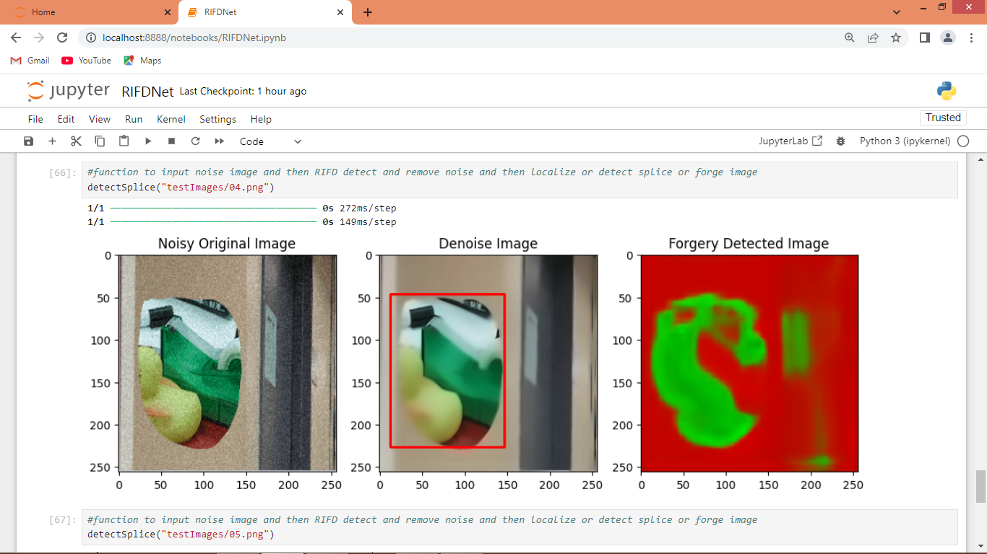

In above screen testing another image

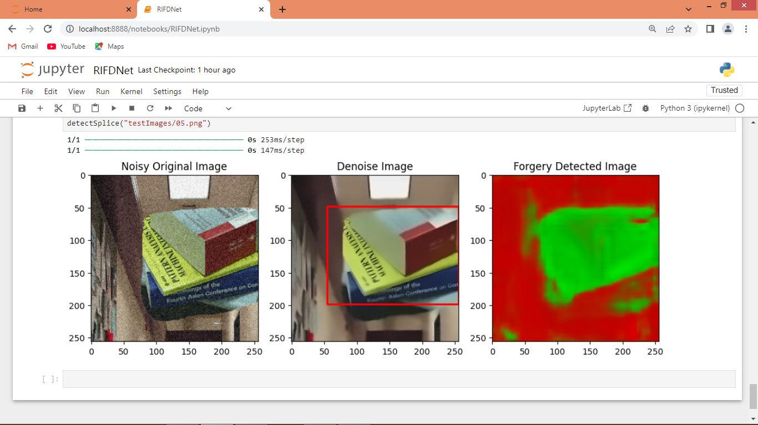

In above screen can see splice detection output of another image where splice region is in red bounding box