

A
Project Report On
"1HealthySync"
(CE451 - Software Project Major)

Prepared by
Krishna Thakor (21CE142)

Under the Supervision of
Prof. Parmanand Patel

Submitted to
Charotar University of Science & Technology (CHARUSAT) for the Partial Fulfillment of the Requirements for the
Degree of Bachelor of Technology (B.Tech.)
in U & P U. Patel Department of Computer Engineering (CE)
for B.Tech Semester 8

Submitted at

Accredited with Grade A+ by NAAC

U & P U. PATEL DEPARTMENT OF COMPUTER ENGINEERING
Chandubhai S. Patel Institute of Technology (CSPIT) Faculty of Technology & Engineering (FTE), CHARUSAT At: Changa, Dist: Anand, Pin: 388421.
May 2025


A
Project Report On
"1HealthySync"
(CE451 - Software Project Major)


Prepared by
Krishna Thakor (21CE142)

Under the Supervision of
Prof. Parmanand Patel

Submitted to
Charotar University of Science & Technology (CHARUSAT) for the Partial Fulfillment of the Requirements for the
Degree of Bachelor of Technology (B.Tech.)
in U & P U. Patel Department of Computer Engineering (CE)
for B.Tech Semester 8

Submitted at

Accredited with Grade A+ by NAAC

U & P U. PATEL DEPARTMENT OF COMPUTER ENGINEERING
Chandubhai S. Patel Institute of Technology (CSPIT) Faculty of Technology & Engineering (FTE), CHARUSAT At: Changa, Dist: Anand, Pin: 388421.
May 2025

DECLARATION BY THE CANDIDATE

I hereby declare that the project report entitled “1HealthySync” submitted by me to Chandubhai S. Patel Institute of Technology, Changa in partial fulfilment of the requirements for the award of the degree of B.Tech Computer Engineering, from U & P U. Patel Department of Computer Engineering, CSPIT, FTE, is a record of bonafide CE451 Software Project Major (project work) carried out by me under the guidance of Prof. Parmanand Patel. I further declare that the work carried out and documented in this project report has not been submitted anywhere else either in part or in full and it is the original work, for the award of any other degree or diploma in this institute or any other institute or university.

Krishna Thakor (21CE142)

This is to certify that the above statement made by the candidate is correct to the best of my knowledge.

Prof. Parmanand Patel
Assistant Professor
U & P U. Patel Department of Computer Engineering,
Chandubhai S Patel Institute of Technology (CSPIT)
Faculty of Technology (FTE)
Charotar University of Science and Technology (CHARUSAT) - Changa.

Date : 8th April, 2025

INTERNSHIP CERTIFICATE (Provisional)

This is to certify that Krishna Maheshchandra Thakor, B.Tech (CE) students of Chandubhai S. Patel Institute of Technology, CHARUSAT, Changa is doing a project on “1HealthySync” at 1RIVET from 6th January, 2025. Her internship will be ending on 30th May, 2025. After the completion of Internship on 30th May, 2025 she will get Project completion certificate.

Thanking you.

For 1RIVET


Ms. Ruchi Kansara
Associate L1



Accredited with Grade A+ by NAAC

CERTIFICATE

This is to certify that the report entitled “1HealthySync” is a bonafied work carried out by Krishna Thakor (21CE142) under the guidance and supervision of Prof. Parmanand Patel & Ms. Ruchi Kansara for the subject Software Project Major (CE451) of 8th Semester of Bachelor of Technology in Computer Engineering at Chandubhai S. Patel Institute of Technology (CSPIT), Faculty of Technology & Engineering (FTE) – CHARUSAT, Gujarat.

To the best of my knowledge and belief, this work embodies the work of candidate herself, has duly been completed, and fulfills the requirement of the ordinance relating to the B.Tech. Degree of the University and is up to the standard in respect of content, presentation and language for being referred by the examiner(s).

Under the supervision of,

Prof. Parmanand Patel Assistant Professor
U & P U. Patel Dept. of Computer Engineering CSPIT, FTE, CHARUSAT, Changa, Gujarat
Ms. Ruchi Kansara
Associate L1
Data Team
1RIVET

Dr. Nikita Bhatt
Head - U & P U. Patel Department of Computer Engineering, CSPIT, FTE, CHARUSAT, Changa, Gujarat.

Chandubhai S. Patel Institute of Technology (CSPIT) Faculty of Technology & Engineering (FTE), CHARUSAT At: Changa, Ta. Petlad, Dist. Anand, Pin: 388421. Gujarat
ABSTRACT
The 1HealthySync (Prescription Management System) is a digital healthcare platform designed to bridge the gap between doctors, pharmacists, and patients by streamlining prescription-related workflows. This system ensures that prescriptions are uploaded, approved, and tracked in real time through its Online Transaction Processing (OLTP) component. By offering a centralized space for prescription handling, it enhances communication, reduces errors, and promotes transparency across all stakeholders involved in the medication management process.
To support data-driven decisions, the system incorporates a robust Extract, Transform, Load (ETL) pipeline. This layer retrieves raw data from the OLTP system, applies transformation rules to ensure data consistency and compliance with the target schema, and then loads it into a well-structured Data Warehouse. The ETL process not only ensures the accuracy and integrity of the stored data but also prepares it for further analysis, enabling a scalable and efficient foundation for health-related insights.
An Online Analytical Processing (OLAP) layer, built on top of a snowflake schema, powers the system’s analytics capabilities. Through business intelligence dashboards, users can perform advanced analyses, such as identifying prescription patterns, tracking approval delays, and monitoring user activity across roles. These insights can significantly improve operational efficiency, support better healthcare decisions, and contribute to enhancing overall patient outcomes through data-driven optimization.

ACKNOWLEDGMENT
I would like to express my sincere gratitude to all those who contributed to the successful completion of this project.
Firstly, I would like to thank my Internal Guide, Prof. Parmanand Patel, for his invaluable guidance, continuous support, and encouragement throughout the course of this project. His expertise and constructive feedback were pivotal in shaping the direction of this work.
I am also deeply grateful to my External Guide, Mr. Vedant Desai and Ms. Nidhi Shah, for their insights and for providing me with the opportunity to work on this challenging yet rewarding project. Their guidance was instrumental in refining the project and ensuring its successful execution.
I would also like to acknowledge the support of the Project Coordinators, Business Analyst and Quality Assurance Team, who played a crucial role in bringing the user interface of the 1HealthySync to life. Their collaboration and expertise in this entire process were key to ensuring a seamless user experience.
Furthermore, I would like to thank the Documentation provided by various resources, especially learn.microsoft.com, which proved to be an excellent learning tool in building and understanding the underlying concepts of SQL Server, ETL Pipeline and Power BI. Their content greatly assisted me in implementing various components of the project.

TABLE OF CONTENTS
ABSTRACT vi
ACKNOWLEDGMENT vii
1. INTRODUCTION 1
1.1 PROJECT SUMMARY 1
1.2 PURPOSE 1
1.3 OBJECTIVE 2
1.4 SCOPE 2
1.5 TECHNOLOGY AND LITERATURE REVIEW 3
2. PROJECT MANAGEMENT 5
2.1 PROJECT PLANNING 5
2.1.1 Project Development Approach and Justification 5
2.1.2 Project Effort and Time, Cost Estimation 5
2.1.3 Roles and Responsibilities 5
2.1.4 Group Dependencies 6
2.2 PROJECT SCHEDULING 6
3. SYSTEM REQUIREMENTS STUDY 7
3.1 USER CHARACTERISTICS 7
3.2 HARDWARE AND SOFTWARE REQUIREMENTS 7
3.2.1 Hardware Requirements: 7
3.2.2 Software Requirements: 8
3.3 ASSUMPTIONS AND DEPENDENCIES 8
4. SYSTEM ANALYSIS 9
4.1 STUDY OF CURRENT SYSTEM 9
4.2 PROBLEMS AND WEAKNESSES OF CURRENT SYSTEM 9
4.3 REQUIREMENTS OF NEW SYSTEM 9
4.3.1 Functional Requirements 9
4.3.2 Non-Functional Requirements 11
4.4 FEASIBILITY STUDY 11
4.4.1 Does the system contribute to the overall objectives of the organization? 11
4.4.2 Can the system be implemented using the current technology and within the given cost and schedule constraints? 11
4.4.3 Can the system be integrated with other systems which are already in place? 11
4.5 PROCESS IN NEW SYSTEM 12
4.6 FEATURE OF NEW SYSTEM 13
4.7 FUNCTIONS OF NEW SYSTEM 13
4.8 DATA MODELLING 15
4.9 DATA DICTIONARY 17
5. SYSTEM DESIGN 22
5.1 SYSTEM APPLICATION DESIGN 22
5.1.1 Method Pseudo Code 22
5.2 INPUT/OUTPUT AND INTERFACE DESIGN 23
5.2.1 Samples of Forms, Reports, and Interface 23
6. IMPLEMENTATION PLANNING 29
6.1 IMPLEMENTATION ENVIRONMENT 29
6.2 MODULES SPECIFICATION 29
6.3 SECURITY FEATURES 29
6.4 CODING STANDARD 30
7. TESTING 31
7.1 TESTING PLAN 31
7.2 TESTING STRATEGY 31
7.3 TEST SUITES DESIGN 32
8. CONCLUSION AND DISCUSSION 33
8.1 SELF ANALYSIS OF PROJECT VIABILITIES 33
8.2 PROBLEMS ENCOUNTERED AND POSSIBLE SOLUTIONS 33
8.3 SUMMARY OF PROJECT WORK 34
9. LIMITATIONS AND FUTURE ENHANCEMENTS 35
10. BIBLIOGRAPHY 37
11. PLAGIARISM REPORT 38

LIST OF TABLES
Table 2.1: Roles and Responsibilities…….....……………………………………………………………6
Table 4.1: Functional Requirements.......…….………………………………………………………….11
Table 4.2: Non-Functional Requirements................……………………………………………………11
Table 7.1: Test Cases……………………………………..…………………………………….…………32

LIST OF FIGURES
Fig 2.1: Agile Methodology.…………….....………………..……………………………………………5
Fig 2.2: Gantt Chart.……………………......……………….……………………………………………6
Fig 4.1: Activity Diagram....……………......……………….…………………………………………..13
Fig 4.2: OLTP Data Model...….…………......…………….……………………………………………15
Fig 4.3: Staging Data Model......…………......…………….……………………………………………16
Fig 4.4: Enterprise Data Warehouse Landing Data Model......…………………………………………16
Fig 4.5: Enterprise Data Warehouse Data Model....….…………………………………………………17
Fig 4.6: Med.Pharmacy Data Dictionary..... ………….…………………………………………………17
Fig 4.7: Med.UserDetails Data Dictionary.......……….…………………………………………………18
Fig 4.8: Med.Prescription Data Dictionary…..........….…………………………………………………18
Fig 4.9: Med.PrescriptionMedicines Data Dictionary.....………………………………………………19
Fig 4.10: Med.Doctor Data Dictionary…........…….……………………………………………………19
Fig 4.11: Med.Allocation Data Dictionary......………..…………………………………………………19
Fig 4.12: Med.DoctorSpecialization Data Dictionary....….……………………………………………20
Fig 4.13: Ref.City Data Dictionary...............……………………………………………………………20
Fig 4.14: Ref.State Data Dictionary...…….......…………………………………………………………20
Fig 4.15: Ref.Medicine Data Dictionary.......……………………………………………………………20
Fig 4.16: Ref.Disease Data Dictionary.........……………………………………………………………21
Fig 4.17: Ref.Status Data Dictionary…........……………………………………………………………21
Fig 4.18: Ref.Specialization Data Dictionary.…..………………………………………………………21
Fig 5.1: System Architecture....…………......…………………………………………………………..22
Fig 5.2: Pseudo Code…….....….…………......…………………………………………………………22
Fig 5.3: User Role Selection.......…………......…………………………………………………………23
Fig 5.4: Doctor Sign Up………….……………………….....…………………………………………23
Fig 5.5: Sign In…………………………………....……………………………………………………23
Fig 5.6: Forgot Password.............................. ……………………………………………………………24
Fig 5.7: Reset Password....................................…………………………………………………………24
Fig 5.8: OTP Verification Code ….............................……………………………………………………24
Fig 5.9: Patient Sign Up……………….…………….....………………………………………………25
Fig 5.10: Pharmacy Sign Up …........................…………………………………………………………25
Fig 5.11: Admin Dashboard………….……....…………………………………………………………25
Fig 5.12: Doctor Dashboard…………………………...….……………………………………………26
Fig 5.13: Patient Dashboard………..............……………………………………………………………26
Fig 5.14: Pharmacy Dashboard...…………......…………………………………………………………26
Fig 5.15: ETL Pipeline Part-1......…………………...……………………………………………………27
Fig 5.16: ETL Pipeline Part-2.........………………………………………………………………………27
Fig 5.17: ETL Pipeline Part-3 ….......……………………………………………………………………28
Fig 5.18: Power BI Dashboard for 2 KPIs…..……………………………………………………………28

1. INTRODUCTION
1.1 PROJECT SUMMARY
1HealthySync is an intelligent, secure, and user-friendly digital solution developed to transform how prescriptions are managed across healthcare facilities such as hospitals, clinics, and pharmacies. By replacing traditional paper-based systems with automated, real-time prescription exchanges, the platform improves collaboration among healthcare providers and patients, ensuring a more streamlined, reliable, and efficient medication workflow.

The system is designed to minimize prescription-related delays and reduce human errors, allowing medical professionals to dedicate more time to patient care. One of the standout features of 1HealthySync is its built-in Key Performance Indicator (KPI) dashboard, which delivers live, data-rich insights into both operational and system-level performance. These insights allow stakeholders to make informed, data-centric decisions aimed at optimizing healthcare delivery and system efficiency.

Core Business Advantages:
- Informed decision-making through real-time analytics
- Faster prescription processing times
- More accuracy and fewer prescription mistakes
- Scalable infrastructure that supports future healthcare innovations
1.2 PURPOSE
At 1HealthySync, the vision is to streamline and modernize the entire prescription management process, creating a more efficient, secure, and connected healthcare environment for doctors, pharmacists, and patients. The platform aims to eliminate outdated paper-based methods by introducing real-time, automated workflows that ensure smooth and transparent prescription handling.

By cutting down on delays and reducing the chances of errors, the system enables medical professionals to focus more on patient care rather than administrative tasks. Additionally, the integrated KPI dashboard delivers clear and actionable insights into system and workflow performance. These analytics empower decision-makers to implement continuous improvements based on real-time data, ultimately enhancing the overall quality and speed of healthcare services.
1.3 OBJECTIVE
The primary objective of the 1HealthySync project is to streamline prescription management by enabling doctors to digitally create, approve, and reject prescriptions. Pharmacists and patients can effortlessly upload, manage, and access prescriptions, making the entire process smoother and more efficient.

Another key goal is to digitize the traditional paper-based workflow. By introducing a secure and centralized system, the project enhances accessibility, traceability, and accuracy in handling medical prescriptions, significantly reducing dependency on manual processes.

The system also promotes data-driven decision-making. Through an integrated KPI visualization dashboard, stakeholders can easily monitor system performance, track user engagement, and analyze turnaround times. Doctors, administrators, and pharmacists can use these insights to identify trends, optimize workflows, and improve patient care.

Minimizing prescription errors is a major focus. By reducing human errors associated with manual entries and handwriting, the platform ensures safer medication delivery and better communication between healthcare providers and patients.

Enhancing operational efficiency is another important aspect. By automating routine tasks, healthcare professionals are freed from repetitive work, allowing them to concentrate more on delivering quality clinical care.

The project is also built with scalability in mind. Its modular infrastructure allows easy integration of future expansions such as billing systems, inventory management for pharmacies, and additional administrative features without compromising the performance of the current version.

Finally, 1HealthySync ensures strong data security and accessibility. It maintains a centralized, encrypted database with role-based access control, safeguarding sensitive patient information while providing authorized users with the necessary access.
1.4 SCOPE
The following areas are in scope for this project:
KPIs:
- Doctor's Dashboard KPIs:
  - View Cancelation and Modification Report
  - Patient Flow
  - High Risk Patient
  - Recurring Prescription Tracking
  - Seasonal Prescription Demand Analysis
  - Tracking Approved Prescription
- Pharmacist KPIs:
  - Stock Utilization Rate
  - Number of Prescriptions vs Medicine Report
- Admin KPIs:
  - View Patients Attended Report
  - Doctor Booking Acceptance Rate
  - Prescription Approval & Rejection Dashboard
  - Doctor Appointment Analytics Dashboard
  - Disease Diagnosis Tracking Dashboard
- Common KPIs for Doctor and Pharmacist:
  - Patient Count by Disease
  - Medicine Demand Forecasting Dashboard
- Common KPIs for Doctor and Admin:
  - Doctor Consultation Analytics Dashboard
1.5 TECHNOLOGY AND LITERATURE REVIEW
Microsoft SQL Server
Microsoft SQL Server is a widely adopted relational database management system known for its robustness, scalability, and support for Online Transaction Processing (OLTP). In the context of this project, SQL Server plays a critical role in managing and storing real-time prescription data. It enables fast insertions, updates, and queries, which are essential for handling high-volume transactional workloads.

The ACID (Atomicity, Consistency, Isolation, Durability) compliance of SQL Server ensures that all prescription-related operations are processed reliably, maintaining data accuracy and integrity across healthcare stakeholders. Literature highlights its effective indexing mechanisms and optimized query processing as key enablers of high-performance transaction handling in enterprise applications.

Visual Studio with SQL Server Integration Services (SSIS) for ETL
To enable analytics, the project employs an Extract, Transform, Load (ETL) pipeline built using Visual Studio with SQL Server Integration Services (SSIS). SSIS is a powerful tool designed for high-performance data integration and transformation. It allows data to be extracted from the OLTP database, cleansed, and reshaped according to the schema requirements of the analytical Data Warehouse.

The flexibility offered by Visual Studio during ETL development supports tasks like data validation, cleansing, type conversions, and conditional logic with ease. Academic sources and industry case studies confirm that Visual Studio combined with SSIS is a reliable choice for building scalable, maintainable ETL workflows in healthcare and business intelligence applications.

Power BI for Business Intelligence and Analytics
Power BI is used in this project as the primary data visualization and analytics tool. It connects seamlessly with the Data Warehouse and provides dynamic dashboards that offer insights into key performance metrics such as prescription approval times, trends, and user activity.

Power BI’s drag-and-drop interface and real-time data refresh capabilities make it accessible even to non-technical users, empowering all stakeholders with decision-making tools. Research literature often cites Power BI’s role in democratizing data access and enabling agile decision-making through interactive visualizations and AI-assisted analytics features.

2. PROJECT MANAGEMENT
2.1 PROJECT PLANNING
2.1.1 Project Development Approach and Justification
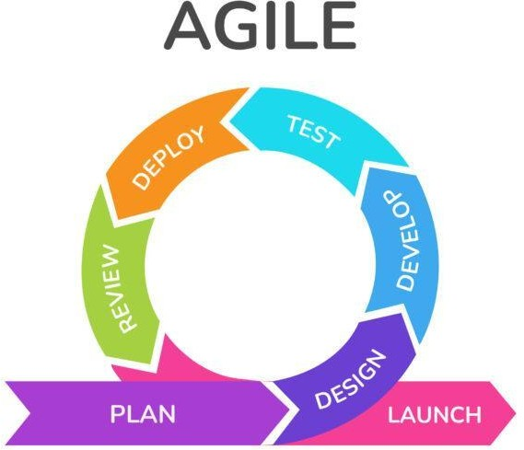
Fig 2.1 Agile Methodology
The project followed an Agile Development Methodology to allow for iterative development, testing, and refinement. This approach ensured flexibility and frequent feedback incorporation, which is crucial when working with evolving user requirements.
2.1.2 Project Effort and Time, Cost Estimation
With a committed team of Nineteen people, the project was expected to take about two months to complete. Based on staffing levels, technological infrastructure, and marketing requirements, costs were estimated. The entire projected cost, which included stipends, software licences, server hosting was approximately rupees 1,80,000. Estimates of time and money were reviewed and modified on a regular basis in response to stakeholder feedback and project developments.
2.1.3 Roles and Responsibilities
Team Members | Role | Responsibilities
Divyesh Pardiwala, Siddhi Patel | Project Coordinator | Responsible for overall project execution and Monitoring timelines and resource allocation.
Nidhi Ahir, Ishan Desai, Param Chhaya, Siddh Bhavsar, Yash Chaubal | Business Analyst | Gathering and documenting requirements, defining Requirements, and ensuring alignment with business needs.
Krishna Thakor, Rushabh Palsanekar, Vivek Parmar, Priyansh Patel, Takshil Chinnakonda, Krishna Mistry, Hetvi Mistry, Maitri Patel, Vishal Singh, Amit Kumawat | Database Developer | Creation of OLTP Data Model, ETL Pipeline and Power BI dashboard.
Jay Desai, Denish Patel | Quality Assurance | Ensuring system meets defined quality benchmarks, Ensuring quality and performance.

Table 2.1 Roles and Responsibilities
2.1.4 Group Dependencies
- Business Analysts coordinated with developers to clarify requirement.
- Developers provided working modules to the QA team for validation.
- Coordinators ensured all teams stayed on track and addressed any cross-functional dependencies.
2.2 PROJECT SCHEDULING
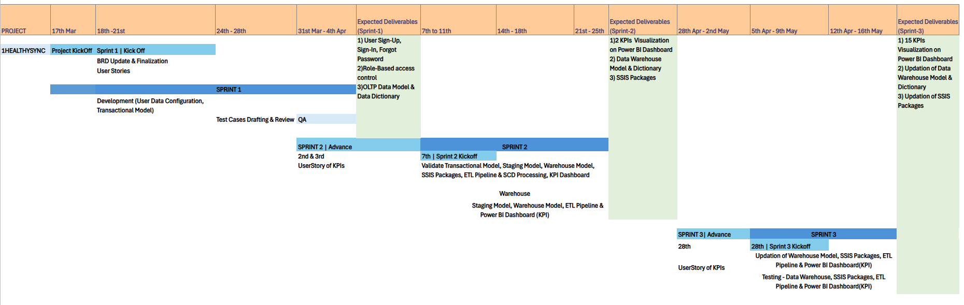

Fig 2.2 Gantt Chart

3. SYSTEM REQUIREMENTS STUDY
3.1 USER CHARACTERISTICS
The 1HealthySync is designed for three primary user groups: doctors, pharmacists, and patients. Doctors require an intuitive interface to create, upload, and manage prescriptions efficiently. Pharmacists need real-time access to approved prescriptions for quick validation and dispensing. Patients benefit from easy access to their prescription history and status updates. Additionally, administrators or healthcare managers may access analytical dashboards to monitor system performance. Users are expected to have basic digital literacy, with interfaces designed to be user-friendly and accessible across devices to ensure smooth interaction for all stakeholders involved in the healthcare workflow.
3.2 HARDWARE AND SOFTWARE REQUIREMENTS
3.2.1 Hardware Requirements
To ensure smooth performance and scalability of the 1HealthySync, the following hardware configurations are recommended:
- Processor: Minimum Intel Core i5 or equivalent, with multi-core support for efficient data processing and system operations.
- RAM: At least 8 GB of memory is required for handling database operations and ETL processing smoothly; 16 GB is recommended for optimal performance.
- Storage: A minimum of 256 GB SSD is suggested to ensure faster read/write speeds, especially for managing large volumes of transactional and analytical data.
- Display: A monitor with at least 1080p resolution for clear visualization, particularly during dashboard interaction in Power BI.
- Network: Reliable internet connectivity with a minimum speed of 10 Mbps for cloud sync, real-time data exchange, and remote access functionalities.

s

3.2.2 Software Requirements
The development and implementation of the 1HealthySync involve the use of several key software tools to support data storage, transformation, and visualization.
- Microsoft SQL Server: Used as the core relational database system for handling OLTP operations. It manages prescription records, user data, and transaction logs in a secure and structured format.
- Visual Studio (with SQL Server Integration Services - SSIS): Serves as the development environment for building the ETL pipeline. It facilitates the extraction of data from the OLTP system, transformation based on business rules, and loading into the Data Warehouse.
- Power BI: Utilized for creating interactive dashboards and reports. It enables real-time monitoring of key performance metrics such as prescription approval times, user activity, and system usage trends.
3.3 ASSUMPTIONS AND DEPENDENCIES
- All users (admin, doctors, pharmacists, and patients) will have access to the internet and a compatible device.
- Doctors and pharmacists will comply with role-based access and follow the approval workflow.
- Doctor Availability: If a doctor is unavailable (marked as busy), the prescription will be forwarded to the next available doctor.
- Time Constraint for Approval: If a doctor does not act on a prescription within a specified time, it will be sent to another doctor.
- There will be a List of Doctors, Medicines, Pharmacy Stores, Diseases, Specializations predefined.
- Only authorized users can access prescription records and approval workflows.
- The uploaded prescription must be in PNG or PDF format and should not exceed 1MB in size.

4. SYSTEM ANALYSIS
4.1 STUDY OF CURRENT SYSTEM
The existing prescription handling system is largely manual and inefficient, leading to delays and dissatisfaction among patients, doctors, and pharmacists. Typically, patients are given handwritten or printed prescriptions, which they must physically carry to a pharmacy. This process often results in waiting periods due to manual verification and, in some cases, pharmacists having to contact doctors for clarification, further extending the timeline.
Additionally, the absence of a centralized digital record increases the chances of prescriptions being misplaced or misused. Without a unified system, tracking a patient’s prescription history is challenging. Moreover, healthcare professionals lack access to analytical tools, making it difficult to identify usage patterns or make data-driven improvements in patient care.
4.2 PROBLEMS AND WEAKNESSES OF CURRENT SYSTEM
- Manual prescription handling increases the chances of human error and miscommunication.
- Illegible handwriting can lead to incorrect medication being dispensed.
- Patients often experience delays due to long queues and verification steps.
- Pharmacists may need to contact doctors for clarification, causing further slowdowns.
- There is no centralized system to store or retrieve a patient's prescription history.
- Lost or misplaced prescriptions are common, leading to repeated consultations.
- Healthcare professionals lack real-time data insights for decision-making.
- The system offers no analytics to detect trends or improve care outcomes.
4.3 REQUIREMENTS OF NEW SYSTEM
4.3.1 Functional Requirements
​​Sr. No. | ​Requirement | ​Description | ​User | ​Priority
​1 | ​User Registration | ​Users should be able to sign up through name, DOB email id and password. | ​All Users | ​High
​2 | ​Login | ​log in securely using an email and password. | ​All Users | ​High
​3 | ​Forgot Password | ​Users should be able to reset their password via email. | ​All Users | ​Medium
​4 | ​Patients Attended Report | ​Tracks the number of patients attended by doctors over a given period. | ​Admin | ​Critical
​5 | ​Prescription Approval & Rejection Dashboard | ​Monitors the rate of approved and rejected prescriptions for compliance analysis. | ​Admin | ​Critical
​6 | ​Number of Prescriptions vs. Medicine Report | ​Automatically save new prescriptions in the user's history after a second checkup. | ​Pharmacist | ​High
​7 | ​Doctor Booking Acceptance Rate  ​ | ​Measures the percentage of doctor appointment requests that are accepted. | ​Admin | ​High
​8 | ​Prescription Approval & Rejection Dashboard | ​Monitors the rate of approved and rejected prescriptions for compliance analysis. | ​Admin | ​Medium
​9 | ​Tracking Approved prescriptions | ​Keeps a record of all successfully approved prescriptions for audit and review. | ​Doctor | ​High
​10 | ​Patient count by disease | ​Analyzes the number of patients diagnosed with different diseases. | ​Doctor, Pharmacist | ​High
​11 | ​Doctor Appointment Analytics Dashboard | ​Evaluates trends in doctor appointments, cancellations, and patient visits. | ​Admin | ​High
​12 | ​High Risk Patients | ​Identifies patients with critical health conditions requiring immediate attention. | ​Doctor | ​High
​13 | ​Doctor Consultation Analytics Dashboard | ​Assesses doctor consultation efficiency, duration, and patient interactions. | ​Admin, Doctor | ​High
​14 | ​Medicine Demand Forecasting Dashboard | ​Predicts future medicine demand based on historical usage and trends. | ​Doctor, Pharmacist | ​High
​15 | ​Disease Diagnosis Tracking Dashboard | ​Tracks disease prevalence to identify emerging health trends. | ​Admin | ​High
​16 | ​Seasonal Prescription Demand Analysis | ​Examines how prescription trends fluctuate based on seasonal variations. | ​Doctor | ​High
​17 | ​Stock Utilization Rate | ​Measures how efficiently medical supplies are being used over time. | ​Pharmacist | ​High
​18 | ​Recurring prescription tracking | ​Monitors patients receiving repeated prescriptions for chronic conditions. | ​Doctor | ​High​

Table 4.1 Functional Requirements
4.3.2 Non-Functional Requirements
Sr. No. | Requirement | Description
1 | Scalability | System should handle increasing users and prescription listings.
2 | Availability & Uptime | The platform should be available most of the time with minimal downtime once a month.
3 | System Backup | Automatic backups of user data and other information.
4 | Usability | The system should have a user-friendly interface.
5 | Cross-Platform Compatibility | The system should work on mobile, and tablets with responsive design.

Table 4.2 Non-Functional Requirements
4.4 FEASIBILITY STUDY
4.4.1 Does the system contribute to the overall objectives of the organization?
Yes, 1HealthySync supports the broader goals of healthcare organizations by streamlining workflows, minimizing errors, and improving service efficiency. By digitizing the prescription process and offering data-driven insights, it enhances operational effectiveness and supports better decision-making, ultimately contributing to improved patient care and organizational performance.

4.4.2 Can the system be implemented using the current technology and within the given cost and schedule constraints?

Yes. The system can be successfully developed using existing technologies such as Microsoft SQL Server, Visual Studio, and Power BI. These tools are readily available and widely supported, reducing the need for costly investments in new platforms. Additionally, the system is modular and scalable, making it possible to build and deploy it within a reasonable timeline and budget, without disrupting existing operations.

4.4.3 Can the system be integrated with other systems which are already in place?

Yes. 1HealthySync is designed to be flexible and compatible with other healthcare systems. It supports data exchange through standardized formats and can be integrated with existing hospital management software, pharmacy inventory systems, or electronic health records (EHRs). This ensures continuity in operations and minimizes the need for major changes to current infrastructure.
4.5 PROCESS IN NEW SYSTEM
1HealthySync streamlines the interaction among four key user roles—Patient, Doctor, Pharmacist, and Admin—through a structured digital workflow. Each user begins by either registering or logging into the system. Patients initiate the process by selecting their health issue or uploading a prescription. The system then assigns a specialized doctor for diagnosis. The doctor evaluates the patient's condition, creates a prescription. If the prescription is uploaded by the pharmacist or patient, it is forwarded to the doctor, if approved, the pharmacist is notified to dispense the medicine; otherwise, the request is forwarded to another available doctor. Meanwhile, the admin generates reports for monitoring and analysis. The final step involves the patient receiving the prescribed medicine, completing the cycle.
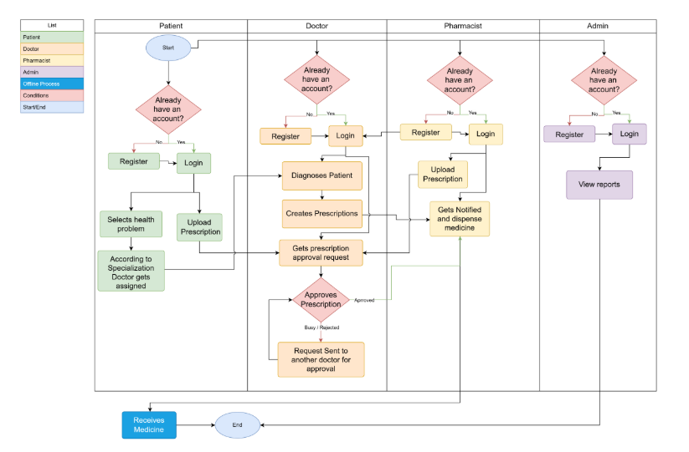
Fig 4.1 Activity Diagram
4.6 FEATURE OF NEW SYSTEM
- Digital Prescription Upload: Doctors can create and submit prescriptions in real-time through a secure web interface, eliminating paper-based methods.
- Real-Time Access for Pharmacists: Pharmacists receive instant notifications of approved prescriptions, allowing faster processing and reduced wait times for patients.
- Patient Portal: Patients can view their prescription history, track approval status, and receive alerts for medication pick-up or renewals.
- ETL Integration: A built-in ETL pipeline automatically extracts, transforms, and loads data into the analytics layer, ensuring clean and structured data for insights.
- Dashboard and Analytics: Power BI dashboards provide interactive visualizations of key metrics such as prescription trends, user activity, and turnaround times.
- Role-Based Access Control: Different access levels ensure that doctors, pharmacists, and patients can only access features relevant to their roles.
- Audit and Tracking: The system maintains logs of all transactions, supporting transparency and traceability of actions taken by users.
- Data Security and Privacy: Secure login, data encryption, and access policies are enforced to protect sensitive medical data.
- Scalability and Flexibility: The system is designed to adapt to growing user bases and can be integrated with other healthcare applications when needed.
  - FUNCTIONS OF THE NEW SYSTEM
- User Authentication and Role Management: Ensures secure login and access control by assigning specific roles to doctors, pharmacists, patients, and administrators.
- Prescription Creation and Submission: Allows doctors to digitally generate and submit prescriptions, which are instantly available in the system.
- Prescription Verification and Approval: Pharmacists can view, verify, and approve prescriptions through their dashboard, reducing delays and manual checks.
- Patient Record Access: Patients can log in to view their prescription history, current medications, and status updates.
- ETL Data Processing: The system includes an ETL pipeline that extracts data from the OLTP system, transforms it into a structured format, and loads it into a data warehouse for analysis.
- Analytics and Reporting: Enables users (especially admins and healthcare managers) to access real-time reports and insights via dashboards, helping in operational and strategic decision-making.
- Data Synchronization: Ensures that updates made by one user (e.g., a doctor uploading a prescription) are reflected in real time across all relevant modules.
- Audit Trail and Logging: Maintains logs of key actions and system changes for transparency, troubleshooting, and accountability.
- Notification and Alerts: Sends automatic updates to users about new prescriptions, approvals, or required actions via system notifications or emails.

  - DATA MODELLING
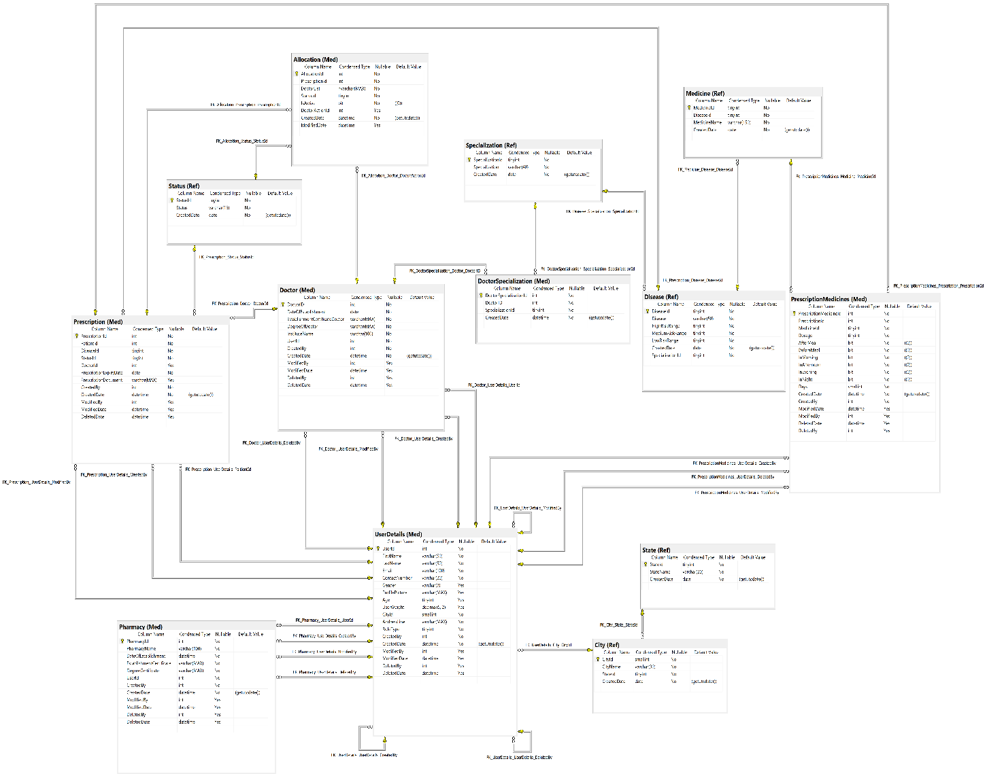
Fig 4.2 OLTP Data Model
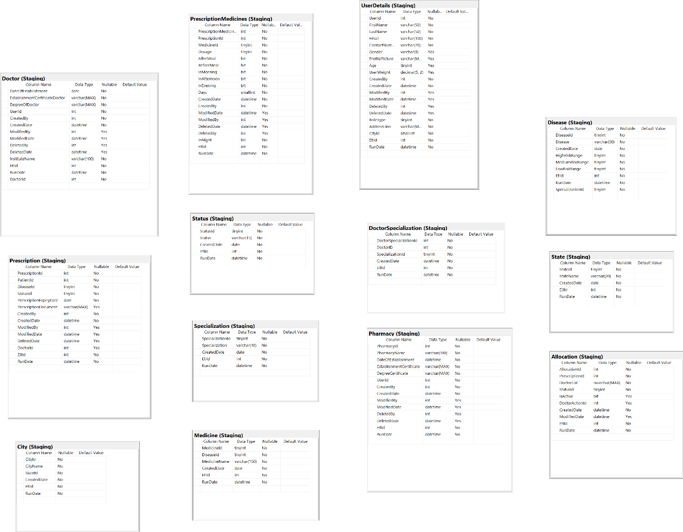
Fig 4.3 Staging Data Model
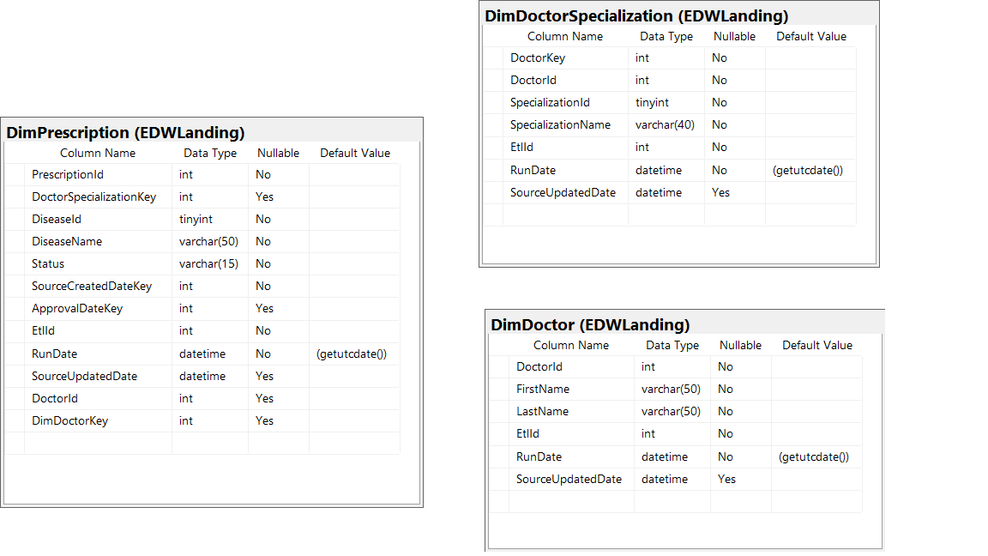Fig 4.4 Enterprise Data Warehouse Landing Data Model
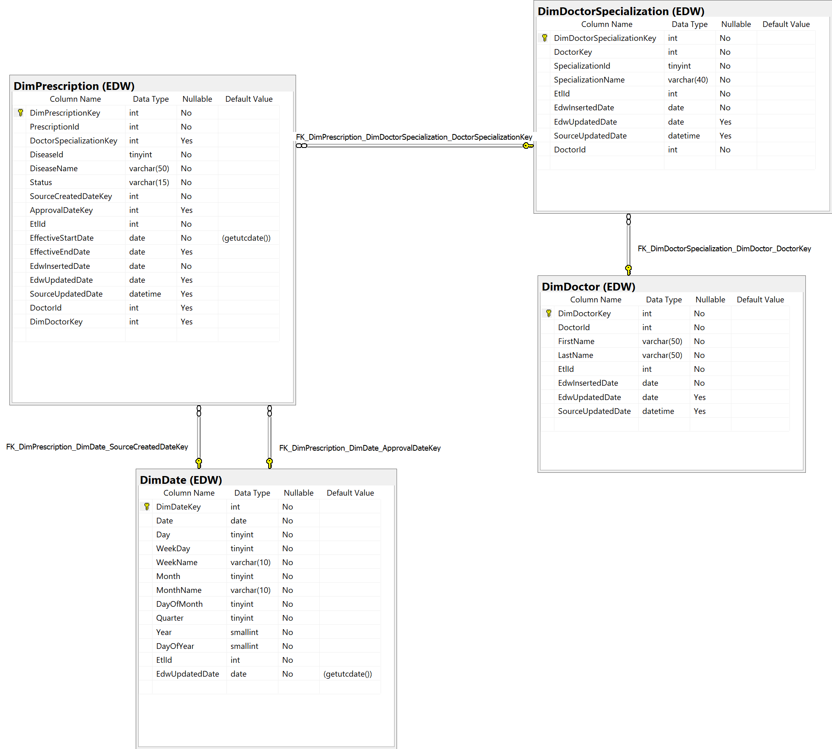
Fig 4.5 Enterprise Data Warehouse Data Model
  - DATA DICTIONARY
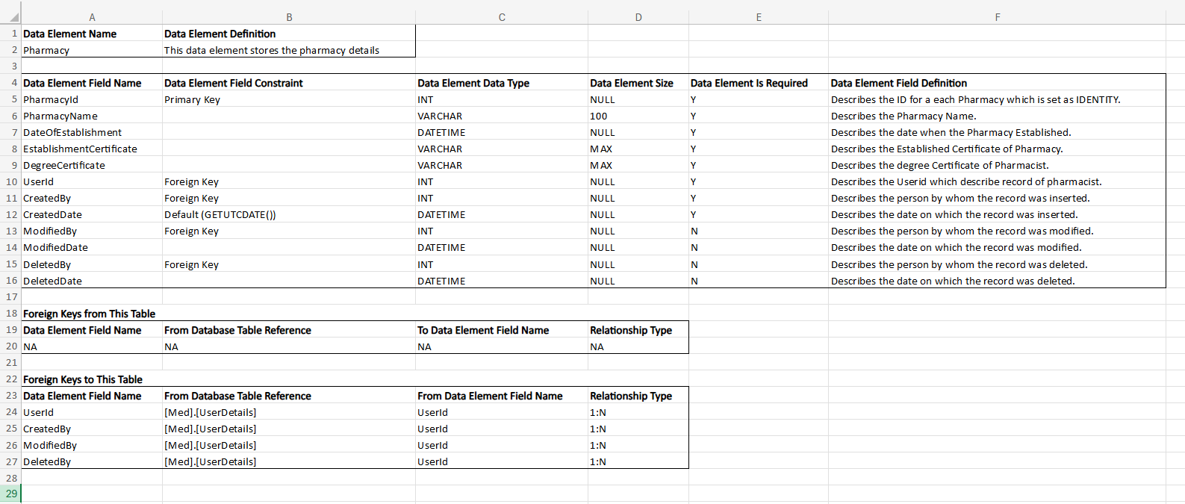
Fig 4.6 Med.Pharmacy Data Dictionary

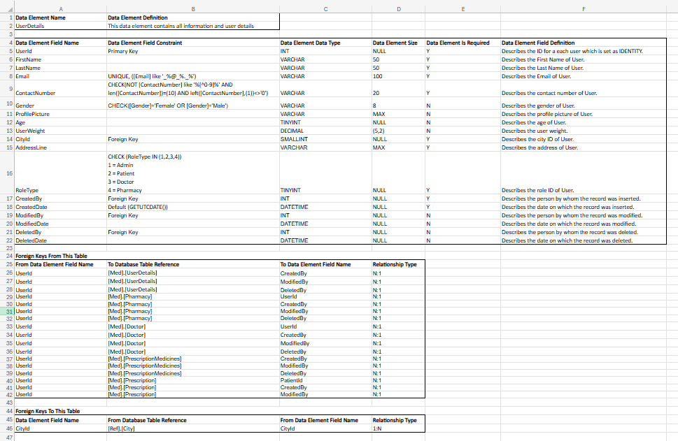
Fig 4.7 Med.UserDetails Data Dictionary

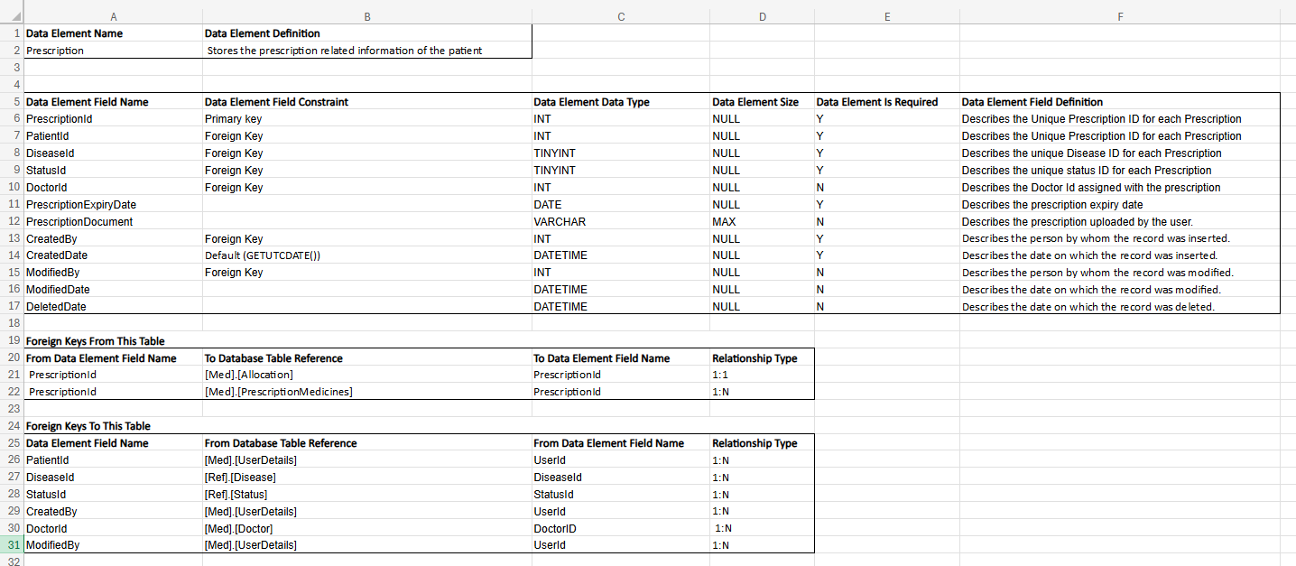
Fig 4.8 Med.Prescription Data Dictionary

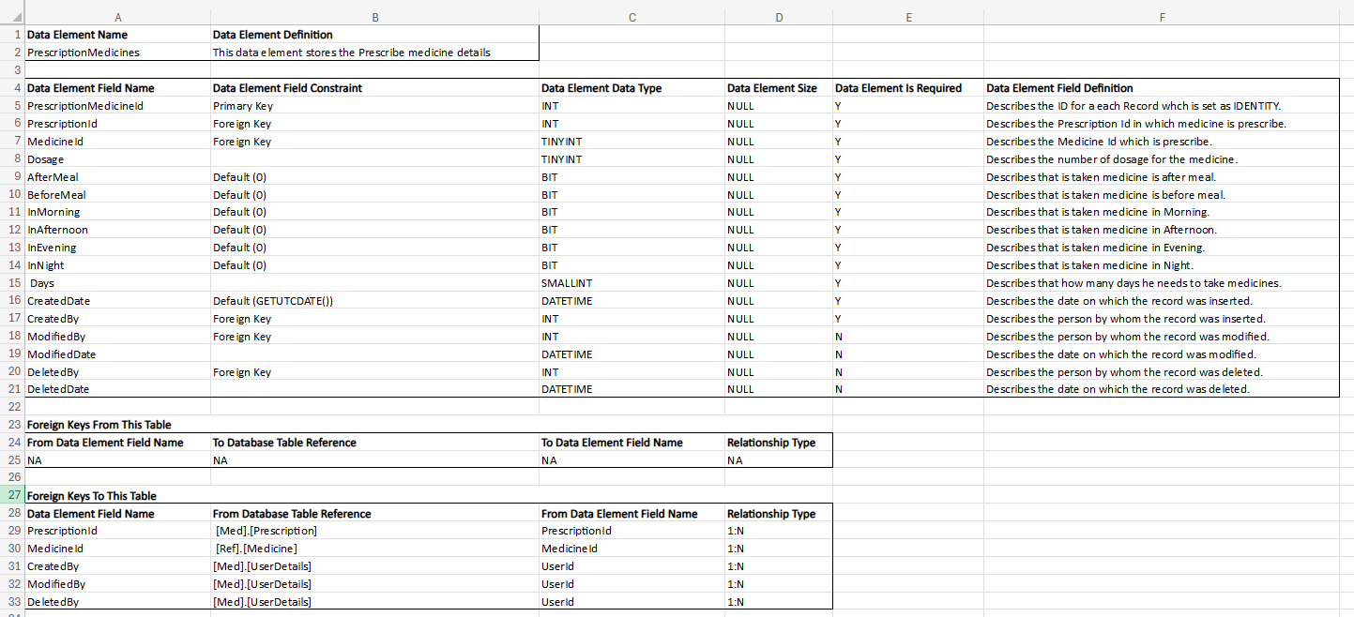
Fig 4.9 Med.PrescriptionMedicines Data Dictionary

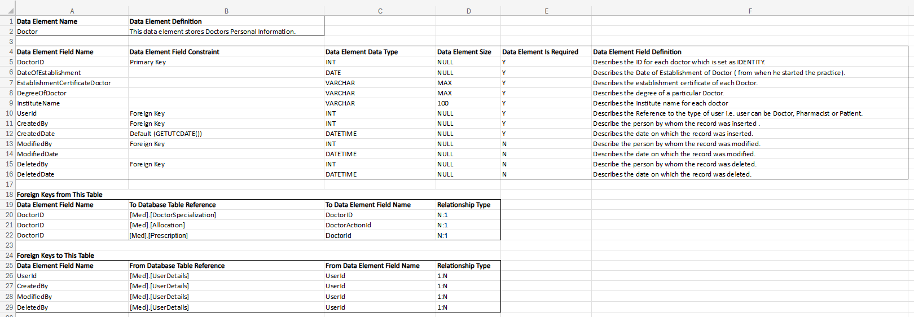
Fig 4.10 Med.Doctor Data Dictionary

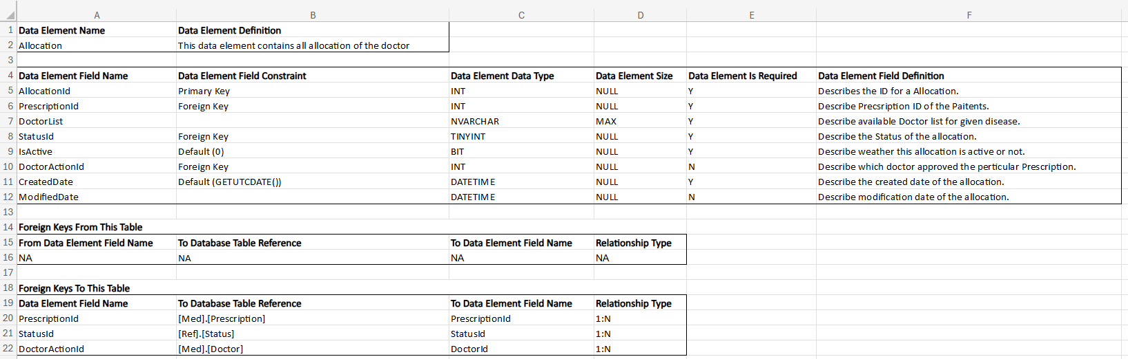
Fig 4.11 Med.Allocation Data Dictionary

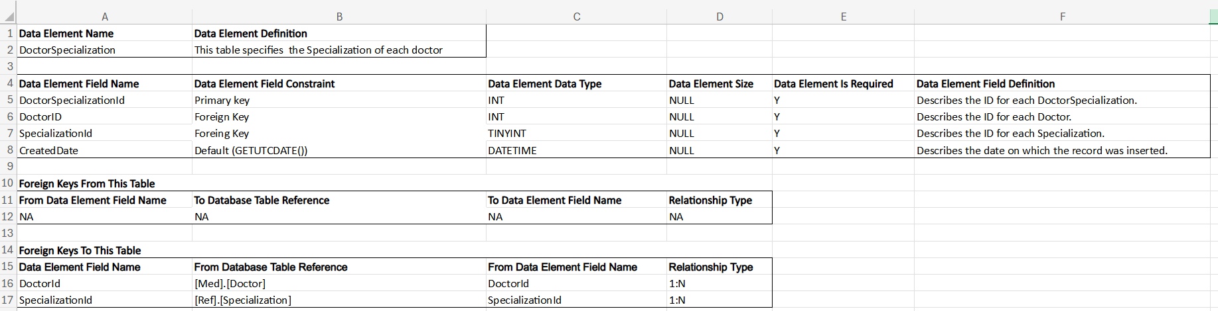
Fig 4.12 Med.DoctorSpecialization Data Dictionary

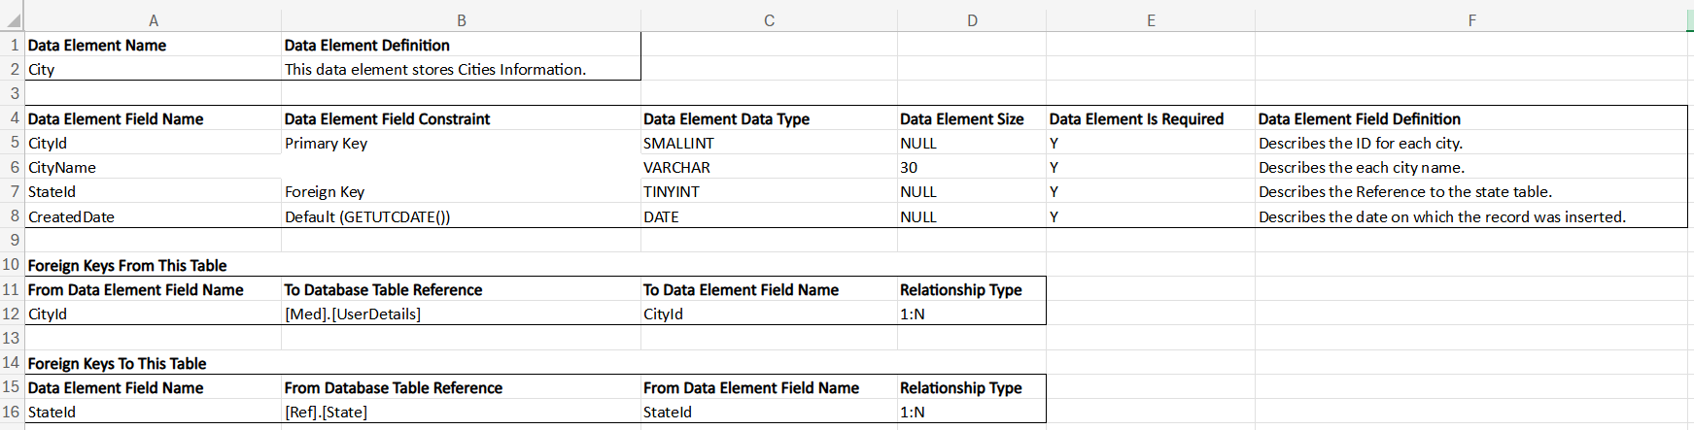
Fig 4.13 Ref.City Data Dictionary

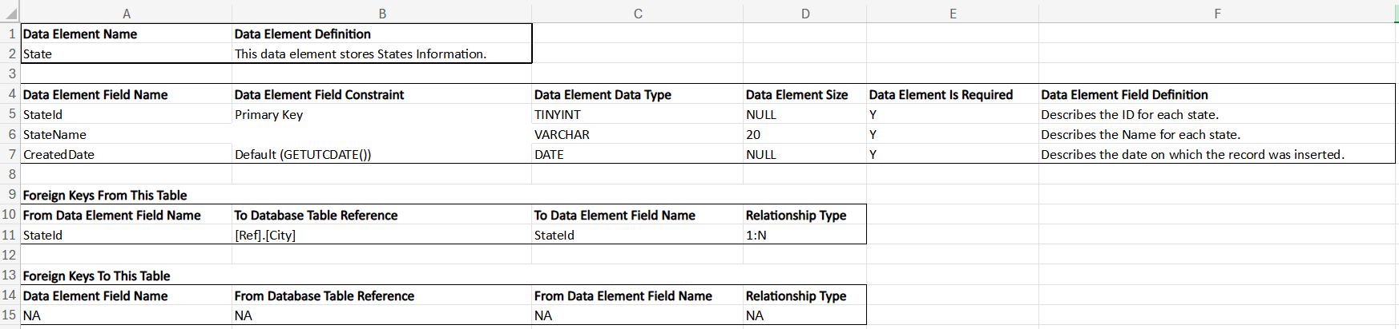
Fig 4.14 Ref.State Data Dictionary

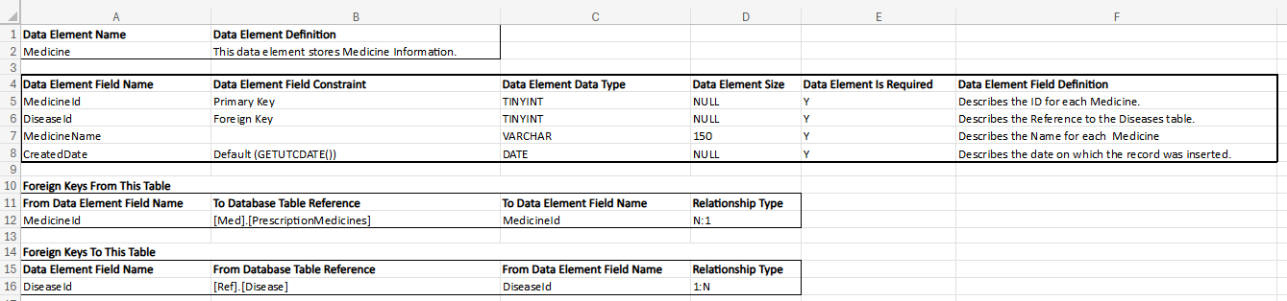
Fig 4.15 Ref.Medicine Data Dictionary

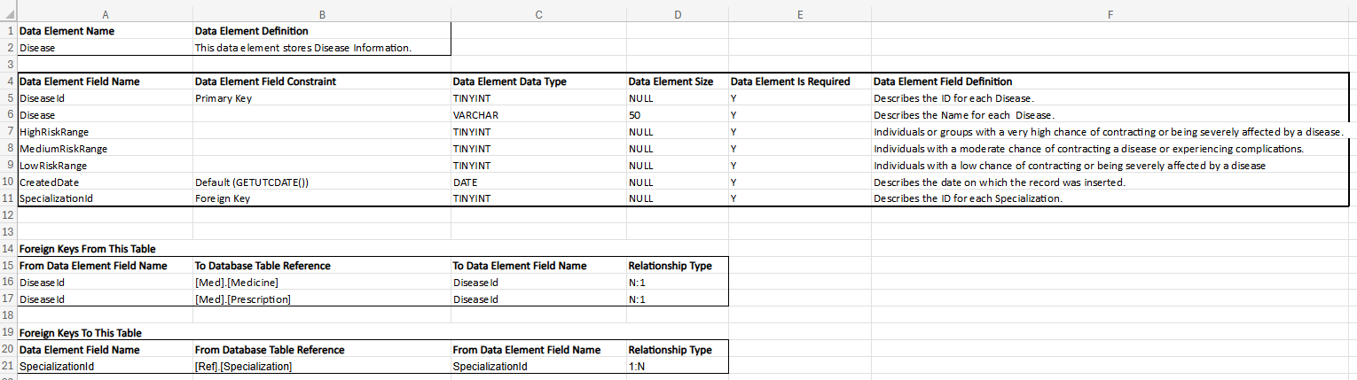
Fig 4.16 Ref.Disease Data Dictionary

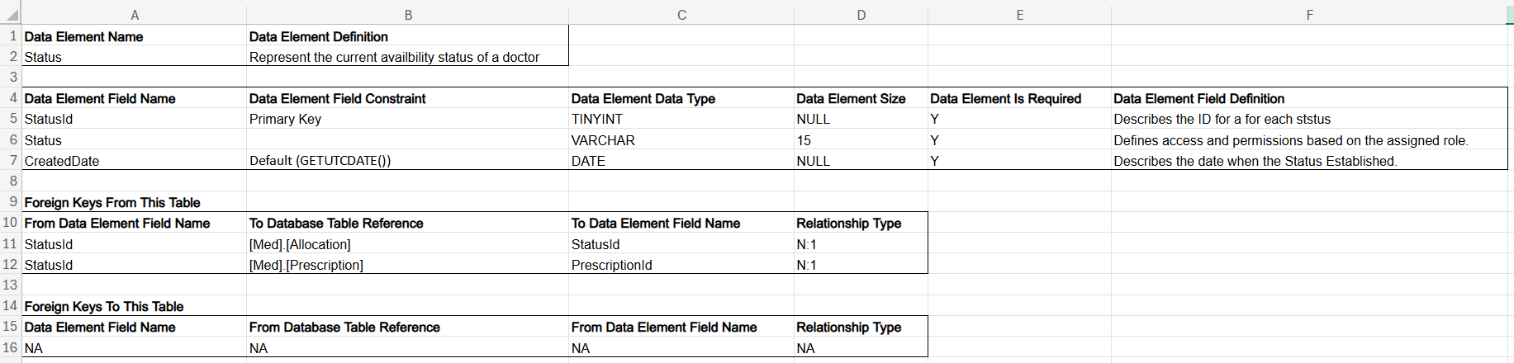
Fig 4.17 Ref.Status Data Dictionary

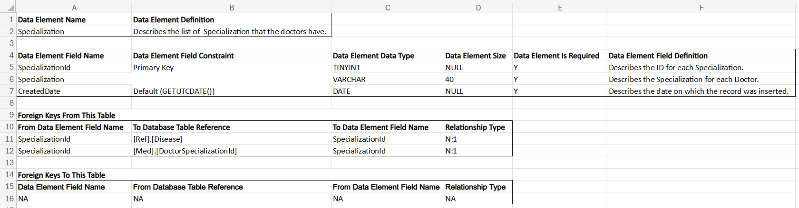
Fig 4.18 Ref.Specialization Data Dictionary

5. SYSTEM DESIGN
5.1 SYSTEM APPLICATION DESIGN
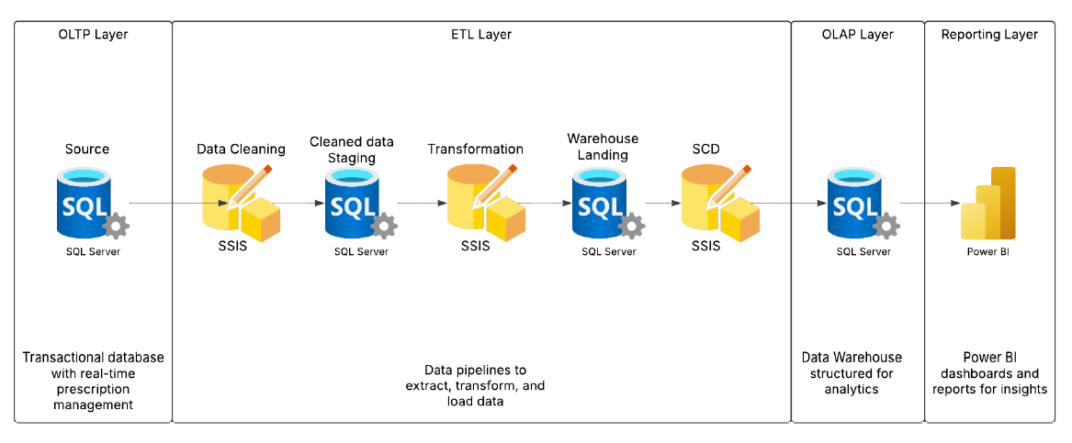
Fig 5.1 System Architecture
5.1.1 Method Pseudo Code
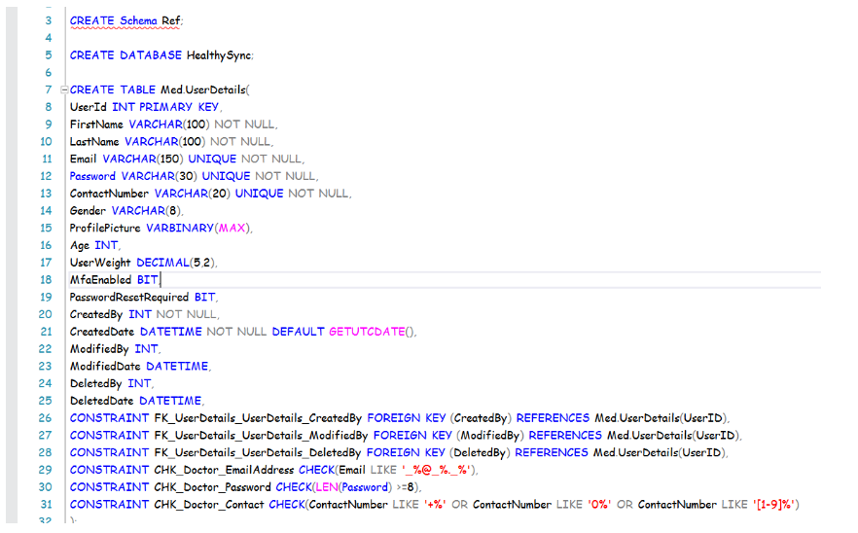
Fig 5.2 Pseudo Code

5.2 INPUT/OUTPUT AND INTERFACE DESIGN
5.2.1 Samples of Forms, Reports, and Interface
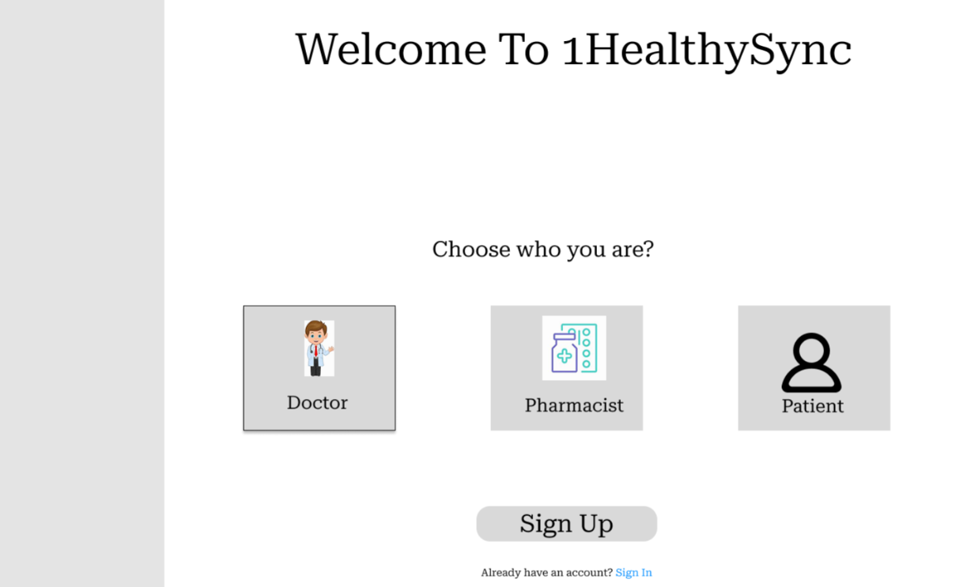
Fig 5.3 User Role Selection
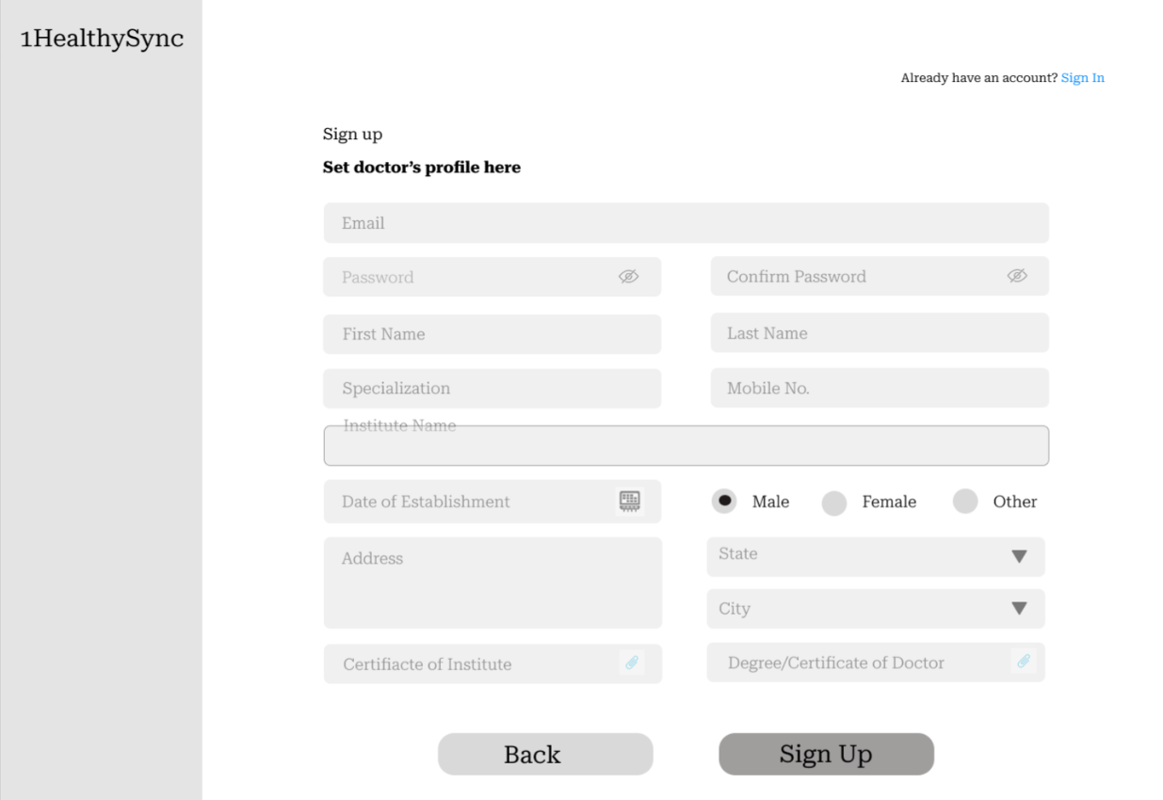
Fig 5.4 Doctor Sign Up
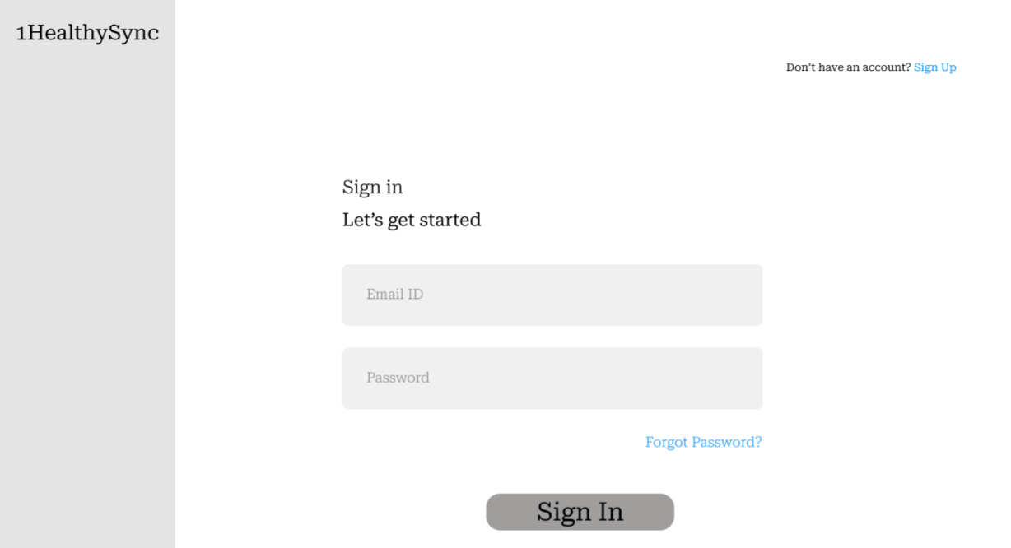
Fig 5.5 Sign In
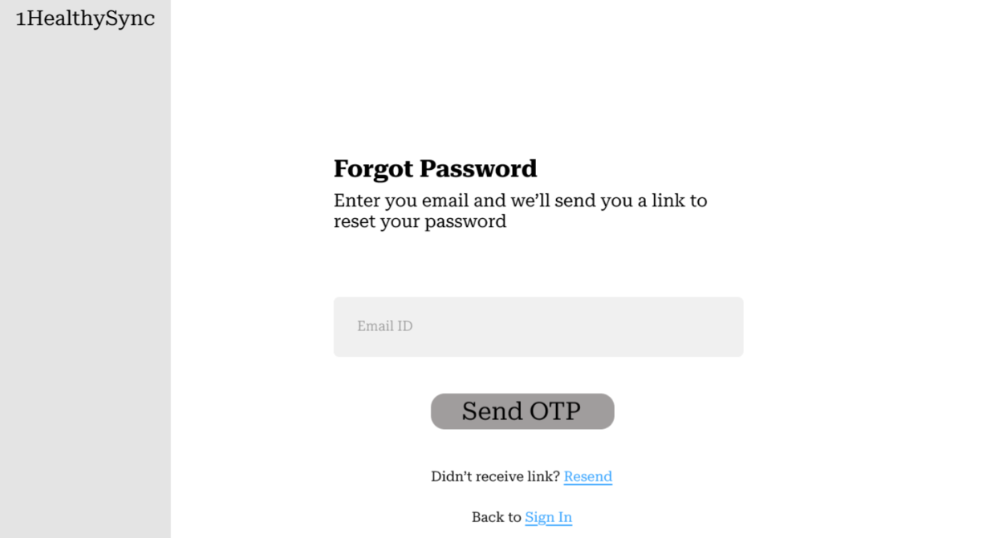
Fig 5.6 Forgot Password
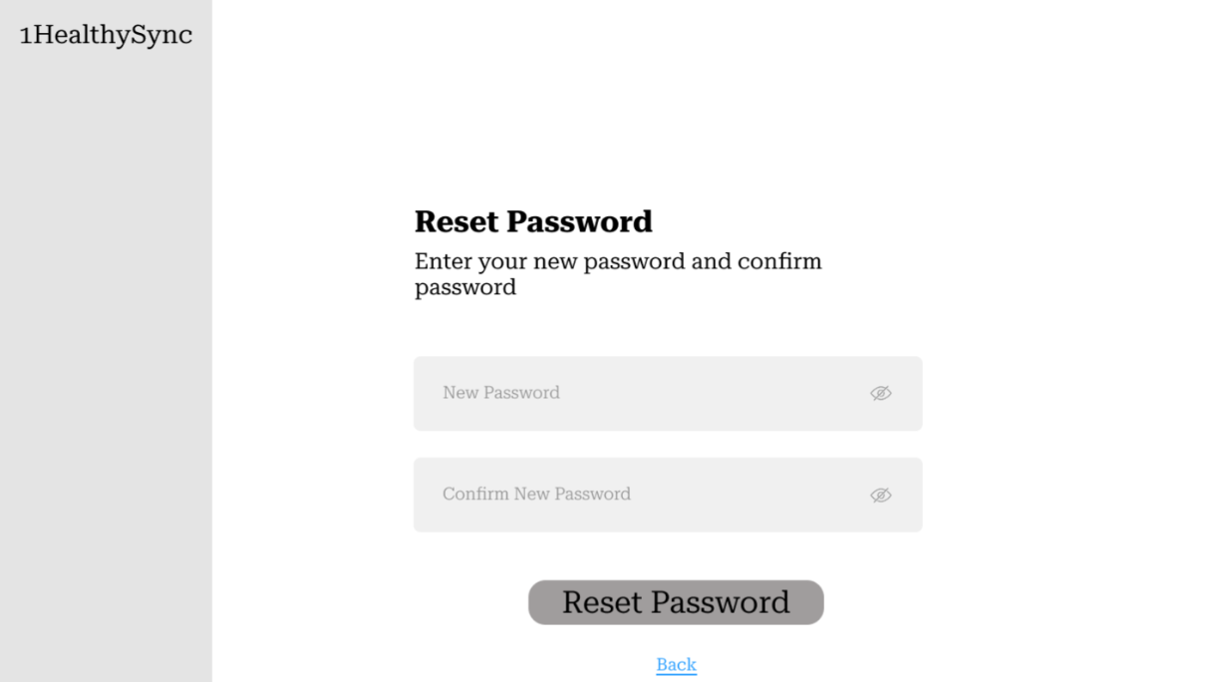
Fig 5.7 Reset Password
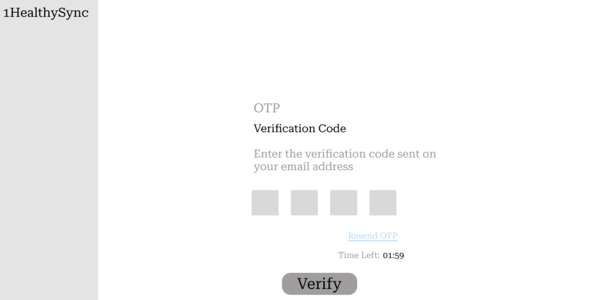
Fig 5.8 OTP Verification Code
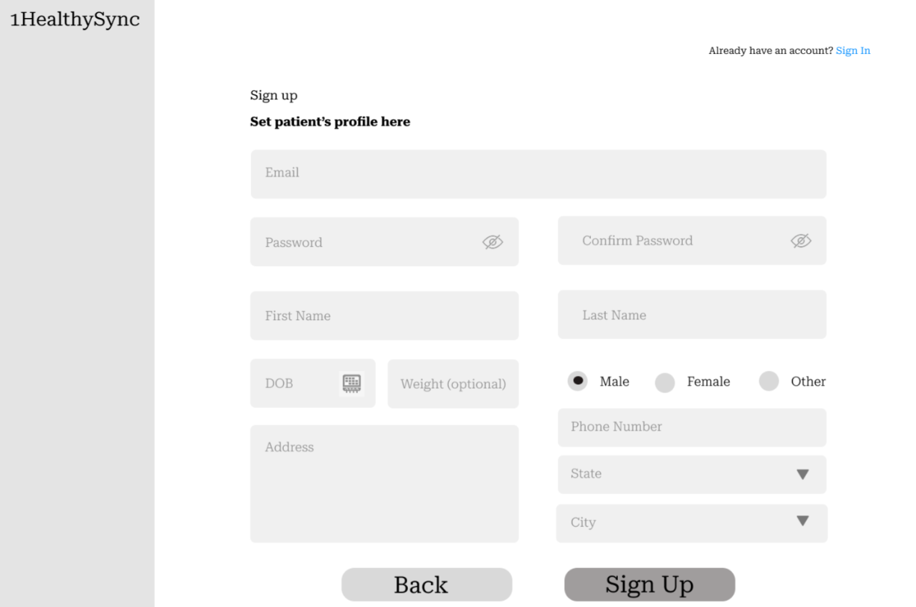
Fig 5.9 Patient Sign Up
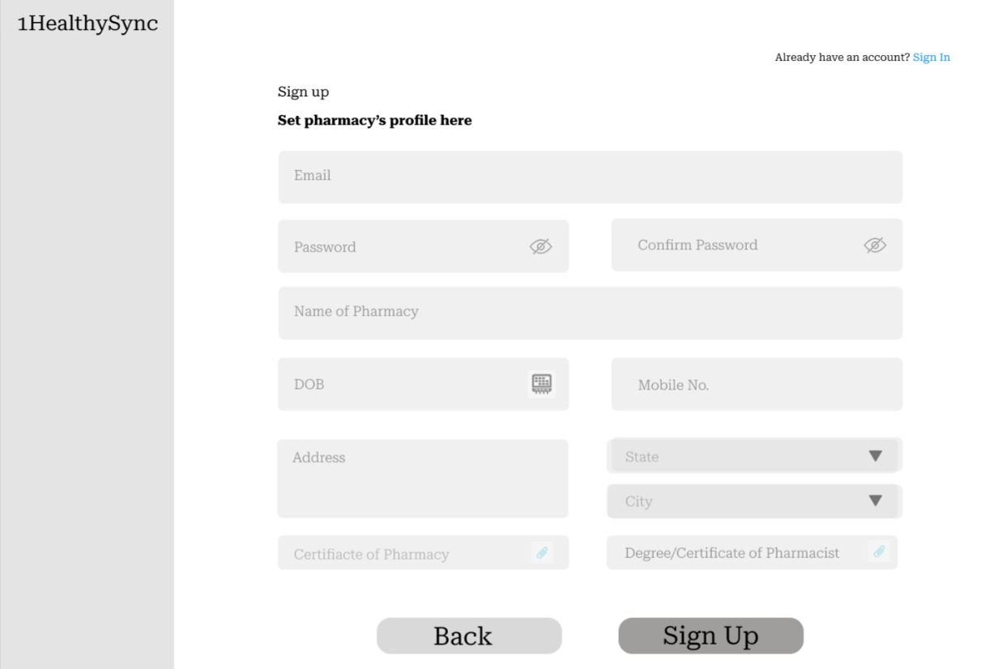
Fig 5.10 Pharmacy Sign Up
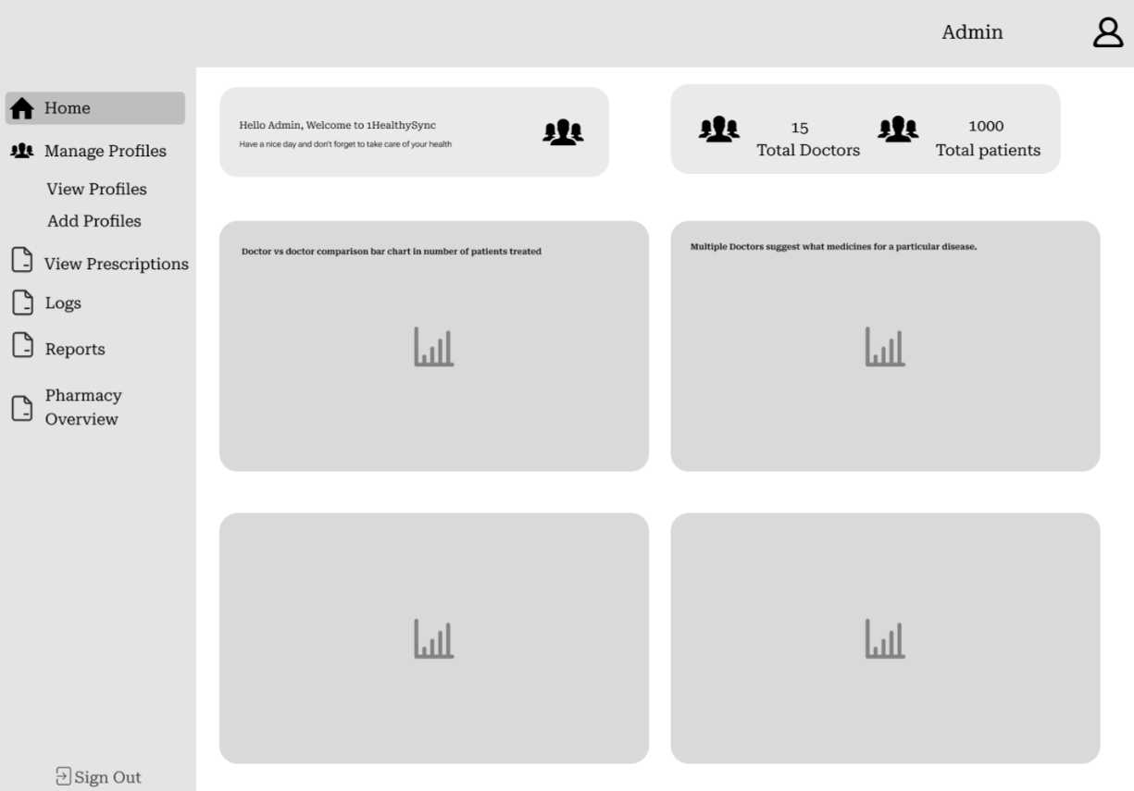
Fig 5.11 Admin Dashboard
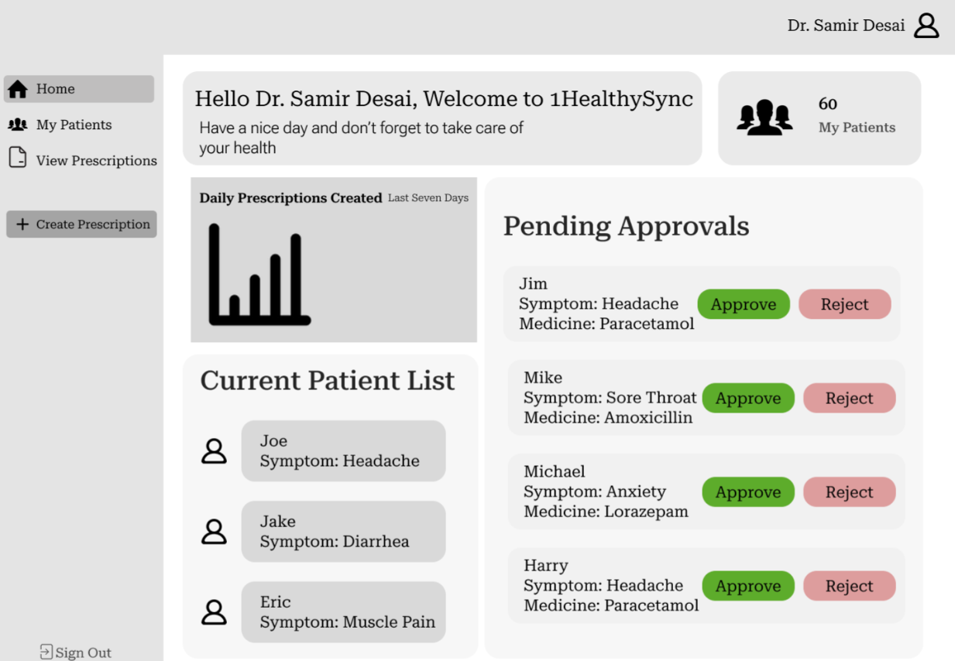
Fig 5.12 Doctor Dashboard
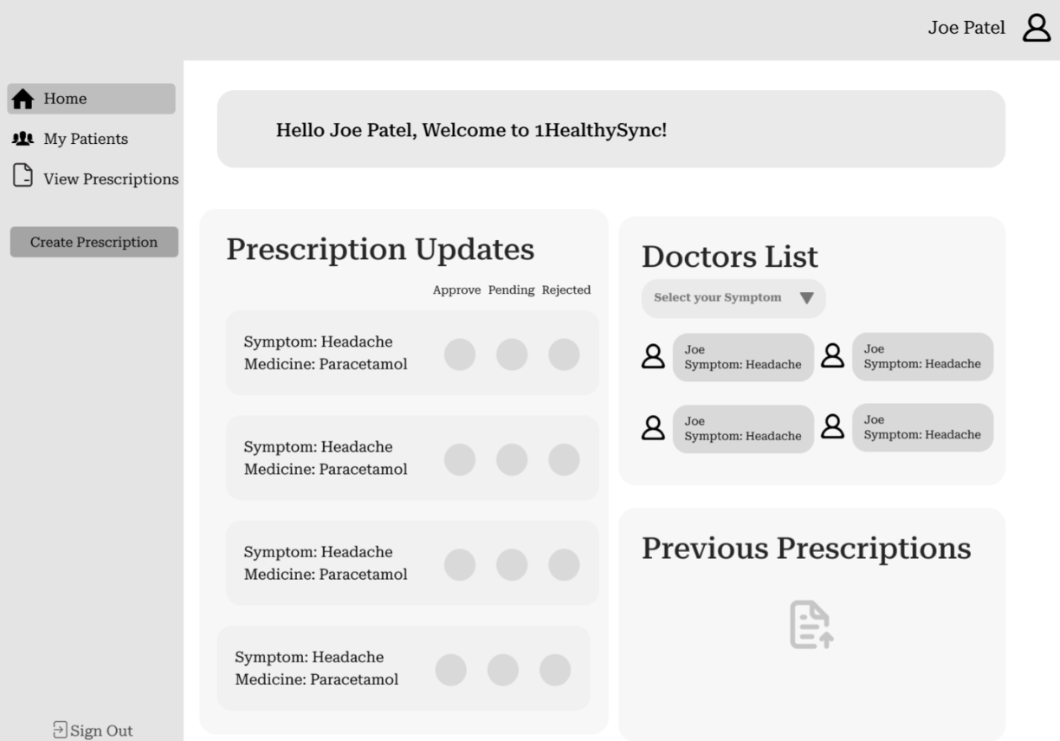
Fig 5.13 Patient Dashboard
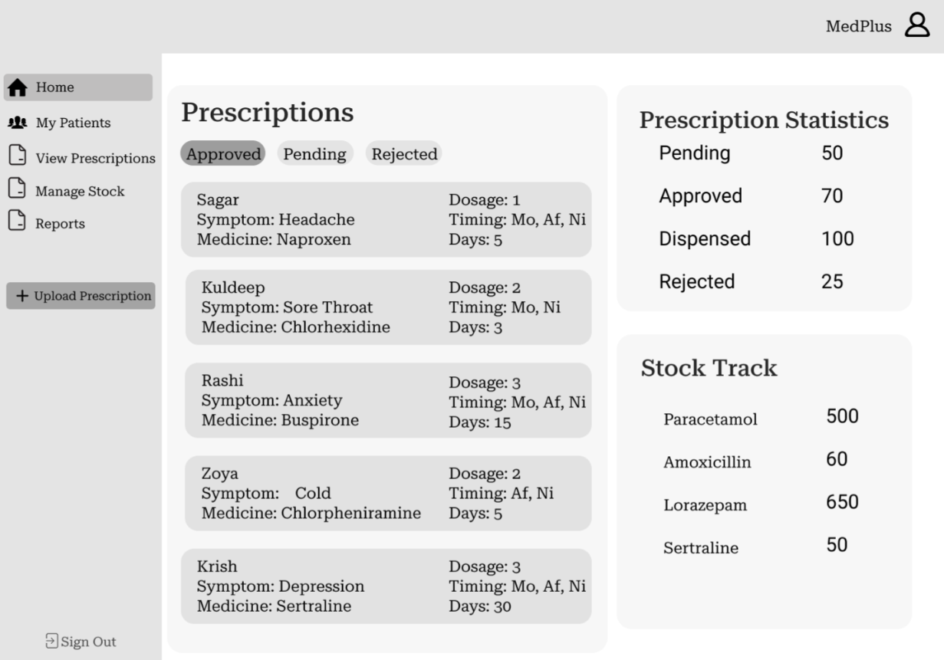
Fig 5.14 Pharmacy Dashboard
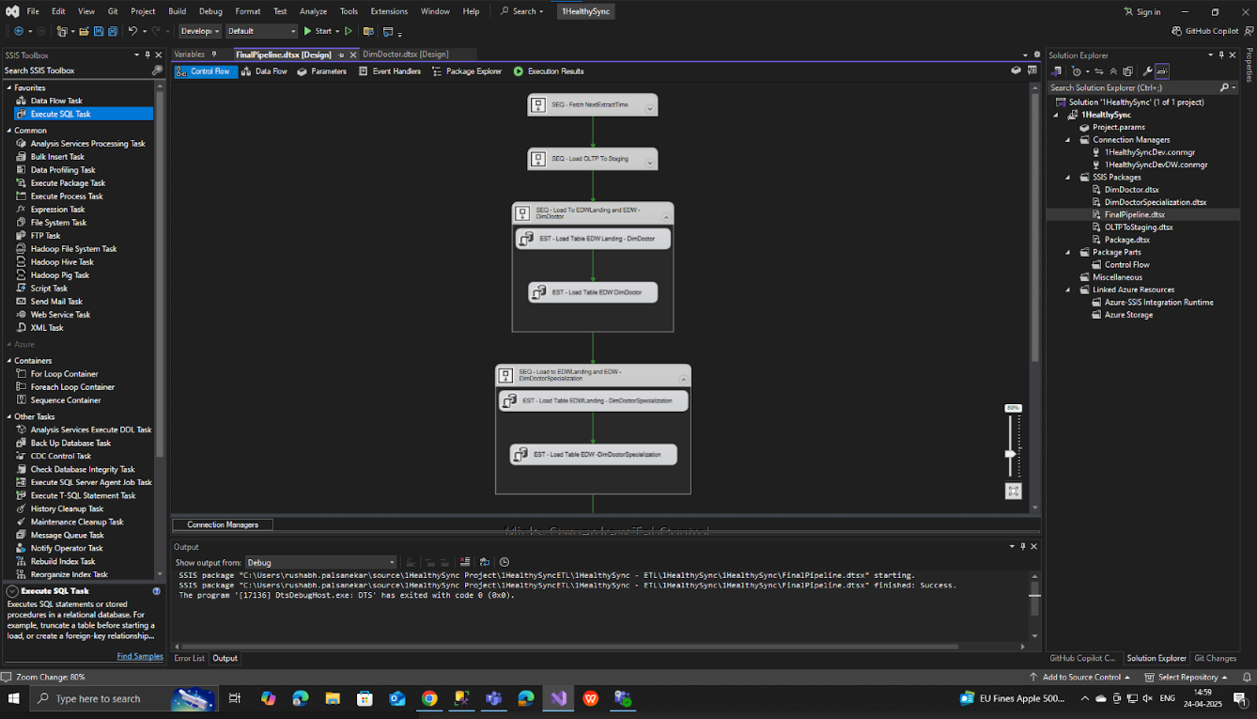
Fig 5.15 ETL Pipeline Part-1
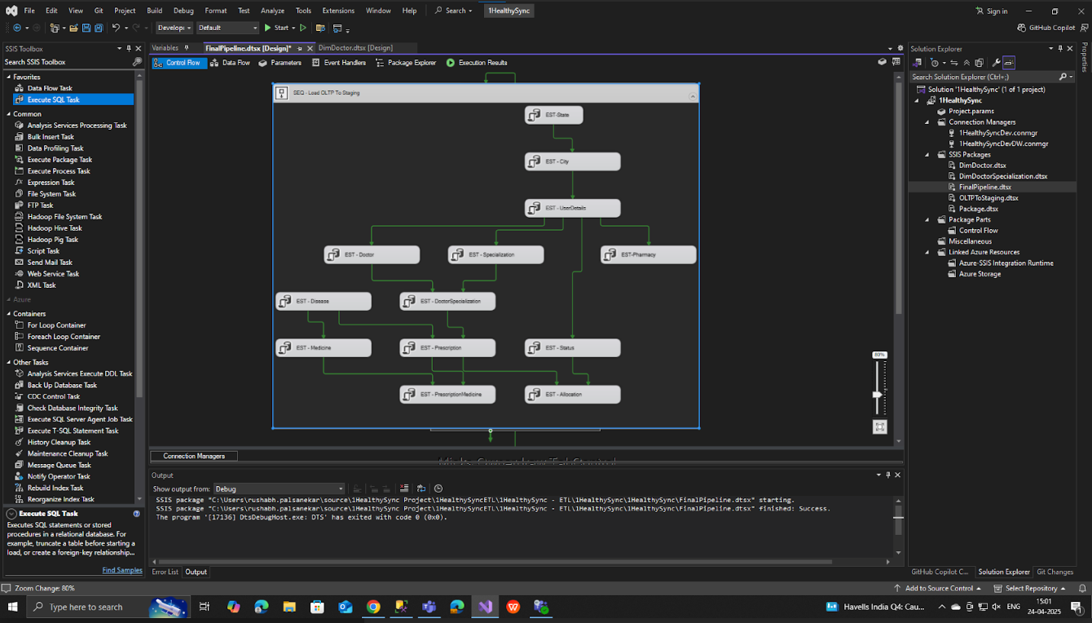
Fig 5.16 ETL Pipeline Part-2
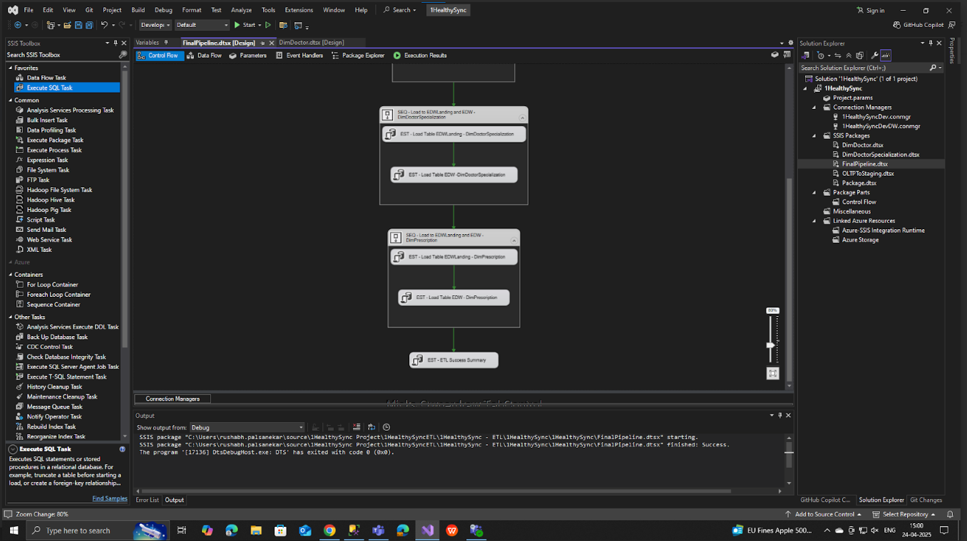
Fig 5.17 ETL Pipeline Part-3
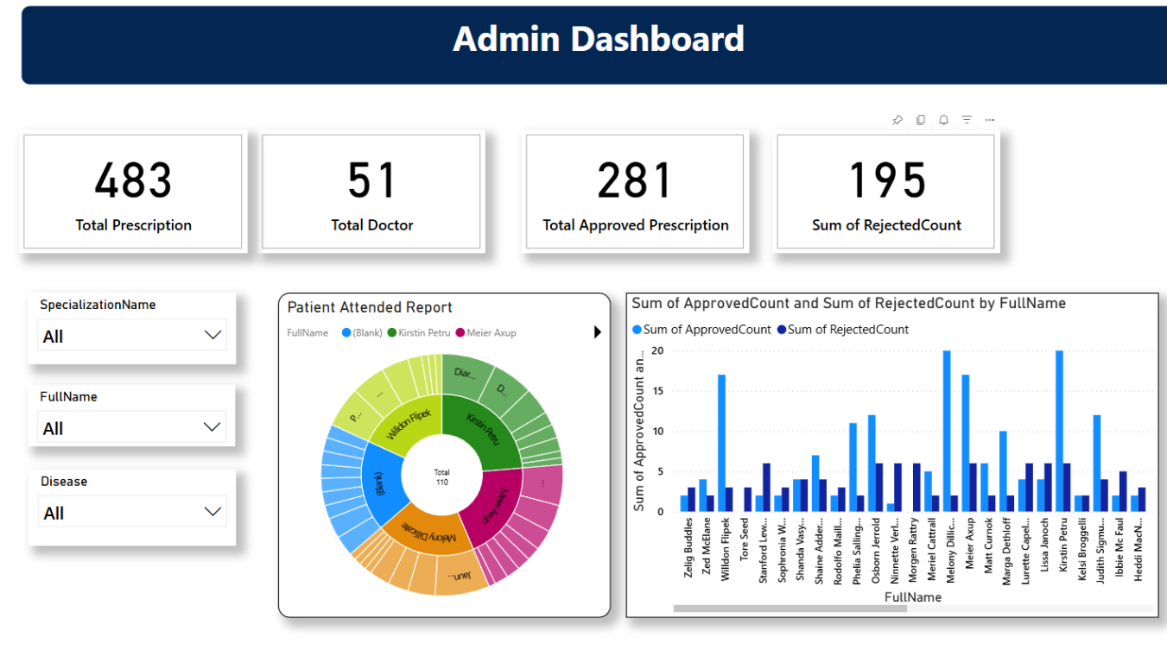
Fig 5.18 Power BI Dashboard for 2 KPIs

6. IMPLEMENTATION PLANNING
6.1 IMPLEMENTATION ENVIRONMENT
The system is developed and deployed using a Microsoft-based technology stack to ensure compatibility and performance. Microsoft SQL Server is used as the database engine for OLTP operations. The ETL pipeline is built using Visual Studio with SQL Server Integration Services (SSIS), and Power BI is used for data visualization. The application is hosted in a secure local or cloud-based environment, depending on the deployment needs, with necessary configurations to support real-time data access, secure logins, and concurrent users.
6.2 MODULES SPECIFICATION
The system is divided into several functional modules to ensure clarity and separation of responsibilities:
- Doctor Module: Enables prescription creation, patient selection, and history viewing.
- Pharmacist Module: Allows prescription verification, approval, and tracking of fulfillment.
- Patient Module: Provides access to prescription history, alerts, and medication status.
- Admin Module: Offers control over user roles, system performance monitoring, and access to analytics dashboards.
6.3 SECURITY FEATURES
Security is a core aspect of the system. Key measures include:
- Role-Based Access Control (RBAC): Users are given access only to the features relevant to their roles (doctor, pharmacist, patient, admin).
- Secure Authentication: Login processes use encrypted credentials to prevent unauthorized access.
- Data Protection: Sensitive patient data and prescriptions are stored securely with encryption.
- Audit Trails: System activities are logged to ensure transparency and detect unusual behavior.
6.4 CODING STANDARD
To maintain code quality and consistency, the following practices are followed:
- Modular Coding: Each functionality is developed in independent modules for easier testing and maintenance.
- Consistent Naming Conventions: Variables, functions, and classes follow meaningful and uniform naming patterns.
- Commenting and Documentation: Important code sections are well-documented to support collaboration and future updates.
- Error Handling: Proper exception handling mechanisms are implemented to improve system stability and user experience.

7. TESTING
  - TESTING PLAN
Testing was an essential part of the development cycle to ensure that the 1HealthySync delivered accurate responses and operated smoothly across different modules. The testing plan focused on:

- Validating system functionality
- Ensuring integration between components
- Testing response accuracy of the Power BI Dashboards
- Verifying security and performance
Testing was performed in Three main phases:

- Unit Testing: Individual functions and modules.
- Integration Testing: Communication between OLTP Layer, OLAP Layer and Power BI
- System Testing: Complete end-to-end user interaction.
7.2 TESTING STRATEGY
A combination of manual and automated testing techniques will be used to ensure comprehensive validation.
- Unit Testing: Individual components, such as prescription submission and data extraction scripts, are tested in isolation to verify their correctness.
- Integration Testing: Interaction between modules (e.g., prescription creation and pharmacist approval) is tested to ensure smooth data flow and coordination.
- System Testing: The complete application is tested as a whole to validate functionality, performance, and security features.
- User Acceptance Testing (UAT): End-users including doctors, pharmacists, and patients will test the system to ensure it meets real-world requirements and expectations.
- Performance Testing: The system is evaluated under load to assess its behavior during high usage and ensure it remains responsive.
- Security Testing: Focuses on login protection, data access permissions, and encryption to ensure sensitive information is secure.
7.3 TEST SUITES DESIGN
​​Test Case ID | ​Description | SQL Query | Status
​TC_001 | Validate Disease table name & presence in database schema. | SELECT * FROM INFORMATION_SCHEMA.TABLES WHERE TABLE_SCHEMA = 'Ref'; | Pass
​TC_009 | ​Validate Specialization table name & presence in database schema. | SELECT * FROM INFORMATION_SCHEMA.TABLES WHERE TABLE_SCHEMA = 'Ref'; | Pass
​TC_013 | Validate City presence in the database schema | SELECT * FROM INFORMATION_SCHEMA.TABLES WHERE TABLE_SCHEMA = 'Ref'; | Pass
​TC_017 | Validate State presence in the database schema | SELECT * FROM INFORMATION_SCHEMA.TABLES WHERE TABLE_SCHEMA = 'Ref'; | Pass
​TC_025 | Validate UserDetails presence in the database schema | SELECT * FROM INFORMATION_SCHEMA.TABLES WHERE TABLE_SCHEMA = 'Med'; | Pass
​TC_033 | ​Validate Pharmacy presence in the database schema​ | SELECT * FROM INFORMATION_SCHEMA.TABLES WHERE TABLE_SCHEMA = 'Med'; | Pass
​TC_041 | Validate Doctor presence in the database schema | SELECT * FROM INFORMATION_SCHEMA.TABLES WHERE TABLE_SCHEMA = 'Med'; | Pass
​TC_045 | Validate PrescriptionMedicines table name & presence in database schema. | SELECT * FROM INFORMATION_SCHEMA.TABLES WHERE TABLE_SCHEMA = 'Med'; | Pass
​TC_047 | Validate Prescription table name & presence in database schema. | SELECT * FROM INFORMATION_SCHEMA.TABLES WHERE TABLE_SCHEMA = 'Med'; | Pass
​TC_050 | Validate Allocation table name & presence in database schema. | SELECT * FROM INFORMATION_SCHEMA.TABLES WHERE TABLE_SCHEMA = 'Med'; | Pass

Table 7.1 Test Cases
8. CONCLUSION AND DISCUSSION
8.1 SELF ANALYSIS OF PROJECT VIABILITIES
This project demonstrated strong viability in both technical and practical aspects. By using reliable and industry-standard technologies like Microsoft SQL Server, Visual Studio, and Power BI, the system was successfully built to be scalable, secure, and easy to maintain. The modular design and layered architecture make it adaptable for integration into existing healthcare ecosystems. Moreover, the inclusion of analytics dashboards provides a competitive edge, supporting continuous service improvement and data-driven operations.
8.2 PROBLEMS ENCOUNTERED AND POSSIBLE SOLUTIONS
During development, several challenges were identified:
- Data Integration Issues: Aligning the ETL process with real-time OLTP data posed difficulties due to mismatches in data formats.
Solution: Standardized data transformation logic and implemented schema validation steps before loading.
- User Interface Complexity: Designing user-friendly dashboards for diverse user roles initially resulted in cluttered layouts.
Solution: Conducted user feedback sessions and simplified interfaces for better navigation.
- Security and Role Management: Implementing strict access control across modules required extra validation layers.
Solution: Developed a flexible role-based access control mechanism with customizable permissions.
8.3 SUMMARY OF PROJECT WORK
1HealthySync successfully delivers a modernized approach to prescription management by eliminating manual bottlenecks and introducing automation at key points in the workflow. With seamless collaboration between doctors, pharmacists, and patients, and real-time analytics through Power BI, the system promotes faster, safer, and more informed healthcare delivery. The implementation of ETL and OLAP components demonstrates the project's strength in handling large datasets and transforming them into meaningful insights. The system's modular structure, scalability, and security readiness make it suitable for deployment in various healthcare settings.

9. LIMITATIONS AND FUTURE ENHANCEMENTS
Limitations
- Limited Scope of Healthcare Services: The current version focuses solely on prescription workflows and analytics. Other healthcare services such as appointment scheduling are not integrated.
- No Pharmacy Inventory Integration: The system does not currently track stock levels of prescribed medicines in pharmacies, which may lead to availability issues for patients.
- Basic Notification System: Alerts are functional but limited to simple notifications. Advanced reminders or integrations with SMS/email services are yet to be implemented.
- Static User Roles: Role assignment is fixed and lacks customization options for institutions with specific workflow needs.
- Offline Support: The system is designed primarily for online access, and may not function well in low-connectivity environments.
Future Enhancements
To overcome the limitations and enhance user experience, several upgrades can be considered in future versions:
- Doctor Appointment Booking Module: Adding a feature that allows patients to book appointments with doctors directly through the platform will streamline the consultation and prescription process.
- Pharmacy Inventory Management: Integrating an inventory system for pharmacies to monitor medicine availability, auto-update stock after dispensing, and notify users of shortages will ensure smoother operations and patient satisfaction.
- Advanced Notification System: Enabling automated SMS or email notifications for prescription updates, medication reminders, and follow-ups will improve communication and engagement.
- Customizable Role Management: Introducing flexible user role configurations based on institutional needs will make the system adaptable to a wider range of healthcare providers.
- Offline Access and Syncing: Developing a hybrid mode that allows offline usage with automatic data synchronization once connectivity is restored will support rural or low-bandwidth environments.

10. BIBLIOGRAPHY
[1] Documentation:
- https://learn.microsoft.com/en-us/sql/sql-server/?view=sql-server-ver16
- https://learn.microsoft.com/en-us/azure/architecture/data-guide/relational-data/etl
- https://learn.microsoft.com/en-us/azure/architecture/example-scenario/data/data-warehouse
- https://learn.microsoft.com/en-us/power-bi/
[2] SQL Server Syntax:
- https://www.w3schools.com/sql/sql_syntax.asp
- https://learn.microsoft.com/en-us/sql/t-sql/language-reference?view=sql-server-ver16
[3] SQL Server Tutorial: https://www.youtube.com/playlist?list=PL08903FB7ACA1C2FB
[4] SSIS Package Tutorial: https://youtu.be/qmSsZhaFcZw?si=B3snYdlsba3Iibvj
[5] Data Warehouse Tutorial: https://www.youtube.com/watch?v=DfmHV7yiy_g&list=PLFbjn94wCCeWqODvODLOFHq16PqwHpRQC
[6] Power BI Tutorial: https://youtu.be/KdC5R7oPCAI?si=rxOnMYKJZpbdOlTi

11. PLAGIARISM REPORT
