KAFKA STUDY GUIDE
CDC Architecture, Monitoring & Streaming Design
Krishna Theja Upadhyaya
Oracle OLR + SQL Server Debezium | Prometheus & Grafana | Uber-Relevant
Oracle → Kafka (OLR) → MySQL / SQL Server / PostgreSQL
SQL Server → Kafka (Debezium) → MySQL / PostgreSQL
How to use this guide
Each major section opens with a plain-language explanation of the concept, followed by a diagram showing how the pieces fit together, then a reference table for interview-grade detail. Read it linearly the first time, then use it as a lookup once you know the structure.
Sections 1–5 build conceptual foundations. Section 6 is your interview answer bank. Section 7 is the configuration cheat sheet you should be able to recall under pressure.

1. Kafka Fundamentals
Kafka is a distributed commit log designed for high-throughput streaming. Records are appended to partitions and never modified in place. Old data is removed by deleting whole log segments based on retention policy, or by log compaction which keeps the latest value per key. Producers append messages to topics, which are split into partitions for parallelism. Consumers read independently, tracking their own progress via offsets. Replication across brokers provides fault tolerance. Everything in your CDC architecture sits on top of these primitives — be able to explain each fluently.

1.1 Core Architecture
The diagram below shows how a single topic is laid out across partitions and how producers, consumers, and replication interact. Pay attention to three things: how the message key determines partition routing, how each partition is independently ordered, and how replication uses leader/follower roles to survive broker failure.
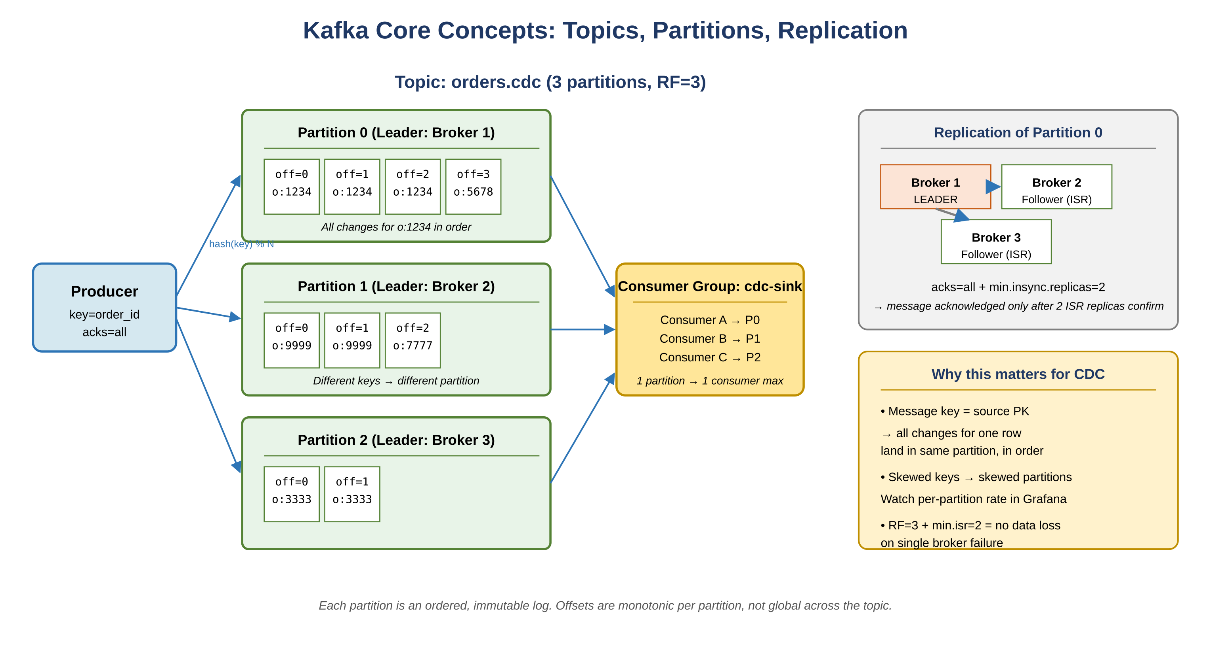
Figure 1.1 — Topics, partitions, message keys, consumer groups, and replication
Concept | What it means
Broker | A Kafka server that stores and serves messages. A cluster has multiple brokers for fault tolerance and parallelism.
Topic | A named, ordered feed of messages. Divided into partitions. Analogous to a database table.
Partition | An ordered, immutable log. The unit of parallelism. Each has a leader broker and optional replicas. Ordering is guaranteed within a partition, not across partitions.
Offset | A monotonically increasing integer identifying each message within a partition. Consumer progress is tracked by offset.
Producer | Writes messages to topics. Routes to a partition via key hashing (default) or round-robin (no key).
Consumer | Reads messages at its own pace. Commits offsets to track progress.
Consumer Group | A set of consumers that cooperate to consume a topic. Each partition is assigned to exactly one consumer in the group at a time.
Replication Factor (RF) | Number of copies of each partition. RF=3 is production standard. Survives loss of 2 brokers.
ISR | In-Sync Replicas. Replicas fully caught up with the leader. With acks=all, the producer waits for all ISR replicas before acknowledging.
KRaft | Kafka 3.x+ metadata management without ZooKeeper. Kafka manages its own cluster state via Raft consensus.

1.2 Message Delivery Guarantees
Every streaming system has to choose what it guarantees about delivery. Kafka supports three modes, each with different producer and consumer settings. For CDC pipelines you almost always operate at at-least-once and rely on idempotent sinks to absorb duplicates.
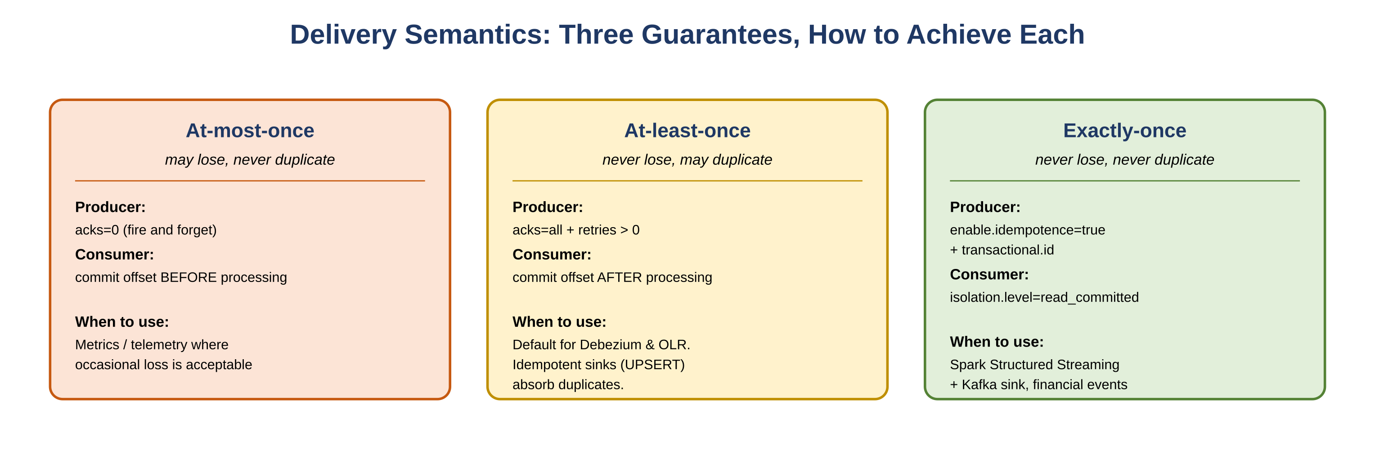
Figure 1.2 — The three delivery guarantees and how each is achieved
Why this matters for your CDC pipelines
Oracle OLR and Debezium both deliver at-least-once. Your downstream sinks (MySQL, PostgreSQL) must use UPSERT logic to absorb duplicates and achieve effective exactly-once at the sink. The composition of an at-least-once stream plus an idempotent sink gives you no loss and no duplicates at the destination, even though no individual layer guarantees exactly-once on its own.

2. Your CDC Architecture Deep Dive
Both pipelines in your production setup, explained with the internals interviewers will probe. The figure below shows the full topology end to end, including the source systems, source connectors, Kafka cluster, sink connectors, and target databases. Sections 2.1 and 2.2 zoom into each pipeline individually.
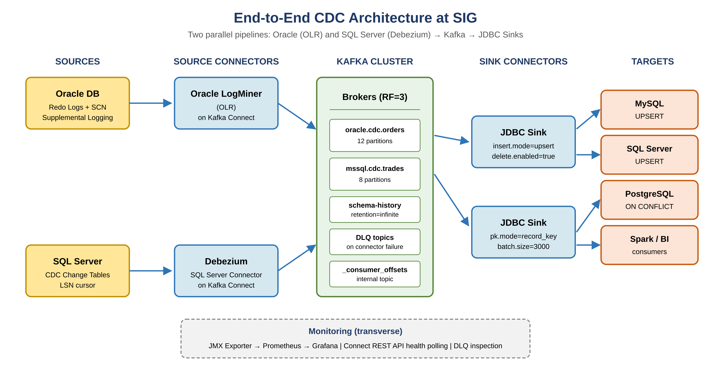
Figure 2.0 — End-to-end CDC architecture: two source pipelines into one Kafka cluster feeding multiple sinks

2.1 Oracle → Kafka via Oracle LogMiner (OLR)

How Oracle CDC works
Oracle CDC reads the redo log, Oracle's write-ahead log that records every committed change for crash recovery. LogMiner is Oracle's built-in utility that parses redo logs into a queryable interface. A Kafka connector (Oracle GoldenGate Kafka Handler, Debezium Oracle, or Oracle's CDC connector) sits on top of LogMiner and publishes row-level change events to Kafka topics.
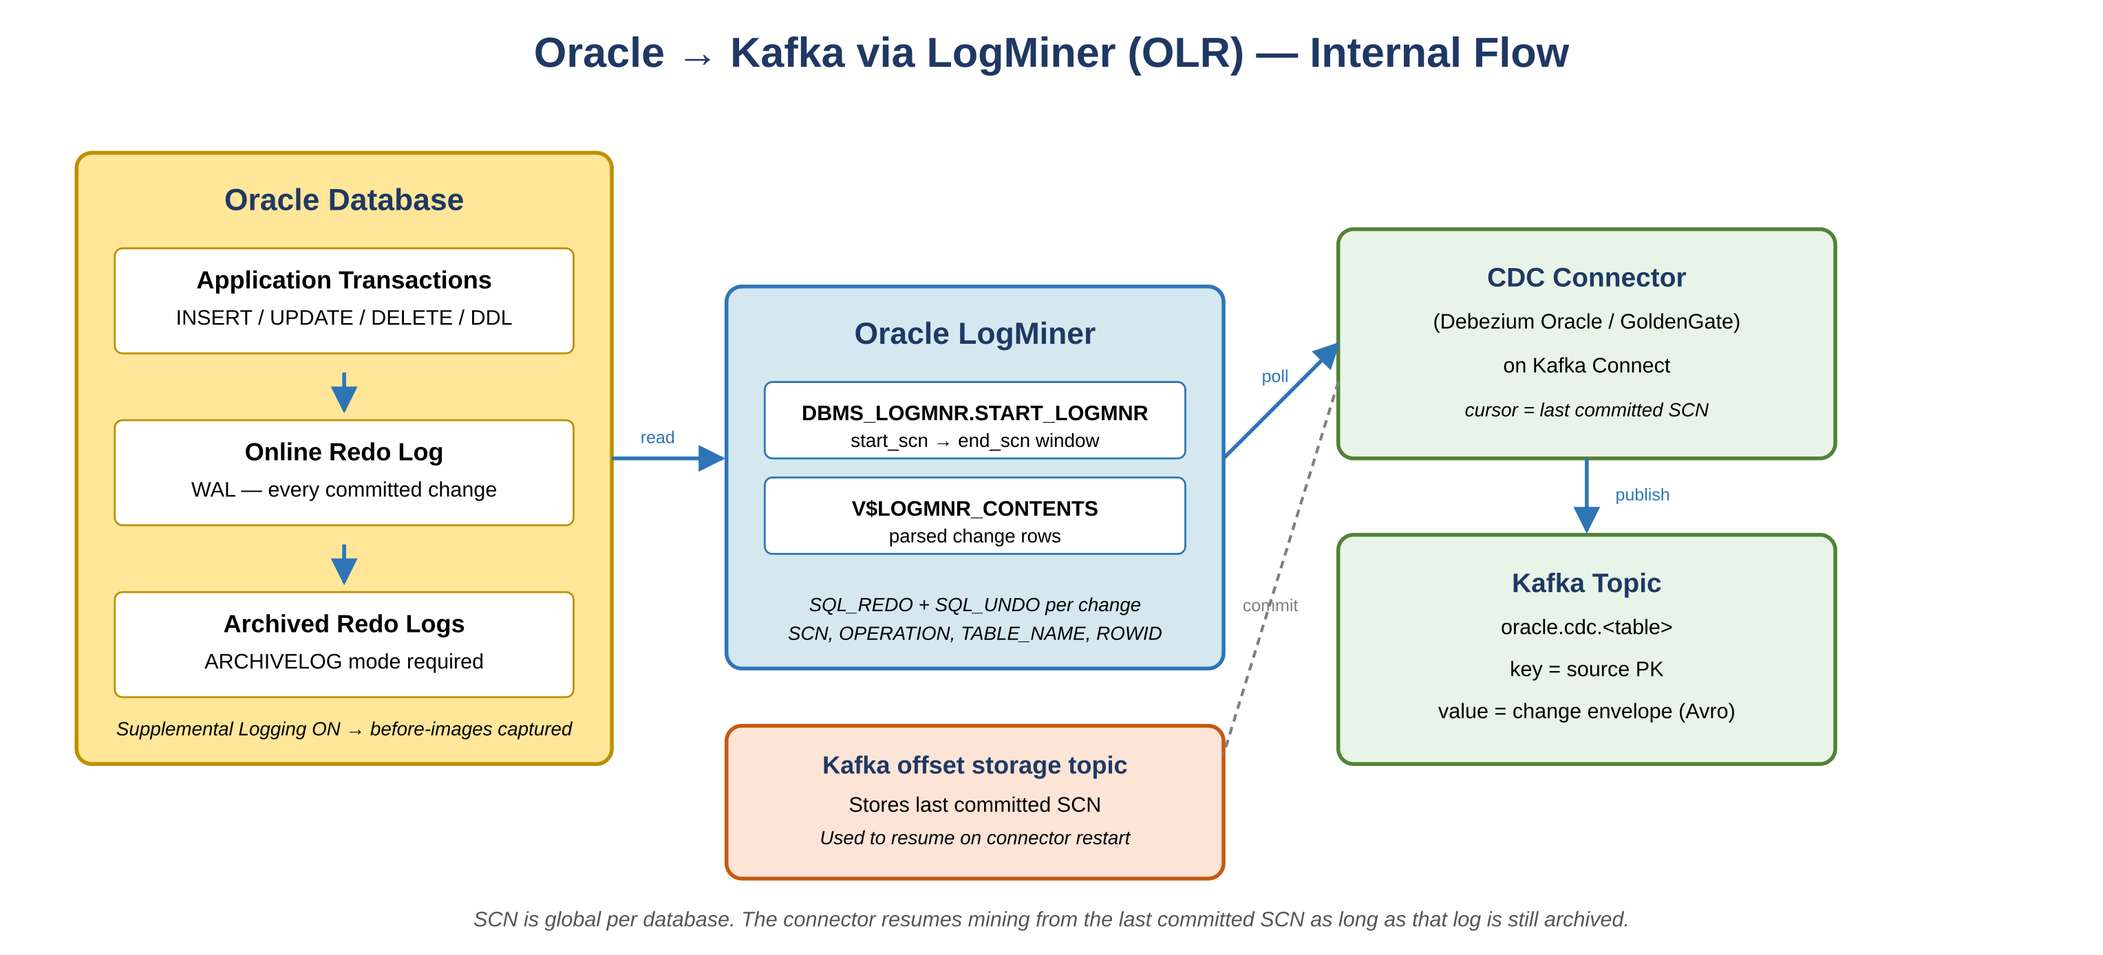
Figure 2.1 — Oracle redo log → LogMiner → CDC connector → Kafka topic

Key internals
Concept | Detail
Redo Log | Oracle's WAL. Every INSERT, UPDATE, DELETE, DDL is written here before commit. The CDC connector reads this.
Supplemental Logging | Must be enabled at DB or table level. Without it, only changed columns appear in the redo log. With ALL COLUMNS, full before-images are captured. Critical for CDC accuracy.
ARCHIVELOG mode | Oracle must be in ARCHIVELOG mode. The connector reads archived redo logs for historical changes and online redo logs for current changes.
SCN | System Change Number. Oracle's global transaction sequence. Used as the connector's cursor / offset. On restart, the connector resumes from the last committed SCN.
LogMiner Session | The connector opens a session with a start and end SCN range to mine. Mining window size affects throughput and Oracle server PGA memory.
Connector Offset | Stored in Kafka's offset storage topic. Survives connector restarts as long as the committed SCN is within the archived log retention window.

Common production issues
- Supplemental logging not enabled on a new table: CDC events missing before-image columns. Always verify V$SUPPLEMENTAL_LOG_DATA after onboarding a new table.
- Archived log purged before connector reads it: the connector loses position. Set archive log retention to at least 2x the connector's expected maximum lag. Alert when the connector's SCN approaches the oldest available archived SCN.
- Large bulk DML operations: produce massive redo entries that stall the connector. Route bulk loads to a separate topic and filter at the consumer.
- LogMiner PGA memory pressure: large mining windows consume server memory. Tune with CONTINUOUS_MINE and monitor Oracle session memory via DBA_HIST_ACTIVE_SESS_HISTORY.

2.2 SQL Server → Kafka via Debezium

How Debezium SQL Server CDC works
Debezium reads SQL Server's native CDC feature. SQL Server CDC populates internal change tables (cdc.dbo_TableName_CT) from the transaction log. Debezium polls these change tables as a Kafka Connect source connector and publishes one Kafka topic per captured table by default.
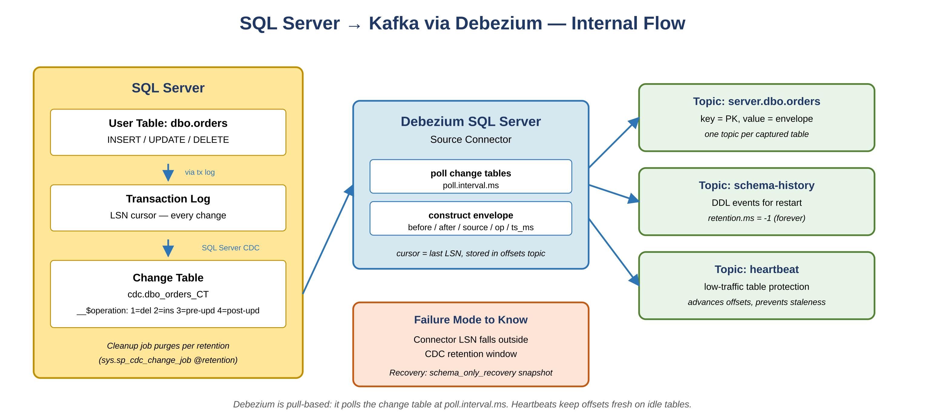
Figure 2.2 — SQL Server CDC change tables → Debezium poll → Kafka topics

Key internals
Concept | Detail
SQL Server CDC enable | EXEC sys.sp_cdc_enable_db and EXEC sys.sp_cdc_enable_table. Creates change tables and a cleanup job.
LSN | Log Sequence Number. SQL Server equivalent of Oracle SCN. Debezium tracks its cursor by LSN, stored in Kafka Connect offset storage.
Change Tables | __$operation codes: 1=delete, 2=insert, 3=before-update, 4=after-update. Debezium maps these to Debezium op codes: d, c, u.
Capture Instance | Each captured table has a capture instance. Up to two per table allowed, enabling zero-downtime schema migrations.
Schema History Topic | Dedicated Kafka topic storing all DDL history. Required for connector restart and schema evolution. Set with infinite retention.
Heartbeat Events | Periodic heartbeat messages advance connector offsets on low-traffic tables. Prevents offset staleness that would force a full snapshot on restart.
Snapshot Mode | initial: full snapshot on first run. schema_only: no data snapshot, stream from current LSN. schema_only_recovery: used after retention breach.

Debezium message envelope
Know this structure cold. Every Debezium event has the same shape, regardless of source DB. The before/after pair lets consumers distinguish the change type without referring back to the source. The op field is the single character code (c, u, d, r) that drives downstream routing logic.
{
"before": { ... }, // row state before change (null for INSERT)
"after": { ... }, // row state after change (null for DELETE)
"source": {
"connector": "sqlserver",
"db": "mydb", "table": "orders",
"change_lsn": "0000002c...",
"commit_lsn": "0000002c...",
"ts_ms": 1711234567890 // source DB event time
},
"op": "c", // c=create u=update d=delete r=snapshot
"ts_ms": 1711234567900 // Debezium processing time
}

Common production issues
- CDC cleanup truncates change tables before Debezium reads: increase retention via sys.sp_cdc_change_job @retention parameter. Alert when connector LSN lag approaches the retention window boundary.
- Long connector downtime beyond retention window: requires schema_only_recovery snapshot. Design for this operationally by monitoring the gap between Debezium LSN and oldest change table LSN.
- Schema change on a captured table: additive changes (new nullable column) handled automatically. Column drops or renames require a new capture instance — create the new instance first, update connector config, then drop the old instance.
- High-volume tables: tune poll.interval.ms and max.batch.size to balance latency and throughput. Monitor source-record-poll-rate metric to verify the connector is keeping up.

3. Kafka Connect Architecture
Both your source connectors (OLR, Debezium) and sink connectors (JDBC) run inside Kafka Connect. Connect is a separate cluster of JVM workers that hosts connector plugins, manages task distribution, and handles offset commits. Understanding Connect internals is essential for production operations and interviews.
Component | Description
Connect Worker | A JVM process hosting connectors. Standalone mode for dev, distributed mode (multiple workers) for production with automatic load sharing and rebalancing.
Source Connector | Reads from an external system, publishes to Kafka. Your Oracle OLR and Debezium SQL Server connectors are source connectors.
Sink Connector | Reads from Kafka, writes to an external system. Your JDBC Sink connectors writing to MySQL and PostgreSQL are sink connectors.
Task | Unit of parallelism within a connector. tasks.max=4 allows 4 partitions to be processed in parallel per connector.
Converter | Serializes message keys and values. AvroConverter (with Schema Registry), JsonConverter, ProtobufConverter. Debezium commonly uses AvroConverter.
SMT | Single Message Transform. Lightweight in-flight transformation: field masking, topic routing, timestamp conversion. Runs before the sink.
Dead Letter Queue | Topic where records that fail connector processing are routed. Configured via errors.deadletterqueue.topic.name. Prevents one bad record from stalling the pipeline.

3.1 JDBC Sink Connector — your MySQL and PostgreSQL sinks
Critical settings for idempotent CDC sinking
- insert.mode=upsert uses INSERT ON DUPLICATE KEY UPDATE (MySQL) or INSERT ON CONFLICT DO UPDATE (PostgreSQL). Makes writes idempotent for at-least-once delivery.
- pk.mode=record_key uses the Kafka message key (your source table PK) as the upsert target. Ensure your CDC connector sets the message key to the source PK.
- delete.enabled=true required to propagate Debezium DELETE events (op=d) to the sink database.
- batch.size tune for sink DB capacity. Start at 3000. Larger batches reduce round trips but increase sink DB memory pressure.
- auto.create=false, auto.evolve=false in production: manage all DDL explicitly on the sink databases.

4. Monitoring: Prometheus & Grafana
Kafka exposes metrics via JMX. The JMX Exporter (a Java agent attached to the broker or Connect JVM) converts JMX metrics into a Prometheus scrape endpoint. Prometheus scrapes these endpoints on a configurable interval. Grafana reads from Prometheus and visualizes dashboards. Alertmanager fires alerts based on Prometheus rules. This is the standard production stack at companies like Uber.
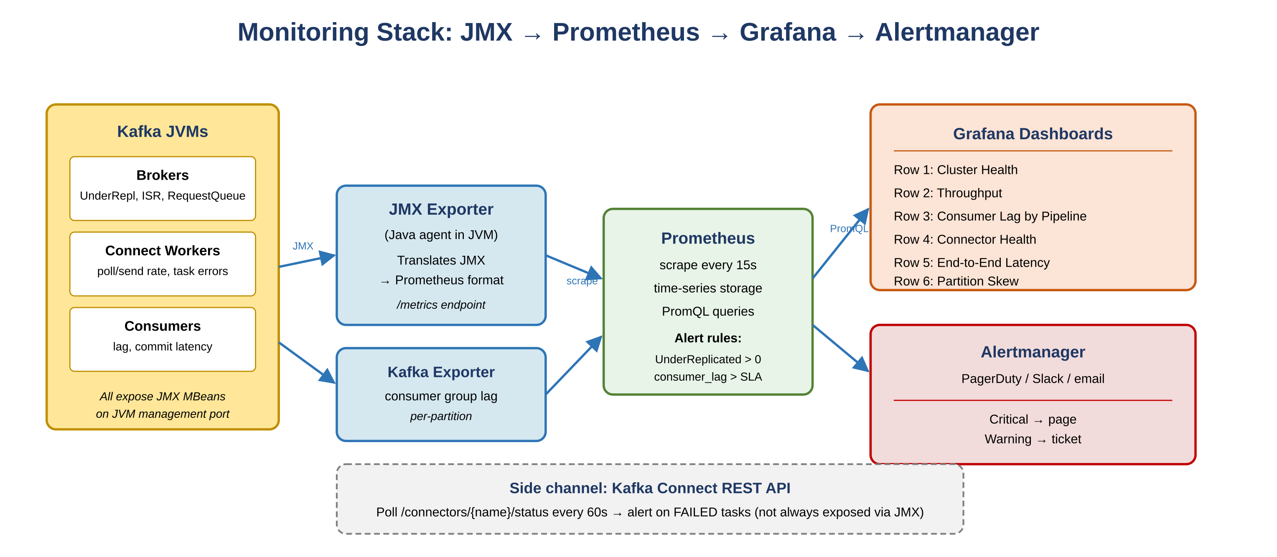
Figure 4.0 — JMX → JMX Exporter → Prometheus → Grafana / Alertmanager

4.1 Critical Broker Metrics
Metric | What to watch | Alert
UnderReplicatedPartitions | Partitions where ISR count is below replication factor. Sustained non-zero = cluster health issue. | Page if > 0 for > 1 min
ActiveControllerCount | Must always be exactly 1 across the entire cluster. 0 = no controller. > 1 = split-brain. | Page if != 1
OfflinePartitionsCount | Partitions with no elected leader. Producers and consumers cannot access these. | Page if > 0
MessagesInPerSec | Ingest rate per broker. Baseline for capacity planning and anomaly detection. | Trend / capacity
BytesInPerSec / Out | Network throughput. Compare to NIC limits to detect saturation. | Capacity warning
RequestQueueSize | Requests waiting to be processed. Spikes indicate broker is overwhelmed or GC paused. | Warn on spike
LogFlushRateAndTimeMs | Time to flush logs to disk. High values indicate storage I/O bottleneck. | Latency warning
ISRShrinkRate | Rate at which replicas fall out of ISR. Sustained non-zero signals follower lag or network issues. | Warn if sustained

4.2 Consumer Lag Metrics — most critical for CDC
Consumer lag is the single most operationally important metric in your CDC pipelines. It measures how far behind a consumer group is from the latest produced offset on each partition. For CDC, lag directly equals data freshness.
Metric | Alert condition
kafka_consumer_group_lag | Per-partition lag per consumer group. Alert when lag for your CDC consumer exceeds SLA threshold (e.g. 10,000 records for near-real-time).
kafka_consumer_group_lag_sum | Aggregate lag across all partitions. Use for overall SLA alerting per pipeline.
records_lag_max | Max lag across all assigned partitions for a single consumer instance. Exposed by Kafka consumer client JMX.
records_consumed_rate | Drop in rate while lag rises = slow consumer. Investigate GC, sink DB latency, or connector task failure.
commit_latency_avg | High values mean slow offset commits. Increases reprocessing window on connector restart.

Pipeline-specific additions
- Oracle OLR: alert when connector SCN falls within 20% of the oldest available archived log SCN. This is your pre-failure warning.
- Debezium SQL Server: alert when connector LSN lag is within 25% of the CDC retention window. Also alert when cleanup job row counts drop sharply.
- Connector health: poll GET /connectors/{name}/status via Connect REST API every 60s. Alert if state transitions out of RUNNING.
- End-to-end latency: compute delta between source.ts_ms in the Debezium envelope and the sink write timestamp. This is true data freshness, not just Kafka throughput.

4.3 Kafka Connect Metrics
Metric | Significance
source-record-poll-rate | Rate of new records polled from source. Drop signals source DB slowdown or connector stall.
sink-record-send-rate | Rate of records written to sink. Compare to poll-rate to detect sink bottleneck.
task-error-total | Total connector task errors. Non-zero warrants DLQ inspection. Increasing rate = systematic bad records.
batch-size-avg | Avg sink batch size. Too small = chatty writes. Too large = latency spikes on sink DB.
offset-commit-completion-rate | Low rate means connector may reprocess messages after restart. Investigate GC or slow Kafka broker.
connector-status (REST API) | RUNNING / PAUSED / FAILED per connector and task. Integrate into alerting via polling script or monitoring plugin.

4.4 Grafana Dashboard Layout
Structure your Grafana dashboards in rows from macro health down to pipeline-specific detail. The progression mirrors how an on-call engineer triages: start at cluster health, then drill into the specific pipeline showing lag or errors.
- Row 1 — Cluster Health: UnderReplicatedPartitions, ActiveControllerCount, OfflinePartitions, BrokerCount. Red/green indicators. First thing ops checks.
- Row 2 — Throughput: MessagesInPerSec, BytesIn/Out per broker, topic-level ingestion rates. Capacity planning and traffic anomaly detection.
- Row 3 — Consumer Lag by Pipeline: separate panel per consumer group: Oracle OLR, Debezium SQL Server, JDBC Sink. Threshold line at SLA lag budget.
- Row 4 — Connector Health: one panel per connector. Status (RUNNING/FAILED), error rate, poll rate, batch size. Color-coded status cells.
- Row 5 — End-to-End Latency: source event time to sink write time per pipeline. Your data freshness SLA dashboard.
- Row 6 — Partition Skew (Uber-relevant): messages per partition for high-volume topics. Uneven distribution signals a bad partition key strategy.

5. Schema Registry & Schema Evolution
At Uber's scale, schema management is non-negotiable. The Schema Registry stores Avro/Protobuf/JSON schemas and enforces compatibility rules before a producer can publish a breaking schema change. Compatibility rules are the contract between your producers and consumers — choosing the wrong mode lets bad schemas reach production.
Compatibility Mode | What it allows
BACKWARD | New schema can read data written with the old schema. Consumers upgrade first. Default. Adding optional fields is backward compatible.
FORWARD | Old schema can read data written with the new schema. Producers upgrade first. Removing optional fields is forward compatible.
FULL | Both backward and forward compatible. Most restrictive. Only adding/removing optional fields with defaults allowed.
NONE | No checks. Dangerous in production. Only for dev or tightly coordinated migrations.
How this works in your setup
Debezium integrates with Schema Registry via AvroConverter. Each source table schema is registered automatically. When SQL Server has a DDL change (new column added), Debezium registers a new schema version. With BACKWARD compatibility, your MySQL and PostgreSQL sink consumers continue working without redeployment, gracefully ignoring fields they do not yet understand.

6. Interview Questions & Strong Answers
Calibrated to Uber's engineering depth. Every answer ties back to your SIG production experience. Practice these aloud — fluency under pressure is what separates a textbook answer from a credible production engineer.

6.1 CDC Architecture
Q: Walk me through your CDC architecture end to end.
Strong Answer: We run two CDC pipelines at SIG. The first uses Oracle LogMiner to capture row-level changes from Oracle into Kafka. LogMiner reads Oracle's redo logs and the connector tracks position using Oracle's SCN. We have supplemental logging enabled at the table level to capture full before-and-after row states. From Kafka, JDBC Sink connectors with upsert mode apply changes to MySQL, SQL Server, and PostgreSQL targets idempotently. The second pipeline uses Debezium's SQL Server connector, reading from SQL Server's native CDC change tables. Debezium tracks position via LSN and publishes full change envelopes (before/after/op/source metadata) to Kafka. JDBC Sink connectors with delete.enabled=true and upsert mode write to MySQL and PostgreSQL targets. Both pipelines run inside Kafka Connect in distributed mode. Monitoring is Prometheus scraping JMX metrics from brokers and Connect workers, visualized in Grafana. I alert on consumer lag per pipeline, connector task failures, and end-to-end latency measured from source ts_ms in the Debezium envelope to the sink write timestamp.
Interview Tip: This is your anchor story. Practice it until it flows under 3 minutes with no hesitation.
Q: How do you handle a Debezium connector that has fallen behind its CDC retention window?
Strong Answer: This is a real production failure mode I plan for explicitly. If Debezium's last committed LSN falls outside SQL Server's CDC retention window, the change tables have been cleaned up and the connector cannot resume from its last position. Recovery options in order of preference: (1) snapshot.mode=schema_only_recovery — Debezium snapshots the current schema only, then resumes streaming from the current LSN. The gap in changes is accepted but the connector recovers quickly. Suitable when the sink can tolerate a brief inconsistency window. (2) Full initial snapshot — drop and recreate the connector with snapshot.mode=initial. Debezium re-snapshots all rows then streams changes. Safe but slow for large tables. (3) Prevention — I monitor the gap between Debezium's last committed LSN and the oldest available LSN in the CDC change tables. I alert at 75% of the retention window, well before it becomes critical. I also coordinate with DBAs to set CDC retention to at least 2x the expected maximum connector downtime.
Interview Tip: Show you have thought about failure modes operationally, not just architecturally.
Q: How do you ensure your CDC pipeline does not drop or duplicate records?
Strong Answer: I think about this at three layers. Source to Kafka: both Oracle OLR and Debezium provide at-least-once delivery. To prevent loss I ensure acks=all on the connector's Kafka producer and min.insync.replicas=2 on the CDC topic. Connector offsets are committed only after successful Kafka write acknowledgment. Kafka durability: replication factor 3 on all CDC topics. With min.insync.replicas=2, a message is acknowledged only after two brokers confirm receipt — this tolerates one broker failure without data loss. Kafka to sink: JDBC Sink connectors use upsert mode. PostgreSQL uses INSERT ON CONFLICT DO UPDATE; MySQL uses INSERT ON DUPLICATE KEY UPDATE. This makes every sink write idempotent, so duplicate delivery from Kafka is absorbed without creating duplicate rows. The result is effective exactly-once semantics at the sink even though each individual layer guarantees only at-least-once.
Q: How would you partition a CDC topic for a high-volume source table?
Strong Answer: Partition key selection for CDC has two goals: even distribution across partitions and per-entity ordering. I use the source table's primary key as the Kafka message key. All changes to a given row always route to the same partition by key hash, preserving row-level ordering. For Uber's context, using ride_id or driver_id as the key means all state changes for a given entity land in the same partition in order — critical for consumers rebuilding current entity state from a CDC stream. For partition count: target throughput / per-partition throughput. A typical rule of thumb is 10MB/s per partition as a starting point. I avoid over-partitioning (wastes broker resources, increases metadata overhead) and under-partitioning (creates bottlenecks on high-traffic keys). For skew: high-activity keys produce more messages than low-activity keys. I monitor per-partition message rates in Grafana and if skew is significant I evaluate salting or a composite key.
Interview Tip: Uber's event volumes will make this a real concern. Show you think about skew proactively.
Q: How do you handle a schema change in SQL Server while Debezium is running?
Strong Answer: Schema evolution needs to be handled at three points. (1) Source connector: Debezium detects DDL changes via SQL Server's CDC schema history. For additive changes (new nullable column), Debezium automatically registers a new schema version with the Schema Registry and begins including the new field. With BACKWARD compatibility, existing consumers ignore the unknown field. (2) For breaking changes (column drop or rename): create a new SQL Server capture instance on the table first — this is why SQL Server allows two capture instances per table. Update the Debezium connector to read from the new instance. Drop the old instance only after consumers have caught up. (3) Sink: with auto.evolve=false (production standard), I coordinate the DDL change explicitly on the MySQL and PostgreSQL targets before the new schema arrives. This prevents the JDBC Sink from encountering a column that does not exist on the target. I also emit a schema change notification to a separate Kafka topic so downstream Spark jobs and BI tools are alerted and can be updated on their own schedules.
Interview Tip: Uber will probe schema evolution depth. Show you have handled this in production with a concrete procedure.

6.2 Monitoring & Operations
Q: Walk me through your production monitoring setup for Kafka.
Strong Answer: Our stack is JMX Exporter on brokers and Connect workers, Prometheus for scraping and alerting, and Grafana for dashboards. On brokers: JMX Exporter runs as a Java agent exposing metrics at a Prometheus scrape endpoint. Prometheus scrapes every 15 seconds. Critical alerts: UnderReplicatedPartitions non-zero for more than 1 minute (pages immediately), ActiveControllerCount not equal to 1, OfflinePartitions greater than 0. Consumer lag: I use Kafka Exporter alongside JMX Exporter specifically for per-partition consumer group lag — the most operationally important metric. I alert when aggregate lag for a CDC consumer group exceeds the threshold tied to our data freshness SLA. Connector health: I poll the Kafka Connect REST API every 60 seconds and alert if any connector task transitions out of RUNNING. I track task-error-total and route to dead letter queue topics for investigation. End-to-end latency: I compute the delta between source.ts_ms in the Debezium envelope and the write timestamp recorded on the sink — this measures true data freshness end-to-end, not just Kafka throughput. Grafana dashboards are structured in rows: cluster health at the top, throughput, consumer lag per pipeline, connector health, and end-to-end latency at the bottom.
Interview Tip: This answer demonstrates operational maturity. Walk through it confidently referencing your actual setup.
Q: Consumer lag is rising on one of your CDC pipelines. How do you diagnose and fix it?
Strong Answer: I follow a structured diagnosis path. Step 1: Grafana consumer lag panel. Is lag rising steadily (throughput mismatch) or spiking suddenly (connector failure or source burst)? Check records_consumed_rate alongside lag. Rate drop with rising lag means the consumer slowed down. Steady rate with rising lag means the source accelerated. Step 2: Connect REST API. Check connector and task status. A FAILED task stops consuming entirely. If failed, check the task error log and dead letter queue topic for the first failing record. Step 3: Broker metrics. Check RequestQueueSize and disk I/O on the broker serving the lagging partitions. A saturated broker throttles consumers. Step 4: Consumer JVM. Check GC logs on the Connect worker. Long GC pauses stall both consumption and offset commits. Check sink DB latency — if MySQL or PostgreSQL is slow, the JDBC Sink backs up. Fixes in order of least invasive: restart the failed task, increase tasks.max for more parallelism, scale Connect workers horizontally, tune JDBC Sink batch.size for better sink throughput, or if the source burst is temporary, let the consumer catch up naturally once ingest rate returns to normal.
Interview Tip: Walk through the diagnosis path methodically. Interviewers want to see structured problem-solving, not guessing.
Q: What Prometheus alerts would you configure for a production Kafka CDC pipeline?
Strong Answer: Critical alerts (page immediately): UnderReplicatedPartitions > 0 for > 2 min; ActiveControllerCount != 1; OfflinePartitionsCount > 0; any CDC connector status != RUNNING for > 1 min; consumer group lag exceeds SLA threshold for > 5 min. Warning alerts (Slack/ticket): ISRShrinkRate > 0 sustained for 10 min; consumer lag growing monotonically for 15 min with no decrease; connector task-error-total increasing (records accumulating in DLQ); broker disk utilization > 80%; end-to-end CDC latency exceeds SLA target (e.g. > 60 seconds for near-real-time pipeline). Oracle OLR specific: connector SCN within 20% of oldest available archived log SCN (pre-failure warning); redo log archival rate significantly outpacing connector mining rate. Debezium SQL Server specific: connector LSN lag within 25% of CDC retention window boundary; CDC cleanup job causes sharp drop in change table row counts.
Interview Tip: Showing SLA-driven and pipeline-specific alerts signals production depth that impresses Uber-level interviewers.

7. Configuration Cheat Sheet
Production-ready settings you should be able to recall without notes. These are the defaults you would push back on if a teammate proposed something different.

7.1 Kafka Broker
Parameter | Recommendation
replication.factor | 3 in production. Tolerates loss of 2 brokers.
min.insync.replicas | 2. With acks=all, ensures durability with one broker down.
log.retention.hours | 48 to 168 hours for CDC topics. Must exceed maximum expected connector downtime.
auto.create.topics.enable | false. Prevents accidental topic creation with wrong settings.
unclean.leader.election.enable | false. Prevents data loss from a lagging replica becoming leader.
log.cleanup.policy | delete (default) for CDC event topics. compact for change-log topics (keeps latest value per key).

7.2 Debezium SQL Server Connector
Parameter | Notes
database.history.kafka.topic | Dedicated DDL history topic. Set retention to permanent (retention.ms=-1).
snapshot.mode | initial for first run. schema_only_recovery for restart after retention breach.
poll.interval.ms | Default 1000ms. Lower for lower latency. Higher for lower load on source DB.
heartbeat.interval.ms | Enable for low-traffic tables. Prevents offset staleness on quiet tables.
tombstones.on.delete | true. Emits null-value tombstone after DELETE for log compaction compatibility.
decimal.handling.mode | string or double. Explicit handling for DECIMAL/NUMERIC to prevent precision loss.
errors.deadletterqueue.topic.name | Always configure a DLQ topic in production. Prevents one bad record from stalling the pipeline.

7.3 JDBC Sink Connector
Parameter | Notes
insert.mode | upsert. Required for idempotent CDC sink writes.
pk.mode | record_key. Uses Kafka message key (source PK) for upsert.
delete.enabled | true. Propagates DELETE events from Debezium envelope.
batch.size | Start at 3000. Tune upward if sink DB can handle larger batches.
auto.create | false in production.
auto.evolve | false in production. Coordinate DDL changes explicitly.

8. Glossary
Quick-reference definitions. If an interviewer drops one of these terms casually, you should be able to answer in under 10 seconds.
Term | Definition
SCN | System Change Number. Oracle's transaction sequence. CDC connector cursor.
LSN | Log Sequence Number. SQL Server equivalent of Oracle SCN. Debezium cursor.
OLR | Oracle Log Reader / Oracle LogMiner. Reads Oracle redo logs for CDC.
Debezium | Open-source CDC platform. Reads DB transaction logs via Kafka Connect.
ISR | In-Sync Replicas. Replicas fully caught up with the partition leader.
DLQ | Dead Letter Queue. Topic for records that failed connector processing.
SMT | Single Message Transform. Lightweight in-flight record transformation.
KRaft | Kafka Raft. ZooKeeper replacement for cluster metadata in Kafka 3.x+.
Log Compaction | Retention policy that keeps only the latest message per key. Useful for change-log topics.
Watermark | Stream processing concept: defines tolerated event lateness before a window closes.
Exactly-once | No loss, no duplicates. Idempotent producer + transactional API + idempotent sink.
Capture Instance | SQL Server CDC concept. One per table. Allows schema migration without downtime.
JMX Exporter | Java agent exposing JMX metrics as Prometheus scrape endpoint.
Kafka Exporter | Tool exposing consumer group lag metrics for Prometheus scraping.
ts_ms (Debezium) | Source event timestamp in the Debezium envelope. Used for end-to-end latency measurement.

Final note
Your Oracle OLR and Debezium production experience is real-world and rare. Most candidates can describe Kafka concepts; far fewer have run two CDC pipelines in production at a financial services firm. Own every answer with confidence. Lead with your SIG context, then generalize to the interviewer's company. The depth speaks for itself.

