DATA MODELING, HIVE & HADOOP/YARN
Senior DE Interview Study Guide
Krishna Theja Upadhyaya
Senior Data Engineer | SIG | 9+ Years
Part 1: Data Modeling & SCD | Part 2: Hive Deep Dive | Part 3: Hadoop/YARN Internals
How to use this guide
Part 1 has been substantially expanded with more worked examples, diagrams, and additional concepts (fact table types, bridge tables, Inmon vs Kimball, medallion architecture, grain). Read it linearly the first time, then use it as a reference once you know the structure.
Each major concept opens with a plain-language explanation, followed by a diagram or worked example, then a reference table or interview-grade detail.

Part 1 — Data Modeling & Slowly Changing Dimensions
Data modeling is the discipline of structuring data to support how the business asks questions of it. The two most consequential decisions are: (1) what does one row in the fact table represent (the grain), and (2) how do we handle dimension attributes that change over time (SCDs). Everything else flows from these.

1.1 Core Concepts: Facts and Dimensions
A dimensional model has two kinds of tables. Fact tables hold the numbers you measure (quantities, prices, durations). Dimension tables hold the descriptive context you slice and filter by (who, what, where, when). The fact table sits in the middle, and dimensions surround it like points of a star.

Fact Tables
- Store measurable, quantitative data about business events: trades, transactions, accruals, page views, orders
- Contain foreign keys to dimension tables and numeric measures
- At SIG: daily accrual facts, end-of-month reconciliation facts, BDI market data facts

Dimension Tables
- Provide descriptive context for facts (who, what, where, when)
- Typically denormalized for query performance (star schema) or normalized (snowflake schema)
- Contain natural keys (business keys) and surrogate keys (system-generated integers)
- At SIG: trade desk dimensions, instrument dimensions, counterparty dimensions, calendar dimensions

Surrogate Keys vs Natural Keys
Every dimension table needs both. The natural key is the business identifier (trader_id = 99). The surrogate key is a system-generated integer (trader_sk = 5247) that uniquely identifies a row, including across SCD Type 2 history. Facts join on the surrogate key, never the natural key, because the natural key alone cannot identify a specific point-in-time version of a dimension row.
Property | Surrogate Key vs Natural Key
Surrogate Key | Integer, system-generated (often via sequence or identity). Meaningless to the business. Stable: never changes. Used as fact-to-dimension join column.
Natural Key | Business identifier (employee_id, ISIN, account number). Carried alongside the surrogate. Useful for source-system traceability and SCD lookups.
Why both | Surrogate gives the model independence from source system changes (renumbered employees, merged companies). Natural key gives source traceability and supports SCD Type 2 versioning.

1.2 Star Schema vs Snowflake Schema
Both organize facts and dimensions, but they differ in how dimensions themselves are normalized. Star keeps each dimension as a single denormalized table. Snowflake normalizes dimensions into hierarchies of related tables. Star is faster for queries; snowflake saves storage at the cost of joins.
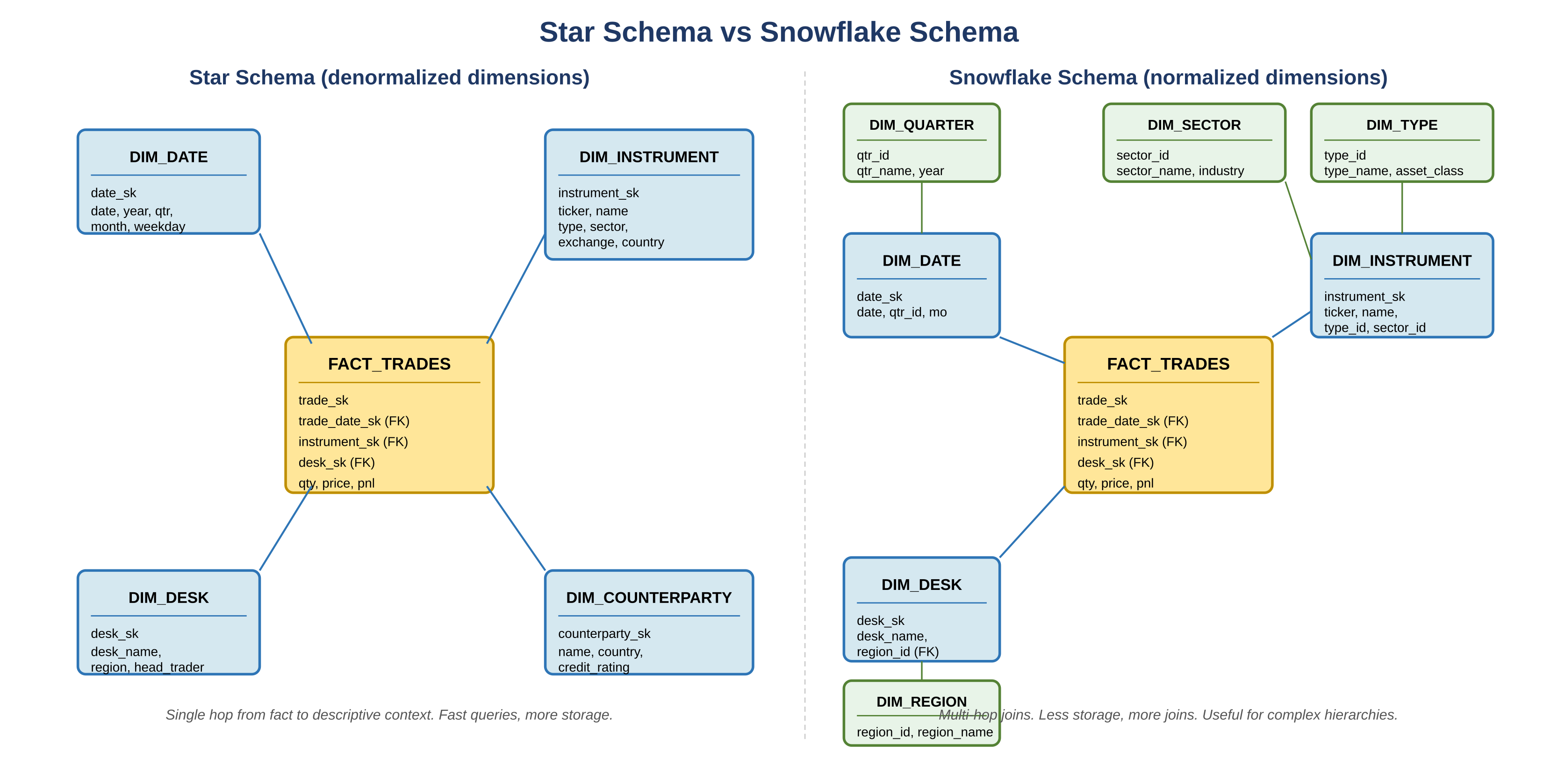
Figure 1.1 — Star schema (left) keeps each dimension flat. Snowflake (right) normalizes dimensions into sub-dimensions
Schema | Description
Star Schema | Dimension tables directly connected to fact table. Denormalized. Faster queries, more storage. Preferred for analytics and BI. Single-hop joins from fact.
Snowflake Schema | Dimension tables normalized into sub-dimensions. Less storage, more joins. Useful when dimension data has complex hierarchies that change frequently.
At SIG | Star schema for trading desk reporting tables. Snowflake for reference data with complex hierarchies (instrument types, desk hierarchies).
When to choose snowflake over star
Default to star. Move toward snowflake only when the dimension has a real hierarchy that benefits multiple facts (an instrument hierarchy used by trades, positions, and risk facts), or when the denormalized dimension is so large it would dominate the row size. For most analytics workloads on Snowflake, Databricks, or Hive, the join cost of snowflake is more expensive than the storage savings.

1.3 Fact Table Types
Not all facts are the same. Picking the right fact table type for the business question is as important as picking the right grain. Senior interviews probe this: candidates who only know transactional facts get caught by questions about lifecycle tracking or coverage.
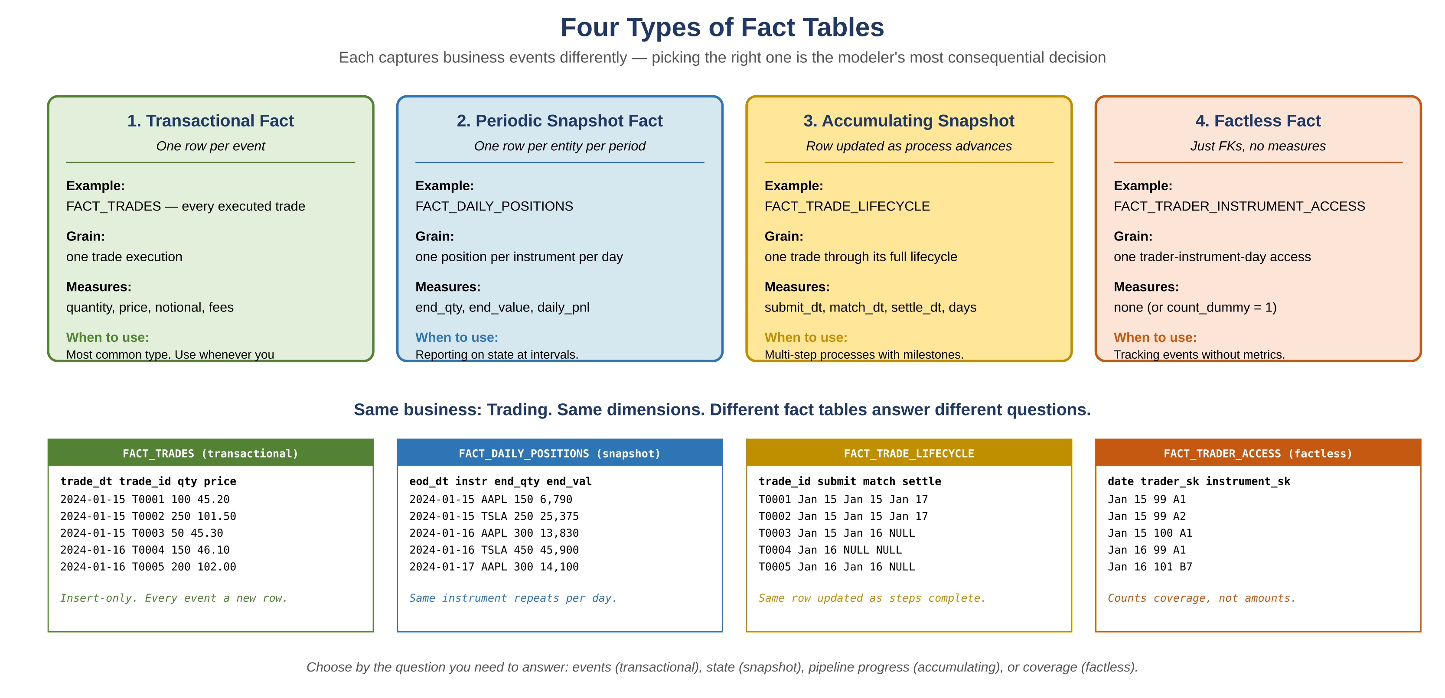
Figure 1.2 — Four fact table types, with sample data showing how each captures business events

1. Transactional Fact
One row per business event. Insert-only, append-only. The most common and simplest type. At SIG, FACT_TRADES is transactional: every executed trade is a new row, never updated.

2. Periodic Snapshot Fact
One row per entity per period (per day, per month). Captures state at regular intervals. Used for end-of-period reporting and trend analysis. At SIG, FACT_DAILY_POSITIONS records the end-of-day state of every instrument held: same instrument appears every day, with that day's quantity and value.

3. Accumulating Snapshot Fact
One row per business process instance, updated as the process advances through milestones. Useful for tracking pipelines or workflows where a single entity moves through defined stages. Example: a trade lifecycle row is inserted at trade submission, then updated when the trade is matched, then updated again when settled. Each update fills in dates and durations as the process completes.

4. Factless Fact
A fact table with only foreign keys, no numeric measures. Used to record that an event happened or a condition existed, without measuring an amount. Example: FACT_TRADER_INSTRUMENT_ACCESS records which traders had access to which instruments on which days. Counts of rows answer questions like 'how many traders had access to instrument X in Q1?' even though no row stores a number.
Type | When to use
Transactional | Default. Use whenever the business event is discrete and measurable. Trades, orders, payments, clicks.
Periodic Snapshot | Reporting on state at intervals: end-of-day positions, monthly account balances, daily inventory.
Accumulating Snapshot | Multi-step business processes with defined milestones: trade lifecycle, loan approval workflow, fulfillment.
Factless | Tracking that something happened, or coverage relationships, without a numeric measure. Eligibility, attendance, access.

1.4 Grain: The Most Important Decision
Grain is the level of detail represented by a single fact row. Defining grain first, before any other modeling choice, is the most critical step in dimensional design. Once grain is set, everything else follows: which dimensions apply, which measures make sense, how to aggregate.
The Kimball method has a specific four-step order, applied to each fact table separately:
- 1. Pick the business process (trading, ordering, lending, billing)
- 2. Declare the grain (state in plain English: 'one row per ___')
- 3. Identify the dimensions (who, what, where, when, applicable to that grain)
- 4. Identify the facts (numeric measures meaningful at that grain)
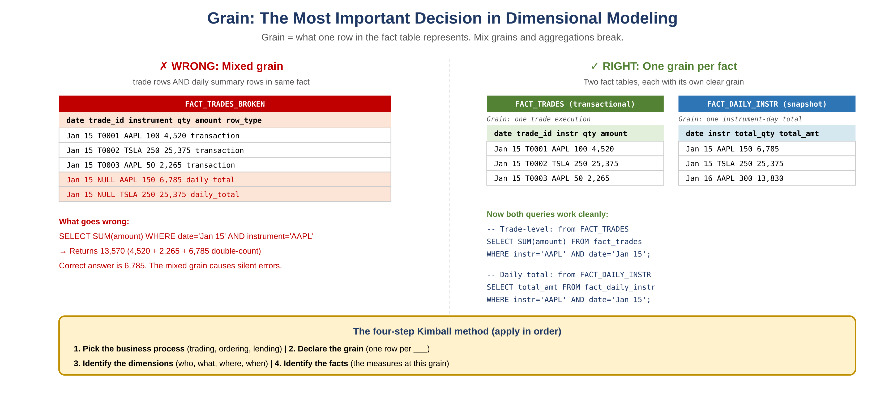
Figure 1.3 — Mixed grain causes silent aggregation errors. One grain per fact table is the rule
What 'one row per ___' actually looks like
Good grain statements are precise and complete:
• 'One row per trade execution' (not 'one row per trade')
• 'One row per order line item per day' (not 'one row per order')
• 'One row per customer per month' (clarifies the periodic snapshot)
• 'One row per loan application milestone reached' (accumulating snapshot)
If you cannot state the grain in one sentence, the model is not yet ready. The grain statement controls what dimensions apply (a daily snapshot fact cannot have a 'transaction time' dimension because individual transactions are no longer the grain) and what measures are valid (you cannot put trade-level pricing in a daily summary fact).

Slowly Changing Dimensions
SCDs handle dimension data that changes over time. Understanding which type to apply, and being able to explain the trade-offs, is a core senior DE interview topic. The 'slowly' in SCD distinguishes these from rapidly-changing dimensions (which need different patterns, see section 1.7).

1.5 SCD Types Explained with Examples

SCD Type 0 — Retain Original
The dimension value is set once and never updated. Historical value is permanently preserved. Use when the attribute should never change by design.
Type 0 example: Account open date
dim_account.account_open_date is captured when the account is created. If a downstream system later sends a corrected open date, you ignore it (or fix in a controlled exception process). The original is treated as canonical.
Other Type 0 candidates: date of birth, instrument inception date, contract original signing date.

SCD Type 1 — Overwrite
The new value overwrites the old value. No history retained. Use when historical accuracy doesn't matter, or when you're correcting a data error.
Type 1 example: Counterparty email update
Counterparty 'Acme Corp' changes their primary contact email from old@acme.com to new@acme.com. There's no business value in remembering the old email. UPDATE the dim_counterparty row in place.
SQL: UPDATE dim_counterparty SET email = 'new@acme.com' WHERE counterparty_id = 123;
Risk: if you Type 1 a desk reassignment, every historical trade now appears to have happened on the new desk. That is almost always wrong. Be careful which attributes are Type 1.

SCD Type 2 — Add New Row (Most Common)
A new row is inserted for every change. Full history preserved via effective date range and a current-row flag. The natural key alone cannot uniquely identify a row, which is why surrogate keys are required.
Type 2 is the workhorse of dimensional modeling. At SIG, it's used for trader-to-desk relationships, counterparty status, and any attribute where regulatory or analytical accuracy requires point-in-time correctness.
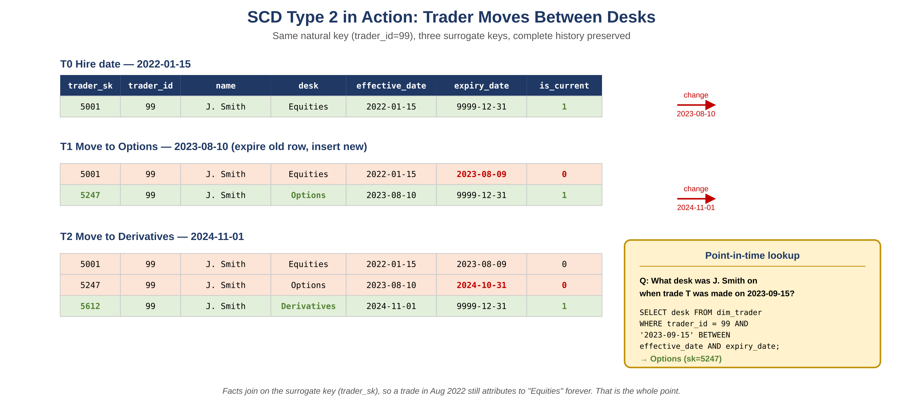
Figure 1.4 — SCD Type 2 in action: trader 99 moves between three desks over two years. All three states preserved

SCD Type 2: Required columns and update pattern
Column | Purpose
surrogate_key (PK) | System-generated integer. Unique per row including history.
natural_key | Business identifier (trader_id, customer_id). Repeated across history rows.
effective_date | When this version became current. Inclusive.
expiry_date | When this version was superseded. Use 9999-12-31 for current rows.
is_current | Boolean flag. Optional but speeds up 'get current' queries.
change attributes | The actual dimension fields that may change (desk, status, etc.).
Update pattern when a change is detected:
-- Step 1: Expire the current row
UPDATE dim_trader
SET expiry_date = current_date - 1, is_current = 0
WHERE trader_id = 99 AND is_current = 1;

-- Step 2: Insert the new row
INSERT INTO dim_trader (trader_id, name, desk, effective_date, expiry_date, is_current)
VALUES (99, 'J. Smith', 'Options', current_date, '9999-12-31', 1);

In Spark/Delta, this is typically done atomically with MERGE:
from delta.tables import DeltaTable

delta_table = DeltaTable.forPath(spark, '/data/dim_trader')
delta_table.alias('target').merge(
updates.alias('source'),
'target.trader_id = source.trader_id AND target.is_current = 1'
).whenMatchedUpdate(set={
'expiry_date': 'source.effective_date - INTERVAL 1 DAY',
'is_current': 'false'
}).whenNotMatchedInsertAll().execute()

Point-in-time lookup query (the test of any SCD Type 2)
To find the dimension value as of a specific date, the query joins on natural key plus a BETWEEN on the date range:

SELECT t.desk FROM dim_trader t
WHERE t.trader_id = 99
AND '2023-09-15' BETWEEN t.effective_date AND t.expiry_date;

Facts join to dim_trader via the surrogate key (trader_sk), which was set at fact-load time to the version of the trader that was current then. So a trade made in August 2022 always reports under 'Equities,' even after the trader has since moved to Options and Derivatives.

SCD Type 3 — Add New Column
Adds a column to store the previous value alongside the current value. Use when only one prior value matters and storage is constrained.
Type 3 example: Previous desk only
If the business only cares about 'current desk' and 'previous desk,' Type 3 is more compact than Type 2.

ALTER TABLE dim_trader ADD COLUMN previous_desk VARCHAR(50);
UPDATE dim_trader SET previous_desk = current_desk, current_desk = 'Equities' WHERE trader_id = 99;

Limitation: only tracks one level of history. Anything older than 'previous' is lost. If the trader moves desks three times, you only see the last two.

SCD Type 4 — History Table
Current dimension table holds only latest values. Separate history table tracks all changes. Useful when current lookups must be fast (small current table, fast joins) but full history is needed for audit.
Type 4 example: Instrument pricing reference
dim_instrument has the current canonical instrument data, joined by every fact for fast lookups. dim_instrument_history captures every prior version with effective dates, queried only for audits and historical analytics.
Trade-off: facts cannot easily reconstruct historical instrument context without explicitly joining to history. If point-in-time correctness is needed everywhere, use Type 2 instead.

SCD Type 6 — Hybrid (Type 1 + 2 + 3)
Combines Type 1 (overwrite current value on every row), Type 2 (new row per change), and Type 3 (previous value column). Most flexible: supports current value lookup, historical accuracy, and one-step-back comparison. Most complex to implement and maintain.
Example structure:
trader_sk | natural key surrogate
trader_id | natural key (Type 1: unchanging business key)
name | Type 1: always overwritten with latest
current_desk | Type 1: always overwritten with latest
desk_at_event | Type 2: the desk this row represents
previous_desk | Type 3: one-step-back comparison
effective_date | Type 2: when this row was current
expiry_date | Type 2
is_current | Type 2

When Type 6 is worth the complexity
Rare. Use Type 6 only when stakeholders genuinely need all three semantics in the same query: 'show every historical state of the trader, with their current name and current desk shown alongside the as-of-trade desk.' If that's the requirement, Type 6 saves you from joining the dimension to itself.
In most cases, Type 2 alone plus a separate join to a 'current dimension view' is simpler to maintain.

1.6 SCD Decision Tree
In an interview, you may be asked 'how would you model this dimension?' Walk through this decision tree explicitly:
If the requirement is... | Use | Why
Value never changes by design | Type 0 | No update logic needed
History does not matter, latest only | Type 1 | Simplest; just UPDATE in place
Full history with point-in-time accuracy | Type 2 | Most common in regulated/analytical contexts
Current and previous value comparison | Type 3 | Compact when only one step back matters
Frequent changes, fast current lookup, full audit | Type 4 | Splits hot path from audit path
All of the above in one model | Type 6 | Maximum flexibility, max complexity
What if attributes within one dimension have different needs?
This is the common case: a customer dimension has email (Type 1), address (Type 2), and signup date (Type 0). Pattern is per-attribute, not per-table. Apply Type 1 logic to email columns, Type 2 logic to address columns, never update signup date. The dimension table itself accommodates all three by following Type 2 row-versioning and applying Type 1 updates to all rows including expired ones for the Type 1 attributes.

1.7 Special Dimension Patterns
Beyond the SCD types, there are recurring patterns for specific modeling problems. Senior interviewers often probe these because they reveal whether a candidate has built dimensional models in production or only studied them.

Conformed Dimensions
Dimensions shared across multiple fact tables and used consistently. dim_date conformed across fact_trades, fact_positions, fact_pnl means a query joining any of these to dim_date gets consistent date attributes (fiscal year, business day flag, holiday calendar). Conformed dimensions are the foundation of the Kimball bus architecture: they make cross-process analysis possible without semantic mismatches.

Role-Playing Dimensions
The same dimension table joined multiple times with different aliases. A single dim_date might appear three times in a fact: trade_date, settle_date, value_date. Each role plays a different semantic role despite using the same physical dimension.
SELECT t.qty, td.fiscal_year AS trade_fy, sd.fiscal_year AS settle_fy
FROM fact_trades t
JOIN dim_date td ON t.trade_date_sk = td.date_sk
JOIN dim_date sd ON t.settle_date_sk = sd.date_sk;

Junk Dimensions
A single dimension table holding multiple low-cardinality flags and indicators that don't fit anywhere else. Common pattern: trade_indicators dimension holding {is_block_trade, is_cross, is_hedge, settlement_type}. Each combination of flag values gets one surrogate key. Without a junk dimension, fact tables sprout dozens of low-cardinality boolean columns.

Mini-Dimensions (for rapidly changing attributes)
When some attributes within a dimension change frequently (causing Type 2 row explosion), split them into a mini-dimension joined separately to the fact. Example: customer credit score changes monthly. Putting it in dim_customer with Type 2 creates a new dim_customer row every month. Instead, create dim_customer_credit_band with bands ('Excellent', 'Good', 'Fair') and join the fact to both dim_customer and dim_customer_credit_band as separate FKs.

Degenerate Dimensions
A dimension attribute stored directly in the fact table rather than in a separate dimension table. Common for transaction IDs, order numbers, or trade reference numbers that have no descriptive attributes worth maintaining separately. Avoids a join for a value that would otherwise be a one-column dimension table.

Bridge Tables (Many-to-Many)
Required when a fact relates to a variable number of dimension instances. A trade with multiple traders (a deal team), an order with multiple discount codes, a document with multiple authors. Bridge tables resolve the many-to-many while preserving the ability to aggregate at either grain.
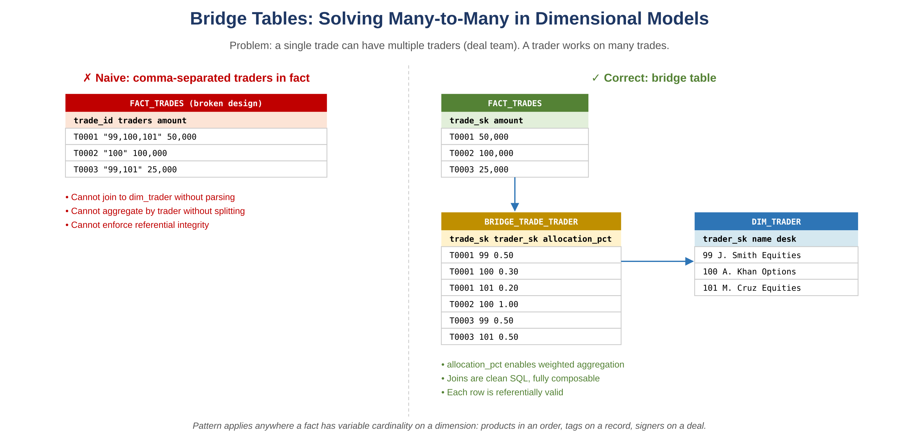
Figure 1.5 — Bridge tables solve many-to-many cleanly. The naive comma-separated approach breaks SQL
Bridge table design notes
Always include an allocation column (allocation_pct, weight, role) in the bridge if any aggregation should distribute the fact value across the dimensions. Without it, summing the fact across the bridge causes double-counting.
If the relationship has its own attributes (effective_date for an author-document tenure, bonus_share for a trader's allocation), the bridge becomes a dimension in its own right and may itself need SCD treatment.

1.8 Inmon vs Kimball: Two Schools of Warehouse Design
These are the two foundational philosophies of data warehousing. Most modern teams blend both, but every senior DE should be able to explain the difference and articulate when each applies.
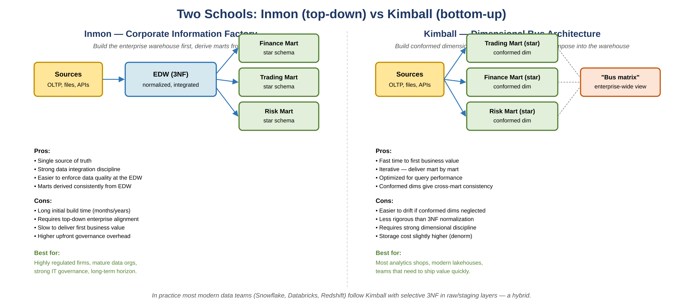
Figure 1.6 — Inmon builds an integrated EDW first, then derives marts. Kimball builds dimensional marts that compose into the warehouse
Aspect | Inmon (top-down) | Kimball (bottom-up)
Starting point | Build the enterprise EDW first | Build a dimensional mart for one process first
Schema | 3NF normalized in EDW | Star schema throughout
Time to value | Months to years | Weeks to months
Marts | Derived from EDW | Are the warehouse, joined via conformed dims
Best fit | Heavily regulated, mature data orgs | Most analytics shops, fast iteration
What this looks like in practice today
Modern lakehouses (Databricks, Snowflake) typically follow a Kimball-influenced pattern with a 3NF or normalized layer beneath, often called the medallion architecture. Bronze and Silver have Inmon-style normalization for replay and quality; Gold layer is dimensional in Kimball style for query performance.
The debate matters less than it did 20 years ago. The right answer at most companies is: 3NF or normalized in raw/staging, dimensional star at the consumption layer, conformed dimensions throughout.

1.9 Medallion Architecture (Modern Lakehouse Pattern)
Most modern lakehouse teams (Databricks, Delta Lake, Iceberg-based stacks) organize data in three layers: Bronze (raw), Silver (cleaned and conformed), and Gold (business-ready aggregates). This is a packaging of older patterns (raw/staging/mart, ODS/EDW/DM) under newer naming, optimized for cloud lakehouse storage.
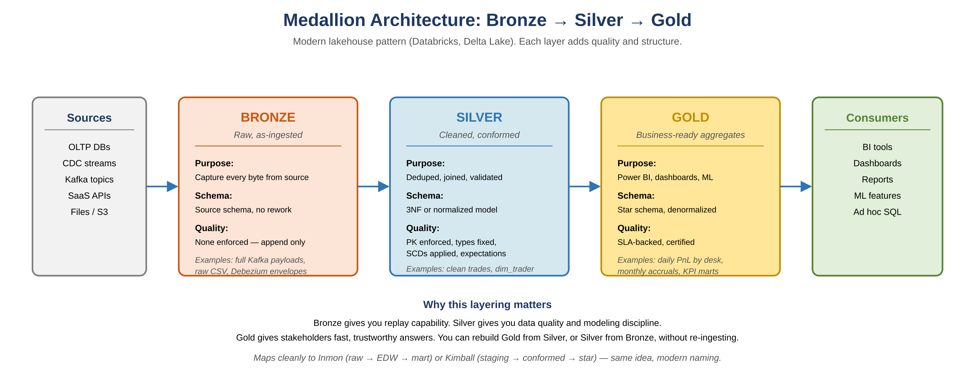
Figure 1.7 — Each layer adds quality and structure. You can rebuild Gold from Silver, or Silver from Bronze, without re-ingesting
Layer | What lives here | Quality bar
Bronze (Raw) | Source-format ingestion, append-only. CDC payloads, raw API responses, file dumps. | None enforced. Replay capability.
Silver (Cleaned) | Deduped, type-corrected, joined, SCDs applied. Normalized or 3NF. | PK enforced, schema validated, expectations checked.
Gold (Curated) | Star schemas, aggregates, marts. Business-aligned datasets. | SLA-backed, certified, documented.

Why this layering pays off
- Replay capability: Bronze gives you the original truth. Silver and Gold can be rebuilt from Bronze if the transformation logic changes.
- Separation of concerns: Data quality enforcement happens at Silver. Business modeling happens at Gold. Ingestion engineering happens at Bronze.
- Independent SLAs: Bronze tables may have hourly SLAs, Silver daily, Gold weekly. Each layer's freshness is decoupled.
- Cost optimization: Bronze can use cheap object storage with high retention. Gold uses warmer compute-optimized storage.

1.10 Normalization Forms
Normalization is the formal discipline behind 3NF design. Worth knowing the definitions cold for interviews even though dimensional modeling intentionally denormalizes.
Form | Rule
1NF | Atomic values only. No repeating groups. Each column holds a single value.
2NF | 1NF plus no partial dependencies. All non-key columns depend on the full primary key (relevant for composite keys).
3NF | 2NF plus no transitive dependencies. Non-key columns depend only on the primary key, not on other non-key columns.
BCNF | Stronger than 3NF. Every determinant is a candidate key. Eliminates all anomalies in most practical cases.
Denormalization | Intentional violation of normal forms for query performance. Common in dimensional models and analytics-focused schemas.
When 3NF beats dimensional
3NF is the right choice for OLTP systems where data integrity and write efficiency matter more than query simplicity. A trading order management system that processes thousands of writes per second uses 3NF tables.
Dimensional modeling is the right choice for analytics: fewer writes, many reads, complex aggregations. Most analytics workloads don't need referential integrity enforcement at the database level (the ETL ensures it).

1.11 Data Vault 2.0 (Brief)
Data Vault is a third major modeling philosophy, designed for raw warehouse layers in highly regulated and audited environments. It separates business keys (Hubs), relationships (Links), and descriptive attributes (Satellites). Less common in pure analytics, more common in financial services, healthcare, and government data warehouses.
Component | Holds | Example
Hub | Business keys only | hub_trader (trader_id, hash_key, load_date)
Link | Relationships between hubs | link_trade_trader (trade_hash, trader_hash, load_date)
Satellite | Descriptive attributes that change over time | sat_trader_details (trader_hash, name, desk, load_date)
When to mention Data Vault
If asked about audit-heavy environments, regulatory data lineage, or warehouse models that need to track every change to every attribute with full source attribution, Data Vault is worth mentioning. It's the answer to 'how do you build a warehouse that survives regulatory audit and source system migrations.'
Most analytics-driven teams don't need Data Vault. The complexity overhead rarely pays off unless audit and lineage are first-class requirements.

1.12 Data Modeling Interview Questions
Q: When would you use SCD Type 2 vs SCD Type 3?
Strong Answer: Type 2 when you need complete history with arbitrary lookback, for example, what desk was a trader on during a specific trade date. Type 3 when you only need to compare current vs immediately prior value and storage is constrained. At SIG, we used Type 2 for desk and counterparty dimensions because regulatory reporting required point-in-time accuracy going back years. Type 3 is rare in finance because the business almost always wants 'what did we know at trade time,' not just current vs previous.
Q: What is grain in a fact table and why does it matter?
Strong Answer: Grain is the level of detail represented by a single fact row, the most atomic unit of measurement. Defining grain first is the most critical step in dimensional modeling. Mixing grains in a single fact table causes incorrect aggregations because rows at different grains will sum together silently. The Kimball method orders the four steps explicitly: pick the business process, declare the grain, identify dimensions applicable at that grain, identify measures meaningful at that grain. At SIG, daily accrual facts were at the trade-day grain; monthly reconciliation facts were at the account-month grain. Mixing them in one fact would have produced double-counting in any quarterly rollup.
Q: How do you handle late-arriving dimension data?
Strong Answer: For Type 2 SCDs, insert the late-arriving row with the correct effective date and adjust surrounding rows' expiry dates accordingly. For fact tables, if facts have already been loaded with the wrong dimension version, identify affected fact records by date range, rejoin to the corrected dimension, and overwrite. In PySpark, partition facts by date to make targeted rewrites efficient. The other option, when full reprocessing is too expensive, is the inferred member pattern: insert a placeholder dimension row when a fact arrives with an unknown natural key, then update that row's attributes when the dimension data eventually arrives. Use Type 1 update on the placeholder, since the row was never accurate to begin with.
Q: What is a degenerate dimension and when do you use one?
Strong Answer: A dimension attribute stored directly in the fact table rather than in a separate dimension table. Common for transaction IDs, order numbers, or trade reference numbers that have no descriptive attributes worth maintaining separately. The transaction ID has no 'who, what, where' to look up, so a separate dim_trade_reference table would be a one-column lookup. Storing it as a degenerate dimension on the fact avoids the join while preserving the ability to filter and group by trade reference.
Q: How do you model a many-to-many relationship in a dimensional model?
Strong Answer: Use a bridge table (also called an associative table or factless fact table). For example, a trade can have multiple traders (deal team), and a trader can have multiple trades. A bridge table with trade_sk and trader_sk resolves the many-to-many while preserving the ability to aggregate at either grain. Always include an allocation column (allocation_pct or weight) if the fact value should be distributed across the related dimensions, otherwise summing across the bridge double-counts. If the relationship has its own attributes (effective dates, role within the team), the bridge becomes a dimension in its own right.
Q: Walk me through the difference between transactional, periodic snapshot, and accumulating snapshot fact tables.
Strong Answer: Transactional facts have one row per business event, insert-only. FACT_TRADES, where every executed trade is a new immutable row. Periodic snapshot facts have one row per entity per period, capturing state at intervals. FACT_DAILY_POSITIONS, where every instrument's end-of-day quantity gets a row each business day. Accumulating snapshot facts have one row per process instance, updated as the process advances through milestones. FACT_TRADE_LIFECYCLE, where one row tracks a trade from submission through matching and settlement, with date columns filled in as each step completes. The choice depends on the business question: events use transactional, state at intervals uses periodic, pipeline progress uses accumulating.
Q: Why surrogate keys instead of natural keys for fact-to-dimension joins?
Strong Answer: Three reasons. First, surrogate keys are stable across source system changes; if a customer is renumbered or two systems are merged, the surrogate stays the same and only the natural key needs updating in one place. Second, surrogate keys enable SCD Type 2: a single natural key (trader_id 99) maps to multiple surrogate keys (5001, 5247, 5612), one per historical version. The fact joins to the version that was current at fact-load time. Third, integer surrogate keys are smaller and faster than composite or string natural keys, especially across large fact tables with billions of rows.
Q: When would you choose snowflake schema over star schema?
Strong Answer: Snowflake is justified when a dimension has a genuine hierarchy that's reused across multiple facts and the hierarchy itself changes frequently. For example, an instrument hierarchy (instrument > sub-asset class > asset class) that's joined to fact_trades, fact_positions, and fact_pnl might benefit from normalization, since updating the asset class for a sub-class only requires changing one row in dim_asset_class instead of many rows in dim_instrument. The cost is more joins per query and more complex SQL. In modern columnar warehouses like Snowflake or Redshift, star is almost always preferred because the join cost is high and the storage savings of snowflake are minimal. Snowflake is more common in older row-store warehouses where storage was expensive.
Q: How does Inmon's approach differ from Kimball's, and which would you choose?
Strong Answer: Inmon builds the enterprise warehouse first as a 3NF normalized model, then derives dimensional marts from it (top-down). Kimball builds dimensional marts directly using star schema and conformed dimensions, with the marts collectively forming the warehouse (bottom-up). Inmon emphasizes data integration discipline and a single source of truth at the cost of long initial build time. Kimball delivers business value faster but requires strong dimensional modeling discipline to keep marts conformed. In practice, modern lakehouses combine both: Bronze and Silver layers use Inmon-style normalized or 3NF tables for replay and quality, Gold layer uses Kimball-style stars for query performance. I'd choose the hybrid for almost any new build today; pure Inmon only when audit and integration discipline are the top priority over time-to-value.
Q: Explain the medallion architecture and why most modern teams use it.
Strong Answer: Medallion is a three-layer pattern: Bronze for raw ingested data, Silver for cleaned and conformed data, Gold for business-ready aggregates and marts. Bronze is append-only and preserves source-format truth, enabling replay if downstream logic changes. Silver applies type correction, deduplication, joins, and SCDs, and enforces quality expectations. Gold contains star schemas, KPI marts, and aggregates with SLA backing. The pattern works because each layer has a clear quality bar and a clear consumer. Bronze serves data engineering replay and audit. Silver serves analytics engineers building models. Gold serves BI tools and stakeholders. You can rebuild any downstream layer from upstream without re-ingesting, which is the key operational benefit. At SIG, we followed this pattern conceptually, even before the medallion naming was popular: raw landing tables, normalized hub tables, then star schema reporting tables.
Q: How do you handle a rapidly changing dimension where Type 2 would explode row counts?
Strong Answer: Three options in order of preference. First, mini-dimension: split the rapidly-changing attributes into a separate dimension and join the fact to both the slow-moving customer dimension and the fast-moving credit-band mini-dimension. The fact ends up with two FKs instead of one, but the customer dimension stays small. Second, banding the volatile attribute into ranges: instead of storing exact credit score (which changes daily), store credit_band ('Excellent', 'Good', 'Fair') which changes only at threshold crossings. Third, use Type 4 history split: keep the volatile attributes in a separate history table, current dimension stays small for hot lookups.

Part 2 — Hive Deep Dive

2.1 Hive Architecture
Component | Role
HiveServer2 | Accepts client connections via JDBC/ODBC/Thrift. Supports concurrent sessions. Replaces original HiveServer.
Metastore | Stores table metadata (schema, partitions, location, SerDe) in a relational DB (MySQL/PostgreSQL). Shared across Hive, Spark, Presto.
Driver | Receives queries, coordinates compilation, optimization, and execution.
Compiler | Parses HQL into an AST, performs semantic analysis, generates a logical plan.
Optimizer | Transforms logical plan into physical plan. Applies predicate pushdown, partition pruning, join reordering.
Execution Engine | Submits physical plan to MapReduce, Tez, or Spark for actual execution.
SerDe | Serializer/Deserializer. Defines how data is read from and written to storage. Critical for custom formats.

2.2 Storage Formats
Format | Characteristics
TextFile | Default. Human-readable. Slowest, no compression or column pruning. Avoid in production.
Parquet | Columnar. Excellent for analytical queries (column pruning, predicate pushdown). Best compression. Primary format at SIG.
ORC | Columnar. Similar to Parquet but native to Hive. Better for Hive-specific workloads. Supports ACID transactions.
Avro | Row-based. Schema evolution support. Good for Kafka integration. Better for write-heavy streaming ingestion.
RCFile | Row Columnar File. Older Hive-specific format. Largely superseded by ORC.
SequenceFile | Hadoop binary format. Splittable. Used for MapReduce intermediate outputs.

2.3 Partitioning & Bucketing

Partitioning
- Physically divides table data into sub-directories by partition column value
- Enables partition pruning: queries with WHERE clause on partition column skip irrelevant partitions entirely
- At SIG: partitioned by date for all time-series pipeline outputs, daily and monthly ingestion jobs only write to their date partition
- Static partitioning: specify partition value explicitly in INSERT, faster, more control
- Dynamic partitioning: Hive infers partition value from data, requires set hive.exec.dynamic.partition=true

-- Static partition insert
INSERT INTO TABLE trades PARTITION (trade_date='2024-01-15')
SELECT trade_id, instrument_id, quantity, price FROM staging_trades;

-- Dynamic partition insert
SET hive.exec.dynamic.partition=true;
SET hive.exec.dynamic.partition.mode=nonstrict;
INSERT INTO TABLE trades PARTITION (trade_date)
SELECT trade_id, instrument_id, quantity, price, trade_date FROM staging_trades;

Bucketing
- Divides data within a partition into a fixed number of files (buckets) based on hash of a column
- Enables efficient joins when both tables bucketed on the same column, avoids full shuffle
- Enables efficient sampling: TABLESAMPLE(BUCKET 1 OUT OF N)
- Unlike partitioning, does not create sub-directories, buckets are separate files within the same directory

CREATE TABLE trades_bucketed (trade_id BIGINT, instrument_id INT, price DECIMAL(18,4))
PARTITIONED BY (trade_date STRING)
CLUSTERED BY (instrument_id) INTO 32 BUCKETS
STORED AS ORC;

2.4 Hive LLAP (Live Long and Process)
LLAP is the most important Hive performance feature at SIG scale. Worth knowing deeply.

What LLAP does
- Eliminates JVM startup overhead by keeping persistent daemon processes alive on cluster nodes
- Caches data in memory across queries, hot data stays warm for repeated access patterns
- Provides in-memory columnar cache: frequently accessed ORC/Parquet data stays in native memory
- Vectorized processing: processes data in batches of 1024 rows rather than row-by-row
- At SIG: implemented LLAP queue management for analytical query workloads on Hive, improved interactive query response time for trading desk analysts

LLAP architecture
Component | Role
LLAP Daemon | Long-running process on each worker node. Handles query fragments, manages in-memory cache, serves data to Tez containers.
LLAP Cache | Columnar in-memory cache backed by native (off-heap) memory. Survives across queries. Evicts using LRU policy.
Tez AM | Still manages DAG orchestration. LLAP daemons execute individual tasks within the DAG.
Query Queue | LLAP capacity managed via YARN queues. Workload governance prevents any single team from starving others.
Heartbeat | LLAP daemons register with ZooKeeper. HiveServer2 discovers daemons via ZooKeeper service registry.

LLAP queue management at SIG
- Configured separate YARN queues for LLAP interactive workloads vs batch pipeline workloads
- Batch pipelines (PySpark ingestion, normalization) run in high-capacity batch queue
- LLAP interactive queries (trading desk analytics) run in dedicated interactive queue with guaranteed capacity
- Workload governance policies prevent batch jobs from consuming interactive queue resources during market hours
- Linux OS upgrades required coordinated LLAP daemon restarts, managed rolling restarts to maintain availability

2.5 Hive Query Optimization
Optimization | How it works
Partition Pruning | WHERE clause on partition column. Hive skips reading non-matching partitions entirely. Most impactful optimization.
Predicate Pushdown | Filter conditions pushed to storage layer (ORC/Parquet). Reduces data read before processing.
Column Pruning | Only selected columns read from columnar storage. Parquet/ORC benefit most.
Map-side Join | Small table broadcast to all mappers. Avoids reduce-side shuffle. SET hive.auto.convert.join=true.
Cost-Based Optimizer (CBO) | Uses table statistics to choose join order and strategy. Requires ANALYZE TABLE to collect stats.
Vectorization | Processes 1024 rows per batch instead of one at a time. SET hive.vectorized.execution.enabled=true.
Parallel Execution | Run independent stages simultaneously. SET hive.exec.parallel=true.
Skew Join Optimization | Handles data skew by splitting oversized keys. SET hive.optimize.skewjoin=true.

-- Collect statistics for CBO
ANALYZE TABLE trades PARTITION(trade_date) COMPUTE STATISTICS;
ANALYZE TABLE trades PARTITION(trade_date) COMPUTE STATISTICS FOR COLUMNS;

2.6 Hive ACID & Transactions
- ORC format required for ACID transactions in Hive
- Supports INSERT, UPDATE, DELETE, and MERGE operations on transactional tables
- Compaction: Hive background process merges delta files into base files, minor and major compaction
- At SIG: used ORC ACID tables for dimension tables that required SCD Type 2 updates via Hive MERGE

-- Hive MERGE for SCD Type 2 (requires ORC ACID table)
MERGE INTO dim_counterparty AS target
USING updates AS source ON target.counterparty_id = source.counterparty_id AND target.is_current = 1
WHEN MATCHED AND source.desk != target.desk THEN
UPDATE SET expiry_date = current_date(), is_current = 0
WHEN NOT MATCHED THEN
INSERT VALUES (source.counterparty_id, source.desk, current_date(), '9999-12-31', 1);

2.7 Hive Interview Questions
Q: What is the difference between Hive internal and external tables?
Strong Answer: Internal (managed) tables: Hive owns the data. DROP TABLE deletes both metadata and data from HDFS. External tables: Hive only manages metadata. DROP TABLE deletes metadata only, data stays in HDFS. At SIG, all production pipeline outputs use external tables so that dropping and recreating a table during schema changes does not destroy the underlying data.
Q: How does Hive metastore work and why does it matter for Spark?
Strong Answer: The metastore is a relational database (MySQL/PostgreSQL) that stores all table schemas, partition information, storage locations, and SerDe configurations. Spark uses the Hive metastore directly via SparkSession with enableHiveSupport(), this means tables created in Hive are immediately available in PySpark and vice versa. At SIG, all PySpark jobs read from and write to Hive-registered tables, sharing a single metastore with the Hive analytical layer.
Q: What causes small file problems in Hive and how do you fix them?
Strong Answer: Small files occur when many tasks each write small outputs, common with dynamic partitioning across many dates or streaming micro-batch writes. Hive/HDFS handles many small files poorly: NameNode memory pressure, slow query planning, poor read performance. Fixes: (1) Merge files post-load using INSERT OVERWRITE with single reducer, (2) Use hive.merge.mapfiles=true and hive.merge.mapredfiles=true, (3) In PySpark, coalesce before writing to control output file count, (4) ORC compaction for ACID tables.
Q: How does SerDe work and when would you write a custom one?
Strong Answer: SerDe defines how Hive serializes data to storage and deserializes it back to rows. Built-in SerDes handle CSV, JSON, Parquet, ORC, Avro. A custom SerDe is needed for proprietary binary formats or complex nested structures not handled by standard formats. You would implement the Deserializer interface for reads and Serializer for writes. At SIG, standard SerDes sufficed but understanding SerDe is important for explaining how Hive reads flat files with custom delimiters.

Part 3 — Hadoop & YARN Internals

3.1 HDFS Architecture
Component | Role
NameNode | Manages filesystem namespace and metadata. Stores file-to-block mapping in memory. Single point of coordination, not storage. HA via Standby NameNode.
DataNode | Stores actual data blocks. Reports block inventory to NameNode via heartbeats. Serves read/write requests from clients.
Block | Default 128MB. Large blocks reduce NameNode memory pressure and improve sequential read throughput.
Replication | Default factor 3. Rack-aware placement: two replicas on same rack, one on different rack. Tolerates one full rack failure.
Standby NameNode | Hot standby for HA. Shares edit log via JournalNodes (Quorum Journal Manager). Automatic failover via ZooKeeper.
JournalNode | Stores HDFS edit log for HA mode. Quorum of 3 JournalNodes standard. Both active and standby NameNode write/read the journal.

3.2 YARN Architecture & Resource Negotiation
YARN (Yet Another Resource Negotiator) separates resource management from job execution. This is the foundation of how PySpark runs on the cluster at SIG.

Core Components
Component | Role
ResourceManager (RM) | Cluster-wide resource arbiter. Has two components: Scheduler (allocates resources) and ApplicationsManager (manages application lifecycle).
NodeManager (NM) | Per-node agent. Launches and monitors containers. Reports node resources and container status to RM.
ApplicationMaster (AM) | Per-application process. Negotiates resources with RM, coordinates execution with NMs. For Spark: the Spark Driver is the AM in cluster mode.
Container | Unit of resource allocation. Encapsulates CPU cores and memory. Launched by NM on behalf of AM.
Scheduler | Pluggable component of RM. Does not monitor or restart failed containers, that is the AM's job.

Resource Negotiation Flow
- 1. Client submits application to ResourceManager (spark-submit or equivalent)
- 2. RM allocates a container on a NodeManager for the ApplicationMaster
- 3. NM launches the AM container (Spark Driver in cluster mode)
- 4. AM registers with RM and requests executor containers (specifying CPU, memory per executor)
- 5. RM Scheduler allocates containers based on available capacity and queue policy
- 6. AM contacts NodeManagers to launch executor containers on assigned nodes
- 7. Executors register back with the Driver (AM), ready to receive tasks
- 8. Driver sends tasks to executors. Executors report results back to Driver
- 9. On completion, AM unregisters from RM. Containers released. Resources returned to pool

Container Lifecycle
State | Meaning
NEW | Container allocated by RM but not yet started.
RUNNING | Container launched and active on a NodeManager.
COMPLETE / SUCCEEDED | Container finished successfully. Resources released.
FAILED | Container exited with non-zero code. AM decides whether to retry.
KILLED | Container terminated by RM (preemption) or AM (explicit kill).

3.3 YARN Schedulers
Scheduler | Behavior
FIFO Scheduler | Simple queue. First-in-first-out. Not suitable for multi-tenant clusters. Not used in production at SIG.
Capacity Scheduler | Hierarchical queues with guaranteed capacity. Multiple tenants share cluster with minimum resource guarantees. Default in most Hadoop distributions. Used at SIG.
Fair Scheduler | Resources shared equally among applications. No minimum guarantees but flexible allocation. Preempts low-priority jobs.

Capacity Scheduler at SIG
- Hierarchical queue structure: root queue split into batch, interactive, and maintenance queues
- Batch queue: high capacity for PySpark ingestion, normalization, and CDC pipeline jobs
- Interactive queue: LLAP and ad hoc Hive queries for trading desk analytics, guaranteed minimum capacity
- Maintenance queue: Hadoop admin operations, cluster migrations, OS upgrades
- Queue ACLs control which service accounts can submit to which queues
- Preemption enabled: if interactive queue needs resources and batch is over capacity, batch containers are preempted

3.4 YARN Memory & Resource Configuration

Key YARN Memory Settings
Property | Meaning
yarn.nodemanager.resource.memory-mb | Total memory available on each node for YARN containers. Typically physical RAM minus OS and NM overhead.
yarn.scheduler.minimum-allocation-mb | Smallest container memory size YARN will allocate. All requests rounded up to this.
yarn.scheduler.maximum-allocation-mb | Largest single container YARN will allocate.
spark.executor.memory | JVM heap for each Spark executor. Does not include overhead.
spark.yarn.executor.memoryOverhead | Off-heap memory per executor for JVM internals, PySpark Python workers, native libraries. Default: max(executorMemory * 0.1, 384MB).
spark.driver.memory | Driver JVM heap. In cluster mode, determines the AM container size.
spark.executor.cores | vCores per executor. Affects task parallelism within each executor.
SIG Production Sizing Pattern
For large ingestion jobs at SIG: spark.executor.memory=8g, spark.yarn.executor.memoryOverhead=2g (total 10g per executor), spark.executor.cores=4. This gives each task 2g of execution memory. Dynamic resource allocation enabled, executors scale from minimum to maximum based on pending tasks. Containerized workloads prevent any single job from monopolizing the cluster.

3.5 Dynamic Resource Allocation
- Spark requests additional executors when tasks are pending beyond a timeout (spark.dynamicAllocation.schedulerBacklogTimeout)
- Spark releases idle executors after a timeout (spark.dynamicAllocation.executorIdleTimeout)
- Requires external shuffle service (spark.shuffle.service.enabled=true) so shuffle data persists after executor release
- At SIG: enabled on all production PySpark jobs, prevents resource hoarding during low-activity periods and scales up automatically during peak ingestion windows

spark.dynamicAllocation.enabled=true
spark.dynamicAllocation.minExecutors=2
spark.dynamicAllocation.maxExecutors=50
spark.dynamicAllocation.schedulerBacklogTimeout=60s
spark.dynamicAllocation.executorIdleTimeout=120s
spark.shuffle.service.enabled=true

3.6 Hadoop Cluster Migration: SIG v2.6 to v3.1
This is a high-value interview story. Know the technical details behind what changed.

Key differences: Hadoop 2.6 vs 3.1
Feature | Change
Erasure Coding | v3.x added erasure coding as an alternative to 3x replication. Same fault tolerance at ~50% storage overhead vs 200% for replication. Used for cold data at SIG.
YARN Timeline Service v2 | Improved scalability for cluster metrics and application history. Backed by HBase instead of LevelDB.
NameNode Federation improvements | Better support for multiple NameNodes managing different namespace volumes.
Container Resource Types | v3.x supports custom resource types beyond CPU and memory (e.g. GPUs, FPGAs).
Intra-datanode balancer | Balances data across disks within a DataNode, not just across nodes.
Removed components | Removed deprecated APIs and MapReduce shuffle handler changes requiring config updates.

Zero-downtime migration approach
- Ran parallel clusters during transition: v2.6 production, v3.1 staging with data replication
- Migrated non-critical pipelines first to validate behavior differences
- Implemented Parquet formatting and partition pruning during migration as a combined initiative
- Updated all PySpark jobs to use v3.1 compatible configurations before cutover
- Coordinated LLAP daemon restarts as part of the Hive upgrade on v3.1
- Managed Linux OS upgrades across the cluster fleet in rolling fashion, one rack at a time
- Maintained production SLA adherence throughout by keeping v2.6 serving until v3.1 was fully validated

3.7 YARN & Hadoop Interview Questions
Q: What happens when a YARN container fails mid-execution?
Strong Answer: The NodeManager detects the container exit and reports it to the ResourceManager. The ApplicationMaster (Spark Driver) is notified of the executor failure. The AM decides whether to request a replacement container from the RM, Spark will retry failed tasks up to spark.task.maxFailures times before failing the job. Shuffle data from the failed executor is handled by the external shuffle service if dynamic allocation is enabled.
Q: How does YARN handle resource preemption?
Strong Answer: When a high-priority queue needs resources and the cluster is at capacity, the RM scheduler can preempt containers from lower-priority queues. The RM first sends a preemption request to the AM, giving it a grace period to voluntarily release containers. If the AM does not release within the timeout, the RM forcibly kills the containers. At SIG, this meant interactive queue jobs could reclaim resources from batch queue jobs during market hours.
Q: What is the difference between YARN client mode and cluster mode for Spark?
Strong Answer: Client mode: Spark Driver runs on the machine that submitted the job. The AM is a lightweight forwarder. Driver is outside the cluster, vulnerable to network issues and machine failure. Good for interactive sessions and debugging. Cluster mode: Driver runs inside the cluster as the AM container. Job survives client machine disconnection. Better for production. At SIG, all production PySpark jobs run in cluster mode for fault tolerance and to keep the Driver close to the data.
Q: How do you diagnose a slow or stuck YARN application?
Strong Answer: (1) YARN ResourceManager UI: check application state, allocated vs used containers, queue position. (2) Spark UI: check active stages, task progress, shuffle read/write sizes, GC time. (3) Spark UI Executors tab: identify stragglers, tasks taking much longer than median. (4) Check for data skew in shuffle stages. (5) Check GC logs for excessive garbage collection. (6) Check HDFS for small file issues causing excessive task creation. At SIG, the most common causes were data skew and YARN queue contention during peak market hours.
Q: What is NameNode federation and why would you use it?
Strong Answer: NameNode federation allows multiple NameNodes to manage different portions of the HDFS namespace independently. Each NameNode manages its own namespace volume and block pool. Use case: when a single NameNode cannot hold the entire namespace in memory due to cluster scale, or when you want to isolate namespace failures between teams. At SIG at current scale, a single NameNode with HA standby was sufficient, but understanding federation is relevant for very large clusters.

3.8 ZooKeeper Role in the Hadoop Ecosystem
- Distributed coordination service used by multiple Hadoop components
- HDFS HA: ZooKeeper tracks which NameNode is active. ZooKeeper Failover Controller (ZKFC) triggers automatic failover
- YARN HA: ResourceManager HA uses ZooKeeper for leader election
- HBase: ZooKeeper manages HBase master election and region server coordination
- Kafka: ZooKeeper (pre-KRaft) managed broker metadata, controller election, and consumer group offsets
- LLAP: LLAP daemons register with ZooKeeper so HiveServer2 can discover them
- At SIG: ZooKeeper quorum of 5 nodes (odd number for majority quorum) managed across all these services

Quick Reference: Key Interview Answers

SCD Type Decision Tree
If you need... | Use
No history (overwrite) | SCD Type 1
Full history, point-in-time accuracy | SCD Type 2 (most common at SIG)
Current vs previous only | SCD Type 3 (add column)
Frequent changes, fast current lookup | SCD Type 4 (history table)
All of the above | SCD Type 6 (hybrid, complex)

Fact Table Type Decision Tree
The business question is about... | Use
Discrete events | Transactional Fact
State at regular intervals | Periodic Snapshot Fact
Multi-step process progress | Accumulating Snapshot Fact
Coverage or eligibility (no measure) | Factless Fact

Hive Performance Checklist
- Is data partitioned on the filter column? If not, all partitions scan.
- Is the storage format columnar (Parquet or ORC)? Text file is always slower.
- Are table statistics collected? CBO cannot optimize without them.
- Is LLAP enabled for the interactive queue? Persistent cache eliminates cold start overhead.
- Is vectorized execution enabled? Batch processing is significantly faster.
- Are small files present? Check file count per partition, too many kills performance.
- Is the join type correct? Small table joins should be map-side (broadcast).

YARN Troubleshooting Checklist
- Application stuck in ACCEPTED state: queue capacity exhausted, check RM UI for queue utilization.
- Executor OOM: increase spark.executor.memory or spark.yarn.executor.memoryOverhead.
- Excessive GC: reduce data cached per executor, increase memory, check for memory leaks.
- Shuffle spill: increase spark.executor.memory, enable AQE, check partition strategy.
- Task stragglers: data skew, use AQE skew join optimization or salting.

Final note
This guide is structured to be both a study tool and a reference. Part 1 has been substantially expanded with worked examples, diagrams, and additional patterns (fact table types, bridge tables, Inmon vs Kimball, medallion, grain). Parts 2 and 3 remain compact reference material. Use the diagrams as anchors when explaining concepts under interview pressure: pointing to a clear mental picture of SCD Type 2 row evolution or grain mismatch is far more memorable than reciting definitions.

