FRESH BOWL HORTICULTURE
MushroomOS
The 470-Hour Standard
Button Mushroom Compost Process
PROCESS-2026C · version 1 · draft for approval
Complete process definition, hour by hour, with the laboratory workflow and a fully worked example batch starting 09:00 on 31 August 2026.
Field | Value
Document | Standard Process Definition — PROCESS-2026C v1
Supersedes | PROCESS-2026B (552-hour model). Not merged, not edited.
Standard envelope | 470 hours, H0 → H470
Turner anchor | H174
Sources | imp_compost_sop_30082026.xlsx · TURNERPRCOESS.xlsx · lab_technician_batch_process.md
Worked example | H0 = Monday 31 August 2026, 09:00 IST
Status | DRAFT — for process-owner and stakeholder sign-off
Issued | 30 August 2026

This document is the factory definition, not a proposal.
Every hour figure in this document is taken from the two source spreadsheets. Nothing has been rounded, averaged for convenience, or invented. Where the two sources disagree, section 14 says so explicitly and states which one this standard follows and why.
Once signed, this becomes PROCESS-2026C version 1 and is frozen. A change publishes a new version; it never rewrites this one, and it never rewrites a batch that has already been planned against it.

Contents

1 · Purpose and scope
This document defines one complete production cycle of button mushroom compost, from the moment the production clock starts to the moment the finished compost leaves the tunnel for the grow room.
It exists to do four things:
- Fix the standard. Every activity, its duration, its position on the clock, and what must be measured.
- Make the parallel work visible. Three preparation streams run at once and converge twice. A stream that starts late is the single most common way a batch slips, and nothing on a day-by-day list shows it.
- Define the laboratory workflow as part of the process, not beside it. A lab result is a gate, and a gate that is not in the process definition is not a gate.
- Give the software one definition to build against, so that what the factory does and what the system believes are the same thing.

1.1 · What the 470 hours are
470 hours is the standard envelope from H0 to the start of grow-room loading for the first bunker stream. It is 19 days and 14 hours. For a batch starting at 09:00 on Monday 31 August 2026, H470 falls at 23:00 on Saturday 19 September 2026.
It is a reference envelope, not a stopwatch. Real operations can take longer when machines, people, material readiness, laboratory work or approvals cause delay. Those delays are recorded as variance against this envelope and, where authorised, handled through a formal extension. They are never handled by moving the envelope.

1.2 · What this document does not do
- It does not compress physical work. A duration here is what the operation takes.
- It does not permit a step to be skipped. Every activity in section 5 is performed.
- It does not cover spawn run, casing, pinning, harvest or packing. Those follow grow-room loading and are outside this standard.

2 · How to read this document

2.1 · Batch hours
Every time in this document is written as a batch hour — H0, H174, H470 — measured continuously from the start of the batch. Calendar midnight does not reset it. H26 is 26 hours after H0 regardless of which day that lands on.
Wall-clock times appear alongside, but only for the worked example. A different batch starting at a different hour has the same H-numbers and different clock times.

2.2 · Three duration figures
The source SOP gives three figures for most activities. They are not interchangeable and this standard uses them differently:
Column | Meaning | How this standard uses it
MIN | Shortest the operation runs | The floor. Finishing faster than this is a deviation to be looked at, not a success.
MAX | Longest the operation runs | The planned duration. The pre-Turner chain in section 5 uses MAX throughout, which is what places the Turner anchor at exactly H174.
AVG | Midpoint of the two | Reporting and capacity planning only. It is never used to build a plan.

Why the standard plans on MAX
Summing the MAX column across the pre-Turner stages gives exactly 174 hours, and 174 is where the Turner sheet begins. Summing MIN gives 154 and AVG gives 164 — neither reaches the anchor. The two source documents agree only on MAX, and that agreement is what makes the 470-hour envelope arithmetically whole: 174 hours before the Turner plus the Turner sheet’s own 296-hour span equals 470 exactly.

2.3 · Work, hold and parallel
Kind | What it means
WORK | A person or a machine is doing something. Consumes hours on the rail.
HOLD | The material is conditioning or resting. Consumes hours on the rail; nobody is working.
PARALLEL | Runs alongside the rail and consumes NO separate hours on it. Paddy preparation, the nitrogen mix, and every laboratory check are parallel. They still have hard deadlines.

Parallel does not mean optional, and it does not mean free.
The paddy stream is 86 hours long and must deliver at H160. Its latest possible start is therefore H74. Start it at H90 and the whole batch slips by 16 hours, even though paddy preparation appears nowhere on the main rail.
The same is true of the laboratory. A lab check consumes no hours — but an unapproved lab result stops the next activity dead.

3 · The process at a glance
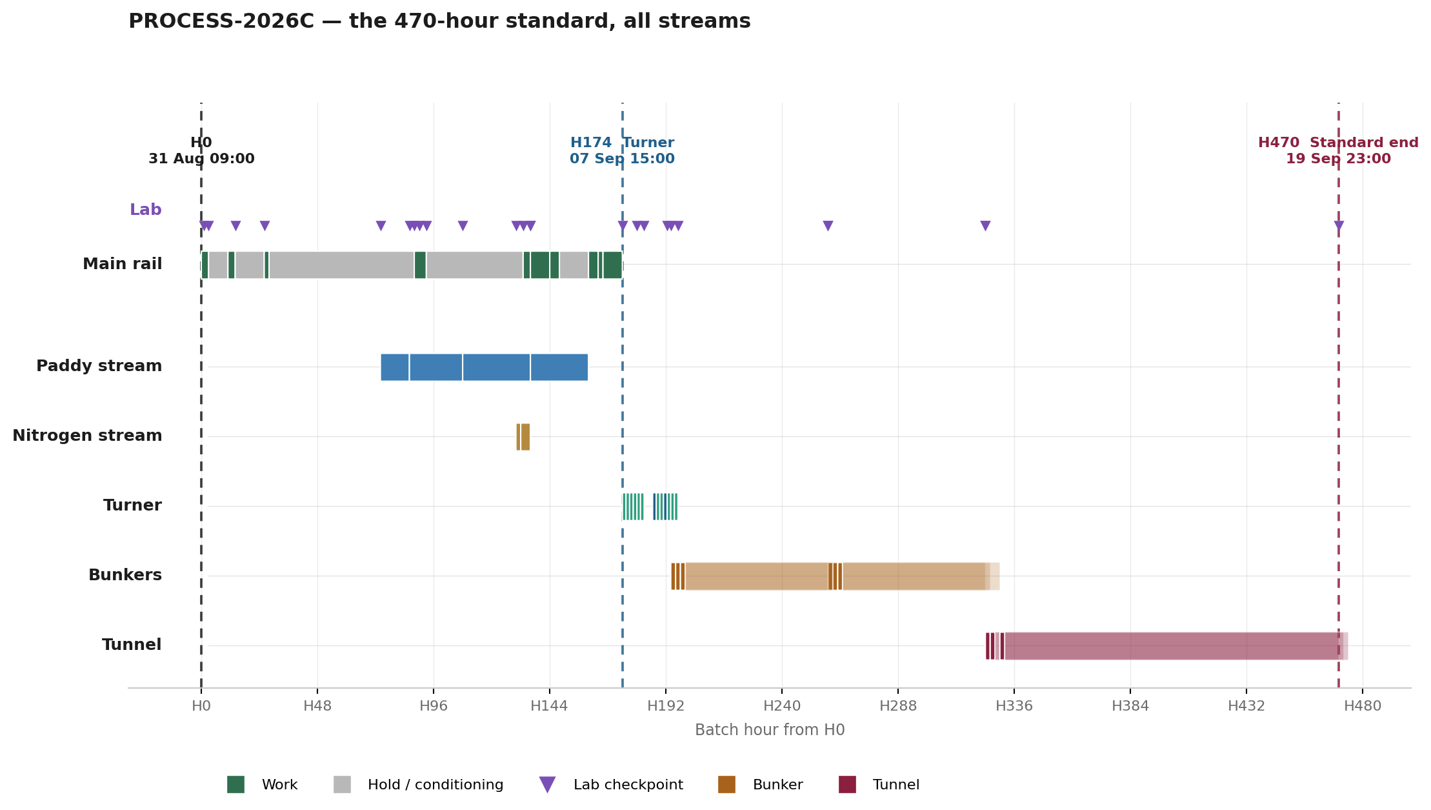
Every stream on one axis. Lab checkpoints are the markers on the top rail. H0 = Mon 31 Aug 09:00 · H174 = Mon 07 Sep 15:00 · H470 = Sat 19 Sep 23:00.

Region | From | To | Hours | What happens
Preparation (main rail) | H0 | H136 | 136 | Bagasse wetting, two hopper passes, heap, bunker loading and two conditioning cycles.
Convergence and yard | H136 | H174 | 38 | Nitrogen mix added, water pass to 73 %, rest, two paddy piles built, two flips.
Turner | H174 | H197 | 23 | Six piles through T0, T1, T2, T3 on two machines. 36 machine-hours.
Bunkers | H194 | H324 | 130 | Three streams: fill, 63-hour hold, unload and reload, second 63-hour hold.
Tunnel | H324 | H470 | 146 | Eight-hour filling window, then 144 hours of levelling, heating, pasteurisation, cooling and conditioning.
STANDARD END |  | H470 | 470 | Unloading and grow-room loading, stream 1. Streams 2 and 3 follow at H472 and H474.

4 · The three streams and the two convergences
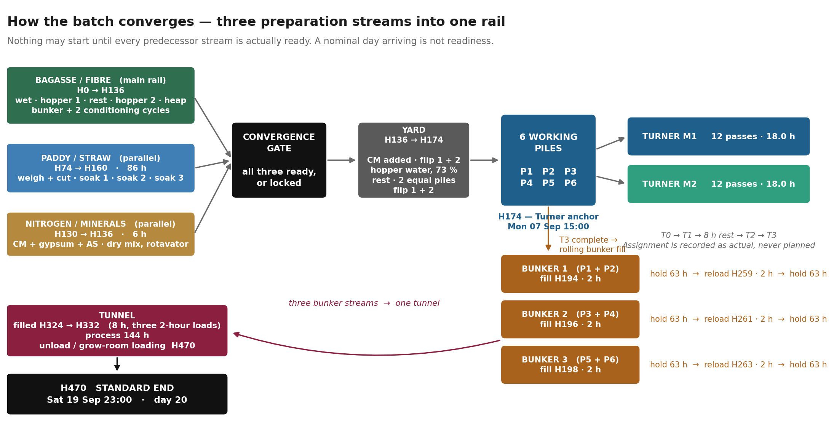
Nothing may start until every predecessor stream is actually ready. A nominal day arriving is not readiness.

5 · The main rail, stage by stage
The activities below run in strict sequence. Each one begins when the one before it ends; the chain is contiguous from H0 to H174 with no gaps and no overlaps. STD is the planned duration (the MAX column); MIN and AVG are shown for reference and are not used for planning.

Stg | Code | Activity | From | To | STD | MIN | AVG | Kind
0A | FIB-WET-1 | Bagasse wetting — hopper pass 1 (full water, target 69–71% moisture) | H0 | H3 | 3 | 3 | 3 | WORK
0A | FIB-REST-1 | Material rest | H3 | H11 | 8 | 8 | 8 | HOLD
0A | FIB-HOP-2 | Hopper pass 2 (dry, or water to reach target moisture) | H11 | H14 | 3 | 3 | 3 | WORK
0A | FIB-HEAP | Heap formation (height ≤1.5 m) + rest | H14 | H26 | 12 | 8 | 10 | HOLD
0B | FIB-BUNK-LOAD | Flipping + bunker filling (ht 2.6–2.7 m), no water | H26 | H28 | 2 | 2 | 2 | WORK
0B | FIB-COND-1 | Bunker conditioning, 45–55 °C. Unload trigger ≥58 °C or ≥60 h | H28 | H88 | 60 | 48 | 54 | HOLD
0C | FIB-RELOAD-1 | Loader unload, flipping, reload to new bunker (no water) | H88 | H93 | 5 | 5 | 5 | WORK
0C | FIB-COND-2 | Conditioning. Unload trigger ≥58 °C or ≥40 h | H93 | H133 | 40 | 40 | 40 | HOLD
0C | FIB-MOIST-DEC | Unload. If moisture ≥68% proceed; if <67% controlled mist via hopper | H133 | H136 | 3 | 3 | 3 | WORK
1B | MIX-CM-ADD | Add chicken-manure mix to conditioned bagasse + loader mix + flip 1 + flip 2 | H136 | H144 | 8 | 8 | 8 | WORK
1B | MIX-HOP-WATER | Hopper pass, full water (target 73% moisture, temp <45–50 °C) | H144 | H148 | 4 | 4 | 4 | WORK
1B | MIX-REST | Rest | H148 | H160 | 12 | 8 | 10 | HOLD
1C | YARD-PILES | Preparation of 2 equal piles on platform | H160 | H164 | 4 | 4 | 4 | WORK
1C | YARD-ADD | Add bagasse + CM mix gradually onto the 2 paddy piles | H164 | H166 | 2 | 2 | 2 | WORK
1C | YARD-FLIP | Flipping 1 + flipping 2, back to back | H166 | H174 | 8 | 8 | 8 | WORK

Total: H0 → H174. Fifteen activities, six of them holds. The holds account for 128 of the 174 hours.

5.1 · The triggers on the rail
Three activities do not simply end when their clock runs out. They end on whichever condition is met first, and both the temperature and the elapsed time are recorded.
Activity | Standard | Trigger
FIB-COND-1 | 60 h | Unload when temperature ≥ 58 °C OR elapsed ≥ 60 h, whichever comes first.
FIB-COND-2 | 40 h | Unload when temperature ≥ 58 °C OR elapsed ≥ 40 h, whichever comes first.
FIB-MOIST-DEC | 3 h | If moisture ≥ 68 % proceed. If moisture < 67 % apply controlled mist through the hopper and re-measure.

The 67–68 % band is undefined in the source, and this standard does not invent one.
The SOP says proceed at ≥ 68 % and mist below 67 %. It does not say what happens at 67.4 %. Until the process owner rules, a reading in that band is recorded, flagged, and referred — it does not auto-proceed and it does not auto-mist.

6 · The parallel streams

6.1 · Paddy / straw preparation — 86 hours
Runs alongside the main rail and consumes none of its hours. It must deliver finished, soaked paddy at H160, when the two piles are built. Working backwards from that, its latest possible start is H74.
Code | Activity | From | To | Hours
STR-WEIGH | Paddy bale weighment + cutting + thread removal | H74 | H86 | 12
STR-SOAK-1 | Soaking 1 — push in, tilt 1, tilt 2, push out (8–10 h) + rest in bunker (10–12 h) | H86 | H108 | 22
STR-SOAK-2 | Soaking 2 — push in, tilt 1, tilt 2, push out (8–10 h) + rest in bunker (18 h) | H108 | H136 | 28
STR-SOAK-3 | Soaking 3 — push in, tilt 1, tilt 2, push out (8–10 h) + rest in bunker (12–14 h) | H136 | H160 | 24

The paddy stream is the hidden critical path.
It is 86 hours long against a rail that gives it 86 hours of room. There is no slack in it at all. If bale cutting starts one hour late, the batch finishes one hour late — and nothing on the main rail will show why.
Latest start: H74. For the worked example that is 11:00 on Thursday 3 September.

6.2 · Nitrogen and minerals — 6 hours
Chicken manure, gypsum and ammonium sulphate. Must be ready at H136, when it is added to the conditioned bagasse. Latest start H130.
Code | Activity | From | To | Hours
CM-WEIGH | Chicken manure + gypsum + ammonium sulphate weighment | H130 | H132 | 2
CM-DRYMIX | Dry mix + rotavator to break manure lumps (no water) | H132 | H136 | 4

No water is added during the dry preparation stage.
Chicken manure is tested twice: once on arrival, and again when it is unloaded for mixing. Composition changes during storage, and the second reading is the one that matters. It is a gate — see section 11.

7 · The Turner — six piles, two machines
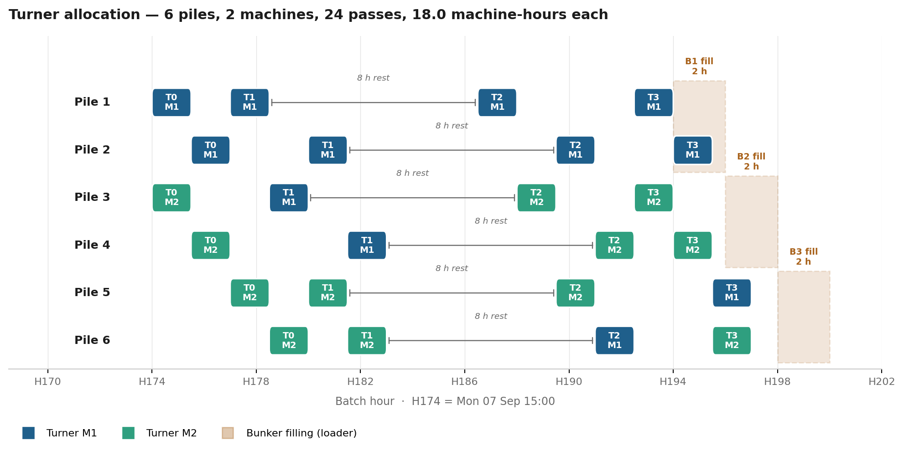
M1 and M2 are the two turner machines. The yellow-numbered columns of the source sheet are the six piles. Both machines run 15:00 → 00:00 with no idle minute.

7.1 · Every pile, every pass
Pile | T0 · dry pass | T1 · water pass | T2 | T3 | T1→T2 rest | T0→T1 gap
Pile 1 | M1 H174 → H175.5  15:00 → 16:30 | M1 H177 → H178.5  18:00 → 19:30 | M1 H186.5 → H188  03:30 → 05:00 | M1 H192.5 → H194  09:30 → 11:00 | 8.0 h | 1.5 h
Pile 2 | M1 H175.5 → H177  16:30 → 18:00 | M1 H180 → H181.5  21:00 → 22:30 | M1 H189.5 → H191  06:30 → 08:00 | M1 H194 → H195.5  11:00 → 12:30 | 8.0 h | 3.0 h
Pile 3 | M2 H174 → H175.5  15:00 → 16:30 | M1 H178.5 → H180  19:30 → 21:00 | M2 H188 → H189.5  05:00 → 06:30 | M2 H192.5 → H194  09:30 → 11:00 | 8.0 h | 3.0 h
Pile 4 | M2 H175.5 → H177  16:30 → 18:00 | M1 H181.5 → H183  22:30 → 00:00 | M2 H191 → H192.5  08:00 → 09:30 | M2 H194 → H195.5  11:00 → 12:30 | 8.0 h | 4.5 h
Pile 5 | M2 H177 → H178.5  18:00 → 19:30 | M2 H180 → H181.5  21:00 → 22:30 | M2 H189.5 → H191  06:30 → 08:00 | M1 H195.5 → H197  12:30 → 14:00 | 8.0 h | 1.5 h
Pile 6 | M2 H178.5 → H180  19:30 → 21:00 | M2 H181.5 → H183  22:30 → 00:00 | M1 H191 → H192.5  08:00 → 09:30 | M2 H195.5 → H197  12:30 → 14:00 | 8.0 h | 1.5 h

The 8-hour rest between T1 and T2 is measured from the END of that pile’s own T1, and it is honoured to the minute on all six piles. It is the only interval in the Turner that is constant, and it is the rule the schedule is built on.

7.2 · How the machines are loaded
The allocation is deliberate. In T0, M1 takes two piles and M2 takes four. In T1 the load inverts — M1 takes four and M2 takes two. That inversion is what lets both machines run nine hours with no idle minute and finish on exactly six passes each.
Machine | T0 | T1 | T2 · T3 | Total
M1 | P1, P2 | P1, P3, P2, P4 | P1, P2, P6 · P1, P2, P5 | 12 passes · 18.0 h
M2 | P3, P4, P5, P6 | P5, P6 | P3, P5, P4 · P3, P4, P6 | 12 passes · 18.0 h

Twenty-four pile-passes in total, 1.5 hours each, 36 machine-hours split exactly 18.0 / 18.0. No machine is ever in two places at once. The span from the first pass to the last is 23 hours, at 78 % utilisation on both machines.

Two things this means for the software
- Which machine takes which pile is recorded as it happens. It is not planned. Four of the six piles change machine mid-process, and that is normal — the machine does not belong to a pile.
- Each pile progresses independently. Pile 1 can be at T2 while pile 4 is still at T0 and pile 6 is waiting. There is no barrier that makes all six finish together.

The gap between T0 and T1 is normal.
Every pile waits between its dry pass and its water pass — 1.5 hours for piles 1, 5 and 6; 3 hours for piles 2 and 3; 4.5 hours for pile 4. This is a consequence of two machines serving six piles and it is what the source schedule does.
It is recorded, and it is not a deviation. "Continuous, no gap" describes the machines, which never stop. It does not describe the piles.

8 · The bunkers — three streams, one after another
The six piles resolve into three bunker streams. Piles 1 and 2 go to bunker 1, piles 3 and 4 to bunker 2, piles 5 and 6 to bunker 3. The three bunkers are filled one after another, two hours apart, on the same loader.

Bunker | Piles | Fill · 2 h | Hold | Unload + reload · 2 h | Hold | Tunnel load · 2 h | Discharge
Bunker 1 | P1 + P2 | H194 → H196  08 Sep 11:00 | 63 h | H259 → H261  11 Sep 04:00 | 63 h | H324 → H326  13 Sep 21:00 | H470  19 Sep 23:00
Bunker 2 | P3 + P4 | H196 → H198  08 Sep 13:00 | 63 h | H261 → H263  11 Sep 06:00 | 63 h | H326 → H328  13 Sep 23:00 | H472  20 Sep 01:00
Bunker 3 | P5 + P6 | H198 → H200  08 Sep 15:00 | 63 h | H263 → H265  11 Sep 08:00 | 63 h | H330 → H332  14 Sep 03:00 | H474  20 Sep 03:00

8.1 · The hold
Each hold is 63 hours: approximately 15 hours for the bunker to reach 70 °C, then 48 hours at temperature. Both holds are on the same terms.
Reload trigger: temperature 73–74 °C with the hold duration satisfied. As on the main rail, whichever condition is met first ends the hold, and both are recorded.

8.2 · Rolling fill
Bunker filling begins the moment the first pile of its pair comes off T3, and the second pile joins as it finishes. Bunker 1 opens at H194 when pile 1 leaves T3, and pile 2 joins at H195.5. Two hours per bunker is the standard and it is a rolling operation, not a batch operation that waits for both piles.

8.3 · Moisture correction at reload
At unload the shrunken height is recorded first — it determines the reload height. Moisture is then measured. If it meets the threshold the material is reloaded directly. If it is short, water is added through the hopper during reloading and pH, EC and moisture are measured again.
The original reading is never overwritten. Both readings are part of the batch record.

9 · The tunnel
One tunnel receives all three bunker streams. Filling runs from H324 to H332 — an eight-hour window in three two-hour loads, which sits inside the factory range of 8–10 hours for tunnel filling.

9.1 · Tunnel preparation
- Tunnel washed; gliding net fixed tight across the whole grid area.
- Nets removed and washed under high pressure — no folds, no dirt, stitch damage repaired.
- 6.0 m of pulling net left at the winch side for unloading.
- Probes cleaned, dried and hung. Sensors checked.

9.2 · The 144-hour process
Six phases. The standard allocation totals 144 hours and every phase sits inside its factory range.
Phase | Standard | Range | Note
Levelling & conditioning 1 | 19 h | 18–20 h
Heating up | 10 h | 8–12 h
Pasteurisation | 9.5 h | 9–10 h
Cooling down 1 | 13 h | 12–14 h
Conditioning 2 | 81.5 h | 80–85 h
Cooling down 2 | 11 h | 8–14 h
TOTAL | 144 h | 135–155 h | Inside range.

9.3 · Unloading
Unloading begins at 24 °C. For stream 1 that is H470 — the standard end of the process. Streams 2 and 3 discharge at H472 and H474, two hours apart, in the same order they were filled.

H470 and H474 are both true, and they mean different things.
H470 is the standard envelope — the point the process is measured against, and the moment the first material reaches the grow room.
H474 is when the last of the batch has left the tunnel. Four hours separate them, and both belong in the record.

10 · The laboratory process
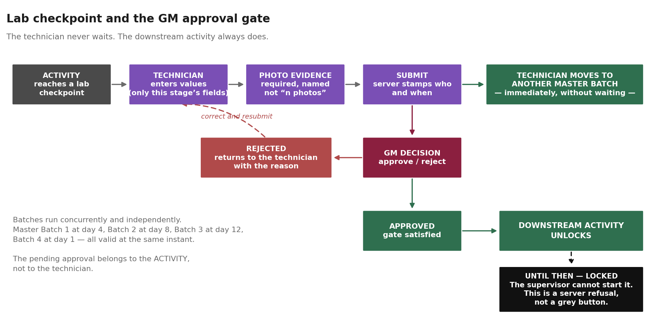
The technician never waits for the GM. The downstream activity always does.

10.1 · Every checkpoint in the batch
Twenty-six checkpoints. Each one is: perform the test, enter the values, upload photo evidence, submit for GM approval. The technician then moves to the next batch without waiting.

Code | Checkpoint | Hour | Worked example | Parameters | Note
LAB-00 | Raw material / bagasse weighment | PRE-H0 | ≈10 h before H0 | Moisture, pH, Dry weight | ADVISORY — does not gate H0
LAB-01 | Bagasse wetting | H1 | 31 Aug 10:00 | Moisture, pH, EC
LAB-02 | Hopper pass 1 | H3 | 31 Aug 12:00 | Moisture, pH, EC
LAB-03 | Hopper pass 2 | H14 | 31 Aug 23:00 | Moisture, pH, EC
LAB-04 | Before bunker loading | H26 | 01 Sep 11:00 | Moisture, pH, EC | GATE — FIB-BUNK-LOAD is locked until approved
LAB-05 | Bunker unloading | H88 | 04 Sep 01:00 | Moisture, pH, EC
LAB-06 | Before hopper pass | H90 | 04 Sep 03:00 | Moisture, pH, EC
LAB-07 | Reloading | H93 | 04 Sep 06:00 | Moisture, pH, EC
LAB-08 | Paddy weighment | H74 | 03 Sep 11:00 | Moisture, Dry weight | Parallel stream
LAB-09 | Paddy soak 1 — pit water | H86 | 03 Sep 23:00 | pH, EC, TDS | Parallel stream
LAB-10 | Paddy soak 2 — pit water | H108 | 04 Sep 21:00 | pH, EC, TDS | Parallel stream
LAB-11 | Paddy soak 3 — pit water | H136 | 06 Sep 01:00 | pH, EC, TDS | Parallel stream
LAB-12 | Chicken manure — on arrival | H130 | 05 Sep 19:00 | Nitrogen, Ash | Parallel stream
LAB-13 | Chicken manure — on unload for mixing | H136 | 06 Sep 01:00 | Nitrogen, Ash | GATE — MIX-CM-ADD locked until approved
LAB-14 | Moisture decision point | H133 | 05 Sep 22:00 | Moisture | DECISION — ≥68% proceed / <67% controlled mist
LAB-15 | After flipping 2 | H174 | 07 Sep 15:00 | Moisture, pH | + photo
LAB-16 | Moisture after T0 | H180 | 07 Sep 21:00 | Moisture | Per pile, 6 records
LAB-17 | Moisture after T1 | H183 | 08 Sep 00:00 | Moisture | Per pile, 6 records
LAB-18 | Moisture after T2 | H192.5 | 08 Sep 09:30 | Moisture | Per pile, 6 records
LAB-19 | Moisture after T3 | H197 | 08 Sep 14:00 | Moisture | Per pile, 6 records; batch average recorded
LAB-20 | Bunker loading | H194 | 08 Sep 11:00 | Bunker height, pH, EC, Moisture, Nitrogen, Ash, C:N | GATE — height checked first
LAB-21 | Bunker unloading (reload 1) | H259 | 11 Sep 04:00 | Shrunken height, Moisture | Height determines reload height
LAB-22 | Bunker reloading | H259 | 11 Sep 04:00 | pH, EC, Moisture, Nitrogen, Ash, C:N | + conditional water branch
LAB-23 | Before tunnel loading | H324 | 13 Sep 21:00 | Tunnel height | Checked first
LAB-24 | Tunnel loading | H324 | 13 Sep 21:00 | pH, EC, Moisture, Nitrogen, Ash, C:N | GATE
LAB-25 | Tunnel unloading | H470 | 19 Sep 23:00 | pH, EC, Moisture, Nitrogen, Ash, C:N, Shrunken height, Actinomycetes | Final QC

10.2 · The gates
Four checkpoints are gates. The activity that follows a gate cannot be started by anyone — not by a supervisor, not by an operator — until the lab result exists, the evidence is attached, and the GM has approved it.
Code | Gate | What it locks
LAB-04 | Before bunker loading | FIB-BUNK-LOAD stays locked until approved.
LAB-13 | Chicken manure on unload | MIX-CM-ADD stays locked until approved.
LAB-20 | Bunker loading | Bunker fill cannot be recorded complete until height and the full parameter set are approved.
LAB-24 | Tunnel loading | Tunnel loading cannot proceed until height, then the full set, are approved.

One checkpoint, LAB-14, is a decision rather than a gate: the moisture reading selects which branch the process takes. Both the reading and the branch chosen are recorded.

10.3 · Measurements and observations are different things
Numerical measurements — moisture, pH, EC, TDS, dry weight, nitrogen, ash, C:N ratio, bunker height, tunnel height, shrunken height — are entered as numbers with their units.
Observations are not numbers and must not be forced into numeric fields:
Observation | Values
Smell test | Recorded as observed.
Colour | Recorded as observed.
Spring / squeeze test | Too dry · Normal · Too wet · Dripping
Actinomycetes | Not visible · Weak · Clearly present. At tunnel unloading only.

Smell, colour and the squeeze test are available at every stage where material is stored in or handled around a bunker or tunnel, including all loading and unloading operations.

10.4 · Evidence
Every checkpoint requires photographic evidence. The photograph is what lets the GM verify the test before approving it, so it is part of the activity and not an optional afterthought.
The record keeps what evidence was required, what was submitted, when, and by whom. Evidence is never deleted; a correction supersedes, it does not overwrite.

10.5 · Day labels
The laboratory workflow document numbers its checkpoints by day — day 0 weighment, day 1 wetting, day 4 unloading, day 8 turnings, day 12 reloading, day 15 tunnel loading, day 22 tunnel unloading. Those labels come from the earlier 552-hour model.
Under this 470-hour standard the sequence is unchanged and the days compress. Days 0 through 15 land within a day of the lab document throughout. The final one does not: tunnel unloading is day 20, not day 22.
The batch hour, not the day label, is authoritative. The day column exists so the laboratory can recognise its own document.

10.6 · Concurrent batches
Several master batches are in progress at once, each at a different day. A technician may be entering day 4 results for one batch, day 8 for another and day 12 for a third within the same hour. The pending approval belongs to the activity, not to the technician, so nothing about one batch blocks work on another.

11 · Worked example — the batch that starts 31 August 2026
H0 is 09:00 on Monday 31 August 2026. Every hour below is that batch’s own clock. A batch that starts at a different hour has the same H-numbers against different wall-clock times.

Milestone | Batch hour | Wall clock
H0 — clock starts | H0 | Mon 31 Aug 2026, 09:00
Turner anchor | H174 | Mon 07 Sep 2026, 15:00
Bunker 1 filled | H194 | Tue 08 Sep 2026, 11:00
Reload 1 begins | H259 | Fri 11 Sep 2026, 04:00
Tunnel loading begins | H324 | Sun 13 Sep 2026, 21:00
H470 — standard end | H470 | Sat 19 Sep 2026, 23:00
Batch fully discharged | H474 | Sun 20 Sep 2026, 03:00

Pre-H0 · Sun 30 Aug, about 23:00 · ≈10 h before H0
Bagasse arrives and is weighed. The lab records moisture, pH and dry weight on the incoming lot and uploads photo evidence.
This is ADVISORY. It is recorded, it is evidence, and it gates nothing. If weighment happened 8 hours before H0 rather than 10, H0 still starts on time. The system records the actual interval and does not block.

Days 1–2 · Mon 31 Aug → Tue 01 Sep · H0 → H26 · wetting and the first bunker
09:00 H0. The production clock starts. From this instant every activity is stamped in batch hours, and midnight does not reset it.
09:00 → 12:00 H0 → H3 Bagasse wetting, hopper pass 1, full water. Target moisture 69–71 %.
Lab LAB-01 at H1 and LAB-02 at H3 — moisture, pH, EC, with photographs. These run alongside the pass; they consume no separate hours on the rail.
12:00 → 20:00 H3 → H11 Material rest, 8 h.
20:00 → 23:00 H11 → H14 Hopper pass 2. Dry if the moisture check passed; with water if it did not. Lab LAB-03 at H14.
23:00 → 11:00 (+1 day) H14 → H26 Heap formation, height ≤ 1.5 m, and rest. Standard 12 h; the factory range is 8–12.

Days 2–5 · Tue 01 Sep → Fri 04 Sep · H26 → H88 · first conditioning cycle
11:00 H26 Lab LAB-04 — moisture, pH, EC before bunker loading. THIS IS A GATE. Bunker filling stays locked until the GM approves it. The technician submits and moves to another batch; the activity waits.
11:00 → 13:00 H26 → H28 Flipping and bunker filling to 2.6–2.7 m, no water. 2 h.
13:00 (day 2) → 01:00 (day 5) H28 → H88 Bunker conditioning at 45–55 °C. Standard 60 h; factory range 48–60.
Unload trigger: temperature ≥ 58 °C OR elapsed ≥ 60 h. Whichever comes first, and both are recorded.

Day 4 · Thu 03 Sep · H74 · the paddy stream opens
11:00 H74 Paddy bales are weighed, cut, threads removed. 12 h. Lab LAB-08 — moisture and dry weight.
This runs in PARALLEL. It consumes no hours on the main rail. But it has a hard latest start: the paddy must be ready at H160, and the stream is 86 hours long. Start it after H74 and the convergence slips.
23:00 H86 Soaking 1 begins — push in, tilt 1, tilt 2, push out (8–10 h), then rest in the bunker (10–12 h). 22 h total. Lab LAB-09 tests the soak-pit water: pH, EC, TDS.

Days 5–6 · Fri 04 Sep → Sat 05 Sep · H88 → H133 · unload, reload, second cycle
01:00 H88 Bunker unloading. Lab LAB-05 — moisture, pH, EC on the sample.
01:00 → 06:00 H88 → H93 Loader unload, flipping, reload to a new bunker, no water. 5 h. Lab LAB-06 before the hopper pass and LAB-07 during reloading.
06:00 (day 5) → 22:00 (day 6) H93 → H133 Second conditioning cycle. 40 h. Unload trigger: ≥ 58 °C OR ≥ 40 h.
21:00 H108 Paddy soaking 2 begins — 28 h, the longest of the three. Lab LAB-10 on the pit water.

Day 6 · Sat 05 Sep · H130 · the nitrogen stream opens
19:00 H130 Chicken manure, gypsum and ammonium sulphate are weighed. 2 h. Lab LAB-12 records nitrogen and ash on arrival.
21:00 H132 Dry mix with the rotavator to break the manure lumps. 4 h. NO WATER at this stage.
Six hours in total, and like the paddy it is parallel with a hard deadline: ready at H136.

Days 6–8 · Sat 05 Sep → Mon 07 Sep · H133 → H160 · first convergence
22:00 H133 Unload. Lab LAB-14 is a DECISION POINT: if moisture ≥ 68 % the batch proceeds; if below 67 % a controlled mist is applied through the hopper and the readings are taken again. The original reading is never erased.
01:00 H136 CONVERGENCE. The conditioned bagasse and the nitrogen mix must both be ready. Lab LAB-13 re-tests the chicken manure for nitrogen and ash after its rest — composition changes in storage, and this is a GATE.
01:00 → 09:00 H136 → H144 Chicken-manure mix added to the conditioned bagasse, loader mixing, flip 1 and flip 2 back to back. 8 h.
09:00 → 13:00 H144 → H148 Hopper pass with full water. Target 73 % moisture, temperature below 45–50 °C.
13:00 (day 7) → 01:00 (day 8) H148 → H160 Rest. Standard 12 h; range 8–12.
01:00 H136 Paddy soaking 3 begins — 24 h. Lab LAB-11 on the pit water. It completes at H160, exactly when it is needed.

Day 8 · Mon 07 Sep · H160 → H183 · the yard, then the Turner
01:00 → 05:00 H160 → H164 SECOND CONVERGENCE. Paddy is ready. Two equal piles are prepared on the platform. 4 h.
05:00 → 07:00 H164 → H166 Bagasse + chicken-manure mix added gradually onto the two paddy piles. 2 h.
07:00 → 15:00 H166 → H174 Flip 1 and flip 2, back to back. 8 h. Lab LAB-15 after the second flip — moisture and pH, with a photograph.
15:00 H174 TURNER ANCHOR. The material is laid out as six working piles. Two machines, M1 and M2, begin.
15:00 → 21:00 H174 → H180 T0, the dry pass. M1 takes piles 1 and 2; M2 takes piles 3, 4, 5 and 6. Lab LAB-16 records moisture after T0 for each pile.
18:00 → 00:00 H177 → H183 T1, the water pass, interleaved with T0 so neither machine stops. M1 takes piles 1, 3, 2, 4; M2 takes 5 and 6. Lab LAB-17 records moisture per pile.
Both machines run 15:00 → 00:00 with no idle minute — six passes each. This is what 'continuous' means here: the machines never stop. Each pile does wait between its own T0 and T1, by 1.5 to 4.5 hours, and that is normal and recorded.

Day 9 · Tue 08 Sep · H183 → H200 · T2, T3 and the bunkers
Each pile now rests exactly 8 hours from the END of its own T1. That is the rule. Pile 1 finished T1 at 19:30 on day 8, so its T2 opens at 03:30.
03:30 → 09:30 H186.5 → H192.5 T2. Moisture is checked; if it is short, controlled water is added and re-checked. Target 73–75 %. The windrow is broken to prevent compaction. Lab LAB-18.
09:30 → 14:00 H192.5 → H197 T3. Lab LAB-19 records moisture per pile, and the batch average is recorded for future reference.
11:00 → 13:00 H194 → H196 BUNKER 1 fills with piles 1 and 2. 2 h. Filling is rolling — it starts the moment pile 1 leaves T3 at 11:00 and pile 2 joins at 12:30 as it finishes.
13:00 → 15:00 H196 → H198 BUNKER 2 fills with piles 3 and 4. 2 h.
15:00 → 17:00 H198 → H200 BUNKER 3 fills with piles 5 and 6. 2 h.
Lab LAB-20 at each fill: bunker height first, then pH, EC, moisture, nitrogen, ash and the calculated C:N ratio. Plus smell, colour and the squeeze test.

Days 9–12 · Tue 08 Sep → Fri 11 Sep · H196 → H265 · first hold and reload
Each bunker holds 63 hours: approximately 15 hours to reach 70 °C, then 48 hours at temperature.
04:00 H259 (Fri 11 Sep, 04:00) Bunker 1 unloads and reloads. 2 h. Lab LAB-21 records the shrunken height — which determines the reload height — and moisture.
If moisture is below threshold, water is added through the hopper while reloading and pH, EC and moisture are taken again. Lab LAB-22 records the full set on reload: pH, EC, moisture, nitrogen, ash, C:N.
06:00 H261 Bunker 2 unloads and reloads. 08:00 H263 Bunker 3.
The three bunkers run two hours apart throughout, one after another, on the same loader.

Days 12–15 · Fri 11 Sep → Mon 14 Sep · H265 → H332 · second hold and the tunnel
A second 63-hour hold on the same terms.
21:00 H324 (Sun 13 Sep, 21:00) Tunnel loading begins. Bunker 1 loads first, 2 h. Lab LAB-23 checks tunnel height FIRST, then LAB-24 records pH, EC, moisture, nitrogen, ash and C:N, with smell, colour and squeeze test.
23:00 H326 Bunker 2 loads. 03:00 on Mon 14 Sep H330 Bunker 3 loads.
The tunnel filling window is H324 → H332 — eight hours, three loads. This matches the factory range of 8–10 h for tunnel filling.

Days 15–20 · Mon 14 Sep → Sat 19 Sep · H332 → H470 · the tunnel process
144 hours inside the tunnel, in six phases:
Levelling and conditioning 1 · 19 h (range 18–20)
Heating up · 10 h (range 8–12)
Pasteurisation · 9.5 h (range 9–10)
Cooling down 1 · 13 h (range 12–14)
Conditioning 2 · 81.5 h (range 80–85)
Cooling down 2 · 11 h (range 8–14)
Total 144 h, inside the factory range of 135–155 h for the tunnel process.

Day 20 · Sat 19 Sep · H470 · the standard end
23:00 H470 Unloading begins and the compost is loaded to the grow room. Lab LAB-25 is the final QC: pH, EC, moisture, nitrogen, ash, C:N, shrunken height, and the actinomycetes observation, plus smell, colour and squeeze test.
H470 is measured on stream 1 — piles 1 and 2. Stream 2 discharges at H472 (Sun 20 Sep, 01:00) and stream 3 at H474 (Sun 20 Sep, 03:00), two hours apart, in the same order they were filled.
THE BATCH IS FULLY DISCHARGED AT H474 — Sun 20 Sep, 03:00. The 470-hour envelope is the standard reference; the last material leaves four hours later.

12 · Source and confidence
Every value in this standard carries a classification. The purpose is to make it impossible to read a figure taken from an example schedule as a figure the factory confirmed. Nothing may be promoted from one class to another without a decision and a source.
Class | Meaning
FACTORY CONFIRMED | A definite factory rule, duration or sequence.
FACTORY RANGE | A factory-specified interval. Both bounds are stated; the actual is the recorded time.
PARALLEL — NO WALL-CLOCK | Concurrent. Consumes zero additional hours on the rail.
CONFIGURABLE | A parameter the factory sets per batch or per profile.
ADVISORY | Guidance. Never blocks and never gates.
UNRESOLVED | Nobody has ruled. Recorded as such; no gate is built on it.

12.1 · Classification of this standard
Element | Class | Source
470-hour envelope | FACTORY CONFIRMED | Process owner, 30 Aug 2026
H174 Turner anchor | FACTORY CONFIRMED | SOP maximum pre-Turner chain
Main rail durations | FACTORY RANGE | imp_compost_sop_30082026.xlsx, MIN/MAX columns
Turner pass, 1.5 h per pile | FACTORY CONFIRMED | TURNERPRCOESS.xlsx
T1 → T2 rest, 8 h | FACTORY CONFIRMED | Both source documents agree
Two turner machines | FACTORY CONFIRMED | TURNERPRCOESS.xlsx
Bunker fill, 2 h | FACTORY CONFIRMED | Process owner, 30 Aug 2026
Three bunkers in sequence | FACTORY CONFIRMED | Process owner, 30 Aug 2026
Bunker hold, 63 h | FACTORY CONFIRMED | TURNERPRCOESS.xlsx
Tunnel process, 144 h | FACTORY RANGE | 135–155 h, SOP
Pre-H0 weighment, ≈10–12 h | ADVISORY | Does not gate H0
Lab checkpoints | PARALLEL — NO WALL-CLOCK | lab_technician_batch_process.md
Moisture band 67–68 % | UNRESOLVED | Undefined in the SOP

13 · Where the two source documents differ
The SOP sheet and the Turner sheet describe the same process and do not agree everywhere. This section records every difference and which source this standard follows. Nothing has been silently reconciled.

Item | SOP sheet | Turner sheet | This standard
Bunker cycles after the Turner | Three (fill + 2 reloads) | Two (fill + 1 reload) | TWO — the Turner sheet. Confirmed by the process owner.
Bunker filling | 10 h | 2 h | 2 h. Confirmed by the process owner.
Tunnel filling | 8–10 h | 2 h × 3 loads | 8 h window, three 2-hour loads. Both sources satisfied.
T3 timing | "immediately after T2" | 1.5 – 4.5 h after T2 | The Turner sheet. The SOP prose is a simplification.
Paddy preparation total | 74 h stated, 86 h in sub-steps | — | 86 h. The four sub-steps are the operations actually performed.
Stage 0C header | 8 h | — | 48 h. The header excludes the 40-hour rest beneath it.
Stage 0D | 24 h claimed, no sub-steps | — | Not carried. It has no timed content in the source.

What signing this document settles
The 470-hour envelope holds only with the Turner sheet’s downstream model — two bunker cycles, two-hour fills. Under the SOP sheet’s three-cycle model the same process runs to roughly 538 hours.
Signing this document is a decision that the factory runs two bunker cycles after the Turner, not three. That is the substantive change from PROCESS-2026B and it is the one worth reading twice.

14 · Approval
On signature this document becomes PROCESS-2026C version 1 and is frozen. Batches planned against it keep their baseline for their whole life, and any subsequent change publishes a new version rather than altering this one.

Role | Name | Signature and date
Process owner
General Manager
Production Manager
Laboratory

Open items carried into version 1
- The moisture band between 67 % and 68 % at FIB-MOIST-DEC is undefined and is recorded as UNRESOLVED.
- Changeover and repositioning time between Turner passes is currently zero in the source schedule. It is recorded as CONFIGURABLE with a default of zero.
- The receiving bunker for each reload is not named in the source. Recorded as UNRESOLVED.

