FRESH BOWL HORTICULTURE
MushroomOS
Technical PRD and
Architecture Handover
What we have · what we build · who builds which half
A complete statement of the existing system, the database contract two developers will work either side of, the screens to be built, and the plan from here to a signed-off product.
Field | Value
Document | Technical PRD · Architecture · Handover
Companion | MushroomOS — The 470-Hour Standard (PROCESS-2026C v1)
Codebase | T:\freshbowl_os\mushroomos
Stack | Supabase / PostgreSQL + RLS · React 18 + Vite · Capacitor for the field build
Baseline | 36 migrations · 50+ tables · ~95 functions · 24 views · 28 test files
Test state | 431 passing · 32 failing on environment · 20 skipped for want of a storage key
Status | DRAFT — for stakeholder sign-off
Issued | 30 August 2026

This document tells the truth about what is built.
Every claim about the existing system in section 2 is marked PROVEN, PARTIAL or UNPROVEN, and "proven" means a test asserts it against a real database. Where a subsystem has never been exercised end to end, this document says so rather than counting it as done.
That matters because the plan in section 6 is sequenced on it. Building screens over an unproven engine is how a demo becomes a rewrite.

Contents

1 · What this document is for
Three audiences, one document.
Reader | What they need from it
Stakeholders | A clear statement of what exists, what it costs to finish, and what they are signing. Sections 2, 6, 11 and 12.
Developer A — screens | The payload contract: what every screen reads, what it writes, and what it must never compute. Sections 8 and 9.
Developer B — engine | The database contract, the schema changes the 470-hour standard requires, and the task order. Sections 4, 5 and 6.

1.1 · The product in one sentence
Management must be able to ask, of any batch: what should have happened, what did happen, when it diverged, who did it, what proved it, and who authorised the difference — and the system must make it hard to retroactively make a late activity look on time.
Everything in the architecture follows from that sentence. If a design choice makes that question harder to answer, it is the wrong choice regardless of how much easier it makes a screen.

1.2 · What is in scope
- The 470-hour compost process from H0 to grow-room loading, as defined in the companion document.
- Operator, Laboratory, Manager, GM and Admin surfaces on web, with the field surface mobile-first.
- Evidence capture, laboratory results, approvals, deviations and authorised extensions.
- Management views: what is happening, what is blocked, why it is late, what proof exists, what it costs H470.

1.3 · What is out of scope for this phase
- Spawn run, casing, pinning, harvest, packing. They follow grow-room loading.
- The Android APK. The web build is kept Capacitor-compatible; packaging waits until the web demo is signed off.
- Re-planning an already-activated batch onto a new process version. No such mechanism exists and none is proposed.

2 · What exists today
The system is further along than it looks from outside. The five-register model is drawn, three of its guarantees are enforced with tests, and the process is already data rather than code. What is missing is specific and listed.

2.1 · By the numbers
 | Count | Note
Migrations | 36 | 0001 → 0036, forward-only, applied in filename order
Tables | 50+ | Across ten domains
Functions | ~95 | RPCs plus internal helpers and triggers
Views | 24 | The read layer the screens are supposed to use
Seed files | 12 | PROCESS-2026B definition, gates, lab specs, demo accounts
Front-end routes | 19 | React 18 + Vite
API modules | 13 | src/api/*
Test files | 28 | Vitest against a real Postgres, transactional rollback

2.2 · Subsystem by subsystem — honestly
PROVEN means a test asserts it against a real database. PARTIAL means it works but a hole is known. UNPROVEN means it has never been exercised end to end and must not be counted as done.

Subsystem | State | Evidence, or what is missing
Plan freeze at activation | PROVEN | Migration 0034. Four enforcement layers, 14 tests. The load-bearing guarantee of the product.
Role resolution and RLS | PROVEN | Migration 0035. 9 tests. Fails closed. Works without dashboard configuration.
Extension / authorisation register | PROVEN | Migration 0036. 21 tests. Request → manager → GM, approval only narrows. NO UI EXISTS.
Process as data | PROVEN | Durations, gates, cardinality, lab specs and evidence requirements are all rows, not code.
Audit trail | PARTIAL | audit_event is append-only by trigger. The demo history has no actor recorded.
Actual execution records | PARTIAL | actual_start / actual_end can still be overwritten. submit_activity takes the caller’s parameter over the stored value. This is a live hole, not theoretical.
Process versioning | PARTIAL | Versions exist and batches pin one. There is no publish step, so a definition an active batch was built from is still editable.
Evidence end to end | UNPROVEN | 20 tests skip on a storage permission error. The claim the whole traceability story rests on is currently an assertion.
Gate engine | UNPROVEN | Gates exist as data and are evaluated. Never audited, and never exercised at pile level.
Lab permission model | UNPROVEN | Never audited.
Resource and movement | UNPROVEN | Occupancy rows exist for vessels nobody allocated.
Forward forecast | MISSING | Everything today looks backwards. There is no projection of where a batch lands.
Turner / pile model | MISSING | PROCESS-2026B has no Turner stage at all.
Authorisation UI | MISSING | Register, RPCs, views and 21 tests exist. An operator cannot request an extension.

The test suite is currently 431 pass / 32 fail / 20 skip — and every failure is the environment.
The 32 failures are all one cause: the database holds one batch where the suites expect three staged demo batches. The 20 skips are a missing storage service key. Neither is a defect in the product.
But while that is true, a real regression is indistinguishable from the environment. Greening the suite is the first task in the plan for exactly that reason, not for tidiness.

3 · The architecture
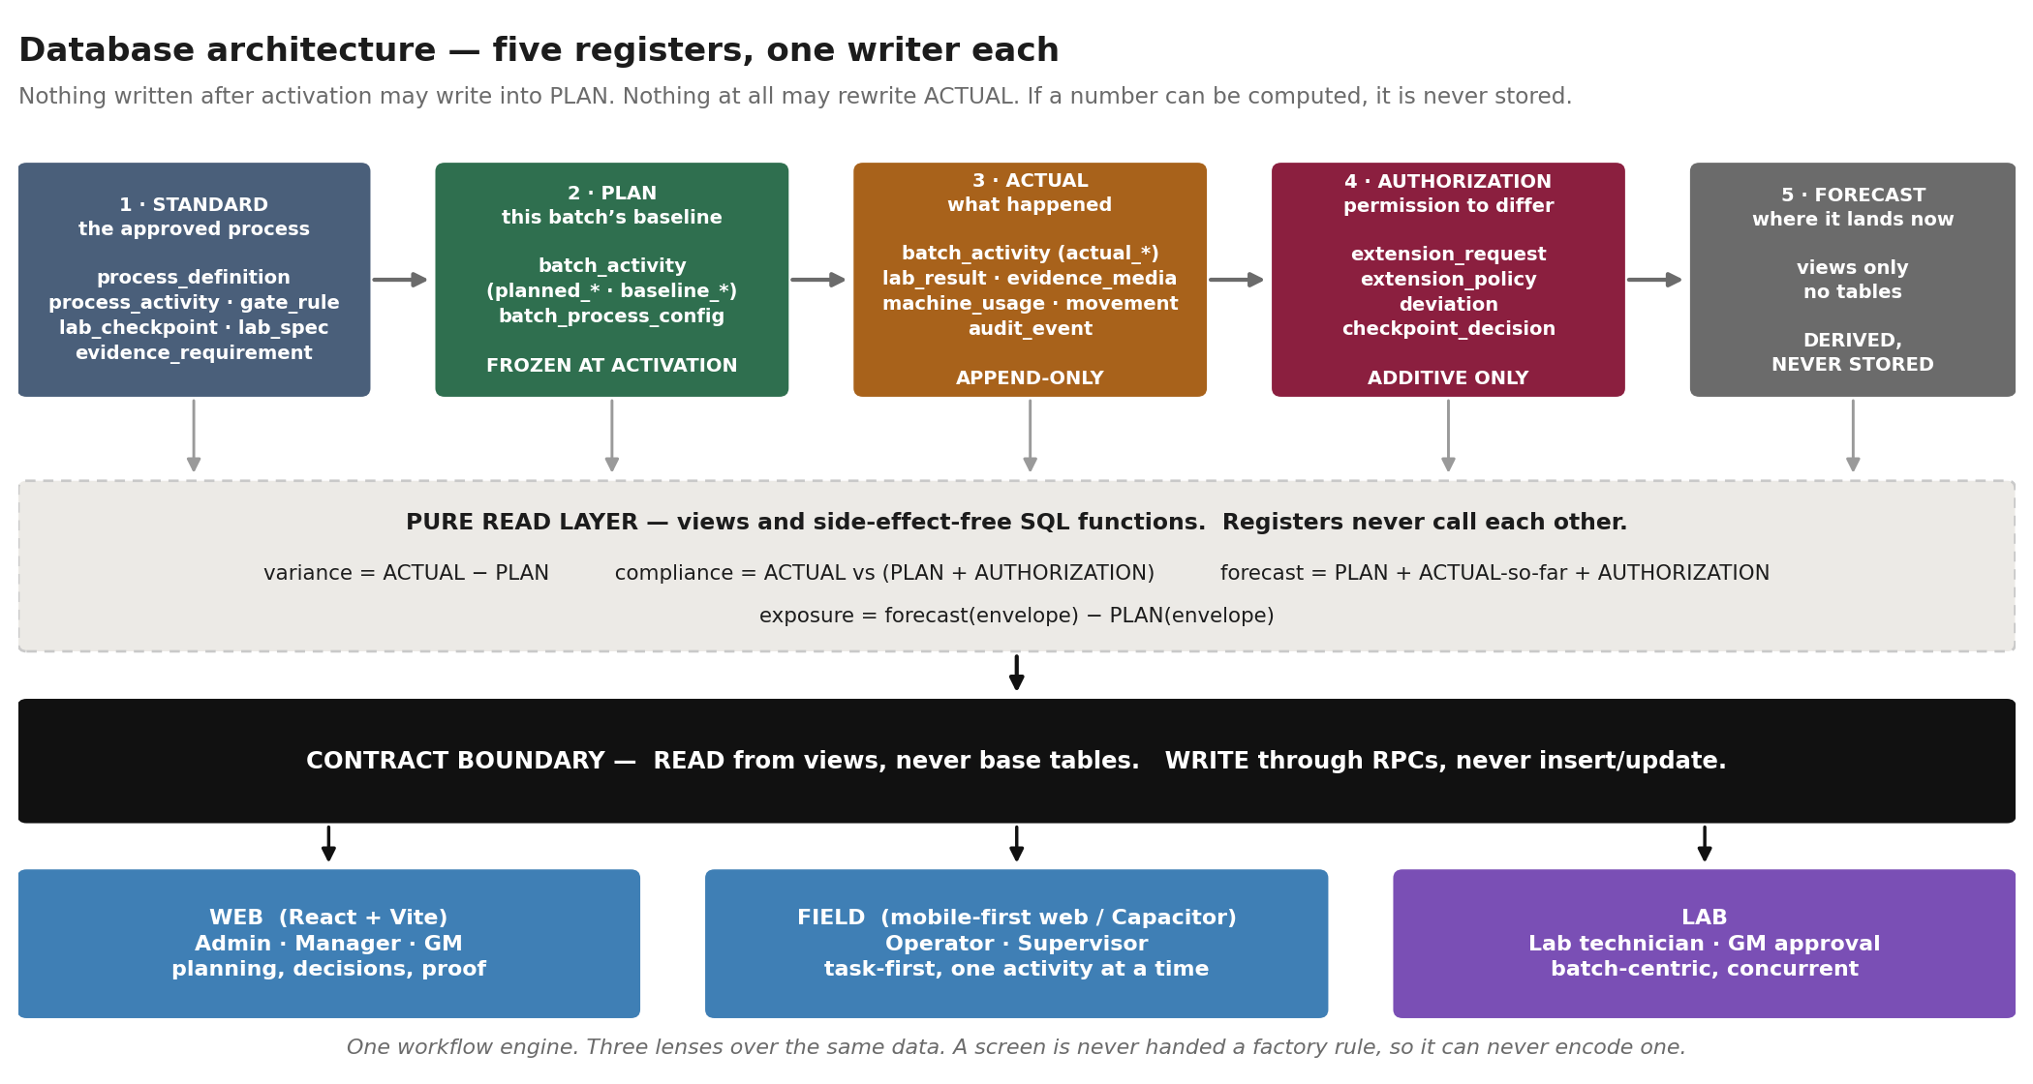
Five registers, one writer each. Registers never call each other; they are joined only by side-effect-free reads.

3.1 · Why five registers
Management must be able to ask, years later, what should have happened, what did, and who authorised the difference. That is only answerable if the four answers are stored separately. The moment any two collapse into one column the question becomes unanswerable, and no amount of UI fixes it afterwards.
Register | Written by | Mutable after write?
STANDARD | Admin, before publish | No. A change publishes a new version.
PLAN | activate_batch, once | NEVER. Frozen at activation.
ACTUAL | submit_activity and friends | APPEND-ONLY. A correction supersedes; it never overwrites.
AUTHORIZATION | Approval RPCs | Additive only. Never rewrites PLAN or ACTUAL.
FORECAST | Nobody — derived | Recomputed. Stored nowhere as truth.

The whole integrity claim in one sentence
Nothing written after activation may write into PLAN. Nothing at all may rewrite ACTUAL. If a number can be computed, it is never stored.

3.2 · The extension is a third number, never an edit
This is the single design decision most likely to be undone by someone trying to make a screen simpler, so it is stated explicitly:
planned end 12:00 never mutated
approved extension +2 h -> authorised 14:00
actual end 13:40

original variance +1 h 40 m <- still visible
within authorisation yes

Applying the extension by moving the planned end to 14:00 would erase the +1h40m. The extension is a third number. Approval only ever narrows — a manager may grant less than was asked, never more, and the GM may not exceed the manager. The window runs from the planned end, not from the approval, so a late approval does not silently buy extra time.

3.3 · Why Supabase stays
Everything the product holds is naturally relational: batch and activity hierarchies, process definitions, dependencies, approvals, roles, resources, evidence metadata. And the guarantees the product depends on — plan freeze, append-only audit, deny-by-default row-level security, server-enforced transitions — are database features.
Reimplementing them in application code would mean reimplementing them once per client, and web plus field plus lab means at least three. The problem was never the database; it was that the boundaries between domains were not explicit enough. Contracts fix that. A different database would not.

4 · The database

4.1 · Tables by domain
Ten domains. Each owns its tables and its rules; others consume contracts, never tables. Dependencies point one way, so a change has a bounded blast radius.

Domain | Tables
Process definition | process_definition · process_activity · process_day · phase · gate_rule · evidence_requirement · resource_requirement · lab_checkpoint · lab_spec · movement_rule · activity_variant · activity_field
Planning | master_batch · batch_activity (planned_* and baseline_*) · batch_process_config · batch_material_role · batch_activity_evidence_req
Execution | batch_activity (actual_*) · batch_activity_value
Evidence | evidence_media (with superseded_by_id)
Lab | lab_sample · lab_test · lab_result
Workflow / gates | gate evaluation state · alerts
Authorization | extension_request · extension_policy · deviation · checkpoint_decision · management_checkpoint · corrective_action
Resources / movement | machine_usage · batch_movement · location_occupancy · batch_vessel_allocation
Time / forecast | views only
Audit | audit_event

4.2 · What the 470-hour standard changes
Three schema changes and one new process version. Nothing else in the database moves.

Migration | Change | Why
0040 | Confidence class enum on process_activity and process_definition | The standard requires every process value to carry the class it was stated at, so a figure read off an example schedule can never be read as one the factory confirmed. Additive; everything backfills to UNRESOLVED.
0041 | envelope_hours on process_definition, plus one resolver view | baseline_hours is generated as (total_days + 1) × 24. It cannot hold 470, because 470 is not a multiple of 24. Storing a factory number as a day count is how a derived figure becomes "the standard".
0042 | Turner / pile structure on the new definition | PROCESS-2026B has no Turner stage. Six piles, two machine class slots, T0–T3, the 8-hour gate, and the pile→bunker movement rules.
0038 | actual_start / actual_end write-once | The plan is frozen; the actuals are not. Freezing one end only moves the hole.

470 is not a multiple of 24, and that is the whole problem.
process_definition.baseline_hours is generated always as ((total_days + 1) * 24). The old H552 was never a factory figure — it is 23 × 24.
The tempting fix is total_days = 19, which gives 480: close enough to look right on a screen, and wrong by ten hours in every variance the product computes. Because the plan freezes at activation, that error would then be permanent and protected by the very guarantee meant to prevent it.
Migration 0041 gives the envelope its own stated column, with a source and a confidence class, and one view that everything reads.

4.3 · The rules that keep the schema clean
- No material name appears in a process definition. Codes are FIB1-WEIGH, never BG-WEIGH; labels resolve at read time. This is what makes "bagasse becomes mustard" a zero-code change, and it is enforced by a CHECK constraint that names the forbidden words.
- A process activity names a machine CLASS, never a unit. Adding a third turner touches the resource tables only.
- Cardinality is a rule, not a constant. Six piles is a row, not a number in a screen.
- Evidence requirements are named, not counted. "Before photograph" and "after photograph", never "2 photos".
- If a number can be computed, it is not stored.

5 · What we reuse and what we build
The honest split. Roughly two thirds of the engine is reusable as it stands.

Component | Verdict | Detail
Auth, roles, RLS | REUSE | Proven and fails closed. No change.
Process-as-data engine | REUSE | Gates, cardinality, lab specs, evidence requirements are already rows.
Plan generation and freeze | REUSE | generate_activity_plan, activate_batch, four freeze layers.
Extension register | REUSE | Built and tested. Needs only a screen.
Audit trail | REUSE | Append-only by trigger.
Evidence storage | REUSE | Built, including supersession. Must be proven before it is trusted.
Lab tables and specs | REUSE | lab_checkpoint, lab_spec, lab_result exist and match the lab workflow document.
View layer | MOSTLY REUSE | v_lab_queue, v_live_batch, v_plant_now, v_activity_timing, v_evidence_state and more exist. Two are missing: a gate view and a planning view.
src/api/batch.ts | REFACTOR | 534 lines spanning Planning, Execution and Evidence. It is the file two developers will collide in. A pure move, no behaviour change.
PROCESS-2026B definition | SUPERSEDE | Copied to PROCESS-2026C. Never edited — an active batch was generated from it.
Envelope model | BUILD | Migration 0041.
Confidence classes | BUILD | Migration 0040.
Turner / pile model | BUILD | Does not exist.
Actual immutability | BUILD | Migration 0038.
Publish / freeze on definitions | BUILD | No publish step today.
Forward forecast | BUILD | One view, replaceable basis. Last, and deliberately.
Operator, Lab, Decision, Now, Story screens | BUILD | Existing routes are a demo scaffold, not these five surfaces.

6 · The plan
Six waves. The order is not preference — three questions decide it. Does it stop a wrong number becoming permanent? Does it unblock two people working at once? Can it be proved?

Wave 0 · Make the ground trustworthy
Nothing else starts until this is done. Two tasks.
Task | What | Why first
ARCH-008 | Capture the deployed schema drift | Two tables and eleven functions exist that no migration creates. A fresh environment is a different database, and two people are about to work in parallel against it.
ARCH-011 | Restore demo data, green the suite | While 32 tests fail on the environment, a real regression is invisible.

Wave 1 · Close the last hole, stop bad numbers becoming standards
Four tasks, all additive, all parallelisable — different tables, no shared files.
Task | What | Why
ARCH-001 | actual_start / actual_end write-once, with a supersession path | The plan is frozen and the actuals are not. Instead of dragging the plan onto the actual, you drag the actual onto the plan.
PRD-001 | Confidence class enum, everything backfilled UNRESOLVED | One afternoon. Makes a whole class of mistake impossible.
PRD-002 | envelope_hours stated, one resolver view, no literal 552 anywhere | Before the new version, not during. During, the pressure is to ship a number.
ARCH-009 | Role guard on send_alert | Five lines. Any signed-in user can currently alert any role.

Wave 2 · Make a standard publishable, then publish the 470-hour one
Task | What | Why
ARCH-003 | publish / freeze on process_definition | Without it the version boundary is a convention, and the pressure to edit PROCESS-2026B in place is highest exactly now.
PRD-003 | publish_process_version refuses an UNRESOLVED standard | Three lines. Turns the classification from documentation into a gate at the one moment it matters.
PRD-004 | Copy PROCESS-2026B → PROCESS-2026C v1 | A copy, never an edit. The live batch must still explain itself.
PRD-005 | Apply the H0 model — H0 is bagasse wetting, pre-H0 advisory | Replay the preserved export. Do not carry the old readiness gate across with the hours.
PRD-006 | Turner / pile / bunker structure on the copy | Six piles, two machine slots, T0–T3, the 8-hour gate, pile→bunker movement rules.

Wave 3 · Unblock the two developers
Task | What | Why
ARCH-002 | Split batch.ts along domain lines | A pure move. The file two developers collide in.
ARCH-010 | Close the contract leak — api modules reading base tables | Where a view exists, switch to it. Where one does not, specify it rather than reading the table "for now".
PRD-007 | Write the payload contract, one section per screen | Section 9 of this document is the first draft. It is what lets Developer A build with the backend unavailable.

Wave 4 · Surface what already exists
Task | What | Why
MGMT-001 | Authorisation UI — operator request, manager and GM decision, four numbers on the story | The largest gap between built and usable. 21 tests and no screen.
ARCH-004 | Prove evidence end to end with a real object | "Evidence is real" is currently an assertion. It is the claim the product rests on.
ARCH-007 | Give the event log an actor | A history with no actor answers none of the product’s questions.

Wave 5 · Forecast, last and deliberately
A forecast built on mutable actuals is worthless, so it waits on ARCH-001. And the factory has not confirmed a formula — so build the mechanism, keep the basis to one view, and label the assumption as an assumption in the UI. Do not bake it into a screen.

7 · How the work divides
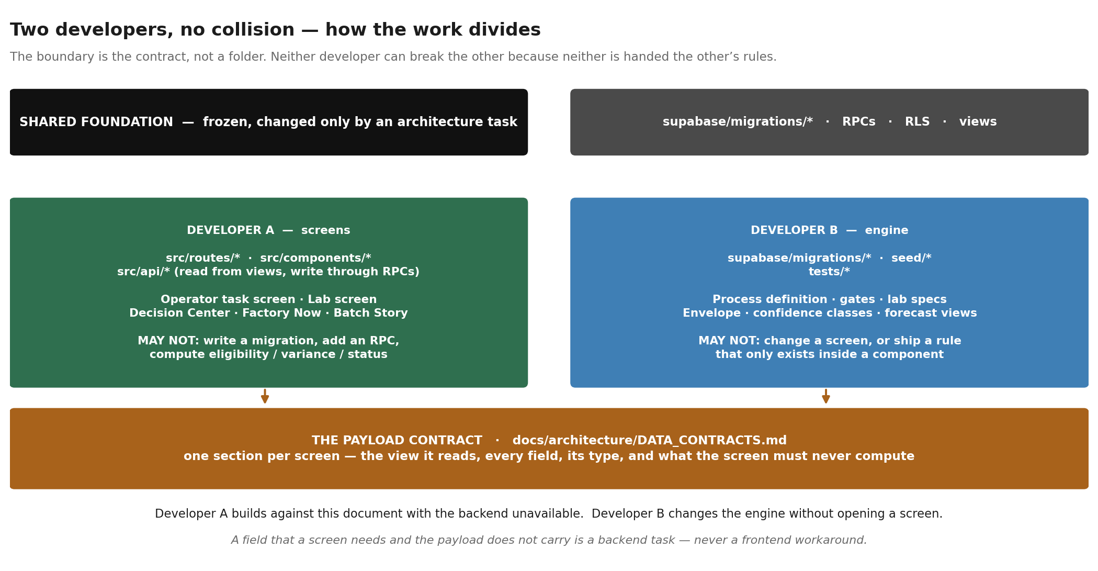
The boundary is the contract, not a folder.

7.1 · The two rules that make parallel work safe
1 · Read from views, never from base tables. 2 · Write through RPCs, never insert or update.
A screen built that way can be rebuilt completely without a backend change, and can never encode a factory rule — because it is never handed one.

7.2 · What a screen must never contain
Process sequence · durations · timestamps it computed itself · gate logic · lab thresholds · approval authority · what "on time" means · how many photographs.
Every one of those arrives as data. If a screen needs a number that is not in its payload, that is a backend task, not a frontend workaround.

7.3 · The rule that matters most when two people work at once
Report bugs outside your boundary; do not fix them. A casual fix to a foundational table is how two parallel workstreams become one broken one.

8 · The screens
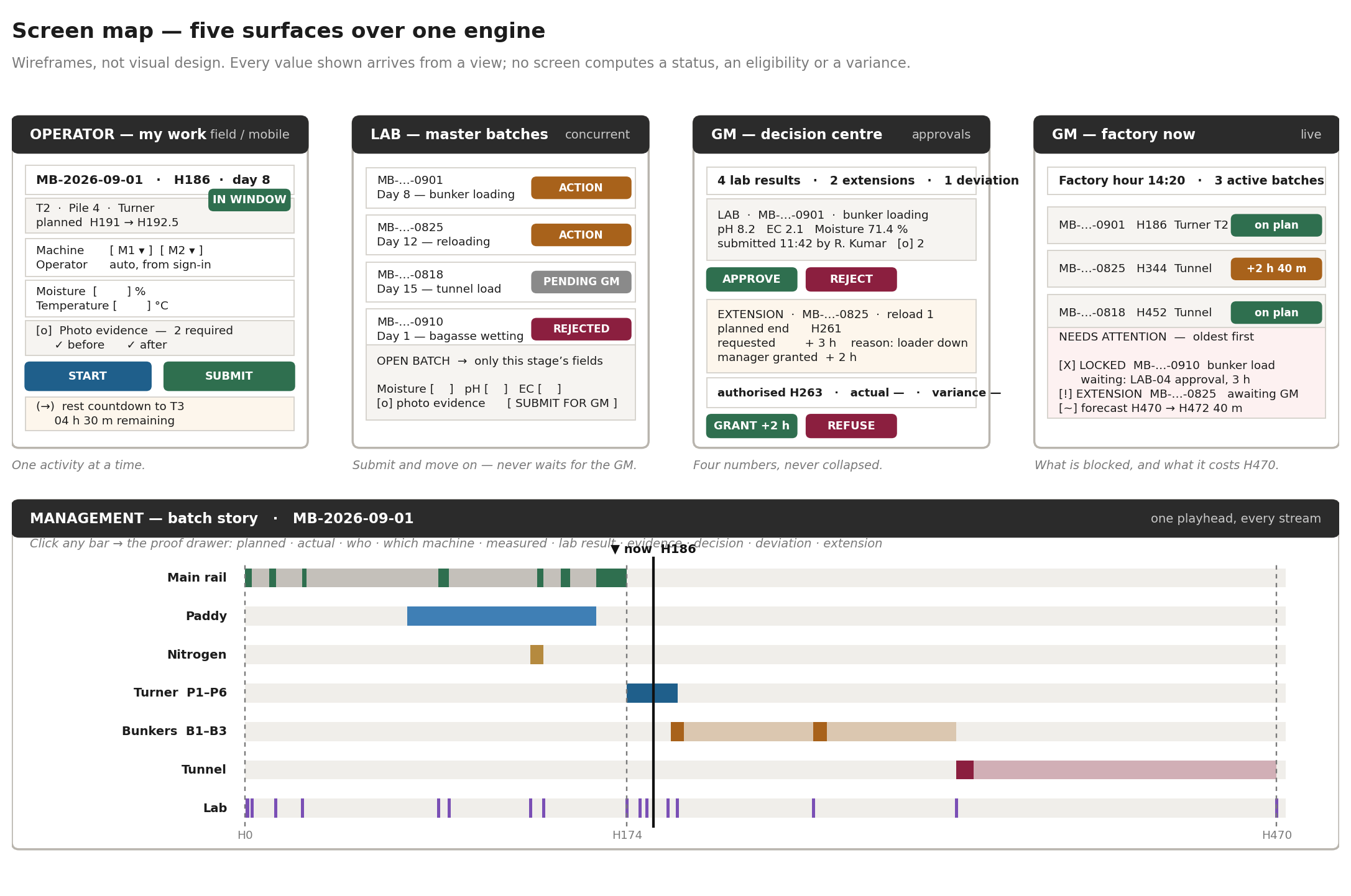
Wireframes, not visual design. Every value shown arrives from a view.

8.1 · Screen inventory
Screen | Role | Reads | Writes
My Work | Operator | v_live_batch · v_activity_timing · v_evidence_state | start_activity · submit_activity · bind_evidence · request_extension
Lab Queue | Lab technician | v_lab_queue · v_lab_result_history | record_lab_result · bind_evidence
Decision Centre | Manager · GM | v_extension_request · v_activity_expectation · lab queue | accept_lab_result · manager_decide_extension · gm_decide_extension · gm_decide_override
Factory Now | GM | v_plant_now · v_batch_variance · v_batch_forecast | nothing
Batch Story | Manager · GM · Admin | v_live_batch · v_activity_timing · v_extension_request · evidence | nothing
Batch Setup | Admin | process definition views | create_master_batch · generate_activity_plan · activate_batch

8.2 · Five things every screen must get right
- Batch hour and calendar time appear together. H186 means nothing on its own to an operator, and 14:20 means nothing to a manager comparing two batches.
- Live and baseline are visually distinct. A planned value and an actual value must never look the same.
- Empty, not-yet-recorded, not-stated and disputed are four different states, and none of them is zero.
- Never invent a completed state. If the server has not said an activity is done, the screen does not say it either.
- Factory language on user-facing screens. The operator sees "Pile 4", not "batch_activity 7f3a".

9 · The payload contract
This is the section Developer A builds against. One block per screen: the view it reads, the fields it gets, and what it must never compute. Where a field is absent, the answer is a backend task — never a workaround.

9.1 · Operator — My Work
GET v_live_batch WHERE assigned_to = me AND state IN (ELIGIBLE, RUNNING, BLOCKED)

activity_id uuid
batch_code text "MB-2026-09-01"
activity_label text "T2 · Pile 4 · Turner" <- resolved server-side
batch_hour numeric 186
planned_start_at timestamptz
planned_end_at timestamptz
authorised_end_at timestamptz planned_end + approved extension, or null
actual_start_at timestamptz null until started
state enum ELIGIBLE | RUNNING | BLOCKED | SUBMITTED | DONE
blocked_reason text null unless BLOCKED. Human sentence, from the server.
required_fields jsonb[] {code, label, unit, type, min?, max?}
required_evidence jsonb[] {code, label, captured: bool}
resource_classes text[] ["TURNER"] <- a class, never a unit
resource_units jsonb[] {id, label} for that class, from the resource register
rest_until_at timestamptz null unless a time gate is open
may_request_extension bool

What this screen must never compute: whether the activity is eligible, whether it is late, how long the rest has left as a rule (it counts down to a server-supplied instant), which fields are required, or how many photographs.

9.2 · Lab — queue and entry
GET v_lab_queue WHERE role = lab_tech

checkpoint_id uuid
master_batch_id uuid
batch_code text
batch_day int the label the laboratory recognises
batch_hour numeric authoritative
checkpoint_label text "Before bunker loading"
action_state enum ACTION_REQUIRED | SUBMITTED | APPROVED | REJECTED
rejection_reason text null unless REJECTED
parameters jsonb[] {code, label, unit, kind: NUMERIC|OBSERVATION,
options?: text[], previous_value?, previous_at?}
required_evidence jsonb[] {code, label, captured}
is_gate bool true if downstream is locked on this

Two things this shape settles. Observations (smell, colour, squeeze, actinomycetes) arrive with kind = OBSERVATION and their option list, so the screen never hard-codes "Too dry · Normal · Too wet · Dripping". And previous_value lets the technician see the last reading without the screen querying history itself.

9.3 · Manager / GM — Decision Centre
GET v_extension_request · v_activity_expectation · v_lab_queue(pending)

request_id uuid
activity_label text
planned_end_at timestamptz <-- four separate fields, never collapsed
requested_hr numeric
approved_hr numeric null until decided
authorised_end_at timestamptz planned_end + approved_hr
actual_end_at timestamptz null while running
original_variance_min int actual − planned. NEVER hidden by an approval.
reason text
evidence_id uuid optional
manager_decision enum null | APPROVED | REJECTED
manager_reason text
gm_required bool from extension_policy, not from the screen
may_decide bool the server’s answer, not a role check in JS

The four numbers are the product.
planned end · approved extension · authorised end · actual end. A screen that shows three of them, or that moves the planned end to match the authorisation, has destroyed the only thing this register exists to preserve.
Role gating comes from the server’s refusal, not from hiding a button.

9.4 · GM — Factory Now
GET v_plant_now · v_batch_variance · v_batch_forecast

factory_now_at timestamptz server clock, never the browser’s
batches[] {batch_code, batch_hour, stage_label, variance_min,
status: ON_PLAN | LATE | BLOCKED}
attention[] {kind: LOCKED|EXTENSION|DEVIATION|CONFLICT, batch_code,
label, waiting_since, waiting_for, oldest_first_rank}
forecast {envelope_hr, projected_hr, exposure_min, basis_label}

basis_label carries the forecasting assumption as text, so the screen can display it as an assumption rather than as a fact. The factory has not confirmed a formula and the UI must not pretend otherwise.

9.5 · Batch Story
GET v_live_batch(batch) · v_activity_timing(batch) · v_extension_request(batch)

streams[] {stream_code, label, lane_order,
segments[]: {activity_id, label, kind: WORK|HOLD|LAB,
planned_start_hr, planned_end_hr,
actual_start_hr, actual_end_hr,
state, variance_min}}
playhead_hr numeric
envelope_hr numeric 470 — from the definition, not a constant
anchor_hr numeric 174

Clicking a segment opens the proof drawer, which is one reusable component: planned · actual · who · which machine · what was measured · the lab result and its timestamp · the evidence, openable as the actual image · the decision and who made it · the deviation · the extension.
"Two photographs uploaded" is not proof. Management must be able to open the image.

10 · Non-negotiable rules
These are product requirements, not preferences. A feature that appears to need one of them relaxed is the wrong feature.

 | Rule
R1 | The baseline cannot be rewritten after activation, by anyone, by any path.
R2 | Actual timestamps cannot be backdated or silently edited. A correction is a new superseding record with a reason.
R3 | A downstream activity with an unmet predecessor stays locked. This is a server refusal, not a grey button.
R4 | A lab result stays associated with the activity that generated it.
R5 | Evidence stays associated with its originating activity, and is never deleted.
R6 | A lab approval may be pending while the technician works on other batches.
R7 | Multiple master batches progress concurrently and independently.
R8 | Turner piles progress independently. There is no barrier that makes all six finish together.
R9 | Turner machine assignment is recorded as actual execution data. It is never planned.
R10 | Extensions are separate authorization records.
R11 | An approved extension never rewrites the original baseline.
R12 | All deviations remain visible.
R13 | A user cannot make a late process look on time by changing the original planned timestamp.
R14 | A process version change does not rewrite historical batches.
R15 | Batch-hour time is continuous and server-authoritative. Calendar midnight does not reset it.
R16 | The 470-hour standard is a reference envelope. Real delay is visible variance or an authorised exception — never a moved envelope.
R17 | No factory rule lives in code or in a screen.
R18 | No material name appears in a process definition.
R19 | Out-of-range never blocks recording. It forces a remark and raises a deviation.
R20 | A refusal must name what to do instead.

11 · Risks and open items
Risk | Severity | Mitigation
Evidence has never been proven end to end | HIGH | ARCH-004, in wave 4, with a real storage object. Until then the traceability claim is an assertion.
Actuals can still be overwritten | HIGH | ARCH-001, wave 1. It is a live path through the supported RPC, not a theoretical one.
Schema drift between migrations and the deployed database | HIGH | ARCH-008, wave 0. Two people cannot share an environment they cannot rebuild.
The gate engine has never been audited | MEDIUM | Exercise it at pile level as part of PRD-006.
No forecasting formula is confirmed | MEDIUM | Build the mechanism, keep the basis to one view, label the assumption in the UI.
The 67–68 % moisture band is undefined | LOW | Recorded UNRESOLVED. Readings in the band are flagged and referred, never auto-decided.
Changeover time between Turner passes is zero in the source | LOW | CONFIGURABLE, default zero, visible so the assumption is not invisible.

11.1 · Open items requiring a factory answer
- The moisture band between 67 % and 68 % at the FIB-MOIST-DEC decision point.
- Changeover and repositioning time between Turner passes.
- The receiving bunker for each reload — the source names no destination.
- Whether the approval chain always requires the GM, or only above a threshold. Seven such settings exist as columns of extension_policy; answering one is an UPDATE, not a migration.

12 · Definition of done
The product is ready for stakeholder testing when every one of these is true and demonstrable.

 | Criterion
1 | PROCESS-2026C is published and frozen, and its envelope reads 470 from a stated column.
2 | A batch receives an immutable baseline at activation, and H0 is server-authoritative.
3 | The main rail, both parallel streams and the laboratory stream are represented correctly.
4 | Six Turner piles exist and progress independently; M1 and M2 allocation is recorded as actual.
5 | T0, T1, T2 and T3 execute at pile level, with the 8-hour gate enforced from T1 actual end.
6 | Six piles resolve into three bunker streams and the streams run two hours apart.
7 | Lab results and evidence are stored, and the evidence opens as the actual image.
8 | A downstream activity with an unapproved lab gate cannot be started by a supervisor.
9 | An operator can request an extension; a manager and the GM can decide it.
10 | Planned end, approved extension, authorised end and actual end appear as four separate numbers.
11 | Deviations appear automatically and remain visible.
12 | The original baseline is unchanged after every one of the above.
13 | Management can see plan versus actual, open the proof, and read the H470 forecast impact.
14 | The full process can be reconstructed from H0 to completion for a finished batch.
15 | The test suite is green, and every skip states why.

13 · Approval
Signature here approves the architecture, the plan and the split of work described in this document. It does not approve the process itself — that is the companion document, PROCESS-2026C v1.

Role | Name | Signature and date
Process owner
General Manager
Technical lead
Developer A — screens
Developer B — engine

