MUSHROOMOS
PROCESS-2026C
470-HOUR STANDARD PROCESS
Final Process + Product Requirements Draft
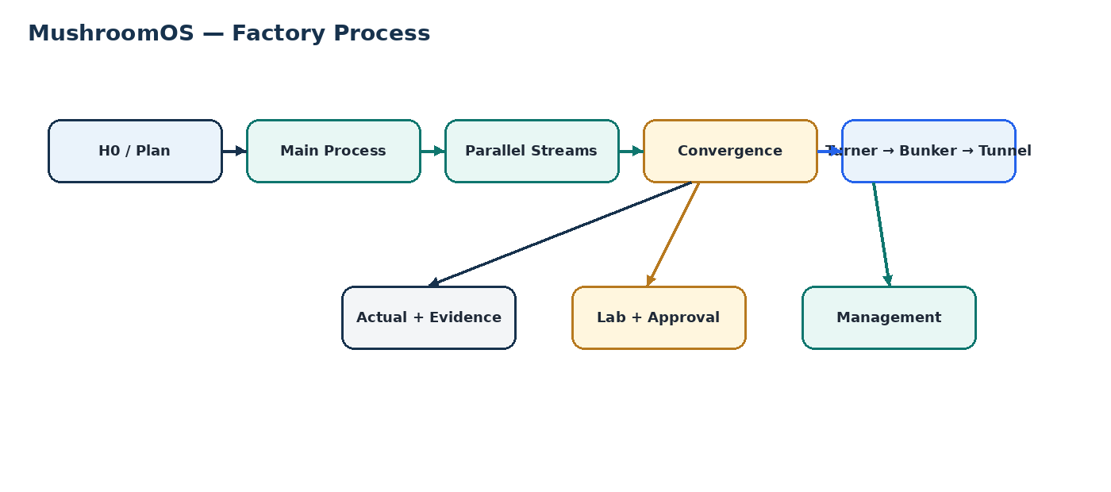
Status | DRAFT — for process-owner, GM, Production Manager and Laboratory sign-off
Standard | 470 hours from H0 to first grow-room loading
Worked example | Monday, 31 August 2026, 09:00 IST
Turner anchor | H174 — Monday, 07 September 2026, 15:00
Purpose | Freeze the process and give the software one definition to build against
SIGN-OFF
Once approved, PROCESS-2026C v1 is frozen. Future changes create a new version and never rewrite an active batch baseline.
****Local Paddy is selected we will have only two soakings so the time is decreased in this parallel process now I need my current sop to adapt for this change so the normal flow of timings will be changed. Make an table and an example scenario for this case of local paddy .****

4.1 Paddy stream
Activity | Example | Lab | Role
Bale weigh/cut/thread removal | H74→H86 · 12h | Moisture + dry weight | Parallel
Soaking 1 | H86→H108 · 22h | pH + EC + TDS | Parallel
Soaking 2 | H108→H136 · 28h | pH + EC + TDS | Parallel
Soaking 3 | H136→H160 · 24h | pH + EC + TDS | Must be ready at H160

1. Purpose and scope
This document is the single process baseline for the current MushroomOS build. It describes the physical factory process, parallel work, timing, laboratory controls, evidence requirements, Turner flow, bunker/tunnel flow, accountability and the decisions that must be confirmed before release.
- Define the 470-hour standard from H0 to the first grow-room loading.
- Make paddy, nitrogen/manure and laboratory work visible as parallel streams.
- Define six Turner working piles and the M1/M2 execution model.
- Define laboratory testing, evidence and hard approval gates.
- Define plan vs actual vs variance vs extension without rewriting history.
- Provide a single process reference for the software implementation.

1.1 The process mental model

2. Freeze rules
Area | Current rule | Status
Master clock | Continuous H0 → H470 | CONFIRMED
H0 | Admin selects the batch start time | CONFIRMED
Pre-H0 weighment | Advisory; never gates H0 | ADVISORY
Parallel streams | Paddy + nitrogen/manure + laboratory | CONFIRMED
Turner | ~6 piles; M1 + M2; T0→T1→T2→T3 | CONFIRMED
Turner laboratory | BEFORE T1 + AFTER T1 only; NO T0/T2/T3 test | CURRENT STAKEHOLDER RULE
Bunker grouping | P1+P2→B1; P3+P4→B2; P5+P6→B3 | CONFIRMED
Post-Turner bunker model | Two cycles, not the older three-cycle model | CONFIRMED
Bunker fills | 2h each; two hours apart | CONFIRMED
Tunnel process | 144h working standard within 135–155h range | FACTORY RANGE
Extensions | Separate authorization; baseline unchanged | CONFIRMED
Versioning | Future changes create a new process version | CONFIRMED
SOURCE DISCIPLINE
FACTORY CONFIRMED, FACTORY RANGE, PARALLEL, CONFIGURABLE, ADVISORY and UNRESOLVED remain distinct. Do not turn a simulation into a factory rule or invent unresolved values.

3. Exact worked timeline — H0 to H474
Example anchor: H0 = Monday, 31 August 2026, 09:00 IST. The timeline below follows the current PROCESS-2026C worked example.
Time | H-hour | Process | Lab / control
29 Aug ~23:00 | PRE-H0 | Raw material / bagasse weighment | Moisture, pH, ,EC,dry weight; advisory
31 Aug 09:00 | H0 | Bagasse wetting + Hopper Pass 1 | Moisture, pH, EC, AFTER H1
31 Aug 12:00 | H3 | Material rest begins | —
31 Aug 20:00 | H11 | Hopper Pass 2; dry or water branch | Moisture, pH, EC,AFTER H2
31 Aug 23:00 | H14 | Heap formation + rest | —
01 Sep 11:00 | H26 | Before first bunker load / 2h bunker fill | LAB-04: moisture, pH, EC + evidence + GM gate
01 Sep 13:00 | H28 | Conditioning begins | 45–55°C; first trigger ≥58°C or ≥60h
03 Sep 11:00 | H74 | Paddy preparation starts | Moisture + dry weight
03 Sep 23:00 | H86 | Paddy soak 1 | pH, EC, TDS
04 Sep 01:00 | H88 | Bunker unload / reload | Moisture, pH, EC
04 Sep 21:00 | H108 | Paddy soak 2 | pH, EC, TDS
05 Sep 19:00 | H130 | Chicken manure + minerals weighment | Nitrogen, Ash
05 Sep 21:00 | H132 | Rotavator dry mix | No water
05 Sep 22:00 | H133 | Moisture decision | ≥68% proceed; <67% correct/retest; 67–68% unresolved
06 Sep 01:00 | H136 | First convergence; CM mix begins | LAB-13 gate; nitrogen + ash
06 Sep 09:00 | H144 to H146H1 ,  H147 to H149H2 | Water hopper pass+Another hopper pass | Target ~73% moisture; <45–50°C
06 Sep 13:00 | H150 | Rest | 10h
07 Sep 01:00 | H160 | Second convergence | Paddy ready; two equal piles
07 Sep 05:00 | H164 | Add conditioned bagasse + CM mix | —
07 Sep 07:00 | H166 | Flip 1 + Flip 2 | Back-to-back
07 Sep 15:00 | H174 | TURNER START | Six working piles; M1 + M2
07 Sep 15:00–21:00 | H174–H180 | T0 | NO LAB AFTER T0
07 Sep ~18:00 onward | H177+ | T1 interleaved with T0 | LAB BEFORE / AFTER T1 only
08 Sep 00:00 | H183 | T1 window complete | Post-T1 moisture per pile
08 Sep onward | H186.5+ | T2 after each pile's 8h rest | NO LAB AFTER T2
08 Sep onward | H192.5+ | T3 | NO LAB AFTER T3
08 Sep 11:00 | H194 | Bunker 1 fill | P1+P2
08 Sep 13:00 | H196 | Bunker 2 fill | P3+P4
08 Sep 15:00 | H198 | Bunker 3 fill | P5+P6
11 Sep 04:00 | H259 | Bunker 1 reload | Height / moisture / full set
11 Sep 06:00 | H261 | Bunker 2 reload | Same pattern
11 Sep 08:00 | H263 | Bunker 3 reload | Same pattern
13 Sep 21:00 | H324 | Tunnel loading stream 1 | Tunnel height + full lab gate
13 Sep 23:00 | H326 | Tunnel loading stream 2 | —
14 Sep 03:00 | H330 | Tunnel loading stream 3 | —
14 Sep 05:00 | H332 | Tunnel filling complete | Tunnel process begins
14–19 Sep | H332–H470 | Tunnel process | 144h working standard
19 Sep 23:00 | H470 | First grow-room stream | Final QC
20 Sep 01:00 | H472 | Second stream discharge | Final QC as configured
20 Sep 03:00 | H474 | Final stream discharge | Full batch discharge

**the supervisor should track or input the bunker number and the tunnel number at their respective processes***

4. Parallel processes
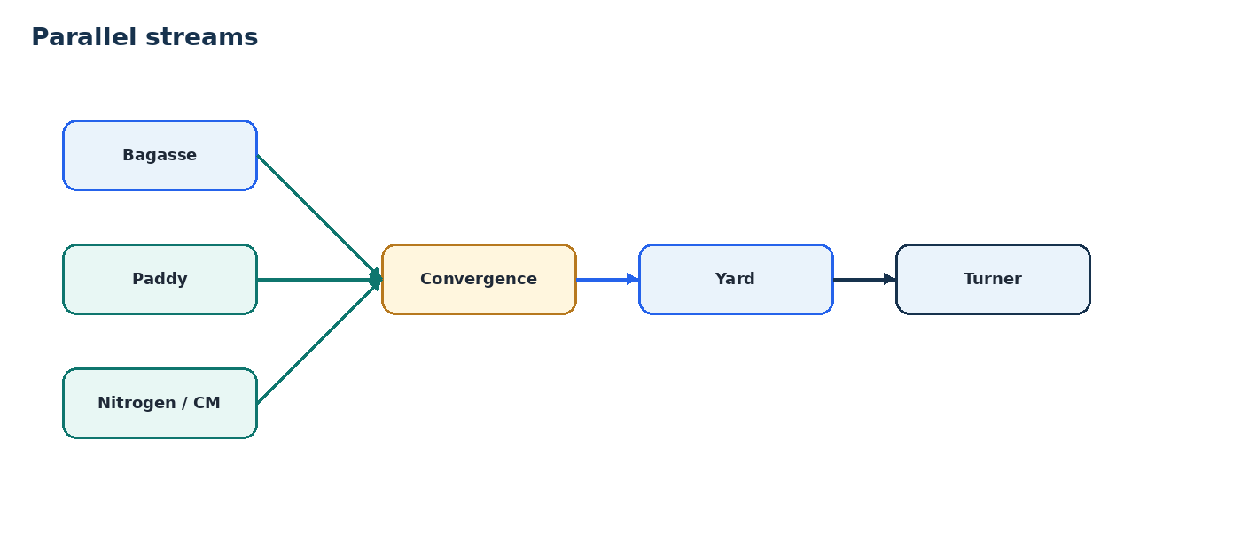
- Paddy is a parallel stream: it starts around H74, takes the current 86h operational sub-step total, and must be ready for the H160 convergence.
- Nitrogen/manure preparation is a parallel stream: it opens around H130, is ready at H136, and its second laboratory result is a gate for mixing.
- Laboratory work is operationally parallel across batches, but a result/approval can be a hard predecessor for downstream physical activity.
- Parallel does not mean optional or irrelevant; a late parallel stream can delay a convergence.

4.1 Paddy stream
Activity | Example | Lab | Role
Bale weigh/cut/thread removal | H74→H86 · 12h | Moisture + dry weight | Parallel
Soaking 1 | H86→H108 · 22h | pH + EC + TDS | Parallel
Soaking 2 | H108→H136 · 28h | pH + EC + TDS | Parallel
Soaking 3 | H136→H160 · 24h | pH + EC + TDS | Must be ready at H160
PADDY TOTAL
The SOP states 74h in its headline, while the four actual sub-steps total 86h. PROCESS-2026C uses 86h because those are the operations actually performed. This stream is parallel, not added to the main rail.

5. Turner process
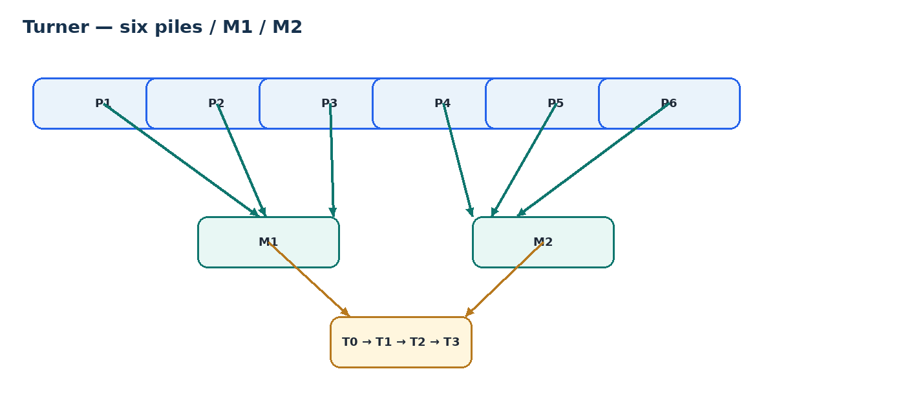
- At H174 the material is laid out as approximately six physical working piles: P1–P6.
- Two Turner machines are available: M1 and M2.
- Piles progress independently. A pile may change machine during execution.
- The Turner workbook is a machine/pile execution simulation; it is not a hardcoded UI sequence.
- The system records actual pile, machine, operator, start/end and evidence.

5.1 Turner stages
Stage | Physical operation | Timing | Lab
T0 | Dry Turner pass | ~7–8h / pile execution | NO LAB TEST
T1 | Water Turner pass | Current Turner schedule | LAB BEFORE T1 + LAB AFTER T1
T2 | Next Turner pass | 8h rest from that pile's T1 end | NO LAB TEST
T3 | Final Turner pass | Current Turner schedule | NO LAB TEST
CURRENT TURNER LAB RULE
BEFORE T1 → moisture test per pile. AFTER T1 → moisture test per pile. NO laboratory test after T0, T2 or T3.

6. Laboratory process
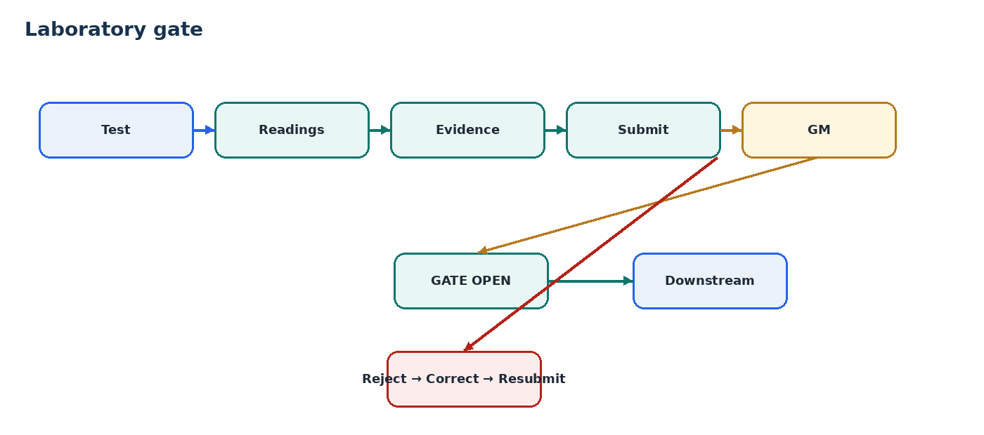
***General Manager will have some remarks about the lab readings , like looking at the lab readings he will change some parameters such as how much water and all these things. The remarks that were put in by the general manager must go to the admin and as well as the lab technician so that he/she can intimate the remarks to the supervisor.***

Process area | Current tests | Evidence | Control
Raw material | Moisture, pH, dry weight | Photo | Advisory
Bagasse / Hopper 1 / Hopper 2 | Moisture, pH, EC | Photo | Checkpoint
Before first bunker loading | Moisture, pH, EC | Photo | HARD GATE
Paddy weighment | Moisture, dry weight | Photo | Parallel
Paddy soak water 1/2/3 | pH, EC, TDS | Photo | Parallel
Chicken manure arrival | Nitrogen, Ash | Photo | Parallel
Chicken manure before mixing | Nitrogen, Ash | Photo | HARD GATE
Moisture decision | Moisture + branch | Photo | DECISION
Pre-Turner | Moisture, pH | Photo | Checkpoint
Before T1 | Moisture × P1–P6 | Photo as configured | Turner lab
After T1 | Moisture × P1–P6 | Photo as configured | Turner lab
After T0 | NO LAB TEST | — | Not in current process
After T2 | NO LAB TEST | — | Not in current process
After T3 | NO LAB TEST | — | Not in current process
Bunker loading | Height, pH, EC, moisture, N, Ash, C:N + observations | Photo | HARD GATE
Bunker reload | Shrunken height, moisture + pH/EC/moisture/N/Ash/C:N | Photo | Conditional
Before tunnel loading | Tunnel height | Photo | Checkpoint
Tunnel loading | pH, EC, moisture, N, Ash, C:N + observations | Photo | HARD GATE
Tunnel unload / final QC | pH, EC, moisture, N, Ash, C:N, shrunken height, actinomycetes + observations | Photo | Final QC
LAB + PRODUCTION
A technician can work on another batch while an approval is pending. Where the standard defines the lab result/approval as a predecessor, the Supervisor/Operator cannot start the downstream activity until the gate passes.

7. Evidence and photo requirements
Evidence is intended to let management later see what happened, not just a count of uploads.
Activity class | Photos | Meaning | Final status
Normal operator-executed task | 2 where configured | 1 BEFORE/START + 1 AFTER/FINISH | Working standard
Laboratory checkpoint | Photo evidence required; exact count not consistently defined | Evidence of sample/test | PROCESS OWNER TO CONFIRM COUNT
Bunker / tunnel handling | Photo evidence where configured | Physical condition / handoff | PROCESS OWNER TO CONFIRM COUNT
Evidence correction | Original retained; replacement is additional history | Preserve provenance | Confirmed principle
DO NOT INVENT PHOTO COUNTS
The normal operator pattern is two photos. The source material does not provide a reliable per-checkpoint photo count for every laboratory/handling activity, so those counts are explicitly left as approval questions rather than guessed.

8. Baseline, actual, variance, extension
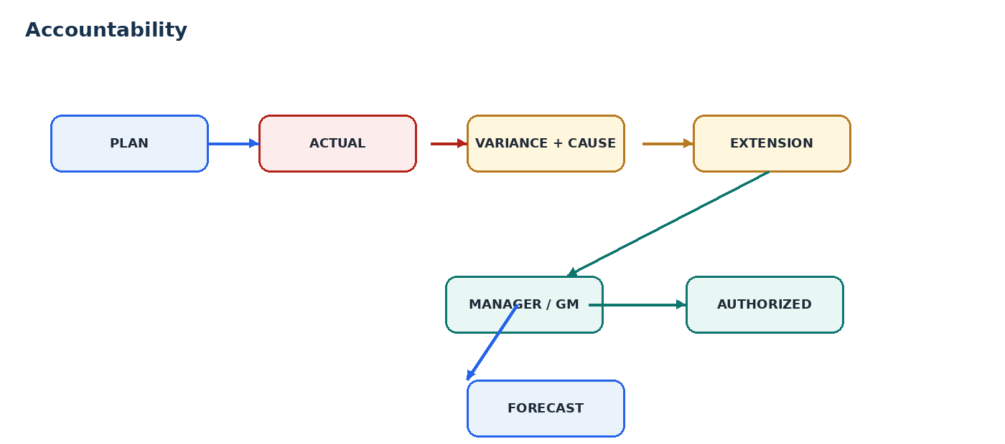
- PLAN = SOP-generated baseline after Admin selects H0.
- ACTUAL = what happened, recorded by execution actions.
- VARIANCE = difference from the baseline, with cause where known.
- EXTENSION = authorized additional time; it does not modify the baseline.
- FORECAST = current expected result after actual progress and authorized exceptions.
Layer | Example | Changes baseline? | Management sees
Plan | 15:00→22:00 | NO | What should happen
Actual | 17:00→00:00 | NO | What happened
Variance | +2h | NO | Why / how much
Extension | +2h approved | NO | Who authorized
Forecast | H472 | NO | Where it now lands

9. Roles
Role | Does | Does not
Admin | Select H0; create/activate batch; permitted configuration | Rewrite active baseline
Operator | Open eligible task; Start; photos; Finish; photos | Enter/edit official timestamps
Laboratory | Test; readings; evidence; submit | Approve own result / bypass gate
Supervisor | Execute downstream activity when eligible | Start locked activity
Manager / GM | Review approvals and extensions | Rewrite history
System | Generate plan; enforce gates; record actuals | Invent factory rules

10. Security and process integrity
ACCOUNTABILITY RULE
The system must protect the facts that affect accountability: plan, actual timestamps, lab result, evidence, approval, deviation, extension, movement and machine usage.

- Published process versions cannot be silently edited.
- Activated baselines cannot be rewritten.
- Normal operator execution does not accept an editable timestamp.
- Lab gates are enforced server-side.
- Submitted evidence and lab results remain traceable.
- Extensions are separate from the plan.
- Movement and machine-use history remain traceable.
- The database is the enforcement point; UI hiding is not security.

11. What software must capture
- Batch identity + process version.
- H0 + generated planned timestamps.
- Activity status and dependency state.
- Actual start/end + actor + capture mode where offline.
- Start/before and finish/after evidence where required.
- Lab checkpoint + parameter + value + unit + actor + approval.
- Pile + Turner stage + actual machine.
- Physical movement source/destination.
- Variance/deviation cause.
- Extension request + approval + authorization.
- Final QC + evidence.
ONE UI RULE
Screens render backend answers. They do not calculate process sequence, gates, duration, variance, forecast, evidence requirements or official timestamps.

12. Approval and freeze
Signing below confirms that the process owner and responsible managers agree that PROCESS-2026C v1 is the process baseline for MushroomOS. Items explicitly listed as unresolved remain unresolved and are not to be invented in software.
Role | Name | Signature / Date
Process Owner
General Manager
Production Manager
Laboratory

13. Source basis
- Compost SOP.xlsx— current SOP.
- TURNERPRCOESS.xlsx — Turner execution schedule / M1 / M2 / six-pile simulation.
- lab_technician_batch_process.md — laboratory workflow, updated with the current stakeholder Turner-testing rule.
- PROCESS-2026C / 470-Hour Standard Process — consolidated process draft.
- Stakeholder clarifications recorded during process-owner review.

***Tunnel cleaning this is also a parallel activity stream where no tunnels can be filled if they aren’t cleaned this is an input entered by the admin.
Bunker Cleaningthis is a parallel activity which needs to happen , this is will be monitered or the photos will be uploaded by the supervisor These options can be selected at the start they are optional and also they can be selected or changed in middle of the process and the photos needs to be uploaded by the supervisor ***
***Machinery Cleaning just photos , uploaded by the supervisor admin will select the machinery which will be used at which process at the beginning all these things ***
WHAT I WANT :
1.For my understanding make UML diagrams Make architecture diagrams and make some Html screens for admin ,Lab and Supervisor . Anything to make this whole process more visual and easy to understand for building things.
2.Also look for a way where we need to have an option of editing the sop in a way that doesn’t effect exisiting tables and makes it easier when the sop is changed
3.Find ways where we track things easily like at turner 1 , 2 and 3 is where I am thinking the supervisors will try to find a workaround and skip work or cheat the entire system . Find the ways where the entire system can be cheated and loopholes that can be exploited.

