MUSHROOMOS
MUSHROOMOS • CURRENT FACTORY PROCESS IMPLEMENTATION BASELINE
Current standard process + NEW HOPPER PASS update
Final Process + Product Requirements Draft
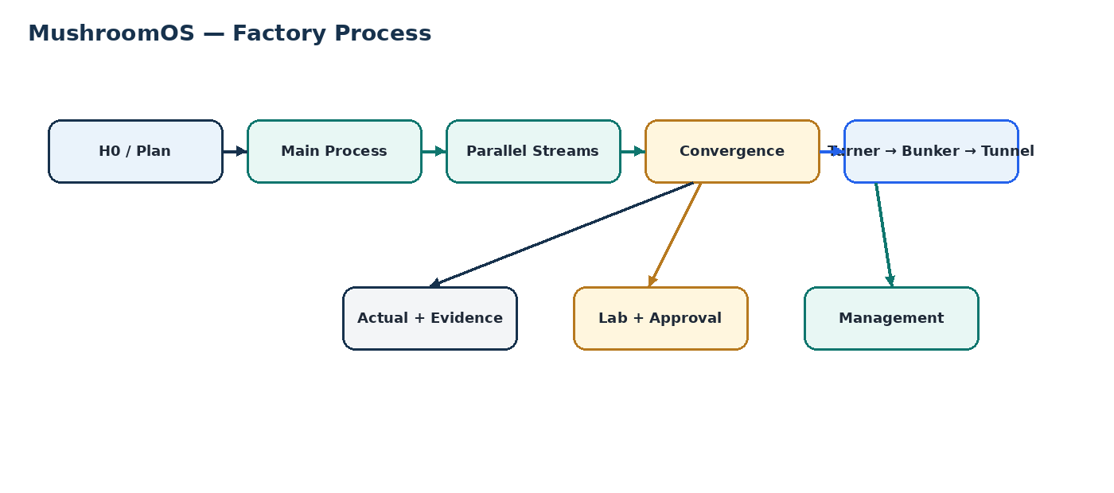
Status | DRAFT — for process-owner, GM, Production Manager and Laboratory sign-off
Standard | Legacy 470-hour worked example; current downstream timing must be recalculated after the NEW HOPPER PASS update.
Worked example | Monday, 31 August 2026, 09:00 IST
Turner anchor | H174 — Monday, 07 September 2026, 15:00
Purpose | Provide the current factory-process reference for task allocation and software implementation; process changes create a new version.
SIGN-OFF
Once approved, PROCESS-2026C v1 is frozen. Future changes create a new version and never rewrite an active batch baseline.

IMPLEMENTATION NOTE — READ THIS FIRST
This document is the current factory-process reference for implementation. The MushroomOS product core is fixed; the factory SOP is versioned process data. When the factory process changes, update the process version and its affected task/Lab/dependency/timing data rather than rewriting the product architecture.
LATEST CONFIRMED CHANGE: a NEW HOPPER PASS has been added after the existing Water Hopper Pass. The new pass must be represented as a separate executable process activity. The sequence after the Water Hopper Pass is therefore: Water Hopper Pass → NEW HOPPER PASS → 10-hour rest → downstream convergence. Exact H-hour placement for the new pass is not supplied in this source and must NOT be invented; downstream planned timings must be recalculated only after the updated SOP provides/approves the timing.
IMPORTANT: this change is a PROCESS change, not a product-core change. The same task, Lab, evidence, monitoring and onboarding mechanisms must consume the new process definition.

1. Purpose and scope
This document is the single process baseline for the current MushroomOS build. It describes the physical factory process, parallel work, timing, laboratory controls, evidence requirements, Turner flow, bunker/tunnel flow, accountability and the decisions that must be confirmed before release.
- Define the 470-hour standard from H0 to the first grow-room loading.
- Make paddy, nitrogen/manure and laboratory work visible as parallel streams.
- Define six Turner working piles and the M1/M2 execution model.
- Define laboratory testing, evidence and hard approval gates.
- Define plan vs actual vs variance vs extension without rewriting history.
- Provide a single process reference for the software implementation.
1.0 Product/process boundary
Fixed product core: authentication, role permissions, batch lifecycle, process execution, parallel streams, tasks, evidence, camera, readings/checklists, Lab, GM approval, monitoring, extensions/tickets and audit history. Changeable process data: stages, activities, streams, sequence, durations, dependencies, holds, Lab checkpoints, readings, evidence rules and approvals.
The application must remain usable by a layperson. The UI renders process answers in simple factory language; it must not expose database or process-engine terminology.

1.1 The process mental model

2. Freeze rules
Area | Current rule | Status
Master clock | Continuous from the applicable batch tracking start; legacy H0→H470 example is not authoritative after the new hopper-pass change. | RECALCULATE
H0 | NEW batch: Admin records actual H0. EXISTING running batch: original physical H0 is not required merely to begin live tracking; Admin selects current node(s) per stream. | CONFIRMED
Pre-H0 weighment | Advisory; never gates H0 | ADVISORY
Parallel streams | Paddy + nitrogen/manure + laboratory | CONFIRMED
Turner | ~6 piles; M1 + M2; T0→T1→T2→T3 | CONFIRMED
Turner laboratory | BEFORE T1 + AFTER T1 only; NO T0/T2/T3 test | CURRENT STAKEHOLDER RULE
Bunker grouping | P1+P2→B1; P3+P4→B2; P5+P6→B3 | CONFIRMED
Post-Turner bunker model | Two cycles, not the older three-cycle model | CONFIRMED
Bunker fills | 2h each; two hours apart | CONFIRMED
Tunnel process | 144h working standard within 135–155h range | FACTORY RANGE
Extensions | Separate authorization; baseline unchanged | CONFIRMED
Versioning | Future changes create a new process version | CONFIRMED
SOURCE DISCIPLINE
FACTORY CONFIRMED, FACTORY RANGE, PARALLEL, CONFIGURABLE, ADVISORY and UNRESOLVED remain distinct. Do not turn a simulation into a factory rule or invent unresolved values.

3. Worked timeline — legacy example + current process change
The rows below preserve the legacy PROCESS-2026C worked example up to the latest confirmed change. From the NEW HOPPER PASS onward, downstream H-hours are provisional and must be recalculated from the updated SOP.
Time | H-hour | Process | Lab / control
31 Aug 09:00 | H0 | Bagasse wetting + Hopper Pass 1 | Moisture, pH, EC, AFTER H1
31 Aug 12:00 | H3 | Material rest begins | —
31 Aug 20:00 | H11 | Hopper Pass 2; dry or water branch | Moisture, pH, EC,AFTER H2
31 Aug 23:00 | H14 | Heap formation + rest | —
01 Sep 11:00 | H26 | Before first bunker load / 2h bunker fill | LAB-04: moisture, pH, EC + evidence + GM gate
01 Sep 13:00 | H28 | Conditioning begins | 45–55°C; first trigger ≥58°C or ≥60h
03 Sep 11:00 | H74 | Paddy preparation starts | Moisture + dry weight
03 Sep 23:00 | H86 | Paddy soak 1 | pH, EC, TDS
04 Sep 01:00 | H88 | Bunker unload / reload | Moisture, pH, EC
04 Sep 21:00 | H108 | Paddy soak 2 | pH, EC, TDS
05 Sep 19:00 | H130 | Chicken manure + minerals weighment | Nitrogen, Ash
05 Sep 21:00 | H132 | Rotavator dry mix | No water
05 Sep 22:00 | H133 | Moisture decision | ≥68% proceed; <67% correct/retest; 67–68% unresolved
06 Sep 01:00 | H136 | First convergence; CM mix begins | LAB-13 gate; nitrogen + ash
06 Sep 09:00 | H144 | Water hopper pass | Target ~73% moisture; <45–50°C
07 Sep 05:00 | H164 | Add conditioned bagasse + CM mix | —
07 Sep 07:00 | H166 | Flip 1 + Flip 2 | Back-to-back
After H144* | TBD | NEW HOPPER PASS (post-water hopper pass) | New confirmed process activity. Exact timing, Lab checkpoint, reading and evidence rules must come from updated SOP; do not invent.
TBD | 10h | Rest after NEW HOPPER PASS | 10-hour rest after the new pass. Start/end H-hours and all downstream timing must be recalculated from the confirmed new-pass timing.
29 Aug ~23:00 | PRE-H0 | Raw material / bagasse weighment | Moisture, pH, ,EC,dry weight; advisory
Recalculate* | Recalculate* | Second convergence | Recalculate after the new hopper-pass timing and 10-hour rest are confirmed.
07 Sep 15:00 | H174 | TURNER START | Six working piles; M1 + M2
07 Sep 15:00–21:00 | H174–H180 | T0 | NO LAB AFTER T0
07 Sep ~18:00 onward | H177+ | T1 interleaved with T0 | LAB BEFORE / AFTER T1 only
08 Sep 00:00 | H183 | T1 window complete | Post-T1 moisture per pile
08 Sep onward | H186.5+ | T2 after each pile's 8h rest | NO LAB AFTER T2
08 Sep onward | H192.5+ | T3 | NO LAB AFTER T3
08 Sep 11:00 | H194 | Bunker 1 fill | P1+P2
08 Sep 13:00 | H196 | Bunker 2 fill | P3+P4
08 Sep 15:00 | H198 | Bunker 3 fill | P5+P6
11 Sep 04:00 | H259 | Bunker 1 reload | Height / moisture / full set
11 Sep 06:00 | H261 | Bunker 2 reload | Same pattern
11 Sep 08:00 | H263 | Bunker 3 reload | Same pattern
13 Sep 21:00 | H324 | Tunnel loading stream 1 | Tunnel height + full lab gate
13 Sep 23:00 | H326 | Tunnel loading stream 2 | —
14 Sep 03:00 | H330 | Tunnel loading stream 3 | —
14 Sep 05:00 | H332 | Tunnel filling complete | Tunnel process begins
14–19 Sep | H332–H470 | Tunnel process | 144h working standard
19 Sep 23:00 | H470 | First grow-room stream | Final QC
20 Sep 01:00 | H472 | Second stream discharge | Final QC as configured
20 Sep 03:00 | H474 | Final stream discharge | Full batch discharge
TIME CASCADE NOTE: The current document’s legacy H148/H160/H164/H166 values are no longer authoritative after the new hopper-pass change. Recalculate affected downstream timing in the next process version.

4. Parallel processes
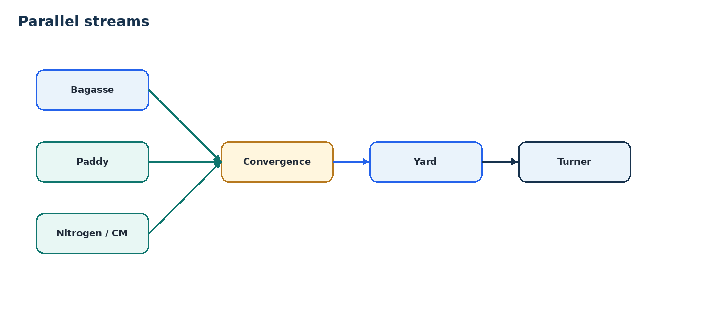
- Paddy is a parallel stream: it starts around H74, takes the current 86h operational sub-step total, and must be ready for the H160 convergence.
- Nitrogen/manure preparation is a parallel stream: it opens around H130, is ready at H136, and its second laboratory result is a gate for mixing.
- Laboratory work is operationally parallel across batches, but a result/approval can be a hard predecessor for downstream physical activity.
- Parallel does not mean optional or irrelevant; a late parallel stream can delay a convergence.

4.1 Paddy stream
Activity | Example | Lab | Role
Bale weigh/cut/thread removal | H74→H86 · 12h | Moisture + dry weight | Parallel
Soaking 1 | H86→H108 · 22h | pH + EC + TDS | Parallel
Soaking 2 | H108→H136 · 28h | pH + EC + TDS | Parallel
Soaking 3 | H136→H160 · 24h | pH + EC + TDS | Must be ready at H160
PADDY TOTAL
The SOP states 74h in its headline, while the four actual sub-steps total 86h. PROCESS-2026C uses 86h because those are the operations actually performed. This stream is parallel, not added to the main rail.

5. Turner process
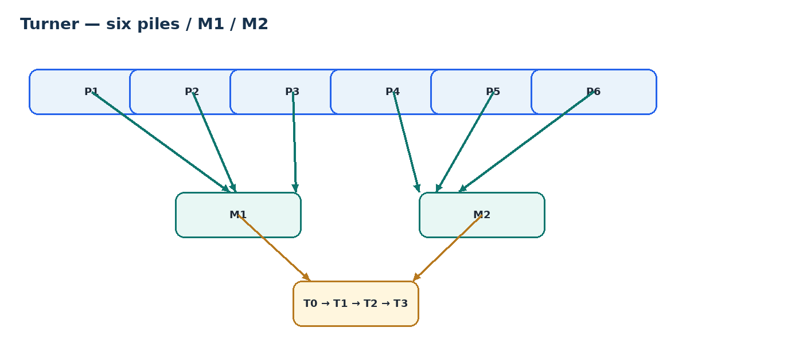
- At H174 the material is laid out as approximately six physical working piles: P1–P6.
- Two Turner machines are available: M1 and M2.
- Piles progress independently. A pile may change machine during execution.
- The Turner workbook is a machine/pile execution simulation; it is not a hardcoded UI sequence.
- The system records actual pile, machine, operator, start/end and evidence.

5.1 Turner stages
Stage | Physical operation | Timing | Lab
T0 | Dry Turner pass | ~7–8h / pile execution | NO LAB TEST
T1 | Water Turner pass | Current Turner schedule | LAB BEFORE T1 + LAB AFTER T1
T2 | Next Turner pass | 8h rest from that pile's T1 end | NO LAB TEST
T3 | Final Turner pass | Current Turner schedule | NO LAB TEST
CURRENT TURNER LAB RULE
BEFORE T1 → moisture test per pile. AFTER T1 → moisture test per pile. NO laboratory test after T0, T2 or T3.

6. Laboratory process
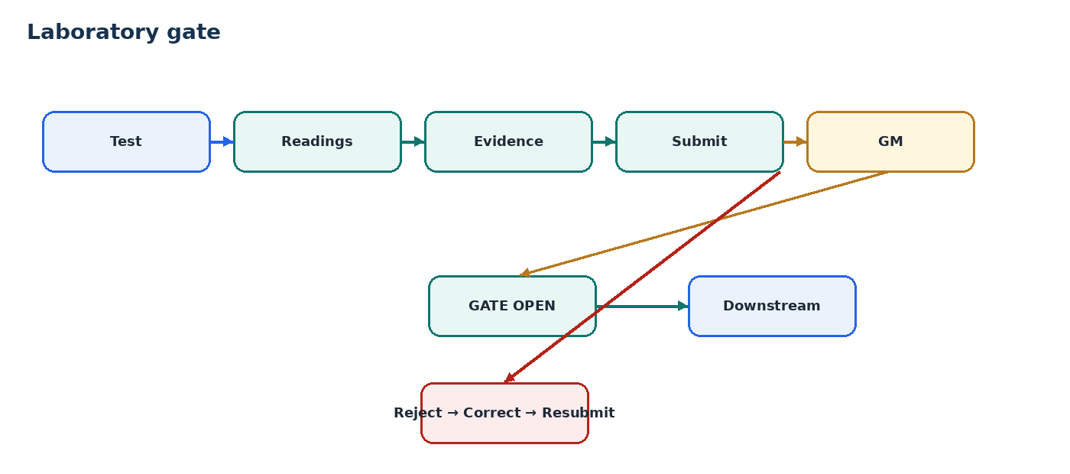
Process area | Current tests | Evidence | Control
Raw material | Moisture, pH, dry weight | Photo | Advisory
Bagasse / Hopper 1 / Hopper 2 / NEW Hopper Pass | Moisture, pH, EC where explicitly defined by the current Lab source; new-pass requirements must be confirmed from updated SOP | Photo where configured | Do not invent a new Lab gate; add only when the updated Lab source defines one.
Before first bunker loading | Moisture, pH, EC | Photo | HARD GATE
Paddy weighment | Moisture, dry weight | Photo | Parallel
Paddy soak water 1/2/3 | pH, EC, TDS | Photo | Parallel
Chicken manure arrival | Nitrogen, Ash | Photo | Parallel
Chicken manure before mixing | Nitrogen, Ash | Photo | HARD GATE
Moisture decision | Moisture + branch | Photo | DECISION
Pre-Turner | Moisture, pH | Photo | Checkpoint
Before T1 | Moisture × P1–P6 | Photo as configured | Turner lab
After T1 | Moisture × P1–P6 | Photo as configured | Turner lab
After T0 | NO LAB TEST | — | Not in current process
After T2 | NO LAB TEST | — | Not in current process
After T3 | NO LAB TEST | — | Not in current process
Bunker loading | Height, pH, EC, moisture, N, Ash, C:N + observations | Photo | HARD GATE
Bunker reload | Shrunken height, moisture + pH/EC/moisture/N/Ash/C:N | Photo | Conditional
Before tunnel loading | Tunnel height | Photo | Checkpoint
Tunnel loading | pH, EC, moisture, N, Ash, C:N + observations | Photo | HARD GATE
Tunnel unload / final QC | pH, EC, moisture, N, Ash, C:N, shrunken height, actinomycetes + observations | Photo | Final QC
LAB + PRODUCTION
A technician can work on another batch while an approval is pending. Where the standard defines the lab result/approval as a predecessor, the Supervisor/Operator cannot start the downstream activity until the gate passes.

7. Evidence and photo requirements
Evidence is intended to let management later see what happened, not just a count of uploads.
Activity class | Photos | Meaning | Final status
Normal operator-executed task | 2 where configured | 1 BEFORE/START + 1 AFTER/FINISH | Working standard
Laboratory checkpoint | Photo evidence required; exact count not consistently defined | Evidence of sample/test | PROCESS OWNER TO CONFIRM COUNT
Bunker / tunnel handling | Photo evidence where configured | Physical condition / handoff | PROCESS OWNER TO CONFIRM COUNT
Evidence correction | Original retained; replacement is additional history | Preserve provenance | Confirmed principle
DO NOT INVENT PHOTO COUNTS
The normal operator pattern is two photos. The source material does not provide a reliable per-checkpoint photo count for every laboratory/handling activity, so those counts are explicitly left as approval questions rather than guessed.

8. Baseline, actual, variance, extension
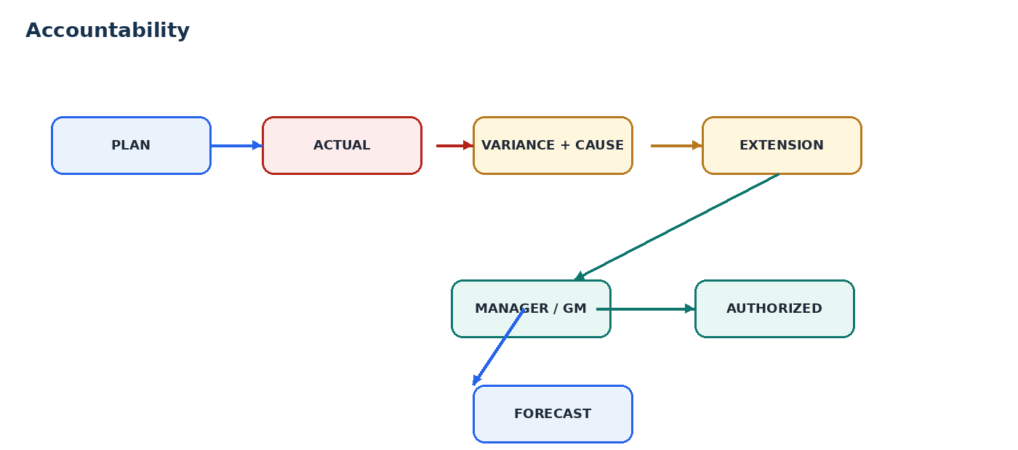
- PLAN = SOP-generated baseline after Admin selects H0.
- ACTUAL = what happened, recorded by execution actions.
- VARIANCE = difference from the baseline, with cause where known.
- EXTENSION = authorized additional time; it does not modify the baseline.
- FORECAST = current expected result after actual progress and authorized exceptions.
Layer | Example | Changes baseline? | Management sees
Plan | 15:00→22:00 | NO | What should happen
Actual | 17:00→00:00 | NO | What happened
Variance | +2h | NO | Why / how much
Extension | +2h approved | NO | Who authorized
Forecast | H472 | NO | Where it now lands

9. Roles
Role | Does | Does not
Admin | Select H0; create/activate batch; permitted configuration | Rewrite active baseline
Supervisor | Open eligible production task; Start; required photos; readings/checklist; Finish; confirm passive holds | Onboard batches; edit official timestamps; start locked work; perform Lab approvals
Laboratory | Test; readings; evidence; submit | Approve own result / bypass gate
Manager / GM | Review approvals and extensions | Rewrite history
System | Generate plan; enforce gates; record actuals | Invent factory rules

10. Security and process integrity
ACCOUNTABILITY RULE
The system must protect the facts that affect accountability: plan, actual timestamps, lab result, evidence, approval, deviation, extension, movement and machine usage.

- Published process versions cannot be silently edited.
- Activated baselines cannot be rewritten.
- Normal operator execution does not accept an editable timestamp.
- Lab gates are enforced server-side.
- Submitted evidence and lab results remain traceable.
- Extensions are separate from the plan.
- Movement and machine-use history remain traceable.
- The database is the enforcement point; UI hiding is not security.

11. What software must capture
- Batch identity + process version.
- H0 + generated planned timestamps.
- Activity status and dependency state.
- Actual start/end + actor + capture mode where offline.
- Start/before and finish/after evidence where required.
- Lab checkpoint + parameter + value + unit + actor + approval.
- Pile + Turner stage + actual machine.
- Physical movement source/destination.
- Variance/deviation cause.
- Extension request + approval + authorization.
- Final QC + evidence.
ONE UI RULE
Screens render backend answers. They do not calculate process sequence, gates, duration, variance, forecast, evidence requirements or official timestamps.

11.1 Batch setup and onboarding rules
NEW BATCH — Admin creates the batch, enters the required pre-H0/initial material information, enters actual H0, and activates the batch. Pre-H0 material values are starting information; they are not a normal post-H0 Lab approval workflow.
EXISTING RUNNING BATCH — Admin onboards the physical batch. Admin selects the process version and the current position for each relevant stream (for example: main/CM, paddy, Turner/pile, bunker and tunnel). The original physical start time is not required merely to start MushroomOS tracking. Earlier work is recorded as BEFORE TRACKING context with no fabricated historical timestamps, performers, photos or readings. The selected current positions become the live tracking entry points; Supervisor then performs the next real work.
ADMIN ROLE — Admin is responsible for user/account creation, SOP/process configuration, new-batch creation, running-batch onboarding and monitoring. Supervisor is the field-production role. Lab is the post-H0 laboratory role. GM is the Lab-approval and progress-oversight role.
11.2 SOP-to-task conversion rules
For every process activity, derive: stage, stream, activity, instruction, human work vs passive hold, dependency, duration when explicitly defined, readings, checklist, evidence, Lab dependency, skip policy and unresolved/conflict status. The runtime task list must come from this structured process data.
When an SOP change adds an activity, review the cascade: task count/instances, sequence, dependencies, rest, parallel streams, convergence, Lab checkpoints, readings, evidence, onboarding positions, monitoring and downstream planned timing. Do not make a local one-row edit and assume the rest of the process is unchanged.
11.3 Current change — new hopper pass
Confirmed current change: add a distinct new hopper-pass activity immediately after the Water Hopper Pass. The existing Water Hopper Pass targets approximately 73% moisture and <45–50°C. The new pass is followed by a confirmed 10-hour rest. Exact timing, task evidence, Lab checkpoint and reading requirements for the new pass must come from the updated SOP; if not explicitly defined, mark them unresolved rather than inventing values.
Downstream activities that depend on this sequence must be re-timed/revalidated against the updated process. Old worked-example H-hours after H144 are not automatically preserved.
11.4 Task allocation by role
The process definition generates executable task instances from the current SOP. Admin does not perform field tasks; Admin creates/configures the batch and process. Supervisor receives production tasks that are executable from the current batch position. Laboratory receives Lab checkpoints defined by the current process. GM receives only the approval/progress work defined for GM. Task assignment must come from process data and eligibility, not hard-coded UI rules.

12. Final approval questions
These are process-owner questions. They must be resolved from the current factory sources before a new process version is published. Engineers must not invent answers.
- Confirm the 470-hour standard envelope from H0 to the first grow-room loading.
- Confirm the worked-example H0: Monday, 31 August 2026 at 09:00 IST.
- Confirm H174, Monday, 07 September 2026 at 15:00, as the Turner anchor.
- Confirm approximately six physical Turner working piles.
- Confirm M1 and M2 as the two Turner machines.
- Confirm that piles may change Turner machine during execution.
- Confirm the Turner laboratory rule: one moisture test BEFORE T1 and one moisture test AFTER T1, per pile; none after T0, T2 or T3.
- Confirm exact T0, T1, T2 and T3 standard durations used for planning.
- Confirm the 8-hour T1→T2 rest from each pile's own T1 end.
- Confirm paddy starts at H74 and must be ready at H160.
- Confirm the 86-hour operational interpretation of paddy despite the SOP's 74-hour headline.
- Confirm nitrogen/manure starts at H130 and must be ready at H136.
- Confirm the moisture decision rule, including what to do with the 67–68% band.
- Confirm the two-cycle post-Turner bunker model, not the older three-cycle model.
- Confirm P1+P2→B1, P3+P4→B2, P5+P6→B3.
- Confirm the 2-hour bunker fill duration and two-hour spacing.
- Confirm whether reload receiving bunkers are fixed or selected operationally.
- Confirm the exact temperature/time trigger priority for bunker unload/reload.
- Confirm the laboratory approval chain and whether Manager/GM delegation is allowed.
- Confirm the extension approval chain and whether Manager + GM is mandatory.
- Confirm the exact photo count for every laboratory checkpoint.
- Confirm the exact photo count for bunker/tunnel handling activities.
- Confirm whether offline capture is required for all operator/lab activities.
- Confirm Turner changeover/repositioning time if it must be a factory rule; current source schedule uses zero/configurable.
- Confirm whether loader capacity must be represented in the model; current scope keeps it out if not specified.
- Confirm that H470 is the first stream standard end and H474 is the full three-stream discharge.

13. Approval and freeze
Signing below confirms that the process owner and responsible managers agree that PROCESS-2026C v1 is the process baseline for MushroomOS. Items explicitly listed as unresolved remain unresolved and are not to be invented in software.
Role | Name | Signature / Date
Process Owner
General Manager
Production Manager
Laboratory
CURRENT IMPLEMENTATION CHANGE NOTE
Latest factory change incorporated in this revision: new hopper pass after the Water Hopper Pass, followed by 10-hour rest. This revision is an implementation baseline for task decomposition; exact new-process timing/Lab/evidence values not explicitly supplied remain unresolved.
LATEST PROCESS CHANGE FOR THIS REVISION
NEW HOPPER PASS: insert as a distinct process activity immediately after the existing Water Hopper Pass. Follow it with a confirmed 10-hour rest. The exact new-pass H-hour and any new Lab/evidence rules are not stated in this document and therefore remain to be confirmed from the updated factory source.

14. Source basis
- imp_compost_sop_30082026(3).xlsx — current SOP.
- TURNERPRCOESS.xlsx — Turner execution schedule / M1 / M2 / six-pile simulation.
- lab_technician_batch_process.md — laboratory workflow, updated with the current stakeholder Turner-testing rule.
- PROCESS-2026C / 470-Hour Standard Process — consolidated process draft.
- Stakeholder clarifications recorded during process-owner review.
PROCESS-2026C • FINAL APPROVAL DRAFT

