1. Below bar plot Shows the distribution of students across different race/ethnicity groups.

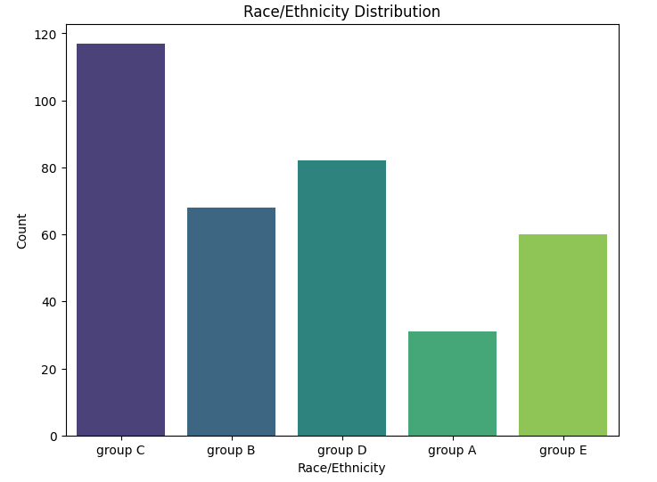

Outcome: We can conclude that group c is higher compared to other groups.

2) Let us compare the distribution of math, reading, and writing scores between male and female students.

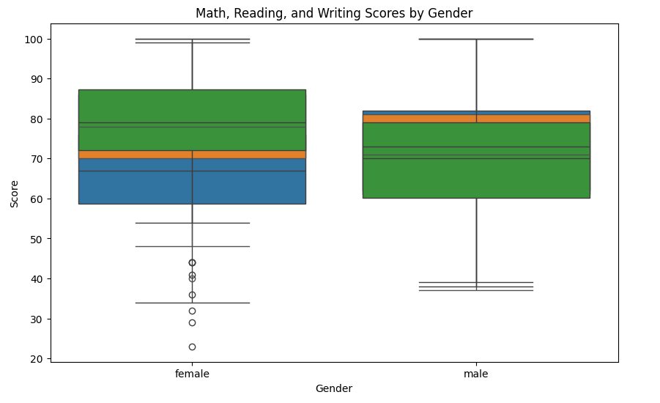

Conclusion: We can conclude that there are more outliers in female compared to male

3)Below plot compares the distribution of math scores based on lunch type and test preparation course.

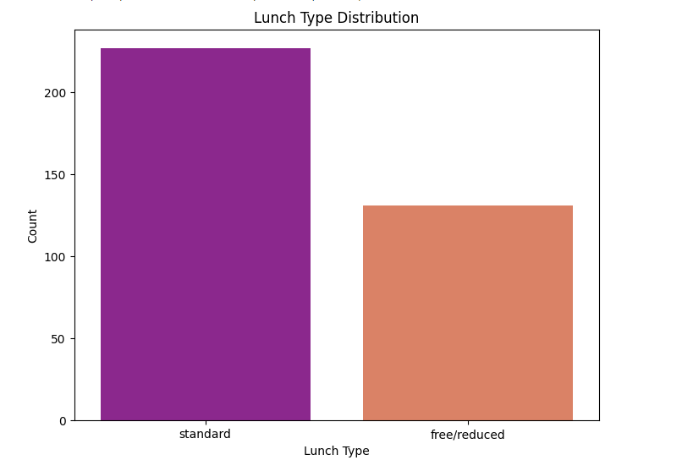

Conclusion: We can conclude that standard lunch type is preferred more among students

4)Below shows the average math, reading, and writing scores based on parental level of education.

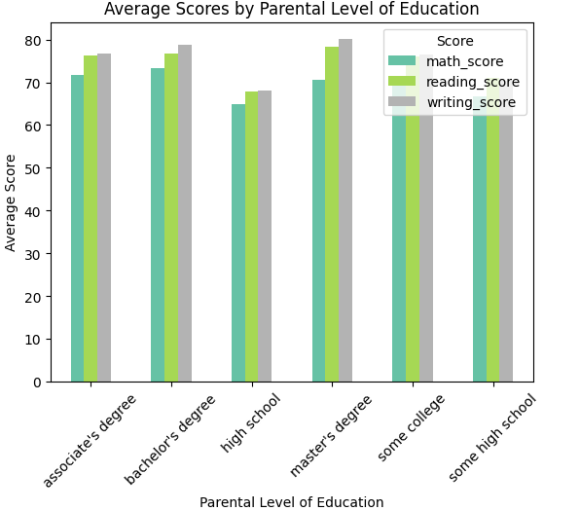

Conclusion: Scores are almost similar for all levels of parental education except high school

5) Visualize the distribution of writing scores across different race/ethnicity groups separated by gender.

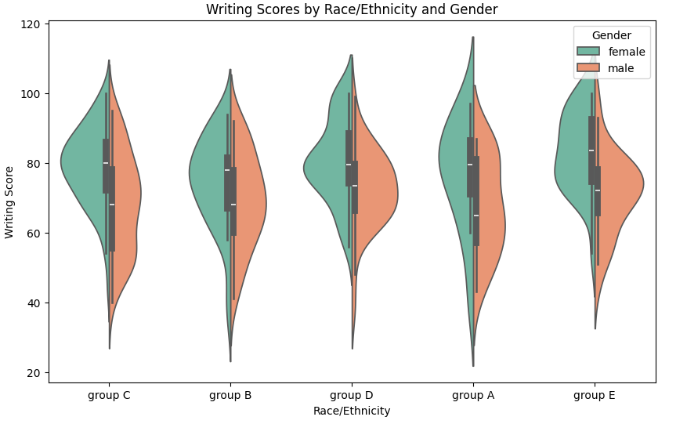

Among all the above analysis bar plot is easier to visualize and draw insights