The functional dependency is a relationship that exists between two attributes. It typically exists between the primary key and non-key attribute within a table.

1. X   →   Y

The left side of FD is known as a determinant, the right side of the production is known as a dependent.

**For example:**

Assume we have an employee table with attributes: Emp_Id, Emp_Name, Emp_Address..6MC++ vs Java

Here Emp_Id attribute can uniquely identify the Emp_Name attribute of employee table because if we know the Emp_Id, we can tell that employee name associated with it.

Functional dependency can be written as:

1. Emp_Id → Emp_Name

We can say that Emp_Name is functionally dependent on Emp_Id.

Types of Functional dependency

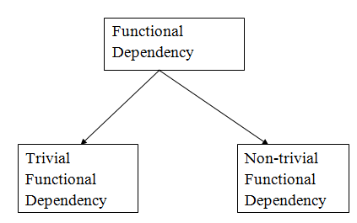

1. Trivial functional dependency

* A → B has trivial functional dependency if B is a subset of A.
* The following dependencies are also trivial like: A → A, B → B

**Example:**

1. Consider a table with two columns Employee_Id and Employee_Name.
2. {Employee_id, Employee_Name}   →    Employee_Id is a trivial functional dependency as
3. Employee_Id is a subset of {Employee_Id, Employee_Name}.
4. Also, Employee_Id → Employee_Id and Employee_Name   →    Employee_Name are trivial dependencies too.

2. Non-trivial functional dependency

* A → B has a non-trivial functional dependency if B is not a subset of A.
* When A intersection B is NULL, then A → B is called as complete non-trivial.

**Example:**

1. ID   →    Name,
2. Name   →    DOB

#### 3. Multivalued Functional Dependency

In **Multivalued functional dependency**, entities of the dependent set are **not dependent** **on each other.**  
i.e. If **a → {b, c}** and there exists **no functional dependency** between **b and c**, then it is called a **multivalued functional dependency.**

#### 4. Transitive Functional Dependency

In transitive functional dependency, dependent is indirectly dependent on determinant.  
i.e. If **a → b** & **b → c**, then according to axiom of transitivity, **a → c**. This is a **transitive functional dependency**