GRAPH

**Basics:-**

**Graph:-** It is a collection of points/vertices/nodes

All trees is a graph but all graphs are not trees because trees has certain rules:

* + - All nodes in a tree must be connected
    - There should not be any cyclic connections

**Vertex**:- Each node in a graph

**Edges:-** Line/Path joining 2 nodes/vertices

There are 2 types of graph:

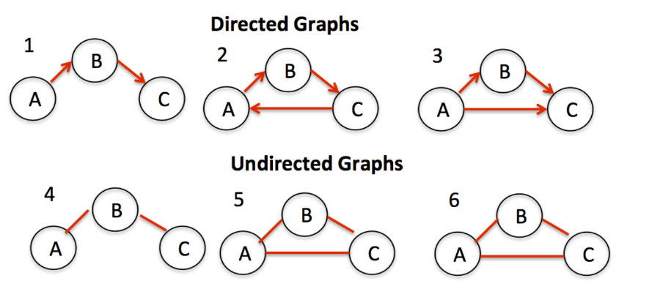

E.g.:- One way road

E.g.:- Two way road

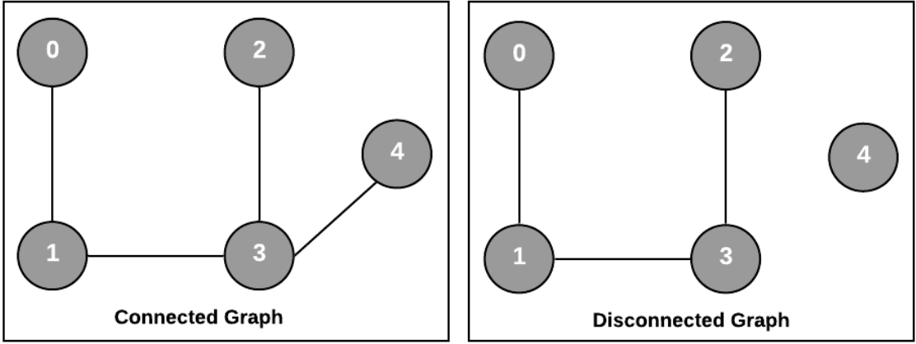

2 vertices are said to be adjacent to each other if there exists a path between them. This path may be both unidirectional or bidirectional.

Degree:- No of nodes connected to a node

Min no of edges in graph=0

Min no of edges in connected graph=n-1

Msx no of edges in connected/Disconnected graph= [n* (n-1) ]**/**2

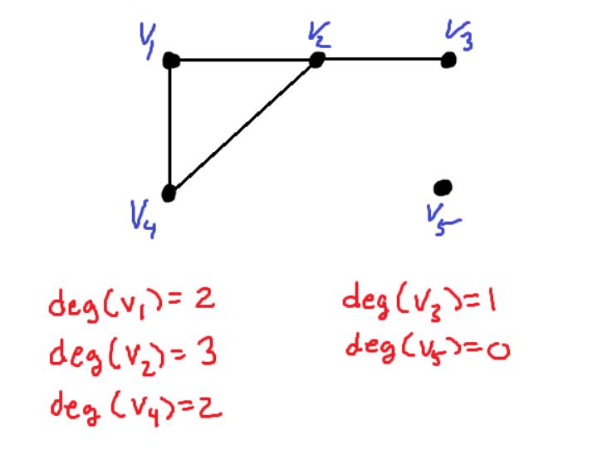

**Max degree** of graph with **N** nodes= **N-1**

**PATH:-** It is defined as the vertices including the start and the end verticesthis coming between the start and end. They can also be multiple path**.**

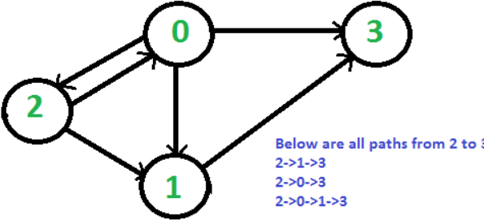

**Ways of Representing a graph:-**

1. **Adjacency Matrix**

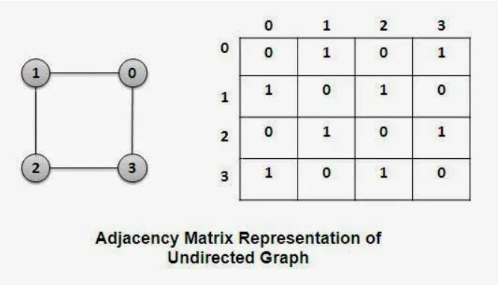**Pro:** time complexity=O(1)

**con:** Space Complexity: O(v^2)

1. **Adjacency List**

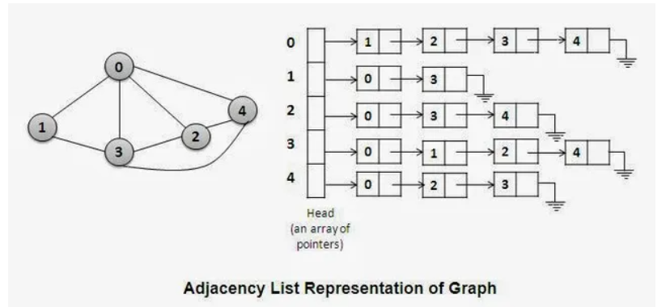

**Minimum spanning tree**

Rules for spanning:-`

While spanning one node should be visited only once

* + There should not be cycling in connection
  + The cost which is min among various spanning tree is called the minimum spanning tree. There could more than 1 min spanning path.

