CloudStore - Cloud-Based File Storage System
Project Report
Table of Contents

Project title: CloudStore - Cloud-Based File Storage System Technologies: Python (Flask), HTML5, CSS3, JavaScript, SQLite Submitted by: (Student name / Roll number) Guide: (Faculty name) Department / College: (Department, College, University) Academic year: 2026-27

Certificate
This is to certify that the project entitled “CloudStore - Cloud-Based File Storage System” is a bonafide work carried out by (student name), in partial fulfilment of the requirements for the award of the degree of (degree) during the academic year 2026-27.
Guide: ____________________ Head of Department: ____________________ External Examiner: ____________________

Acknowledgement
I express my sincere gratitude to my project guide, the Head of the Department and the faculty members for their guidance and encouragement throughout this project. I also thank my friends and family for their support.

Abstract
Storing important documents on a single personal computer is risky: disks fail, devices are lost and files cannot be reached from elsewhere. Commercial cloud-storage services solve this, but understanding how they work requires building one. This project presents CloudStore, a web-based file storage system in which users create an account, sign in and upload, list, download and delete their files from any browser.
The backend is written in Python with the Flask framework; the frontend uses HTML, CSS and JavaScript without external libraries; user data and file metadata are stored in SQLite, while the file contents are stored on the server in a separate folder for every user under randomly generated names. Passwords are stored as salted hashes, sessions are protected with HttpOnly cookies and CSRF tokens, and every database query is restricted to the signed-in user so that users can access only their own files. The system also shows the size of each file, enforces per-file and per-user limits, handles errors gracefully and adapts to phones, tablets and desktops.
The application was verified with 39 automated tests (all passing) and with an end-to-end browser run that produced the screenshots included in this report.
Keywords: cloud storage, Flask, authentication, access control, file upload, web security, responsive design.

Table of Contents
- Introduction
- Problem Statement
- Objectives
- Scope and Limitations
- Literature / Technology Survey
- System Requirements
- System Analysis and Design
- Implementation
- Security Design
- Testing
- Results and Screenshots
- Conclusion
- Future Enhancements
- References
- Appendix - Installation and Source Layout

1. Introduction
Cloud storage lets people keep files on a remote server and reach them through the internet. Services such as Google Drive, Dropbox and OneDrive are used by millions, yet their internal workings - user accounts, secure uploads, per-user isolation, quota accounting - are rarely seen by students. CloudStore is a compact but complete implementation of these ideas that can run on a laptop or on any cloud server.
The project follows the three-tier architecture (presentation, application, data) and uses only open-source tools, so it can be installed with two commands and no paid account or API key.

2. Problem Statement
Users need a simple, secure place to store files so that:
- files remain available from any device with a browser;
- each person’s files are private - no other user can see, download or delete them;
- users can see what they have stored and how much space each file uses;
- the system stays reliable when users make mistakes (wrong password, oversized file, network failure).
Existing services are closed systems. There is a need for an open, understandable implementation that demonstrates the full life cycle of authenticated file storage.

3. Objectives
- Provide user registration and login with secure password handling.
- Allow authenticated users to upload one or many files with progress feedback.
- List the user’s files with name, size and upload date.
- Allow download and deletion of files.
- Guarantee that a user can access only their own files (access control).
- Display file sizes and total storage usage against a quota.
- Handle errors gracefully with clear messages.
- Offer a responsive interface usable on mobile and desktop.
- Document, test and package the project so it runs without any special configuration.

4. Scope and Limitations
In scope: registration, login/logout, upload, listing, size display, download, delete, search/sort, quota, security hardening, automated tests, documentation.
Out of scope (future work): file sharing between users, folders, password-reset by e-mail, versioning, virus scanning, distributed object storage.
Limitations: SQLite and local disk are suited to small and medium deployments; login throttling is held in memory of the running process; the application serves files itself rather than through a CDN.

5. Literature / Technology Survey
Area | Options considered | Choice and reason
Backend language | Python, Java, Node.js, PHP | Python - readable, strong libraries, common in colleges
Web framework | Django, Flask, FastAPI | Flask - lightweight, ideal for learning request handling, blueprints and sessions
Database | MySQL, PostgreSQL, SQLite, Firebase | SQLite - zero configuration, ACID transactions, included in Python; no external service or credentials needed
File storage | Database BLOBs, local disk, S3/Firebase Storage | Local disk in per-user folders - simple, fast and easy to back up; can be swapped for object storage later
Frontend | React, Angular, plain JS | Plain HTML/CSS/JS - no build tools, works offline, easy to understand
Password hashing | MD5/SHA-1, bcrypt, scrypt, PBKDF2 | scrypt via Werkzeug - memory-hard, salted, recommended
Related concepts studied: client-server model, REST principles, HTTP sessions and cookies, OWASP Top 10 (broken access control, injection, XSS, CSRF), multipart form uploads, responsive design with CSS media queries.

6. System Requirements

6.1 Functional requirements
ID | Requirement
FR1 | A visitor can register with username, email and password
FR2 | A registered user can sign in with username or email and sign out
FR3 | A signed-in user can upload one or more files
FR4 | The system lists only the signed-in user’s files
FR5 | The system shows the size of each file and total usage
FR6 | A user can download a file they own
FR7 | A user can delete a file they own after confirmation
FR8 | A user cannot read, list or delete another user’s files
FR9 | The system rejects invalid input and shows clear error messages

6.2 Non-functional requirements
ID | Requirement
NFR1 | Security - hashed passwords, CSRF protection, secure headers, input validation
NFR2 | Usability - responsive layout, drag and drop, progress indication, notifications
NFR3 | Reliability - no orphaned files or records; errors never crash the server
NFR4 | Portability - runs on Windows, macOS and Linux with Python 3.10+
NFR5 | Maintainability - modular code (blueprints), automated tests, documentation
NFR6 | Performance - list and download operations respond within milliseconds for typical sizes

6.3 Hardware and software
- Hardware: any computer with 2 GB RAM and 1 GB free disk (plus storage for uploads).
- Software: Python 3.10+, pip, a modern browser (Chrome, Edge, Firefox, Safari).
- Python packages: Flask, python-dotenv (see requirements.txt).

7. System Analysis and Design

7.1 Architecture
CloudStore is a three-tier system (see figure below). The browser communicates with the Flask application over HTTP(S); the application reads and writes the SQLite database and the per-user folders.
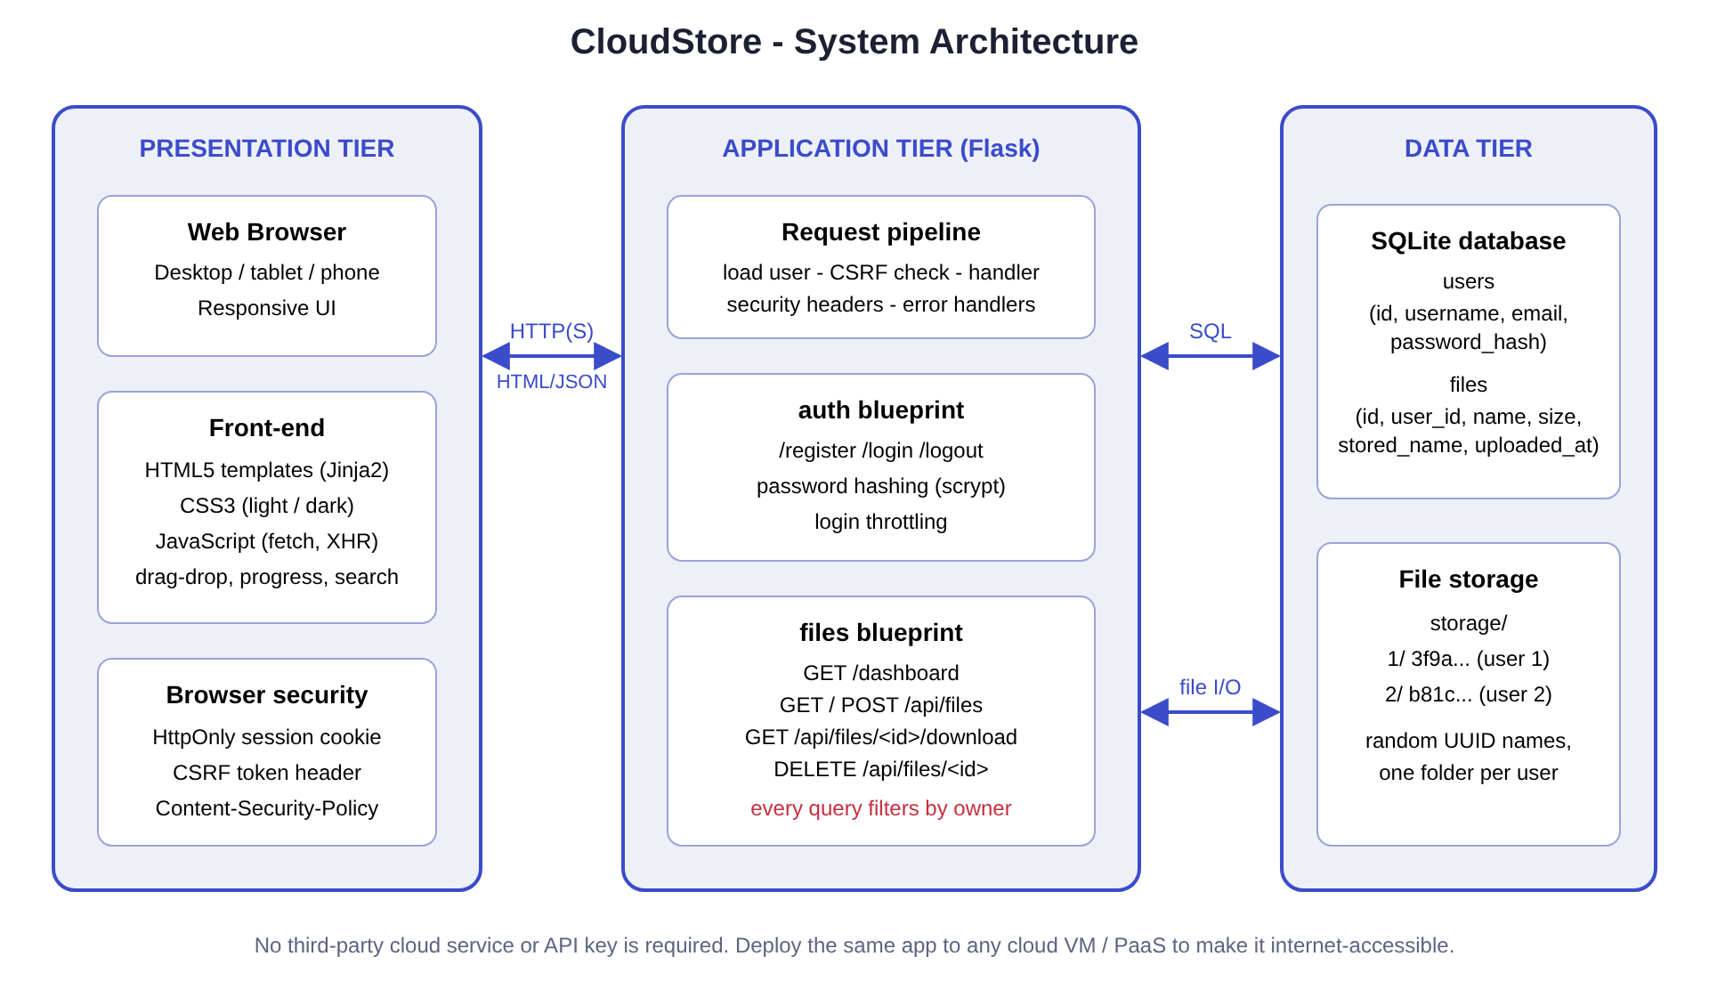
System architecture
- Presentation tier: Jinja2-rendered HTML pages, one CSS file, one JavaScript file. JavaScript performs uploads with XMLHttpRequest (for progress events), and list/delete calls with fetch.
- Application tier: Flask application factory with two blueprints - auth (register, login, logout) and files (dashboard, list, upload, download, delete) - plus a request pipeline that loads the current user, checks CSRF tokens, adds security headers and converts errors to friendly pages or JSON.
- Data tier: SQLite stores users and files; file contents are written to storage/<user_id>/<uuid>.

7.2 Data flow (summary)
Level 0: User -> (credentials, files, requests) -> CloudStore -> (pages, file lists, downloads) -> User.
Level 1 processes: (1) Authenticate user, (2) Manage files (upload / delete), (3) Retrieve files (list / download). Data stores: D1 users, D2 files metadata, D3 file storage.

7.3 Database design
Table users
Column | Type | Notes
id | INTEGER | Primary key, auto-increment
username | TEXT | Unique, case-insensitive
email | TEXT | Unique, case-insensitive
password_hash | TEXT | Salted scrypt hash
created_at | TEXT | UTC timestamp
Table files
Column | Type | Notes
id | INTEGER | Primary key
user_id | INTEGER | Foreign key -> users(id), ON DELETE CASCADE, indexed
original_name | TEXT | Sanitised display name
stored_name | TEXT | Random UUID, unique - the real file name on disk
size | INTEGER | Bytes (shown as B/KB/MB/GB)
mime_type | TEXT | Guessed from the name; used for the download header
uploaded_at | TEXT | UTC timestamp
Relationship: one user owns many files (1 : N).

7.4 Use cases
Actor | Use case
Visitor | Register, Sign in
Signed-in user | Upload file(s), View file list and sizes, Search/sort, Download, Delete, Sign out
System | Validate input, enforce quota, enforce ownership

7.5 Key sequences
Upload: the browser sends POST /api/files with the CSRF header and session cookie -> server verifies session and token -> validates extension, size and quota -> writes the file under a UUID name in the user’s folder -> inserts a metadata row -> returns JSON -> browser refreshes the list.
Download: browser requests /api/files/<id>/download -> server runs SELECT ... WHERE id = ? AND user_id = <me> -> if no row, replies 404 -> otherwise streams the file as an attachment.

7.6 API design
Method | Endpoint | Purpose
GET | /api/files | List files and usage
POST | /api/files | Upload
GET | /api/files/<id>/download | Download
DELETE | /api/files/<id> | Delete
GET/POST | /register, /login | Account forms
POST | /logout | End session
GET | /dashboard | Main page

8. Implementation

8.1 Project structure
cloud-file-storage/
run.py config.py requirements.txt .env.example README.md
app/ __init__.py db.py auth.py files.py utils.py
templates/ static/{css,js,img}
tests/test_app.py scripts/capture_screenshots.py docs/

8.2 Backend modules
- config.py reads limits and cookie flags from environment variables. If no secret key is configured, a random one is generated once and stored in instance/secret_key, so the project runs immediately yet no key is ever hard-coded.
- app/db.py opens one SQLite connection per request (sqlite3.Row), enables foreign keys and creates tables on start-up.
- app/auth.py validates registration (username pattern, e-mail pattern, password strength, confirmation), hashes passwords with generate_password_hash, authenticates with check_password_hash (comparing against a dummy hash for unknown users to keep timing similar), clears the session on login and throttles repeated failures.
- app/files.py implements the four file operations. Upload checks extension, emptiness, per-file size (on the stream, before writing), quota and writes with a UUID name; on any failure it removes partial files and rolls back, so storage and database stay consistent.
- app/utils.py provides login_required, CSRF verification, security headers, human-readable size formatting and file-name cleaning.
- app/__init__.py builds the app and registers handlers: HTTP errors and unexpected exceptions become a styled page (browsers) or {"error": ...} JSON (API); stack traces are only logged.

8.3 Frontend
- Templates: base.html (navigation, flash messages, toast area), index, register, login, dashboard, error.
- CSS: CSS variables for light and dark themes, fluid typography, a card layout and a media query at 720 px that turns the file table into stacked cards and the menu into a toggle.
- JavaScript: drag-and-drop upload with a progress bar, client-side size checks, toast notifications, live search and sorting, <dialog>-based delete confirmation, password show/hide, all values inserted with textContent (never innerHTML) to avoid XSS.

8.4 Error handling
Situation | Behaviour
Invalid registration data | Form re-displayed with a list of problems, entered values kept
Wrong credentials | Generic message (does not reveal whether the user exists)
Too many failed logins | Temporary lock with message
Not signed in | Redirect to login (pages) or 401 JSON (API)
Missing/invalid CSRF token | 400 with instruction to refresh
File too large / empty / blocked type / quota exceeded | Per-file message, other files in the same upload still succeed
Request larger than limit | 413 JSON message
Another user’s / unknown file id | 404 “File not found”
File bytes missing on disk | 404 with explanation
Network failure in browser | Toast “Network error…”
Unexpected exception | Generic 500 page, details only in the log

9. Security Design
Threat (OWASP) | Countermeasure in CloudStore
Broken access control | Ownership filter on every query; foreign ids return 404
Cryptographic failures | Salted scrypt password hashes; random secret key; HttpOnly, SameSite cookies
Injection | Parameterised SQL everywhere; Jinja2 auto-escaping
XSS | textContent rendering, CSP script-src 'self' with no inline scripts
CSRF | Token in session, required for all state-changing requests
Security misconfiguration | X-Frame-Options, X-Content-Type-Options, Referrer-Policy, Cache-Control: no-store, debug off by default
Identification failures | Password rules, login throttling, session reset on login, 2-hour expiry
Unrestricted upload | Size/quota limits, blocked executable extensions, forced download with nosniff, UUID storage names
Path traversal | User-supplied names never used as paths

10. Testing

10.1 Strategy
Automated unit/integration tests (Python unittest with Flask’s test client, using a temporary database and storage folder for every test) plus an end-to-end browser run (Playwright/Chromium) that drives the real interface and captures screenshots.

10.2 Test cases
ID | Test | Expected result | Result
T01 | Open home, login, register pages | HTTP 200 | Pass
T02 | Register with valid data | Redirect to login; user folder created | Pass
T03 | Register with bad username / short password | 400 with messages | Pass
T04 | Password without digit | Rejected | Pass
T05 | Password confirmation mismatch | Rejected | Pass
T06 | Duplicate username (any case) / email | Rejected | Pass
T07 | Password stored as hash | Hash prefix scrypt/pbkdf2, plain text absent | Pass
T08 | Login by username and by email | Redirect to dashboard | Pass
T09 | Wrong password / unknown user | Same generic error, 401 | Pass
T10 | Repeated failures | Account locked even for correct password | Pass
T11 | Logout | Dashboard no longer accessible | Pass
T12 | Logout via GET | 405 | Pass
T13 | POST without CSRF token | 400 | Pass
T14 | Dashboard / API without login | Redirect / 401 | Pass
T15 | Upload -> list -> download round trip | Same bytes, size shown, attachment header | Pass
T16 | Upload multiple files in one request | All stored | Pass
T17 | File size formatting (B, KB, MB, GB) | Correct strings | Pass
T18 | User B lists User A’s files | Empty list | Pass
T19 | User B downloads User A’s file | 404, no data | Pass
T20 | User B deletes User A’s file | 404, file intact | Pass
T21 | Owner deletes file | Record and bytes removed, usage updated | Pass
T22 | Delete / upload without CSRF token | 400 | Pass
T23 | Upload with no file | 400 “No file selected” | Pass
T24 | Blocked extension (.exe) | Rejected | Pass
T25 | Empty file | Rejected | Pass
T26 | File over per-file limit | Rejected | Pass
T27 | Quota exceeded; other user unaffected | Rejected; separate quota | Pass
T28 | Request over size limit | 413 JSON | Pass
T29 | Filename ../../etc/passwd | Stored as passwd, nothing escapes folder | Pass
T30 | Filename containing <script> | Output escaped | Pass
T31 | Stored bytes missing on disk | 404 | Pass
T32 | Unknown URL (page and API) | Styled 404 / JSON 404 | Pass
T33 | Security headers present | CSP, frame, nosniff, no-store | Pass
T34 | Unhandled exception | 500 page, no internals leaked | Pass
(The suite contains 39 test methods in total; several rows above group related checks.)

10.3 Result
All 39 automated tests pass (python -m unittest discover -s tests -v). The browser run completed registration, login (including a failed login), upload of five files, delete with confirmation, a cross-user access attempt (404) and a mobile-width view without errors.

11. Results and Screenshots
The following figures were captured from the running system.
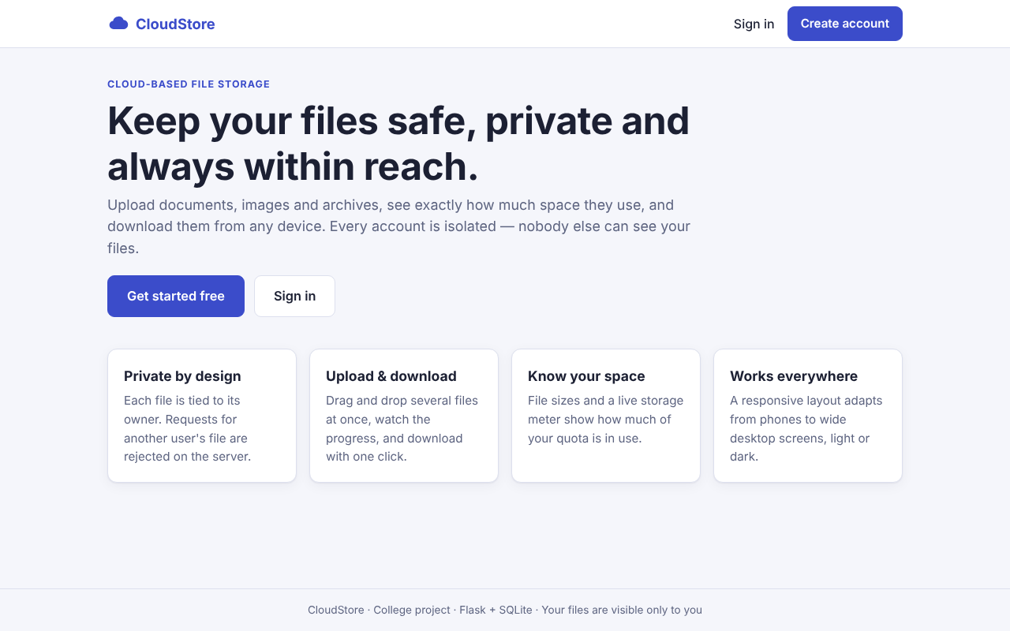
Figure 1 - Home page
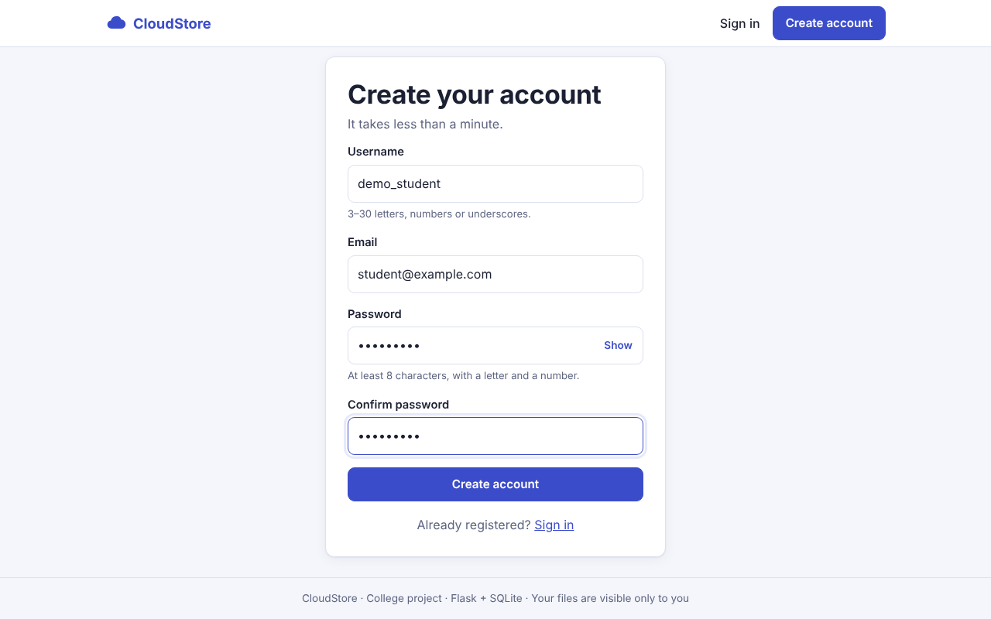
Figure 2 - Registration
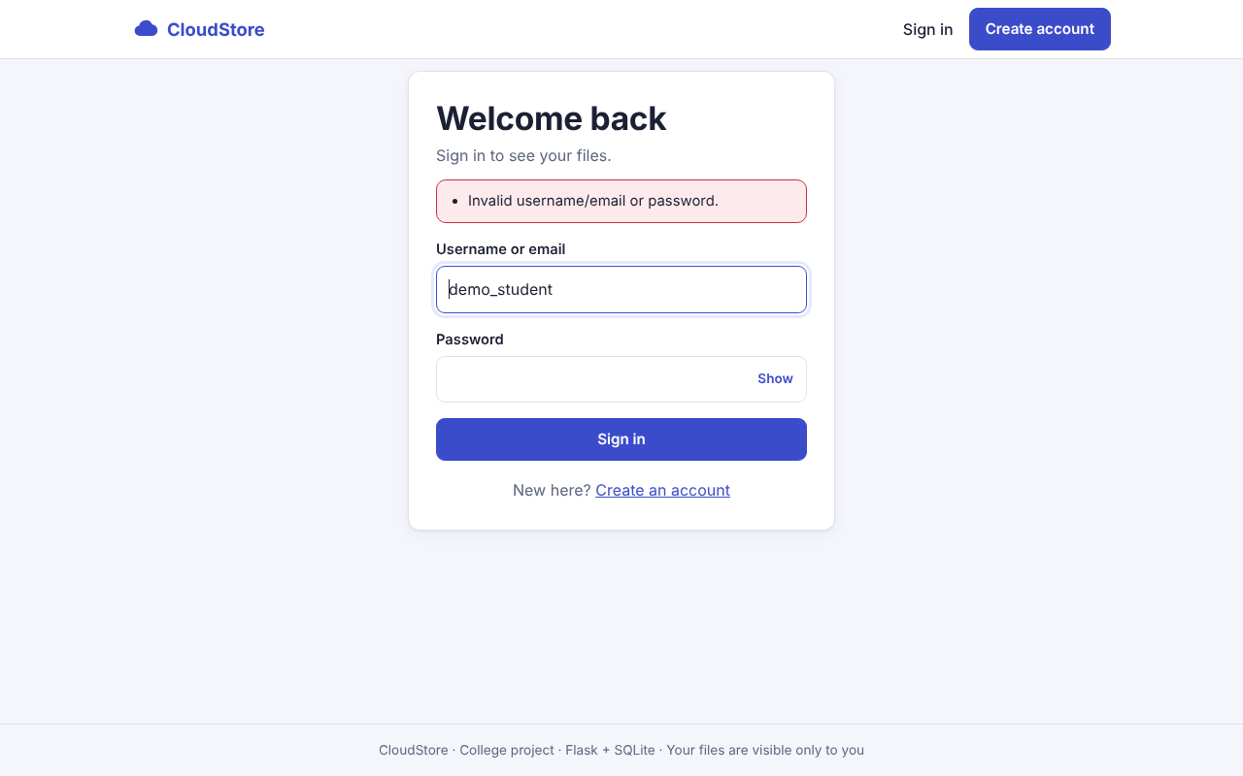
Figure 3 - Login error handling
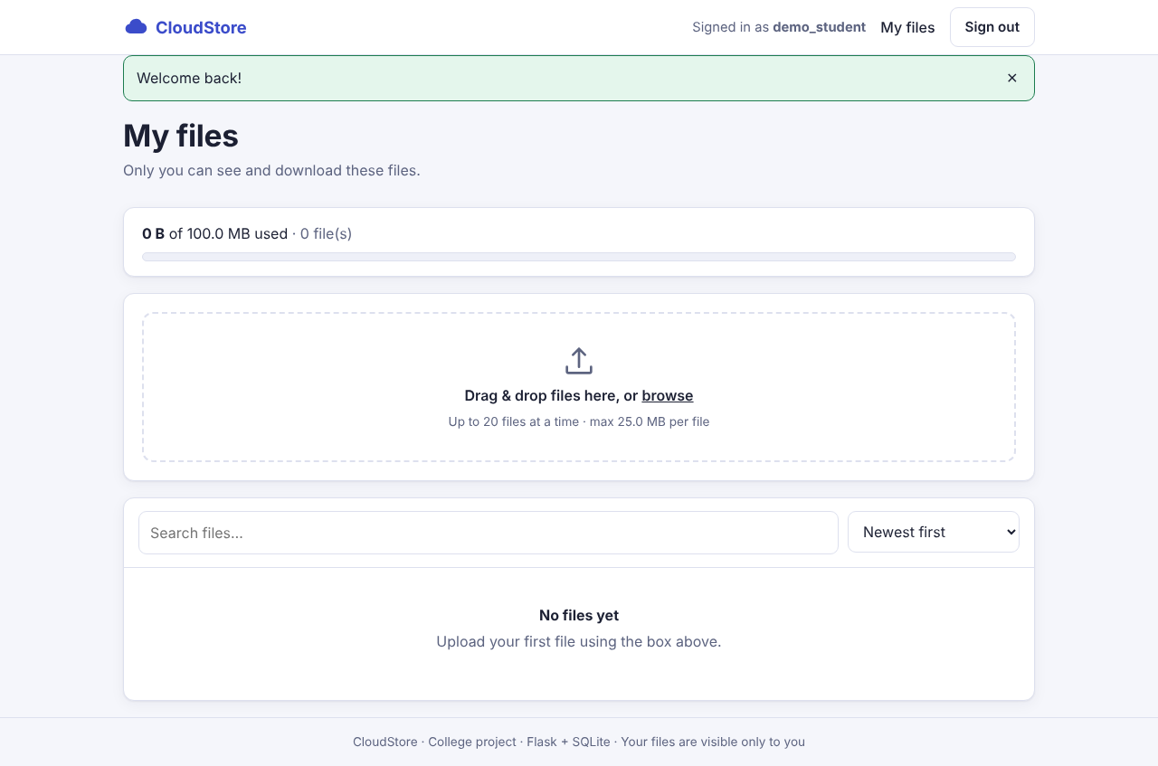
Figure 4 - Empty dashboard with storage meter
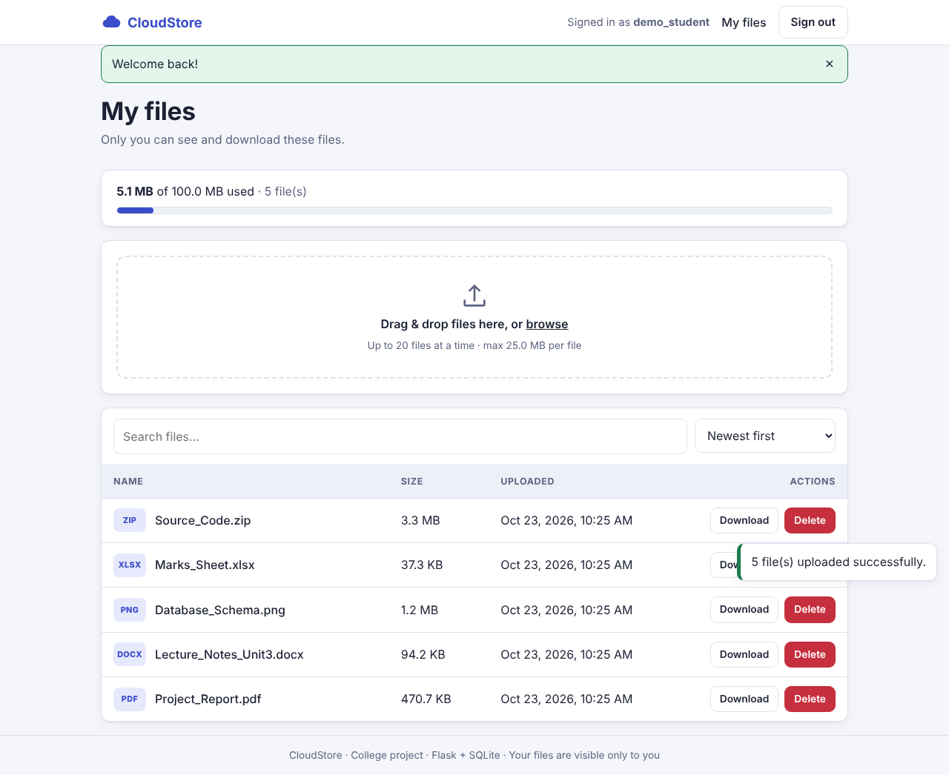
Figure 5 - Upload success notification
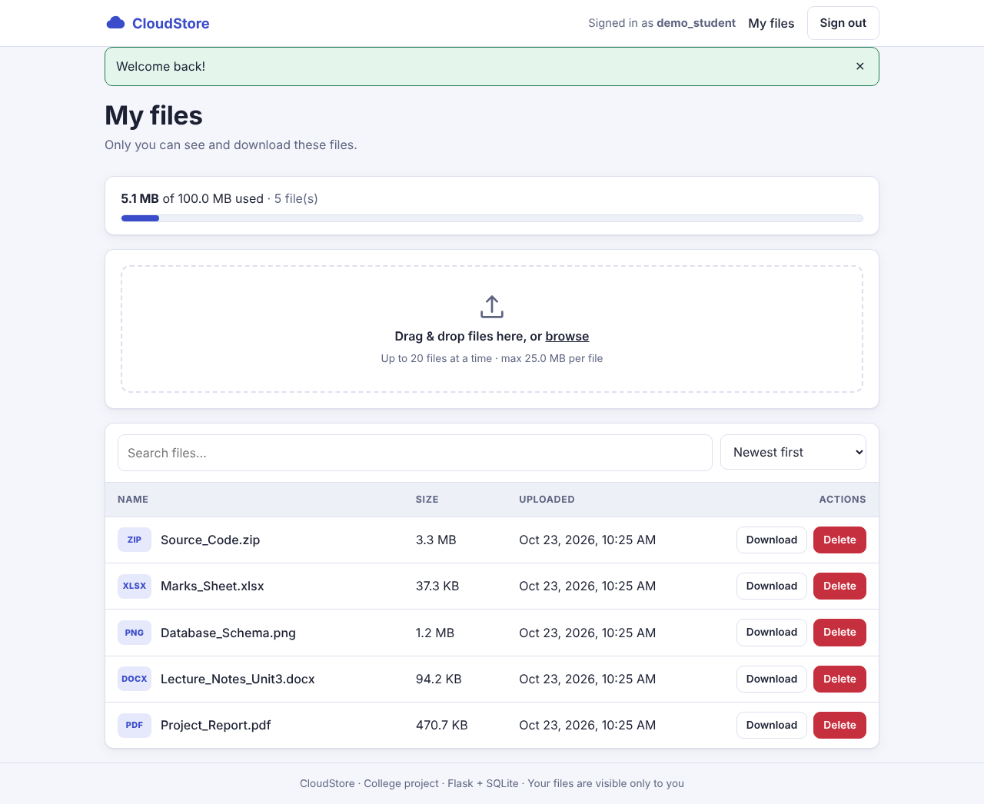
Figure 6 - File list with sizes
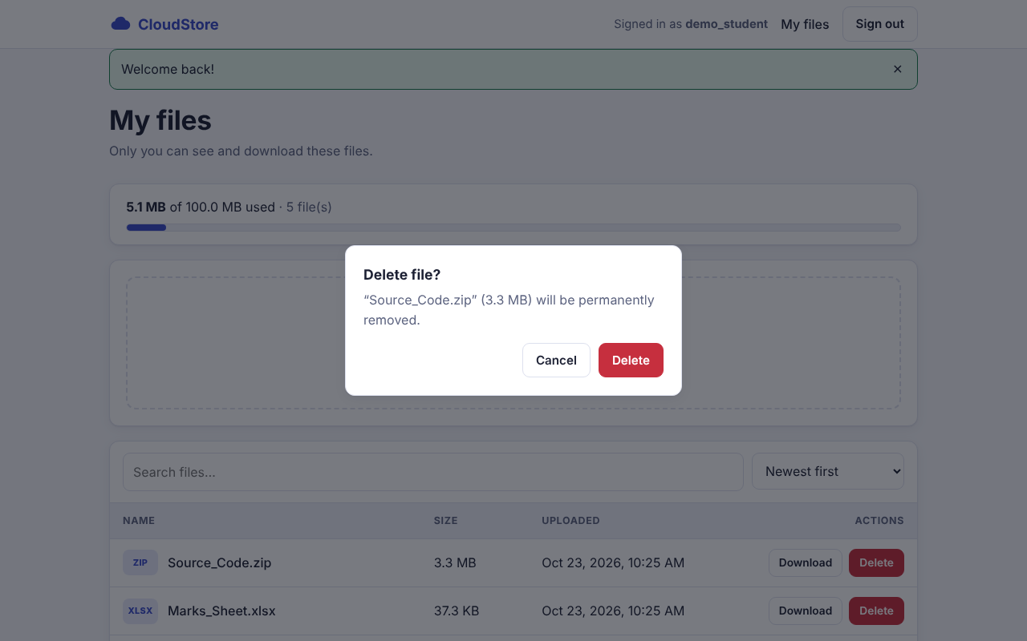
Figure 7 - Delete confirmation
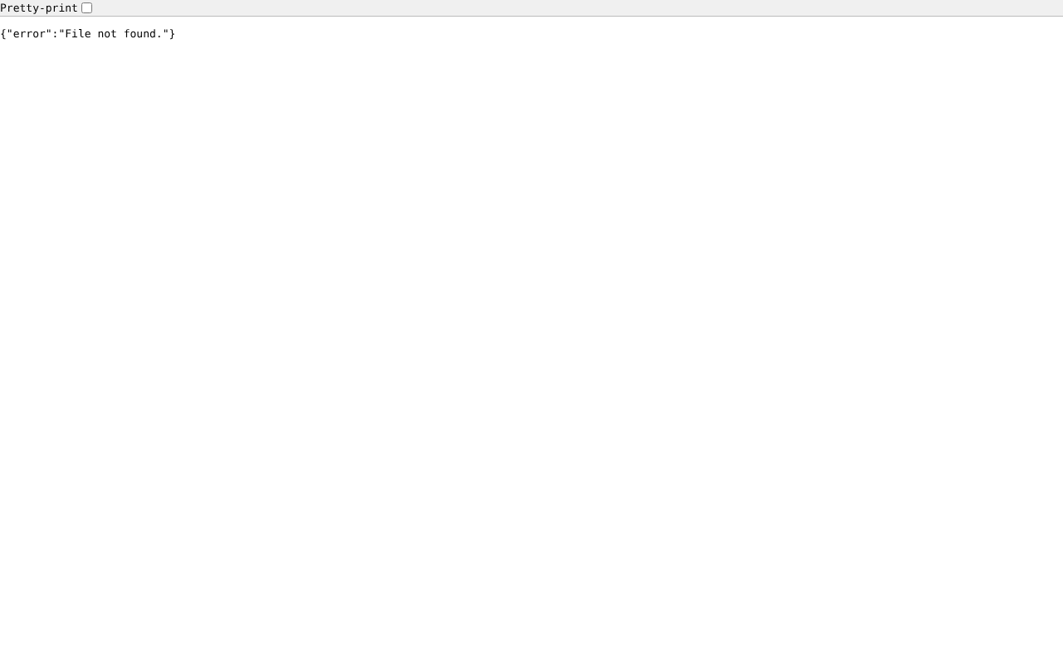
Figure 8 - Another user requesting this file: access denied (404)
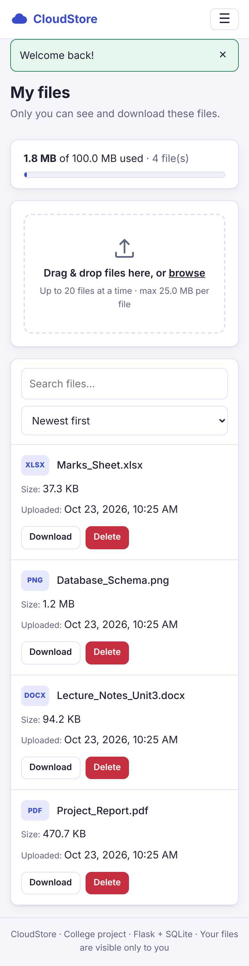
Figure 9 - Responsive mobile layout

12. Conclusion
CloudStore demonstrates how a cloud-style storage service can be built with a small, well-understood stack. All required features - registration, login, upload, download, delete, listing, file-size display and strict per-user access control - are implemented, with validation, error handling and a responsive interface. Security was treated as a design requirement rather than an afterthought, and the behaviour is verified by automated tests. The project can be installed in minutes without any external account, and the modular design allows each part (database, storage, authentication) to be upgraded independently.

13. Future Enhancements
- Share files or folders with other users using expiring links and permissions.
- Folders, rename, move and bulk operations.
- Move metadata to PostgreSQL and file bytes to object storage (Amazon S3 or compatible) for scalability.
- E-mail verification, password reset and two-factor authentication.
- Server-side encryption at rest and antivirus scanning of uploads.
- Chunked / resumable uploads for very large files.
- File preview (images, PDF), version history and trash/restore.
- Administrator dashboard and audit logs; shared rate-limit store (Redis).

14. References
- Flask documentation - https://flask.palletsprojects.com/
- Werkzeug security utilities - https://werkzeug.palletsprojects.com/
- SQLite documentation - https://www.sqlite.org/docs.html
- OWASP Top 10 - https://owasp.org/www-project-top-ten/
- OWASP Cheat Sheet Series (CSRF, File Upload, Password Storage) - https://cheatsheetseries.owasp.org/
- MDN Web Docs (HTML, CSS, JavaScript, Fetch, Content-Security-Policy) - https://developer.mozilla.org/
- Python unittest documentation - https://docs.python.org/3/library/unittest.html

15. Appendix - Installation and Source Layout
cd cloud-file-storage
python -m venv venv
venv\Scripts\activate # macOS/Linux: source venv/bin/activate
pip install -r requirements.txt
python run.py # open http://127.0.0.1:5000
python -m unittest discover -s tests -v
Source files: run.py, config.py, app/__init__.py, app/db.py, app/auth.py, app/files.py, app/utils.py, app/templates/*.html, app/static/css/style.css, app/static/js/app.js, tests/test_app.py. The complete source code is included in the project ZIP.

