MAD LAB_CYCLE2

1.Create 2 activity from the 1st activity on a button click move to the 2nd activity
CODE:
<?xml version="1.0" encoding="utf-8"?>
<RelativeLayout xmlns:android="http://schemas.android.com/apk/res/android"
xmlns:app="http://schemas.android.com/apk/res-auto"
xmlns:tools="http://schemas.android.com/tools"
android:layout_width="match_parent"
android:layout_height="match_parent"
tools:context=".MainActivity">
<TextView
android:layout_width="wrap_content"
android:layout_height="wrap_content"
android:layout_alignParentStart="true"
android:layout_alignParentLeft="true"
android:layout_alignParentTop="true"
android:layout_marginStart="147dp"
android:layout_marginLeft="147dp"
android:layout_marginTop="221dp"
android:text="Activity1" />
<Button
android:id="@+id/button"
android:layout_width="wrap_content"
android:layout_height="wrap_content"
android:layout_alignParentStart="true"
android:layout_alignParentLeft="true"
android:layout_alignParentBottom="true"
android:layout_marginStart="110dp"
android:layout_marginLeft="110dp"
android:layout_marginBottom="210dp"
android:text="open Activity2" />
</RelativeLayout>
<?xml version="1.0" encoding="utf-8"?>
<RelativeLayout
xmlns:android="http://schemas.android.com/apk/res/android"
xmlns:app="http://schemas.android.com/apk/res-auto"
xmlns:tools="http://schemas.android.com/tools"
android:layout_width="match_parent"
android:layout_height="match_parent"
tools:context=".MainActivity">
<TextView
android:layout_width="wrap_content"
android:layout_height="wrap_content"
android:layout_alignParentStart="true"
android:layout_alignParentLeft="true"
android:layout_alignParentTop="true"
android:layout_marginStart="147dp"
android:layout_marginLeft="147dp"
android:layout_marginTop="221dp"
android:text="Activity2" />

</RelativeLayout>
JAVACODE:
package com.example.sjcet.myapplication;
import android.content.Intent;
import android.support.v7.app.AppCompatActivity;
import android.os.Bundle;
import android.view.View;
import android.widget.Button;
public class MainActivity extends AppCompatActivity {
private Button button;
@Override
protected void onCreate(Bundle savedInstanceState) {
super.onCreate(savedInstanceState);
setContentView(R.layout.activity_main);
button = (Button) findViewById(R.id.button);
button.setOnClickListener(new View.OnClickListener() {
@Override
public void onClick(View v) {
openActivity2();
}
});
}
public void openActivity2() {
Intent intent = new Intent(this ,Activity2.class);
startActivity(intent);
}
}

OUTPUT:
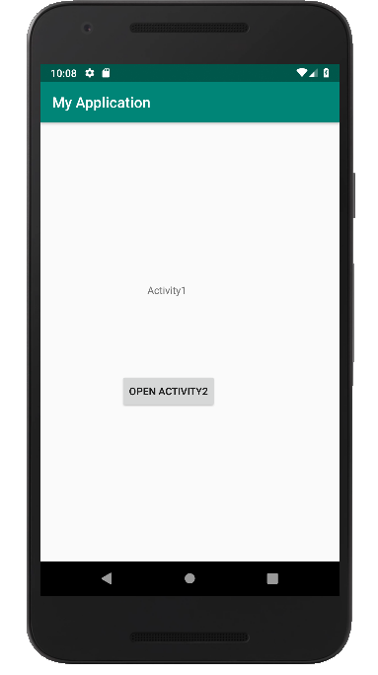
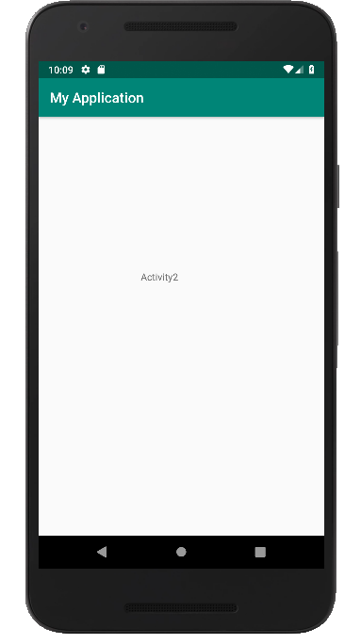

2.CREATE AN ACTIVITY AND MOVE TO THE FACEBOOK BUTTON CLICK??
CODE:
<LinearLayout
android:layout_height="match_parent"
xmlns:android="http://schemas.android.com/apk/res/android"
android:layout_width="match_parent"
android:orientation="horizontal"
android:gravity="center">
<Button
android:layout_width="wrap_content"
android:layout_height="wrap_content"
android:id="@+id/btn"
android:text="FaceBook Login"
android:onClick="FBLogin"
android:gravity="center"/>
</LinearLayout>
javacode:
import android.content.Intent;
import android.net.Uri;
import android.support.v7.app.AppCompatActivity;
import android.os.Bundle;
import android.view.View;

import android.widget.Button;
public class MainActivity extends AppCompatActivity {
Button btn;
@Override
protected void onCreate(Bundle savedInstanceState) {
super.onCreate(savedInstanceState);
setContentView(R.layout.activity_main);
btn = findViewById(R.id.btn);
btn.setOnClickListener(new View.OnClickListener() {
@Override
public void onClick(View v) {
Intent intent = new Intent(Intent.ACTION_VIEW,Uri.parse("https://www.facebook.com/"));
startActivity(intent);
}
});
}
}

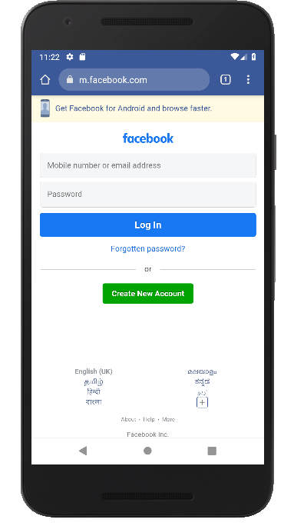
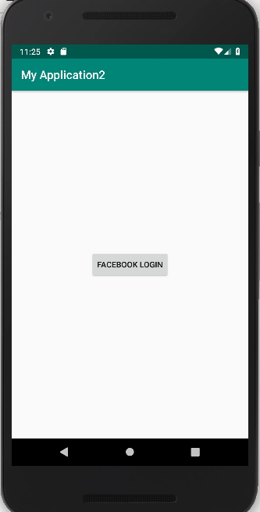

3.Read message from 1st Activity and pass it onto the 2nd Activity on a button click.
CODE:
<?xml version="1.0" encoding="utf-8"?>
<RelativeLayout
xmlns:android="http://schemas.android.com/apk/res/android"
xmlns:app="http://schemas.android.com/apk/res-auto"
xmlns:tools="http://schemas.android.com/tools"
android:layout_width="match_parent"
android:layout_height="match_parent"
tools:context=".MainActivity">
<EditText
android:id="@+id/send_text_id"
android:layout_width="300dp"
android:layout_height="wrap_content"
android:textSize="25dp"
android:hint="Input"
android:textStyle="bold"
android:layout_marginTop="20dp"
android:layout_marginLeft="40dp"/>
<Button
android:id="@+id/send_button_id"
android:layout_width="wrap_content"
android:layout_height="40dp"
android:text="send"
android:textStyle="bold"
android:layout_marginTop="150dp"
android:layout_marginLeft="150dp"/>
<?xml version="1.0" encoding="utf-8"?>
<RelativeLayout xmlns:android="http://schemas.android.com/apk/res/android"
xmlns:app="http://schemas.android.com/apk/res-auto"
xmlns:tools="http://schemas.android.com/tools"
android:layout_width="match_parent"
android:layout_height="match_parent"
tools:context="com.example.sjcet.myapplicationc3.NextActivity">
<TextView
android:id="@+id/received_value_id"
android:layout_width="300dp"
android:layout_height="50dp"
android:textStyle="bold"
android:textSize="40dp"
android:layout_marginTop="20dp"
android:layout_marginLeft="40dp"/>
</RelativeLayout>

package com.example.sjcet.myapplicationc3;
import android.content.Intent;
import android.support.v7.app.AppCompatActivity;
import android.os.Bundle;
import android.view.View;
import android.widget.Button;
import android.widget.EditText;
public class MainActivity extends AppCompatActivity {
// define the variable
Button send_button;
EditText send_text;
@Override
protected void onCreate(Bundle savedInstanceState) {
super.onCreate(savedInstanceState);
setContentView(R.layout.activity_main);
send_button = (Button)findViewById(R.id.send_button_id);
send_text = (EditText)findViewById(R.id.send_text_id);
// add the OnClickListener in sender button
// after clicked this button following Instruction will run
send_button.setOnClickListener(new View.OnClickListener() {
@Override
public void onClick(View v)
{
// get the value which input by user in EditText
// and convert it to string
String str = send_text.getText().toString();
// Create the Intent object of this class Context() to Second_activity class
Intent intent = new Intent(getApplicationContext(), NextActivity.class);
// now by putExtra method put the value in key, value pair
// key is message_key by this key we will receive the value, and put the string
intent.putExtra("message_key", str);
// start the Intent
startActivity(intent);
}
});
}
}
package com.example.sjcet.myapplicationc3;
import android.content.Intent;
import android.support.v7.app.AppCompatActivity;
import android.os.Bundle;
import android.widget.TextView;
public class NextActivity extends AppCompatActivity {
TextView receiver_msg;
@Override
protected void onCreate(Bundle savedInstanceState)
{
super.onCreate(savedInstanceState);
setContentView(R.layout .activity_next);
receiver_msg = (TextView)findViewById(R.id.received_value_id);
// create the get Intent object
Intent intent = getIntent();
// receive the value by getStringExtra() method
// and key must be same which is send by first activity
String str = intent.getStringExtra("message_key");
// display the string into textView
receiver_msg.setText(str);
}
}
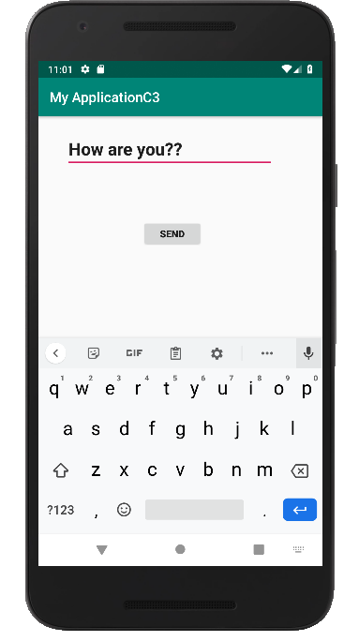
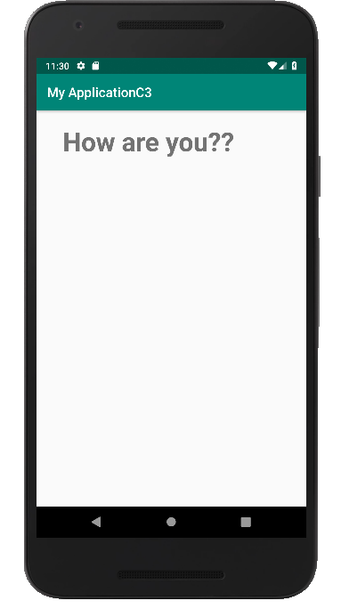

4.Create registration page with full validation and pass the information to the second activity (using shared preference)

Mandatory fields : fname,lname,gender,email,phone number,password,dob(date picker)
CODE:
<?xml version="1.0" encoding="utf-8"?>
<LinearLayout xmlns:android="http://schemas.android.com/apk/res/android"
xmlns:tools="http://schemas.android.com/tools"
android:id="@+id/activity_main"
android:layout_width="match_parent"
android:layout_height="match_parent"
android:orientation="vertical"
>
<EditText
android:id="@+id/editTextName"
android:layout_width="match_parent"
android:layout_height="wrap_content"
android:ems="10"
android:hint="Enter First Name"
android:inputType="textPersonName" />
<EditText
android:id="@+id/editTextlName"
android:layout_width="match_parent"
android:layout_height="wrap_content"
android:ems="10"
android:hint="Enter Last Name"
android:inputType="textPersonName" />
<EditText
android:id="@+id/editTextgender"
android:layout_width="match_parent"
android:layout_height="wrap_content"
android:ems="10"
android:hint="Enter Gender"
android:inputType="textPersonName" />
<EditText
android:id="@+id/editTextEmail"
android:layout_width="match_parent"
android:layout_height="wrap_content"
android:ems="10"
android:hint="Enter Email"
android:inputType="textPersonName" />
<EditText
android:id="@+id/editTextMobile"
android:layout_width="match_parent"
android:layout_height="wrap_content"
android:ems="10"
android:hint="Enter Mobile Number"
android:inputType="textEmailAddress" />
<EditText
android:id="@+id/editTextDob"
android:layout_width="match_parent"
android:layout_height="wrap_content"
android:ems="10"
android:hint="Enter Date of Birth (DD/MM/YYYY)"
android:inputType="date" />
<EditText
android:id="@+id/editTextpassword"
android:layout_width="match_parent"
android:layout_height="wrap_content"
android:ems="10"
android:hint="Enter Password"
android:inputType="textPassword" />
<Button
android:id="@+id/buttonSubmit"
android:layout_width="match_parent"
android:layout_height="wrap_content"
android:text="Submit" />
</LinearLayout>
<LinearLayout android:layout_width="match_parent" android:layout_height="match_parent"
android:orientation="vertical"
android:gravity="center"
xmlns:android="http://schemas.android.com/apk/res/android">
<TextView
android:layout_width="match_parent"
android:layout_height="wrap_content"
android:id="@+id/tv"
/>
<TextView
android:layout_width="match_parent"
android:layout_height="wrap_content"
android:id="@+id/tv1"
/>
<TextView
android:layout_width="match_parent"
android:layout_height="wrap_content"
android:id="@+id/tv2"
/>
<TextView
android:layout_width="match_parent"
android:layout_height="wrap_content"
android:id="@+id/tv3"
/>
<TextView
android:layout_width="match_parent"
android:layout_height="wrap_content"
android:id="@+id/tv4"
/>
<TextView
android:layout_width="match_parent"
android:layout_height="wrap_content"
android:id="@+id/tv5"
/>
<TextView
android:layout_width="match_parent"
android:layout_height="wrap_content"
android:id="@+id/tv6"
/>
</LinearLayout>
JAVACODE:package com.example.sjcet.myapplicationreg4;
import android.content.Intent;
import android.net.Uri;
import android.support.v7.app.AppCompatActivity;
import android.os.Bundle;
import android.text.TextUtils;
import android.util.Patterns;
import android.view.View;
import android.widget.DatePicker;
import android.widget.EditText;
import android.widget.Button;
import android.widget.Toast;
import android.content.SharedPreferences;
public class MainActivity extends AppCompatActivity {
EditText editTextName, editTextlName,editTextEmail, editTextMobile,
editTextDob, editTextgender,editTextpassword;
Button buttonSubmit;
@Override
protected void onCreate(Bundle savedInstanceState) {
super.onCreate(savedInstanceState);
setContentView(R.layout.activity_main);
buttonSubmit =findViewById(R.id.buttonSubmit);
editTextName =findViewById(R.id.editTextName);
editTextlName =findViewById(R.id.editTextlName);
editTextEmail =findViewById(R.id.editTextEmail);
editTextMobile =findViewById(R.id.editTextMobile);
editTextDob =findViewById(R.id.editTextDob);
editTextgender =findViewById(R.id.editTextgender);
editTextpassword =findViewById(R.id.editTextpassword);
buttonSubmit.setOnClickListener(new View.OnClickListener() {
@Override
public void onClick(View view) {
checkDataEntered();
SharedPreferences mypref=getSharedPreferences("activity_main2.xml",0);
SharedPreferences.Editor editor=mypref.edit();//only write editor
editor.putString("fname",editTextName.getText().toString()); //bundle the data
editor.putString("lname",editTextlName.getText().toString());
editor.putString("gender",editTextgender.getText().toString());
editor.putString("phone",editTextMobile.getText().toString());
editor.putString("pwd",editTextpassword.getText().toString());
editor.putString("email",editTextEmail.getText().toString());
editor.putString("dob",editTextDob.getText().toString());
editor.commit();
// String str = editTextName.getText().toString();
//String str1 = editTextName.getText().toString();
Intent intent = new Intent(getApplicationContext(), Main2Activity.class);
intent.putExtra("fname",editTextName.getText().toString());
intent.putExtra("lname",editTextlName.getText().toString());
intent.putExtra("gender",editTextgender.getText().toString());
intent.putExtra("phone",editTextMobile.getText().toString());
intent.putExtra("pwd",editTextpassword.getText().toString());
intent.putExtra("email",editTextEmail.getText().toString());
intent.putExtra("dob",editTextDob.getText().toString());
startActivity(intent);
}
});
}
boolean isEmail(EditText text) {
CharSequence email = text.getText().toString();
return (!TextUtils.isEmpty(email) && Patterns.EMAIL_ADDRESS.matcher(email).matches());
}
boolean isEmpty(EditText text) {
CharSequence str = text.getText().toString();
return TextUtils.isEmpty(str);
}
void checkDataEntered() {
if (isEmpty(editTextName)) {
Toast t = Toast.makeText(this, "You must enter first name to register!", Toast.LENGTH_SHORT);
t.show();
}
if (isEmpty(editTextlName)) {
editTextlName.setError("Last name is required!");
}
if (isEmpty(editTextMobile)) {
editTextMobile.setError("mobile number is required!");
}
if (isEmpty(editTextgender)) {
editTextgender.setError("Gender is required!");
}
if (isEmpty(editTextpassword)) {
editTextpassword.setError("Password is required!");
}
if (isEmpty(editTextDob)) {
editTextDob.setError("DOB is required!");
}
if (isEmail(editTextEmail) == false) {
editTextEmail.setError("Enter valid email!");
}
}
}

package com.example.sjcet.myapplicationreg4;
import android.content.SharedPreferences;
import android.widget.TextView;
import android.content.Intent;
import android.support.v7.app.AppCompatActivity;
import android.os.Bundle;
public class Main2Activity extends AppCompatActivity {
TextView tv,tv1,tv2,tv3,tv4,tv5,tv6;
@Override
protected void onCreate(Bundle savedInstanceState) {
super.onCreate(savedInstanceState);
setContentView(R.layout.activity_main2);
tv =findViewById(R.id.tv);
tv1 =findViewById(R.id.tv1);
tv2 =findViewById(R.id.tv2);
tv3 =findViewById(R.id.tv3);
tv4 =findViewById(R.id.tv4);
tv5 =findViewById(R.id.tv5);
tv6 =findViewById(R.id.tv6);
Intent intent = getIntent();
SharedPreferences mypref=getSharedPreferences("activity_main2.xml",0);
String str = mypref.getString("fname",null);
String str1 = mypref.getString("lname",null);
String str2 = mypref.getString("gender",null);
String str3 = mypref.getString("phone",null);
String str4 = mypref.getString("pwd",null);
String str5 = mypref.getString("email",null);
String str6 = mypref.getString("dob",null);
tv.setText(str);
tv1.setText(str1);
tv2.setText(str2);
tv3.setText(str3);
tv4.setText(str4);
tv5.setText(str5);
tv6.setText(str6);
}
}

OUTPUT
