1. Using the iris data set implement the KNN algorithm. Take different values for Test and training
data set .Also use different values for k. Also find the accuracy level.
CODE:
import numpy as np
import matplotlib.pyplot as plt
import pandas as pd
dataset = pd.read_csv('iris.csv')

dataset.head()

X = dataset.iloc[:, :-1].values
y = dataset.iloc[:, 4].values
from sklearn.model_selection import train_test_split
X_train, X_test, y_train, y_test = train_test_split(X, y, test_size=0.20)

from sklearn.preprocessing import StandardScaler
scaler = StandardScaler()
scaler.fit(X_train)
X_train = scaler.transform(X_train)
X_test = scaler.transform(X_test)

from sklearn.neighbors import KNeighborsClassifier
classifier = KNeighborsClassifier(n_
classifier.fit(X_train, y_train)

y_pred = classifier.predict(X_test)

from sklearn.metrics import classification_report, confusion_matrix
print(confusion_matrix(y_test, y_pred))
print(classification_report(y_

error = []
# Calculating error for K values between 1 and 40
for i in range(1, 40):
knn = KNeighborsClassifier(n_
knn.fit(X_train, y_train)
pred_i = knn.predict(X_test)
error.append(np.mean(pred_i != y_test))

plt.figure(figsize=(12, 6))
plt.plot(range(1, 40), error, color='red', linestyle='dashed', marker='o',
markerfacecolor='blue', markersize=10)
plt.title('Error Rate K Value')
plt.xlabel('K Value')
plt.ylabel('Mean Error')

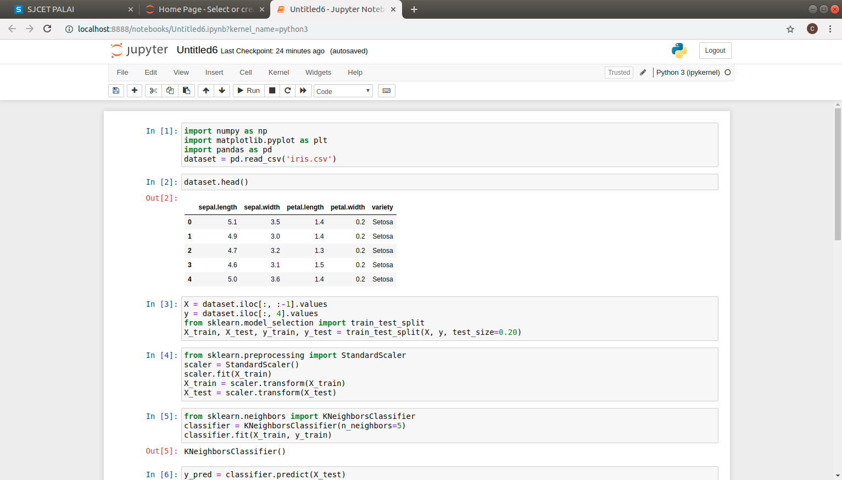
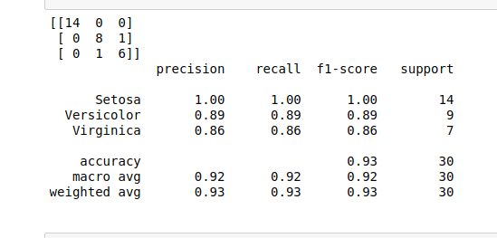
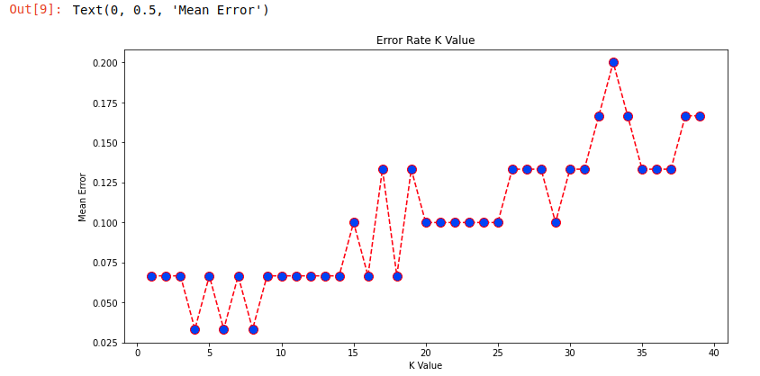

2. Download another data set suitable for the KNN and implement the KNN algorithm. Take different
values for Test and training data set .Also use different values for k.

