DOCUMENTATION

Document summary:

Project / Product name | FSS-CMS
Product version | V5.1.0
Project / Product ID
Doc version No | V1.0
Customer name | Internal

Document Change History

Ver.No | Date | Changes | Prepared by | Reviewed by | Approved by
1.0 | 31/03/20 | Initial Draft Document | Srivaishnavi. K

JBOSS IMPLEMENTAION – APP SERVER

INTRODUCTION :

- Jboss Application Server is an Open Source , Cross platform Java Application server developed by JBOSS.

- It is used for Implementing Java Applications and other Web – Based applications and software.

- It is usable on any operating system that supports Java.

STEPS TO DOWNLOAD JBOSS :

- JBOSS is an open source so that it can be directly downloaded it from the concern website.

- Link to Download JBOSS : https://developers.redhat.com/products/eap/download

- Download the latest version of JBOSS (Stable Version).

- To Download latest version from Red HAT → Should be a registered customer for the Portal .

- Complete Sign-Up while downloading the JBOSS.

STEPS TO INSTALL JBOSS:

Operating System: Windows

Extract the Downloaded ZIP File. ( Right Click of the Zip File and give Extract Here Option)

Once it has been Extracted , the server can be used to deploy the Applications

Operating System: Other than Windows:

To Extract the ZIP File :

There are two ways

1. Extract the Downloaded ZIP File. ( Right Click of the Zip File and give Extract Here Option)

2. Using Command Prompt :

- Go the Exact folder location where the downloaded zip files resides.

- Cmd : unzip FileName

Once it has been unzipped , the server can be used deploy the Applications

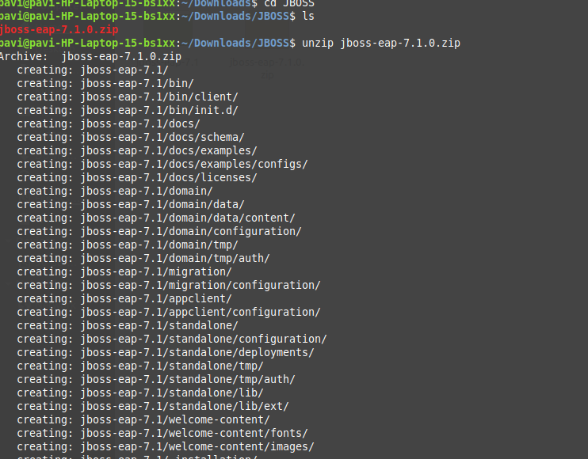

Files : Explanation (Before Deploying the WAR)

- /bin - Startup, shutdown, and other scripts.

- *.sh files (for Unix systems) are functional duplicates of the *.bat files (for Windows systems).

- ./conf - Configuration files and related DTDs.

- The most important file in here is server.xml. It is the main configuration file for the container

- ./logs - Log files are here by default

Pre Requisite : Before deploying an WAR.

1. JDK : Either it should exactly should be sync with the WAR Which has been Compiled , or should be the greater version.

2. JAVA_HOME need to be setted.

WAR Deployment:

1. Place your WAR in Deployement Folder ( jboss-eap-7.1/standalone/deployments)

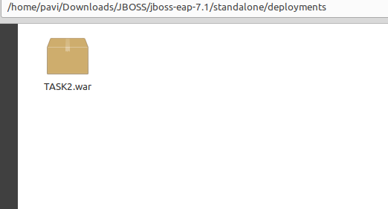

2. Place the /dodeploy File. (File name should be as same as your WAR)

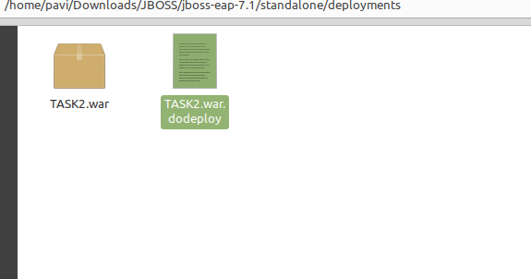

Note : .dodeploy is an Extension

Ex: If the war name is Sample.war then dodeploy file should be Sample.war.dodeploy (.dodeploy is an extension)

3. Start the standalone.bat file in cmd (Windows) standalone.sh for (UNIX Systems)

Go to the folder path till bin and then start ./standalone.(bat/sh)

(Location : /jboss-eap-7.1/bin/standalone.(bat/sh)

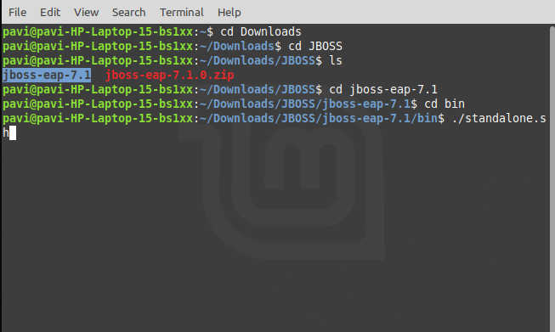

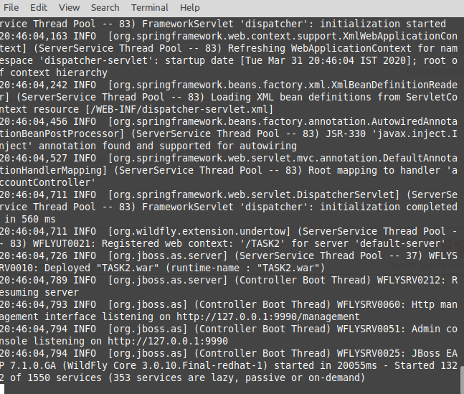

Explanation about : standalone.bat / standalone.sh

- On running standalone.bat/ standalone.sh -> Internally this will be calling standalone.conf file

- standalone.conf → Which holds the main Configuration for an server to deploy the WAR.

Standalone.sh ( UNIX) → Calling Standalone.Conf

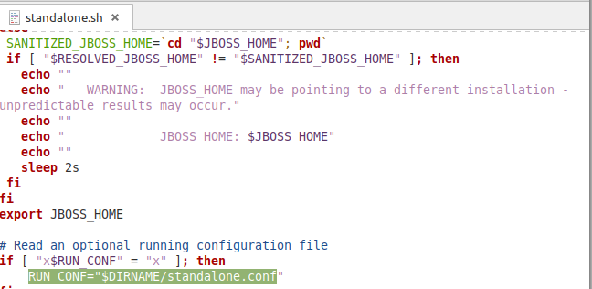

Standalone.bat ( WINDOWS) → Calling Standalone.Conf

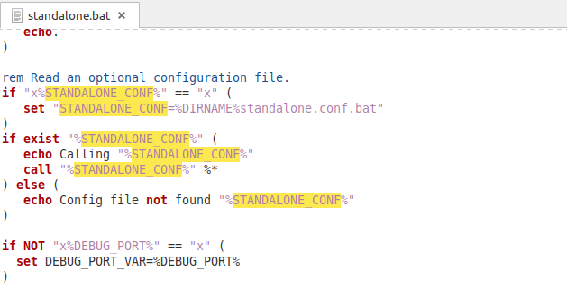

Standalone.conf

JAVA_HOME="/opt/java/jdk"

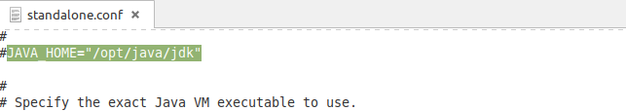

- If JAVA_HOME path is not setted in standalone.confg File → Default environment variable will be consider by the server to deploy the WAR / Need to set the JAVA_HOME in cmd.

- If JAVA_HOME has been setted in standalone.conf → Though Environment Variable has been configured , finally server will consider conf file JAVA_HOME to deploy and to start the server.

SPACE ALLOCATION :

JAVA_OPTS="-Xms1303m -Xmx1303m -XX:MetaspaceSize=96M -XX:MaxMetaspaceSize=256m -Djava.net.preferIPv4Stack=true"

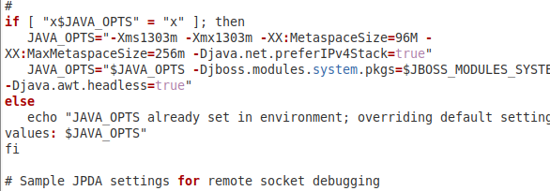

JAVA_OPTS define the Space allocation for the server.

-Xms1303m → Minimum size of Space Allocation

-Xmx1303m → Maximum size of Space Allocation

-XX:MetaspaceSize=96M → Minimum size for Creating Object at Runtime

-XX:MaxMetaspaceSize=256m → Maximum size for Creating Object at Runtime

m represent → MB

Example : Changed these configuration as mentioned below-

-Xms300m → Minimum size of Space Allocation

-Xmx500m → Maximum size of Space Allocation

-XX:MetaspaceSize=60M → Minimum size for Creating Object at Runtime

-XX:MaxMetaspaceSize=200m → Maximum size for Creating Object at Runtime

m represent → MB

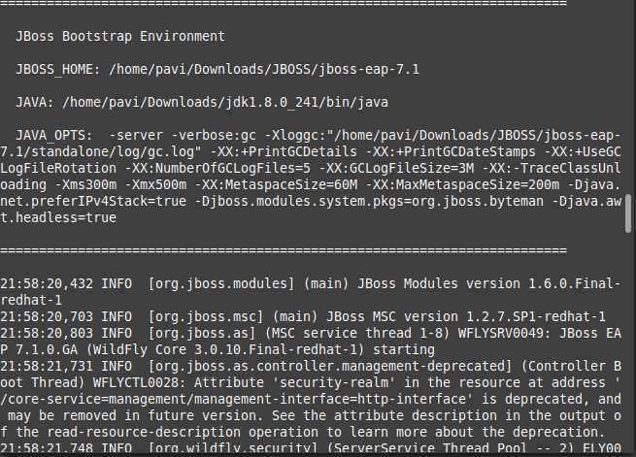

- Please refer the above pic : JAVA_OPTS → This has been assigned with the 300mb as mininum and 500 mb as maximum and runtime object allocation where 60m as minimum and 200m as maximum.

- Based on the configuration which has been mentioned in standalone.conf → Server will be started and war will be deployed.

- Once war got deployed : URL need to be accessed to view the application, Since we didn’t change the port and IP → Application will be accessed with localhost and default port.

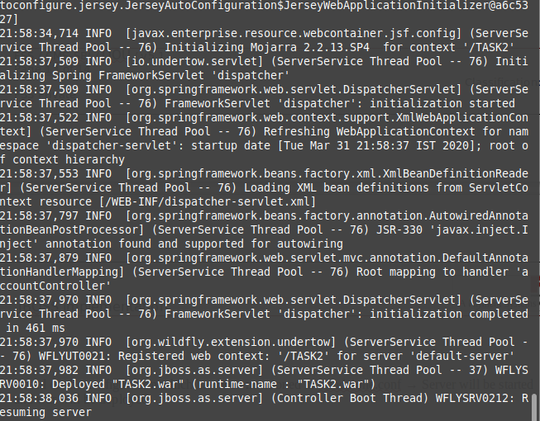
URL:

http://localhost:8080/TASK2/

→ /TASK2 is my context path.
→ Initializing Mojorro → Context Path will be shown. (Please Refer above screenshot)

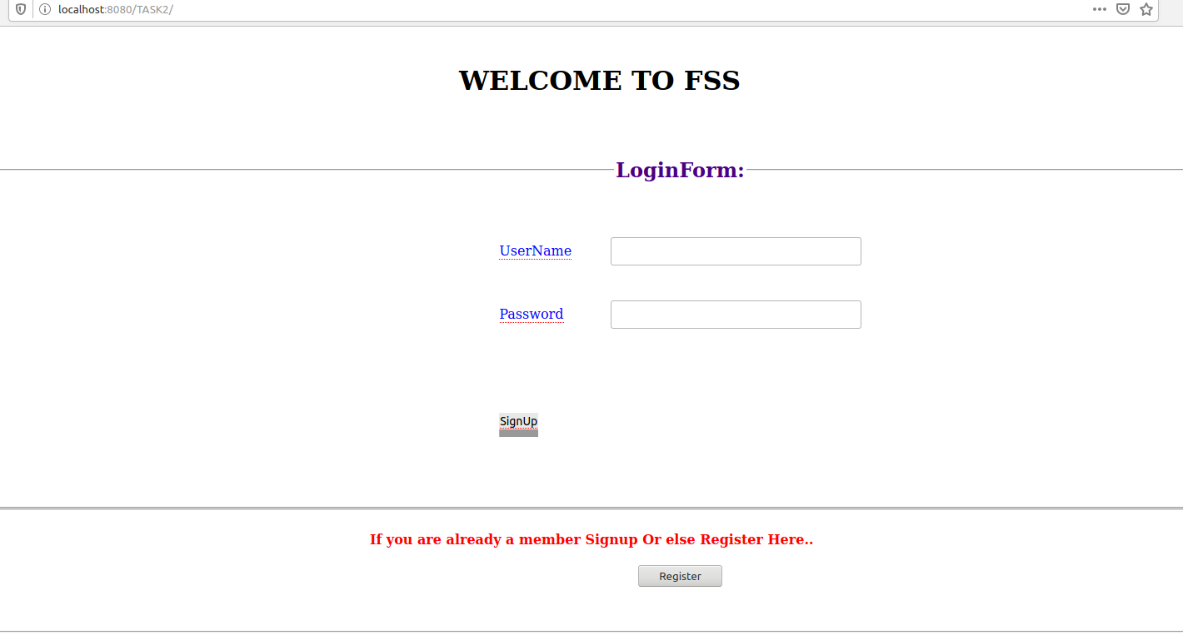

Standalone.xml : Port - IP Configuration

- IP and Port Configuration will be configured in standalone.xml

- Default Port : 8080

- Offset :0

Offset value will be added to the Port and together the sum of port + offset will be the actual Port.

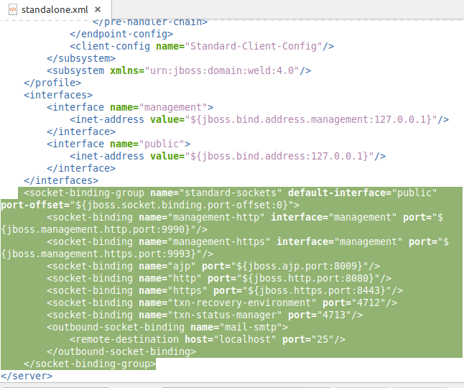
Example

The above mentioned configuration is the default one.

HTP Port : 8080

Offset: 0

Sum → 8080+0 =8080

So server will be running in the 8080 port.

Accessing URL : http://localhost:8080/TASK2/

Changing the Offset to 20

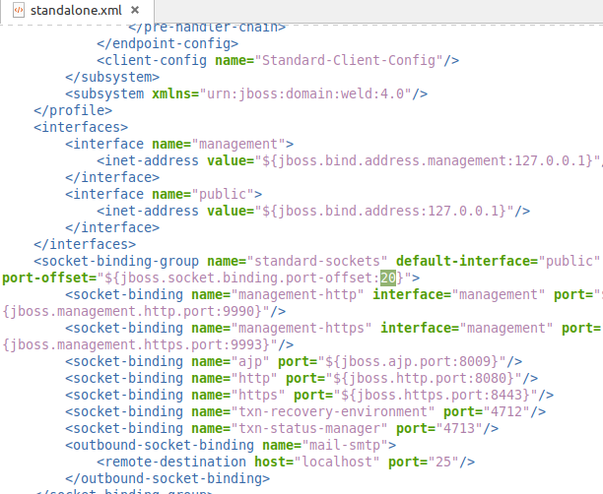

Server need to be Restarted whenever the configuration has been changed.

PIC 1:

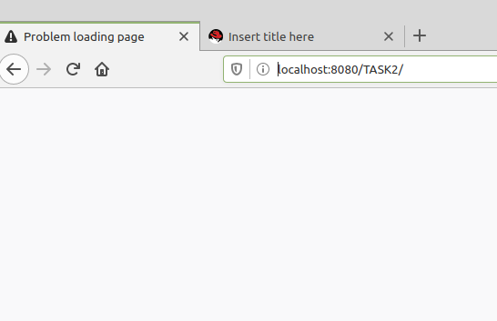

This above PIC : URL has been accessed with 8080 Port

PIC 2:

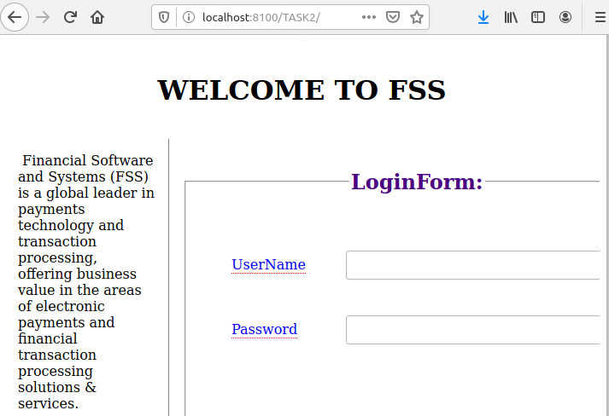

- In the above PIC → URL has been accessed with 8100

- Offset has been Mentioned as 20 → Port +Offset (8080 +20)= 8100

- 8100 → Actual http port for the Application

- PIC 1: 8080 ( Since offset has been mentioned as 20 : Application URL is not running in 8080)

- PIC 2 :8100 ( Since offset has been mentioned as 20 : Application URL is running in 8100)

- This Offset is not only applicable for the HTTP Port is for all the ports which have been mentioned in standalone.xml (AJP,...etc)

ADMIN CONSOLE:

- JBOSS Console can be accessed by the generated User.

- Admin Console URL: On WAR Deployment , Admin Console URL will be exposed in terminal.

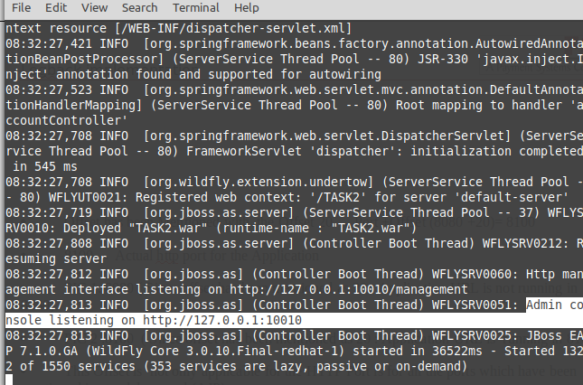

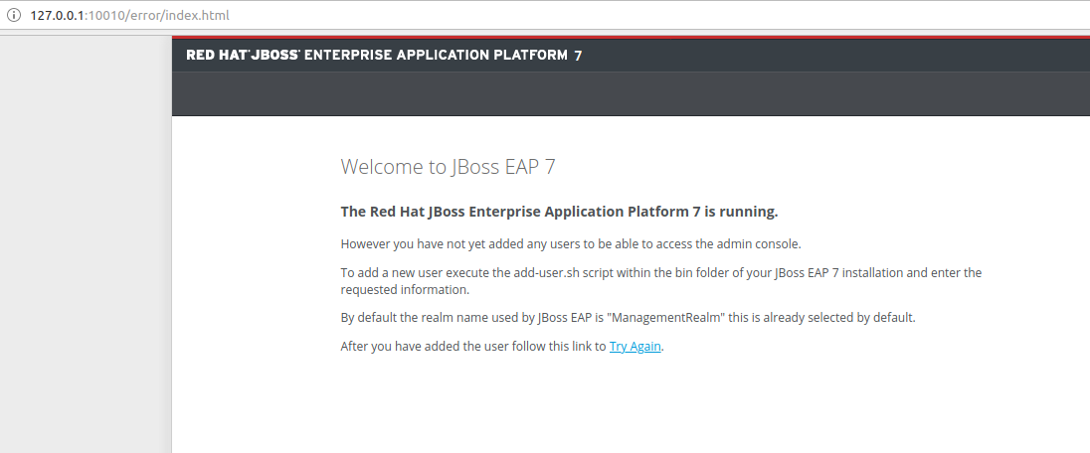
Accessing JBOSS Console:

Since we didn’t create user : Console can’t be accessed

Steps to Create User :

1. Run Add-user.(sh/bat) file → Location (jboss-eap-7.1/bin)

2. Go to terminal/cmd and go to the folder path till bin

3. Execute Add-user.(sh/bat)

4. Select Management User Option

5. Give valid user and password.

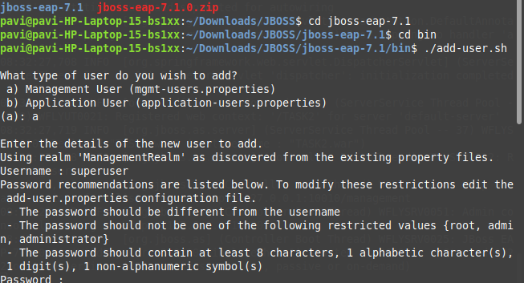

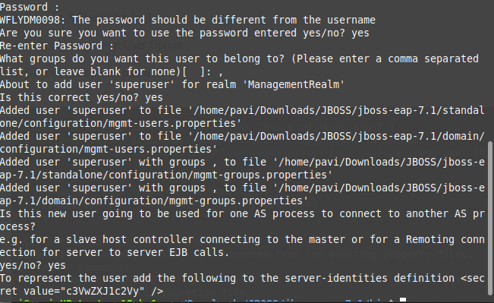

Now User has been created → User Name : superuser , Password : superuser

Accessing JBOSS Console:

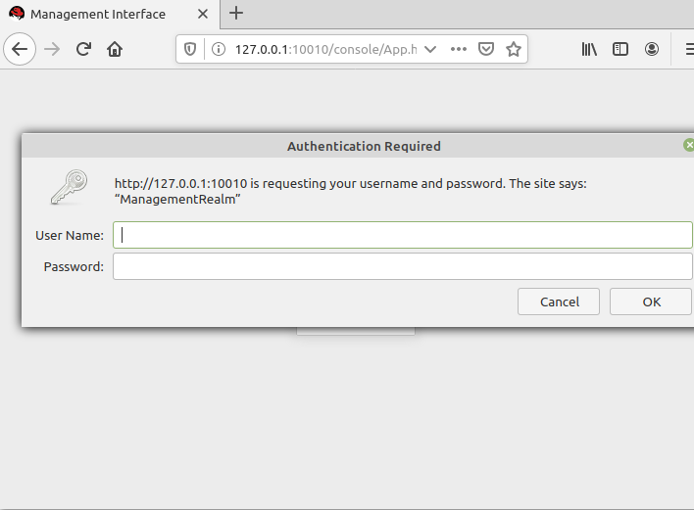

- Once User has been Created : Console will respond with username and password for authentication.

- Provide the registered user details

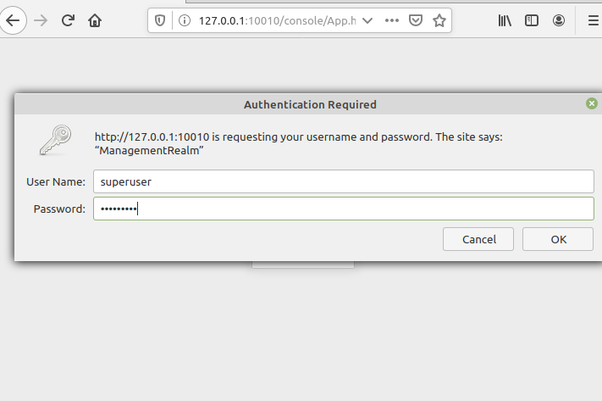

- After Authenticating the User , console will be displayed

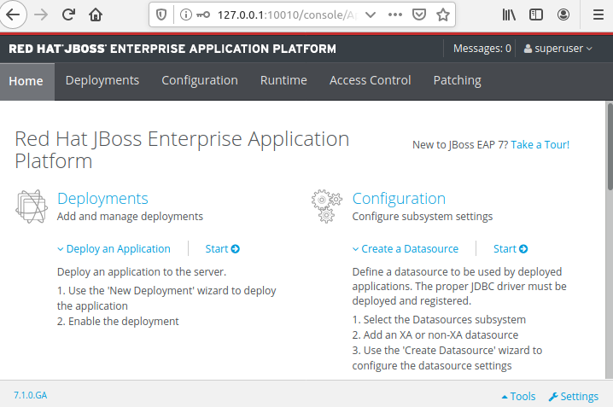

RBAC : ROL BASED ACCESS CONTROL

- Role based access control is designed to restrict system access or specifying permissions for management users.

- Each user with the management access id give a role that role defines what they can and cannto access.

Predefined Roles:

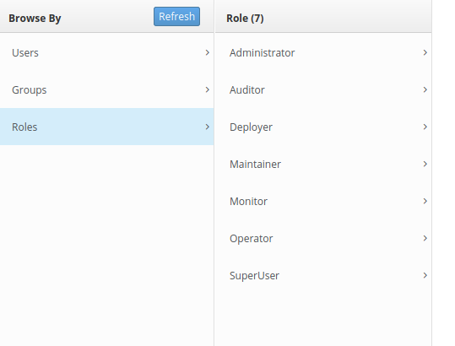

- These are seven predefined role which has been present in JBOSS.

- Each of these roles has a different set of permissions and is designed for specific use cases. The Monitor, Operator, Maintainer, Administrator, and Super User role each build upon each other, with each having more permissions than the previous. The Auditor and Deployer roles are similar to the Monitor and Maintainer roles respectively but have some additional special permissions and restrictions.

1. Monitor
- Users of the Monitor role have the fewest permissions and can only read the current configuration and state of the server. This role is intended for users who need to track and report on the performance of the server.
- Monitors cannot modify server configuration nor can they access sensitive data or operations.
2.Operator
- The Operator role extends the Monitor role by adding the ability to modify the runtime state of the server. This means that Operators can reload and shutdown the server as well as pause and resume JMS destinations. The Operator role is ideal for users who are responsible for the physical or virtual hosts of the application server so they can ensure that servers can be shutdown and restarted corrected when needed.
- Operators cannot modify server configuration or access sensitive data or operations.
3.Maintainer
- The Maintainer role has access to view and modify runtime state and all configuration except sensitive data and operations. The Maintainer role is the general purpose role that doesn't have access to sensitive data and operation. The Maintainer role allows users to be granted almost complete access to administer the server without giving those users access to passwords and other sensitive information.
- Maintainers cannot access sensitive data or operations.
4.Administrator
- The Administrator role has unrestricted access to all resources and operations on the server except the audit logging system. Administrator is the only role (except SuperUser) that has access to sensitive data and operations. This role can also configure the access control system. The Administrator role is only required when handling sensitive data or configuring users and roles.
- Administrators cannot access the audit logging system and cannot change themselves to the Auditor or SuperUser role.
5.SuperUser
- The SuperUser role has no restrictions and has complete access to all resources and operations of the server including the audit logging system. This role is equivalent to the administrator users of earlier versions of JBoss EAP 6 (6.0 and 6.1). If RBAC is disabled, all management users have permissions equivalent to the SuperUser role.
6.Deployer
- The Deployer role has the same permissions as the Monitor, but can modify configuration and state for deployments and any other resource type enabled as an application resource.
7.Auditor
- The Auditor role has all the permissions of the Monitor role and can also view (but not modify) sensitive data, and has full access to the audit logging system. The Auditor role is the only role other than SuperUser that can access the audit logging system.
- Auditors cannot modify sensitive data or resources. Only read access is permitted.

Stanalone.xml Before Asssigning the roles

- Provider will be Simple in standalone.xml by default , once RBAC has been enabled Provider will be changed into RBAC

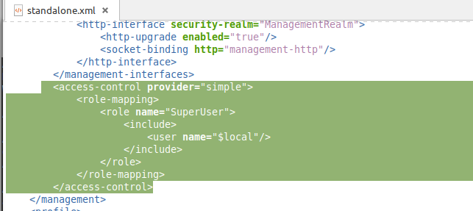

ASSIGNING ROLES TO THE USER:

- Create User (Ex: dev user , dep user , and nonuser , administrator)

- Create Groups assigning to roles

- Assign User to the groups

USER | GROUPS | ROLES
1. devuser | Development | Auditor
2. depuser | Deployerment | Deployer
3. nonuser | Monitoring | Monitor
4. superuser | SuperUser | SuperUser
5. adminuser | Administration | Administration
6. operatoruser | Operator | Operator
7.maintainuser | Maintainer | MAintainer

Complete steps:

- Add all the user as mentioned in the table as management user using add-user.(sh/bat)

- Start the server by running standalone.sh with the default port 8080

- Execute the cmd in terminal : jboss-cli.sh --connect in the same terminal

- Realod the server : cmd → :reload

- Execute the cmd in terminal : core-service=management/access=authorization:write-attribute(name=provider,value=rbac)

- Check standalone.xml file → Provider would have changed from simple to RBAC.

- Execute the cmd in terminal : /core-service=management/access=authorization/role-mapping=SuperUser/include=ManagementRealm:add(name=superuser,type=USER)

- login console with "superuser"

- Create groups as mentioned in the table

- Execute the cmd in terminal : /core-service=management/access=authorization/role-mapping=Monitor/include=ManagementRealm:add(name=user1,type=USER)

- Please find the below explanation for the command

/core-service=management/access=authorization/role-mapping=RoleName/ include=ManagementRealm:add(name=”username”,type=USER)

1. Created User by Running add-user.sh (Location→ jboss-eap-7.1/bin)

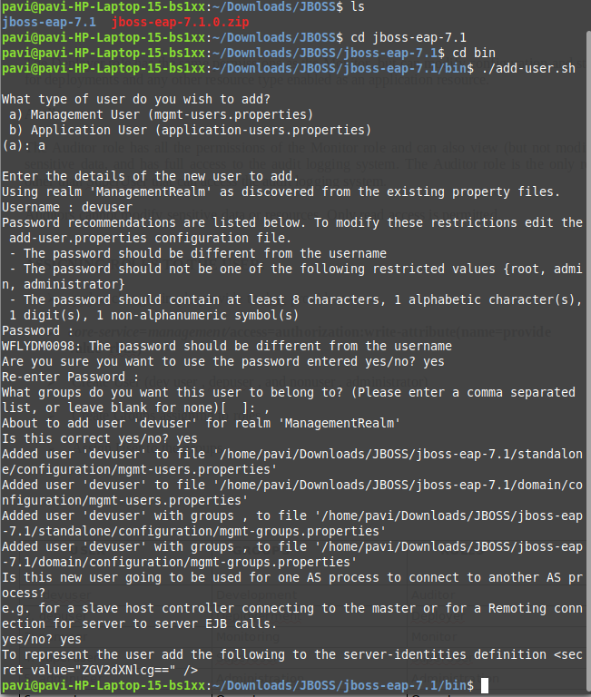

2. Starting the server by Running standalone.(sh/bat) and the folder path location (jboss-eap-7.1)

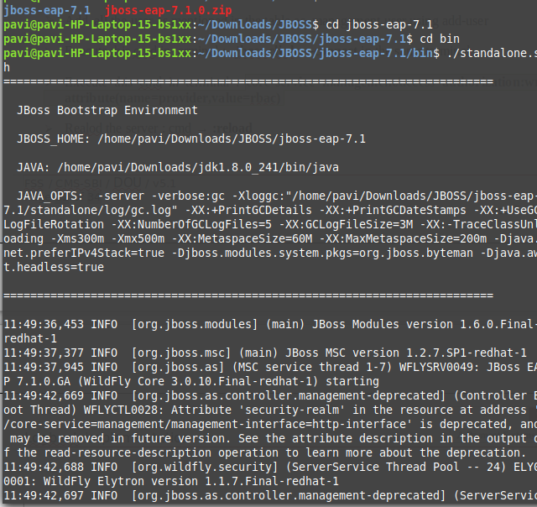

2. After Starting the server execute the connect cmd : Location (Folder Path -> Jboss-eap-7.1/bin)
Once it has been connected Reload the server and then enable RBAC

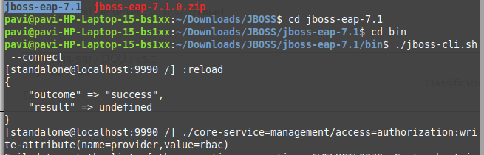

4. Once RBAC has been enabled ,standalone.xml configuration will be changed from simple to RBAC

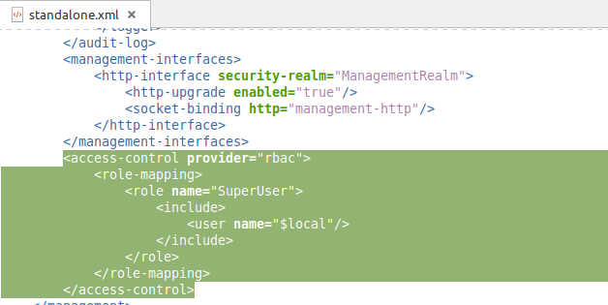

5. Assigning user to the Roles.

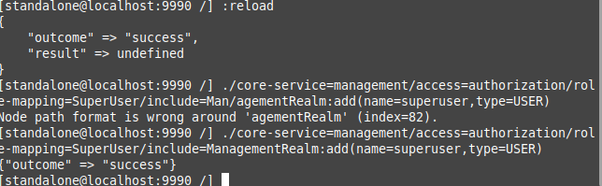

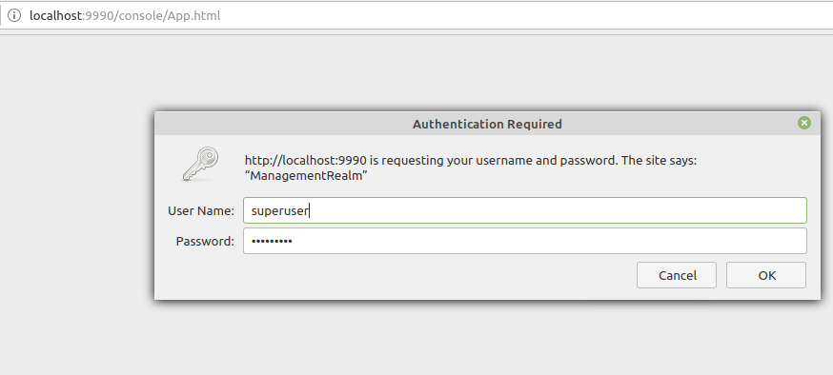
6. Once Super User has been assigned with the Super User role , login through console for creating other groups.

7. After Successful Login : Create Groups for other roles

Access Control → Groups → Click on ADD Button.
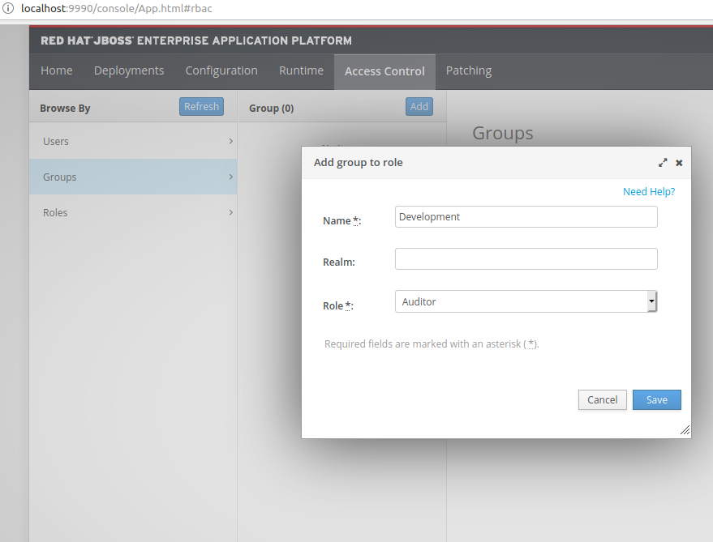

- Once group has been added respective user we can be mapped to the roles

8. In the below pic , User→ devuser has been mapped into role → Auditor Role

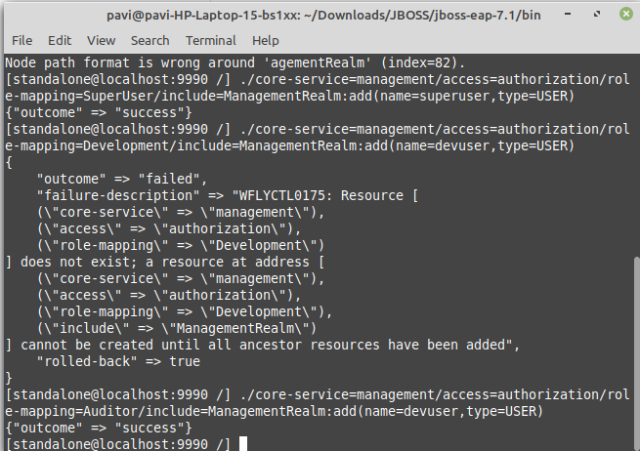

9. Once user has been mapped into the role , logging into console to verify the uuser and role access

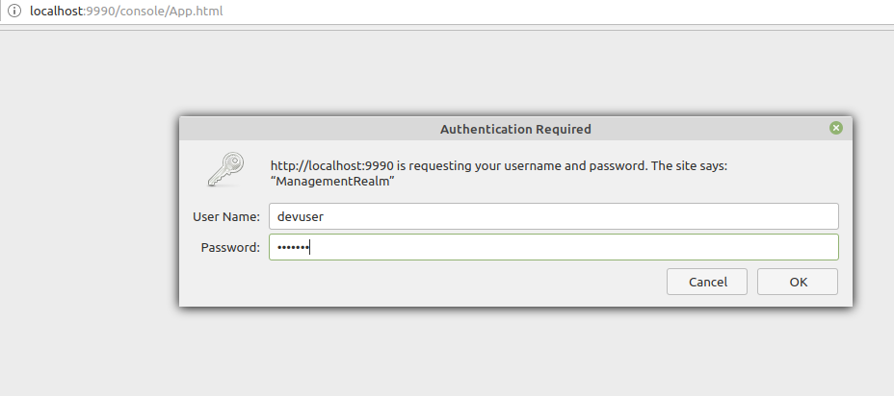

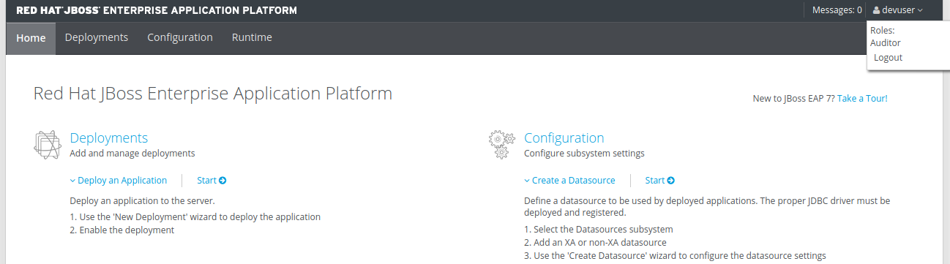

10 . Refer the below pic, Groups have been created for all the Roles by using Super User Login.

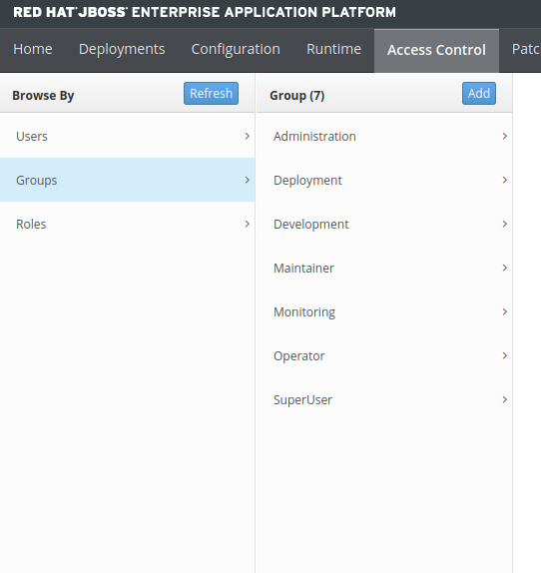

11. Created all the user for the mentioned groups as per the table : Refer below pic.

12. Assign roles to all the user : Refer below Pic

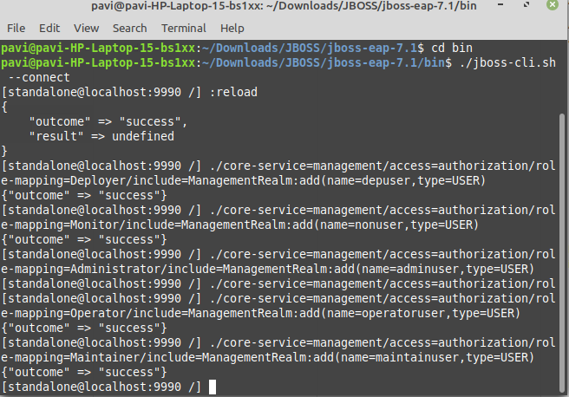

Please find all the user and roles which have been mapped and their respective access.

11. User : depuser → Role : Deployer

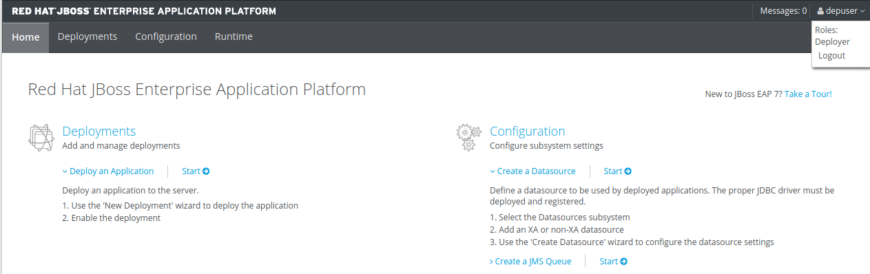

12. User : nonuser → Role : Monitor

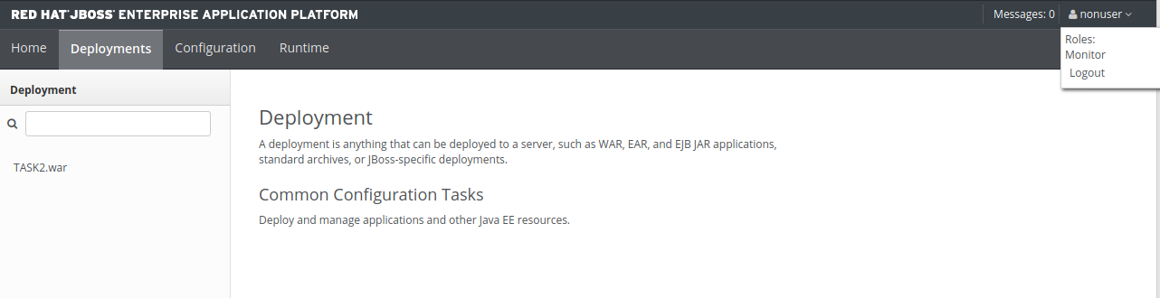

13. User : adminuser → Role : Administrator

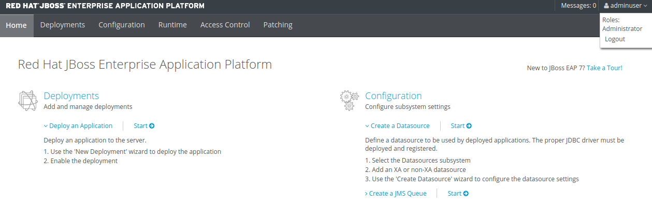

14. User : operatoruser → Role : Operator

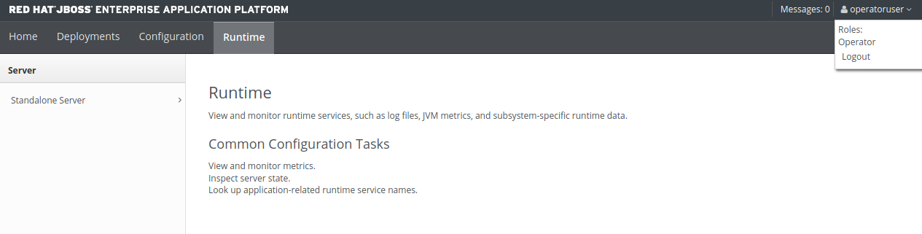

15.User : maintainuser → Role : Maintainer

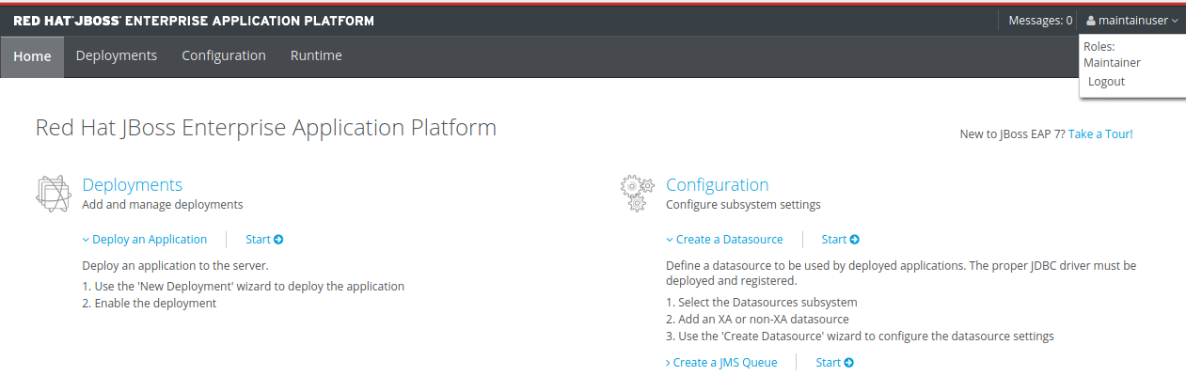

MODES OF RUNNING THE SERVER IN JBOSS

1. Standalone Mode

2. Domain Mode

1. Standalone Mode is simply a single server, deploying the war in single server.

DOMAIN MODE:

JBoss domain mode allows for the centralized management of multiple nodes, running multiple instances of the JBoss application server, configured to provide different services.

Configuration File | Purpose
domain.xml | This file holds the domain configuration such as profiles to apply to server instances, server groups, deployments and management interface access control. It is only used by the domain master.
host.xml | This is the default configuration file for the host controller. If no alternative host configuration is specified on the command line this file will be used
host-slave.xml | An example configuration file for a slave host. You can edit this file for the slave host or the host.xml above. If you edit this file you will need to provide it on the command line when running the domain.sh script.
host-master.xml | An example configuration file for a master host. You can edit this file for the master host or the host.xml above. If you edit this file you will need to provide it on the command line when running the domain.sh script. The host,xml file is already configured for master mode.

Diagrammatic Representation of Domain Mode :

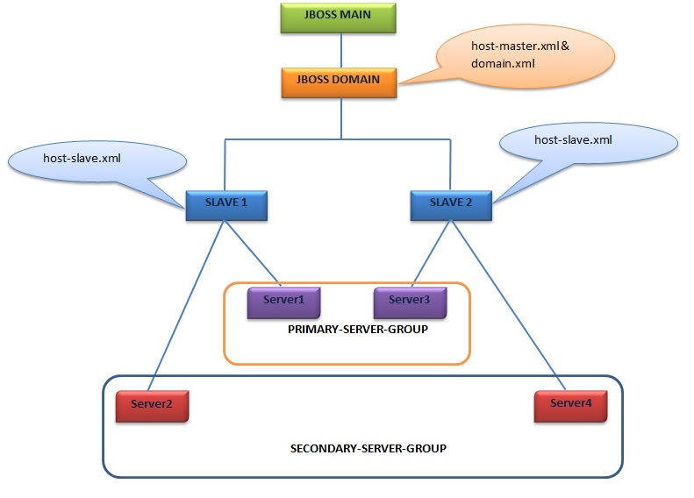

Implementation of domain mode:

Overview : Two servers with the Different IP and Different Port should be created as an slave servers and master will be controlling it.

Steps to Implement Domain Mode Configuration:

1. Create Two Folders as Master and Slave

2. Place JBOSS instance in both the folders

3. Create User for Master and make a note of Secret Value.

4.In Slave Folder : Change the Configuration as mentioned below in host-slave.xml

→ Secret Value should be changed to the secret value of the user which have been created in the master side

→ In Place of name field , need to be changed the name of the user which have been created in the master side

→ Need to provide Master IP and Port .

→ IP need to be changed in host-slave.xml , because same IP we cannot use for both master and the slave

5.Start the server in both master and slave with the below mentioned cmd.

Master: ./domain.sh --host-config=host-master.xml

Slave : ./domain.sh --host-config=host-slave.xml

6.Remove all the default Configuration in console and create the New Server as Dev and UAT.

6. Go to the Deployment in both the servers independently and start and start the server without the dependent of others.

7. On logging as an master user, we can monitor the slave server and their deployments.

STEPS :

1. Created Two Folders : Master ans Slave

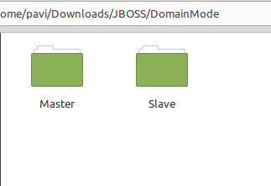

2. Place JBOSS instance inside each Folder.

Placed JBOSS Instance in Master Folder

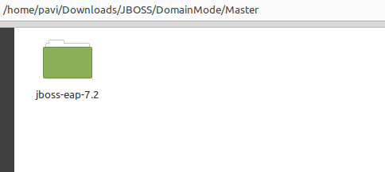

Placed JBOSS instance in Slave Folder

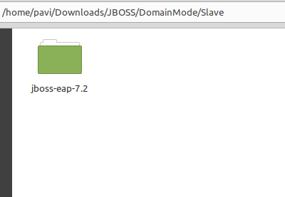

3. Create user in Master Side and make a note of Secret Value.

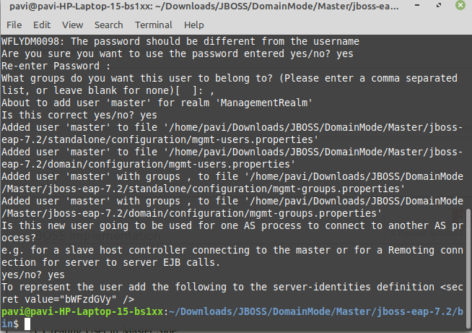

4. Change the Configuration in host-slave.xml

Location : JBOSS/DomainMode/Slave/jboss-eap-7.2/domain/configuration

- Added name for host as “slave1”

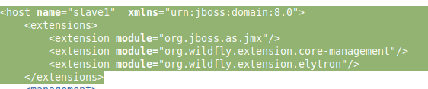

- Change the Master Port and name as the user of Master

<discovery-options>
<static-discovery name="primary" protocol="${jboss.domain.master.protocol:remote+http}" host="${jboss.domain.master.address}" port="${jboss.domain.master.port:9990}"/>
</discovery-options>

- Change from the above configuration to the mentioend below.

<discovery-options>
<static-discovery name="master" protocol="${jboss.domain.master.protocol:remote+http}" host="127.0.0.1" port="${jboss.domain.master.port:9990}"/>
</discovery-options>

name=”master” → this represent the user name of the Master Configuration
host-”127.0.01” → IP of the Master Configuration

<server-identities>
<secret value="c2xhdmVfdXMzcl9wYXNzd29yZA=="/>
</server-identities>

- Change the Secret Value from above configuration to an below one.

<server-identities>
<secret value="bWFzdGVy" />
</server-identities>

Above mentioned secret value is belong to the user of master’s.

- Change the Port of the Slave Configuration

<interface name="management">
<inet-address value="${jboss.bind.address.management:127.0.0.1}"/>
</interface>

<interface name="public">
<inet-address value="${jboss.bind.address:127.0.0.1}"/>
</interface>

From the Above to the Below mentioned one

<interface name="management">
<inet-address value="${jboss.bind.address.management:127.0.0.2}"/>
</interface>

<interface name="public">
<inet-address value="${jboss.bind.address:127.0.0.2}"/>
</interface>

- Now start the Server of both Master and Slave Configuration.

Start of the Master Server

- cmd to run both their configuration(Master and Slave)
- Location Path : till bin Folder

Master: ./domain.sh --host-config=host-master.xml

Slave : ./domain.sh --host-config=host-slave.xml

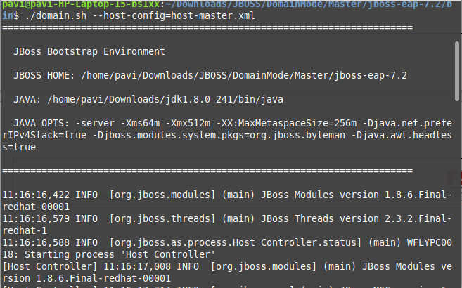

Start of the Slave Server

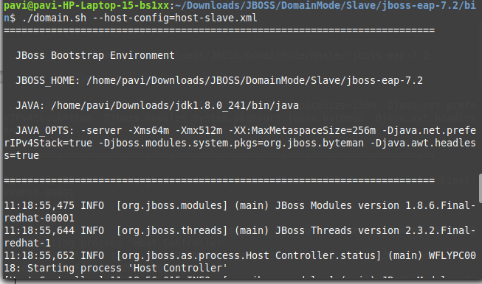

5. Login through Console by using master credentials and delete the Existing configuration and create a New Servers

- Logging with Master’s User Credentials

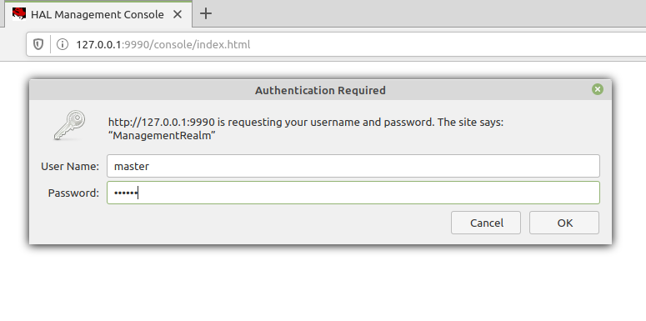
Runtime → Will display the servers which has been configured with the name of the slaves we have given in configuration file : host-slave.xml (Salve3)
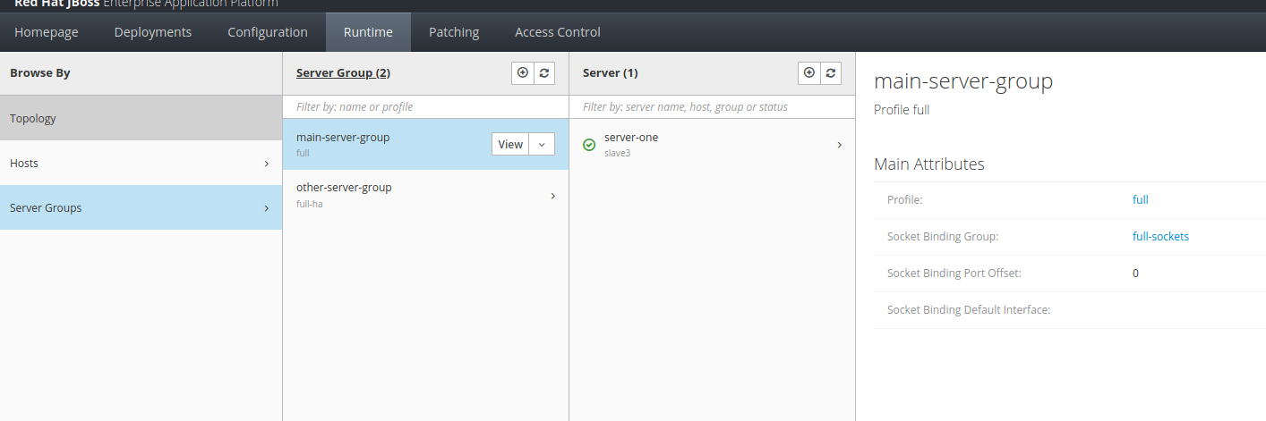

6. Stopping and adding new server and deploying war respectively

- Stop the Running Servers to add the New Servers

Runtime → Server Groups → Main Server Group → server One → Select Stop in the dropdown

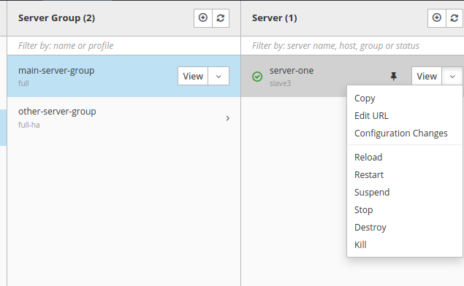

Runtime → Server Groups→ Other Server Group → server One → Select Stop in the dropdown

- Removing the Servers

Runtime → Server Groups→ main-server-group- →Server1→ Select Remove from the dropdown

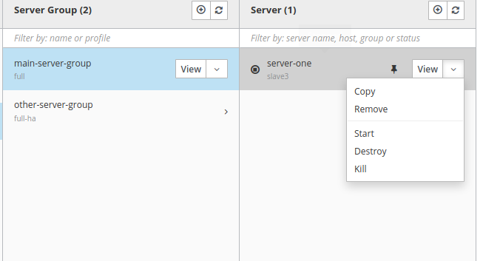
Runtime → Server Groups→ other-server-group- → Server1→ Select Remove from the dropdown

- Once it has been removed Add the two new Servers with different Port.

- Development Server : Port Offset :10

- UAT Server: Port Offset :20

Runtime → Server Groups→ main-server-group → Click Add Button

- Adding Development Server

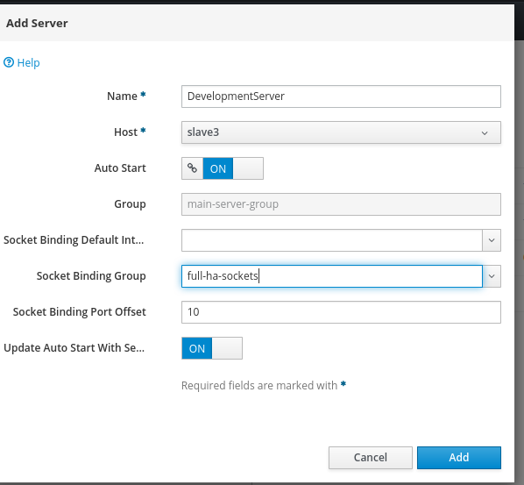

- Adding UAT Server

Runtime → Server Groups→ other-server-group → Click Add Button

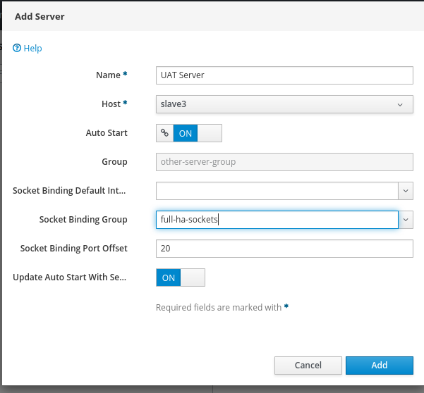

- Once the server has been added , deploy the WAR

Deployment → server groups → main-server-group → Click the Add button and choose your file.

- Adding Deployment into both the server

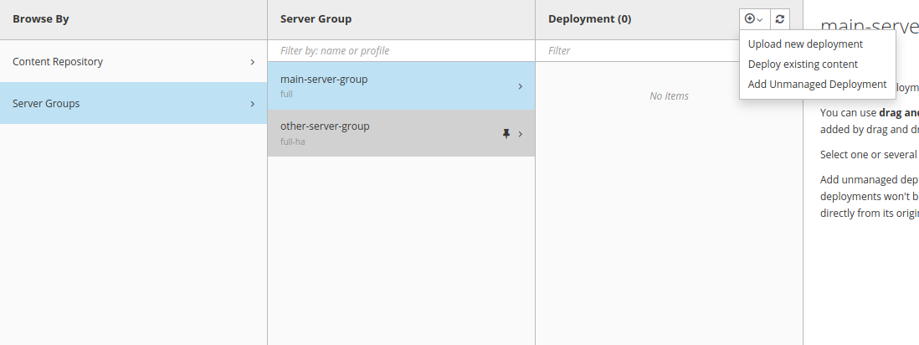

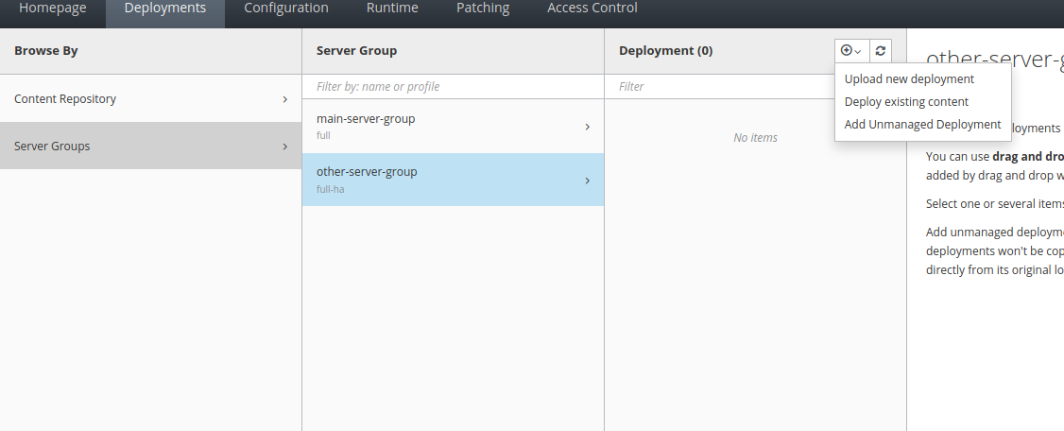

Deployment → server groups → other -server-group → Click the Add button and choose your file

- Once Deployment has been Added into the Server , Start the server

Runtime → server Groups → main -server -group → Development Server → Select Start from the Dropdown

Deployment → server groups → other-server-group → Click the Add button and choose your file.

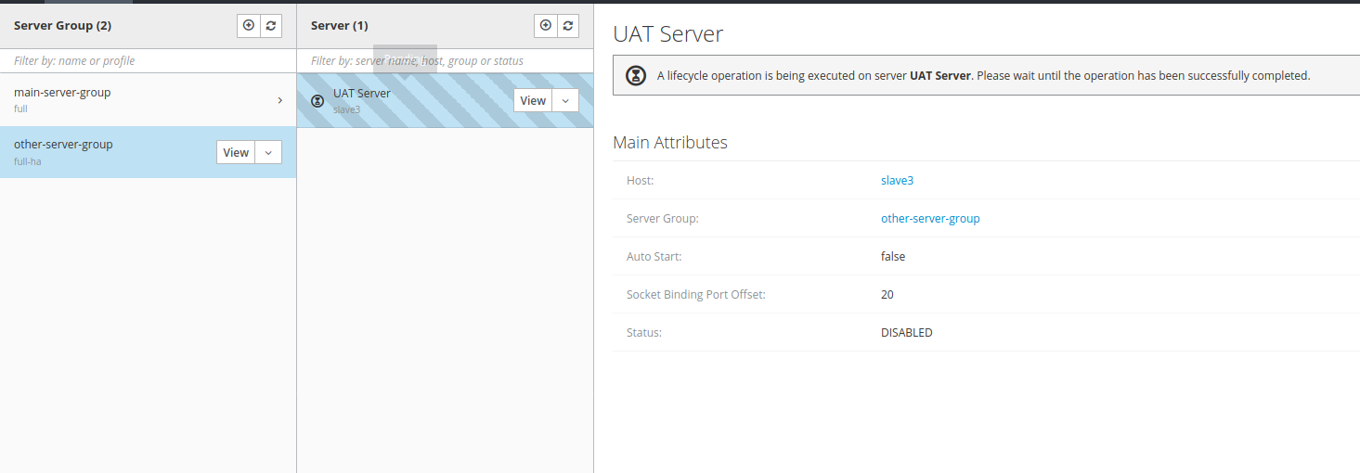

- Once the server has been added , WAR will be deployed automatically.

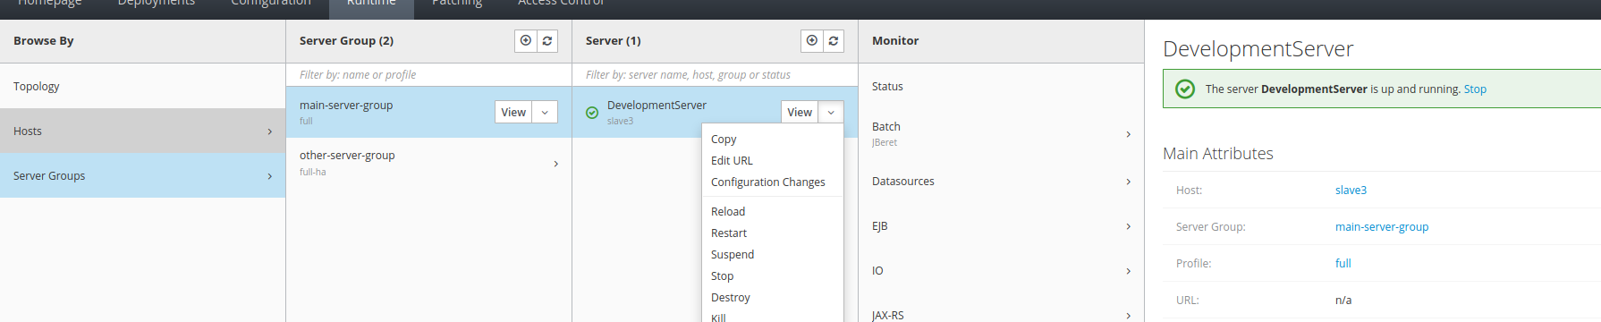

- Once WAR has been Deployed can be accessible through URL

http://127.0.0.2:8090/TASK2/ → Development URL

http://127.0.0.2:8100/TASK2/ → UAT URL

- Since these two war has been deployed with the different server both are independent, so that we can start and stop as our convenient

DEV Application :

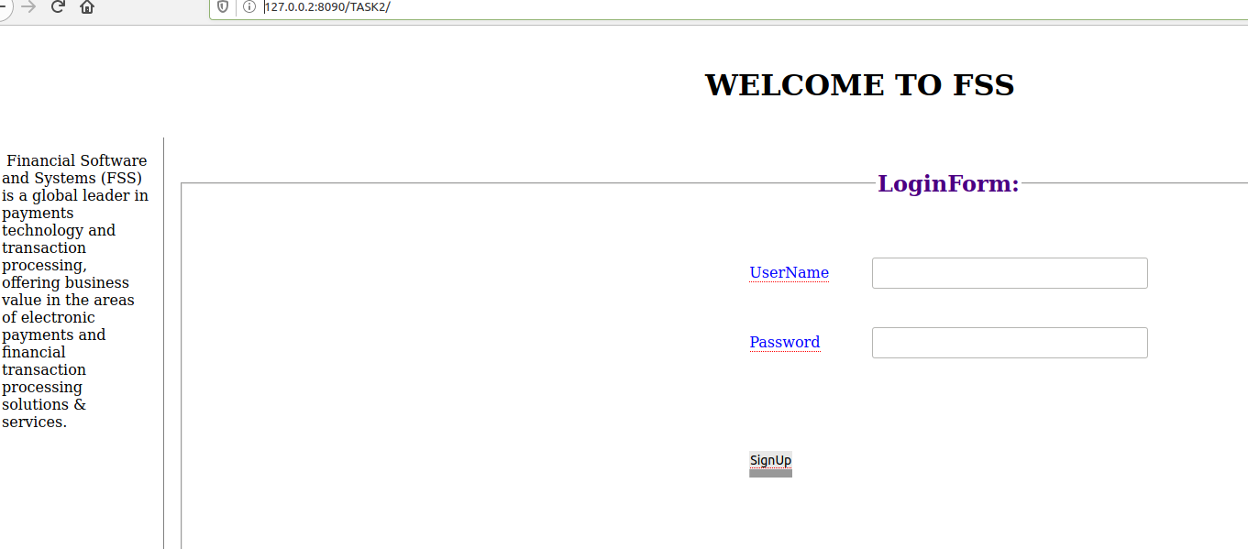

UAT Application :

