TASK-10

1.Using python pip command create a “requirement.txt” file from the terminal\command prompt of your system?

Creating a file as my environment and opening the folder.

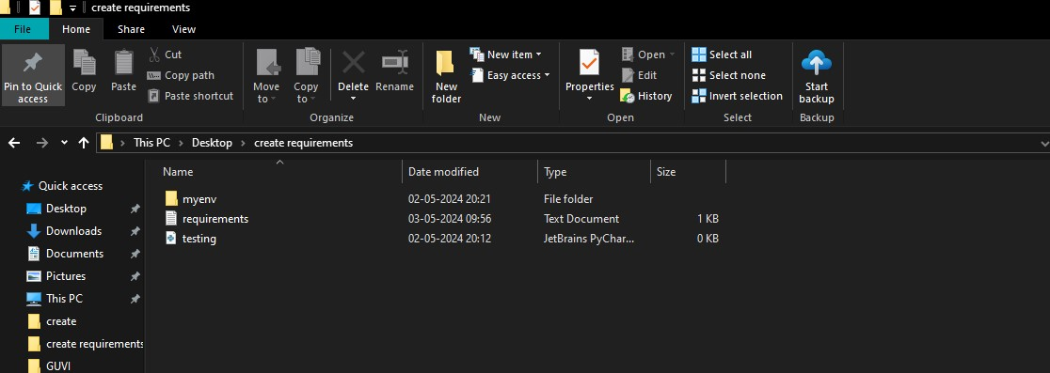

Installing pandas in terminal in myenv .

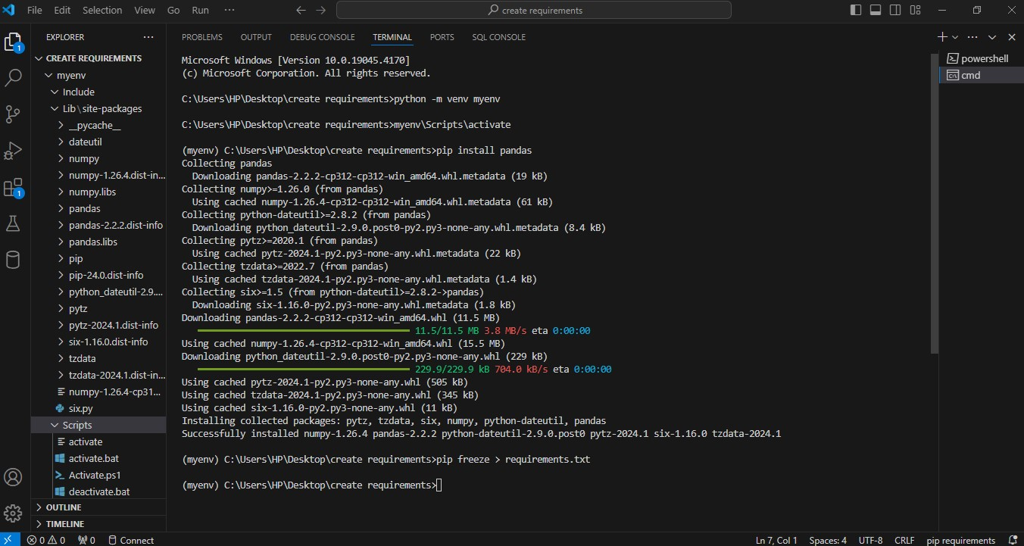

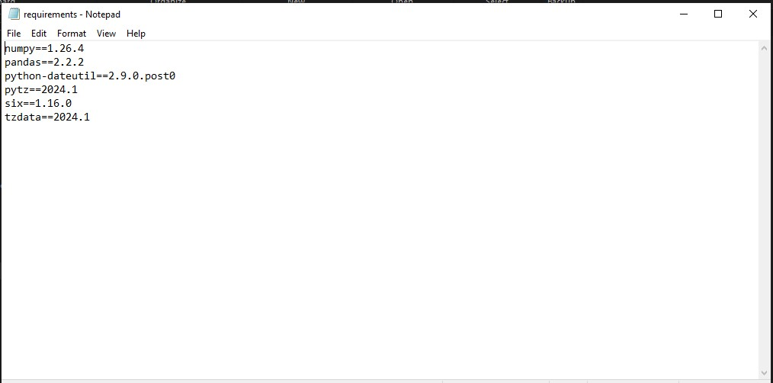

Viewing the package installed in myenv .