TASK-10

1.Using python pip command create a “requirement.txt” file from the terminal\command prompt of your system?

Creating a file as my environment and opening the folder.

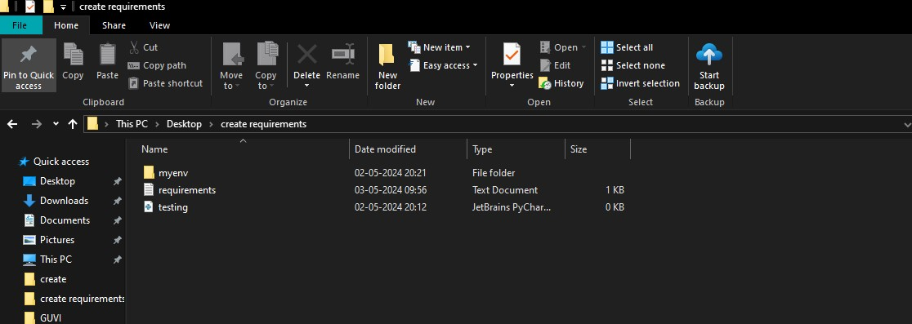

Installing pandas in terminal in myenv .

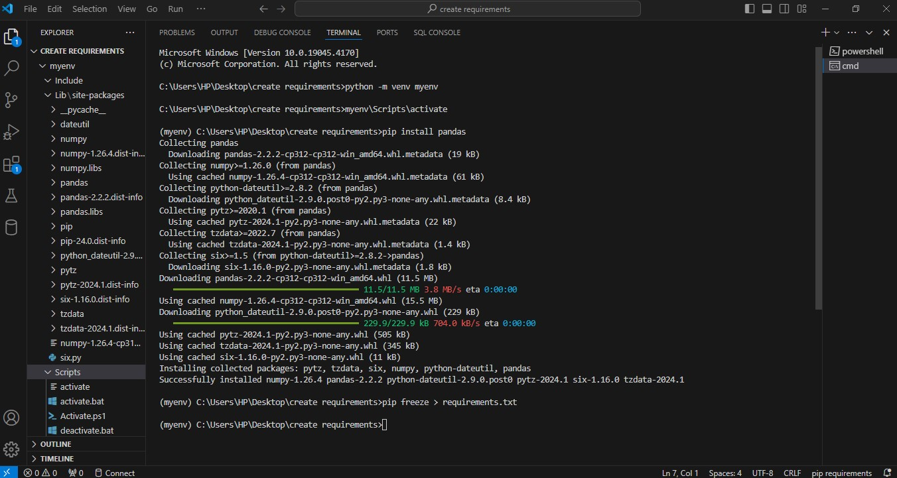

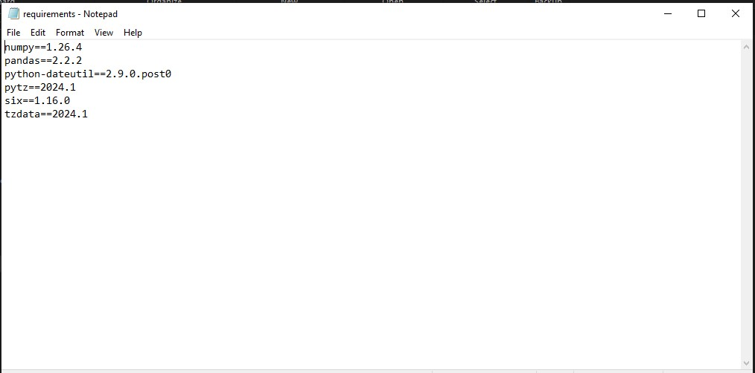

Viewing the package installed in myenv .

2.using python pip command install the flask module<2.0 into your system?

Install flask package

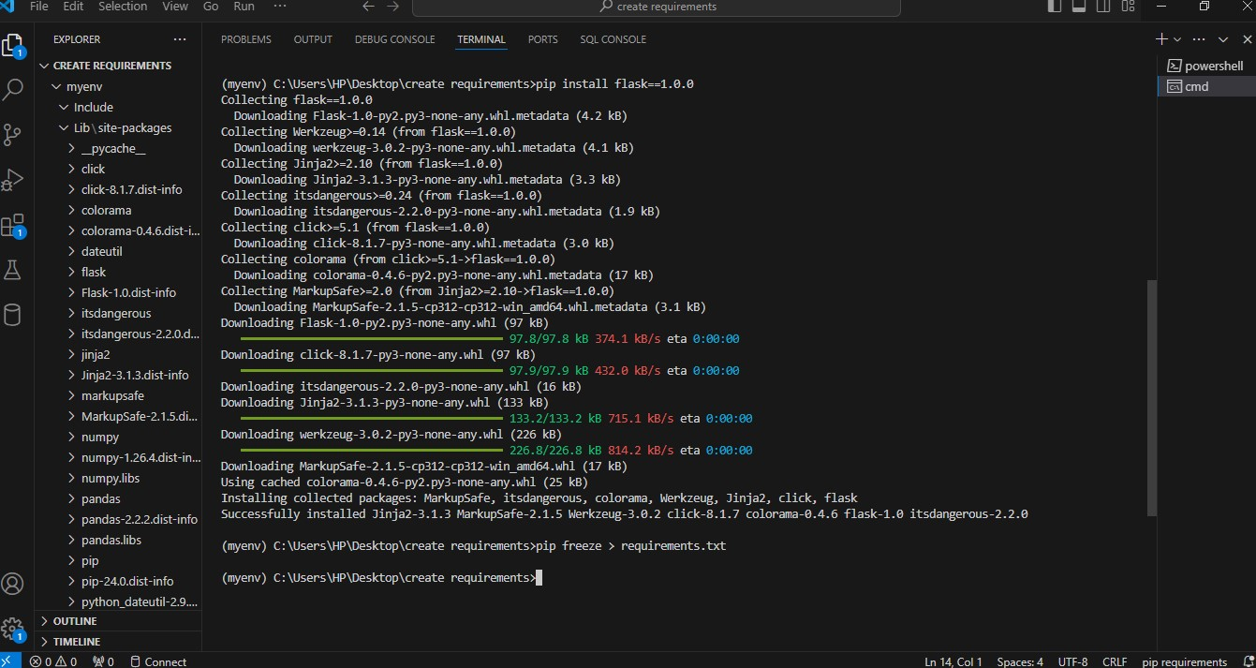

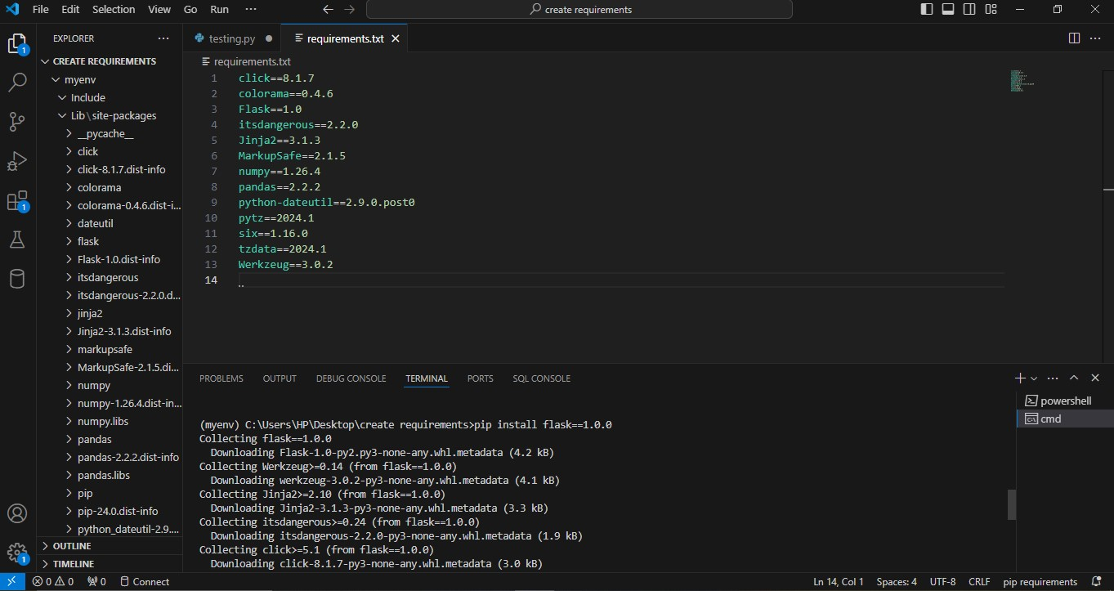

Using pip freeze requirement.txt installed packages are viewed.