Deployment Instructions

of

Pricing Skill on Amazon Echo

using Lambda function and EC2

Version: 3.0

Version Date: February 15, 2018

**Document Control**

**Document History**

|  |  |  |  |
| --- | --- | --- | --- |
| **Version** | **Author** | **Description** | **Date** |
| Version 1 | Krishnaveni Bujaranpally | DRAFT | January 16, 2018 |
| Version 2 | Krishnaveni Bujaranpally | DRAFT | January 24, 2018 |
| Version 3 | Krisnhnaveni Bujaranpally | FINAL | February 14, 2018 |
|  |  |  |  |
|  |  |  |  |
|  |  |  |  |

This document describes in detail the steps to deploy a Pricing Skill on Amazon Echo. A REST API has been developed which will be deployed on a EC2 instance and this will be consumed by the Lamda function running on cloud.

Sample Utterance : Alexa, ask Pricing Application what is the price for Amazon today

Amazon Echo : The price of Amazon is $$$.

Below are the steps to deploy the REST API on a EC2 instance. We will be choosing Ubuntu Server 16.04 LTS as the operating system for our EC2 instance.

Step 1: Login to the Amazon AWS portal using the credentials provided to you.

<https://aws.amazon.com/>

Step 2: Choose the solution that you would like to start, in this case launching a virtual machine.

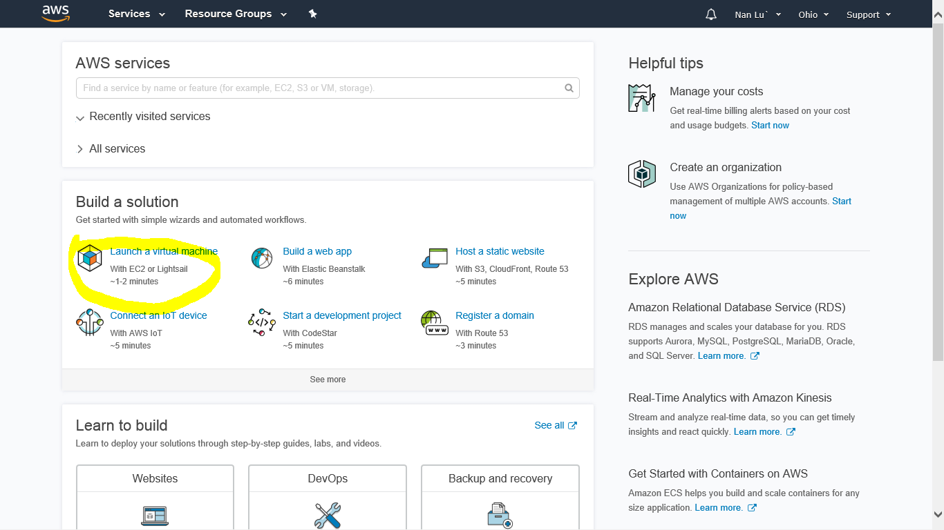

Step 3: Click on “Get Started” under EC2 instance.

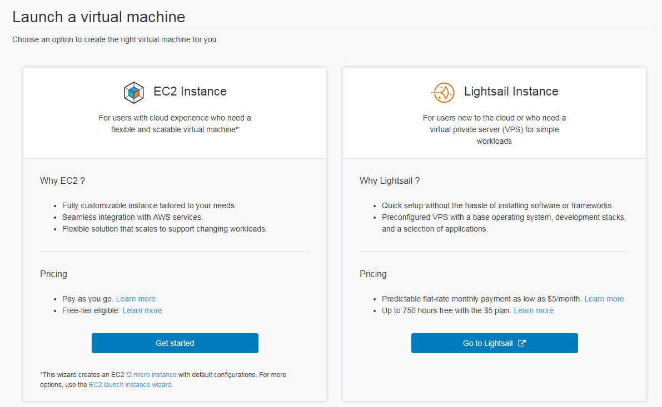

Step 4: Choose a name for your instance and click on “Use this name”.

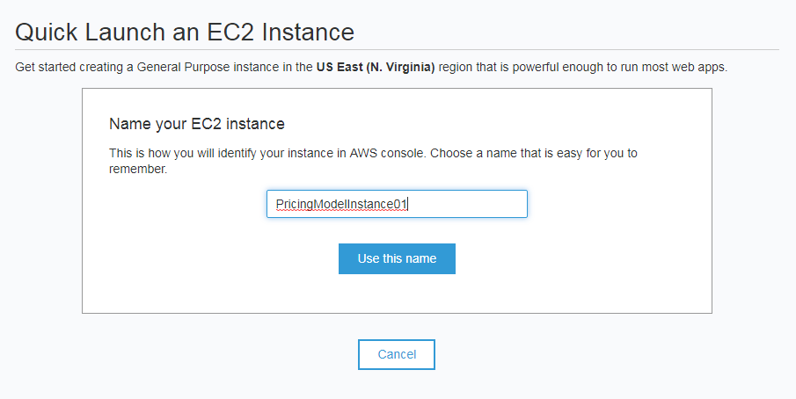

Step 5: Choose the OS you would like to use from the OS image library: for this exercise, we will choose the Ubuntu linux image, select the image and click on ‘Next’.

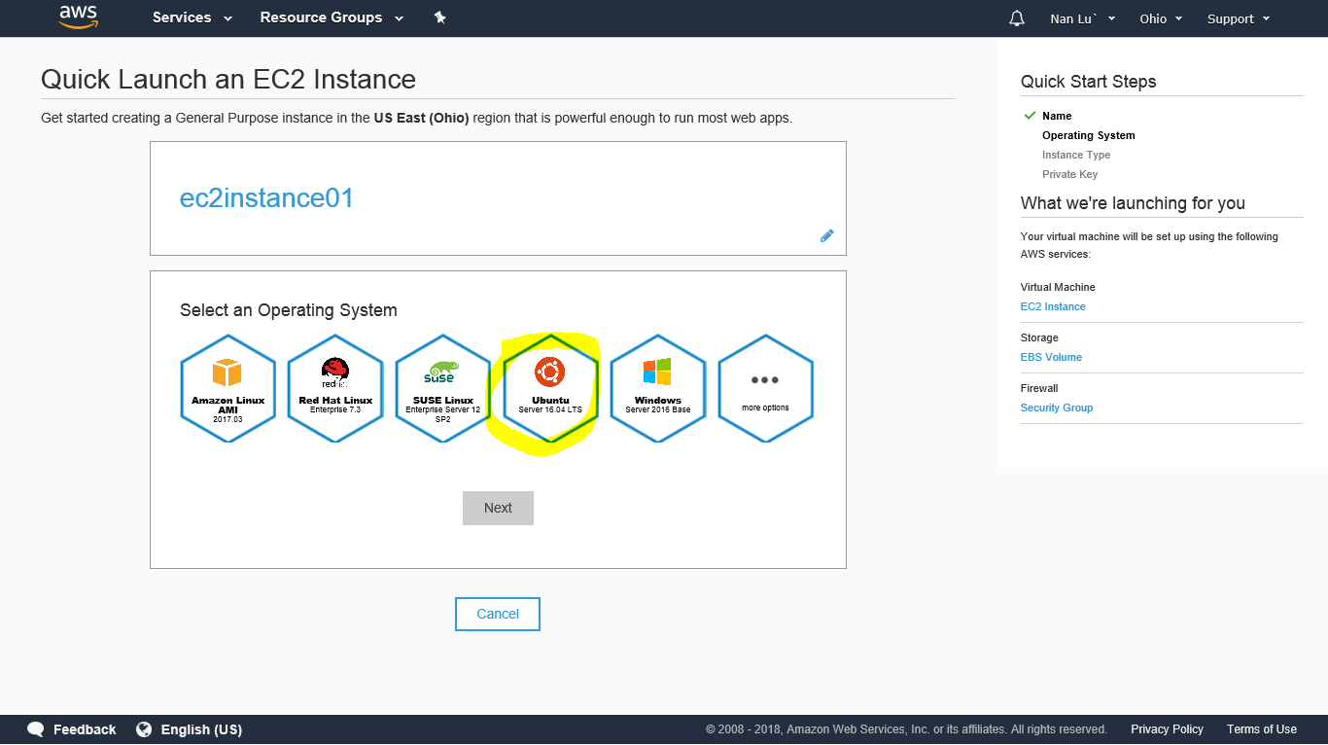

Step 6: Choose the free tier t2.micro configuration and click on “Next”. Click on “Download” to download the key in a secure location for the connection.

Make sure to save the key in a secure location as it cannot be recovered from AWS if lost. Click on “Okay!Start Download” to proceed with the download.

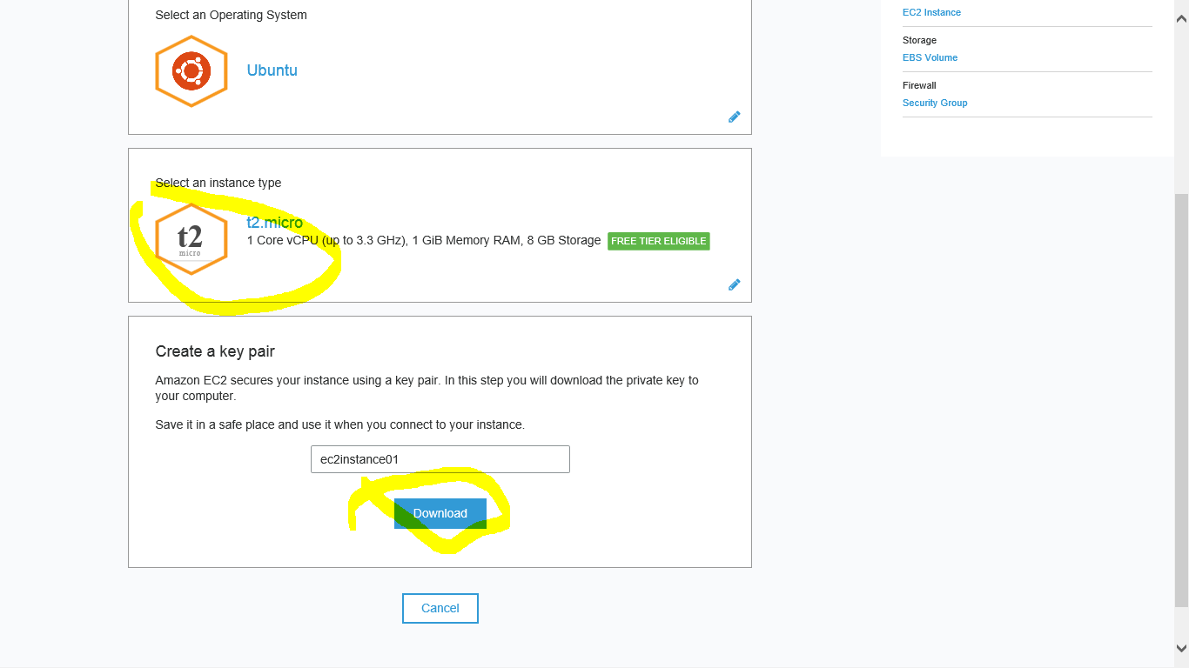

Step 7: After downloading the private key click on “Create this instance” to launch the instance.

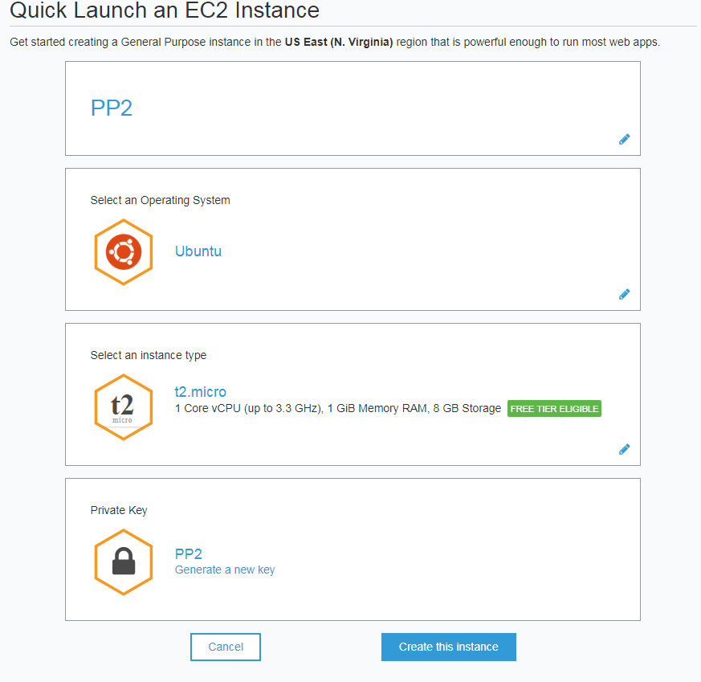

Step 8: After the instance is created successfully, click on “Proceed to EC2 console” to connect to the instance.

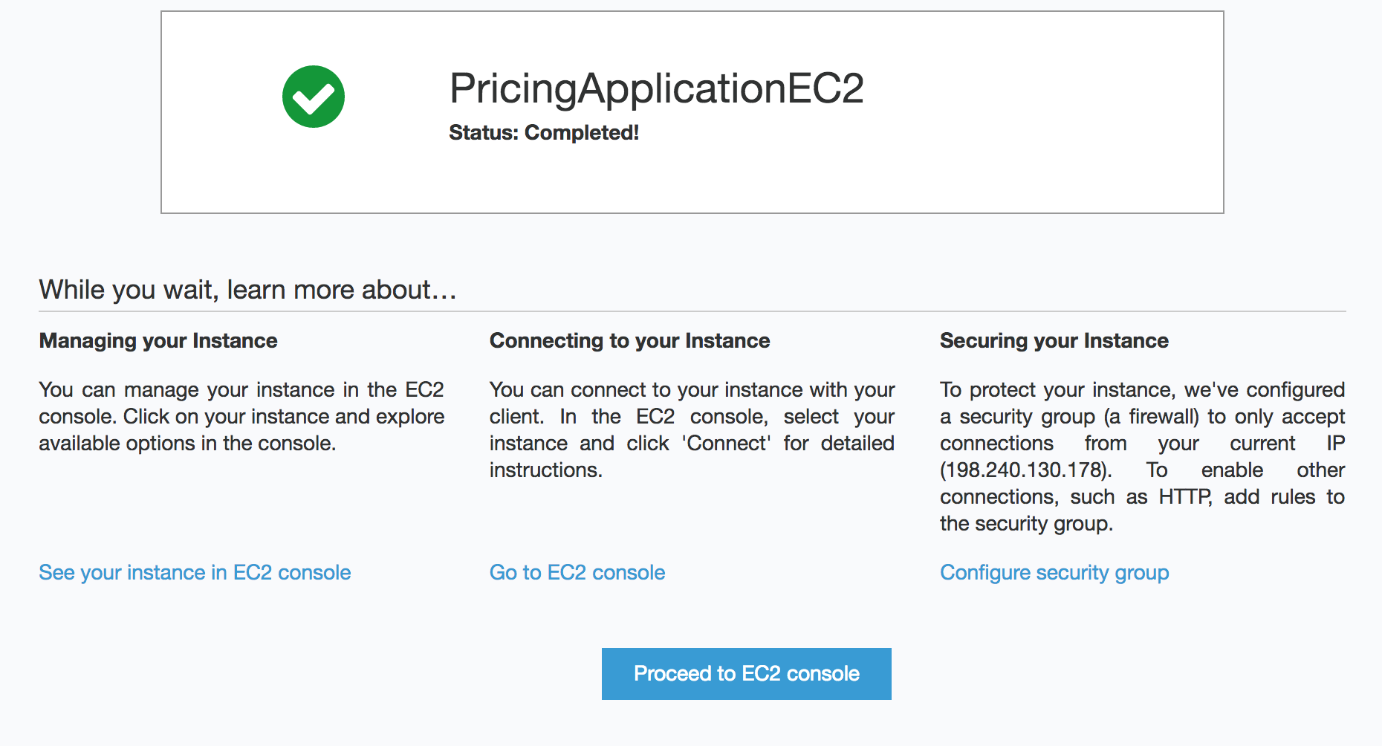

Step 9: Find your instance in the list, and make sure that the instance is in the running state. Select your instance and click on “Connect” for instructions to connect to the EC2 instance using the private key through SSH or putty.

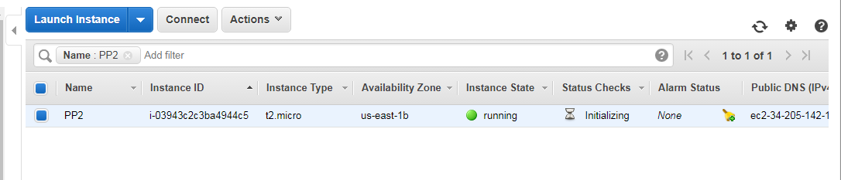

Step 10: After connecting to the EC2 instance, install nodejs and npm using the commands below (for Linux).

sudo apt-get update

sudo apt-get install nodejs-legacy

sudo apt-get install npm

Step 11: After installing nodejs and npm, clone the github repo using the below command

git clone <https://github.com/krishnavenib22/PricingSkill.git>

Step 12: Run the following commands inside of the folder PricingSkill/RestAPIEc2 to install dependencies

npm install

**companylist.csv file contains the details of all the companies listed under NASDAQ. We will be using this to get a mapping of company name and TICKER.

Step 13: Select “Security Groups” under Network and Security tab, and click on “Edit” under the Inbound tab to add a new rule to your server. Add HTTP type on port 80 and click on “Save”.

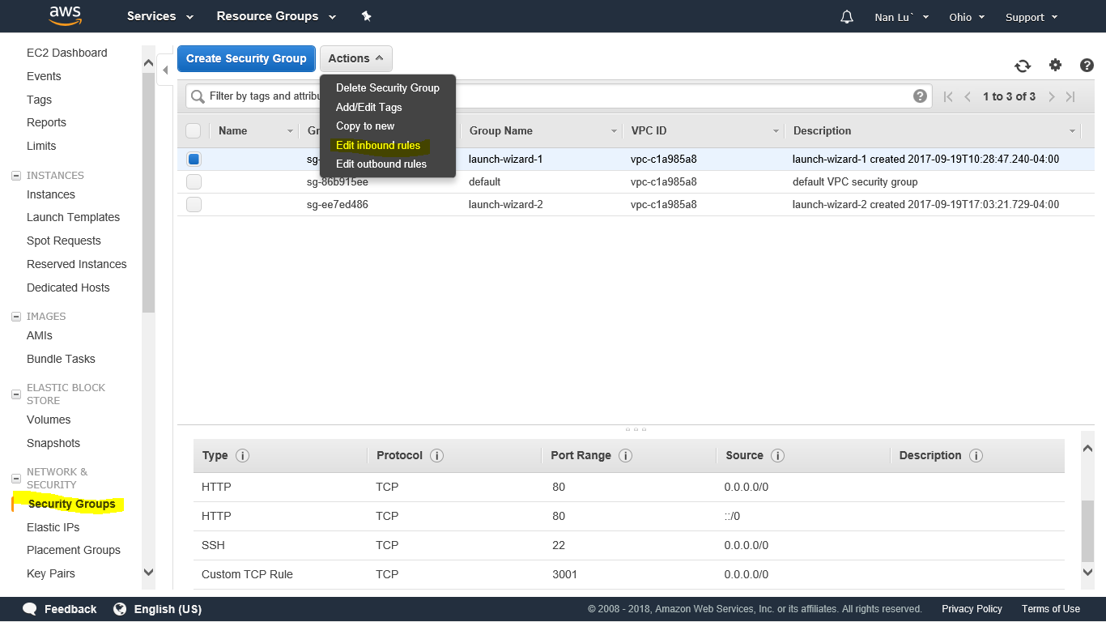

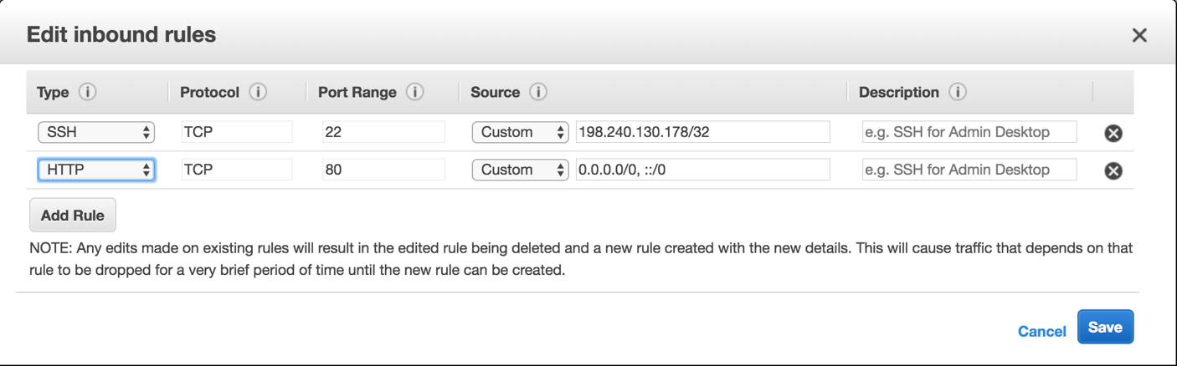

Step 14: Run the following command inside of PricingSkill/RestAPIEc2 to launch the HTTP server .

sudo node app.js

Step 15: To test the REST API, point your browser to your server to get the prices, for eg:

<http://ec2-52-90-97-81.compute-1.amazonaws.com/pricing?ticker=Alphabet%20Inc>

Below are the steps to create a Amazon Lambda function for the Pricing Skill which will consume the Rest API. Below steps can be done either on your local machine or in the cloud.

Step 1: Sign into <https://developer.amazon.com/>. (Create a developer account if you don’t already have one)

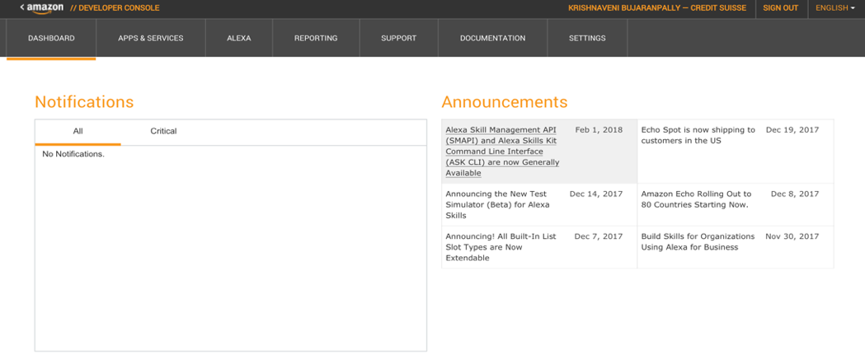

Click on the Alexa tab, and choose Get Started under Alexa Skills Kit.

Step 2: Click on Add a new skill button and enter the following details as shown in the below screen shot. Copy the Application Id for future reference and click on Next.

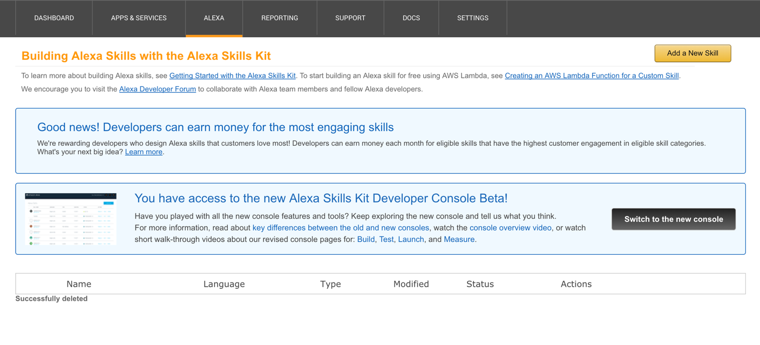

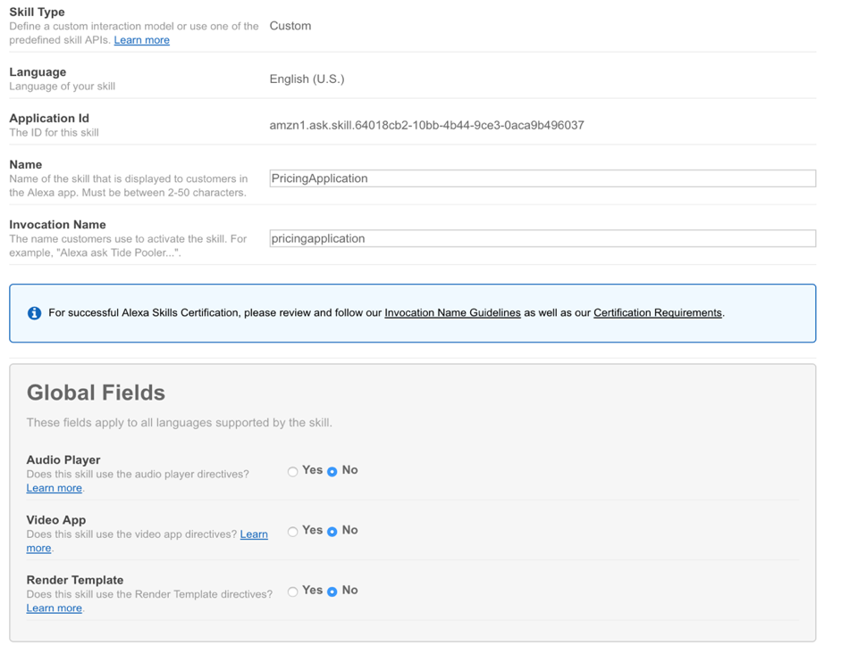

Step 3: Enter the following information in Intent Schema.

{

"intents": [

{

"slots": [

{

"name": "Ticker",

"type": "LIST_OF_TICKER"

},

{

"name": "Date",

"type": "AMAZON.DATE"

}

],

"intent": "GetPricing"

}

]

}

Step 4: Create a new custom slot type “LIST_OF_TICKER” and enter the following as sample values and click on “Add”.

Agilent Technologies

Apple Inc

Berkshire Hathaway

Citigroup

Alphabet Inc.

Harley-Davidson Inc.

Hewlett-Packard

Intel

The Coca-Cola Company

Southwest Airlines

Minnesota Mining and Manufacturing (3M)

Microsoft

AT&T

Target Corporation

Texas Instruments

Walmart

Step 5: Enter the following under Sample Utterances and click on Next. We will come back to this at a later point.

GetPricing what is the price for {Ticker} for {Date}

GetPricing give me the price for {Ticker} for {Date}

GetPricing get me the price for {Ticker} for {Date}

GetPricing tell me the price for {Ticker} for {Date}

GetPricing What is the price of {Ticker} for {Date}

GetPricing give me the price of {Ticker} for {Date}

GetPricing get me the price of {Ticker} for {Date}

GetPricing tell me the price of {Ticker} for {Date}

Step 6: Install node.js and npm on your local machines.

sudo apt-get update

sudo apt-get install nodejs-legacy

sudo apt-get install npm

Step 7: Clone the github repo using the following command

git clone <https://github.com/krishnavenib22/PricingSkill.git>

Step 8: Go the folder PricingSkill/LamdaFunction and run the following command to install dependencies.

npm install

Step 9: Go to the folder LambdaFunction and replace the APP_ID in index.js with the Application ID copied in Step 2, and the variable string in the function GetPrice with the URL of the EC2 instance that we created and save it.

Step 10: Create a zip file with all the contents in the folder LamdaFunction, but not including LambdaFunction. The contents of the zip file should be index.js, node_modules, package.json and package-lock.json.

Step 11: Sign into <https://aws.amazon.com/console/> with your credentials, and search for Lamda function in the search box.

Step 12: Click on create function and then enter the details shown in the following screen shot. Before selecting Choose an existing role, you need to create a custom role following the instructions in

<https://github.com/alexa/alexa-cookbook/blob/master/aws/lambda-role.md>

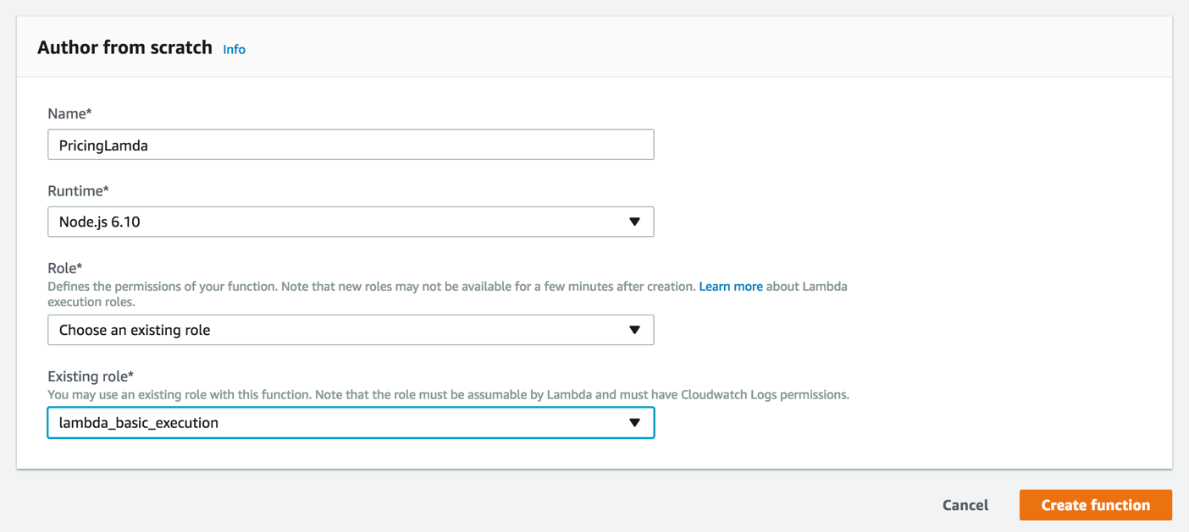

Step 13: Choose Upload a .zip file as the Code entry type in Function code and choose the .zip folder you created in Step 10.

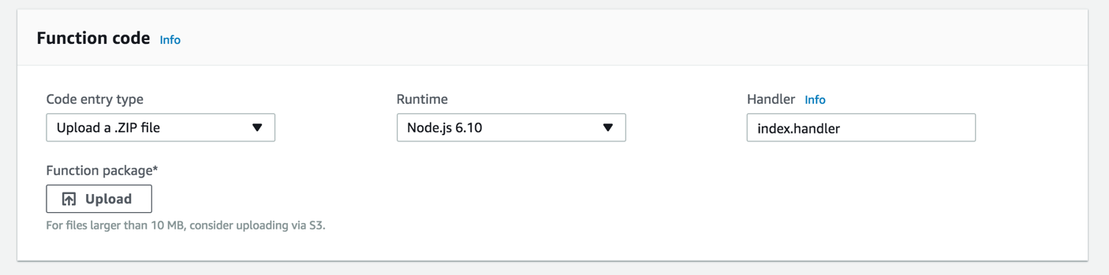

Step 14: Choose Alexa Skills Kit as a trigger under Designer and click on “Configuration required”.

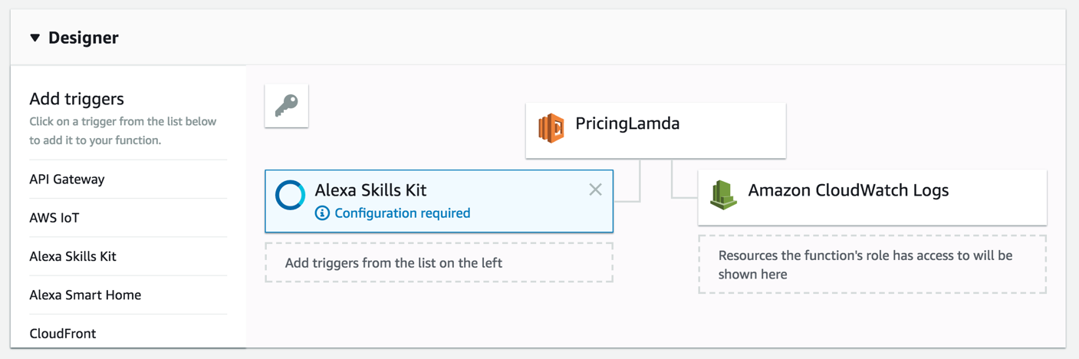

Step 15: Enter the Application Id copied in Step 2 under Skill ID and click on Add and save the configuration. Copy the ARN (Amazon Resource Number) for future reference.

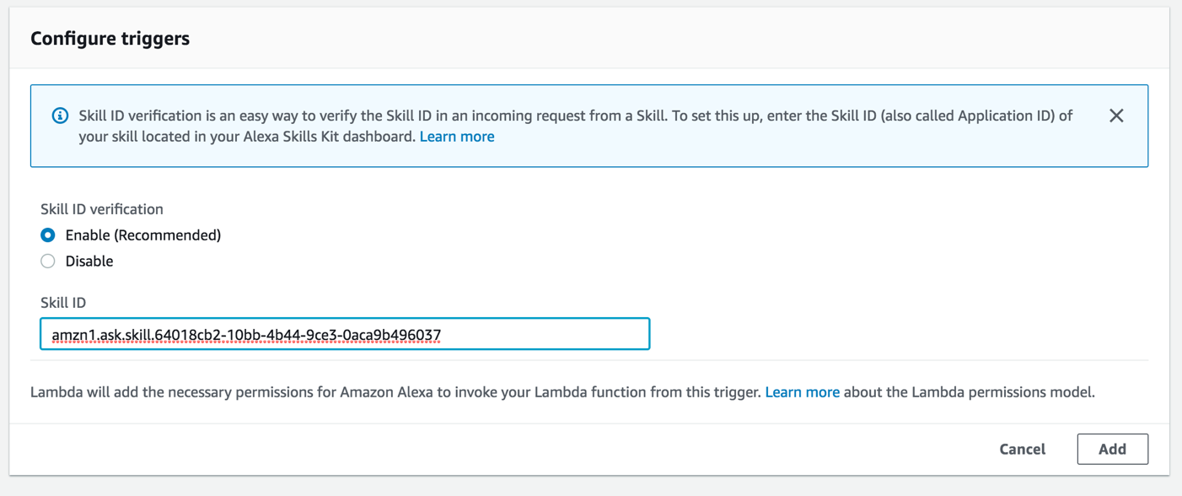

Step 16: In the configuration tab in the developer console (where we left, Step 5), choose ARN as the end point and enter the ARN number copied from Step 15 in Default field.

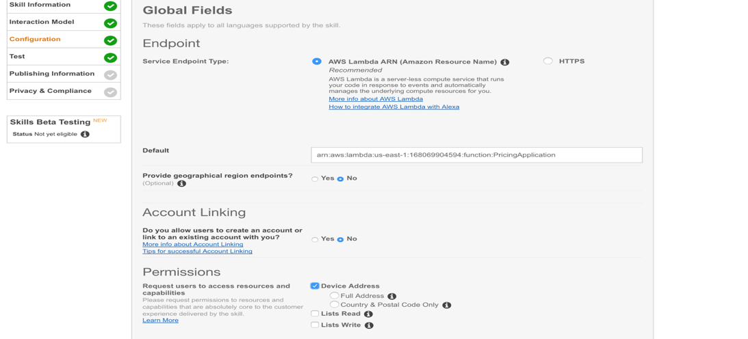

Step 17: Click on Next and test your Lambda function. Make sure that the HTTP server on the Ec2 instance is running before testing.

