Business Analyst — Technical Assessment
Question Set C — Answer Document
Dataset: hotel_bookings.csv (12,000 records, 28 columns)

Section 1 — Data Forensics

DQ1 — Bookings with num_rooms = 0
Answer: 60 bookings (0.50%) have num_rooms = 0, and all of them correctly carry total_amount = 0, confirming this is not a downstream calculation error.
Implication: the upstream booking pipeline does not enforce a num_rooms ≥ 1 constraint at the point of entry — a validation gap, not a pricing-engine bug.

DQ2 — Bookings before customer signup
Answer: 364 bookings (3.03%) have a booking_date earlier than customer_signup_date.
Two plausible explanations (not necessarily data corruption):
- System migration: customers migrated from a legacy system may show customer_signup_date as when their profile was created in the current system, not their true original signup — so genuine older bookings can appear to precede it.
- Timezone / batch-load timing: if booking_date and customer_signup_date are written by different services running on different clocks or batch schedules, a same-day signup-then-book sequence can register in reverse order without real corruption.

DQ3 — Bookings with no review, by status
Answer: 57.70% of all bookings have no review.
booking_status | % with no review | volume
Completed | 45.83% | 9,279
Cancelled | 97.88% | 2,360
No-Show | 100.00% | 361
Does the pattern make sense? Yes — a guest can only review a stay, so No-Show is 100% blank and Cancelled is nearly all blank. Completed still shows 45.83% blank, unsurprising since review submission is voluntary.

DQ4 — Undocumented data-integrity issue (discovery)
Issue found: total_amount formula violation. Recomputing the stated formula (adr × nights × num_rooms − discount_amount) and comparing it to the stored total_amount shows 35 bookings (0.29%) that disagree by more than Re 1 — split across Completed (26) and Cancelled (9) bookings, not concentrated in any one coupon code.
Why it matters: this is a pricing-integrity issue distinct from every footnote (which cover dates, IDs, encodings, and review scales — not the pricing formula itself).
Proposed handling rule: flag any row where |total_amount − expected_total| > Re 1 as a pricing-discrepancy record. Do not auto-correct total_amount; route these 35 rows to source-system reconciliation and exclude them from analyses that assume the stated pricing formula holds exactly.

Section 2 — Case Study: The VIP-vs-Volume Strategy
Briefing: the Head of Growth has Rs 50 lakh of incremental budget and must split it between acquiring new customers (Rs 3,000 CAC) and retaining at-risk existing customers (Rs 500/customer/year). This section defines VIP rigorously, characterizes VIP behaviour, and derives a budget split from the math.

CS1 — Define VIP Three Ways
Computed only over Completed bookings. Top 10% of 4,719 customers = 472 customers per definition: (i) total spend, (ii) booking count, (iii) LTV rate (spend ÷ months since signup, floored at 1 month).
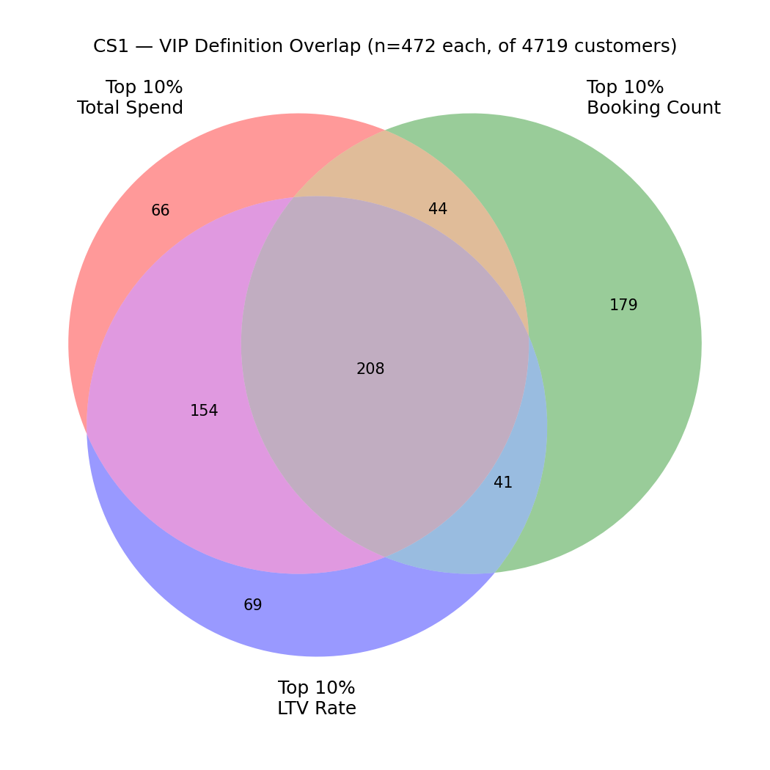
Overlap | Count | % of union (761)
All 3 definitions (true VIPs) | 208 | 27.3%
Exactly 2 definitions | 239 | 31.4%
Only 1 definition | 314 | 41.3%
Interpretation: only 208 customers qualify as VIP under all three definitions. Total Spend and LTV Rate overlap the most (362 shared) — big spenders tend to also spend fast. Booking Count is the outlier: 179 customers qualify only by frequency — frequent, low-value bookers, not high-revenue customers. This is exactly the ambiguity Operations flagged.

CS2 — VIP Risk Profile
Definition selected: Top 10% by Total Spend — most directly tied to revenue (the business objective), and already captures most of the LTV Rate group. Booking Count is excluded since it isolates low-value, high-frequency customers.
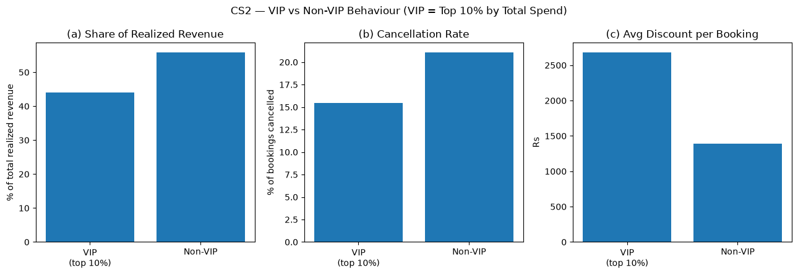
Metric | VIP (top 10%) | Non-VIP
Share of realized revenue | 44.1% | 55.9%
Cancellation rate | 15.4% | 21.1%
Avg discount per booking | Rs 2,684 | Rs 1,390
Verdict: VIPs are lower-risk — cancellation rate is 15.4% vs 21.1% for non-VIP (~27% relative reduction). The platform currently gives VIPs more discount, not fewer, in absolute rupee terms (Rs 2,684 vs Rs 1,390 per booking) — though as a % of gross booking value the gap nearly disappears (5.2% vs 5.5%), meaning the larger absolute discount mostly reflects VIPs booking bigger-ticket stays.
Combined picture: a segment that is only 8.6% of customers drives 44.1% of realized revenue and churns less — exactly the profile that makes the retention argument in CS3 worth running the numbers on.

CS3 — Acquisition vs Retention Math

(a) Acquisition
New customers acquirable: Rs 50,00,000 ÷ Rs 3,000 = 1,667
Average customer lifetime spend (Completed bookings): Rs 58,598
Year-1 revenue from acquisition spend = 1,667 × Rs 58,598 × 20% = Rs 1,95,32,790 (~3.9x return)

(b) Retention
Theoretically retainable customers: Rs 50,00,000 ÷ Rs 500 = 10,000
Metric | Value
Theoretical retainable customers | 10,000
Total customers in the entire dataset | 5,464
Actual VIP (high-value) customers | 472
Retainable budget as multiple of real VIP pool | 21.2x
What this tells us: spending the full Rs 50L on retention is not realistic — theoretical capacity (10,000) exceeds the entire customer base by 83%, and the real VIP pool by 21x. Retention budget should be capped at the size of the actual VIP pool, not the arithmetic ceiling.

CS4 — Recommendation + Leading Indicator
 | Amount | % of Rs 50L
Retention (covers all 472 VIPs @ Rs 500) | Rs 2,36,000 | 4.7%
Acquisition (remainder) | Rs 47,64,000 | 95.3%
Recommendation: Rs 2.36L to retention (100% VIP coverage), Rs 47.64L to acquisition — because the retention opportunity is capacity-constrained (only 472 real VIPs exist), while acquisition still has clear, uncapped ~3.9x year-1 ROI headroom. The Rs 47.64L acquires ~1,588 new customers, generating ~Rs 1.86 Cr year-1 revenue.
Why retention still matters despite the small rupee amount: the 472 VIPs sit behind Rs 12.2 Cr of annual realized revenue (44.1% of platform total). Spending Rs 2.36L to protect that — just 0.19% of the revenue at stake — is extremely high-leverage.
Leading indicator (first 90 days): 90-day repeat-booking rate among VIPs who received the retention offer, vs. a held-out control group of VIPs who did not. Among VIPs with any subsequent visit, 85.3% already rebook within 90 days with no intervention — the natural baseline. Treat the program as reaching genuinely at-risk customers only if the treated group's rate is at least 8-10 points above this baseline (≥93-95%); if uplift over control is under ~5 points, review the targeting criteria before committing further retention budget.

Section 3 — SQL Challenge
The dataset is denormalized. A normalized schema is designed below, and the required queries are written against it (verified by executing the equivalent SQL against the flat CSV loaded as a single table in SQLite).

Schema Design
CREATE TABLE customers (
customer_id INTEGER PRIMARY KEY,
customer_name VARCHAR(100) NOT NULL,
customer_segment VARCHAR(20) NOT NULL,
customer_signup_date DATE NOT NULL,
customer_home_city VARCHAR(50) NOT NULL,
customer_loyalty_tier VARCHAR(10) NOT NULL
);
CREATE TABLE properties (
property_id INTEGER PRIMARY KEY,
property_name VARCHAR(100) NOT NULL,
property_city VARCHAR(50) NOT NULL,
property_star_rating SMALLINT NOT NULL CHECK (property_star_rating BETWEEN 1 AND 5),
property_type VARCHAR(30) NOT NULL,
property_total_rooms INTEGER NOT NULL CHECK (property_total_rooms > 0),
UNIQUE (property_name, property_city) -- Footnote 5
);
CREATE TABLE bookings (
booking_id INTEGER PRIMARY KEY,
customer_id INTEGER NOT NULL REFERENCES customers(customer_id),
property_id INTEGER NOT NULL REFERENCES properties(property_id),
booking_date DATE NOT NULL,
checkin_date DATE NOT NULL,
checkout_date DATE NOT NULL,
room_type VARCHAR(20) NOT NULL,
num_rooms SMALLINT NOT NULL CHECK (num_rooms > 0), -- Footnote 3
nights SMALLINT NOT NULL CHECK (nights > 0),
booking_channel VARCHAR(20) NOT NULL,
adr DECIMAL(10,2) NOT NULL CHECK (adr > 0),
discount_amount DECIMAL(10,2) NOT NULL DEFAULT 0 CHECK (discount_amount >= 0),
coupon_code VARCHAR(20), -- NULL = no coupon (Footnote 4)
total_amount DECIMAL(12,2) NOT NULL CHECK (total_amount >= 0),
payment_method VARCHAR(20) NOT NULL,
booking_status VARCHAR(15) NOT NULL,
CHECK (checkout_date > checkin_date) -- Footnote 1
);
CREATE TABLE reviews (
review_id INTEGER PRIMARY KEY,
booking_id INTEGER NOT NULL UNIQUE REFERENCES bookings(booking_id),
review_rating DECIMAL(3,1) NOT NULL, -- Footnote 7
review_date DATE NOT NULL
);
CREATE INDEX idx_bookings_customer_checkin ON bookings (customer_id, checkin_date);
Design notes: booking_status / customer_segment use app-level validation instead of a DB-level CHECK IN (...) list, since new categories are a plausible business change. Reviews are a separate table so a review on a Cancelled booking (Footnote 6) is an explicit, checkable violation. All money columns use DECIMAL, never FLOAT, to avoid rounding drift.
Index justification: C-Q1 partitions/orders by (customer_id, checkin_date) for every completed booking — this composite index turns that sort into an index scan.

C-Q1 — Average total_amount by booking sequence
WITH numbered AS (
SELECT customer_id, total_amount,
ROW_NUMBER() OVER (PARTITION BY customer_id ORDER BY checkin_date) AS seq
FROM bookings
WHERE booking_status = 'Completed'
),
labeled AS (
SELECT CASE WHEN seq = 1 THEN 'first'
WHEN seq = 2 THEN 'second'
ELSE '3-or-later' END AS sequence_label,
total_amount
FROM numbered
)
SELECT sequence_label, ROUND(AVG(total_amount), 2) AS avg_total, COUNT(*) AS n
FROM labeled
GROUP BY sequence_label
ORDER BY CASE sequence_label WHEN 'first' THEN 1 WHEN 'second' THEN 2 ELSE 3 END;
sequence_label | avg_total | n
first | 29,765.24 | 4,719
second | 29,328.32 | 1,884
3-or-later | 30,197.68 | 2,676
Answer: average spend is essentially flat across booking sequence — no strong pattern of spending more, or less, as a customer returns.

C-Q2 — Top 5 properties by normalized average review rating (≥20 reviews)
Footnote 7: review_rating is on a 1-5 scale for Individual/Group customers but 1-10 for Corporate. Corporate ratings are divided by 2 before averaging.
WITH normalized_reviews AS (
SELECT b.property_id,
CASE WHEN c.customer_segment = 'Corporate' THEN r.review_rating / 2.0
ELSE r.review_rating END AS normalized_rating
FROM reviews r
JOIN bookings b ON b.booking_id = r.booking_id
JOIN customers c ON c.customer_id = b.customer_id
)
SELECT p.property_name, p.property_city, COUNT(*) AS num_reviews,
ROUND(AVG(nr.normalized_rating), 2) AS normalized_avg_rating
FROM normalized_reviews nr
JOIN properties p ON p.property_id = nr.property_id
GROUP BY p.property_id, p.property_name, p.property_city
HAVING COUNT(*) >= 20
ORDER BY normalized_avg_rating DESC
LIMIT 5;
property_name | property_city | num_reviews | normalized_avg_rating
Tusker Lodge | Mumbai | 91 | 3.95
Banyan Heights | Mumbai | 78 | 3.92
Crimson Residency | Chennai | 97 | 3.92
Mango Manor | Jaipur | 91 | 3.91
Pearl Retreat | Mumbai | 76 | 3.89
Note: queries were run against the flat CSV loaded as a single table; they work unchanged against the normalized schema above since customers/properties/bookings/reviews map 1:1 onto the flat CSV's columns. Full standalone SQL is also delivered as schema.sql and queries.sql in the code/ folder.

