DSAA ASSIGNMENT 3
Name:Boddu Venkata Krishna Vinay
Roll No.:201501222
CSE

2.
for (45,420),
outputimage =

196 202 195 192 126 76 55 42
195 198 197 189 133 78 57 51
199 200 199 194 149 83 54 43
193 201 193 195 157 80 52 55
200 195 202 197 149 71 49 60
192 204 201 197 139 65 59 45
191 193 198 192 127 67 60 58
193 192 199 190 127 72 74 62

outputDCT =

287.7500 248.6693 -12.8347 -81.3074 3.5000 38.6439 -5.5076 -29.6091
4.1718 3.0647 1.7974 5.1075 2.3008 -5.3716 -4.8122 0.6541
-15.3957 -0.9591 14.9121 -6.4836 -11.9804 10.2532 7.2552 -11.1191
0.2433 2.9303 2.2072 -4.6059 -3.9145 2.5832 -0.1947 -5.6933
1.0000 -0.8022 -1.4022 2.9298 3.7500 -0.3188 -0.7722 1.5154
-1.1389 -1.9458 -1.2578 0.7296 0.3654 -2.7581 -4.3026 -2.6733
5.2947 3.6561 -1.2448 -0.8679 -0.1789 -2.2374 -2.4121 -0.3939
1.1684 1.8005 1.2375 0.4751 2.2638 5.2466 5.1065 2.2993

quantisedDCT =

9 11 -1 -3 0 0 0 0
0 0 0 0 0 0 0 0
-1 0 0 0 0 0 0 0
0 0 0 0 0 0 0 0
0 0 0 0 0 0 0 0
0 0 0 0 0 0 0 0
0 0 0 0 0 0 0 0
0 0 0 0 0 0 0 0

reconstructed =

183.0081 195.9551 200.1918 179.4677 143.9191 119.3683 118.1930 127.3132
185.6869 198.6339 202.8706 182.1465 146.5979 122.0471 120.8718 129.9920
189.4752 202.4222 206.6589 185.9349 150.3863 125.8354 124.6602 133.7803
192.1540 205.1010 209.3377 188.6137 153.0651 128.5142 127.3390 136.4591
192.1540 205.1010 209.3377 188.6137 153.0651 128.5142 127.3390 136.4591
189.4752 202.4222 206.6589 185.9349 150.3863 125.8354 124.6602 133.7803
185.6869 198.6339 202.8706 182.1465 146.5979 122.0471 120.8718 129.9920
183.0081 195.9551 200.1918 179.4677 143.9191 119.3683 118.1930 127.3132

error =

331.6851

for (298,427):
outputimage =

188 194 186 173 164 169 180 187
186 173 153 158 172 195 204 211
177 164 176 186 207 210 216 216
178 179 197 197 196 205 201 206
158 179 173 186 183 184 194 187
171 158 177 180 185 179 178 182
176 174 183 177 174 180 176 181
183 184 170 180 177 172 182 174

outputDCT =

446.6250 -49.0223 12.6057 1.4379 1.3750 3.5618 0.0552 0.0240
25.7629 -22.1644 25.4454 4.5105 -3.1688 -3.2109 2.3184 -0.7493
-28.8857 35.1789 28.5323 2.0974 -1.6816 -1.7996 -4.7808 -2.4104
-34.1907 25.2713 -0.5697 -14.2621 -3.6621 -1.2602 1.1090 -0.7632
3.8750 26.8691 -5.9664 -15.5617 -9.3750 -1.0841 -11.4644 -5.8650
18.2917 15.1930 -12.4891 -13.5383 -2.0626 1.4619 14.5360 4.1699
5.0646 0.1480 -13.7808 -0.1134 8.6792 3.3819 -0.2823 8.4648
-1.4562 -4.0275 -4.8551 -2.6877 -4.2698 -1.9194 -8.6680 -0.5353

quantisedDCT =

14 -2 1 0 0 0 0 0
1 -1 1 0 0 0 0 0
-1 1 1 0 0 0 0 0
-1 1 0 0 0 0 0 0
0 1 0 0 0 0 0 0
0 0 0 0 0 0 0 0
0 0 0 0 0 0 0 0
0 0 0 0 0 0 0 0

reconstructed =

201.9602 191.2579 175.6573 163.4372 160.6325 167.6704 179.3047 187.8604
177.7340 173.9577 169.8936 170.2806 177.9734 191.8008 206.7442 216.4083
166.9939 169.0694 173.9281 182.2781 193.8719 206.9444 218.4818 225.2798
177.1808 180.3049 185.4932 191.1297 195.7721 198.7137 200.0907 200.5197
179.0615 181.9039 185.9310 188.7971 188.8410 186.0558 182.0907 179.2818
168.2763 171.0761 175.4483 179.5940 182.0809 182.5303 181.6752 180.7787
171.0317 171.5702 172.7475 174.6421 177.1478 179.8831 182.2493 183.6286
186.8632 183.9453 179.5066 175.5703 173.6887 174.1482 175.9259 177.4036

error =

55.9534

ans =

1

for (230,30):
outputimage =

187 185 182 187 183 186 184 184
187 185 182 187 181 185 181 182
183 185 192 183 194 186 178 189
186 184 185 191 179 186 183 181
183 184 187 178 190 182 181 187
188 181 182 189 184 184 185 181
181 181 180 185 186 185 183 184
182 185 187 184 187 181 185 186

outputDCT =

459.1250 2.1864 -4.2647 -0.2507 4.6250 -1.3702 2.4430 -0.5847
2.5832 4.1411 1.0057 1.1200 -0.2897 -0.2234 2.9370 -4.3226
-0.6553 -1.6590 1.5884 0.7154 -0.1469 1.3229 -3.4383 -2.2307
-3.0942 -0.6409 2.6488 5.2795 1.3822 4.8957 -2.6588 -2.4412
0.3750 0.5310 2.6083 -2.3712 -2.6250 0.3442 -1.2157 1.0196
0.2241 -1.6090 -2.4108 1.2012 0.0109 3.6724 -0.0564 -4.9516
5.2775 0.4957 -1.6883 -1.5126 1.2785 -1.7092 1.4116 4.4922
1.3750 -4.5171 -0.9893 -1.9659 0.9710 -12.8298 3.0179 9.4070

quantisedDCT =

14 0 0 0 0 0 0 0
0 0 0 0 0 0 0 0
0 0 0 0 0 0 0 0
0 0 0 0 0 0 0 0
0 0 0 0 0 0 0 0
0 0 0 0 0 0 0 0
0 0 0 0 0 0 0 0
0 0 0 0 0 0 0 0

reconstructed =

183.0000 183.0000 183.0000 183.0000 183.0000 183.0000 183.0000 183.0000
183.0000 183.0000 183.0000 183.0000 183.0000 183.0000 183.0000 183.0000
183.0000 183.0000 183.0000 183.0000 183.0000 183.0000 183.0000 183.0000
183.0000 183.0000 183.0000 183.0000 183.0000 183.0000 183.0000 183.0000
183.0000 183.0000 183.0000 183.0000 183.0000 183.0000 183.0000 183.0000
183.0000 183.0000 183.0000 183.0000 183.0000 183.0000 183.0000 183.0000
183.0000 183.0000 183.0000 183.0000 183.0000 183.0000 183.0000 183.0000
183.0000 183.0000 183.0000 183.0000 183.0000 183.0000 183.0000 183.0000

error =

27.5500

images are
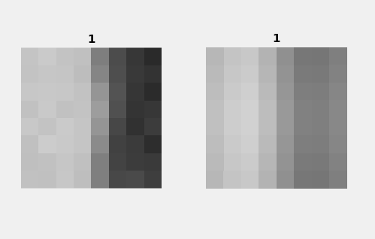
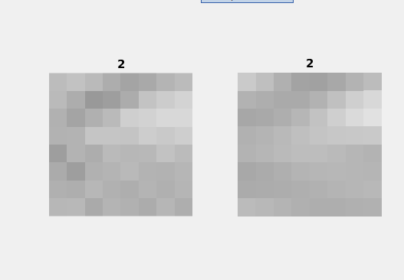
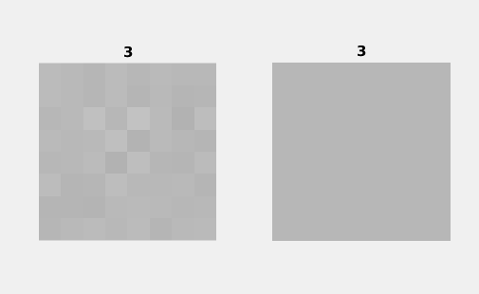
because of lossy compression. the block has lesser color variation the original image as can be seen clearly in images

3.Since the quantisation matrix weights increases at the bottom.
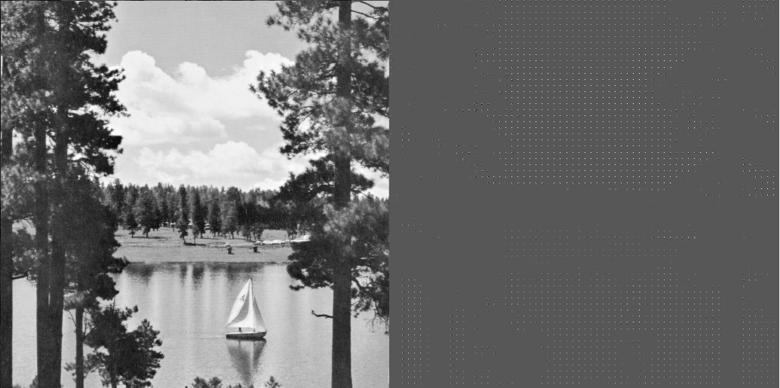

We notice dots whenever there is a difference in color. On dequantization followed by iDCT, we will get tge original image back.

5.

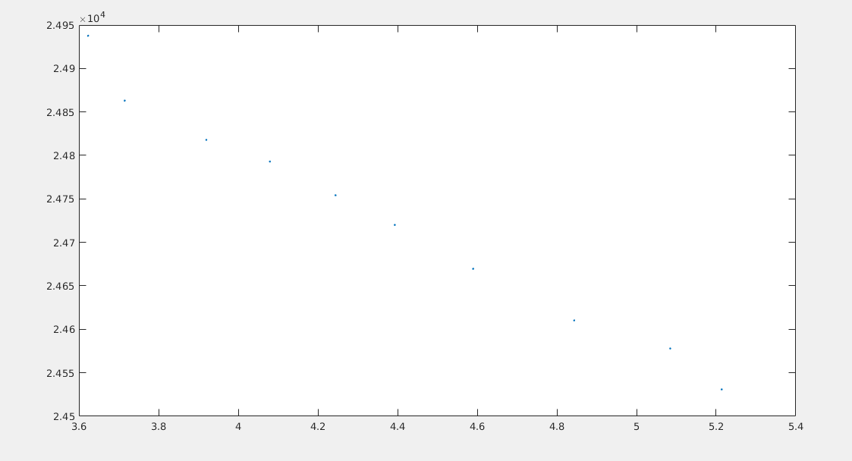

The plot shows higher entripy initially, which gradually reduces with c s increase.. and increase in rmse

4.

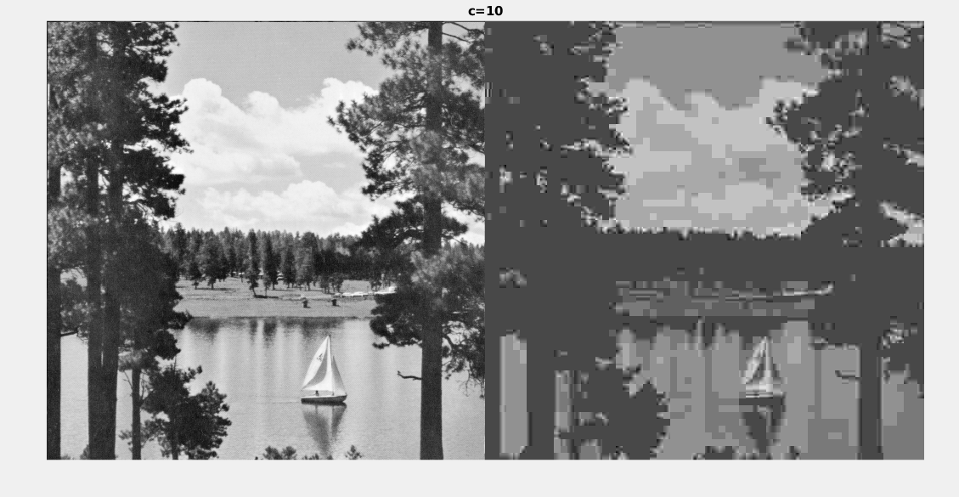
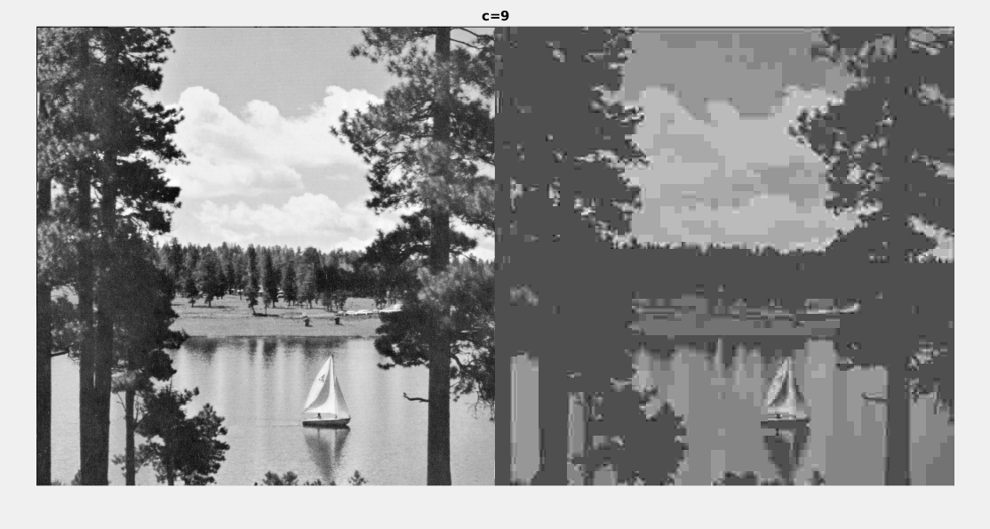

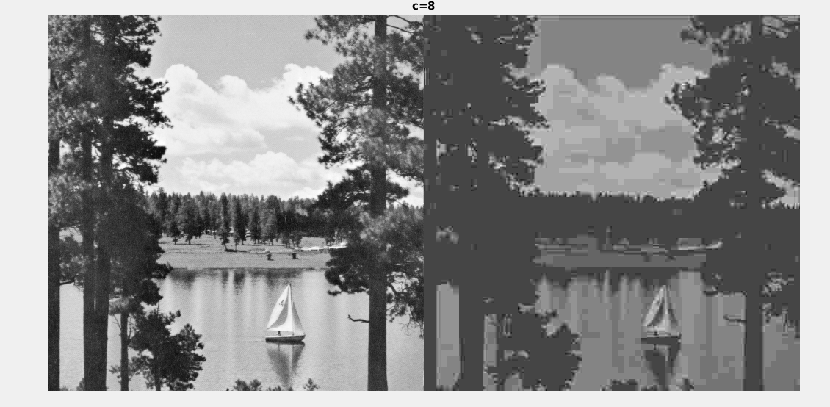
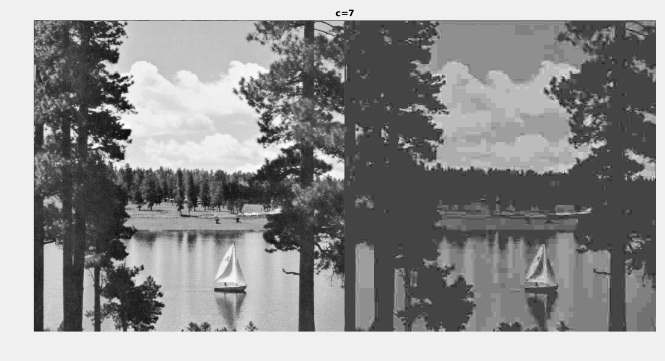

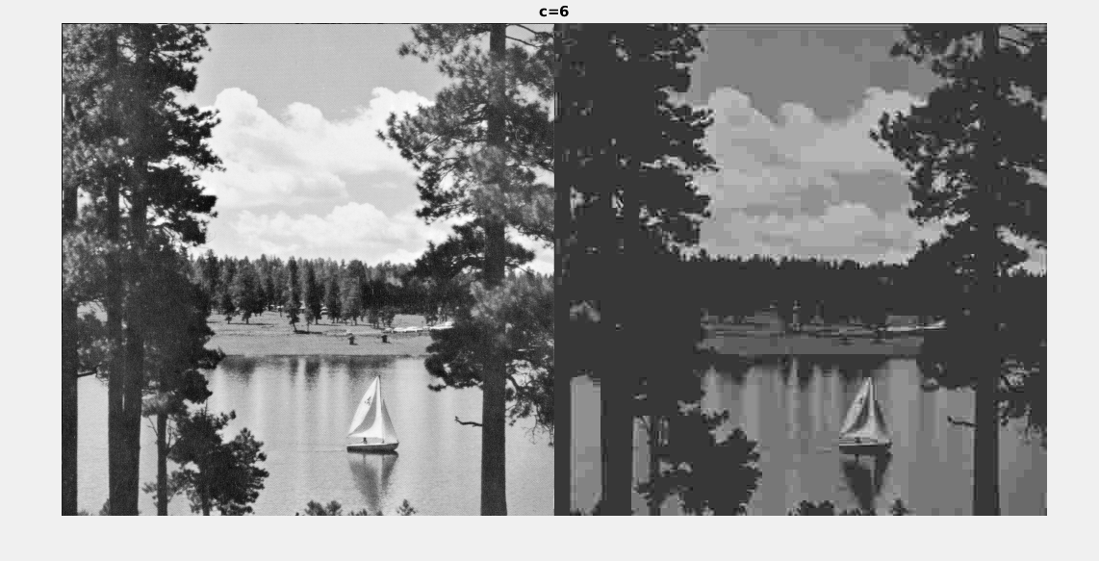
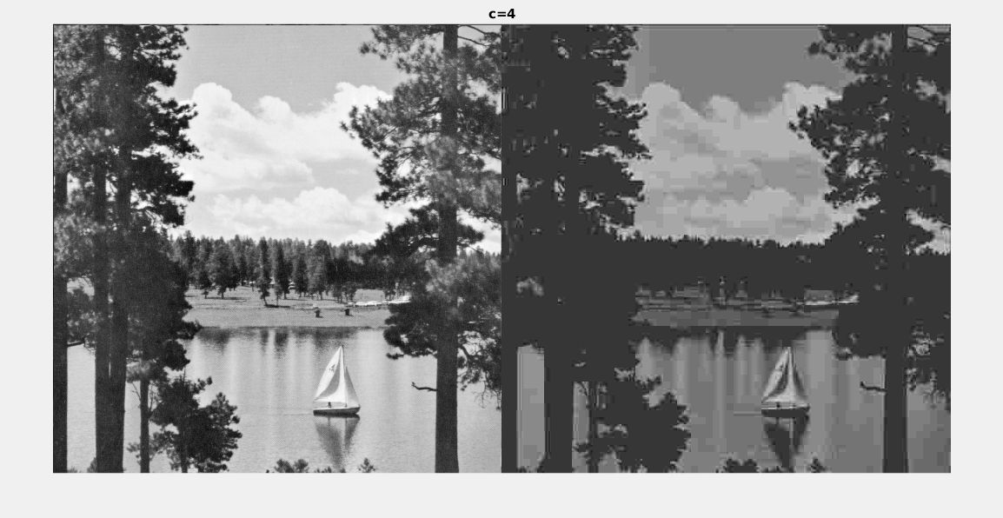

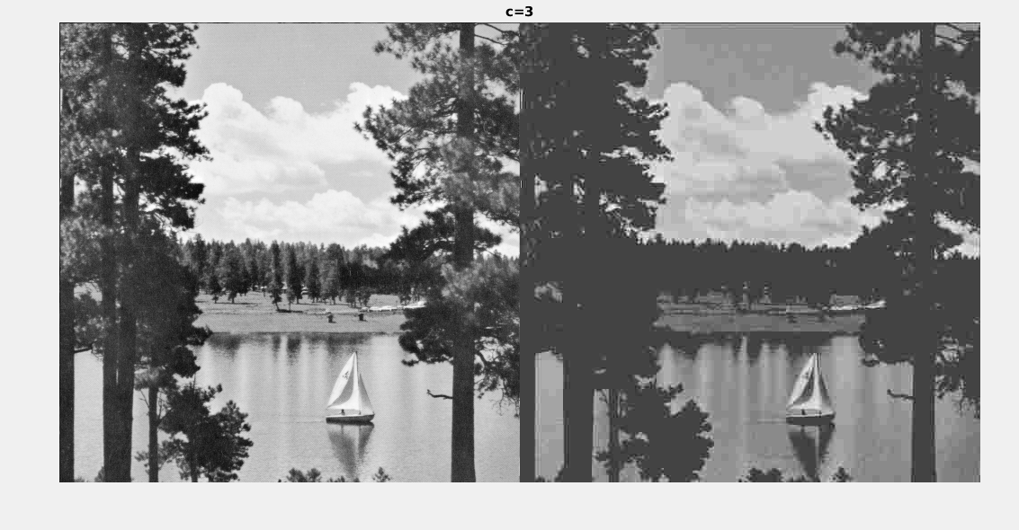
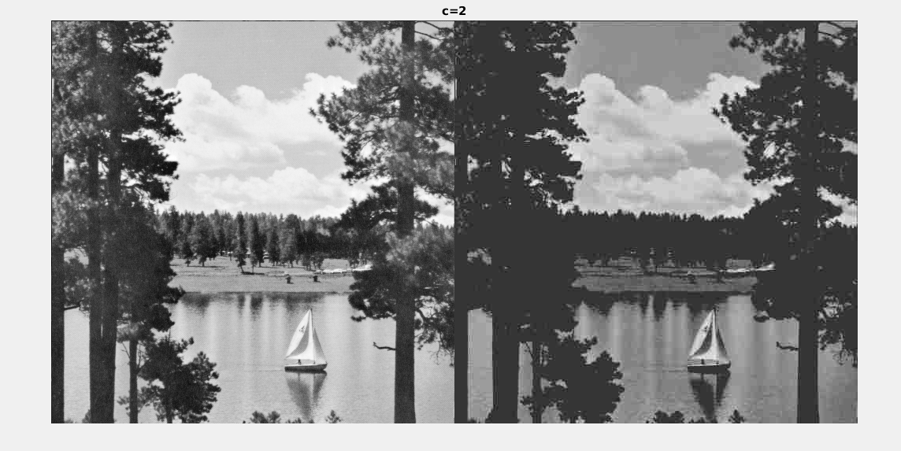
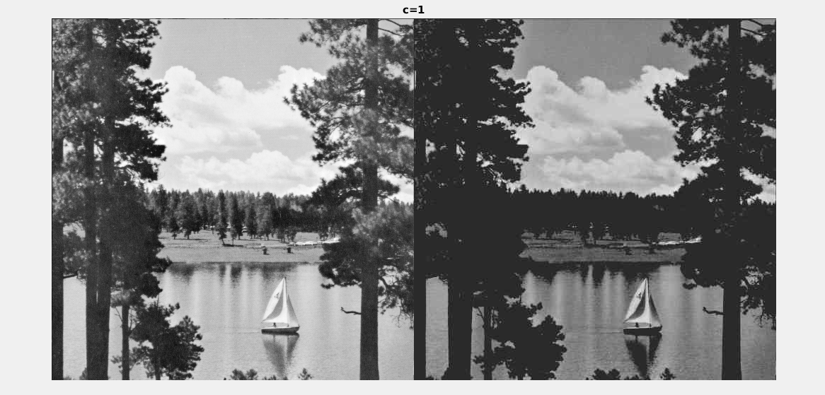
rmserror =

1.0e+04 *

2.4531 2.4578 2.4610 2.4670 2.4720 2.4754 2.4793 2.4818 2.4863 2.4938

entro =

5.2137 5.0846 4.8435 4.5899 4.3931 4.2442 4.0795 3.9199 3.7150 3.6232

read for individual figure from left to right.
The highest value of c so that the distortions of the reconstructed image are just perceptible is c=4.
Secondly, for c=10, image has lost a lot details, and looks just as a paint.

