

American International University-Bangladesh (AIUB)  
Department of Computer Science  
Faculty of Science &Technology (FST)  
Summer 22-23

Section: F  
Software Quality Assurance and Testing

for

FoodHub

A Report submitted

By

|  |  |  |
| --- | --- | --- |
| SN | Student Name | Student ID |
| 1 | Krishnndu Das | 19-40762-2 |
| 2 | Tasin Hasan Rahe | 19-41008-2 |
| 3 | Abdullah Alamgir | 19-40920-2 |
| 4 | Tasnia Amin Neha | 20-43398-1 |

Under the supervision of

Md. Moman UL Haque Khan

Assistant Professor

Software Test Plan

for

<Project>

Version 1.0 approved

Prepared by

Krishnndu Das

Tasin Hasan Rahe

Abdullah Alamgir

Tasnia Amin Neha

<FoodHub>

<16/05/2023>

Checked By Industry Personnel

Name: S A Saharukh

Designation: Lead Software Engineer

Company: Munchies

Sign:

Date:05/08/2023

Table of Contents

Revision History 3

1. TEST PLAN IDENTIFIER: FP-TP1.3 4

2. REFERENCES 4

3. INTRODUCTION 4

3.1 Background to the Problem 4

3.2 Solution to the Problem 4

4. REQUEIREMNT SPECIFICATION 4

4.1 System Features 4

4.2 System Quality Attributes 8

4.3 System Interface 8

4.4 Project Requirements 9

5. FEATURES NOT TO BE TESTED 9

6. TESTING APPROACH 9

6.1 Testing Levels 10

6.2 Test Tools 10

6.3 Meetings 10

7. TEST CASES/TEST ITEMS 10-16

8. ITEM PASS/FAIL CRITERIA 16.

9. TEST DELIVERABLES 16.

10. STAFFING AND TRAINING NEEDS 17

11. RESPONSIBILITIES 18.

12. TESTING SCHEDULE 18

13. PLANNING RISKS AND CONTINGENCIES 18.

14. APROVALS 19.

# Revision History

|  |  |  |  |
| --- | --- | --- | --- |
| Revision | Date | Updated by | Update Comments |
| 0.1 | 28/03/2023 | Group-6 Members | First Draft |
|  |  |  |  |
|  |  |  |  |
|  |  |  |  |
|  |  |  |  |
|  |  |  |  |
|  |  |  |  |
|  |  |  |  |
|  |  |  |  |

# TEST PLAN IDENTIFIER: RS-MTP01.3

# REFERENCES

* https://www.FoodHub.com.bd

# INTRODUCTION

## 3.1 Background to the Problem

We all need food, but many of us find cooking to be a difficult skill to learn while we crave for restaurant quality foods. Individuals who have mobility issues or a busy schedule have a lot more trouble leaving their home or place of employment to enjoy food from a restaurant. Many working or bachelor students are too busy to think about what they should eat to maintain their regular diet. They may even miss breakfast, lunch, or dinner to make more time for other tasks, which can have major negative health effects.

## 3.2 Solution to the Problem

FoodHub provides a convenient way for people to enjoy their restaurant-quality meals without having to leave their home or office. You may easily order the food you want and have it delivered to your house or another location using the FoodHub app on your phone. FoodHub also offers variety of cuisine options to select food which can meet you cravings without physically visiting each restaurant. FoodHub offers a secure way for individuals to eat their favorite meal at home, even when it's risky to leave the house due to an emergency like the COVID pandemic. FoodHub partners with many local or franchise restaurants which helps to support these business.

# REQUEIREMNT SPECIFICATION

## System Features

### Sign Up:

Functional Requirements

1. The system enables new users to register with it.
2. The user must enter their first and last names, email addresses, phone numbers, and the reason they choose our company.

## To confirm the user's identity, a verification code will be provided to their email or phone number.

## If the verification process is successful, they are added to the system; otherwise, a new verification code is provided.

**4.1.2 Login**

1. If a user has already registered with the system, they can sign in immediately by entering their email address or phone number and password.
2. The system will prevent users from logging in and will send them a verification code to reset their password if they enter an incorrect email address, phone number, or password more than three times.

**Cross-reference:** Sign up

**4.1.3 Forgot Password**

**Functional Requirements**

1. If a registered user forgot their password with the system and could not able to sign in the system, they can choose the option of forgot password.
2. The system will provide the user a verification method where user has to give the email address that was registered before and in the email address system will send a code for verification.
3. User has to provide the code and if the code matches the user can able to change his/her password again and then they can again login with the system using the password.

**Cross-reference:** Sign up

**4.1.4 View Food Items:**

**Functional Requirements**

1. User can see different food items according to the restaurant.
2. System will show the food items details including price.
3. If the food item is not in the list or any wrong food name is entered than food name will not showed in the list.

**Priority level**: High.

**Precondition**: User logged in and provided correct food name and check the restaurant.

**Cross-reference:** Sign up, Login

**4.1.5 Add to Cart:**

**Functional Requirements**

1. After selecting the food items if user select add to cart option, then food items will be added in add cart page
2. User can select more than one food items in the add cart option according to their choice and can remove the item from the cart also.

**Priority level**: High.

**Precondition**: Select more than one items or only one from the food items and user has to order more than 100tk.

**Cross-reference:** Login, View Food Items

**4.1.6 Payment Method:**

**Functional Requirements**

1. After adding the desired food products to the shopping basket, customers must make a cash payment.
2. The system offers a number of online payment options, including Bkash and credit cards, from which a user can choose the most appropriate one to finish the payment procedure.

**Priority level**: High.

**Precondition**: Items should be added to the cart Cash Payment and user must has some retail money for cash on delivery system.

**Cross-reference:** Login, Add to Cart

**4.1.7 Confirm Address:**

**Functional Requirements**

1. The user must verify their proper address after adding a payment method.

2. The user can then verify their order after that.

**Priority level**: High.

**Precondition:** User should add payment method

**4.1.8 Menu:**

**Functional Requirements**

1. System provides menu option where student can find many options like Favorites, settings, address, challenges and rewards, profile, vouchers, help center, privacy, logout.
2. Student combo pack. There is always 20% offer for student in any 3 orders.

**Priority level**: Low

**Precondition:** Student have to logged in to the system with their valid information

**4.1.9 Settings:**

**Functional Requirements**

1. System provides setting option in menu bar
2. In setting section user can change the language, floating icon, receive push notifications, and receive offers by email.
3. User can also deactivate their account in setting option.

**4.1.10 Change Password:**

**Functional Preconditions**

1. The system offers a password changing option so that students can do so if they so choose.
2. Students must first log into the system before going to the system menu and selecting the profile option.

**Priority level**: Medium

**Precondition:** Users has to logged in to the system with their valid information

**Cross-reference:** Login, Update Profile

**4.1.11 Update Profile**

**Functional Preconditions**

1. The user can change their profile information.
2. Users can edit their personal information, including their email, name, and mobile number, as well as their password, by selecting the profile option in the menu bar.

**Priority:** Low

**Precondition:** User must have logged in and visited the system menu before continuing.

**Cross-reference:** Login

**4.1.12 Log out**

1. The user can log out their system by the option.

**Priority level**: Medium

**Precondition:** Users has to log in to the system.

## System Quality Attributes

* Usability: The FoodHub app should be easy to use and navigate for customers, with clear menus and ordering options. The delivery drivers should also have a clear and easy-to-use app to track and fulfill orders.
* Performance: The app should be able to handle high volumes of orders and traffic without slowing down or crashing. The delivery drivers should be able to efficiently navigate to the delivery locations and complete deliveries in a timely manner.
* Scalability: The app and delivery system should be able to handle an increasing number of customers and orders without becoming overwhelmed or experiencing performance issues.
* Availability: The app and delivery system should be available and functioning reliably at all times, with minimal downtime or disruption to service.
* Security: The app and delivery system should be secure and protect customer data and payment information from unauthorized access or breaches.

*.*

## System Interface

The system interface where the users will interact with the system’s functionality.

**Login Page**

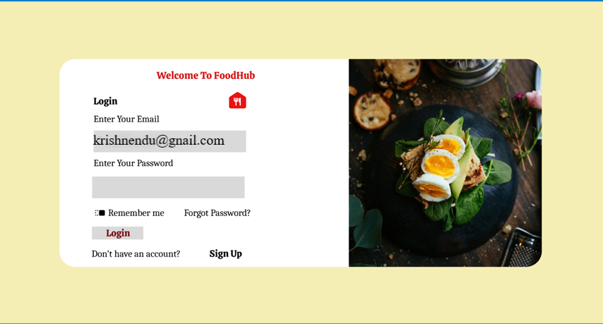

**Signup Page**

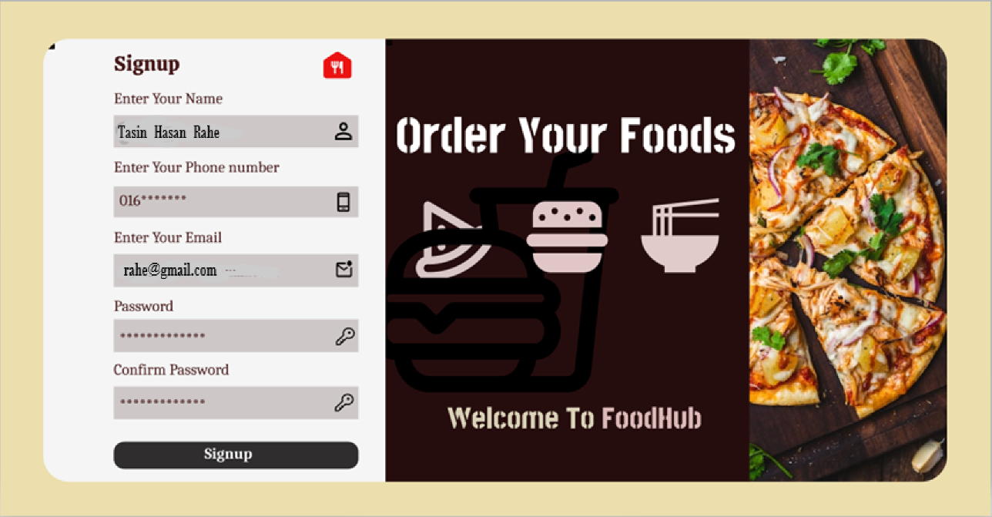

**Homepage**

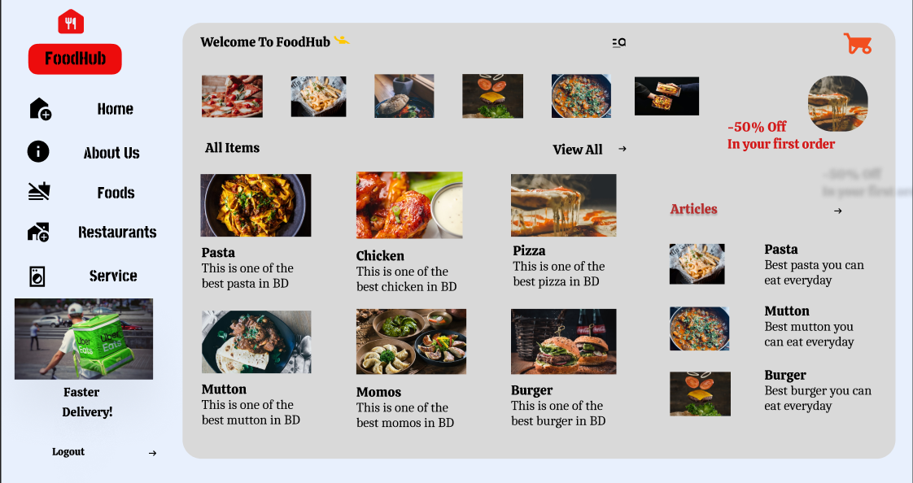

## Project Requirements

Based on our request, here are some of project requirements that should be considered in project management:

Time: The project should be completed within two months.

Budget: The project should be completed within a predefined budget about 50,000 BDT only

Environmental requirements: The project comply with all environmental regulations and guidelines related to the project, including safety, health, and environmental protection.

Quality: The project meet the required quality standards including performance, reliability, and durability.

# FEATURES NOT TO BE TESTED

1. In our application there is a feature where a user can contact manager through messaging. This feature is not to be tested in this release of the software.

2. A user can add vouchers during the payment. It will be released but not tested as a functional part of the release of this version of the software.

3. While the app may offer various payment methods, such as credit card or Bkash, Nagad, Rocket, the functionality of these methods is typically tested separately from the app itself.

4. The quality of the food is not within the control of the app, so it is not typically tested. However, the app may provide feedback or ratings for restaurants based on customer reviews.

5. Weather conditions are outside of the control of the app, so they are not typically tested. However, the app may provide updates or alerts related to inclement weather that could impact delivery times.

# TESTING APPROACH

## Testing Levels

The testing will be done for the food delivery company FoodHub to ensure that the software meets the functional and non-functional requirements and it provides reliable and user friendly experience for the customers. The testing will be conducted using a combination of manual and automated testing methods.

* Unit Testing: Test the individual modules of FoodHub, such as Signup, login, View Food items, Add to cart, Deactivate Account, Change Password, Update Profile and Payment method to ensure that they work correctly. This testing will be conducted by developer team and the critical defects will be corrected.
* System/Integration Testing: The process of system integration testing is putting a software system together while running tests to find interface flaws. After performing unit testing on each module, assembling modules incrementally, ensuring that the extra modules perform as planned without interfering with the functionality of the previously assembled modules. System integration testing involves the software system as a whole to confirm whether it complies with requirements and performs as intended.
* Acceptance Testing: Test the FoodHub with end-users to ensure that it meets their expectations and that they can use it effectively.

## Test Tools

Selenium software will be used to test the software system of FoodHub.

We are planning to test the key features and functionalities that need to be tested such as login, payment process and etc. Using selenium, we will develop test cases for each of the identified features and functionalities such as login process, entering valid and invalid credentials and verifying that the user is redirected into correct pages. Using Selenium, which will automate the process of interacting with the web platform, entering data, and verifying results. The tests can be run repeatedly to ensure that the platform is functioning correctly under different conditions and scenarios.

## Meetings

Twice a week, we held meetings where we would take notes and make progress-related plans. We have distributed the work among the group members and will address the problem at the following meeting. We have chosen to use the Selenium testing tool. We will create test cases for each individual module, and in the event that a test case fails, we can figure out which feature or functionality is at fault and correct it. To be sure that this change did not affect any previously functioning functionality, we will perform regression testing.

7. TEST CASES/TEST ITEMS

**Sign up**

|  |  |  |  |  |
| --- | --- | --- | --- | --- |
| Project Name: FoodHub | | | Test Designed by: Tasin Hasan Rahe | |
| Test Case ID: FP-TP1.3 | | | Test Designed date: 11/08/2023 | |
| Test Priority (Low, Medium, High): High | | | Test Executed by: | |
| Module Name: Sign Up | | | Test Execution Date: | |
| Test Title: Verify sign up sending verification code | | |  | |
| Description: Test the sign-up verification | | |  | |
| Precondition: User should have valid email or phone number | | |  | |
| Test Steps | Test Data | Expected Results | Actual Results | Status  (Pass/Fail) |
| * Go to the website sign up page * Enter first name * Enter last name * Enter valid email * Enter valid phone number * Select reason for choosing us * Click sign up | FirstName: Tasin  Last Name: Rahe  Email:rahe@gmail.com  Password: 1234567  Phone no: 019334245 | If sign up with the valid information properly a verification code will send into users email or phone number |  |  |
| Post Condition: User should get the verification code and confirm it and get sign up in to the system successfully. | | |  | |

**Login**

|  |  |  |  |  |
| --- | --- | --- | --- | --- |
| Project Name: FoodHub | | | Test Designed by: Krishendu Das | |
| Test Case ID: FP-TP1.3 | | | Test Designed date: 13/08/2023 | |
| Test Priority (Low, Medium, High): High | | | Test Executed by: | |
| Module Name: Login | | | Test Execution Date: | |
| Test Title: Verify Login | | |  | |
| Description: Test the login verification | | |  | |
| Precondition: User should have valid email or phone number and password that used in sign up | | |  | |
| Test Steps | Test Data | Expected Results | Actual Results | Status  (Pass/Fail) |
| * Go to the website sign up page * Enter valid email or * Enter valid phone number * Enter Password | Email: krishnendu@gnail.com      Phone no: 019334245  Password: 1234567 | If all information are correct with the database of sign up then it will take into the home page of this user account |  |  |
| Post Condition: | | |  | |

**View Food List**

|  |  |  |  |  |
| --- | --- | --- | --- | --- |
| Project Name: FoodHub | | | Test Designed by: Tasnia Amin Neha | |
| Test Case ID: FP-TP1.3 | | | Test Designed date: 16/08/2023 | |
| Test Priority (Low, Medium, High): High | | | Test Executed by: | |
| Module Name: View Food List | | | Test Execution Date: | |
| Test Title: Verify all food items are shown properly. | | |  | |
| Description: Test the Food list | | |  | |
| Precondition: User should have user account | | |  | |
| Test Steps | Test Data | Expected Results | Actual Results | Status  (Pass/Fail) |
| * Login * Click food * Select shop * Show all food | Food Item: Fried Rice  Available in: Urban void  Bistro  Hotel Alza | After login user can see all the available food items |  |  |
| Post Condition: User should get the confirmation message of order. | | |  | |

**Add to Cart**

|  |  |  |  |  |
| --- | --- | --- | --- | --- |
| Project Name: FoodHub | | | Test Designed by: Abdullah Alamgir | |
| Test Case ID: FP-TP1.3 | | | Test Designed date: 18/08/2023 | |
| Test Priority (Low, Medium, High): High | | | Test Executed by: | |
| Module Name: Add to Cart | | | Test Execution Date: | |
| Test Title: Verify the food items are added into cart properly | | |  | |
| Description: Test the add to cart option | | |  | |
| Precondition: User should have the valid account | | |  | |
| Test Steps | Test Data | Expected Results | Actual Results | Status  (Pass/Fail) |
| * Go to website. * Login * Search food * Select shop * Select item * Click add cart | Food Item: Fried Rice  Available in: Urban void  Bistro  Hotel Alza  Select shop: Urban void  Select item : Fried rice  Click add to cart |  |  |  |
| Post Condition: User should get the verification code of order and deliver time | | |  | |

**Payment Method**

|  |  |  |  |  |
| --- | --- | --- | --- | --- |
| Project Name: FoodHub | | | Test Designed by: Krishnendu Das | |
| Test Case ID: FP-TP1.3 | | | Test Designed date: 19/08/2023 | |
| Test Priority (Low, Medium, High): High | | | Test Executed by: | |
| Module Name: Payment Method | | | Test Execution Date: | |
| Test Title: Verify sign up sending verification code | | |  | |
| Description: Test the payment method | | |  | |
| Precondition: User should have valid account | | |  | |
| Test Steps | Test Data | Expected Results | Actual Results | Status  (Pass/Fail) |
| * Login * Search food * Select shop * Select item * Click add cart * Confirm order * Make Payment | Add cart: 1 item  Make payment: 200 tk  Bkash  Cash on delivery  Nagad | System must accept the payment |  |  |
| Post Condition: User should get the verification code and confirm the order | | |  | |

**Change Password**

|  |  |  |  |  |
| --- | --- | --- | --- | --- |
| Project Name: FoodHub | | | Test Designed by: Tasnia Amin Neha | |
| Test Case ID: FP-TP1.3 | | | Test Designed date: 20/08/2023 | |
| Test Priority (Low, Medium, High): High | | | Test Executed by: | |
| Module Name: Change Password | | | Test Execution Date: | |
| Test Title: Verify the previous password and confirm new one | | |  | |
| Description: Test the changing password | | |  | |
| Precondition: User should have valid account and valid password | | |  | |
| Test Steps | Test Data | Expected Results | Actual Results | Status  (Pass/Fail) |
| * Go to website. * Login. * Setting. * Change password. * Give previous password and then give new password. * Confirm password. | Previous Password: 1234567  New Password: 23456 | Password should be added by the user and stored in database. |  |  |
| Post Condition: User should get the message in the email or phone number that password is changed | | |  | |

**Update Profile**

|  |  |  |  |  |
| --- | --- | --- | --- | --- |
| Project Name: FoodHub | | | Test Designed by: Tasin Hasan Rahe | |
| Test Case ID: FP-TP1.3 | | | Test Designed date: 21/08/2023 | |
| Test Priority (Low, Medium, High): Medium | | | Test Executed by: | |
| Module Name: Update Profile | | | Test Execution Date: | |
| Test Title: update the user profile | | |  | |
| Description: Test the update profile | | |  | |
| Precondition: User should have valid email or phone number | | |  | |
| Test Steps | Test Data | Expected Results | Actual Results | Status  (Pass/Fail) |
| * Go to website. * Login. * View Profile * Change picture * Change location | Username: Tasin Hasan Rahe  Password: 234567  Profile picture; add picture  Edit location: Mohakhali |  |  |  |
| Post Condition: | | |  | |

**Deactivate Account**

|  |  |  |  |  |
| --- | --- | --- | --- | --- |
| Project Name: FoodHub | | | Test Designed by: Abdullah Alamgir | |
| Test Case ID: FP-TP1.3 | | | Test Designed date: 22/08/2023 | |
| Test Priority (Low, Medium, High): Medium | | | Test Executed by: | |
| Module Name: Deactivate Account | | | Test Execution Date: | |
| Test Title: Verify user can deactivate account properly | | |  | |
| Description: Test the deactivate user account | | |  | |
| Precondition: User should have valid account | | |  | |
| Test Steps | Test Data | Expected Results | Actual Results | Status  (Pass/Fail) |
| * Go to website. * Login. * Setting. * Deactivate account. * Give password. * Confirm | Email: Imran@gmail.com      Password: 234567 | User can deactivate the account with giving proper reason. |  |  |
| Post Condition: User get the deactivation message. | | |  | |

8. ITEM PASS/FAIL CRITERIA:

For the FoodHub, we intend to use 8 test cases. Unit testing will involve the execution of test cases, and based on how well they go, we will label the test as passed or failed. If there are any problems, we will repair them. We will fix the problems causing it if the testing is as successful as possible given the possibility that certain test cases may fail.

9. TEST DELIVERABLES:

Project Name: FoodHub  
Test Phase: Unit, System/Integration

Introduction:   
The Unit, System/Integration and Acceptance Testing phase is planned to validate the software's integration, compatibility, and performance with external systems and interfaces. The testing will be performed based on the approved test plan, and all identified issues will be reported.

Test Objectives:  
 The objectives of the test plan phase are as follows:

* To validate the software's integration and compatibility with external systems and interfaces.
* To verify the software's performance and scalability under load and stress conditions.
* To identify and report any issues related to the software's integration, compatibility, or performance.

Test Approach:  
 The following approach will be taken to perform the SIT phase:

* The testing will be performed on a dedicated testing environment that simulates the production environment.
* The testing will be performed using automated and manual testing techniques, including functional, performance, and compatibility testing.
* The testing will be performed in accordance with the approved test plan and test cases.
* The testing will be performed by a team of experienced testers, led by a test manager.

Test Cases:   
The test plan phase will include a total of 8 test cases, including functional, performance, and compatibility tests. The test cases will be designed based on the software requirements documents.

Defect Management:   
All identified issues and defects will be reported. Each defect will be assigned a unique identifier, description, priority, severity, and status. Defects will be reviewed and prioritized by the test manager and addressed by the development team.

Conclusion:   
The test plan phase is an essential part of the software testing process, and its successful completion is critical to the software's overall quality and performance. The test plan provides a comprehensive overview of the testing objectives, approach, environment, test cases, defect management, and schedule. The testing activities will be conducted by an experienced team of testers, and all identified issues and defects will be reported.

10. STAFFING AND TRAINING NEEDS:

1. Determine the specific objectives of the FoodHub testing project, such as identifying and reporting bugs or testing specific features.
2. Identify the roles needed for the project such as Test Lead, Test Engineer, and QA Analyst. Define their responsibilities and skill requirements.
3. Determine the project's estimated start and end dates, taking into account any dependencies, such as development cycles or software releases.
4. Evaluate the existing team's knowledge and skill levels and identify any gaps that need to be addressed through training.
5. Based on the skill gaps identified, develop a training plan that includes the topics to be covered, the delivery method, and the timeline.
6. Based on the project scope, timeline, and roles and responsibilities, determine the number of staff needed for the project.
7. Recruit staff with the required skills and experience, and provide them with an orientation to the project, its objectives, and the team's roles and responsibilities.
8. Provide ongoing training and support to the team to ensure they are equipped with the skills and knowledge needed to successfully complete the project.
9. Regularly monitor the project's progress and adjust staffing and training plans as needed to ensure the project's objectives are met within the specified timeline.

11. RESPONSIBILITIES:

|  |  |  |  |  |  |
| --- | --- | --- | --- | --- | --- |
|  | TM | PM | DEV Team | Test Team | Client |
| Acceptance test Documentation and Execution | X | X |  | X | X |
| System/Integration test Documentation and Execution | X |  | X | X |  |
| Unit test documentation and Execution | X |  | X | X |  |
| System Design Reviews | X | X | X | X | X |
| Detail Design Reviews | X | X | X | X | X |
| Test Procedures and rules | X | X | X | X |  |
| Screen and Report prototype reviews | X | X | X | X | X |
| Change control and regression testing | X | X | X | X |  |

12. RESTING SCHEDULE:

Time has been allocated within the project plan for the following testing activities.

|  |  |  |
| --- | --- | --- |
| **Task Name** | **Duration** | **Responsible** |
| Requirement Analysis | 4 Days | Project Manager |
| Design | 4 Days | Project Manager |
| Writing Codes | 13 Days | Developers |
| Unit Test | 15 Days | Developers |
| Documentation | 5 Days | Test Engineer |

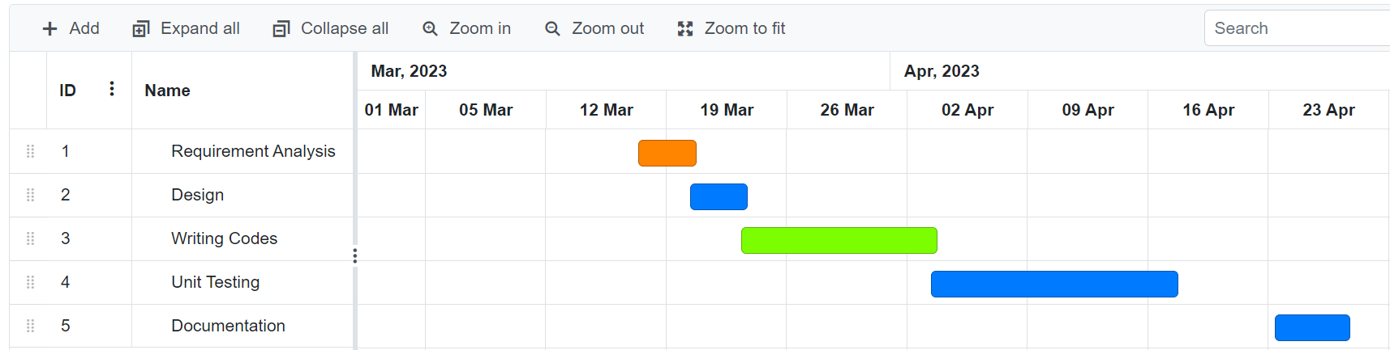

13. PLANNING RISKS AND CONTINGENCIES:

A comprehensive planning and contingency strategy is crucial for ensuring that the food delivery service meets its quality and performance standards, and that the testing process is conducted in a timely and efficient manner. It is important to involve all stakeholders in the planning and contingency process and to regularly review and update the testing plan as needed. This FoodHub idea can be expensive, and upkeep might be a pain. There is relatively little interaction between people. Given that it is a self-service system, the user must be cautious when choosing the food items.

14. APROVALS

|  |  |
| --- | --- |
| Project Sponsor | Artur |
| Development Management | Kruck Manager |
| EDI Project Manager | Kookie Project |
| RS Test Manager | Dale Tester |
| RS Development Team Manager | Dale Tester |
| Reassigned Sales | Dart Sales |
| Order Entity EDI Team Manager | Jupiter Order |
|  |  |

s