**Process documentation for Step-by-Step approach for creating subset of data:**

1. **Parent data set downloaded from** - <http://www.pewinternet.org/datasets/october-2013-pictorial-activities-omnibus/>
2. **Tools used for data processing** - SPSS(Statistical Package for the Social Sciences)
3. In SPSS use the **SELECT CASES: FILTER** function to extract the subset from the parent data set. Please find below steps to filter out the required data in SPSS.
   1. The Select Cases function in SPSS enables users to select specific cases of data according to a variety of user-specified conditions. This is useful when focusing on subgroups within a dataset.
   2. To use the Select Cases function, click on 'Data' in the toolbar at the top of the Data Editor window, and then click on 'Select Cases' in the dropdown menu.

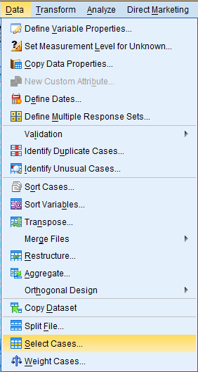

* 1. Select the 'If condition is satisfied' option and click 'If...' to specify the filtering conditions. Extracted the filtered data from the main dataset.

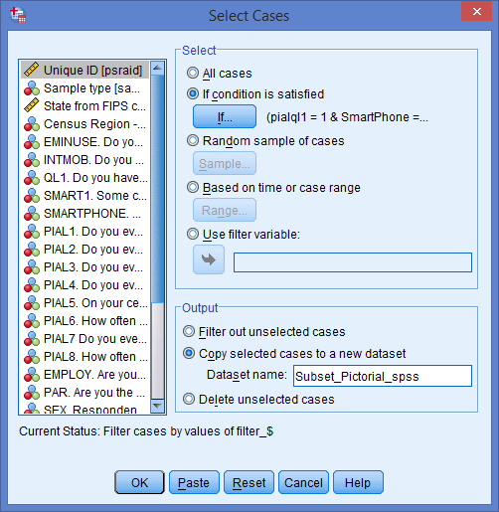

* 1. Enter the specific conditions according to the subset you want to extract from the parent data set. Then click on continue to create the subset.

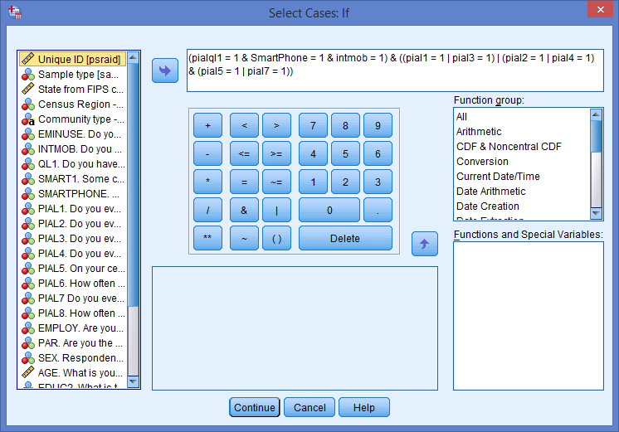

1. **Please find below the script generated in SPSS to filter subset from the parent data set**:

*GET*  **\*/ to get the file into SPSS/\***

*FILE='D:\UMD_Krishnesh\Syllabus\INFM600\Info_Organization\October-2013--Pictorial-Activities-(omnibus)\Omnibus_Oct_2013_Pictorial_spss.sav'.*

*DATASET NAME DataSet1 WINDOW=FRONT.*

*SAVE OUTFILE=*

*'D:\UMD_Krishnesh\Syllabus\INFM600\Info_Organization\October-2013--Pictorial-Activities-(omnibus)'+*

*'\Subset_Omnibus_Oct_2013_Pictorial_spss.sav'*

*/COMPRESSED.*

*USE ALL.*

*COMPUTE filter_$=((pialql1 = 1 & SmartPhone = 1 & intmob = 1) & ((pial1 = 1 | pial3 = 1) | (pial2 = 1 | pial4 = 1) & (pial5 = 1 | pial7 = 1))).* **\*/to filter out the required subset of data/\***

*VARIABLE LABELS filter_$ '(pialql1 = 1 & SmartPhone = 1 & intmob = 1) & ((pial1 = 1 | pial3 = 1) | (pial2 = 1 | pial4 = 1) & (pial5 = 1 | pial7 = 1)) (FILTER)'.*

*VALUE LABELS filter_$ 0 'Not Selected' 1 'Selected'.*

*FORMATS filter_$ (f1.0).*

*FILTER BY filter_$.*

*EXECUTE.*

*DATASET COPY subset.*  **\*/ to extract the subset into new SPSS file/\***

*DATASET ACTIVATE subset.*

*FILTER OFF.*

*USE ALL.*

*SELECT IF ((pialql1 = 1 & SmartPhone = 1 & intmob = 1) & ((pial1 = 1 | pial3 = 1) | (pial2 = 1 | pial4 = 1) & (pial5 = 1 | pial7 = 1))).*

*EXECUTE.*

*DATASET ACTIVATE DataSet1.*

*DATASET ACTIVATE subset.*

*SAVE OUTFILE=* **\*/ saving the data into output file/\***

*'D:\UMD_Krishnesh\Syllabus\INFM600\Info_Organization\October-2013--Pictorial-Activities-(omnibus)'+*

*'\Subset_Pictorial_spss.sav'*

*/COMPRESSED.*

1. **The subset of the parent data set** - <https://github.com/krishnesh7/INFM600---Information-Organization/blob/master/Subset_Pictorial_spss.csv>