Employee Burnout Prediction System R.K.KRISHNI – 24BDS1070
1. Problem Statement
The Employee Burnout Prediction System is a software application developed to predict and monitor employee burnout risk using employee-related information and machine learning models. The system allows HR Managers to manage employee data, generate burnout predictions, view prediction history and trends, and identify high-risk employees. Administrators manage users and datasets, while Machine Learning Engineers train, retrain, and update the prediction models.

2. Identified Actors
2.1 HR Manager
The HR Manager uses the system to manage employee information and monitor employee burnout.
Responsibilities:
- Login
- Manage Employee Data
- Predict Burnout Risk
- View Prediction Result
- View Prediction History
- View Burnout Trend
- View High-Risk Alert
- Generate Reports
2.2 Administrator
The Administrator manages system users, employee data, datasets, and machine learning models.
Responsibilities:
- Login
- Manage Employee Data
- Manage Users
- Manage Dataset
- Update Model

2.3 Machine Learning Engineer
The Machine Learning Engineer manages the machine learning model and training activities.
Responsibilities:
- Login
- Manage Dataset
- Train Model
- Retrain Model
- Update Model

3. List of Use Cases
The major use cases identified from the system are:
- Login
- Manage Employee Data
- Predict Burnout Risk
- Preprocess Data
- Validate Data
- View Prediction Result
- View Prediction History
- View Burnout Trend
- High-Risk Alert
- Generate Reports
- Manage Users
- Manage Dataset
- Train Model
- Retrain Model
- Update Model
Use Case Relationships
- Predict Burnout Risk <<include>> Preprocess Data
- Predict Burnout Risk <<include>> Validate Data
- View Burnout Trend <<extend>> View Prediction History
- High-Risk Alert <<extend>> Predict Burnout Risk

4. Use Case Diagram
Figure 1: Use Case Diagram of Employee Burnout Prediction System
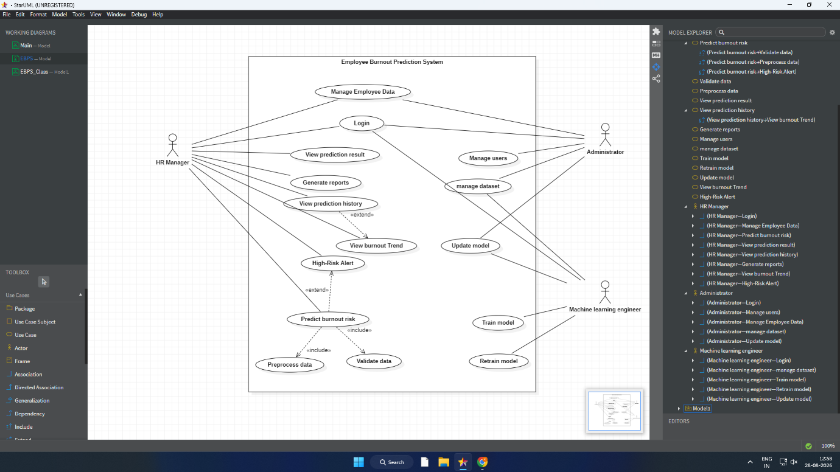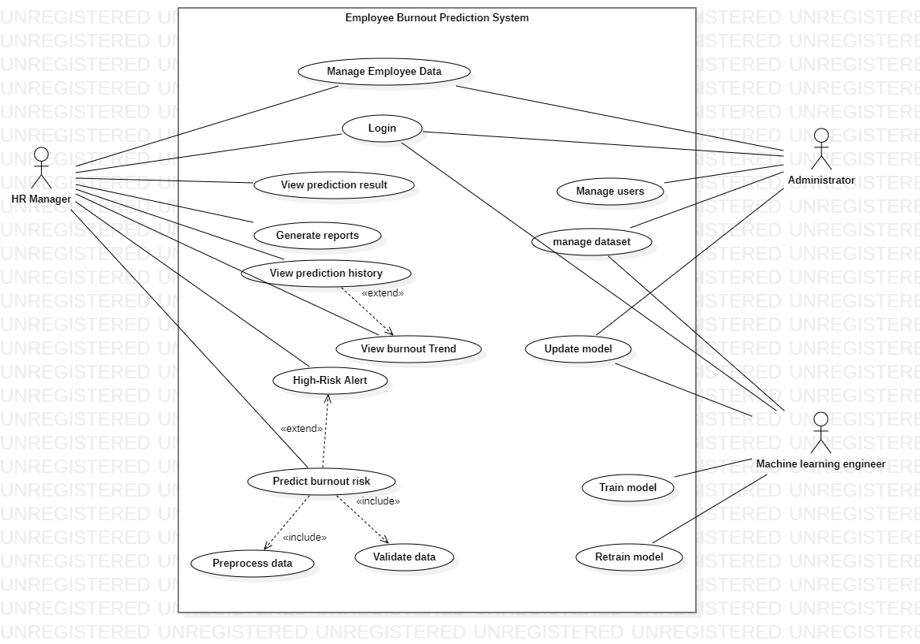
Brief Explanation
The Use Case Diagram represents the interaction between the system and its three main actors: HR Manager, Administrator, and Machine Learning Engineer. HR Managers perform employee management and burnout monitoring, Administrators manage users and system data, and Machine Learning Engineers manage datasets and machine learning models. The diagram also shows include and extend relationships for prediction, preprocessing, validation, trend analysis, and high-risk alerts.

5. Identified Classes
The following classes were identified for the Employee Burnout Prediction System:
- Employee
- User
- Prediction
- Model
- PredictionFeature
- BurnoutProfile

6. Class Attributes and Operations
6.1 Employee
Attributes:
- employeeID : int (PK)
- dateofJoining : Date
- gender : String
- wfhSetup : String
- designation : int
- resourceAllocation : float
- mentalFatigueScore : float
Operations:
- addEmployee()
- updateEmployee()
- getEmployee()

6.2 Model
Attributes:
- modelID : int (PK)
- modelName : String
- version : String
- trainingDate : Date
- accuracy : float
- status : String
Operations:
- trainModel()
- evaluateModel()
- updateModel()

6.3 User
Attributes:
- userID : int (PK)
- name : String
- email : String
- password : String
- role : String
Operations:
- login()
- logout()

6.4 Prediction
Attributes:
- predictionID : int (PK)
- employeeID : int (FK)
- modelID : int (FK)
- userID : int (FK)
- predictionDate : Date
- riskScore : float
- riskLevel : String
Operations:
- predictionBurnout()
- getResult()

6.5 PredictionFeature
Attributes:
- featureID : int (PK)
- predictionID : int (FK)
- mentalFatigue : float
- resourceAllocation : float
- designation : int
- month : int
Operation:
- prepareFeatures()

6.6 BurnoutProfile
Attributes:
- profileID : int (PK)
- currentRiskLevel : String
- lastAssessmentDate : Date
- monitoringStatus : String
- employeeID : int (FK)
Operations:
- updateProfile()
- getRiskLevel()

7. Primary Keys and Foreign Keys
Primary Keys
Class | Primary Key
Employee | employeeID
User | userID
Prediction | predictionID
Model | modelID
PredictionFeature | featureID
BurnoutProfile | profileID
Foreign Keys
Class | Foreign Key
Prediction | employeeID → Employee
Prediction | modelID → Model
Prediction | userID → User
PredictionFeature | predictionID → Prediction
BurnoutProfile | employeeID → Employee

8. Relationships and Cardinality
Relationship | Cardinality | Description
Employee — Prediction | 1 : M | One employee can have multiple predictions.
User — Prediction | 1 : M | One user can generate multiple predictions.
Model — Prediction | 1 : M | One model can generate multiple predictions.
Prediction — PredictionFeature | 1 : M | One prediction can contain multiple features.
Employee — BurnoutProfile | 1 : 1 | One employee has one burnout profile.
The Prediction–PredictionFeature relationship is represented using composition in the Class Diagram because prediction features belong to a particular prediction.

9. Class Diagram
Figure 2: Class Diagram of Employee Burnout Prediction System
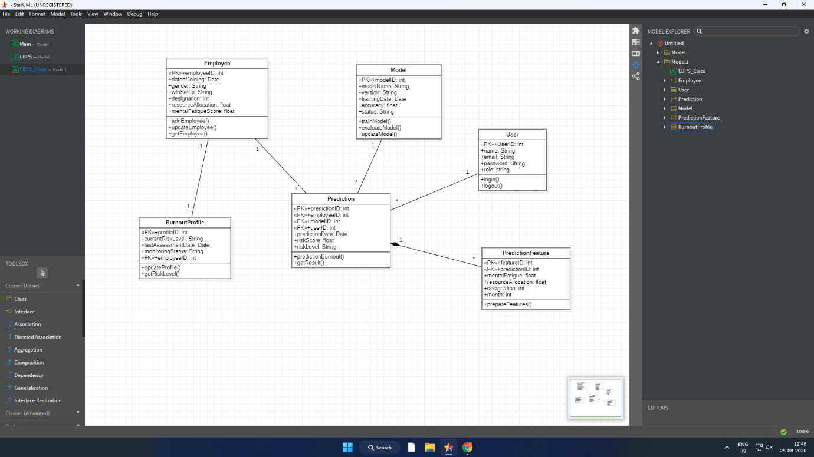
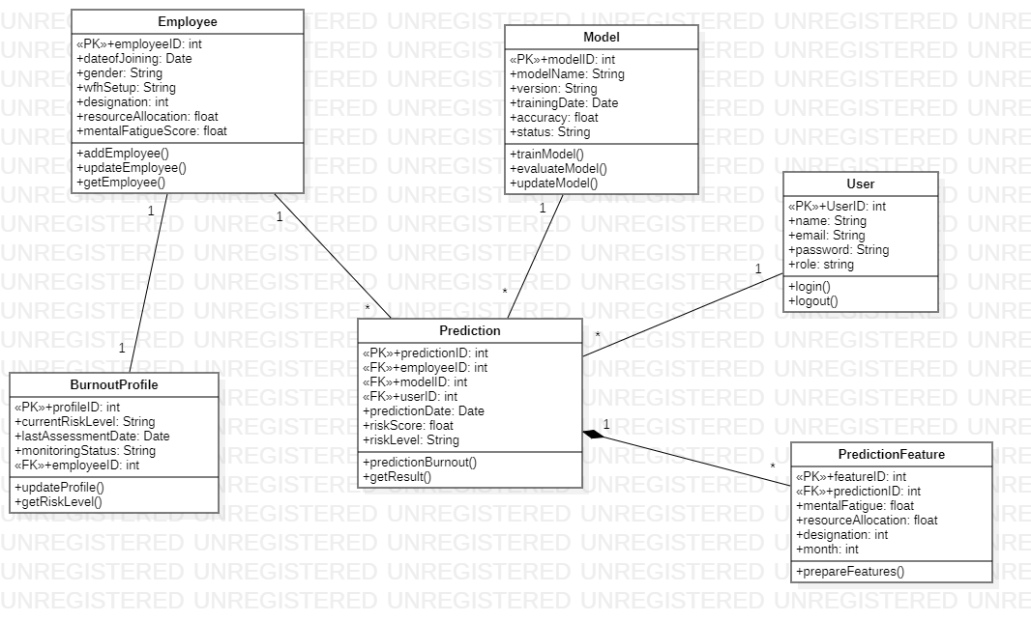
Brief Explanation
The Class Diagram represents the static structure of the Employee Burnout Prediction System. The Employee and User classes store employee and user information, while Prediction stores generated burnout prediction results. The Model class represents the machine learning model, PredictionFeature stores the features used for prediction, and BurnoutProfile maintains the employee's burnout monitoring information. Primary keys, foreign keys, methods, and class relationships are represented to provide a structured object-oriented design.

10. Brief Explanation of Design Decisions
The system is divided into separate classes according to their responsibilities. Employee manages employee information, User manages system users, and Prediction stores the results generated by the machine learning model. Model manages model-related information, while PredictionFeature stores the input features used during prediction. BurnoutProfile maintains the current burnout status of an employee. The use case model and class model together provide a clear representation of the system's functional and structural requirements.

