Software Engineering Lab
Requirement Modelling- Context(L-0) and DFD diagram
NAME : R.K.KRISHNI DATE : 31-07-2026
REG.NO : 24BDS1070 EXPERIMENT -3

Project Title
Employee Burnout Prediction System using Hybrid CNN-LSTM

Functional Requirements
- Upload employee dataset.
- Preprocess and clean employee data.
- Perform feature engineering.
- Generate time-series data for employees.
- Train the Hybrid CNN-LSTM model.
- Predict employee burnout risk.
- Display burnout prediction results on the dashboard.
- Generate burnout analysis reports.
- Store prediction history in the database.
- Manage users and update the trained model.

External Entities
- HR Manager – Requests burnout predictions, views reports, and monitors employee burnout risk.
- Administrator – Manages users, updates datasets, and maintains the system.
- Machine Learning Engineer – Retrains and updates the CNN-LSTM model.
- Employee Dataset (CSV/Kaggle) – Provides employee information used for training and prediction.

1. Context Diagram (Level-0 DFD)
The Context Diagram represents the Employee Burnout Prediction System as a single process and shows how external entities such as the HR Manager, Administrator, Machine Learning Engineer, and Employee Dataset interact with the system. It provides a high-level view of the system without showing internal processes or data stores.
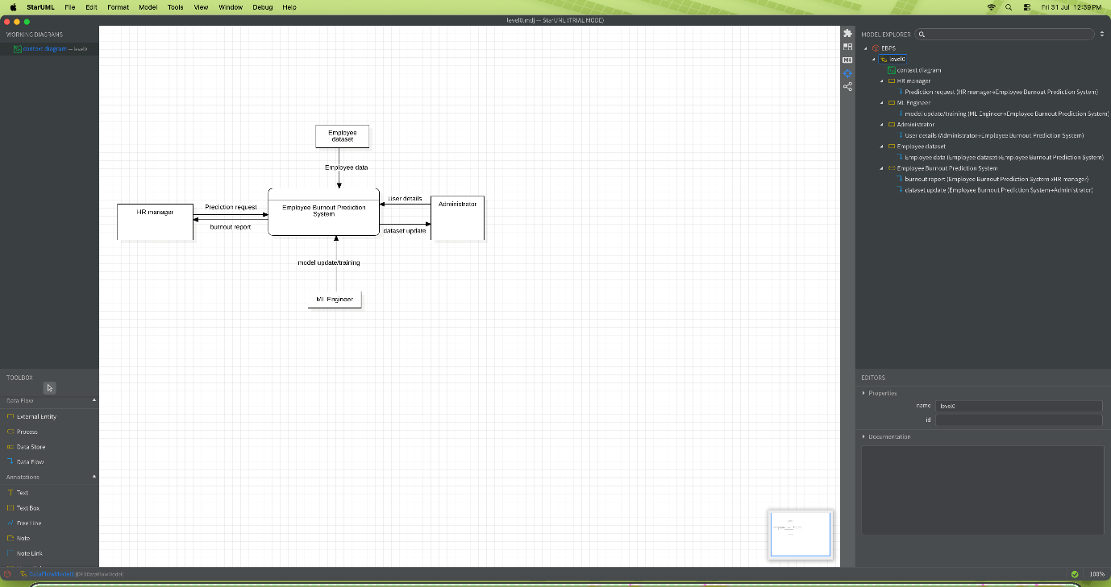

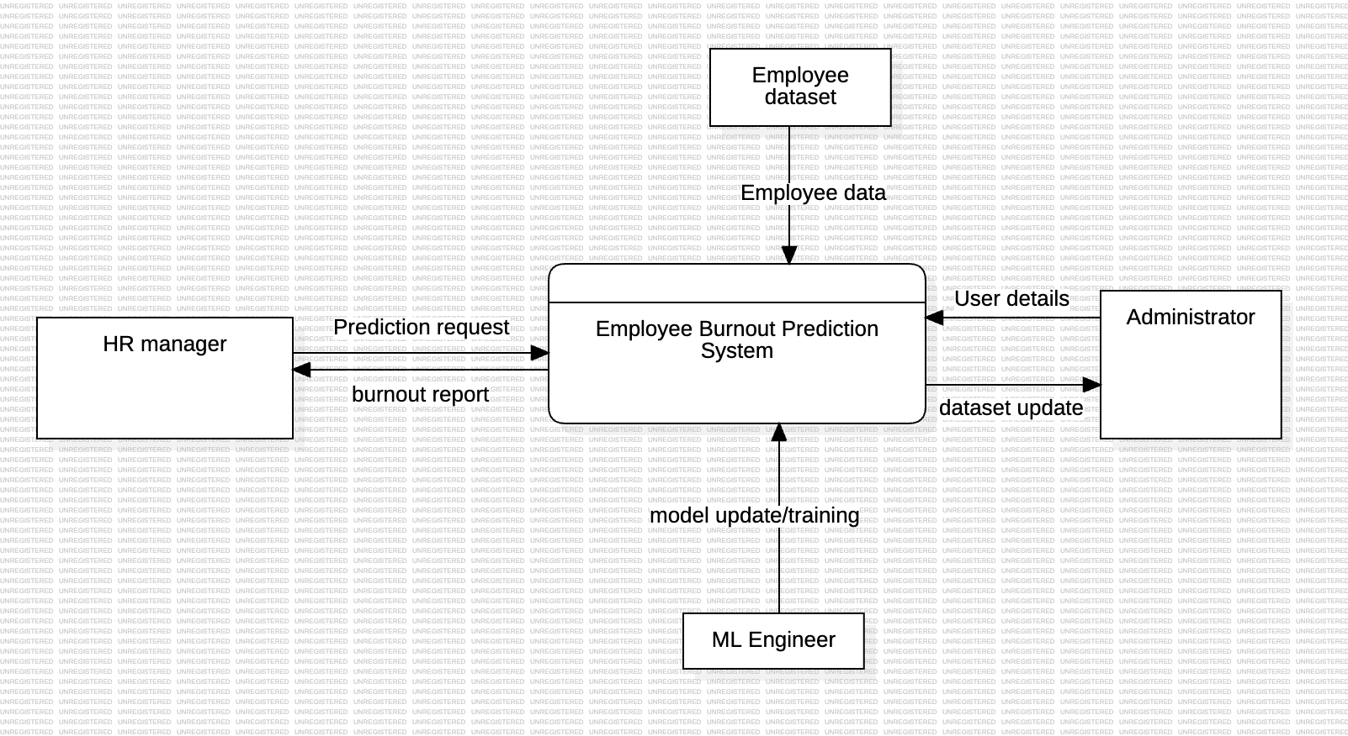

2. Level-1 DFD

The Level-1 DFD decomposes the system into major functional processes such as Data Preparation, Feature Engineering, Burnout Prediction, Report Generation, and User Management. It also includes data stores and illustrates how data flows between users, processes, and the database.
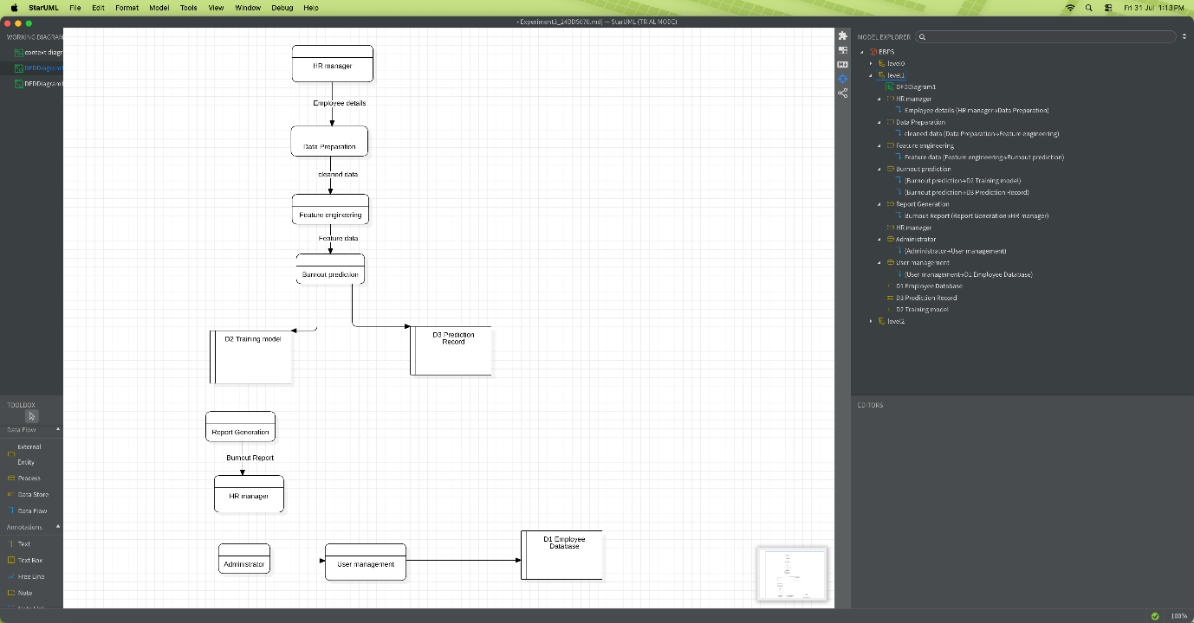
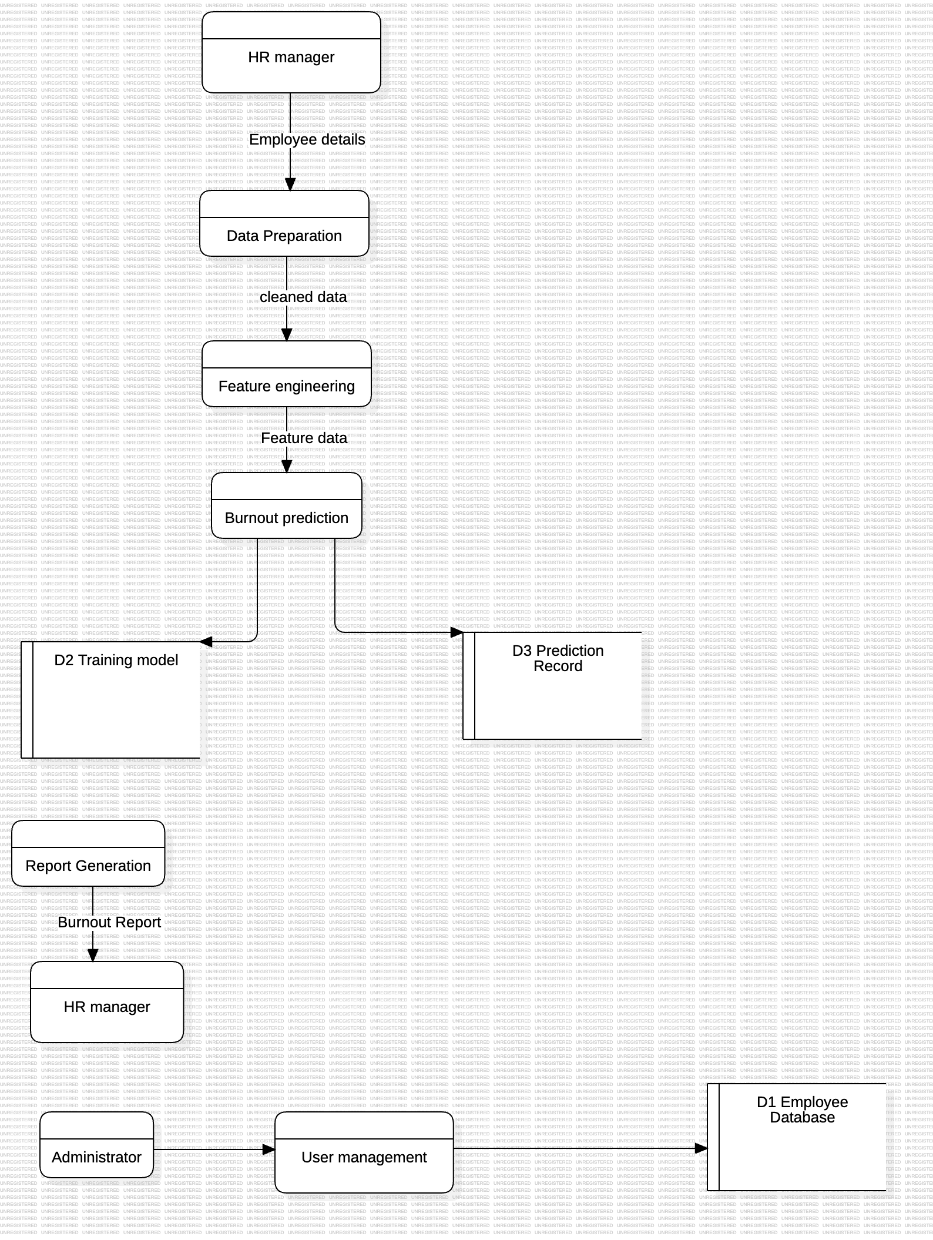

3. Level-2 DFD (Burnout Prediction Process)
The Level-2 DFD provides a detailed breakdown of the Burnout Prediction process. It shows the sequence of validating employee data, preprocessing features, loading the trained CNN-LSTM model, predicting burnout risk, storing prediction results, and generating the final output for the HR Manager.
