SOFTWARE ENGINEERING LAB-2 DATE : 24-07-2026
NAME : R.K.KRISHNI REG.NO :24BDS1070

AIM :
To design and implement different types of Work Breakdown Structures (WBS) using ProjectLibre for the Employee Burnout Prediction System using Hybrid CNN-LSTM, estimate the project effort and duration, assign resources and dependencies, and generate a project schedule using a Gantt chart.

Gantt Chart:
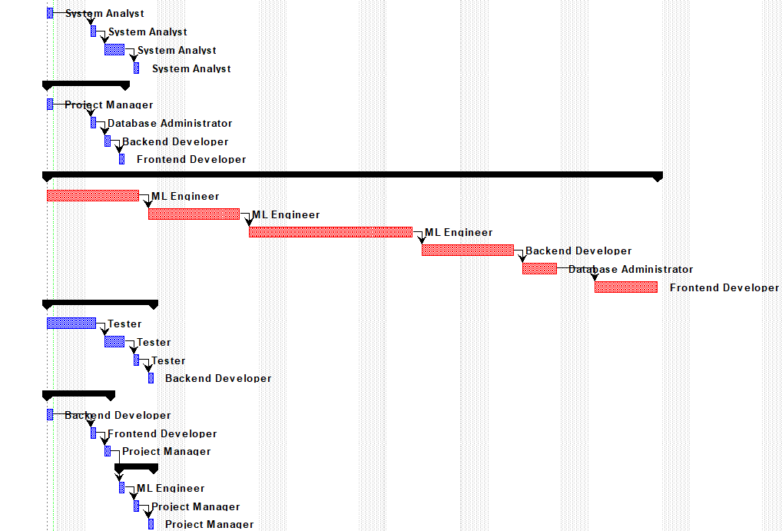
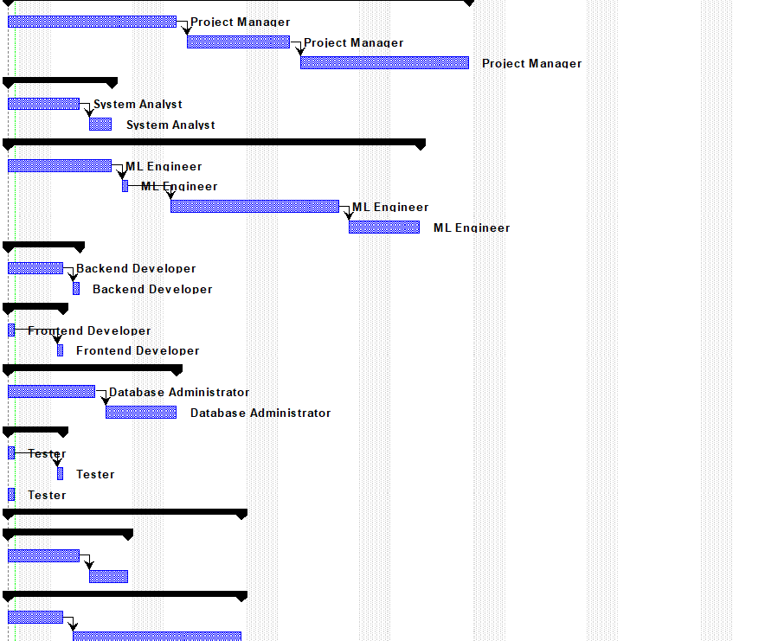
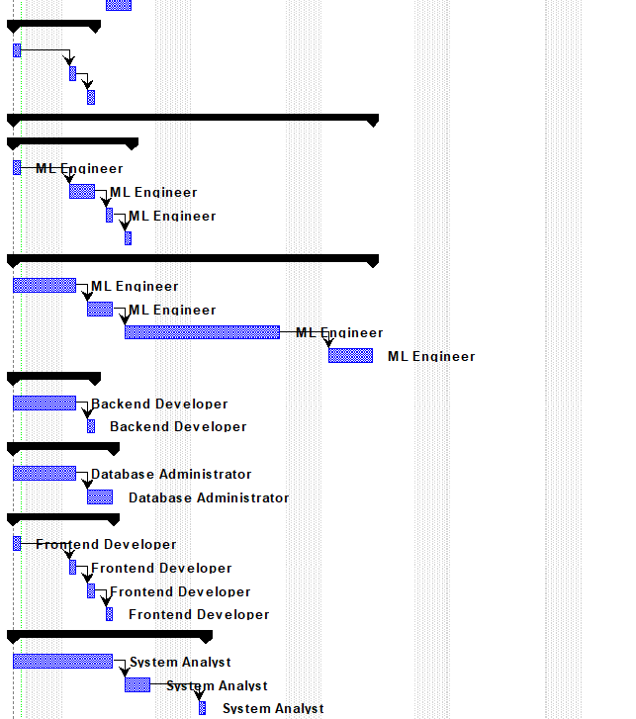

Network:
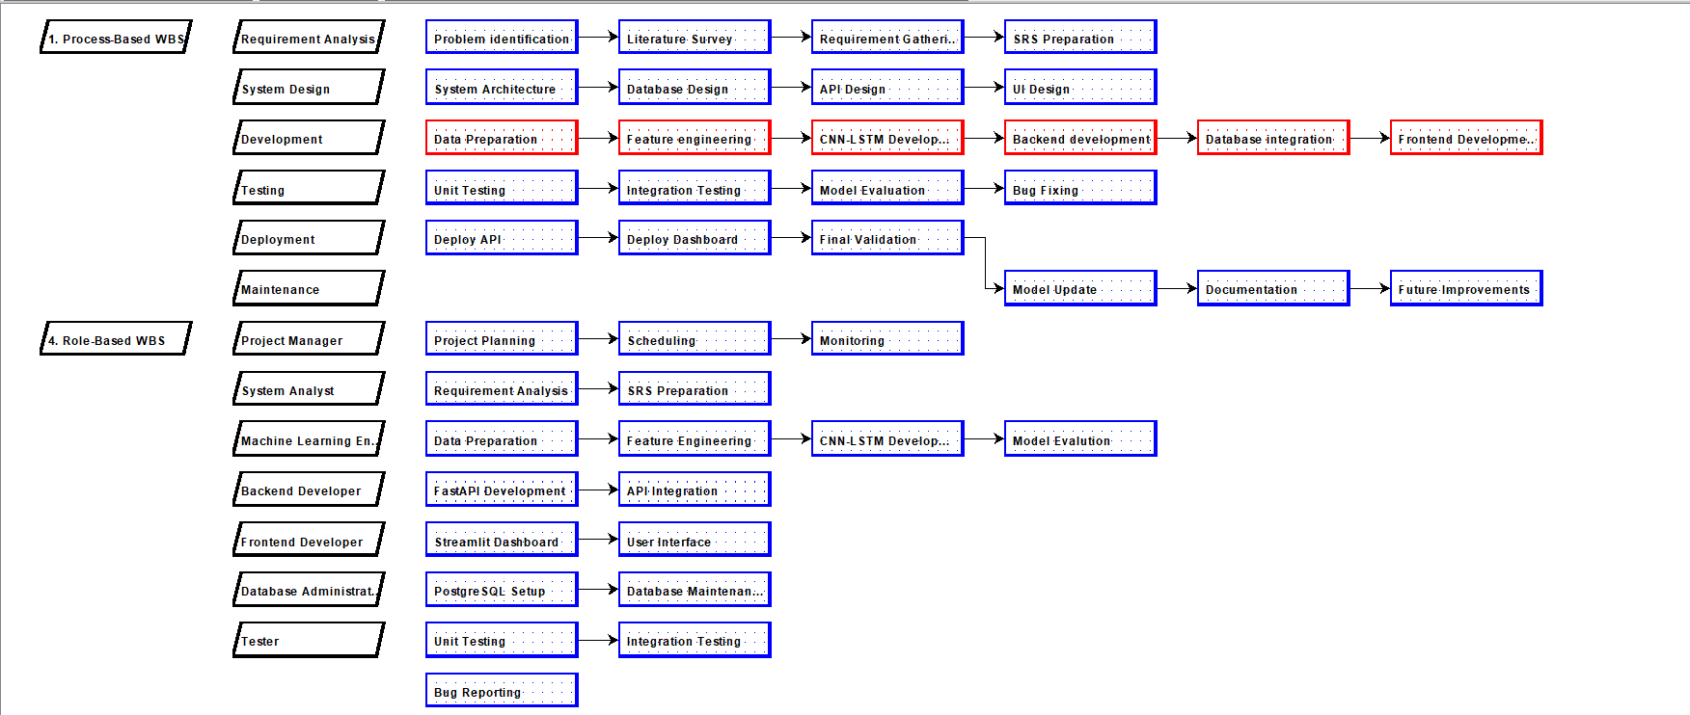
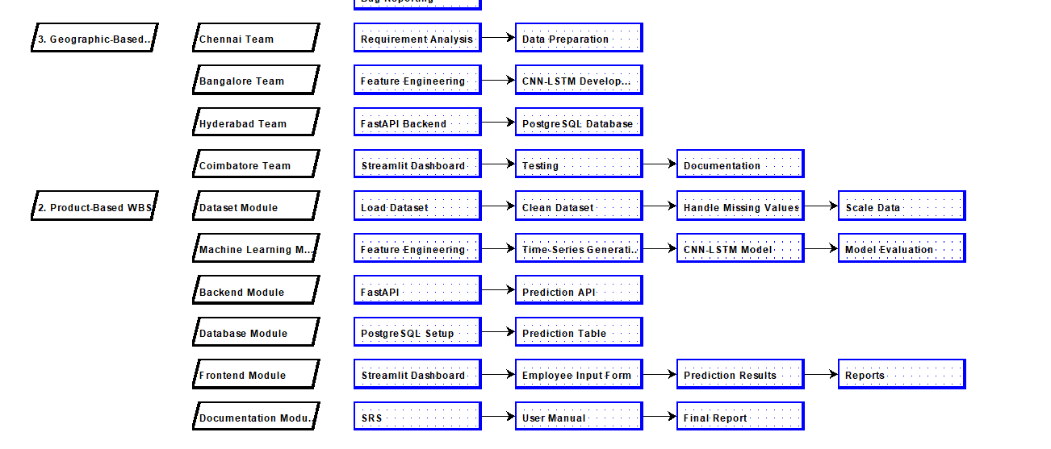

WBS:
Process-Based :
The Process-Based WBS organizes the project according to the Software Development Life Cycle (SDLC). It divides the Employee Burnout Prediction System into phases such as requirement analysis, system design, development, testing, deployment, and maintenance. This helps in planning, scheduling, and monitoring the project from start to finish.
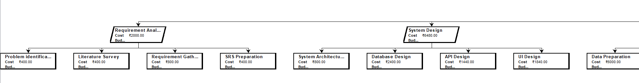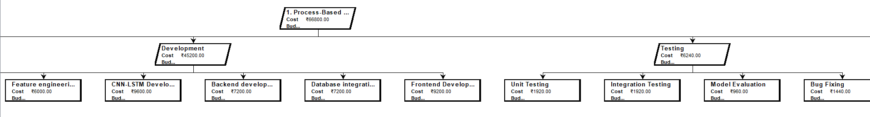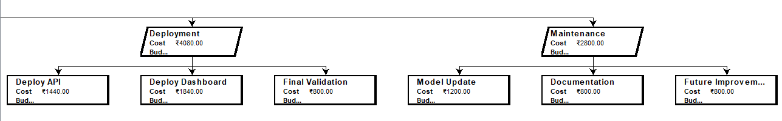
Geographical-Based :
The Geographic-Based WBS groups project activities based on different development locations or teams. In this project, the work is distributed among teams responsible for data preparation, machine learning, backend development, frontend development, and testing. This approach is useful for managing projects with distributed development teams.
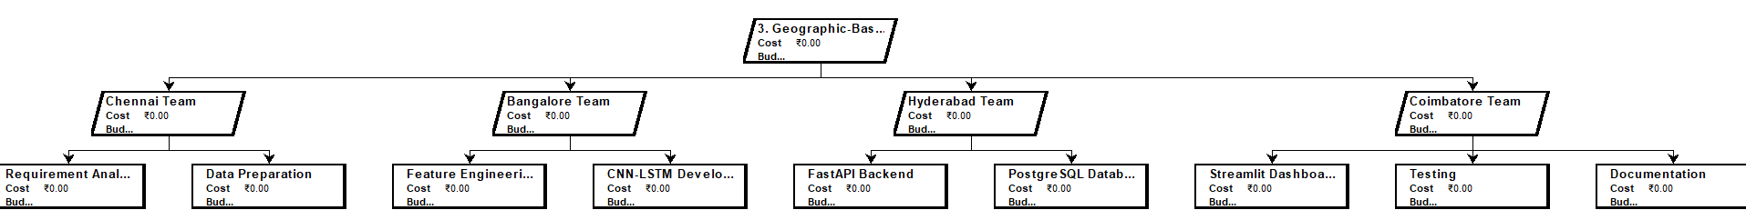
Product-Based :
The Product-Based WBS organizes the project based on its deliverables and functional modules. For this project, the main modules include dataset preparation, machine learning model development, backend API, database, frontend dashboard, and documentation. This structure focuses on the final products that need to be developed.
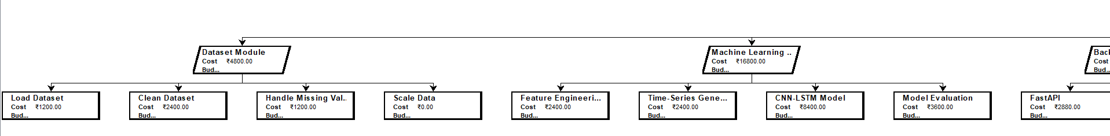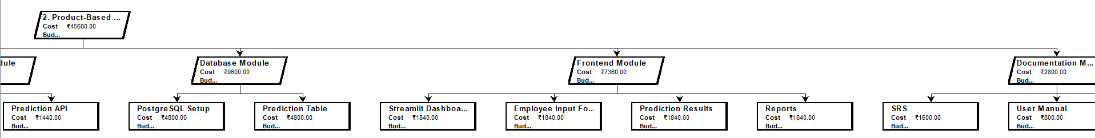
Role-Based :
The Role-Based WBS categorizes project tasks according to the responsibilities of different team members such as the Project Manager, System Analyst, Machine Learning Engineer, Backend Developer, Frontend Developer, Database Administrator, and Tester. It clearly defines the duties of each role and improves resource management.
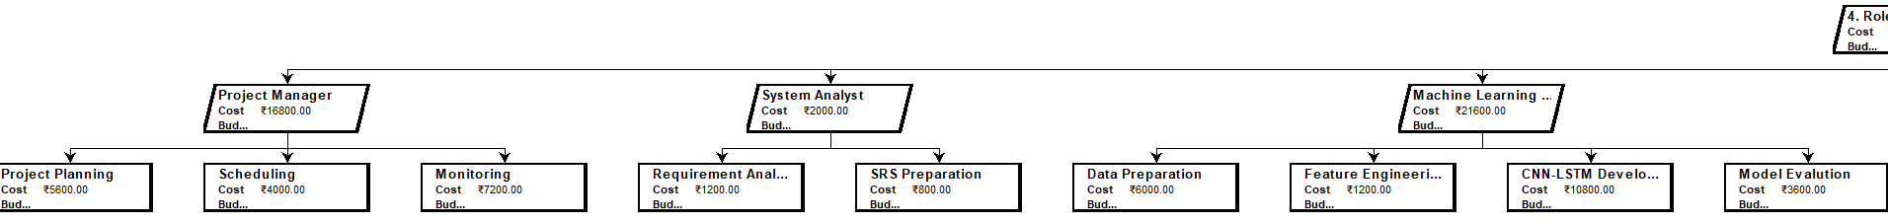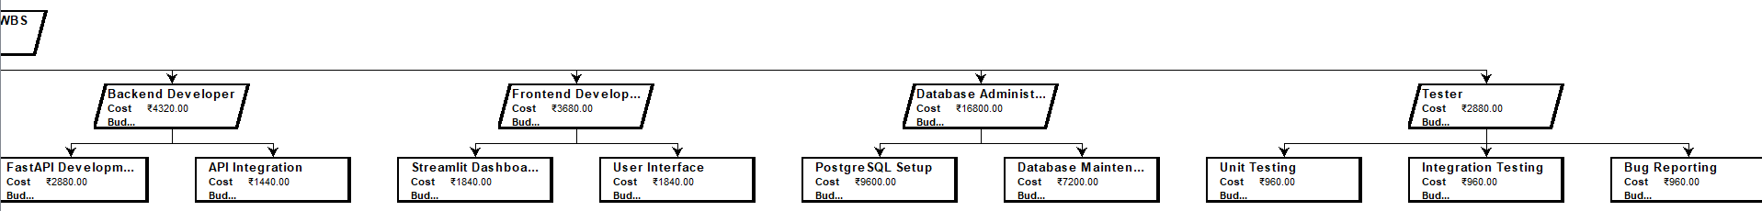
Conclusion
The Work Breakdown Structures developed in ProjectLibre provided a systematic approach to planning the Employee Burnout Prediction System using Hybrid CNN-LSTM. The Process-Based WBS helped organize the project according to SDLC phases, while the Product-Based, Geographic-Based, and Role-Based WBS offered different perspectives for managing deliverables, distributed teams, and responsibilities. Resource allocation, task dependencies, project scheduling, and the generated Gantt chart enabled effective project planning and estimation. Overall, this exercise demonstrated how ProjectLibre can be used to improve project organization, monitoring, and timely completion of a software engineering project.

