SOFTWARE ENGINEERING LAB EXPERIMENT - 4
R.K.KRISHNI 24BDS1070
ER DIAGRAM

1. Problem Statement
The Employee Burnout Prediction System is a machine-learning-based system designed to predict and monitor employee burnout risk. The system stores employee information, user details, machine learning model versions, prediction results, and the temporal features used for prediction.
The system allows authorized users to generate burnout predictions using a CNN-LSTM model. Each prediction is associated with an employee and a particular model version. Prediction features are stored to support the time-series analysis and future monitoring of employee burnout.

2. List of Identified Entities
The following entities are identified:
- Employee
- Employee_Burnout_Profile
- User
- Prediction
- Model
- Prediction_Feature

3. Entity Attributes
3.1 Employee
Stores basic employee and work-related information.
Attribute | Classification
employee_id | Primary Key
date_of_joining | Simple
gender | Simple
company_type | Simple
wfh_setup | Simple
designation | Simple
resource_allocation | Simple
mental_fatigue_score | Simple

PK: employee_id
3.2 Employee_Burnout_Profile
Stores the current burnout monitoring profile of an employee.
Attribute | Classification
profile_id | Primary Key
employee_id | Foreign Key
current_risk_level | Simple
last_assessment_date | Simple
monitoring_status | Simple

PK: profile_id
FK: employee_id
This entity represents the current burnout-monitoring profile of an employee.

3.3 User
Stores information about users who access the system.
Attribute | Classification
user_id | Primary Key
name | Simple
email | Simple
password | Simple
role | Simple

PK: user_id
The role can represent HR Manager, Administrator, or Machine Learning Engineer.
3.4 Prediction
Stores the burnout prediction generated by the system.
Attribute | Classification
prediction_id | Primary Key
employee_id | Foreign Key
model_id | Foreign Key
user_id | Foreign Key
prediction_date | Simple
risk_score | Simple
risk_level | Derived

PK: prediction_id
FKs: employee_id, model_id, user_id
Derived: risk_level

3.5 Model
Stores information about the machine-learning models used by the system.
Attribute | Classification
model_id | Primary Key
model_name | Simple
version | Simple
training_date | Simple
accuracy | Simple
status | Simple

PK: model_id
3.6 Prediction_Feature
Stores the feature values used for a particular prediction across different time periods.
Attribute | Classification
feature_id | Primary Key
prediction_id | Foreign Key
mental_fatigue | Simple
resource_allocation | Simple
designation | Simple
month | Simple

PK: feature_id
FK: prediction_id
4. Primary Keys and Foreign Keys
Entity | Primary Key | Foreign Keys
Employee | employee_id | —
Employee_Burnout_Profile | profile_id | employee_id
User | user_id | —
Prediction | prediction_id | employee_id, model_id, user_id
Model | model_id | —
Prediction_Feature | feature_id | prediction_id

5. Relationship Description
Relationship 1 — Employee and Employee_Burnout_Profile
Relationship: has_profile
Each employee has one current burnout profile, and each burnout profile belongs to exactly one employee.
Type: 1:1
Employee 1 ───── 1 Employee_Burnout_Profile
This provides the required One-to-One relationship.
Relationship 2 — Employee and Prediction
Relationship: has
One employee can have multiple predictions over time, while each prediction belongs to one employee.
Type: 1:M
Employee 1 ───── M Prediction
Relationship 3 — User and Prediction
Relationship: generates
One user can generate multiple predictions, while each prediction is generated by one user.
Type: 1:M
User 1 ───── M Prediction
Relationship 4 — Model and Prediction
Relationship: produces
One model version can produce multiple predictions, while each prediction uses one model version.
Type: 1:M
Model 1 ───── M Prediction
Relationship 5 — Prediction and Prediction_Feature
Relationship: contains
One prediction contains multiple feature records, while each feature record belongs to one prediction.
Type: 1:M
Prediction 1 ───── M Prediction_Feature
6. Many-to-Many Relationship
This is the important part for your requirement.
Employee ↔ Model
An employee can be evaluated using multiple versions of the machine-learning model.
At the same time, one model version can be used to generate predictions for many employees.
Therefore:
Employee M ───── N Model
This is an M:N relationship.
However, we should not directly draw an M:N line between Employee and Model.

Instead, the relationship is resolved using the associative entity:
Prediction
So:
Employee
1
|
M
Prediction
M
|
1
Model
Therefore, Prediction acts as the bridge/associative entity between Employee and Model.
Why Prediction is a good bridge entity
The relationship itself has important attributes:
- prediction_id
- prediction_date
- risk_score
- risk_level
- user_id
Therefore, Prediction is not just a technical bridge; it represents an actual prediction event in your system.

7. Cardinality and Participation Constraints
Relationship | Type | Cardinality | Participation
Employee – Employee_Burnout_Profile | 1:1 | 1:1 | Employee: Partial, Profile: Total
Employee – Prediction | 1:M | 1:M | Employee: Partial, Prediction: Total
User – Prediction | 1:M | 1:M | User: Partial, Prediction: Total
Model – Prediction | 1:M | 1:M | Model: Partial, Prediction: Total
Prediction – Prediction_Feature | 1:M | 1:M | Prediction: Total, Feature: Total
Employee – Model | M:N | M:N | Resolved through Prediction

Explanation
- An employee may or may not have a burnout profile, but each profile belongs to one employee.
- An employee may have multiple predictions.
- Every prediction must belong to one employee.
- A user can generate multiple predictions.
- Every prediction is generated by one user.
- A model can generate multiple predictions.
- Every prediction uses one model.
- A prediction contains multiple temporal feature records.
- An employee can be associated with multiple model versions through predictions.
- A model can be associated with multiple employees through predictions.

8. Attribute Classification
Simple Attributes
Examples:
- gender
- company_type
- designation
- resource_allocation
- mental_fatigue_score
- model_name
- version
- role
Composite Attributes
- current_risk_level
- name
- designation

Multivalued Attributes
- prediction_status
- version
- designation
- email

Derived Attribute
risk_level is derived from risk_score.

9. Final ER Diagram Structure
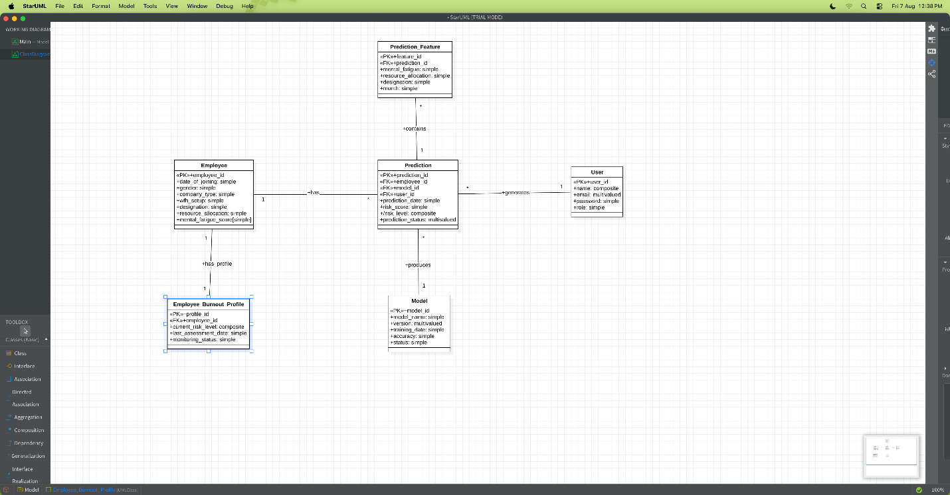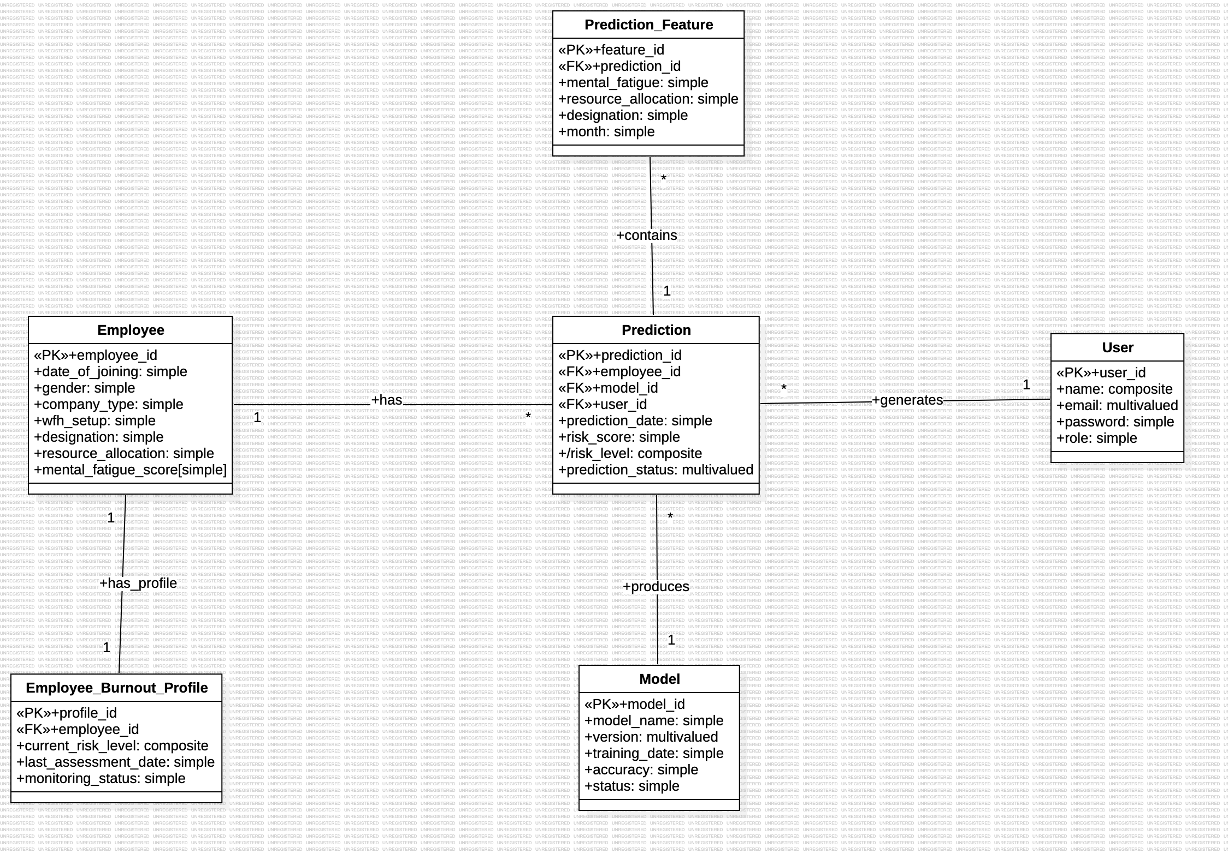

10. Brief Explanation of the Design
The ER diagram represents the database structure of the Employee Burnout Prediction System. The Employee entity stores employee information, while Employee_Burnout_Profile maintains the employee's current burnout monitoring information through a 1:1 relationship. Prediction records connect employees, users, and machine-learning models and therefore resolve the M:N relationship between Employee and Model. Prediction_Feature stores the temporal feature values used for CNN-LSTM predictions. Primary and foreign keys maintain entity integrity and establish relationships between the entities.

