CIN628 Internet and Web Programming
Trimester 3 – 2018
Lab 3

XHTML Validation
The correctness of XHTML code is verified using an XHTML Validation Service, such as W3C’s XHTML Validation Service (http://validator.w3.org/).
An XHTML document is validated against a DTD and the set of XHTML syntax rules that is identified below:
XHTML Syntax Rules
    - The XHTML DTD defines mandatory elements
    - Tag names must be in lowercase
    - Attribute names must be in lower case
    - Attribute values must be quoted
    - The id attribute replaces the name attribute
    - XHTML elements must be properly nested
    - All XHTML elements must be closed

Exercise 1: XHTML Validation under a given DTD
Figure 1 on page 2 shows an incorrectly written XHTML 1.0 document under the Transitional DTD that is to be corrected.
Instructions:
- Use the Source Code provided in Figure 1 and save it into a file, as “invalid.xhtml”.
- Open the W3C HTML Validation Service available at http://validator.w3.org.
- Check for Validation by :
  - Direct Input of code or
  - File Upload of invalid.xhtml
- View the errors listed from validation and update/modify your code in invalid.xhtml to eliminate these errors, and save the changes made.
- Check again for validation after fixing these errors by the methods shown in Step 3.
- Repeat Steps 5-6 until your code fully passes validation.
- Once your document is fully validated, save the document as “valid.xhtml”.
- View valid.xhtml in browser to see the emerging XHTML document after corrections. Your validated XHTML should look like Figure 2. Note that you can crop the image from Figure 2 and include in your site.

<!DOCTYPE html PUBLIC "-//W3C//DTD XHTML 1.0 Transitional//EN"
"http://www.w3.org/TR/xhtml1/DTD/xhtml1-transitional.dtd">

<!-- //transitional DTD -->

<html xmlns="http://www.w3.org/1999/xhtml" xml:lang="en">

<head>
<title>
XHTML Validation Example &minus; Valid
</title>
<meta http-equiv="Content-Type" content="text/html;
charset=iso-8859-1" />
</head>

<body BGCOLOR=#CFCFF0>
<h1 align = CENTER> <u>Core Web Fonts</U></h1>
<font FACE="Times New Roman">
<h4 align = CENTER>This is Times New Roman</h4></font>
<font FACE="Courier New">
<h4 align = CENTER>This is Courier New</h4></font>
<font FACE="Arial">
<h4 align = CENTER>This is Arial</H4></font>

This is a XHTML validation test<br>
This is the <i><b>valid</i></b> code output of
<b>invalid.xhtml</b><br>
Try <a href="http://validator.w3.org/#validate_by_upload">this
validation service.

<br>(<B>select and copy</B> either the <B>source
code</B> or <B>URL</B> for this page - so that you
can paste it into the website.)

<br><br>
<img src="/www.jpg" alt="image not found" />

</body>

Figure 1
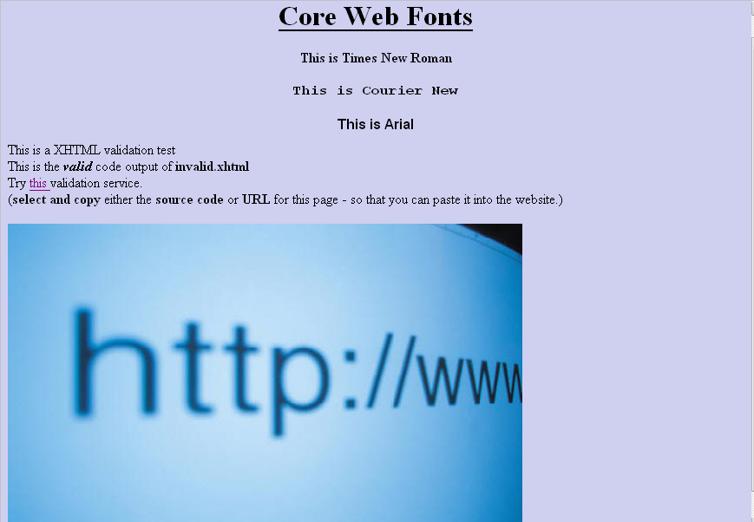

Figure 2

Exercise 2: W3Schools: https://www.w3schools.com/html/

Go to the above site and go through CSS tutorial.

