Practice Exercises for ‘Find and Replace’ with MS Word.

Exercise 1
Use ‘Find and Replace’ to change all the ‘Humpty Dumpty’ to ‘Mighty Mac’.
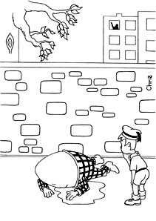
Assassination rumours! Did he fall or was he pushed?
Humpty Dumpty sat on a wall. Humpty Dumpty had a great fall. All the king’s horses and all the king’s men are having scrambled eggs for a week.
Local crime investigators would like anyone who was in or near the area of the wall at 6am on Tuesday when Humpty Dumpty met this accident to come forward with any information they might have about the circumstances of Humpty Dumpty and his fall.

Exercise 2 Activity Week
 | P4 | P5 | P6 | P7
9-10am | Football | Uni-hoc | Skateboarding | Rounders
10-11pm | Tennis | Football | Uni-hoc | Skateboarding
11-12noon | Rounders | Tennis | Football | Uni-hoc
1-2pm | Skateboarding | Rounders | Tennis | Football
2-3pm | Uni-hoc | Skateboarding | Rounders | Tennis

Unfortunately the skateboarding sessions will not be available during the Activity Week, but will be replaced by Athletics. Can you make the changes on the timetable using ‘Find and Replace’? Use the Highlighter tool.

Activity 3
The reporter didn’t know that Alex was a girl. Can you correct this article by changing the pronouns.

Alex Smith is having a fantastic season this year. His record win at the Southern Championships last week put him in the history books as the fastest ever 11 year old to win the ‘Speedo’ trophy at the Riverside Aqua Centre. His time of 42.6 seconds over this distance makes him a very likely choice for the international championship heats later this month. His parents – Bob and Beth Smith are delighted at his success and are looking forward to seeing him in the national squad soon. ‘He has worked hard to deserve his place in the team’, says his proud Dad.
