CIN628 Internet and Web Programming
Trimester 3 – 2018
Lab 1

Reference:
- HTML: http://www.w3schools.com/

Part A: Use the following elements to create your very first web page
<html>
<head>
<title>Example One</title>
</head>
<body>
A very simple web page.
</body>
</html>
Here is A very simple web page in a browser:

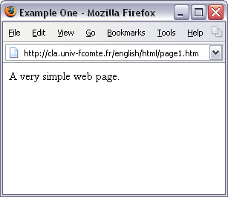

Part B: W3Schools: https://www.w3schools.com/html/

Go to the above site and go through the tutorial on the following topics:
- HTML Home
- HTML Introduction
- HTML Editors
- HTML Basic
- HTML Elements
- HTML Attributes
- HTML Headings
- HTML Paragraphs
- HTML Styles
- HTML Formatting
- HTML Quotations
- HTML Comments
- HTML Colors

Part C: Building a Basic Web Page
First, right-click on the picture of this cat below and save it to a folder on your computer so you can use it as an image on your web page.
When finished creating the html file, save your source document with the .html file extension. The document and the cat's picture must be in the same folder.

Welcome!

I will link to Yahoo
Required Tags in the Example
- The source document's text and codes go between the <html> opening tag and the </html> closing tag. An HTML source document contains two sections: Head and Body.
- The Head section (with the <head> and </head> tags) contains your title for the top of the browser. Type your title's name between the <title> and </title> tags.
- The contents of the Body section go between the <body> and </body> tags.
Other Tags in the Example
- The image tag needs source, width, height and alt (description) attributes:
<img src="cat.jpg" width="50" height="50" alt="cat">. The image element and a few others do not have closing tags.
- <p> starts a paragraph, and </p> ends it.
- Text between <b> and </b> appears in bold type.
- <a href="http://www.yahoo.com">Yahoo</a> links this page to Yahoo.com. To link to a second page on your own site, use the attribute href="page2.htm". The a tag stands for anchor. The word Yahoo between the anchor tag and its closing is set as a hyperlink.

