CIN628 Internet and Web Programming
Trimester 3 – 2018
Lab 6

Part A: Setting up a PHP Project in the NetBeans IDE for PHP

Reference: https://netbeans.org/kb/docs/php/quickstart.html
NetBeans is an Integrated Development Environment (IDE) for developing with Java, JavaScript, PHP, Python, Ruby, Groovy, C, C++, Scala, Clojure, and others. It is an open source and is written in the Java programming language. It can run on a platform where a Java Virtual Machine (JVM) is installed, including Windows, Mac OS, Linux, and Solaris. A JDK is required for Java development functionality, but is not required for development in other programming languages.
The NetBeans IDE is free for commercial and non-commercial use, and they are supported by Sun Microsystems. It can be downloaded from http://www.netbeans.org

To start PHP development in the NetBeans IDE for PHP, you first need to create a project.
- Start the IDE, switch to the Projects window, and choose File > New Project. The Choose Project panel opens.
- In the Categories list, choose PHP.
- In the Projects area, choose PHP Application and click Next. The New PHP Project > Name and Location panel opens.
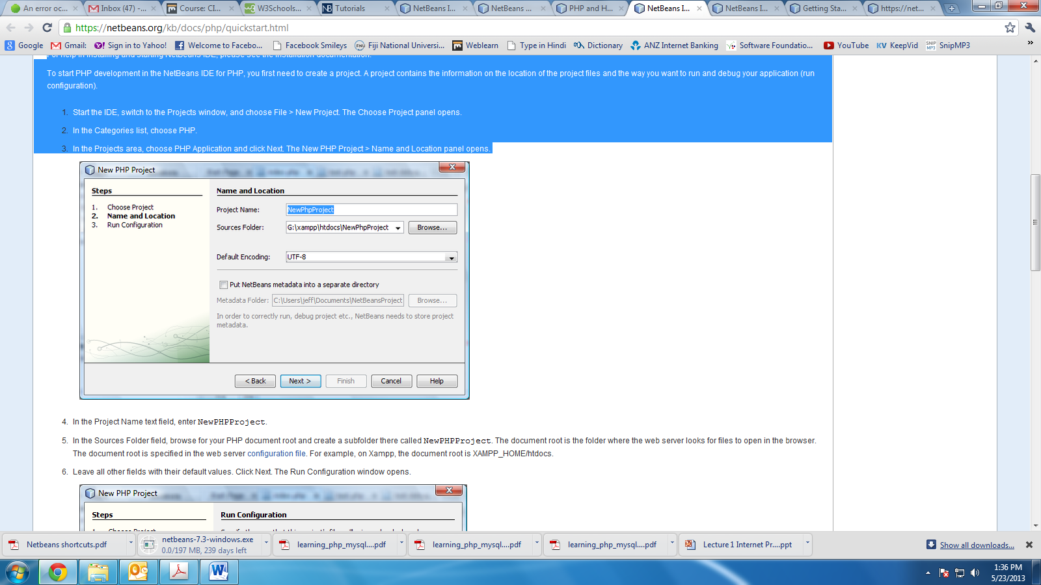

- In the Project Name text field, enter NewPHPProject.
- Note that a server is required to run PHP. To configure XAMPP server for PHP, follow the instructions on the following site: https://netbeans.org/kb/docs/php/configure-php-environment-windows.html
- Leave all other fields with their default values. Click Next. The Run Configuration window opens.
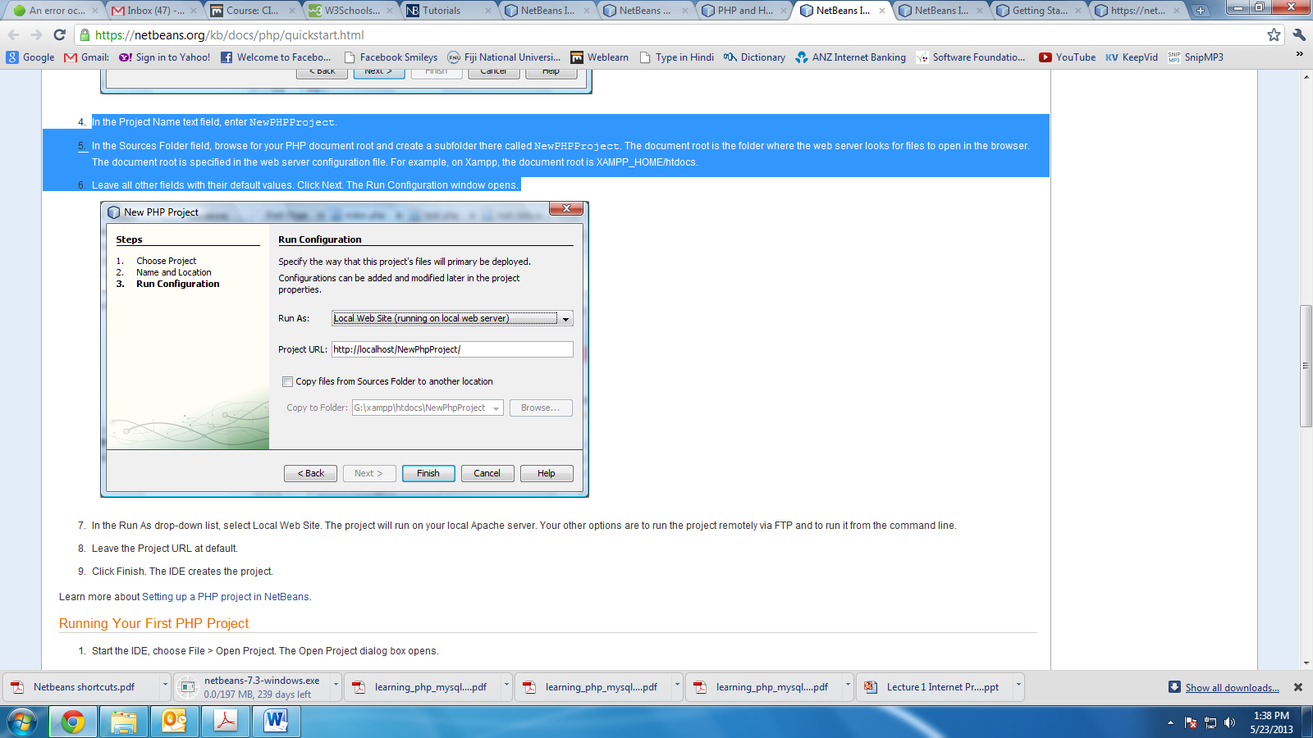
- In the Run As drop-down list, select Local Web Site. The project will run on your local Apache server. Your other options are to run the project remotely via FTP and to run it from the command line.
- Leave the Project URL at default.
- Click Finish. The IDE creates the project.

Part B: Running Your First PHP Project

Reference: https://netbeans.org/kb/docs/php/quickstart.html
- Start the IDE, choose File > Open Project. The Open Project dialog box opens.
- Select NewPHPProject and click Open Project. The NewPHPProject tree appears in the Projects window and the project's index.php file opens in the editor and in the Navigator window.
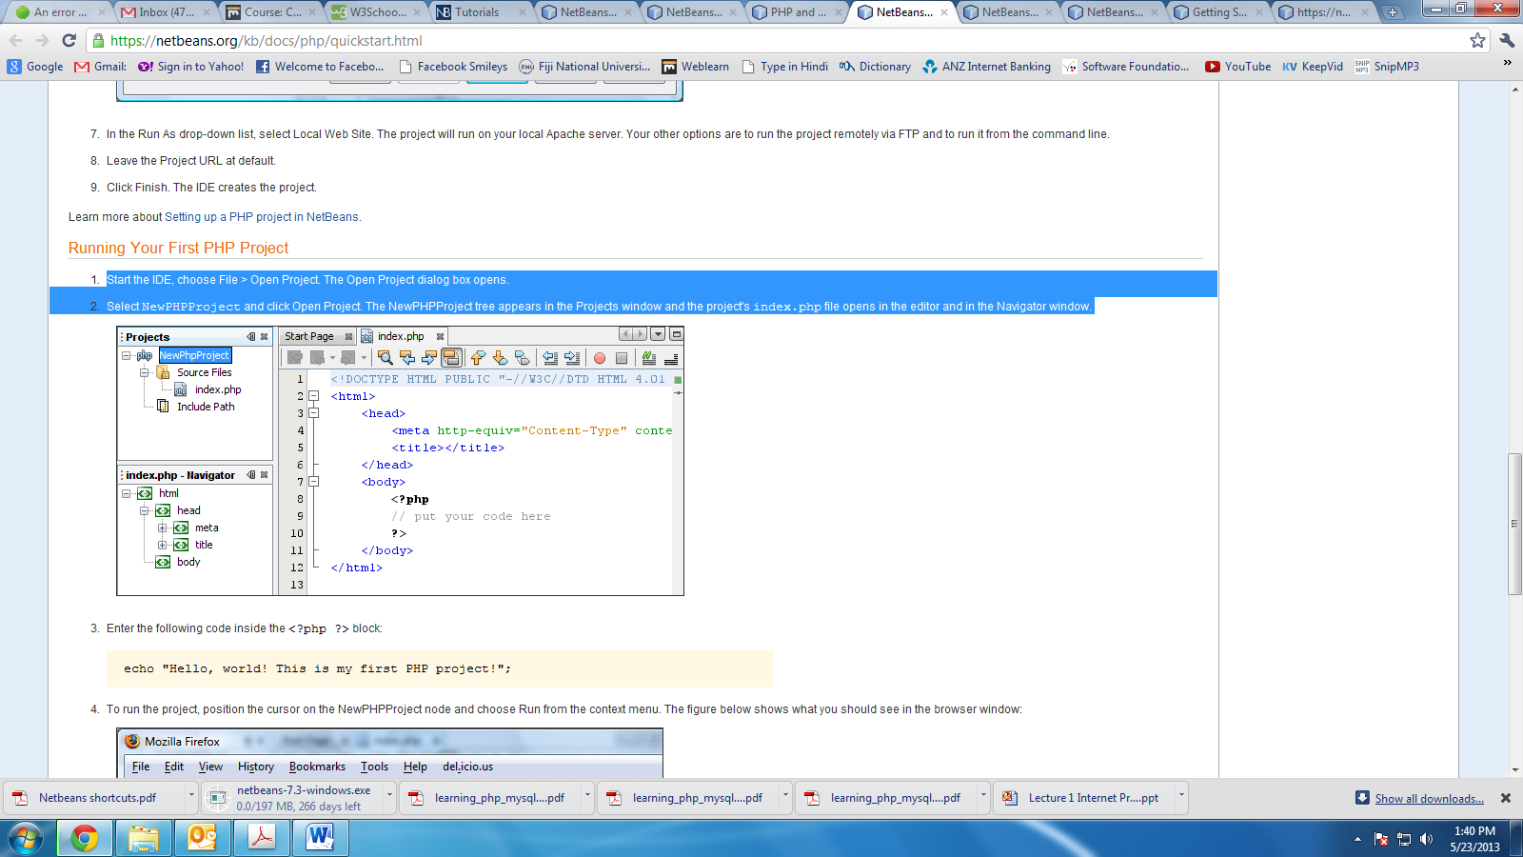
- Enter the following code inside the <?php ?> block:
echo "Hello, world! This is my first PHP project!";
- To run the project, position the cursor on the NewPHPProject node and choose Run from the context menu. The figure below shows what you should see in the browser window:
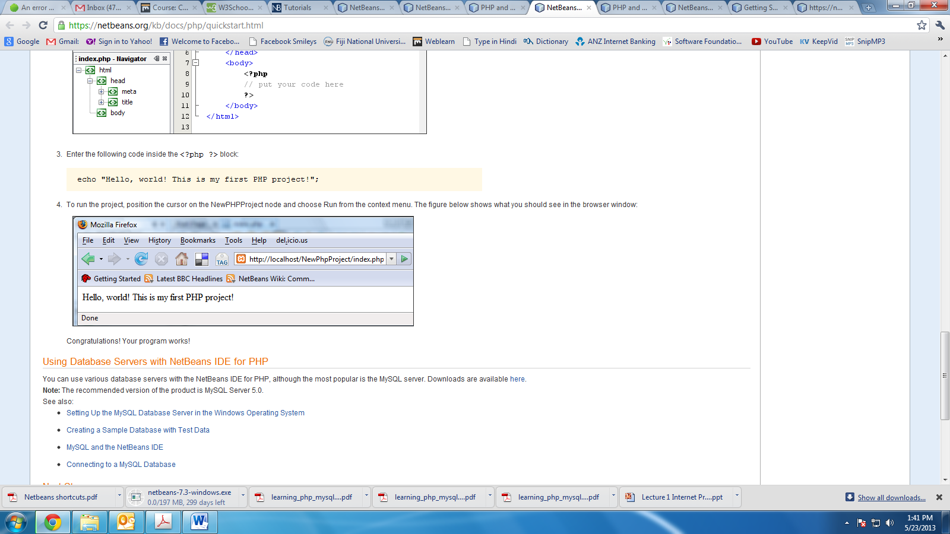

Part C: PHP Basics
Read through and carry out instruction from the site: http://www.w3schools.com/php/default.asp. Focus on the following:
- Intro
- Syntax
- Variables
- Data Types
- String
- Constants
- Operators
- If…Else…Elseif
- While Loops
- For Loops
- Functions
- Arrays

